Supplementary Information

Evolution of Focused Streams for Viscoelastic Flow in Spiral Microchannels

Hua Gao, Jian Zhou,* Mohammad Moein Naderi, Zhangli Peng, and Ian Papautsky*

Department of Biomedical Engineering, University of Illinois Chicago, Chicago, IL 60607, USA

*Address correspondence to:

Dr. Jian Zhou (jzhou88@uic.edu)
Dr. Ian Papautsky (papauts@uic.edu)
Department of Biomedical Engineering
851 S. Morgan Street, 218 SEO
University of Illinois Chicago
Chicago, IL 60607, USA

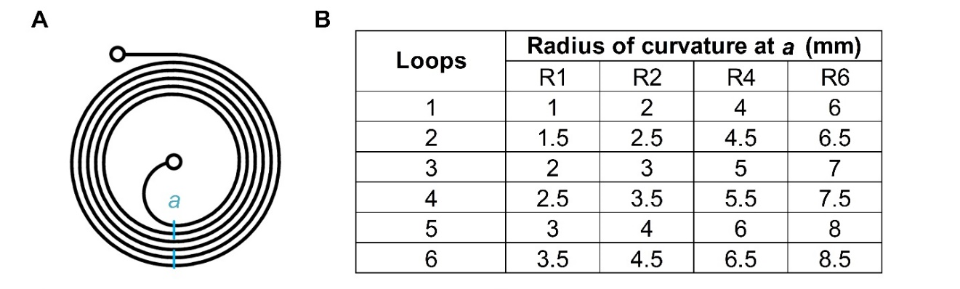
Fig. S1. Details of device design. (A) Schematic layout of spiral channel. (B) Table summarizing details of the four devices of different initial radii of curvature. Loop radius is given at position a for each device.

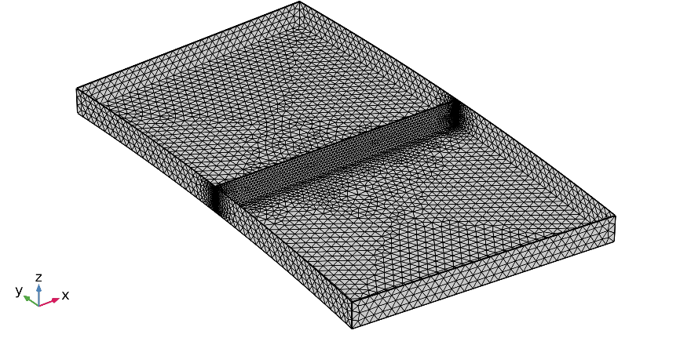
Fig. S2. Model mesh configuration. Finer mesh was used in the cross-section of interest.

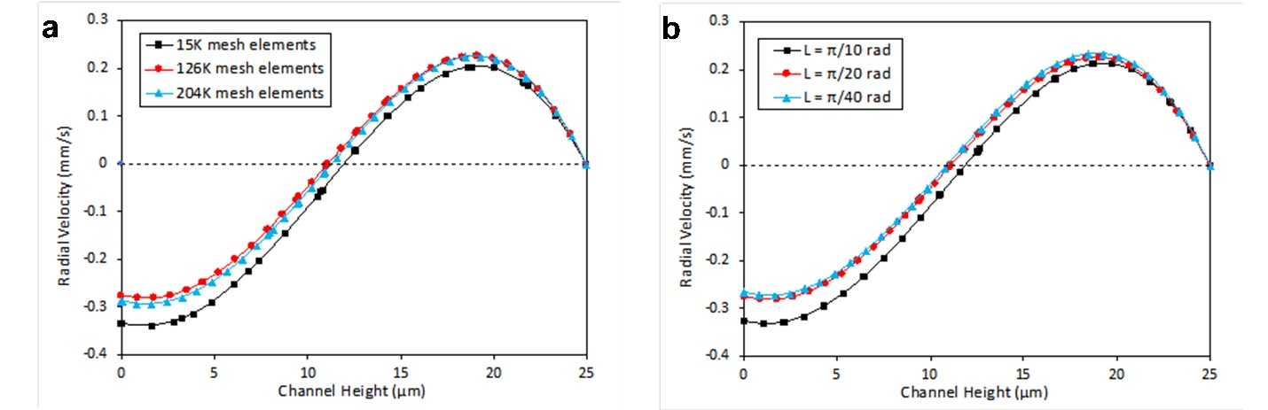
Fig. S3. Dependency of simulation results on the number of mesh elements and the spiral segment length by plotting radial velocity along half the channel height. (A) three different mesh configurations with 15000, 126000, and 204000 number of elements were evaluated, and the mesh-independency was observed beyond 126K elements. (B) Segment lengths of π/10, π/20 nd π/40 were simulated; channel length of π/20 ensured independence of the results from the domain length and provided longest possible channel segment for the flow to develop.
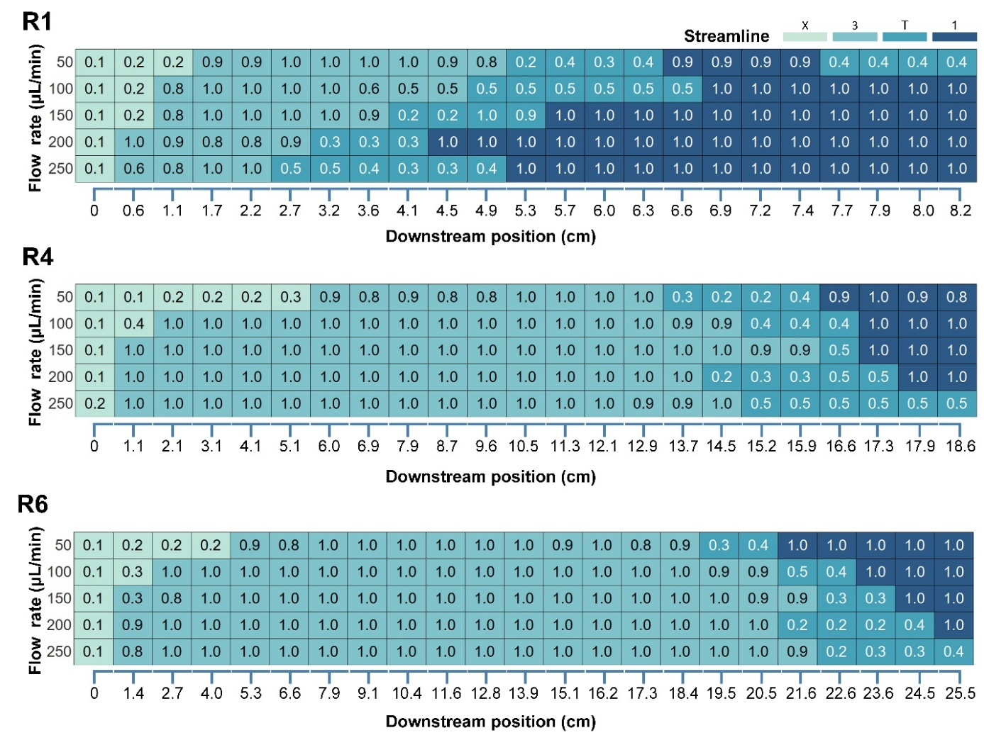Fig. S4. Particle migration and focusing in R1, R2, R4, and R6. Heat map illustrates the evolution of particle focusing streams. Each cell reports focusing quality (FQ = a/FWHM) of fluorescent streams. The color of each cell indicates the unfocused (X), three stream (3), transition (T) or single stream (1) regions.

Fig. S5. Downstream evolution of focusing for 7.32 μm, 15 μm, and 25 μm diameter beads. Stacked fluorescent streak images illustrating downstream evolution of particle focusing in R2 spiral channel (aspect ratio AR = 0.2) at 250 μL/min flow rate in 500 ppm PEO solution. The +/-125 scale indicates the normalized width of the 250 μm wide channel. Downstream position is indicated at the bottom of the panel set.

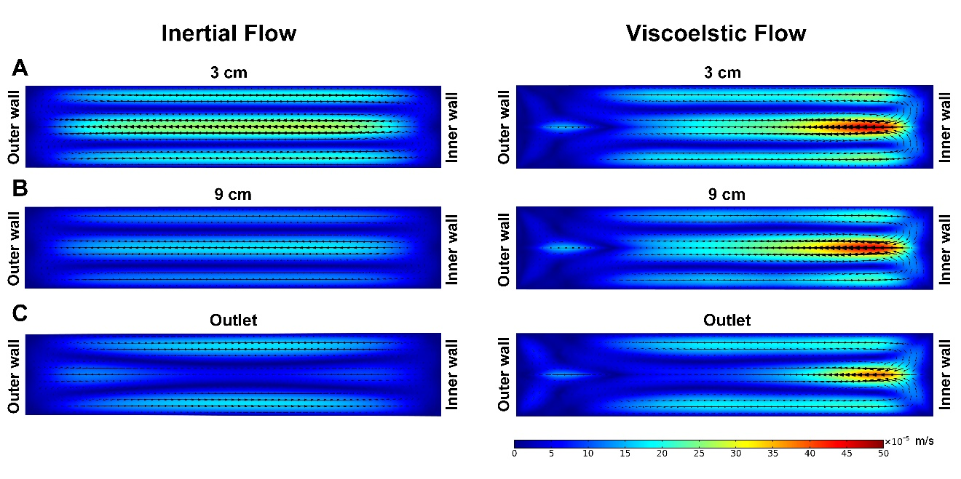
Fig. S6. Comparison of inertial and viscoelastic flows. Numerical predictions of the secondary Dean flow velocity profiles in the channel cross-sections show strong asymmetry in the viscoelastic flow. Results are for R2 spiral channel (aspect ratio AR = 0.2) at 100 μL/min flow rate in water (inertial flow) and 500 ppm PEO solution (viscoelastic flow). Cross-sections are shown at downstream positions of (A) 3 cm, (B) 9 cm, and (C) outlet.
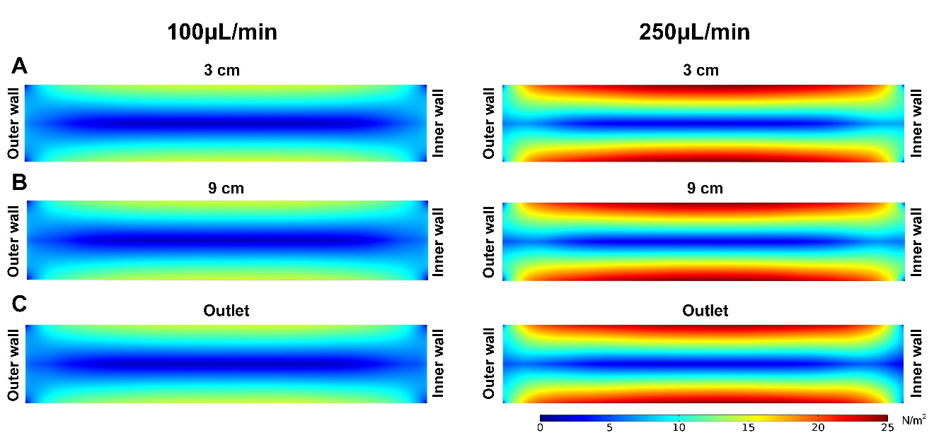
Fig. S7. Numerical predictions of the first normal stress difference in the channel cross-sections in the downstream. Results are for R2 spiral channel (aspect ratio AR = 0.2) at 100 μL/min (left column) and 250 μL/min (right column) flow rates at (A) 3cm, (B) 9cm, and (C) outlet (11cm) downstream. Dimensionless numbers at both flowrates are: El = 2.6, Re = 3.7/9.4, and Wi = 9.8/24.5.

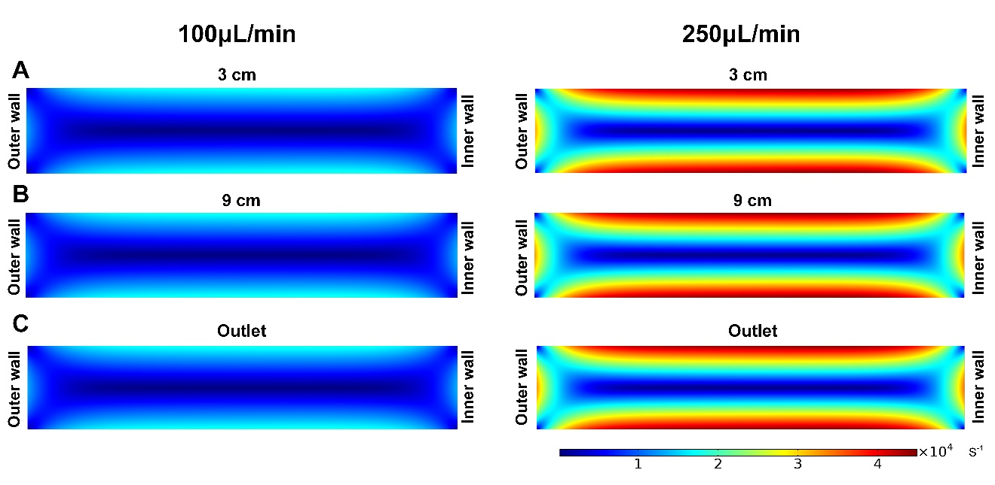
Fig. S8. Numerical predictions of the shear rate in the channel cross-sections in the downstream. Results are for R2 spiral channel (aspect ratio AR = 0.2) at 100 μL/min (left column) and 250 μL/min (right column) flow rates at (A) 3cm, (B) 9cm, and (C) outlet (11cm) downstream. Dimensionless numbers at both flowrates are: El = 2.6, Re = 3.7/9.4, and Wi = 9.8/24.5.

