Supplementary materials

PEDOT:PSS-based Bioelectronics for Brain Monitoring and Modulation
Jing Li^{1,6,‡}, Daize Mo^{3,‡}, Jinyuan Hu^{1,‡}, Shichao Wang¹, Jun Gong⁴, Yujing Huang², Zheng Li^{5,7}, Zhen Yuan², Mengze Xu^{1,2,5*}

¹ Department of Systems Science, Faculty of Arts and Sciences, Beijing Normal University, Zhuhai 519087, China
² Centre for Cognitive and Brain Sciences, Faculty of Health Sciences, University of Macau, Macau SAR 999078, China
³ School of Applied Physics and Materials, Wuyi University, Jiangmen 529020, P. R. China
⁴ Central Laboratory of YunFu People's Hospital, Yunfu, Guangdong, China
⁵ Department of Psychology, Faculty of Arts and Sciences, Center for Cognition and Neuroergonomics, State Key Laboratory of Cognitive Neuroscience and Learning, Beijing Normal University, Zhuhai, China
⁶ School of Systems Science, Beijing Normal University, Beijing 100875, China
⁷Beijing Key Laboratory of Applied Experimental Psychology, National Demonstration Center for Experimental Psychology Education (Beijing Normal University), Faculty of Psychology, Beijing Normal University, Beijing, China

‡Equal contribution. *Corresponding author: mengzexu@bnu.edu.cn.



Figure S1: Copyright permission for Figure 3-1 reproduced from Springer Nature 2024.

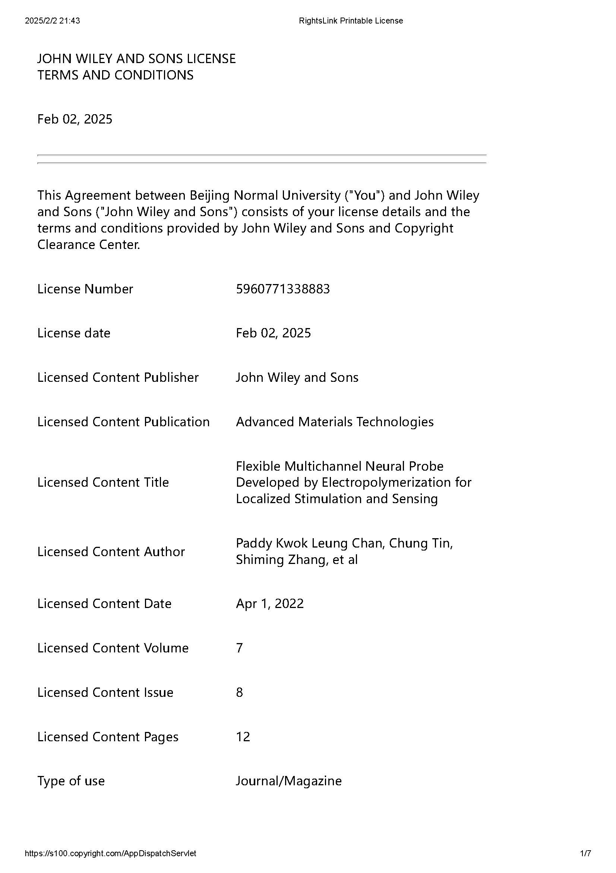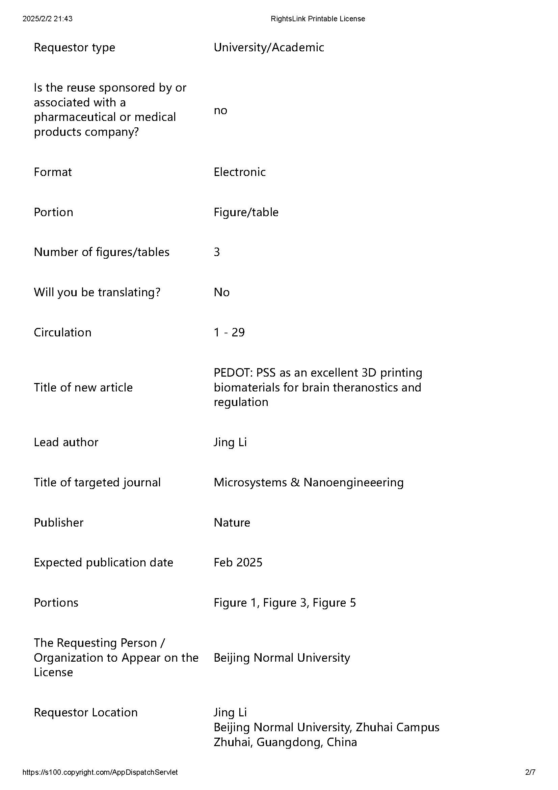

Figure S2: Copyright permission for Figure 3-2 reproduced from John Wiley and Sons 2022.

Figure S3: Copyright permission for Figure 3-3 reproduced from John Wiley and Sons 2022.

Figure S4: Copyright permission for Figure 4-1 reproduced from THE AMERICAN ASSOCIATION FOR THE ADVANCEMENT OF SCIENCELICENSE 2022.



Figure S5: Copyright permission for Figure 4-2 reproduced from John Wiley and Sons 2024.



Figure S6: Copyright permission for Figure 4-3 reproduced from Springer Nature 2023.



Figure S7: Copyright permission for Figure 5-1 reproduced from Springer Nature 2020.

Figure S8: Copyright permission for Figure 5-2 reproduced from Springer Nature 2020.

