Supplementary Materials for
Intelligent Single-cell Manipulation: LLMs- and Object Detection-enhanced Active-Matrix Digital Microfluidics
Zhiqiang Jia^{1,2,3,4}, Chen Jiang², Jiahao Li⁵, Yacine Belgaid⁵, Mingfeng Ge¹, Li Li¹, Siyi Hu^{1,4}, Xing Huang⁶, Tsung-Yi Ho², Wenfei Dong^{1,3*}, Zhiwen Yu^{6,7*}, and Hanbin Ma^{1,4,5,6*}
¹CAS Key Laboratory of Bio-Medical Diagnostics, Suzhou Institute of Biomedical Engineering and Technology, Chinese Academy of Sciences, Suzhou, 215163, P.R.China.
²Department of Computer Science and Engineer, The Chinese University of Hong Kong, Hongkong, 999077, P.R.China.
³College of Mechanical and Electrical Engineering, Changchun University of Science and Technology, Changchun, 130022, P.R.China.
⁴Guangdong ACXEL Micro & Nano Tech Co., Ltd, Foshan, 528000, P.R.China.
⁵ACX Instruments Ltd, St John’s Innovation Centre, Cowley Road, Cambridge, CB4 0WS, United Kingdom.
⁶School of Computer Science, Northwestern Polytechnical University, Xi’an, 710072, P.R.China.
⁷College of Computer Science and Technology, Harbin Engineering University, Harbin, 150001, P.R.China.

Correspondence to: wenfeidong@sibet.ac.cn,
zhiwenyu@nwpu.edu.cn,
and mahb@sibet.ac.cn.

This PDF file includes:
Figs. S1 to S7
Tables S1 to S10
Movie S1 to S2

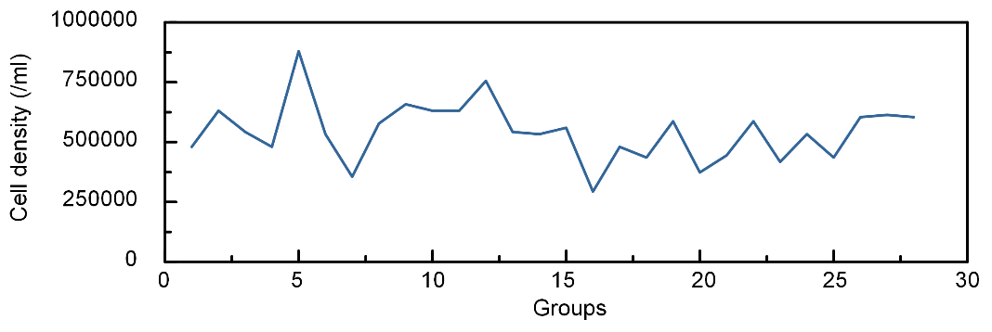
Fig. S1. Cell density analysis using our platform.

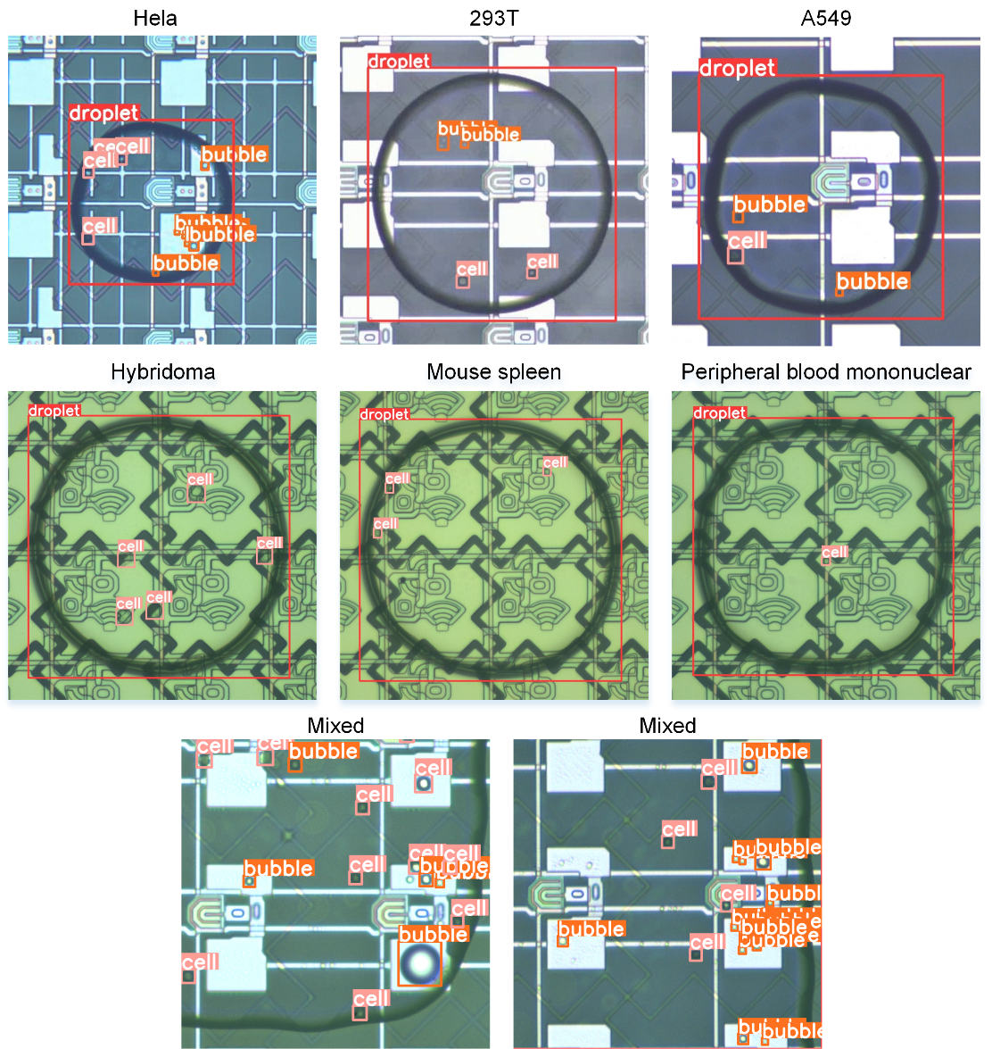
Fig. S2. Generalization test for various types of cell detection using the proposed model
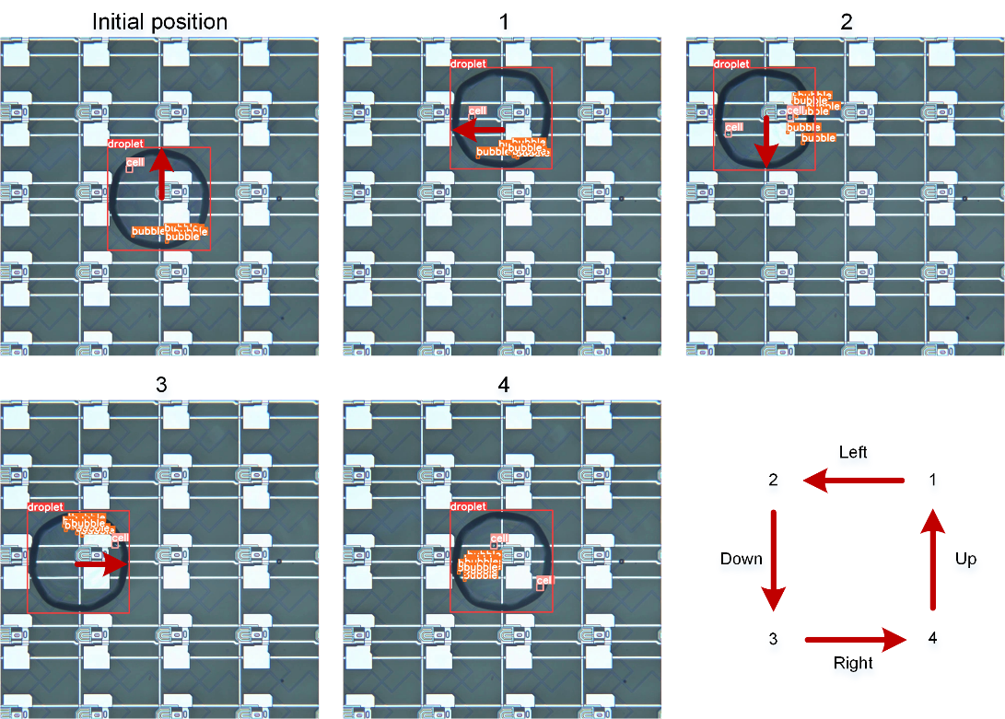
Fig. S3. Method for statistically analyzing the percentage of cell positions distributed within the droplets.
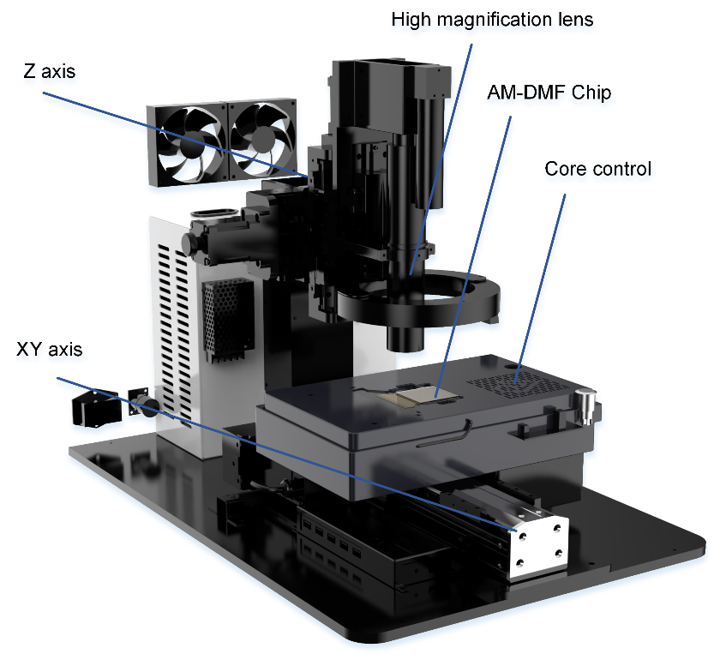
Fig.S4. Integrated AM-DMF chip core control, high-magnification camera, and image processing platform.
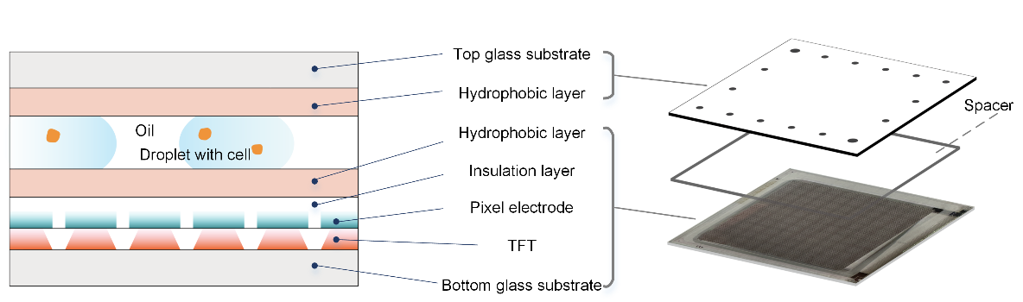
Fig.S5. Structure and cross-section view of the AM-DMF chip.

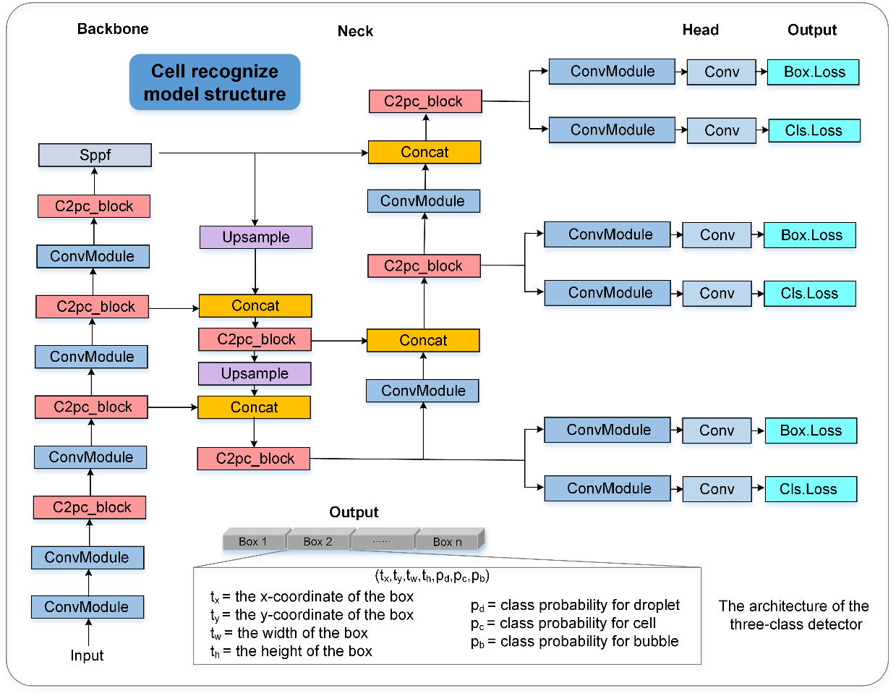
Fig.S6. The structure of the three-class cell recognition model.
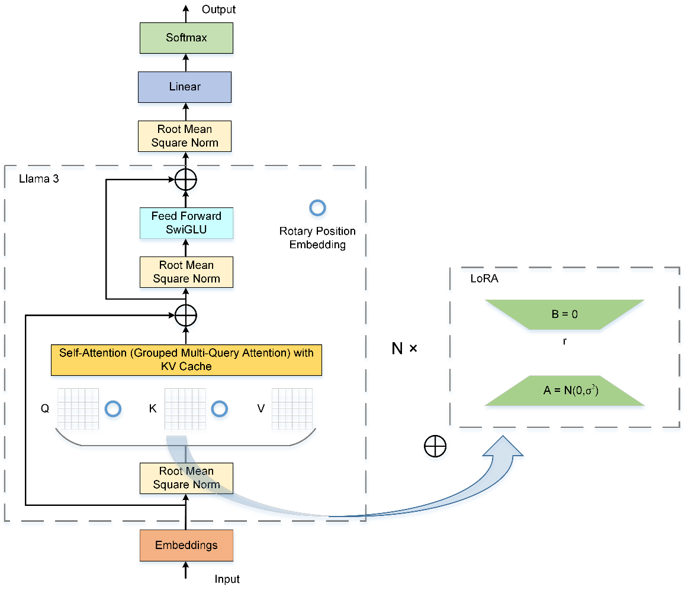
Fig.S7. The structure of the DPG model.
Table S1. Comparison of single-cell processing techniques.
Technical platform Processing Techniques | Flow cytometry | Microwell microfluidics | Microdroplet microfluidics | Optoelectronic tweezers | Digital microfluidics
Single cell separation
Single cell-level cell biology
Single cell-level molecular experiment
Single cell two-dimensional manipulation

Table S2. Cell category recognition performance comparison between two-class and three-class methods across different models.
This work
 | AP₅₀ | AP₇₅ | AP_{50:95}
Two-class | 96.4% | 90.9% | 74.8%
Three-class | 96.8% | 91.9% | 75.5%
Improvement | 0.4% | 1.0% | 0.7%
YOLOv7-tiny¹
 | AP₅₀ | AP₇₅ | AP_{50:95}
Two-class | 94.2% | 85.7% | 70.1%
Three-class | 94.9% | 87.0% | 71.3%
Improvement | 0.7% | 1.3% | 1.2%
Object Box²
 | AP₅₀ | AP₇₅ | AP_{50:95}
Two-class | 95.9% | 87.6% | 71.9%
Three-class | 96.7% | 88.2% | 72.9%
Improvement | 0.8% | 0.6% | 1.0%
YOLOv8-s
 | AP₅₀ | AP₇₅ | AP_{50:95}
Two-class | 96.2% | 90.3% | 74.4%
Three-class | 96.5% | 91.4% | 75.2%
Improvement | 0.3% | 1.1% | 0.8%

Table S3. Original format (Fig 6 g).
- original format: | (108,38)(1,1);(108,59)(1,1);(111,45)(1,1);(114,45)(1,1);(117,52)(1,1)-800  (108,37)(1,1);(108,58)(1,1);(111,44)(1,1);(114,44)(1,1);(117,51)(1,1)-800  (108,36)(1,1);(108,57)(1,1);(111,43)(1,1);(114,43)(1,1);(117,50)(1,1)-800  (108,35)(1,1);(108,56)(1,1);(111,42)(1,1);(114,42)(1,1);(117,49)(1,1)-800  (108,34)(1,1);(108,55)(1,1);(111,41)(1,1);(114,41)(1,1);(117,48)(1,1)-800  (107,34)(1,1);(107,55)(1,1);(110,41)(1,1);(113,41)(1,1);(116,48)(1,1)-800  (106,34)(1,1);(106,55)(1,1);(109,41)(1,1);(112,41)(1,1);(115,48)(1,1)-800  (105,34)(1,1);(105,55)(1,1);(108,41)(1,1);(111,41)(1,1);(114,48)(1,1)-800  (104,34)(1,1);(104,55)(1,1);(107,41)(1,1);(110,41)(1,1);(113,48)(1,1)-800  (103,34)(1,1);(103,55)(1,1);(106,41)(1,1);(109,41)(1,1);(112,48)(1,1)-800  (102,34)(1,1);(102,55)(1,1);(105,41)(1,1);(108,41)(1,1);(111,48)(1,1)-800  (101,34)(1,1);(101,55)(1,1);(104,41)(1,1);(107,41)(1,1);(110,48)(1,1)-800  (100,34)(1,1);(100,55)(1,1);(103,41)(1,1);(106,41)(1,1);(109,48)(1,1)-800  (99,34)(1,1);(99,55)(1,1);(102,41)(1,1);(105,41)(1,1);(108,48)(1,1)-800  (98,34)(1,1);(98,55)(1,1);(101,41)(1,1);(104,41)(1,1);(107,48)(1,1)-800  (97,34)(1,1);(97,55)(1,1);(100,41)(1,1);(103,41)(1,1);(106,48)(1,1)-800  (96,34)(1,1);(96,55)(1,1);(99,41)(1,1);(102,41)(1,1);(105,48)(1,1)-800  (96,33)(1,1);(96,54)(1,1);(99,40)(1,1);(102,40)(1,1);(105,47)(1,1)-800  (96,32)(1,1);(96,53)(1,1);(99,39)(1,1);(102,39)(1,1);(105,46)(1,1)-800  (96,31)(1,1);(96,52)(1,1);(99,38)(1,1);(102,38)(1,1);(105,45)(1,1)-800  (96,30)(1,1);(96,51)(1,1);(99,37)(1,1);(102,37)(1,1);(105,44)(1,1)-800  (96,29)(1,1);(96,50)(1,1);(99,36)(1,1);(102,36)(1,1);(105,43)(1,1)-800  (96,28)(1,1);(96,49)(1,1);(99,35)(1,1);(102,35)(1,1);(105,42)(1,1)-800  (96,28)(1,1);(96,48)(1,1);(99,34)(1,1);(102,34)(1,1);(105,41)(1,1)-800  (96,28)(1,1);(96,47)(1,1);(99,33)(1,1);(102,33)(1,1);(105,40)(1,1)-800  (96,28)(1,1);(96,46)(1,1);(99,32)(1,1);(102,32)(1,1);(105,39)(1,1)-800  (96,28)(1,1);(96,45)(1,1);(99,31)(1,1);(102,31)(1,1);(105,38)(1,1)-800  (96,28)(1,1);(96,44)(1,1);(99,30)(1,1);(102,30)(1,1);(105,37)(1,1)-800  (96,28)(1,1);(96,43)(1,1);(99,29)(1,1);(102,29)(1,1);(105,36)(1,1)-800  (96,28)(1,1);(96,42)(1,1);(99,28)(1,1);(102,28)(1,1);(105,35)(1,1)-800  (96,28)(1,1);(96,41)(1,1);(99,28)(1,1);(102,28)(1,1);(105,34)(1,1)-800  (96,28)(1,1);(96,40)(1,1);(99,28)(1,1);(102,28)(1,1);(105,33)(1,1)-800  (96,28)(1,1);(96,39)(1,1);(99,28)(1,1);(102,28)(1,1);(105,32)(1,1)-800  (96,28)(1,1);(96,38)(1,1);(99,28)(1,1);(102,28)(1,1);(105,31)(1,1)-800  (96,28)(1,1);(96,37)(1,1);(99,28)(1,1);(102,28)(1,1);(105,30)(1,1)-800  (96,28)(1,1);(96,36)(1,1);(99,28)(1,1);(102,28)(1,1);(105,29)(1,1)-800  (96,28)(1,1);(96,35)(1,1);(99,28)(1,1);(102,28)(1,1);(105,28)(1,1)-800  (96,28)(1,1);(96,34)(1,1);(99,28)(1,1);(102,28)(1,1);(105,28)(1,1)-800  (96,28)(1,1);(96,33)(1,1);(99,28)(1,1);(102,28)(1,1);(105,28)(1,1)-800  (96,28)(1,1);(96,32)(1,1);(99,28)(1,1);(102,28)(1,1);(105,28)(1,1)-800

Table S4. Generations obtained from DPG model (Fig 6 g).
- Prompt: | Please plan the single-cell samples to the column movement -4, row movement -12, column space 3, and y_start 28. Position: [(108, 38), (108, 59), (111, 45), (114, 45), (117, 52)]. Delay time: 800.
- Response: | {'type':'single-cell path planning', 'path': {'delay_time': 800, 'col_movement': -4, 'col movement coordinate mapping': {(108, 38): (108, 34), (108, 59): (108, 55), (111, 45): (111, 41), (114, 45): (114, 41), (117, 52): (117, 48)}, 'row_movement': -12, 'row movement coordinate mapping ': {(108, 34): (96, 34), (108, 55): (96, 55), (111, 41): (99, 41), (114, 41): (102, 41), (117, 48): (105, 48)}, 'y_start': 28, 'col distance': 3,'sort coordinate mapping': {(96, 34): (96, 28), (96, 55): (96, 32), (99, 41): (99, 28), (102, 41): (102, 28), (105, 48): (105, 28)}}}

Table S5. Generations obtained from DPG model (Fig 6 d).
- Prompt: | The starting droplet’s row:45, col:21, width:1, height:1. The end droplet’s row:38, col:27, width:1, height:1. Delay time:-600.
- Response: | 1:-d:600.  2:45,21-h:1-w:1.  3:44,21-h:1-w:1.  4:43,21-h:1-w:1.  5:42,21-h:1-w:1.  6:41,21-h:1-w:1.  7:40,21-h:1-w:1.  8:39,21-h:1-w:1.  9:38,21-h:1-w:1.  10:38,22-h:1-w:1.  11:38,23-h:1-w:1.  12:38,24-h:1-w:1.  13:38,25-h:1-w:1.  14:38,26-h:1-w:1.  15:38,27-h:1-w:1.

Table S6. Generations obtained from DPG model (Fig 6 e).
- Prompt: | Droplet position: row:30, col:75, width:4, height:4. Sub-droplet details: width:2, height:2, row spacing:2, col spacing:4. Delay time:-1000.
- Response: | 1:-d:1000.  2:30,75-h:4-w:4.  3:30,74;30,78-h:4-w:2.  4:30,73;30,79-h:4-w:2.  5:29,73;33,73;29,79;33,79-h:2-w:2.

Table S7. Generations obtained from DPG model (Fig 6 f).
- Prompt: | Please plan the movement and splitting path for the droplets. Initial position: row:60, col:36, width:2, height:4. Final position: row:54, col:42. Sub-droplet details: width:1, height:2, row spacing:2, col spacing:2. Delay time:-500.
- Response: | 1:-d:500.  2:60,36-h:4-w:2.  3:59,36-h:4-w:2.  4:58,36-h:4-w:2.  5:57,36-h:4-w:2.  6:56,36-h:4-w:2.  7:55,36-h:4-w:2.  8:54,36-h:4-w:2.  9:54,37-h:4-w:2.  10:54,38-h:4-w:2.  11:54,39-h:4-w:2.  12:54,40-h:4-w:2.  13:54,41-h:4-w:2.  14:54,42-h:4-w:2.  15:53,42;57,42-h:2-w:2.  16:53,41;53,44;57,41;57,44-h:2-w:1.

Table S8. Paths generated by DPG for 10 droplets assigned to designated locations.
- Prompt: | The starting droplet’s row:60, col:25: The end droplet’s row:45, col:8.  The starting droplet’s row:60, col:28: The end droplet’s row:45, col:13.  The starting droplet’s row:60, col:31: The end droplet’s row:45, col:18.  The starting droplet’s row:60, col:34: The end droplet’s row:45, col:23.  The starting droplet’s row:60, col:37: The end droplet’s row:45, col:28.  The starting droplet’s row:60, col:40: The end droplet’s row:50, col:8.  The starting droplet’s row:60, col:43: The end droplet’s row:50, col:13.  The starting droplet’s row:60, col:46: The end droplet’s row:50, col:18.  The starting droplet’s row:60, col:49: The end droplet’s row:50, col:23.  The starting droplet’s row:60, col:52: The end droplet’s row:50, col:28.  width:1, height:1. Delay time:-600. Please plan the movement path for the droplets.
- Response: | 1:-d:600  2:60,25;60,28;60,31;60,34;60,37;60,40;60,43;60,46;60,49;60,52-h:1-w:1  3:59,25;59,28;59,31;59,34;59,37;59,40;59,43;59,46;59,49;59,52-h:1-w:1  4:58,25;58,28;58,31;58,34;58,37;58,40;58,43;58,46;58,49;58,52-h:1-w:1  5:57,25;57,28;57,31;57,34;57,37;57,40;57,43;57,46;57,49;57,52-h:1-w:1  ……  44:45,8;45,23;45,18;45,13;45,28;50,28;50,9;50,13;50,18;50,23-h:1-w:1  45:45,8;45,23;45,18;45,13;45,28;50,28;50,8;50,13;50,18;50,23-h:1-w:1

Table S9. Concepts used in the prompts and responses of DPG model
Concept | Definition | Function
Prompts
Initial position | The position where each droplet begins to move in the system, typically represented by coordinates (row:, column:). | Serves as the starting point for the DPG model to calculate the droplet’s movement path, helping to determine where to begin controlling the droplet.
Final position | The target position where the droplet needs to reach, usually represented by coordinates (row:, column:). | Determines the droplet’s destination, allowing the DPG model to compute the movement path from its initial to its final position.
Width | The width of the droplet, typically measured in units of the electrode. | Used to calculate the space occupied by the droplet in the chip, affecting its movement and avoiding other droplets or obstacles.
Height | The height of the droplet, typically measured in units of the electrode. | Along with width, determines the space occupied by the droplet in the chip, influencing its stability during movement.
Sub-droplet  row spacing | The row spacing when generating a sub-droplet array, typically measured in units of the electrode. | Controls the distance between rows of droplets when generating a sub-droplet array.
Sub-droplet column spacing | The column spacing when generating a sub-droplet array, typically measured in units of the electrode. | Controls the distance between columns of droplets when generating a sub-droplet array.
Row movement | The movement distance of the droplet in the row (x) direction, typically measured in units of the electrode. | Specifies the distance the droplet needs to move in the row direction, helping the DPG model determine the horizontal path between the initial and final positions.
Column movement | The movement distance of the droplet in the column (y) direction, typically measured in units of the electrode. | Specifies the distance the droplet needs to move in the column direction, helping the DPG model determine the vertical path between the initial and final positions.
x_start | The starting position of the droplet array in the row (x) direction | Specifies the starting position of the droplet array in the row direction, providing a reference point for the droplet’s path calculation.
y_start | The starting position of the droplet array in the column (y) direction | Specifies the starting position of the droplet array in the column direction, providing a reference point for the droplet’s path calculation.
Delay time | The time interval between each step in the droplet movement path, typically measured in milliseconds. | The electrode activation duration, ensuring the stability of the droplet’s movement.
Responses
-d:xxx | The time interval between each step in the droplet movement path, typically measured in milliseconds. | The electrode activation duration, ensuring the stability of the droplet’s movement.
n: x1,y1; x2,y2; x3, y3 -h:h-w:w | The electrode activation coordinates and electrode size for the nth step in the droplet movement path. | Activate the corresponding electrodes based on the coordinate information to control the droplet’s movement.

Table S10. Model parameter settings for the cell detection model and DPG model.
Cell detection model | DPG model
Device: 4090-24 GB | Device: 2 4090-24 GB
Image size: 1280*1280 | Per device batch size: 1
Batch size: 32 | Gradient accumulation steps: 2
Initial learning rate: 0.01 | Initial learning rate: 0.00005
Momentum: 0.937 | Lr scheduler type: cosine
Weight decay: 0.0005 | Warmup ratio: 0.1
Warm-up epochs: 3 | Cut off length: 2500
Warm-up momentum: 0.8 | Maximum epochs: 1
Maximum epochs: 200 | Finetuning type: LoRA
Patience: 50 | LoRA target: All
NMS threshold: 0.6 | LoRA rank: 8
Optimization: SGD | fp16: true
Number of classes:2

References
1. Wang, C.-Y., Bochkovskiy, A. & Liao, H.-Y.M. YOLOv7: Trainable bag-of-freebies sets new state-of-the-art for real-time object detectors. In Proc. IEEE/CVF Conference on Computer Vision and Pattern Recognition (CVPR) 7464–7475 (IEEE Computer Society, 2023).
2. Zand, M., Etemad, A. & Greenspan, M. Objectbox: From centers to boxes for anchor-free object detection. In European Conference on Computer Vision (ECCV) 390–406 (Springer, 2022).

