Supplementary Information
Infectious disease diagnostic device using rapid and efficient qPCR assays on a multi-target chip: idream-qPCR

Kiran Shrestha^{1,2}, Seongryeong Kim^{1,2}, Jiyeon Han^{1,2}, Meng Zhang², Sajjan Parajuli² and Gyoujin Cho^{1,2}*
¹Department of Biophysics, Institute of Quantum Biology, Sungkyunkwan University; Suwon 16419, South Korea
²Department of Intelligent Precision Healthcare Convergence, Sungkyunkwan University; Suwon 16419, South Korea

The file includes:
Figures s1 to s10
Tables s1 and s4
Note s1
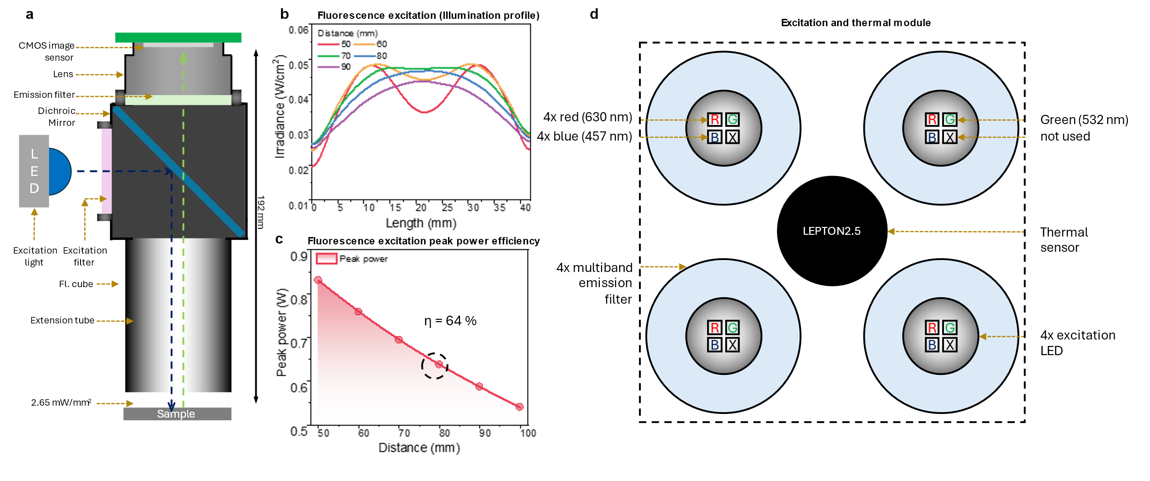

Fig. s1. Fluorescence measurement and characterization a. The conventional fluorescence cube-based fluorescence intensity measurement setup was prepared with equivalent excitation power and equal optical path length of 192 mm and excitation light intensity as in idream-qPCR. b. The simulation result of the light profile achieved at various heights of excitation light from the PCR chip using Zemax Optic Studio with the distances between the light source and PCR Chip from 50 to 90 mm. At the distance of 80 mm, the excitation light density resulted in a plateau shape over the PCR chip without an intensity depth at the center c. The efficiency of the coupled light energy when excited from various distances, at 80 mm 64 % light energy was coupled. d. The excitation and thermal module was installed in the idream-qPCR device for the non-contact thermal measurement from above the PCR chip and excitation of fluorescence using multi-wavelength LED and multiband optical filter.

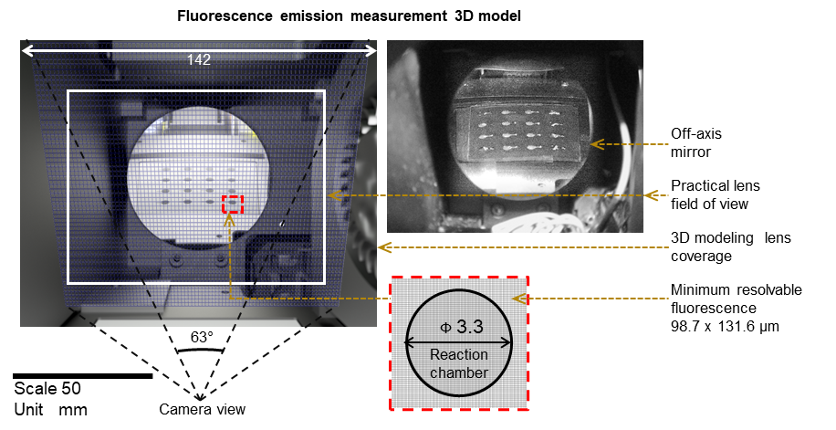

Fig. s2. (left) 3D model of the off-axis mirror, the reflected PCR visible from the camera field of view of 63 mm and 6 mm focal length. (right) The real image was captured using an idream-qPCR device. From the model, we calculated the minimum resolvable fluorescence intensity. We determined the emitted fluorescence image captured by the 6 mm lens with a 63° field of view (FoV) via the simulation and mapped it with the real image, determining the area covered by each pixel of the CMOS image sensor at the focal distance of the PCR chip. Next, we divided the images into each pixel, which resulted in a coverage of 98.7 × 131.6 µm by each pixel of the CMOS image sensor.

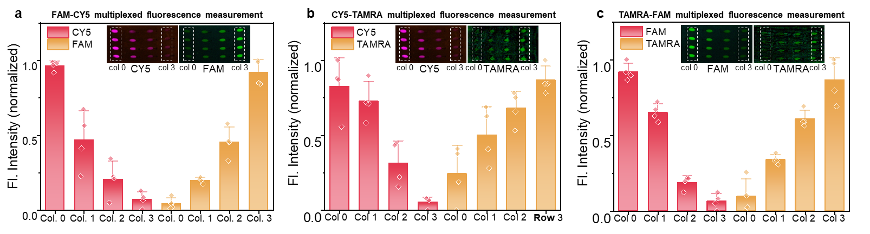

Fig. s3. Multiplexed fluorescence measurement and characterization a. CY5 and FAM were pre-mixed with the concentration pair of (10, 1.25), (5, 2.5), (2.5, 5) and (1.25, 10) µM and loaded in the 4 columns each with three reaction chambers. b. and c. Similar experiments were repeated for CY5, TAMRA, and FAM, TAMRA pair.

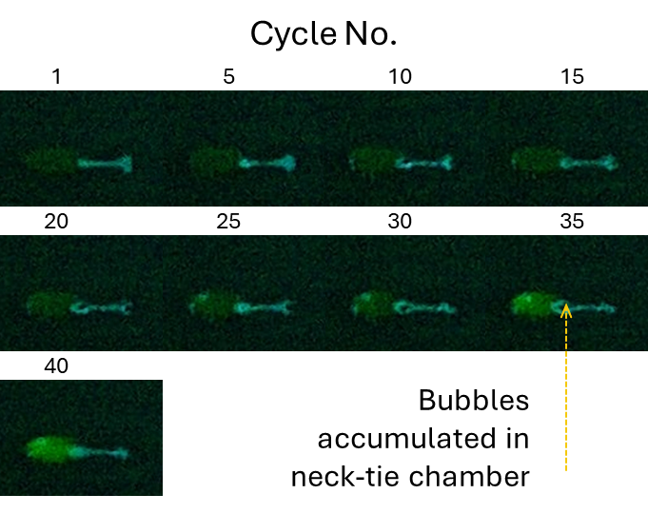

Fig. s4. Images captured at the interval of every 4 cycles during PCR thermal cycles show the accumulation of the evaporated bubbles in the neck-tie chambers.

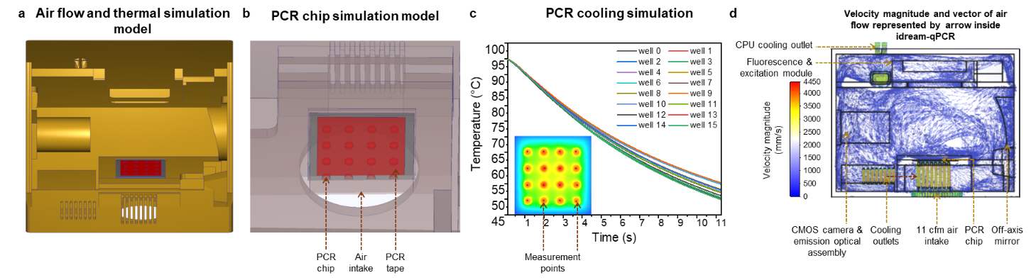

Fig. s5. Simulation of the thermal cycle (cooling). a. An equivalent model of the idream-qPCR device was designed in Inventor, and Autodesk CFD was used for the thermal simulation. b. The PCR chip was also designed for simulation with lamination film and 5.5 µL water in the reaction chamber. Round wells were designed for the simulation. c. The cooling simulation shows that with a fan of 1100 cfm, all mini-wells cooled from 95 °C temperature with a difference of approximately 1 s (practically ~2 s). d. Shows the velocity magnitude and vector diagram of airflow inside the device, which assisted in uniformly cooling the PCR chip and regulating the temperature of the device.

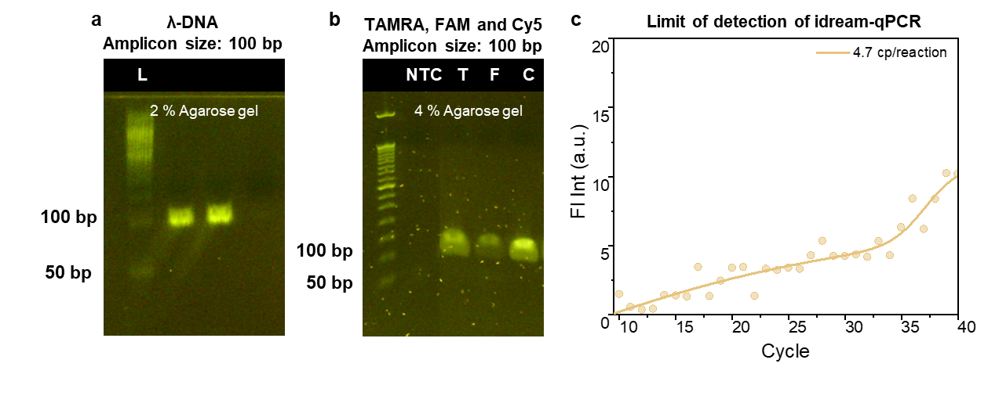
Fig. s6. Gel electrophoresis image of the amplified target. a. λ DNA of 100bp target was amplified using SYBR green dye b. followed by TAMRA, CY5, and FAM channels using λ-DNA of 100bp. c. The raw amplification plot of 4.7 copies/reaction is the limit of detection of idream-qPCR.

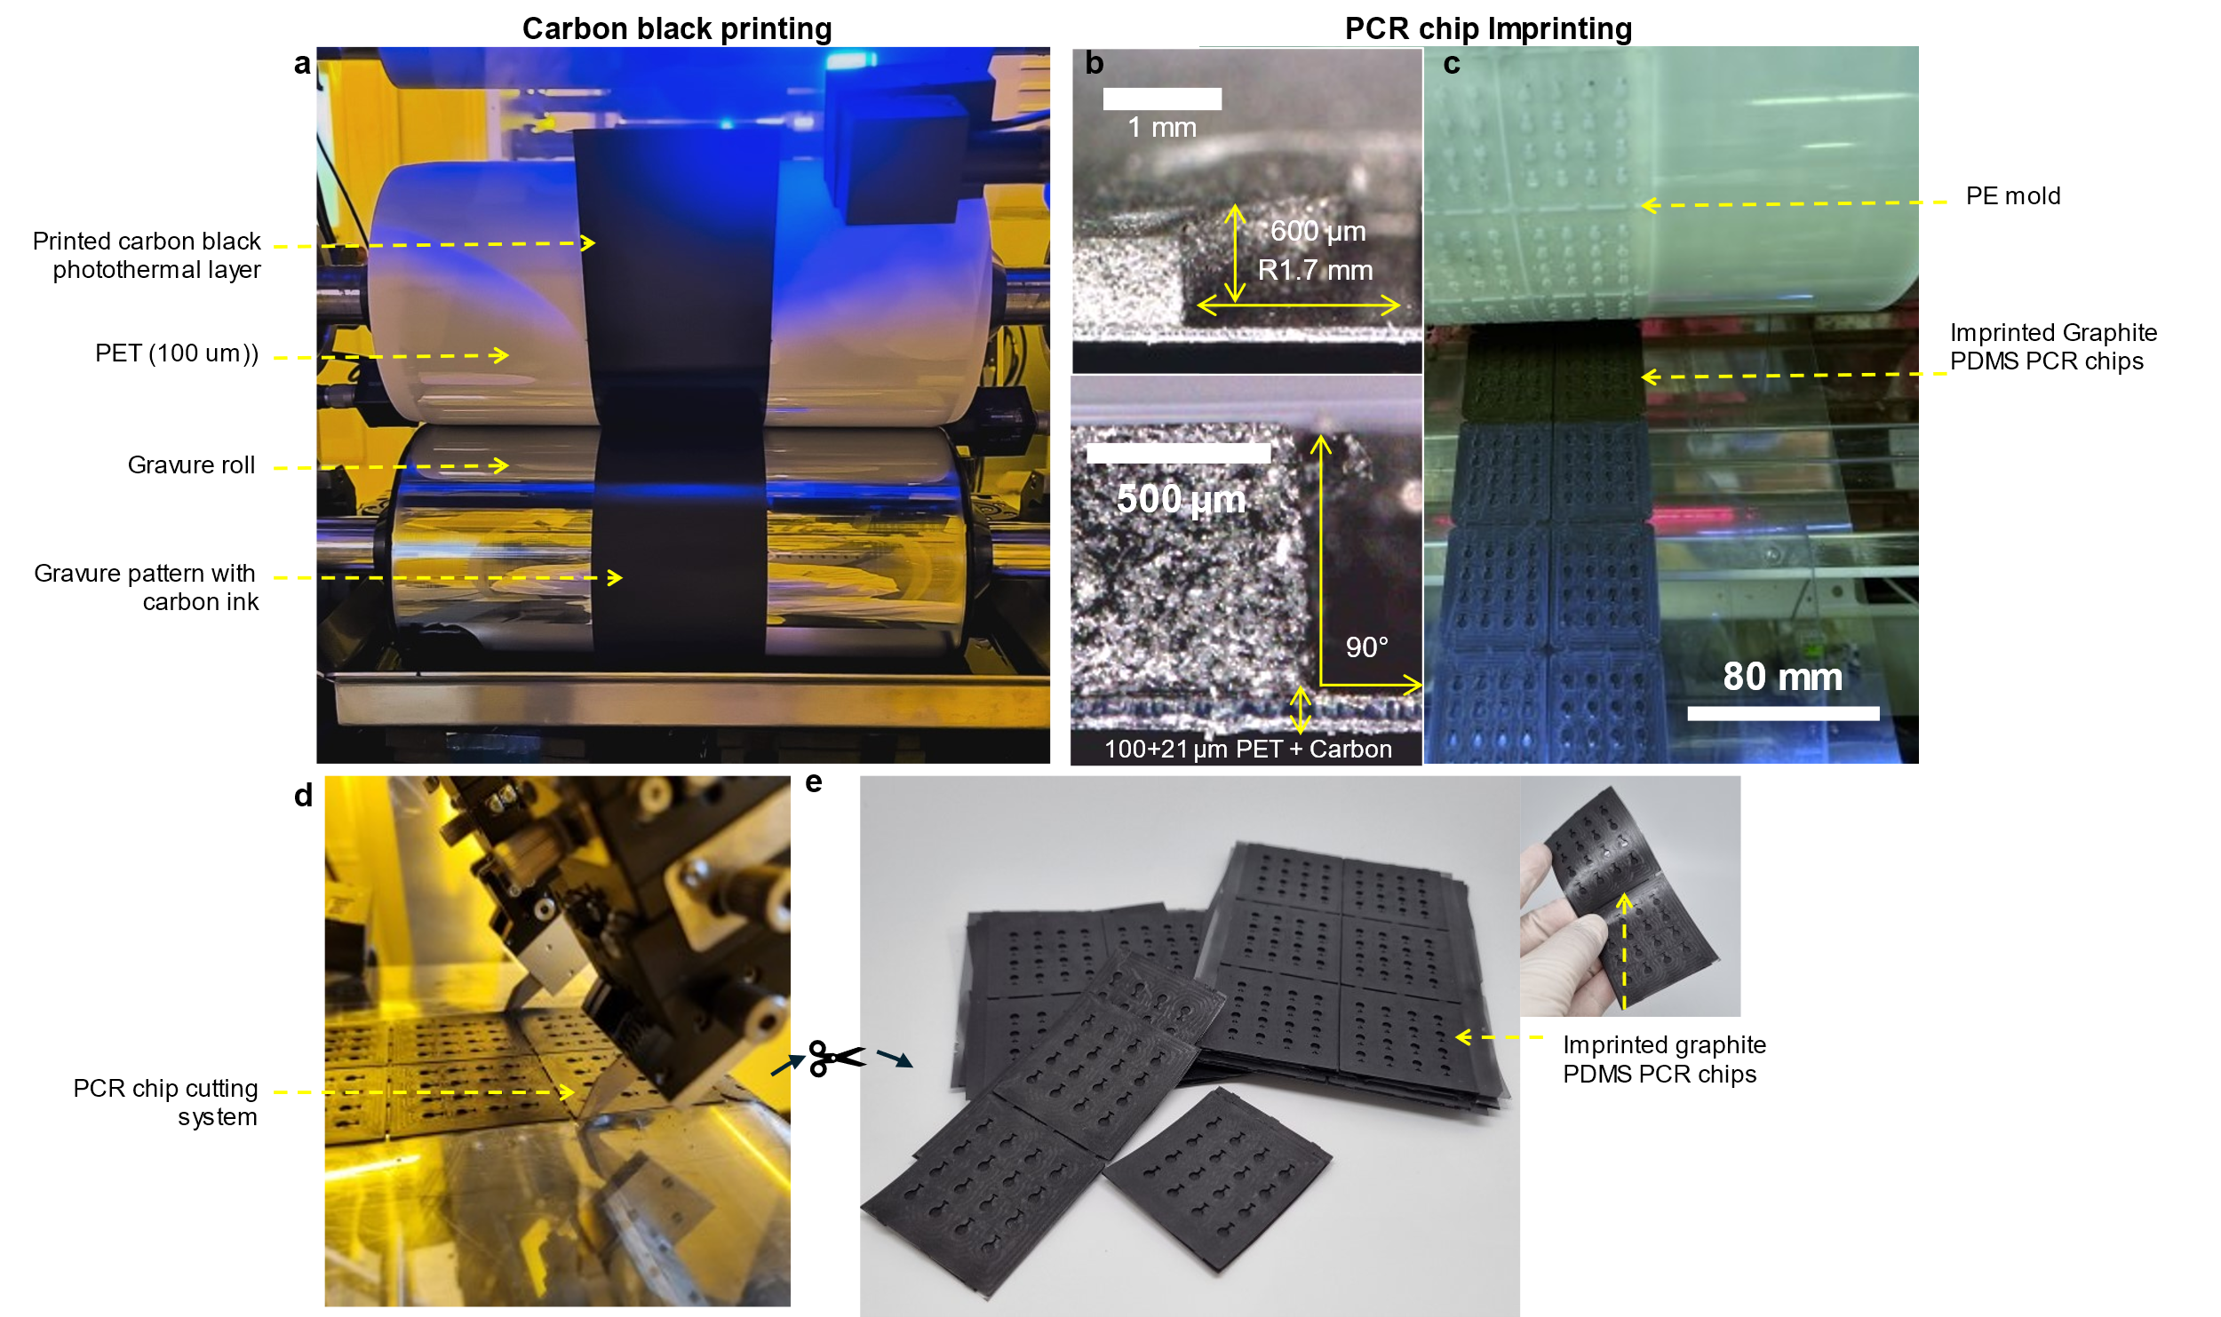

Fig. s7. PCR chip fabrication using R2R printing and imprinting. a. Carbon-black photothermal layer printing using R2R gravure printing on PET film. b. Cross-section view of the imprinted PCR chip using graphite PDMS. c. R2R imprinting method using a polyethylene-based mold to imprint PCR chip on carbon-black layer. d. The two columns of imprinted chips are cut using an inline cutter during imprinting. e. The flexible PCR chips are further cut into a single unit using scissors manually.

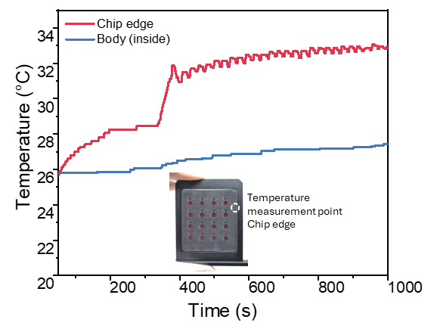
Fig. s8. Temperature of the PCR chip and inside of the PCR device during isothermal stage and photothermal cycling. The temperature at the edge of the PCR chip reached up from ~25 °C to ~32 °C while the inner body temperature slightly increased to ~27 °C.

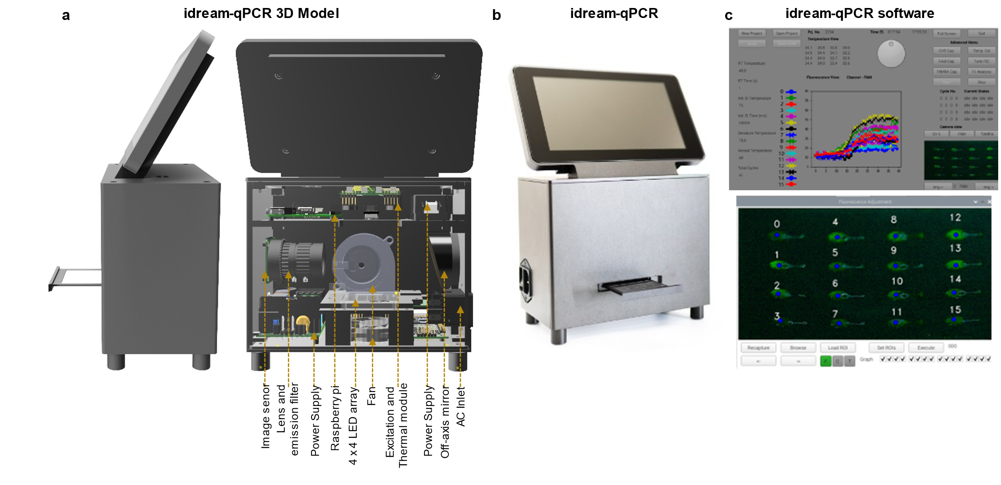

Fig. s9. 3D design model and real idream-qPCR. a. Right side perspective view of idream-qPCR and perspective back-view showing major parts. b. An image of idream-qPCR with PCR chip installed in the cartridge. c. Main user interface and fluorescence analysis window of the software. We developed interactive software for user interfaces to adjust temperature, time, and cycle number. Furthermore, the interface allows users to view and change those parameters during PCR reactions and save them as recipes for future retrieval. Before the qPCR, region-of-interests were selected from a camera preview that locates the physical position of the reaction mini-wells for real-time fluorescence intensities measurement of all chambers. During the qPCR, information such as real-time temperatures, amplification curves, state of the reaction, and fluorescence images of all reaction mini-wells are displayed.

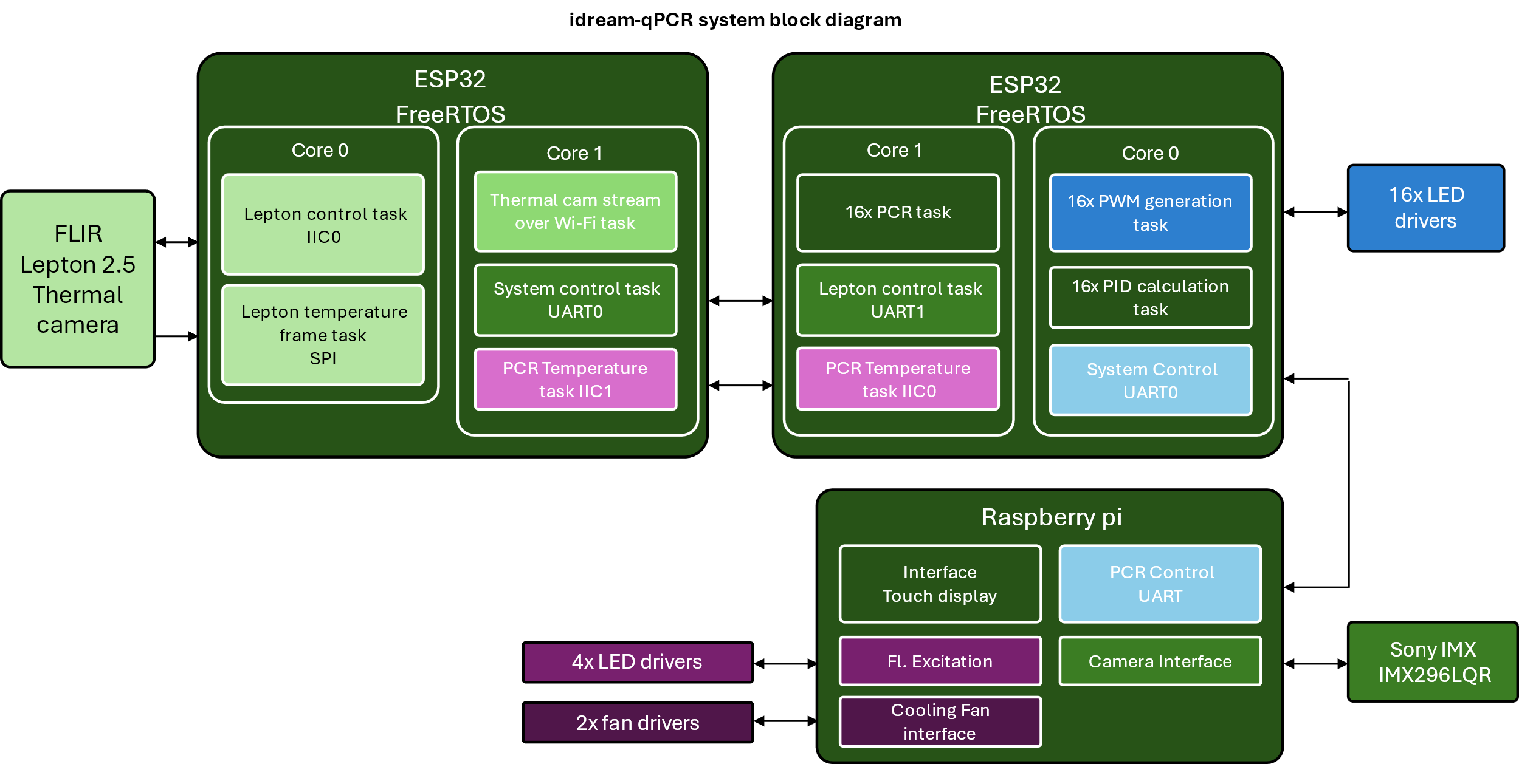

Fig. s10. The logical block diagram of the idream-qPCR device showing the connection of major electronic components and their firmware/software development. The software was developed using Python, and the firmware was developed using C and C++.

Table s1. PCR and RT-PCR primers and probes for Lambda DNA, and SARS-CoV-2 (N1, E and RdRP genes) detection as recommended by the CDC.
Target | Specification | Oligonucleotide sequence (5' to 3') | Fluorophore | Amplicon size (bp)
λ-DNA | Forward primer | GTT CTG AGG TCA TTA CTG GAT C | SYBR green | 100
 | Reverse primer | TAC GCT CCT GTC CGG CAA A
SARS-CoV-2 | N1 gene forward primer | GAC CCC AAA ATC AGC GAA AT |  | 72
 | N1 gene reverse primer | TCT GGT TAC TGC CAG TTG AAT CTG
 | N1 gene probe | [FAM]ACC CCG CAT TAC GTT TGG TGG ACC[BHQ1] | FAM
SARS-CoV-2 | E gene forward primer | ACA GGT ACG TTA ATA GTT AAT AGC GT |  | 100
 | E gene reverse primer | ATA TTG CAG CAG TAC GCA CAC A
 | E gene probe | [CY5]ACA CTA GCC ATC CTT ACT GCG CTT CG[BHQ2] | CY5
SARS-CoV-2 | RdRP gene forward primer | GTG AAA TGG TCA TGT GTG GCG G |  | 113
 | RdRP gene reverse primer | CAA ATG TTA AAA ACA CTA TTA GCA TA
 | RdRP gene probe | [TAMRA]CAG GTG GAA CCT CAT CAG GAG ATG C[BHQ2] | TAMRA

Table s2. The parts required for of idream-qPCR system.
Function | Major Parts/Function | Model | Supplier | Quantity | Cost  (USD)
Thermal controller | Temperature sensor | Lepton 2.5 | FLIR | 1 | $109
Thermal controller | Microcontroller | ESP32-WROOM-32 | Espressif | 2 | $10
Thermal controller | Thermal LED | LZ4-00R708-0000 | Osram | 16 | $174
Thermal controller | Power Supply | TPP 180A-M | Traco Power | 1 | $108
User Interface | Microprocessor | Raspberry Pi 3 Model A+ SC0130(J) | Raspberry Pi | 1 | $25
User Interface | Touch display | SC1227 | Raspberry Pi | 1 | $60
User Interface | Power Supply | TPP 15-105-J | Traco Power | 1 | $40
Fluorescence measurement | Emission Filter | 89402m | Chroma | 1 | $600
Fluorescence measurement | Excitation Filter | 89402x | Chroma | 4 | $2400
Fluorescence measurement | Off-axis mirror | 50.8 × 136.1 mm EFL 30° #35-609 | Edmund Optics | 1 | $499
Fluorescence measurement | Excitation LED | LZ4-00MA00 | Osram | 4 | $32
Fluorescence measurement | Image sensor / Interface | Sony IMX296LQR-C / SC0715 (IR filter removed) | Sony / Raspberry Pi | 1 | $50
Fluorescence measurement | Lens | SC0124 | Raspberry Pi | 1 | $25
Circuits and Mechanical structure | PCB, Casing and cartridge | Custom aluminum milling | PCBWay | - | $1000
 |  |  | Fl. Optics total |  | $3499
 |  |  | Single unit device total |  | $5123
Table s3. Comparison of idream-qPCR with recently published miniature PCR systems.
Year | Thermal cycler | Heating rate / Cooling rate (°Cs⁻¹) | Time (total min)  / Cycle | Sample No.  /  Volume (µL) | Fl. Channel | Sensitivity | Power (Peak heating only) | Targets | Ref.
2021 | Peltier | 2.8  -2.5 | 18  /  40 | 1  /  70 | 1 | 26 copies /70 µL | - | Influenza A (H1N1) | ¹
2018 | Peltier | 3  - | 60  /  45 | 1  /  10 | 2 | 45 copies /10 µL | - | Hepatitis C | ²
2022 | Volumetric Photothermal | 6.7  -4.7 | 22  /  45 | 1  /  10 | 3 | 2.2 copies /1 µL | - | SARS-CoV-2 N1, N2 | ³
2020 | Volumetric Photothermal | 13.2  -4.5 | 17  /  40 | 3  /  10 | 1 | 3.2 copies /1 µL | 1.12 W (optical) | SARS-CoV-2 N1, N2, RPP30 | ⁴
2023 | Surface Photothermal | 22  -2.6 | 14  /  40 | 4  /  1 | 1 | 19 copies /  1 µL | 8 * 4 W (electrical) | SARS-CoV-2 N1 | ⁵
2023 | Surface Photothermal | 18.9  -8.9 | 10  /  40 | 1  /  2 | 1 | 20 copies / 2 µL | 8.4 W (electrical) | SARS-CoV-2 E | ⁶
This work | Surface Photothermal | 5.8  2.2 | 17  /  40 | 16  /  5.5 | 3 | 4.7 copies /5.5 µL | 5.5 * 16 W  (electrical) | SARS-CoV-2 E, N1, RdRp

Table s4. Comparison of idream-qPCR to commercially available miniaturized PCR systems.
Product | Company | PCR type | Fl. Channels | Time (min) | Sample No. | Power | Ref.
Q-POC | QuantuMDx | Qualitative | 6 | 30 | 1 | < 90 W | ⁷
LOAA Analyzer  On-Point | Optolane | Quantitative | 2 | 30 | 4 | < 90 W | ⁸
Cobas liat | Roche | Quantitative | 1 | 20 | 1 | < 130 W | ⁹
This work | - | Quantitative | 3 | 17 | 16 | < 108 W

Note s1. Instrumentation of thermal cycler
To measure the temperature, we used a Lepton 2.5 radiometric sensor with a FoV 55° × 60° and a resolution of 60 × 80 pixels, which resolved the temperature of area 0.064 mm² of the PCR chip. An ESP32 microcontroller was used to interface with the sensor to collect the 14-bit temperature and stream the data at 26 Hz via a serial peripheral interface data bus. However, the sensor’s actual temperature measurement rate was 8.7 Hz because the three frames were repeated in the data stream. For data collection, visualization, and debugging, the thermal images were streamed over Wi-Fi at 8-bit resolution.
To control the temperature profiles of all RT-qPCRs, we used a real-time operating system (free RTOS) to implement task scheduling for all software-based PID control systems. After adjusting the P, I, and D values for all control systems, they were saved in the chip’s flash memory, which was retrieved during the boot along with other information, such as the temperature sensors’ pixel location of reaction chambers.

References
1. Seder, I. et al. Fluidic handling system for PCR-based sample-to-answer detection of viral nucleic acids. Sensors Actuators B Chem. 349, 130788 (2021).
2. Shin, D. J., Trick, A. Y., Hsieh, Y.-H., Thomas, D. L. & Wang, T.-H. Sample-to-Answer Droplet Magnetofluidic Platform for Point-of-Care Hepatitis C Viral Load Quantitation. Sci. Rep. 8, 9793 (2018).
3. Blumenfeld, N. R. et al. Multiplexed reverse-transcriptase quantitative polymerase chain reaction using plasmonic nanoparticles for point-of-care COVID-19 diagnosis. Nat. Nanotechnol. 17, 984–992 (2022).
4. Cheong, J. et al. Fast detection of SARS-CoV-2 RNA via the integration of plasmonic thermocycling and fluorescence detection in a portable device. Nat. Biomed. Eng. 4, 1159–1167 (2020).
5. Shrestha, K. et al. Mobile Efficient Diagnostics of Infectious Diseases via On‐Chip RT‐qPCR: MEDIC‐PCR. Adv. Sci. (2023) doi:10.1002/advs.202302072.
6. Kang, B.-H. et al. Ultrafast Plasmonic Nucleic Acid Amplification and Real-Time Quantification for Decentralized Molecular Diagnostics. ACS Nano 17, 6507–6518 (2023).
7. QuantuMDx - Multiplex PCR solutions for the Point of Need. https://www.quantumdx.com/.
8. Products - OPTOLANE - Technologies Inc. https://optolane.com/analyzer/.
9. cobas® liat system. https://diagnostics.roche.com/global/en/products/instruments/cobas-liat-ins-6050.html.

