Supporting information
Note SN1
Under 40% uniaxial tensile strain, the strain distributions of epidermal electrodes with various geometries are illustrated in Figure 1A. As summarized in Table S1, the serpentine island-bridge configuration demonstrates exceptional mechanical compliance and deformability, underscoring its strong potential for use in flexible and stretchable electronic applications.
In this study, Abaqus finite element simulation software was employed to systematically optimize the geometric parameters of flexible epidermal electrodes subjected to displacement loading. The strain distribution across the electrode structure was meticulously analyzed to evaluate its mechanical performance under deformation. Given the heterogeneous material composition of the electrodes, traditional failure criteria were deemed insufficient, necessitating a redefinition. The gold (Au) layer, characterized by a fracture strain of 1%, is significantly more susceptible to rupture compared to the polyimide (PI) substrate, which exhibits a considerably higher fracture strain of 50%. Consequently, a 1% fracture strain threshold was established as the failure criterion for the electrode. To address the computational complexity associated with analyzing the repetitive serpentine array structure, a modular simplification strategy was adopted. A three-dimensional shell model was developed within Abaqus, where the U1, U2, and U3 axes corresponded to the X, Y, and Z directions, respectively. Material properties for PI, Au, and Ti layers were modeled using elastoplastic parameters, and S4R quadrilateral shell elements were employed for mesh generation. Additionally, geometric nonlinearity was activated, with the time parameter set to 0.1. A parametric study was conducted by varying the periodic length of the serpentine structure from 0.9 mm to 1.7 mm under identical uniaxial tensile displacement conditions (Figure S1A). The results, summarized in Table S2, revealed a positive correlation between periodic length and tensile strain, indicating enhanced stretchability with increased periodicity. However, it was also observed that excessive periodic length leads to a reduction in effective contact area, thereby compromising interface performance. Based on these findings, a periodic length of 1.1 mm was identified as the optimal design parameter, effectively balancing mechanical stretchability and contact efficiency for the flexible epidermal electrode system.
With a fixed periodic length, the epidermal electrodes were designed with varying line widths, ranging from 0.06 mm to 0.2 mm (Figure S1B). The modeling parameters and simulation conditions were consistent with the previously described setup. Simulation results revealed that under a 40% uniaxial tensile displacement, a decrease in line width led to a reduction in maximum principal strain (Table S3). However, excessively reducing the line width increases fabrication complexity and challenges precision manufacturing. To achieve an optimal balance between mechanical stretchability and effective skin contact area, a line width of 0.1 mm was identified as the most suitable design parameter for the serpentine structure.
To further investigate the stretching performance of epidermal electrodes, this study analyzed the effect of PI film thickness, ranging from 0.005 mm to 0.03 mm (Figure S1C). Consistent modeling methods and parameters from previous analyses ensured result comparability. Simulation results showed that under a 20% uniaxial tensile strain, increasing PI thickness led to a rise in maximum principal strain (Table S4). According to mechanical principles, electrode flexibility is inversely related to its thickness. Thinner electrodes exhibit higher strain capacity and better conformal contact with the skin. In this work, 5-μm-thick PI film was selected due to its lower cost, enhanced flexibility, and superior stretchability, allowing for close skin adherence and accurate signal acquisition during deformation.
Figure S1. Design and Fabrication of Epidermal Electrodes. (A-C) Finite element analysis maps of epidermal electrodes under different stretching conditions: period, line width, and film thickness.

Figure S2. ECG monitoring under different conditions. (A) ECG of the mouse continuously monitored for 30 minutes; (B) ECG signals of mice during resting and walking states.

Figure S3. ECG signal changes before electrode trimming and during surgery. (A) ECG signals before and after trimming the epidermal electrodes; (B) Changes in the mouse's ECG during heart removal surgery.

Table S1 Effect of different geometry on stretchability of epidermal electrodes
Geometry | Material properties  Elastic modulus (MPa)  Poisson's ratio | Mesh structure | Tensile  conditions | Maximum principal strain | Time parameter
Z Type | Au 79500 0.42  PI 2760 0.407 | S4R  (Quadrilateral  shell element) | Uniaxial stretching 40% | 0.022 | 0.1
W Type | Au 79500 0.42  PI 2760 0.407 | S4R  (Quadrilateral  shell element) | Uniaxial stretching 40% | 0.098 | 0.1
Serpentine Type | Au 79500 0.42  PI 2760 0.407 | S4R  (Quadrilateral  shell element) | Uniaxial stretching 40% | 0.012 | 0.1
Serpentine Island | Au 79500 0.42  PI 2760 0.407 | S4R  (Quadrilateral  shell element) | Uniaxial stretching 40% | 0.017 | 0.1
Bridge Type | Au 79500 0.42  PI 2760 0.407 | S4R  (Quadrilateral  shell element) | Uniaxial stretching 40% | 0.011 | 0.1

Table S2 Effect of different cycle length on stretchability of epidermal electrodes
Cycle Length  (mm) | Material properties  Elastic modulus (MPa)  Poisson's ratio | Mesh structure | Tensile  conditions | Maximum principal strain | Time parameter
0.9 | Au 79500 0.42  PI 2760 0.407 | S4R  (Quadrilateral  shell element) | 40%  (0.54) | 0.039 | 0.1
1.1 | Au 79500 0.42  PI 2760 0.407 | S4R  (Quadrilateral  shell element) | 40%  (0.66) | 0.001 | 0.1
1.3 | Au 79500 0.42  PI 2760 0.407 | S4R  (Quadrilateral  shell element) | 40%  (0.78) | 0.00034 | 0.1
1.5 | Au 79500 0.42  PI 2760 0.407 | S4R  (Quadrilateral  shell element) | 40%  (0.9) | 0.0003 | 0.1
1.7 | Au 79500 0.42  PI 2760 0.407 | S4R  (Quadrilateral  shell element) | 40%  (1.02) | 0.00029 | 0.1

Table S3 Effect of different line width on stretchability of epidermal electrodes
Line Width  (mm) | Material properties  Elastic modulus (MPa)  Poisson's ratio | Mesh structure | Tensile  conditions | Maximum principal strain | Time parameter
0.06 | Au 79500 0.42  PI 2760 0.407 | S4R  (Quadrilateral  shell element) | 40%  (0.65) | 0.00018 | 0.1
0.08 | Au 79500 0.42  PI 2760 0.407 | S4R  (Quadrilateral  shell element) | 40%  (0.66) | 0.00018 | 0.1
0.1 | Au 79500 0.42  PI 2760 0.407 | S4R  (Quadrilateral  shell element) | 40%  (0.69) | 0.00076 | 0.1
0.15 | Au 79500 0.42  PI 2760 0.407 | S4R  (Quadrilateral  shell element) | 40%  (0.72) | 0.052 | 0.1
0.2 | Au 79500 0.42  PI 2760 0.407 | S4R  (Quadrilateral  shell element) | 40%  (0.75) | 0.069 | 0.1

Table S4 Effect of different film thickness on stretchability of epidermal electrodes
Film Thickness  (μm) | Material properties  Elastic modulus (MPa)  Poisson's ratio | Mesh structure | Tensile  conditions | Maximum principal strain | Time parameter
5 | Au 79500 0.42  PI 2760 0.407 | S4R  (Quadrilateral  shell element) | 20%  (0.66) | 0.00025 | 0.1
10 | Au 79500 0.42  PI 2760 0.407 | S4R  (Quadrilateral  shell element) | 20%  (0.66) | 0.00031 | 0.1
15 | Au 79500 0.42  PI 2760 0.407 | S4R  (Quadrilateral  shell element) | 20%  (0.66) | 0.00035 | 0.1
20 | Au 79500 0.42  PI 2760 0.407 | S4R  (Quadrilateral  shell element) | 20%  (0.66) | 0.0004 | 0.1
30 | Au 79500 0.42  PI 2760 0.407 | S4R  (Quadrilateral  shell element) | 20%  (0.66) | 0.00044 | 0.1

Table S5 Comparison of electrodes for ECG sensors
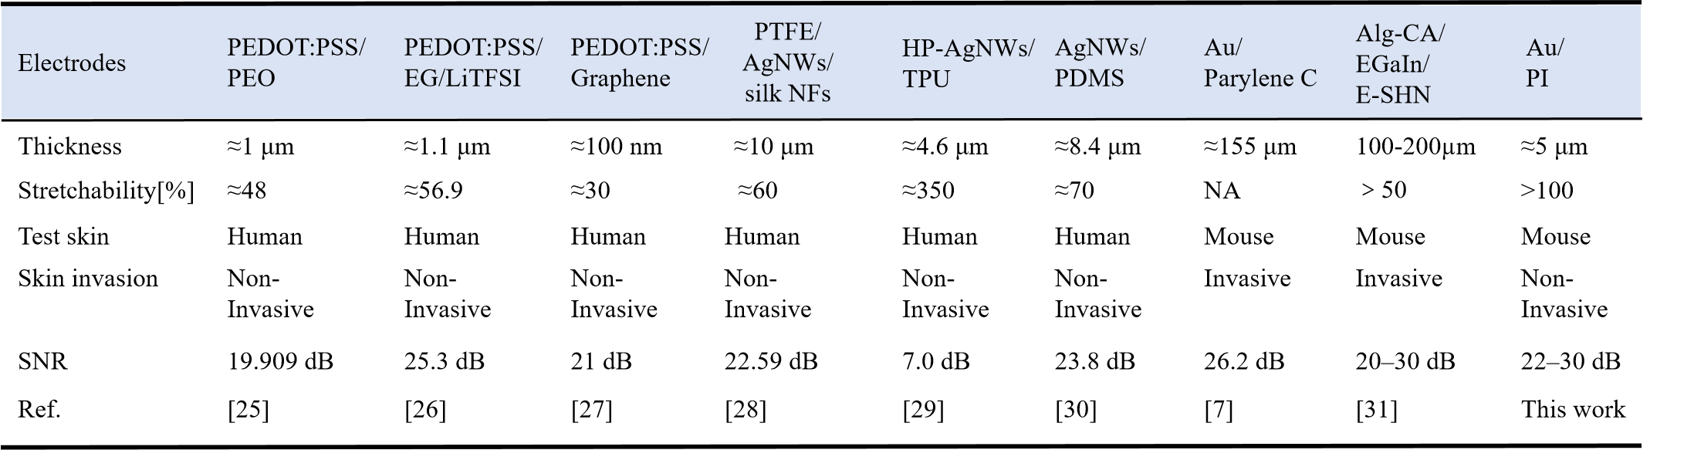
Table S6 Comparison of ECG monitoring devices
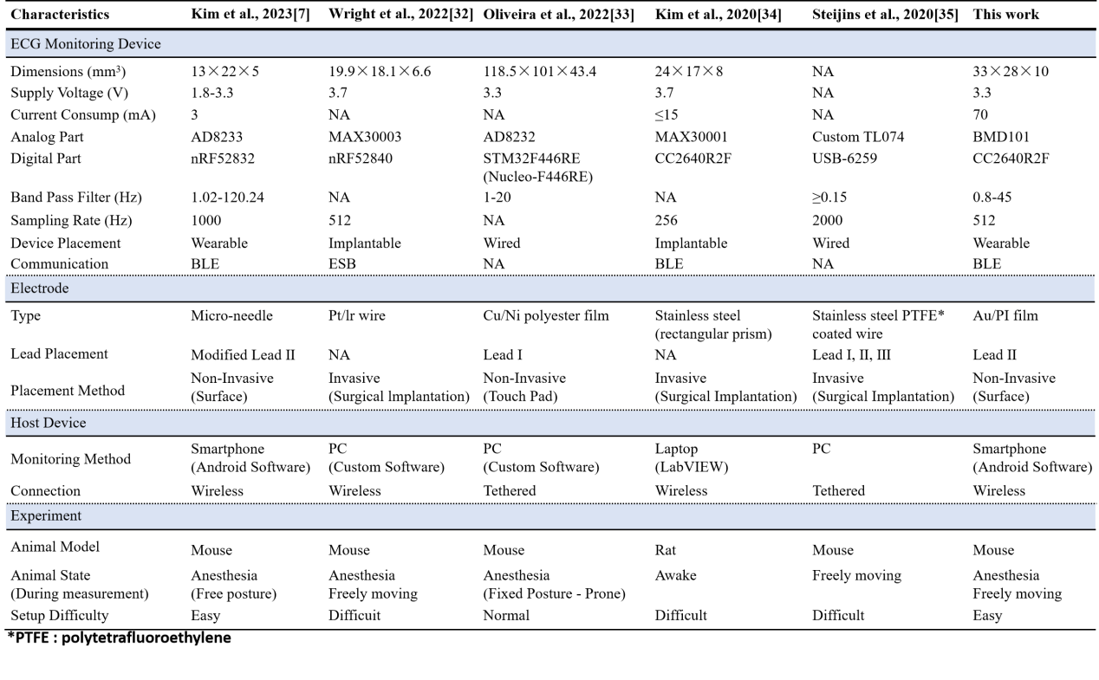

25 Li, G. et al. Substrate-free ultra-thin epidermal bioelectrodes with enhanced conformality and breathability for long-term physiological monitoring. Science China Materials 67, 1481-1490 (2024).
26 Wei, B. et al. Ultraflexible tattoo electrodes for epidermal and in vivo electrophysiological recording. Cell Reports Physical Science 4 (2023).
27 Zhao, Y. et al. Ultra-conformal skin electrodes with synergistically enhanced conductivity for long-time and low-motion artifact epidermal electrophysiology. Nature Communications 12, 4880 (2021).
28 Yan, X. et al. Highly breathable, surface-hydrophobic and wet-adhesive silk based epidermal electrode for long-term electrophysiological monitoring. Composites Science and Technology 230, 109751 (2022).
29 Zhou, W. et al. Gas-permeable, ultrathin, stretchable epidermal electronics with porous electrodes. ACS nano 14, 5798-5805 (2020).
30 Fang, Y. et al. Cryo‐Transferred Ultrathin and Stretchable Epidermal Electrodes. Small 16, 2000450 (2020).
31 Choi, H. et al. Adhesive bioelectronics for sutureless epicardial interfacing. Nature Electronics 6, 779-789 (2023).
32 Wright, J. P. et al. A fully implantable wireless bidirectional neuromodulation system for mice. Biosensors and Bioelectronics 200, 113886 (2022).
33 Oliveira, R. G. et al. Development of a new integrated system for vital sign monitoring in small animals. Sensors 22, 4264 (2022).
34 Kim, J. et al. A wireless power transfer based implantable ECG monitoring device. Energies 13, 905 (2020).
35 Steijns, F. et al. Ambulatory electrocardiographic monitoring and ectopic beat detection in conscious mice. Sensors 20, 3867 (2020).

