Supporting Information

Dean Migration Mechanisms: Facilitating the Control of microbial Contaminants in Cell Therapy Product Manufacturing
Junhao Tan^{1,2}, Jianbo Yang², Junjie Huang², Ziming Huang², Liang Xu², Weizhao Yao^{1,2}, Chengshun Shen^{1,2}, Ming Zhao^{2*}, Luping Zhou^{2*}

¹Medical School, Faculty of Medicine, Tianjin University, 300072, Tianjin, China.
²Hangzhou Institute of Medicine, Chinese Academy of Sciences, Hangzhou, 310022, Zhejiang, China.
*Corresponding author(s). E-mail(s): Zmingys@ucas.ac.cn; zhouluping6060@163.com;

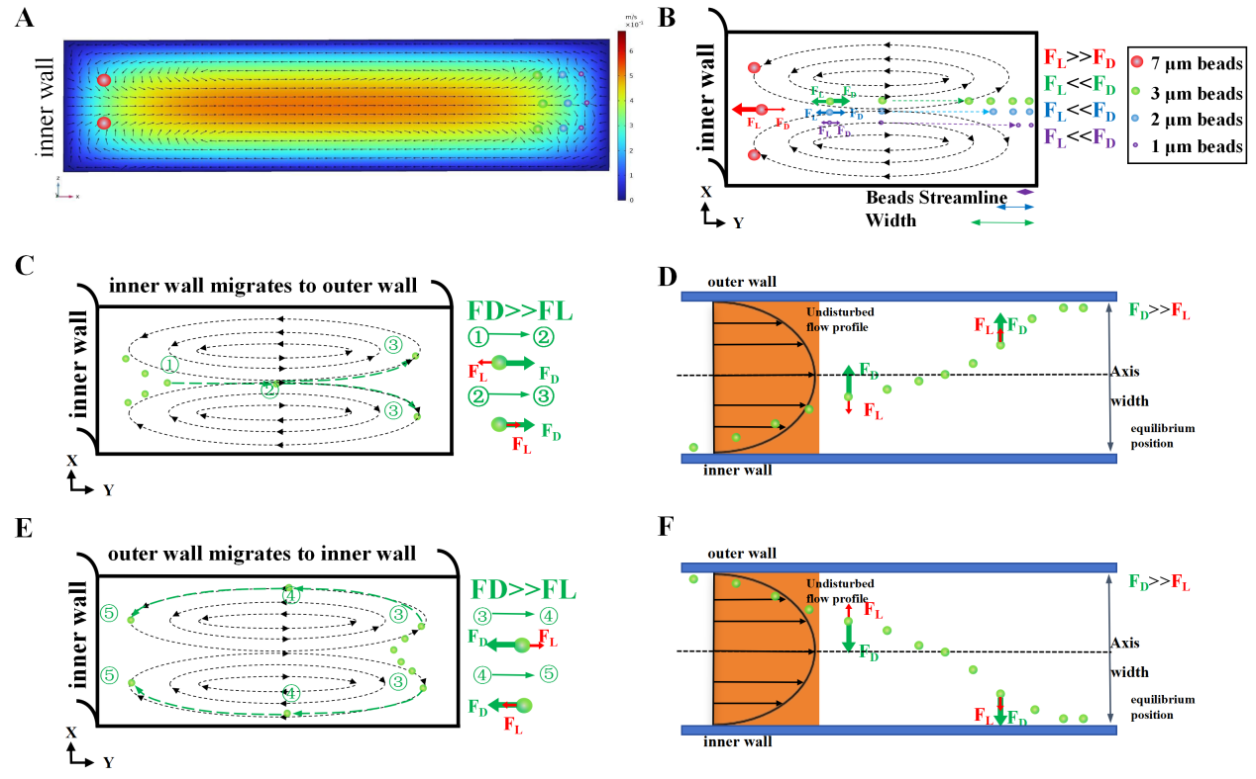
Figure S 1. Two models of Dean migration. (A) Dean flow vortex. Dean vortex for 90 μm height microfluidic channel for comsol fluid simulation, directly derived from comsol original scale. (B) Schematic of microfluidic particle migration cross-section at 90 μm height. (C) Dean migration from the inner to the outer wall (cross-section). (D) Dean migration from the inner to the outer wall (top view). (E) Dean migration from the outer to the inner wall (cross-section). (F) Dean migration from the outer to the inner wall (top view).

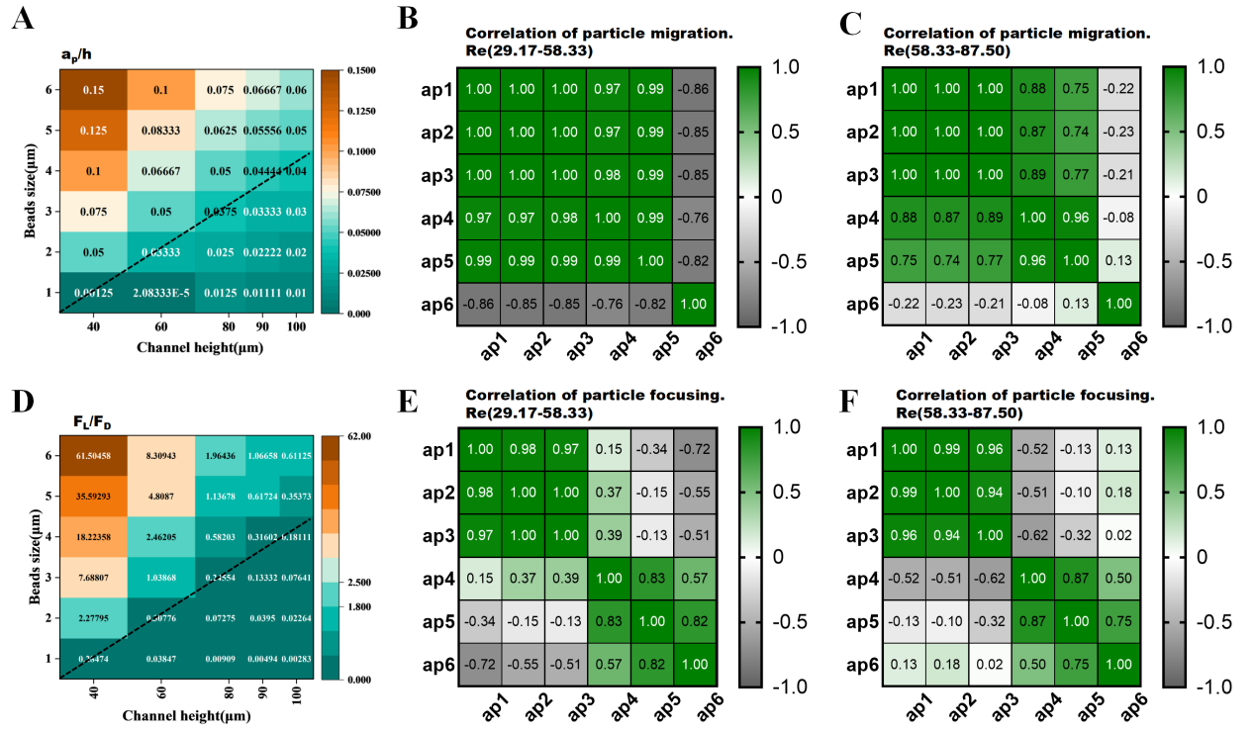
Figure S 2. Relationship between particles under the influence of characteristic length (ap, h; A, D) and flow conditions (Re; BC, EF). (A) Heat map of the ratio of feature lengths (ap/h). (B) Correlation of particle migration Re(29.17-58.33). (C) Correlation of particle migration. Re(58.33-87.50). (D) Heat map of the ratio of inertial force to Dean force (F_{L}/F_{D}). (E) Correlation of particle focusing. Re(29.17-58.33). (F) Correlation of particle focusing. Re(58.33-87.5).

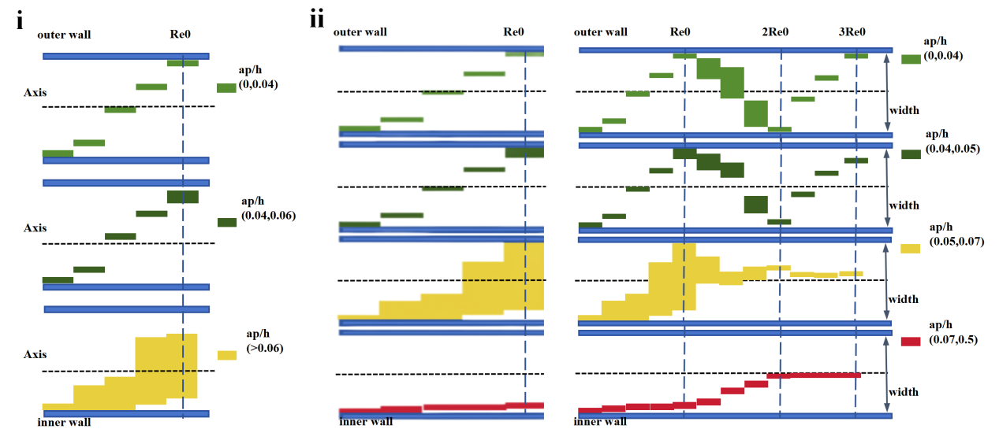
Figure S 3. Migration Patterns of Particles in Spiral Microfluidic.(i) Migration patterns at low Reynolds numbers. Due to the Reynolds number being too low, inertial migration does not occur. (ii) Particle migration patterns at moderate Reynolds numbers. Under moderate Reynolds numbers, both inertial migration and Dean migration occur simultaneously. Furthermore, as the Reynolds number continues to increase, inertial effects become further enhanced.
Dean migration Patterns. A comprehensive understanding and analysis of the forces and motion characteristics of particles of varying sizes within a channel are critical for developing size-based separation methods. This approach not only markedly enhances separation efficiency but also establishes a vital theoretical framework for designing separation devices, particularly in optimizing key parameters such as channel height and Reynolds number.
In this study, particle manipulation based on Dean migration is categorized into two distinct states, determined by the occurrence of inertial focusing. (i) Low Reynolds number condition: Inertial forces acting on particles are insufficient to trigger inertial migration. By deliberately reducing the Reynolds number to suppress inertial effects, only particles with a size ratio a_{p}/h < 0.06 (where a_{p} is the particle diameter and h is the channel height) are governed by Dean forces and undergo Dean migration. (ii) Moderate Reynolds number condition: Inertial migration and Dean migration occur concurrently. Particles meeting the inertial focusing criterion are dominated by inertial forces and concentrate at equilibrium positions. Conversely, particles with a_{p}/h < 0.04 are fully controlled by Dean forces, forming a focused particle stream that displays periodic lateral migration within the channel.
For particles with 0.04 < a_{p}/h < 0.05, although predominantly influenced by Dean forces, the onset of inertial force effects becomes evident. Consequently, while these particles experience Dean migration, their focusing degree deviates significantly from that of particles entirely under Dean force control. Moreover, as the Reynolds number increases, heightened inertial effects cause these particles to be displaced from the channel wall by the wall-induced inertial lift force ( F_{LW}), increasing their separation from the wall.
For particles with 0.05 < a_{p}/h < 0.07, the competitive interplay between inertial and Dean forces results in dispersed, unfocused particle streams within the channel. These intermediate-state particles progressively come under inertial force dominance as the Reynolds number rises, exhibiting migration and focusing behaviors akin to those of inertia-dominated particles.
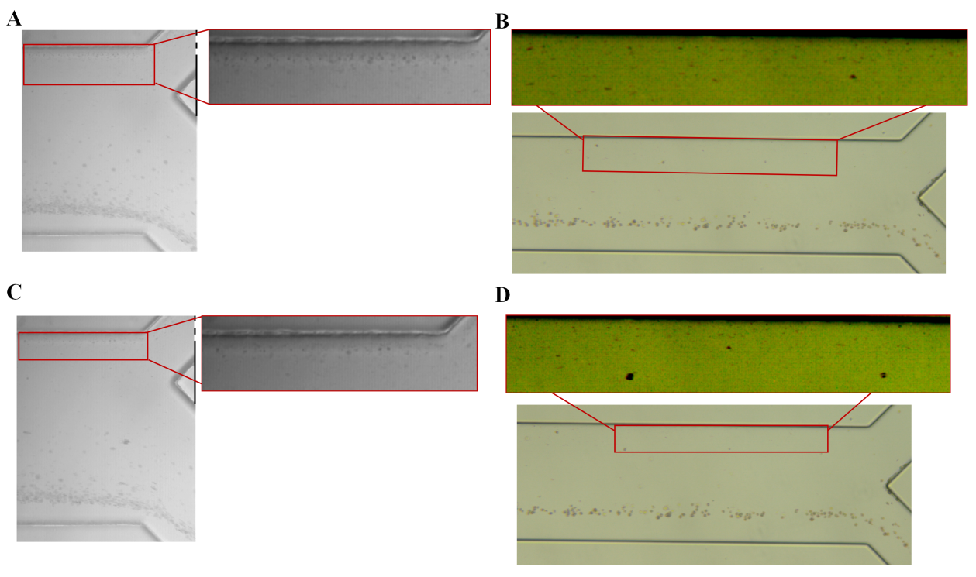
Figure S 4. Recording the continuous separation of biological particles (T cells, bacteria). (A&C) A high-speed camera records the bacterial isolation process. The enlarged view shows the outer wall of the microfluidic channel (outlet2, bacterial outlet). (B&D) Color camera recording the bacteria isolation process. Magnified view shows the outer wall of the microfluidic channel (outlet 2, bacterial outlet)

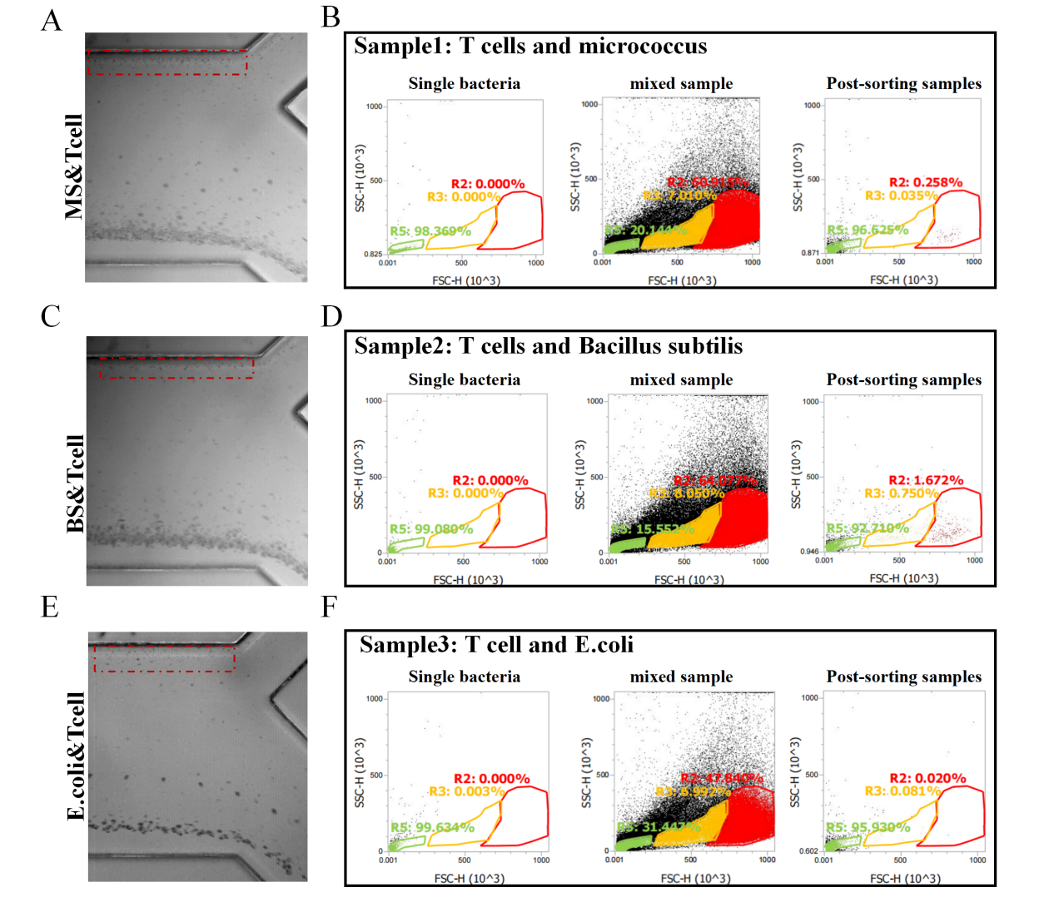
Figure S 5. Bioparticle (Tcell & Bacteria) Separation Process and Characterization Results (Flow Chart). (A) The process of isolation of Micrococcus from T cells. (B) Flow characterization of micrococcus and T cell isolation. (C) The process of isolation of Bacillus subtilis from T cells. (D) Flow characterization of Bacillus subtilis and T cell isolation. (E) The process of isolation of E.coli from T cells. (F)The process of isolation of E.coli from T cells.
To achieve absolute quantitative analysis of particle concentrations with different sizes in separated samples, this study employed an acoustic focusing flow cytometer (Attune NxT, Thermo Fisher Scientific, USA) for detection. This instrument features high-throughput sampling capability and stable flow rate control. By setting a fixed volume (50–200 µL) for sample injection, it enables direct particle counting, thereby eliminating the reliance on standard microsphere calibration typical of traditional flow cytometry and enhancing the repeatability and quantitative precision of the data.
In the detection workflow, individual measurements were first performed on four single components: T cells, Escherichia coli, Micrococcus luteus, and Bacillus subtilis. A basic particle gating strategy was established using forward scatter (FSC, 488 nm) and side scatter (SSC, 405 nm) signals. Subsequently, a mixed cell-bacteria system was analyzed, with dual-channel fluorescence labeling introduced to confirm population specificity: T cells were labeled with CD45-PE (excitation/emission: 565/578 nm), while bacteria were stained with SYTO BC Green nucleic acid fluorescent probe (excitation/emission: 485/530 nm). By combining fluorescence and scatter characteristics, distinct particle populations were effectively discriminated in the FSC/SSC plot, achieving label-free identification in the mixed system.
During data processing, a uniform gating strategy was applied to both original and separated samples to ensure analytical consistency and comparability. Based on FSC signal intensity, detected objects were classified into three subgroups: R2 for live cells, R3 for dead cells, and R5 for bacteria. The SSC parameter, reflecting internal cellular complexity, further supported the gradient distribution identification of these three particle types.
Notably, the bacterial gate signal exhibited interference, primarily from the overlap of cell debris (FSC/SSC ratio: 0.8–1.2) and culture medium particles (FSC/SSC ratio: 1.5–2.0) with true bacterial signals (FSC/SSC ratio: 0.5–0.7), resulting in a misidentification risk of approximately 12% ± 3%. To minimize the influence of non-biological particles, bacteria were specifically labeled with SYTO BC Green fluorescent dye, reducing the false positive rate from non-biological particles to below the detection limit (<0.1%). Fluorescence microscopy was additionally employed to validate the data, ensuring reliability.

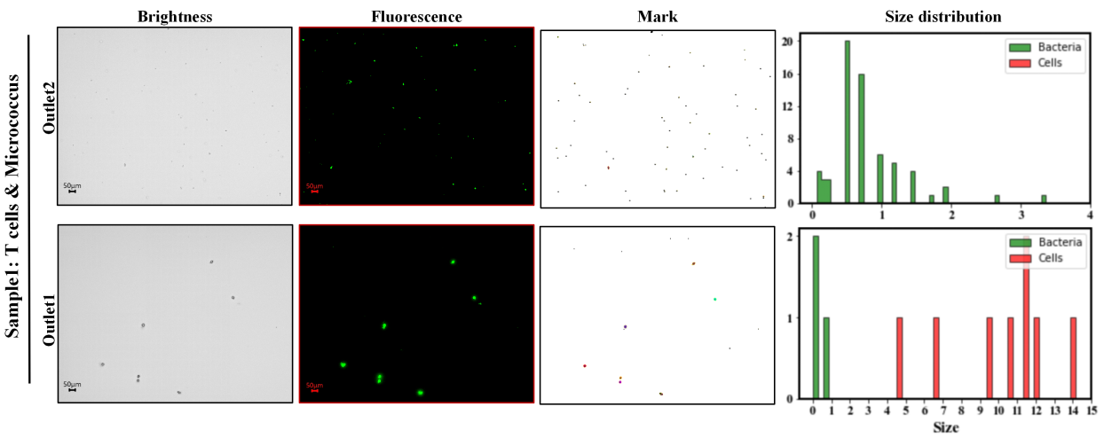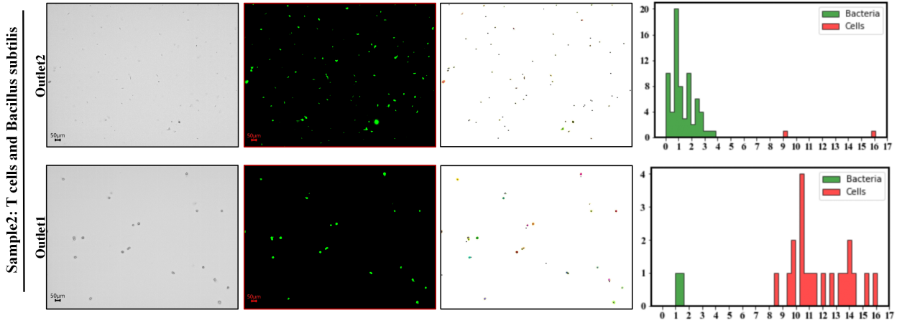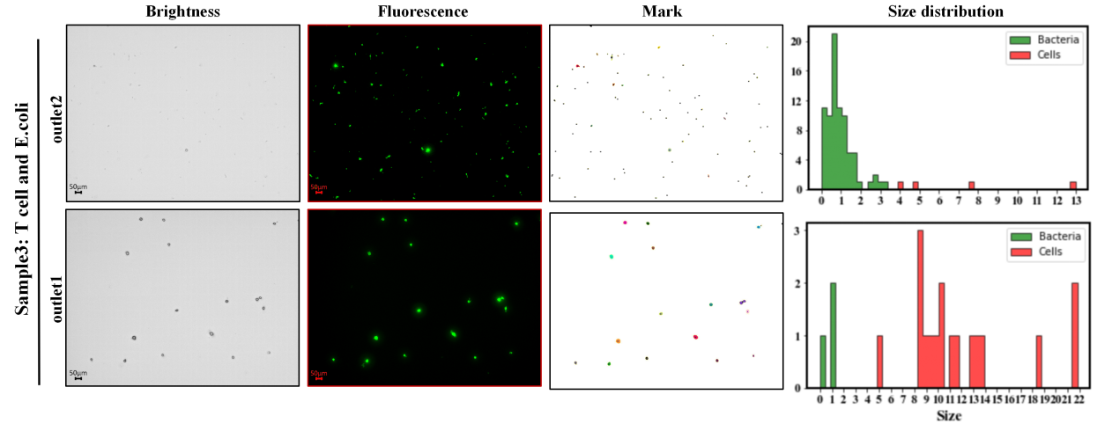
Figure S 6. Fluorescence microscopic analysis of the separation results for biological particles (T cells & bacteria).
To further validate the separation efficiency of T cells and bacteria, the separated samples were prepared as smears and imaged using a fluorescence microscope (Keyence BZ-X800LE, Japan). Observations were conducted with 20× (0.95 NA) and 40× (0.95 NA) objectives, capturing both brightfield and fluorescence darkfield images. The brightfield channel was employed to directly assess the morphological characteristics of T cells and bacteria, while the fluorescence darkfield channel (FITC filter) was used to detect biological particles stained with SYTO9. Post-acquisition, images were processed using ImageJ for particle counting and quantitative analysis of fluorescence signals to evaluate the separation efficiency and distribution of biological particles.
Image Preprocessing. Brightfield images were initially imported into ImageJ via the "File > Open" command. To enhance image quality and facilitate subsequent segmentation, preprocessing steps were executed: background subtraction was performed using "Process > Subtract Background" to correct for uneven illumination, followed by the application of a Gaussian blur filter via "Process > Filters > Gaussian Blur" to reduce high-frequency noise while preserving structural edges. Thresholding was then applied to distinguish foreground from background using the "Default" method in "Image > Adjust > Threshold," ensuring that objects of interest were represented as black pixels against a white background. To this end, the "Black background" option in "Process > Binary > Options" was deselected to correctly interpret the binary image. Morphological operations were subsequently applied, utilizing "Process > Binary > Fill Holes" to fill voids within segmented objects, ensuring each object was treated as a whole. The "Analyze > Analyze Particles" tool was employed to detect and quantify particles corresponding to cells and bacteria, with minimum and maximum size parameters set to exclude noise and circularity adjusted as necessary. Detected particles were added to the ROI manager for further analysis. To confirm that the detected particles were biological, corresponding fluorescence images were imported and aligned with the brightfield images if required. The ROIs derived from brightfield analysis were applied to the fluorescence images using the ROI manager, and fluorescence intensity (e.g., mean intensity or integrated density) within each ROI was measured via "Analyze > Measure." Based on the fluorescence intensity distribution or control samples, a threshold was established to classify particles with fluorescence intensity above this threshold as biological, retaining only these for subsequent analysis.
Particle Size Distribution. A refined dataset was used to construct the particle size distribution, with outliers (extremely large and small values) removed. This method did not employ watershed algorithms for overlapping region segmentation; instead, larger pixel areas resulting from overlapping cells (typically two) were averaged during post-processing. This approach was chosen because watershed algorithms would also segment regions representing rod-shaped bacteria (similar to overlapping circular cells). To address this, Python code was utilized to implement the aforementioned steps, creating a mask after particle detection and applying the watershed algorithm to segment overlapping regions for particles exceeding a specified size threshold. Python was also used to generate classified particle size distribution plots.
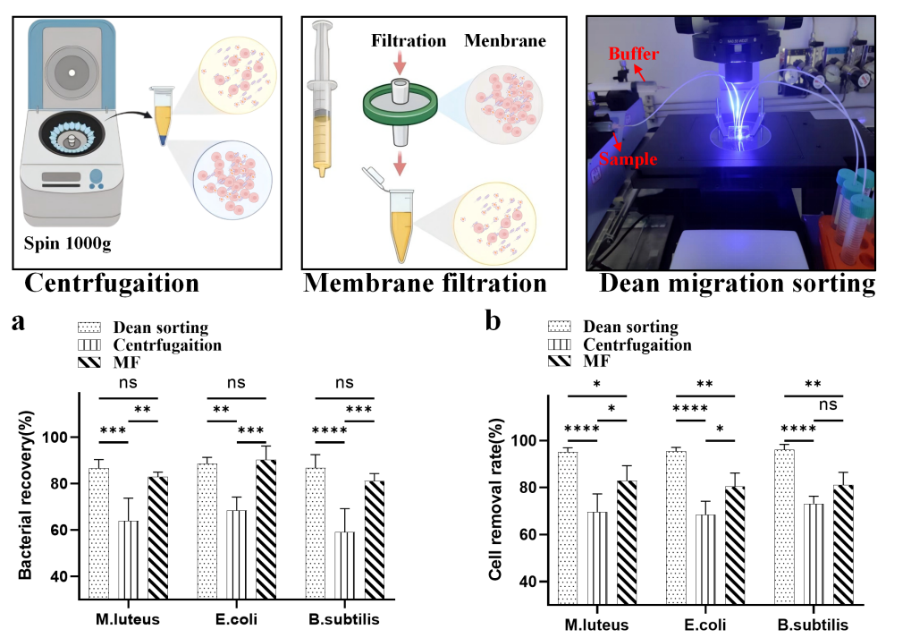
Figure S 7. Comparison of methods for separation of T-cell particle contamination. (a) Bacterial recovery by different isolation methods. (Outputs/Inputs) (b) Cell removal rates for different separation methods. cell removal rate = 1 - (Number of cells collected at the bacterial outlet (i.e., supernatant from centrifugation, filtrate from membrane filtration, or outlet 2 from DMM) / Number of input cells. ns: no significant effect. ∗: P < 0.05. ∗∗: P < 0.01. ∗∗∗: P < 0.001. ∗∗∗∗: P < 0.0001.
This study compared the performance of traditional separation methods with DMM in removing bacteria from T cell culture medium contaminated by bacteria, using bacterial contamination as an example. The contaminated samples were divided into four groups: three groups underwent experiments using different separation methods, while one group was reserved for flow cytometry analysis. The supernatant obtained from centrifugation, the suspension after membrane filtration, and the sample from outlet 2 after DMM separation were analyzed and compared with the input contaminated sample. Experimental results showed that, in terms of bacterial recovery, DMM achieved recovery rates of 86%, 88%, and 86% for M. luteus, E. coli, and B. subtilis, respectively—significantly higher than those of centrifugation (approximately 64%, 68%, and 59%) but not significantly different from those of membrane filtration (approximately 83%, 90%, and 81%) (Fig. 8a). In terms of T cell removal, DMM achieved removal rates of 95%, 95%, and 96% for M. luteus, E. coli, and B. subtilis, respectively, which were significantly higher than those achieved by centrifugation (approximately 70%, 68%, and 73%) and membrane filtration (approximately 83%, 80%, and 81%) (Fig. 8b). It is noteworthy that although DMM did not exhibit a significant difference in bacterial recovery compared with membrane filtration, the filtration device itself is not well suited to the separation of complex samples; an excess of particles larger than the pore size can easily clog the device. For example, in the experiment, a 4µm filter membrane became completely clogged, and an 8µm pore membrane was ultimately used. Moreover, both centrifugation and membrane filtration require operation by trained personnel, which not only increases labor costs but also introduces potential human errors and a risk of cross-contamination. In contrast, the Dean migration mechanism (DMM) can achieve label-free, continuous separation of particles within a specific size range directly in a liquid environment. Its compact and automated nature makes it more suitable for specialized applications. For instance, during cell culture, DMM can be directly integrated into an established cell culture system for particulate contamination monitoring; when combined with a rapid contaminant identification system, real-time monitoring can be realized.

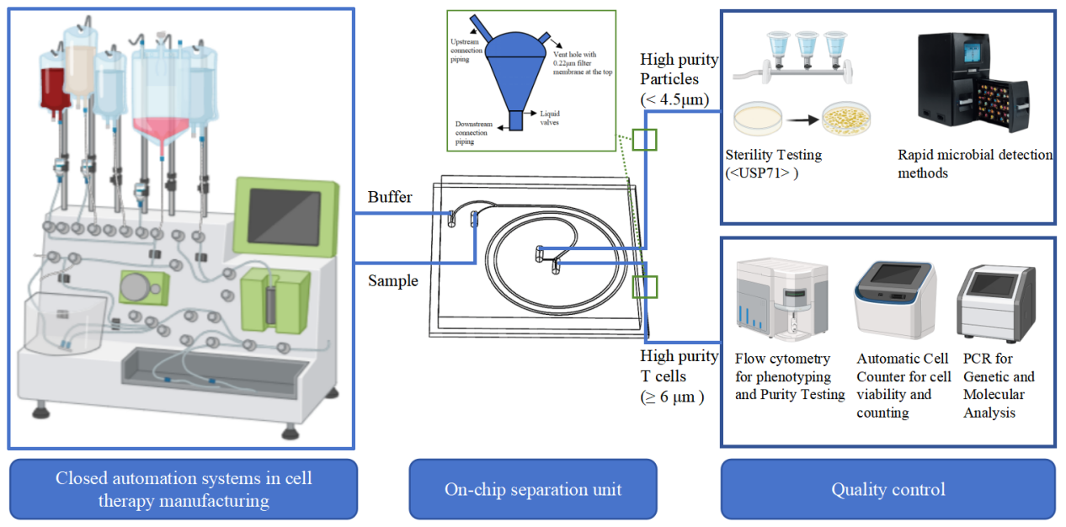
Figure S 8. Schematic diagram of the fully enclosed automated real-time quality monitoring system.
Highly integrated and automated closed systems are essential for both contamination control and quality control, representing a critical aspect of next-generation cell therapy production. Closed systems, such as the CliniMACS Prodigy, are increasingly recommended for use in Grade A areas to ensure consistent sterility assurance. These systems establish a physically isolated environment, thereby minimizing the risk of contaminant introduction from the surrounding environment and personnel. By reducing manual operations and exposure to uncontrolled environments, closed systems inherently decrease the likelihood of contamination events. The adoption of closed systems marks a robust and reliable advancement in contamination control strategies compared to traditional open processing methods, particularly for autologous cell therapies, where the risk to individual patients is substantial.
Automation and closed processes diminish reliance on stringent cleanroom environments and reduce operator-dependent variability, yielding more consistent and safer products. Sampling constitutes a pivotal component of in-process control (IPC) and final product quality control (QC). It enables manufacturers to monitor the manufacturing process, evaluate critical quality attributes, and ensure that the final product adheres to predefined specifications for safety, purity, potency, and consistency. Sterile sampling from closed systems is crucial for obtaining representative samples without compromising the sterility of the remaining cell culture or introducing contaminants into the system. The accuracy and reliability of quality control tests depend directly on the quality of the samples obtained. Consequently, implementing validated and standardized sampling procedures is indispensable for effective contamination control.
Following sampling, samples typically require immediate transfer to nearby analytical laboratories for downstream analysis and testing. This process often involves manual transportation, and certain testing methods necessitate further sample processing, such as the lysis of animal cells for ATP bioluminescence-based rapid microbial detection systems or other techniques requiring additional handling of samples containing animal cells.
The microfluidic separation device developed in this study comprises a closed liquid environment that manipulates particle separation through precise fluid control. It facilitates integration with closed culture systems and downstream detection systems via straightforward tubing connections. The high separation efficiency and purity of the sorting mechanism accommodate most downstream detection methods. For instance, sorted high-purity live cells, numbering approximately 10⁴ to 10⁵, meet the requirements for flow cytometry and can be directly interfaced with the flow cytometer’s sampling line for characterization. Intermediate steps can also be incorporated for antibody incubation. On the contaminant outlet side, the system simultaneously integrates the membrane enrichment culture method required by <usp71> and certain rapid microbial detection (RMM) closed systems.
However, establishing a robust disconnection mechanism between units is critical to ensure that each unit remains relatively independent and closed, with unidirectional liquid flow from upstream to downstream through sterile tubing. To address this, we designed a simple intermediate component to implement the disconnection mechanism. As depicted in Figure 5-7, an intermediate device, resembling a collection bag, is positioned between the outlet tubing of the on-chip separation unit and the downstream quality control detection unit. This device connects the separation and quality control units via tubing, employing automated valves to obstruct the connection, and features a vent with a 0.22 µm filter to balance pressure differences. This design preserves the separation efficiency of the separation unit while enabling both connection and disconnection between upstream and downstream paths. According to the design, the system processes samples at a minimum flow rate of 50–100 µl/min, handling 3–6 ml of samples within an hour. This throughput is sufficient for quality testing, given that sampling volumes in cell therapy product process and quality monitoring typically range from 0.02 to 2 ml. Nevertheless, there remains scope for improvement. A practical approach to enhance throughput involves adopting multi-stage configurations or parallel multiplexing.

 | - coli (10²cfu/ml) | B. Subtilis (10²cfu/ml) |  |  | Mix(10²cfu/ml)
Inlet | 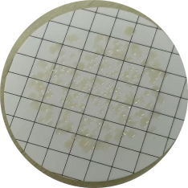 | 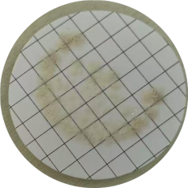 | 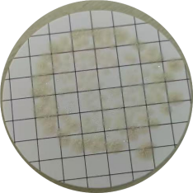 | 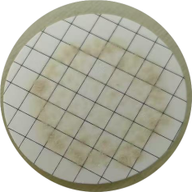 | 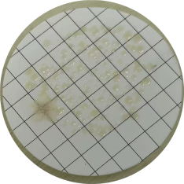
Outlet1 | 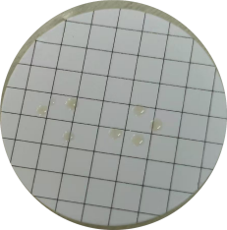 | 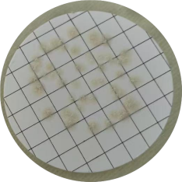 | 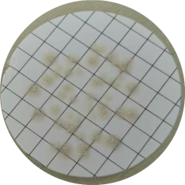 | 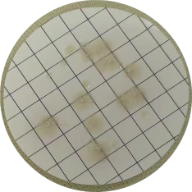 | 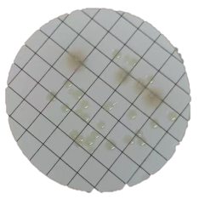
Outlet2 | 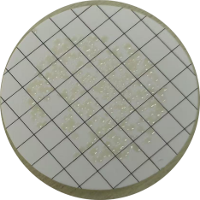 | 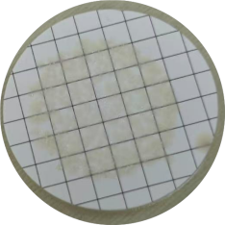 | 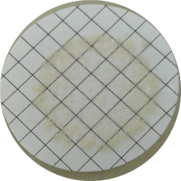 | 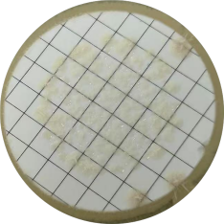 | 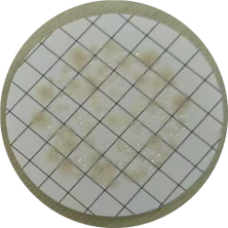
Figure S 9. Detection was performed using a pharmacopeia-compliant membrane filtration and cultivation method. At this stage, the bacterial inoculum load approximated several hundred colony-forming units (CFU). Significant discrepancies in detection counts were observed between Outlet 1 and Outlet 2. For both single bacterial strains and mixed bacterial samples, only a limited number of colonies (ranging from several to tens) were detected at Outlet 1, whereas Outlet 2 yielded CFU counts comparable to the initial inoculum load (hundreds of CFU). However, the high density of colonies precluded precise enumeration;nevertheless, the recovery rate was confirmed to exceed 90%.

 | E. coli(1cfu/ml) |  |  | E. coli(10¹cfu/ml)
Inlet | 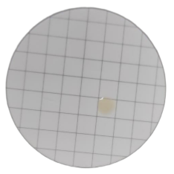 | 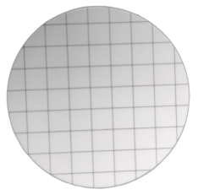 | 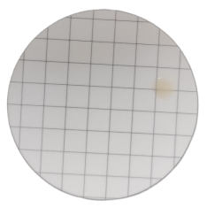 | 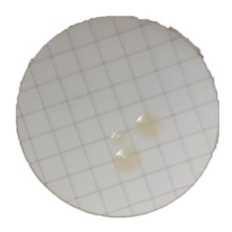 | 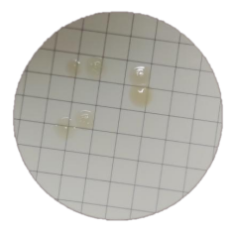 | 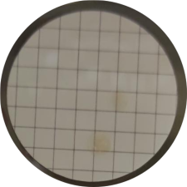
Outlet1 | 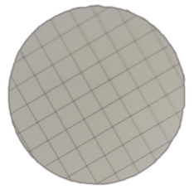 | 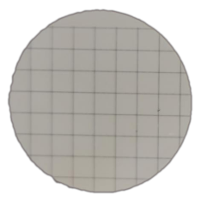 | 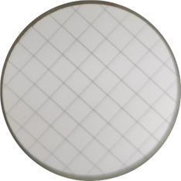 | 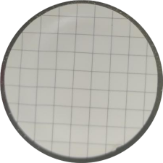 | 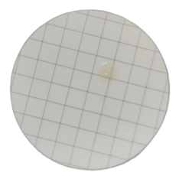 | 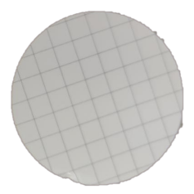
Outlet2 | 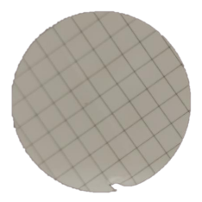 | 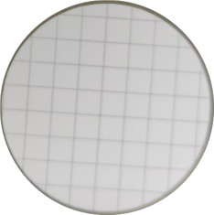 | 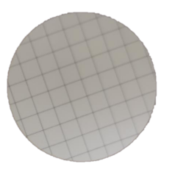 | 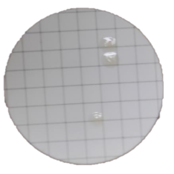 | 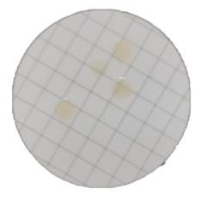 | 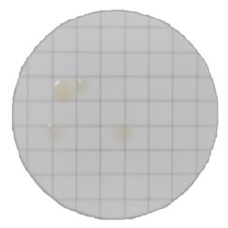
 | M. sp. & B. Subtilis (1cfu/ml) |  |  | M. sp. & B. Subtilis (10¹cfu/ml)
Inlet | 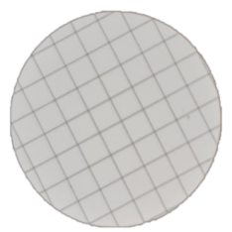 | 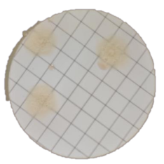 | 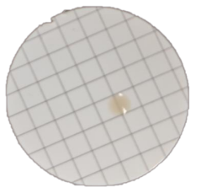 | 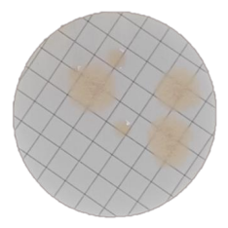 | 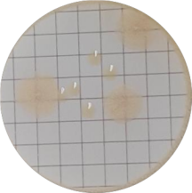 | 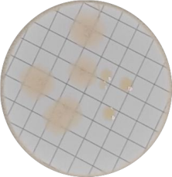
Outlet1 | 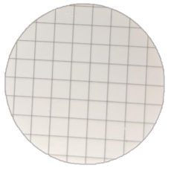 | 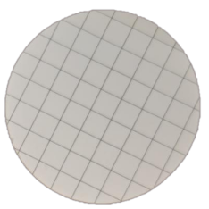 | 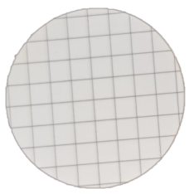 | 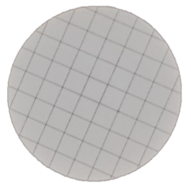 | 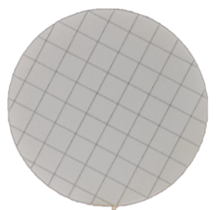 | 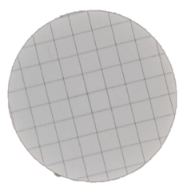
Outlet2 | 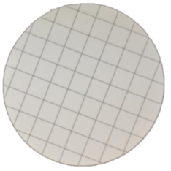 | 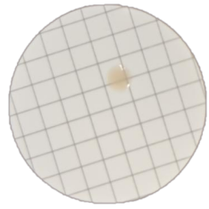 | 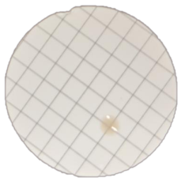 | 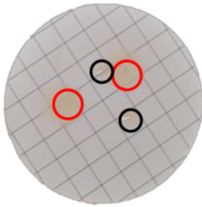 | 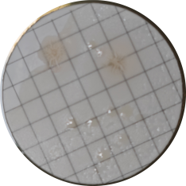 | 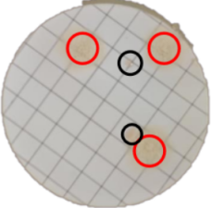
Figure S 10. Using the pharmacopoeia-compliant membrane filtration and incubation method for detection, the bacterial inoculum was adjusted to approximately 1 to several CFU. For Escherichia coli at the lowest inoculum of 1 CFU, no bacteria were detected at either outlet 1 or outlet 2. This may be attributed to sampling error, as similar nondetection events were observed repeatedly in multiple replicates of the unseparated samples. At slightly higher inocula of several CFU, E. coli was detected only once at outlet 1 across multiple replicates, with a recovery of 1 CFU. At outlet 2, the number of detected colonies was comparable to, though not fully consistent with, the input inoculum, which may also be explained by sampling error. For the mixed samples of Micrococcus and Bacillus subtilis, the detection pattern was similar to that observed in single-strain experiments. Notably, in the mixed samples, regardless of whether the inoculum was 1 CFU or several CFU, no bacteria were detected at outlet 1 across all replicate experiments. All blank control groups performing filtered PBS in biosafety cabinets and incubators showed no colonization.

