Supplementary information for
Fast Net-Forming of Biomimetic Hierarchical Structures with Robust Oil/Water Separation Performance
Jianan Fu^{1,2,3}, Liangchi Zhang^{1,2,3}*, Zhen Li^{1,2,3}, Jiang Ma^{4,5}
1 Shenzhen Key Laboratory of Cross-Scale Manufacturing Mechanics, Shenzhen 518055, Guangdong, China
2 SUSTech Institute for Manufacturing Innovation, Shenzhen 518055, Guangdong, China
3 Department of Mechanics and Aerospace Engineering, Southern University of Science and Technology, Shenzhen 518055, Guangdong, China
4 Guangdong Provincial Key Laboratory of Micro/Nano Optomechatronics Engineering, Shenzhen University, Shenzhen 518060, China
5 Shenzhen Key Laboratory of High Performance Nontraditional Manufacturing, College of Mechatronics and Control Engineering, Shenzhen University, Shenzhen 518060, China

E-mail addresses of all authors:
fujn2022@mail.sustech.edu.cn;
zhanglc@sustech.edu.cn;
liz33@sustech.edu.cn;
majiang@szu.edu.cn;
*Corresponding author email address: zhanglc@sustech.edu.cn

This file includes:
1. Supplementary Experimental Section
  - Materials and Tools
  - Preparation of solutions with different surface tensions
  - Self-cheaning experiment
- Abrasion test
- Water jet impalement
  - Liquid corrosion treatment
- High and low-temperature treatment
- Mill treatment

2. Supplementary Figure
- Fig. S1 PTFE surface morphology before and after milling
- Fig. S2 The specific geometry and parameters of the scribing tool.
- Fig. S3 XRD pattern of PTFE plate and BHS.
- Fig. S4 The size distribution of microbulges at the top of the BHS.
- Fig. S5 EDS mapping of BHS.
- Fig. S6 WCA of M6D6, M4D6, M2D6 and PTFE plate with time.
- Fig. S7 WCA of PTFE surface after milling.
- Fig. S8 SEM image of M4D6 and M2D6, the inset shows the details of morphology.
- Fig. S9 The Cassie-Baxter Model for M6D6, M4D6 and M2M6.
- Fig. S10 Photographs of different droplets on the M6D6
- Fig. S11 Relationship between surface tension and ethanol content.
- Fig. S12 PTFE plate, M2D6, M4D6 and M6D6 of hydrophobic transition at different surface tensions.
- Fig. S13 Surface roughness variation of the BHS top surface before and after wear.
- Fig. S14 Process of M6D6 wettability after high and low temperature treatment.
- Fig. S15 The process of M6D6 mesh and the photograph of fabricated M6D6 mesh.
- Fig. S16 Change process of oil droplets dropping on M6D6.
- Fig. S17 Oil/water mixtures of n-hexane and kerosene were separated using the M6D6 mesh.
- Fig. S18 Self-cleaning efficiency of BHS for solid particles under dynamic shocks.

3. Supplementary Table
- Comparison of oil/water separation performance with other materials

3. Supplementary Movie
- Movie S1 The process of BHS by net-forming strategy
- Movie S2 The free impact of a single water droplet on the M6D6 and PTFE plate
- Movie S3 The wettability of M6D6 after high-temperature shock at about 1250 °C and low-temperature treatment at about -195 °C
- Movie S4 The process of oil/water separation for M6D6 mesh

1. Supplementary Experimental Section
Materials and Tools
The PTFE was bought from Enbaiyuan Plastic Products Co. Ltd (Dongguan, China), and was specifically prepared using a molding process. Milling and scribing tools with a diameter of 6 mm were purchased from Fuchwan Precision CNC Cutting Tool Co. Ltd (Shenzhen, China). The scribing tool consists of a rake face, main cutting edge, secondary cutting edge, main flank face, feed edge and secondary flank face. The detailed geometry and morphology of the scribing tool are provided in Fig. S2.

Preparation of solutions with different surface tensions
Mixed solutions were prepared by pure water and ethanol (AR, 99.7%) in specified mass ratios to create solutions with varying surface tensions. The mass ratios of pure water to ethanol were 9:1, 8:2, 7:3, 6:4, 5:5, 4:6, 3:7, 2:8 and 1:9 (wt%). A specific amount of water was added to concentrated sulfuric acid (H₂SO₄, 98%) and potassium hydroxide solid (KOH, 99%) to prepare a 1 mol/L H₂SO₄ and KOH solution. Nescafé, non-skimmed milk and Fanta soft drinks were purchased from Nestlé, Yili, and Coca-Cola, respectively.

Self-cheaning experiment
The BHS with an area of 15000 mm² was fabricated on a PTFE plate with a size of 200 mm*150 mm using the processing parameters of movement (M) 0.6 mm and depth (D) 0.6 mm, and then the surface was hit with a NaCl solution with a 3.5 wt.%, muddy water and ink.
A layer of sand was spread evenly over the surface with BHS, and then a water stream was allowed to fall from above and impact the surface.

Abrasion test
In the abrasion test, a 500 g load was applied to M6D6 with an area of 400 mm². M6D6 was pulled across 400 mesh sandpaper, with each movement resulting in a displacement of 15 cm. The WCA of M6D6 was measured after every five abrasion cycles, with a total of 6 m of abrasion performed.

Water jet impalement
M6D6 was positioned 10 cm away from the nozzle, which subsequently impaled upon it with a high-velocity water jet impalement at a flow rate of 89 mm/s for 20 s. The WCA of M6D6 after treatment was measured every 20 s.

Liquid corrosion treatment
M6D6 was immersed in 1 mol/L HCl and KOH solutions for 180 hours, respectively, to evaluate the impact of liquid corrosion on its surface wettability.

High and low-temperature treatment
M6D6 was exposed to a thermal impact at ~1250 ℃, enduring 10 s per impact, for a cumulative total of 6 impacts. Low-temperature treatment of M6D6 was performed by immersion in liquid nitrogen for 2 min. The WCA of M6D6 was measured after thermal shock treatment and low-temperature treatment.

Mill treatment
M6D6 was clamped onto the CNC machine and milled using a numerical program that specifies a machining depth of 0.2 mm and a milling speed of 2,000 mm/min. The WCA of M6D6 was measured after milling treatment.

2. Supplementary Figures
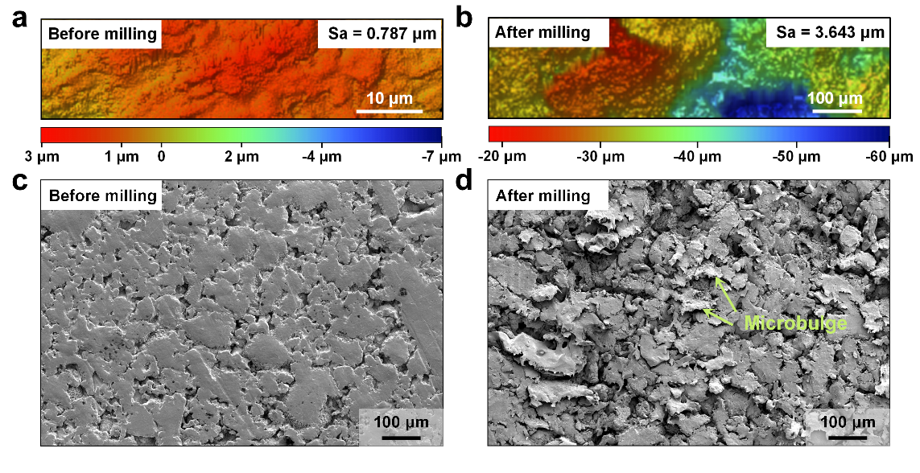
Fig. S1 a 3D Morphology of PTFE plate before milling. b 3D Morphology of PTFE plate after milling. c SEM image of PTFE plate before milling. d SEM image of PTFE plate after milling.

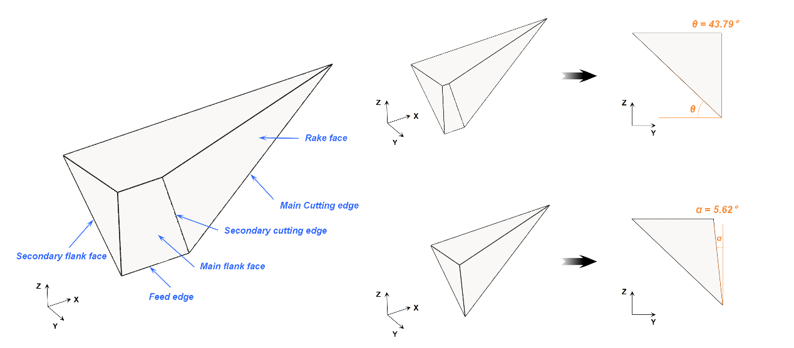
Fig. S2 The specific geometry and parameters of the scribing tool.

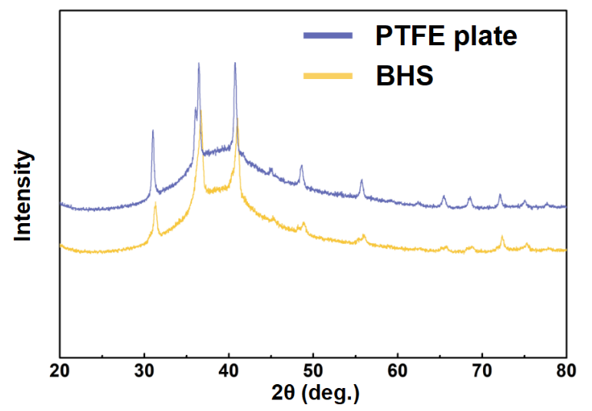
Fig. S3 XRD pattern of PTFE plate and BHS.

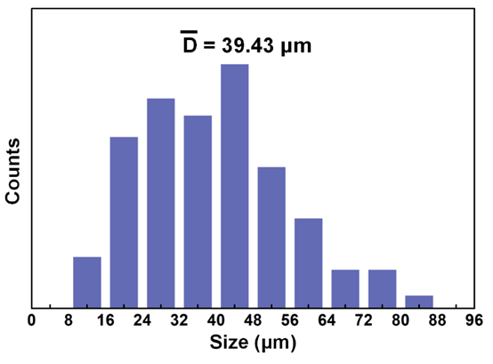
Fig. S4 The size distribution of microbulges at the top of microarrays.

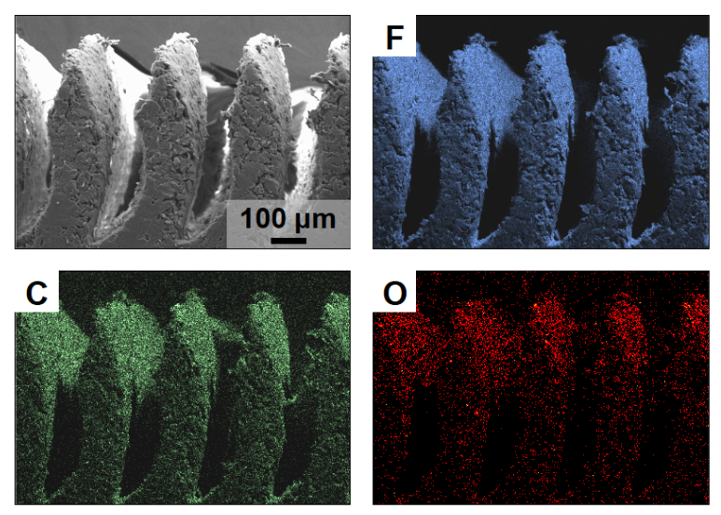
Fig. S5 EDS mapping of BHS.

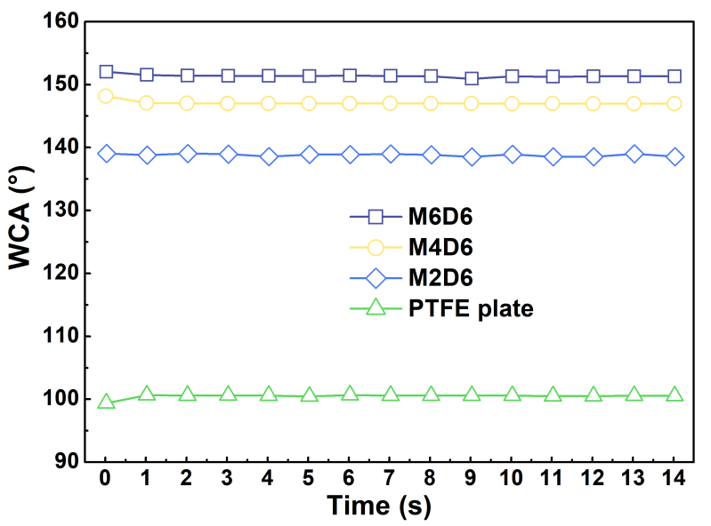
Fig. S6 WCA of M6D6, M4D6, M2D6 and PTFE plate with time.

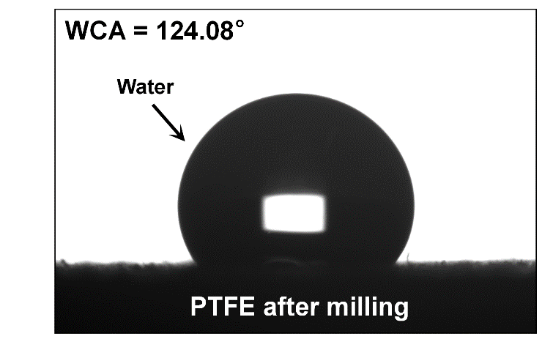
Fig. S7 WCA of PTFE surface after milling.

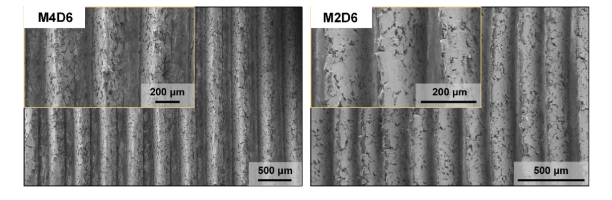
Fig. S8 SEM image of M4D6 and M2D6, the inset shows the details of morphology.

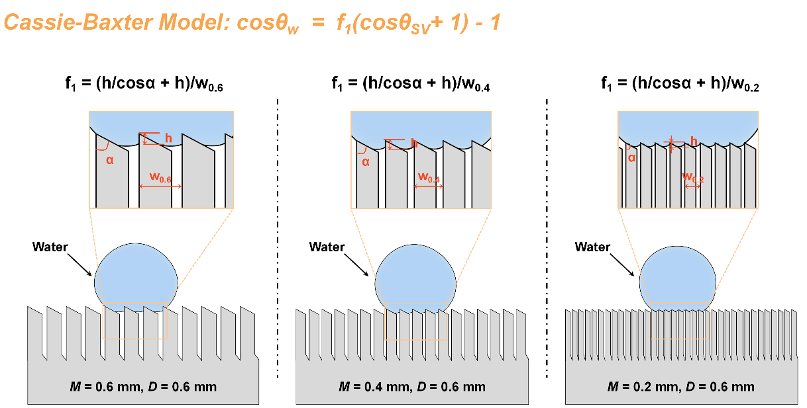
Fig. S9 The Cassie-Baxter Model for M6D6, M4D6 and M2D6.

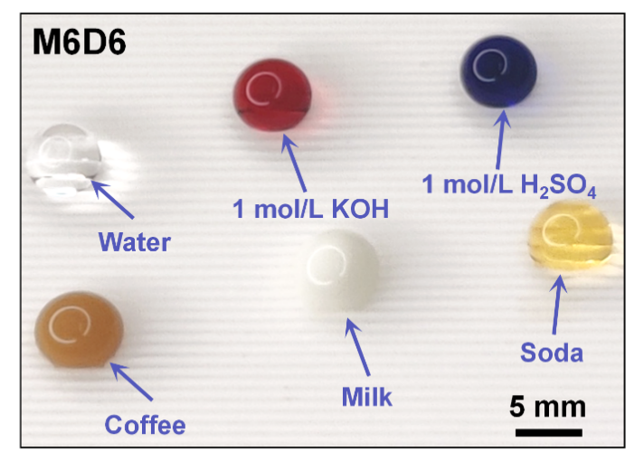
Fig. S10 Photographs of different droplets on the M6D6.

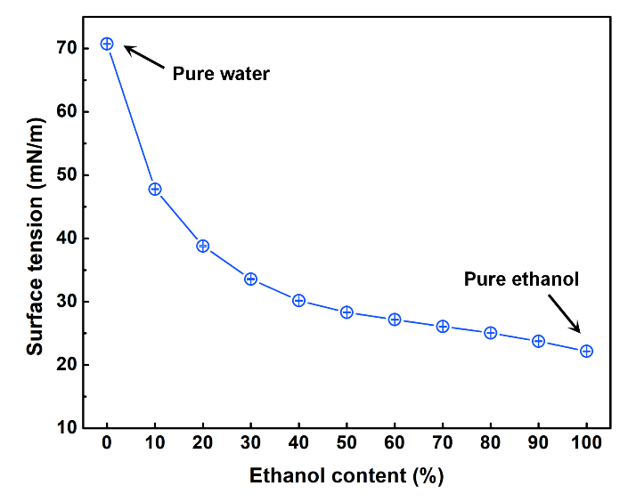
Fig. S11 Relationship between surface tension and ethanol content.
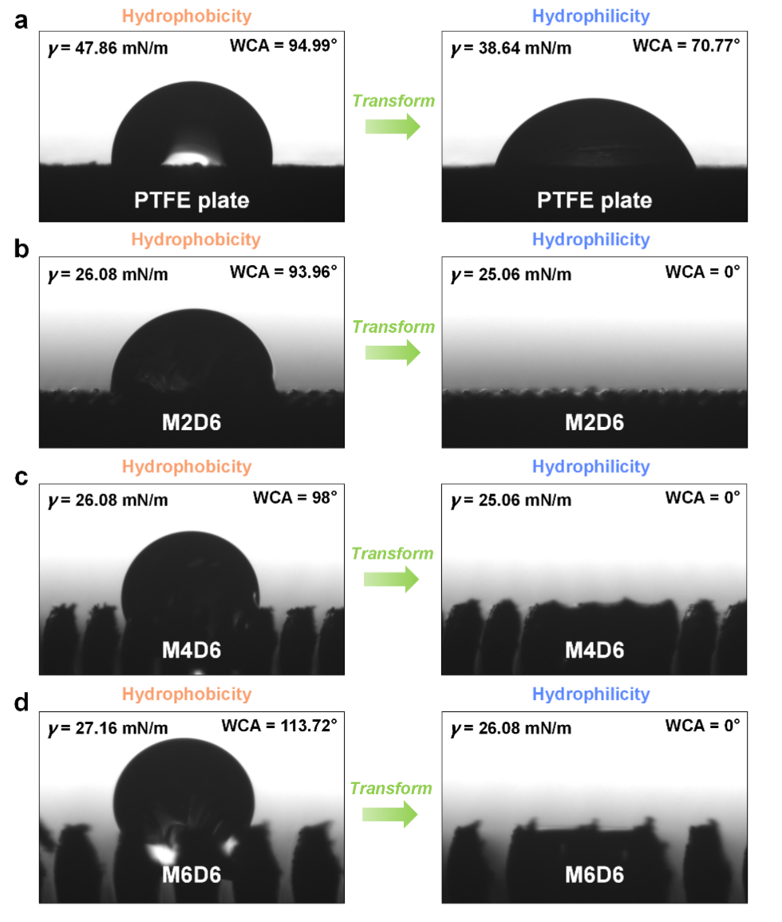
Fig. S12 PTFE plate, M2D6, M4D6 and M6D6 of hydrophobic transition at different surface tensions.

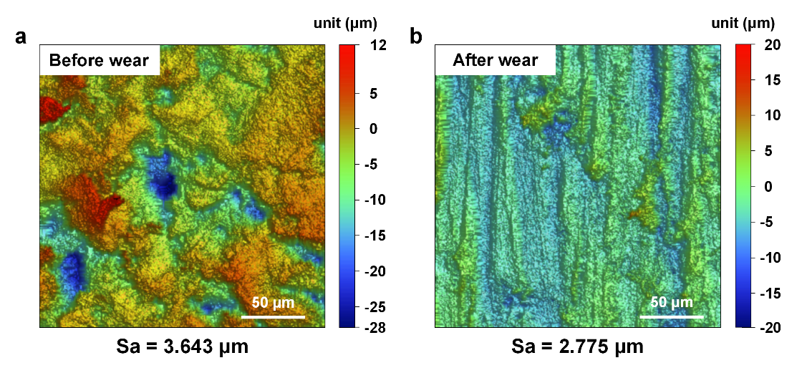
Fig. S13. Surface roughness variation of the BHS top surface before and after wear.

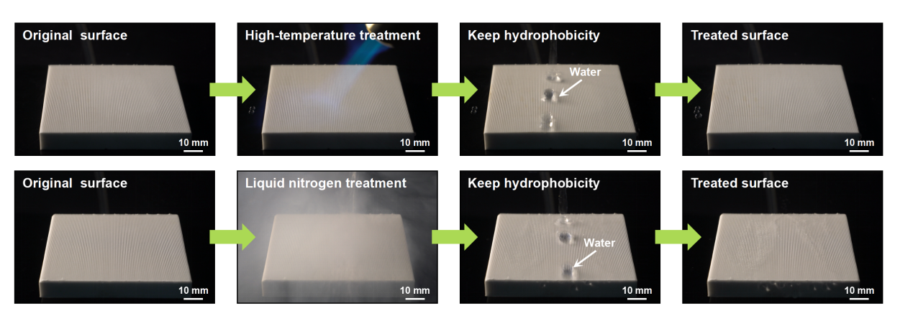
Fig. S14 Process of M6D6 wettability after high and low temperature treatment.

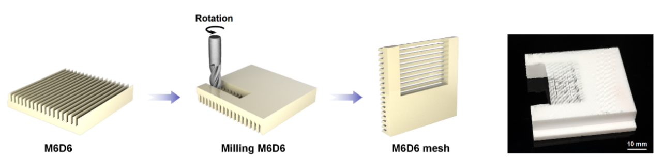
Fig. S15 The process of M6D6 mesh and the photograph of fabricated M6D6 mesh.

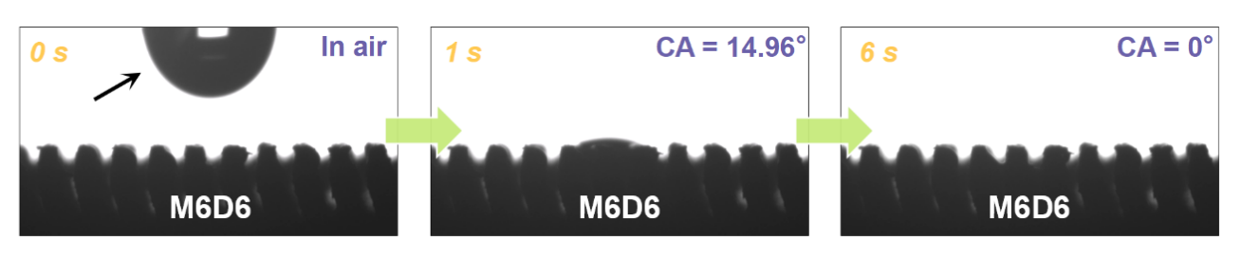
Fig. S16 Change process of oil droplets dropping on M6D6.

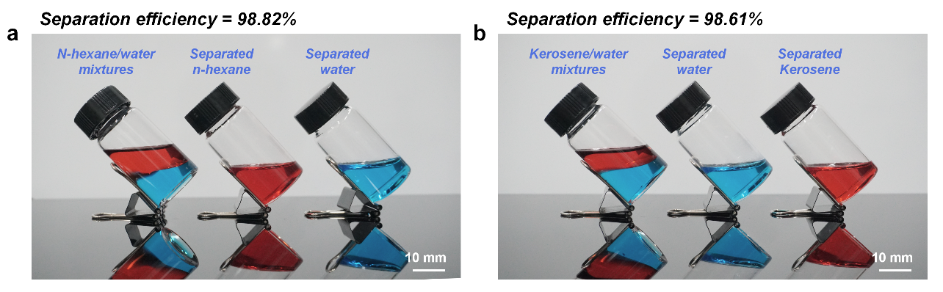
Fig. S17 a Photograph of the n-hexane/water mixture and the separated n-hexane and water. b Photograph of the kerosene/water mixture and the separated kerosene and water.
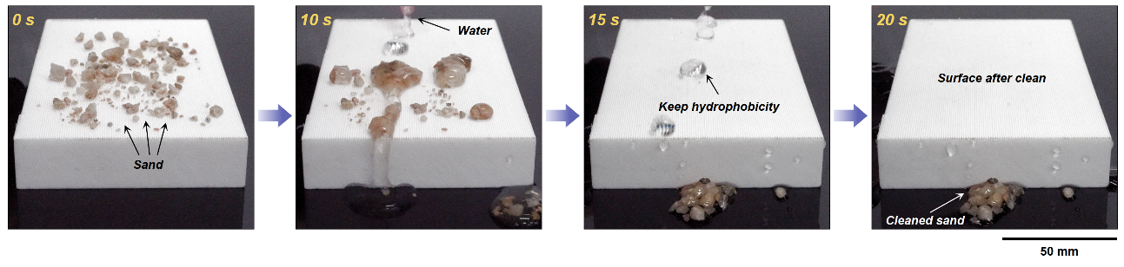
Fig. S18 Self-cleaning efficiency of BHS for solid particles under dynamic shocks.

3. Supplementary Table
Table S1 Comparison of oil/water separation performance with other materials
Materials | Separation efficiency (%) | Separation flux (L m⁻² h⁻¹) | Ref.
M6D6 mesh | 99.10 | 2710 | This work
Superhydrophobic CF | 98 | 950 | ¹
PDVB@CF | 99 | 635 | ²
fluorine-free  paper | 99.2 | 1165 | ³
AEL-PF | 96.6 | 655.4 | ⁴
WCSP | 99.99 | 1750 | ⁵
RGO@mesh-300 | 98 | 1752 | ⁶
poly(PYBP-oda)-coated cotton fabric | 90 | 580 | ⁷
Silica sol/SiO₂/PFDT | 98.2 | 1176 | ⁸
EP-SiO₂@PDMS cotton fabric | 99.75 | 2310.8 | ⁹
PDMS/ZnO/CR | 99 | 132.7 | ¹⁰
BN-CuSA₂ membrane | 95 | 1667.63 | ¹¹
super-wetting copper foam | 99 | 3100 | ¹²
SiO2/carbon stainless steel mesh | 97 | 934 | ¹³

References
1 Cheng, Q.-Y., Zhao, X.-L., Weng, Y.-X., Li, Y.-D. & Zeng, J.-B. Fully sustainable, nanoparticle-free, fluorine-free, and robust superhydrophobic cotton fabric fabricated via an eco-friendly method for efficient oil/water separation. ACS Sustainable Chem. Eng. 7, 15696-15705 (2019).
2 Cheng, Q.-Y., Guan, C.-S., Li, Y.-D., Zhu, J. & Zeng, J.-B. Robust and durable superhydrophobic cotton fabrics via a one-step solvothermal method for efficient oil/water separation. Cellulose 26, 2861-2872 (2019).
3 Li, H., Wang, X., He, Y. & Peng, L. Facile preparation of fluorine-free superhydrophobic/superoleophilic paper via layer-by-layer deposition for self-cleaning and oil/water separation. Cellulose 26, 2055-2074 (2019).
4 Gong, X. et al. Construct a stable super-hydrophobic surface through acetonitrile extracted lignin and nano-silica and its application in oil-water separation. Ind. Crops Prod. 166, 113471 (2021).
5 Li, J. et al. Gravity-directed separation of both immiscible and emulsified oil/water mixtures utilizing coconut shell layer. J. Colloid Interface Sci. 511, 233-242 (2018).
6 Chen, J. et al. Highly efficient and robust oil/water separation materials based on wire mesh coated by reduced graphene oxide. Langmuir 33, 9590-9597 (2017).
7 Manickam, M., Pichaimani, P., Arumugam, H. & Muthukaruppan, A. Synthesis of nontoxic pyrazolidine-based benzoxazine-coated cotton fabric for oil–water separation. Ind. Eng. Chem. Res. 58, 21419-21430 (2019).
8 Ma, K. et al. Superhydrophobic composite coatings with thermal stability for oil/water separation. Mater. Today Commun. 44, 111907 (2025).
9 Liu, Z., Xu, N., Yu, X., Yang, C. & Chu, H. Preparation of superhydrophobic coatings with excellent mechanical and chemical stability by one-step spraying method with selected fluorine-free modifiers. Appl. Surf. Sci. 642, 158635 (2024).
10 Li, H., Zhang, H., Luo, Y., Shi, H. & Peng, L. Fabrication of durable and sustainable superhydrophobic‐superoleophilic paper for efficient oil/water separation. Cellulose 28, 5033-5053 (2021).
11 Wang, F.-p. et al. Sustainable, superhydrophobic membranes based on bacterial cellulose for gravity-driven oil/water separation. Carbohydr. Polym. 253, 117220 (2021).
12 Xin, G. et al. Fabrication of super-wetting copper foam based on laser ablation for selective and efficient oil-water separation. Surf. Coat. Technol. 424, 127650 (2021).
13 Liu, D., Yu, Y., Chen, X. & Zheng, Y. Selective separation of oil and water with special wettability mesh membranes. RSC Adv. 7, 12908-12915 (2017).

