Supporting information
Iridium Complex-Loaded Biomimetic Vesicles Enable Enhanced Photodynamic Therapy and Immune Modulation
Xiaohui Zhang^{abf, 1}, Xuelin Tang^{c, 1}, Lin Bai^{d} , Rui Zhaoª, Yaohui Chen^{e *}, Xiaohe Tian^{ag, *}
ª Department of Radiology, Huaxi MR Research Center (HMRRC), Institute of Radiology and Medical Imaging, West China Hospital of Sichuan University, Chengdu, Sichuan, China
^{b}State Key Laboratory of Oral Diseases & National Center for Stomatology & National Clinical Research Center for Oral Diseases, West China Hospital of Stomatology, Sichuan University, Chengdu, China.
^{c}Department of Ophthalmology, West China Hospital, Sichuan University, Chengdu 610041, China
^{d}Histology and Imaging Platform, Core Facilities of West China Hospital
^{e}Department of Thoracic Surgery and Institute of Thoracic Oncology, West China Hospital of Sichuan University, Chengdu, 610097, China
^{f}State Key Laboratory of Oral Diseases & National Center for Stomatology & National Clinical Research Center for Oral Diseases, West China Hospital of Stomatology, Sichuan University, Chengdu, China.
^{g} Xiamen Key Lab of Psychoradiology and Neuromodulation, Department of Radiology, West China Xiamen Hospital of Sichuan University, Xiamen, Fujian, China
¹ These authors contributed equally to this work.
*Correspondence address: Prof. Yaohui Chen: yhchen@scu.edu.cn; Prof. Xiaohe Tian: xiaohe.t@wchscu.cn;

Contents

1. Materials and Apparatus 2

2. Experimental Section 2

2.1 Synthesis and characterization 2

2.2 Fluorescence response of IrC8 to different microenvironments in vitro 2

2.3 Singlet oxygen (¹O2) generation detection 3

2.4 Live cell and ex vivo experiment 3
Cell culture 3
Cytotoxicity assay 3
Live/Dead assay with calcein AM/PI 3
Flow cytometry study 4
3D spheroids 4
Mitochondrial Co-localization Assays 4
Mitochondrial membrane potential Detection 4
Nuclear DNA damage detection 4
Cell death pattern detection 5

2.5 Induction of immune activation of G-IrC8 5
Immunofluorescence detection 5
BMDC maturation detection 5
CD8 positive cell detection 5

2.6. Anti-tumor studies in vivo 5

1. Materials and Apparatus
All chemicals for sample fabrication and organic solvents were purchased from Aladdin industrial corporation，dried and purified by standard methods. The¹H-NMR and ¹³C-NMR spectra were obtained on Bruker AV 400 spectrometer (Germany) with TMS as internal standard. Mass spectra were performed on a Micromass GCT-MS spectrometer (UK). UV-vis absorption spectra were recorded on a UV-265 spectrophotometer. Fluorescence measurements were carried out on a Hitachi F-7000 fluorescence spectrophotometer. All the photodynamic light sources use handheld ultraviolet lamps with a power of 1W/cm2 and a wavelength of 365nm, and the irradiation time is 10 minutes. The date of particle size distribution and zeta potential was collected on a Brookhaven BI-200 SM dynamic light scattering (DLS). Confocal imaging data were acquired by Leica Stellaris5 microscopy, 100×oil-immersion objective lens and and Image J. Flow cytometry was performed on BD FACSymphony A5 SE and BD FACS Calibur flow cytometer (Beckaman/Gallios).

2. Experimental Section

2.1 Synthesis and characterization
Synthesis of IrC8: IrC8 was synthesized according to the literature reported before.¹

2.2 Fluorescence response of IrC8 to different microenvironments in vitro
Before the response test, an appropriate amount of 1 mM IrC8 solution was diluted with PBS to 10⁻⁵ mol/L for reserve. For amino acid titration, each amino acid was weighed and prepared with deionized water to a concentration of 10 mg/mL, which was dropped into the above standby diluted IrC8 solution until 200 μL, and the corresponding fluorescence intensity was recorded. For the pH response, 20 μL of IrC8-solution with concentration of 1 mM was added to 2 mL of different pH values modulated by pH meter, respectively, and the change of fluorescence intensity was recorded. For the AIE property, PBS and DMSO were mixed in different proportions and 20 μL of 1mM IrC8 solution was added to record the change of fluorescence intensity.

2.3 Singlet oxygen (¹O2) generation detection
The ROS detection was carried out by exposing a solution containing DCFH (10 μm) and G-IrC8 (10 μm) to a handheld ultraviolet lamp with a power of 1 W/cm² at 365 nm for 1 minute. At the same time, a solution containing only DCFH was used as a control. The fluorescence intensity changes were detected by the enzyme immunoassay instrument (Ex = 488nm, Em = 500 - 550nm). The singlet oxygen was measured by a singlet oxygen indicator named DPBF. [Ru(bpy)3] ²⁺ was used as the standard, and calculated that the singlet oxygen conversion efficiency of IrC8 was 0.18.²

2.4 Live cell and ex vivo experiment

Cell culture and preparation of GPMVs
Various cell lines purchased from Shanghai Bioleaf Bio Biotech. Co. Ltd. The cells were incubated in Dulbecco's Modified Eagle's medium (DMEM) containing 10% FBS or 10% Gibco FBS (for normal cells) and 1% antibotics (penicillin and streptomycin), maintained at 37 °C in an atmosphere of 5% CO₂ and 95% air. Cells were seeded in 35 mm glass bottom cell culture dishes, at a density of 1×10⁵ cells and were allowed to grow when the cells reached more than 70% confluence. When the B16 cells reach a density of at least 70%, wash the cells twice with GPMVs buffer. Add 5 mL of vesicle formation agent (4.9 mL GPMVs buffer + 90 μL 4% PFA + 10 μL DTT) to each 10 cm dish, incubate at 37°C for overnight. Collect the supernatant, centrifuge at 100 g for 10 minutes, remove the cell debris, and centrifuge the supernatant again at 20,000 g at 4°C for 1 hour. The precipitate is the GPMVs.

Cytotoxicity assay
The cytotoxicity of IrC8towards various cell lines was determined by 5-dimethylthiazol-2-yl-2, 5-diphenyltetrazolium bromide (MTT) assay. Various of exponentially grown cell lines were seeded in triplicate into 96-well plates at 10⁴ cells per well. After 24 h, the cells were treated with G-IrC8 respectively at different concentrations (0 µM, 0.5 µM, 1µM, 2 µM，4 µM, 8 µM, 10 µM, 15 µM and 20 µM) and incubated for 24 h. After that time, the media was removed and the cells were rinsed once with PBS and placed with fresh media. Subsequently, cells were treated with 5 mg/mL MTT (10 μL/well) and incubated for an additional 4 h (37 ºC, 5% CO₂). After MTT medium removal, the formazan crystals were dissolved in DMSO (100 μL/well). The plate was incubated for 10 mins while shaking it with an oscillator. The absorbance was measured at 450 nm using a microplate reader (SpectraMax Paradigm). The cell survival rate was calculated according to the corresponding formula.

Live/Dead assay with calcein AM/PI
B16 cells were incubated with G-IrC8 (2 μM) for 30 min. 0.5 μL AM (a live cell indicator, 10 mM) was added to each group, incubated for 15 min in an incubator maintained at 37 °C and 5% CO₂ at all times, and 10 μL PI (5 mM) was added before imaging. Fluorescence images were collected by confocal laser scanning microscopy after laser irradiation.

Flow cytometry study
Cells seeded into the 6-well plates were cultured for 24 h. Next, the medium was replaced with a medium containing G-IrC8 (2 μM) at 37 °C for 30 min. After being irradiated by light for 10 min (Concentration: 2 μM, Light: 405 nm), the cells were incubated for another 1 h, then collected by centrifugation and resuspended in binding buffer containing Propidium Iodide (PI, 10 μL) and Annexin-V FITC (5 μL) for 15 min in darkness. The signal was collected by a BD FACS Calibur flow cytometer (Beckaman/Gallios).

3D spheroids
Add 5 mL of growth medium containing 5×10⁵ B16 cells to a 25T culture flask pre-coated with 1.25% (W/V) agarose, and aggregated spheres will spontaneously form within 3-5 days.³ When the spheres grow to about 300 μm, aspirate the spheres and transfer them to confocal dishes. Then, 10μM of G-IrC8 (stock solution contration= 1mM) were added to a total volume of 1 mL of complete medium. After different treatments, AM and PI was added for another 15mins before confocal imaging.

Mitochondrial Co-localization Assays
B16 cell was inoculated into a special confocal cell culture dish. When the cell density grew to 70%, MTDR 0.5 μL at the concentration of 1mM was added, 15 mins later, 1 mM G-IrC8 2 μL was added to incubate for 10 mins, and PBS washed 3 times, then confocal imaging was performed.

Mitochondrial membrane potential Detection
Mitochondria membrane potential sensitive commercial dye mitochondria red were added to B16 cells treated with different mitochondria, and confocal imaging was performed 15min later and the fluorescence intensity of different treatment groups was analyzed.

Nuclear DNA damage detection
After the B16 cells were treated in different ways, single cell suspension was collected and mixed with low melting point agarose, alkaline lysate was cracked for 1h, alkaline buffer was subjected to agarose gel electrophoresis for 20min, neutral solution was immersed for 15min, PI staining solution was added and confocal imaging was performed.

Cell death pattern detection
To execute western blotting analysis, proteins were transferred to polyvinylidene fluoride membranes. They were blocked in 5% BSA solution for 1 h, and incubated with an Bax, BCL2, Caspase3 and Actived-caspase3 antibody overnight at 4 °C and an anti- HRP rabbit antibody for 1 h. The proteins were visualized in an imaging system (Bio Rad Image system).

2.5 Induction of immune activation of G-IrC8

Immunofluorescence detection
B16 cells were seeded on confocal dishes at a density of 1 × 105 per well. After 24 h incubation, the cells were washed with PBS twice. And after different treatment, fixed with 4% paraformaldehyde, incubated with 5% BSA for 1h, anti-CRT antibody or anti-HMGB1 antibody overnight in 4 °C and 647-conjugated secondary antibody for 1 h. The nuclei were stained with PI at room temperature for 10 min. The fluorescence signal of CRT and HMGB1 was detected via a confocal scanning laser microscope (λex = 633 nm, λem = 660 nm).

BMDC maturation detection
BMDC was extracted from humerus and tibiofibula of mice and differentiated into DC cells by GM-CSF induction, and then cultured with supernatant of different treatment groups for 24h. The cells were collected and the proportion of CD80 and CD86 double-positive cells was detected by flow cytometry.

CD8 positive cell detection
Mouse spleens were ground under sterile conditions, lymphocytes were extracted by Ficoll, and supernatants of different treatment groups were added. Cells were collected at 3 and 7 days of incubation, respectively, and the proportion of CD8 positive cells was detected after flow cytometry was added.

2.6. Anti-tumor studies in vivo
5 × 10⁵ B16 cells were subcutaneously injected into the right lower back of mice. The tumor volume (V) was monitored and calculated from the equation: V = ab²/2, where a and b are the length and width of the tumor. When the tumor volume reached about 100 mm3, the mice were randomly divided into two groups (Blank and G-IrC8+Laser). These formulations were peritumoral injection at an volume of 200μL (10⁻⁴ mol/L). Treatment lasts 7 days. The tumor volume and the body weight were recorded every day. At the end of the treatment, mice were sacrificed to collect tumors and major organs for H&E, TUNEL, KI67 staining, and immunohistochemistry analysis.

Figure S1. 1H NMR spectrum (400 MHz, d6-Acetone) of IrC8

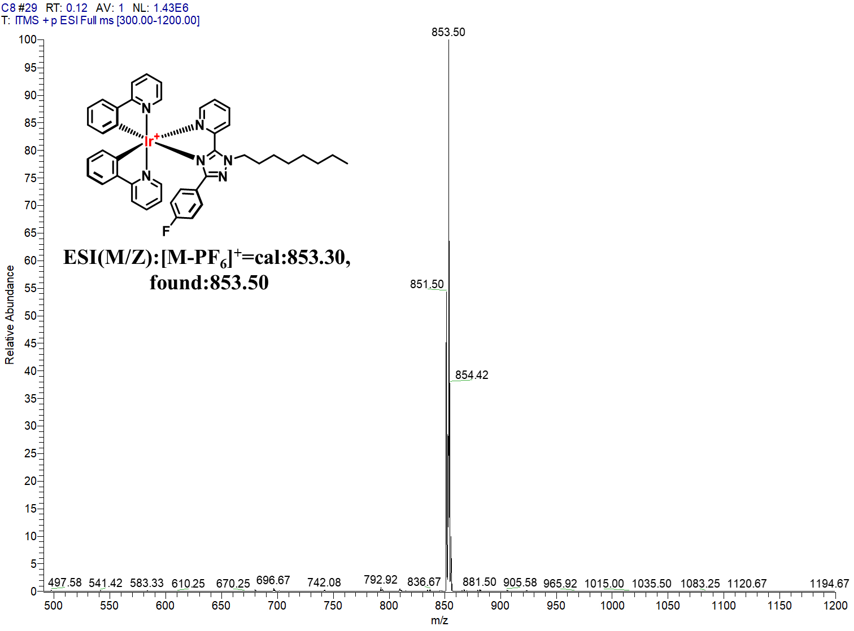
Figure S2. Mass spectrum of IrC8
Figure S3. Fluorescence emission spectra of IrC8(10 µM) under different pH.
Figure S4. The cytotoxicity of GPMVs derived from B16 cells was evaluated in both B16 and Bend3 cells.
Figure S5. Coomassie and Western blotting blue staining images of total protein and GPMVs protein from B16 cells.
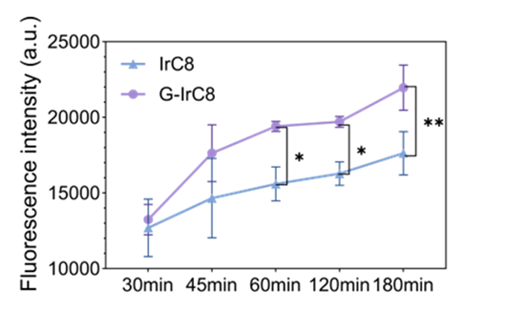
Figure S6. The uptake of IrC8 and GPMV-encapsulated G-IrC8 by B16 cells at different time points.
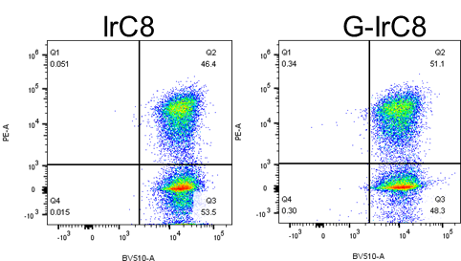
Figure S7. The uptake of IrC8 by B16 cells was assessed before and after encapsulation within GPMVs.
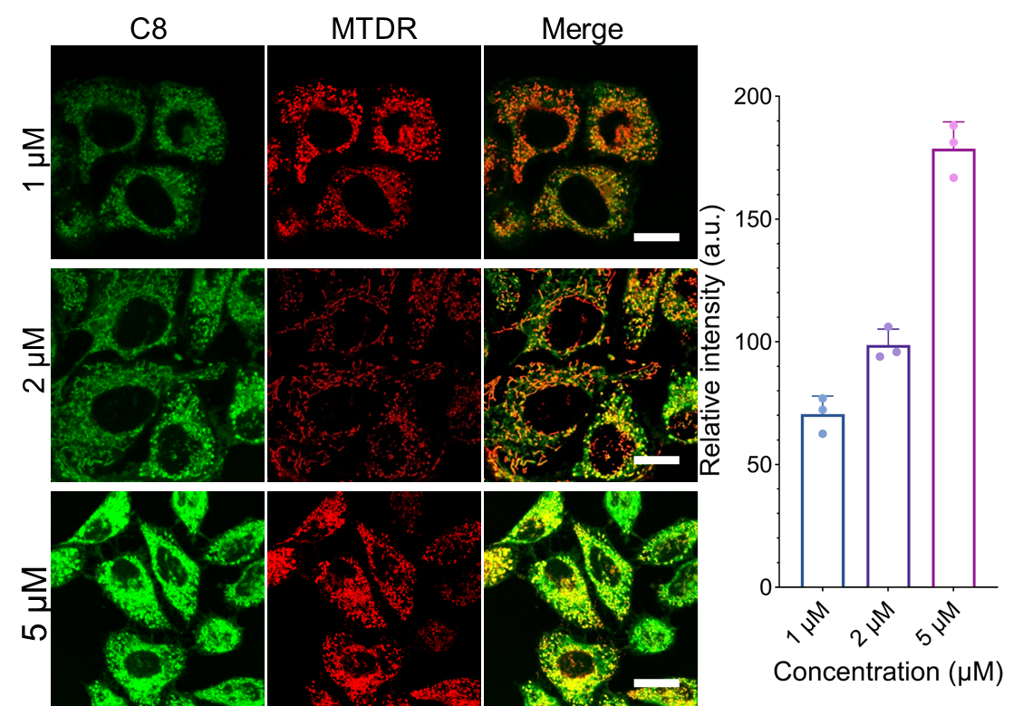

Figure S8. Co-localization imaging of G-IrC8 (10 min) and mitochondria deep red (0.5 μM, 15 min) with different concentration.
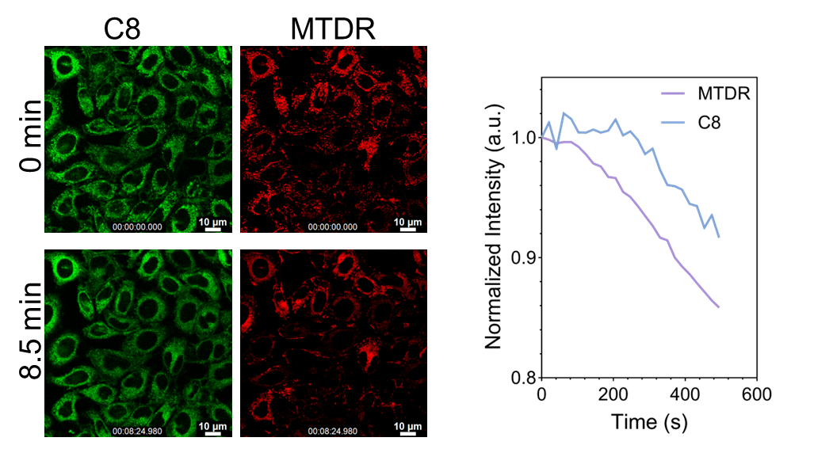
Figure S9. Fluorescence intensity changes of G-IrC8 and commercial mitochondrial dye MTDR under 365nm light.

Figure S10. The Original data of expression levels of apoptosis-related proteins

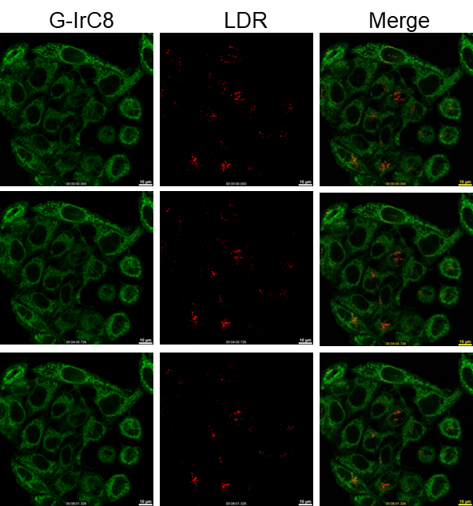

Figure S11. Co-localization imaging of G-IrC8 (2 μM, 10 min) and lysosome deep red (0.5 μM, 15 min) in different time points.
Figure S12. The expression levels of autophagy-related proteins LC3-II and LC3-I were analyzed following different treatments by western blot.
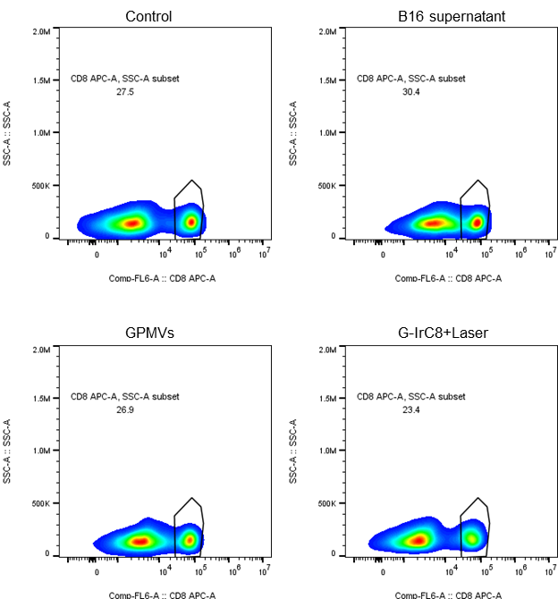
Figure S13. Flow cytometry analysis was performed to assess leukocyte immune activation in response to the supernatant from different treatment groups on day3.
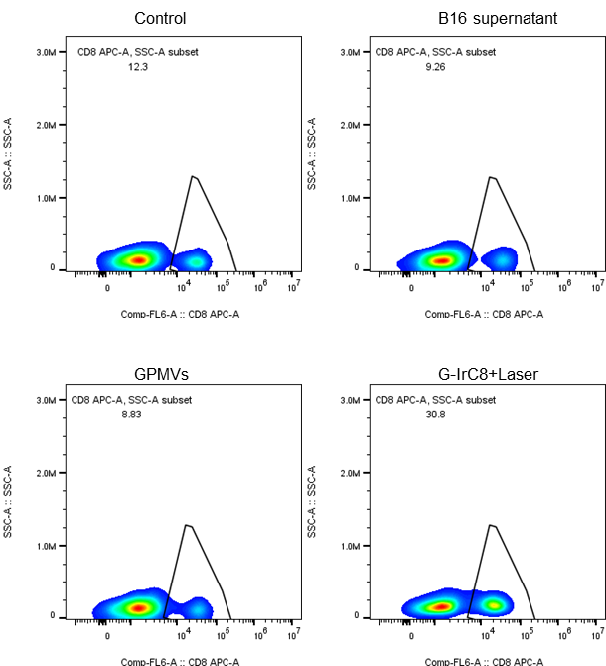
Figure S14. Flow cytometry analysis was performed to assess leukocyte immune activation following a 7-day incubation with the supernatant from different treatment groups.
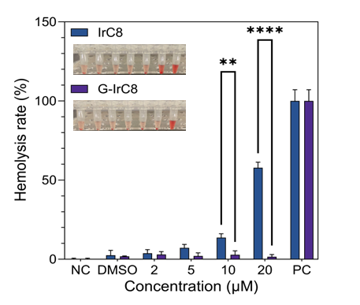
Figure S15. Hemolysis rates before and after encapsulation of gpmvs.

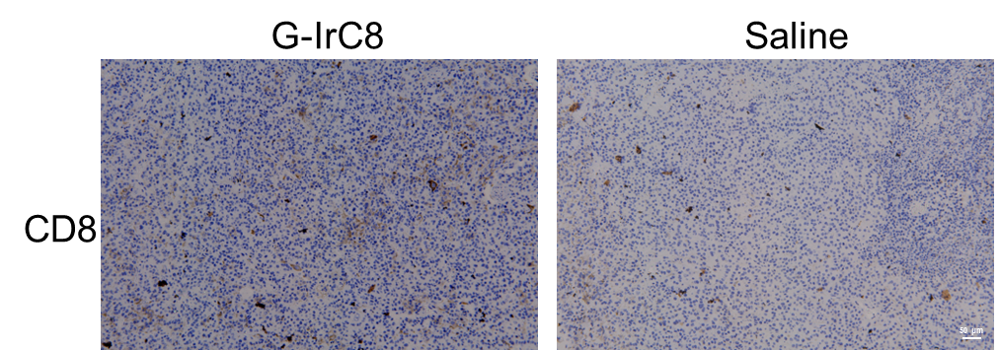
Figure S16. Immunohistochemical (IHC) analysis was performed to evaluate CD8+ T cell infiltration in tumor tissues from both experimental and control groups of mice.
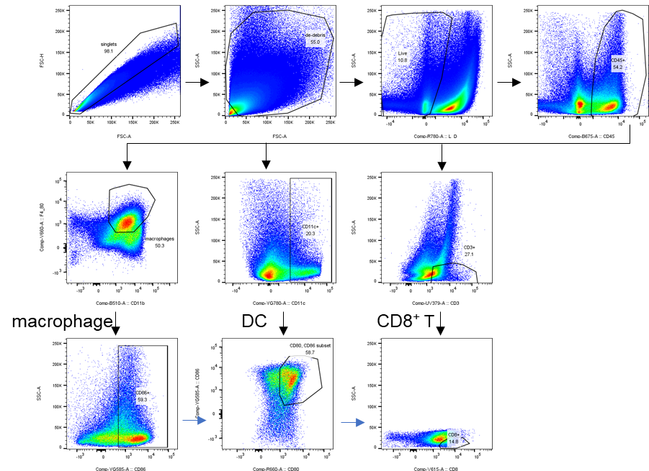
Figure S17. The gate of tissue cytometry.

Table 1. Photophysical properties for IrC8 in different solvents
Complex | Solvent | λ_{max} (ε)ª | λ_{max} ^{b} | Φ [%]^{c} | τ [ns]^{d} | k_{r} [s⁻¹]^{e} | k_{nr}[s⁻¹]^{e}
IrC8 | CH3CN | 418(2.65) | 556 | 19.48 | 29.94 | 6.50×10⁶ | 2.68×10⁷
IrC8 | H2O | 430(7.51) | 541 | 40.47 | 4200 | 9.63×10⁴ | 1.41×10⁵
[a] The strongest absorption peak position in the ultraviolet-visible spectrum (nm)；[b] extinction coefficient
(×10⁴mol⁻¹•L cm⁻¹)；[c] Absolute quantum yield；[d] lifetime；[e] Radiative transition rate and non-radiative transition rate (k_{r} and k_{nr}).
References：
1. T. Shao, Z. Feng, Y. Shen, D. Chen, P. Xiang, Q. Zhang, S. Ma, Y. Tian and X. Tian, Journal of Inorganic Biochemistry, 2025, 262, 112760.
2. P. Xiang, R. Huang, T. Shao, Y. Shu, D. Li, Q. Zhang, Y. Tian and X. Tian, Sensors and Actuators B: Chemical, 2022, 361, 131677.
3. M. Li, T. Fu, S. Yang, L. Pan, J. Tang, M. Chen, P. Liang, Z. Gao and L. Guo.

