Supplementary Information
Extending the boundaries of ultraviolet-visible meta-optics via direct imprinting of tantalum pentoxide composite
Eunji Lee¹, Hyunjung Kang², Heechang Yun¹, Junsuk Rho^{1,2,3,4,5,*}
¹Department of Chemical Engineering, Pohang University of Science and Technology (POSTECH), Pohang 37673, Republic of Korea
²Department of Mechanical Engineering, Pohang University of Science and Technology (POSTECH), Pohang 37673, Republic of Korea
³Department of Electrical Engineering, Pohang University of Science and Technology (POSTECH), Pohang 37673, Republic of Korea
⁴POSCO-POSTECH-RIST Convergence Research Center for Flat Optics and Metaphotonics, Pohang 37673, Republic of Korea
⁵National Institute of Nanomaterials Technology (NINT), Pohang 37673, Republic of Korea
* Corresponding author: jsrho@postech.ac.kr

Supplementary Note 1: Size distribution of Ta₂O₅ nanoparticles
The particle size distribution of Ta₂O₅ nanoparticles dispersed in MIBK was evaluated using laser diffraction spectroscopy. This technique determines particle size by analyzing the angular dependence of light scattering intensity, which is modeled using Mie theory. The nanoparticles exhibited a size distribution ranging from 20 to 50 nm, with an average diameter of approximately 29 nm, whereas the designed range was 10–30 nm (Figure S1). The measured distribution appeared slightly broader, likely due to partial aggregation within the MIBK medium. When nanoparticles are in proximity, the scattering system may interpret multiple particles as a single, larger entity. Such minor aggregation effects are expected to contribute to the apparent broadening observed in the size distribution.
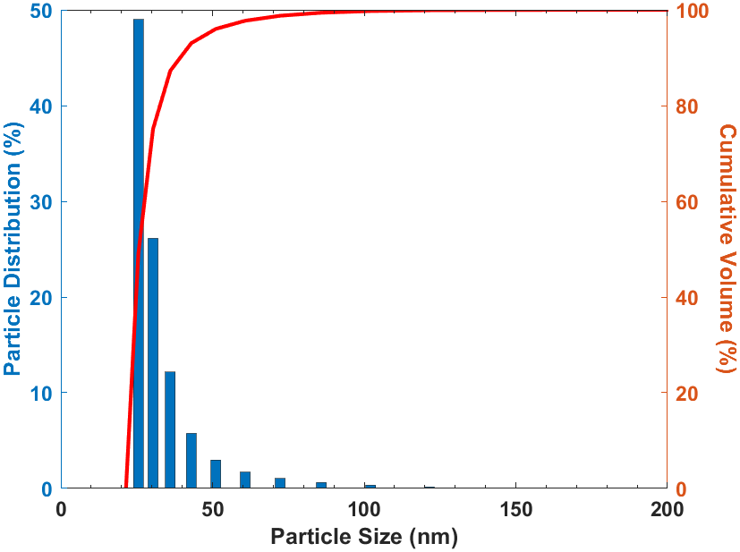
Figure S1. Measured particle size distribution of Ta₂O₅ nanoparticles dispersed in MIBK using laser diffraction analyzer.

Supplementary Note 2: Surface morphology and roughness analysis by AFM.
Figure S2. Atomic force microscopy (AFM) topography and line profile analysis of the Ta₂O₅ PER film.

The 3D AFM image (left) reveals smooth and uniform surface morphology over 3$×$5 um² area (Figure S2). The corresponding height profiles (right) show only small fluctuations, consistent with an RMS roughness (Sq) of approximately 1.2 nm, an average roughness (Sa) of 1.0 nm, and a skewness (Ssk) of -0.086, indicating a highly symmetric and flat surface.

Supplementary Note 3: Optical transparency and scattering characteristics of Ta₂O₅ PER
Figure S3. (a) Transmittance and (b) haze spectrum of 80 wt% Ta₂O₅ PER films measured by UV-visible spectrometry.

The optical characteristics of the Ta₂O₅ PER film were evaluated through transmittance and haze measurements, as shown in Figure S3. The film exhibits consistently high transmittance across the 300–700 nm spectral range. This behavior indicates that this PER film introduces minimal absorption within the UV–visible region. The haze spectrum further supports the high optical quality of the film, with haze remaining below 1% over the entire measurement range. Such low haze confirms negligible light scattering, suggesting uniform nanoparticle dispersion and a smooth film surface. These results demonstrate that the Ta₂O₅ PER provides an optically clear platform suitable for broadband metasurface fabrication.

Supplementary Note 4: Ellipsometry results of Ta₂O₅ PER
The optical constants of PER films were determined by spectroscopic ellipsometry. This technique measures the amplitude ratio ($Ψ$) and phase difference ($Δ$) between P- and S-polarized light reflected from the film surface and fits the data using an appropriate optical model to extract the refractive index and thickness. To determine the refractive index (n) and extinction coefficient (k) of the 80 wt% Ta₂O₅ PER was spin-coated onto a Si substrate. The measured Ψ and Δ spectra were fitted using the Tauc-Lorentz model and an effective medium approximation (EMA) framework incorporating the intrinsic optical constants of Ta₂O₅ (Figure S4). The mean square error (MSE) of 25.3 indicates a reasonable agreement between the measured and modeled data, supporting the validity of treating the nano-PER film as an optically homogeneous medium. The optical constants for additional weight ratios are provided in Figure S5, confirming consistent trends in refractive index enhancement with increasing nanoparticle loading.
Figure S4. Measured amplitude ratio ($ψ$) and phase difference ($Δ$) of Ta₂O₅ PER with 80 wt% nanoparticle concentration.
Figure S5. Measured refractive indices of Ta₂O₅ PER film according to particle concentrations: 89 wt%, 50 wt %, and 25 wt%.
Supplementary Note 5: Master mold fabrication process
Figure S6. Schematic of the master mold fabrication process.

Supplementary Note 6: Low-magnification SEM images of imprinted Ta₂O₅
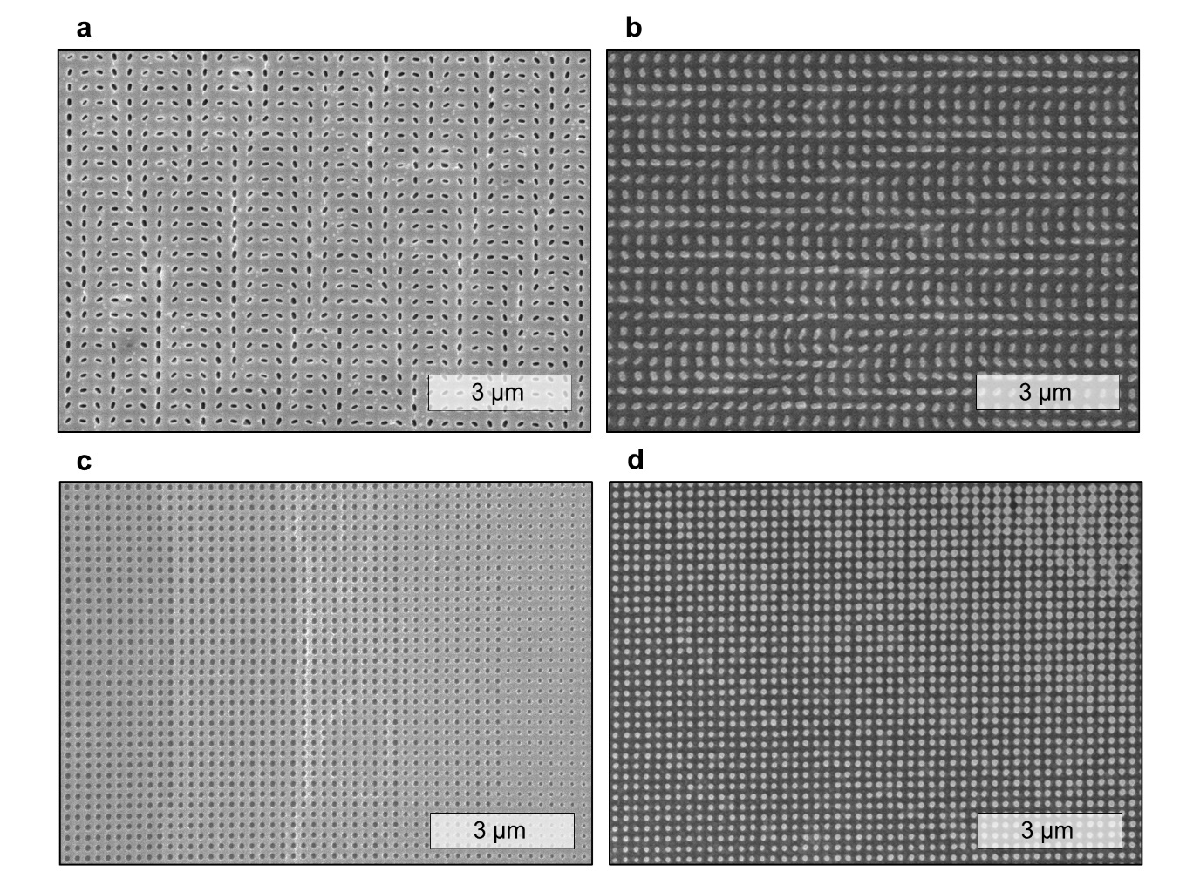
Figure S7. Low-magnification SEM images highlighting each fabricated process. Rectangular design: (a) soft mold with rectangular cavities and (b) the imprinted surface featuring well-defined rectangular nanoposts. Cylindrical design: (c) soft mold with cylindrical recesses and (d) the resulting metasurface consists of cylindrical nanopillars.

Supplementary Note 7: Tilted-view SEM images of imprinted Ta₂O₅
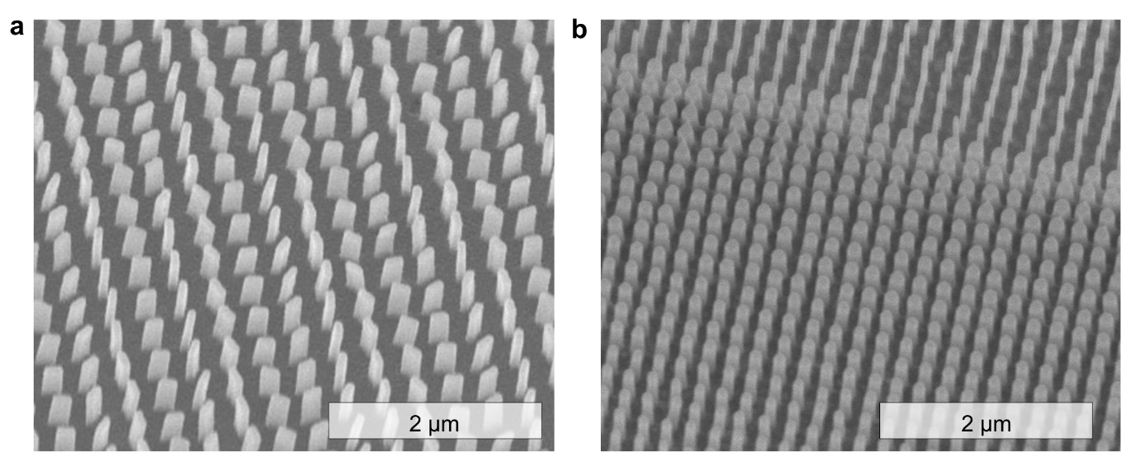
Figure S8. 30° Tilted-view SEM images of (a) rectangular nanoposts and (b) cylindrical nanopillars. Sample stage tilted 30° from top view, corresponding to a 60° viewing angle to the sidewalls, where the apparent height is approximately $\frac{1}{2}$ of the true height.

Supplementary Note 8: Fabrication conditions for imprinting Ta₂O₅ metasurfaces
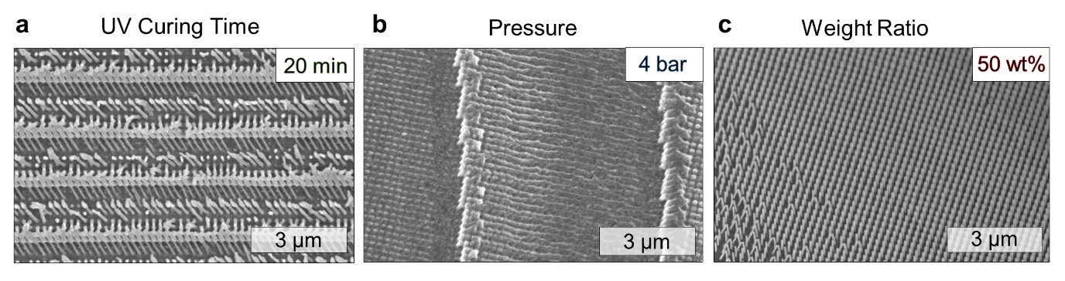
Figure S9. Influence of key process parameters on imprint quality. (a) Short UV-curing time leads to the resin mechanically under cross linked, causing collapse during demolding. (b) Excessive imprint pressure deforms the soft mold, distorting the replicated pattern. (c) An in sufficient nanoparticle to resin weight ratio under the same curing time fails to support high AR, leading to structural instability.

Figure S10. Cross-sectional SEM images of PB phase meta-toms fabricated with different Ta₂O₅ nanoparticle weight ratios (50 wt% and 80 wt%) under the same curing time condition.

Supplementary Note 9: Simulation results of E-field distribution
Figure S11. Simulated electromagnetic field distributions in the yz-plane under x-polarized light incident on the meta-atom rotated by θ = 45° at wavelengths of 320, 405, 450, 532, and 635 nm using finite element simulation. The field intensity is presented in absolute units ${\left(V/m\right)}^{2}$, showing wavelength-dependent field confinement within the dielectric meta-atom (black outline). The variation in the intensity of ${\left|E_{x}\right|}^{2}$ and ${\left|E_{y}\right|}^{2}$ suggests polarization conversion effects that vary with wavelength. The structural parameters used in the simulations are a width of 80 nm, length of 200 nm, height of 600 nm, and period of 320 nm.

Supplementary Note 10: Phase map for Ta₂O₅ hologram
Figure S12. Phase-only metahologram design with a phase map generated via the Gerchberg–Saxton (GS) algorithm.
Supplementary Note 11: Optical setup of hologram measurement
Figure S13. Schematic of the PB phase experimental hologram capturing setup (LP: linear polarizer, QWP: quarter wave plate, MS: metasurface). The holographic image at the 320 nm wavelength was recorded using a CCD camera due to the limited sensitivity of the human eye. Images at the other wavelengths were directly captured from the projection screen.

Supplementary Note 12: Design of hyperbolic metalens
Figure S14. Numerical characterization of Ta₂O₅ PER hyperbolic metalens: (a) calculated phase map and (b) normalized intensity distribution at the designed focal plane.

Supplementary Note 13: Meta-atom field confinement
Figure S15. Simulated magnetic field intensity (${\left|H\right|}^{2}$) profiles for eight selected meta-atoms using finite element simulation. The field intensity is presented in absolute units ${\left(A/m\right)}^{2}$, showing strong field confinement to minimize the coupling among structures (black outline)

Supplementary Note 14: Optical setup of lens measurement
Figure S16. Schematic of the propagation phase experimental lens measurement setup (MS: metasurface, OL: object lens, TL: tube lens).

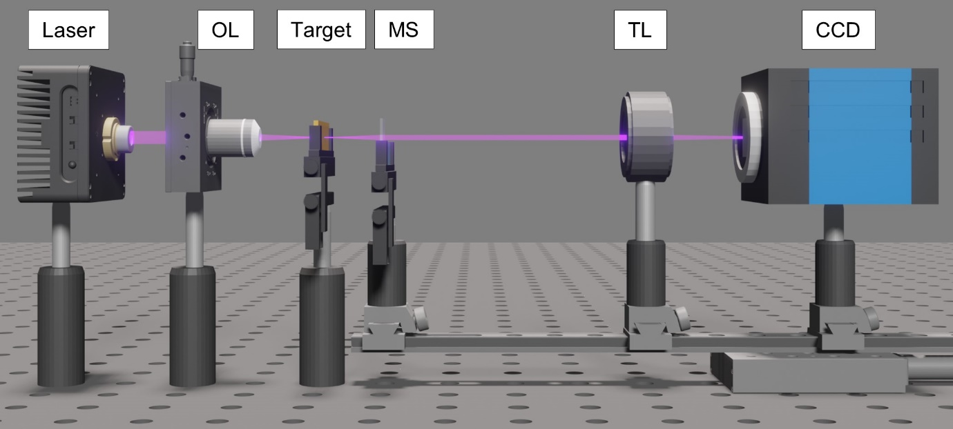
Figure S17. Schematic of the propagation phase imaging setup (OL: object lens, MS: metasurface, TL: tube lens).

Supplementary Note 15: MTF analysis
Figure S18. Measured modulation-transfer function (MTF) of the PER metalens (ML) (solid line) versus the diffraction-limited MTF (dashed). The PER ML attains the theoretical cutoff frequency of 1250 lp/mm. The corresponding spatial frequencies at MTF = 0.7, 0.5, 0.3, and 0.1 are 186, 341, 565, and 807 lp/mm, respectively.

