Triboelectric Horology: Escapement-Inspired Design Strategy for Prolonged Energy Harvesting under Irregular Mechanical Inputs

Donghan Lee^{1*}, Sanghu Ju^{1*}, Dong Yong Park^{2*} Seokhoon Kwon¹, Yong Woo Jeong¹, Minsik Choi¹, Sangjun Lee¹, Yu-seop Kim¹, Sumin Cho¹, Dongik Kam¹, Zong-Hong Lin^{1,3**}, and Dongwhi Choi^{1**}

¹Department of Mechanical Engineering (Integrated Engineering Program), Kyung Hee University, 1732 Deogyeong-daero, Yongin, Gyeonggi, 17104, Republic of Korea
²Advanced Mobility Components Group, Korea Institute of Industrial Technology, 320 Techno sunhwan-ro, Yuga-eup, Dalsung-gun, Republic of Korea
³Department of Biomedical Engineering, National Taiwan University, Taipei, 106319, Taiwan

*D. Lee, and S. Ju contributed equally to this work

**To whom all correspondence should be addressed.
Email: zhlin@ntu.edu.tw (Prof. ZH. Lin)
Email: dongwhi.choi@khu.ac.kr (Prof. D. Choi)
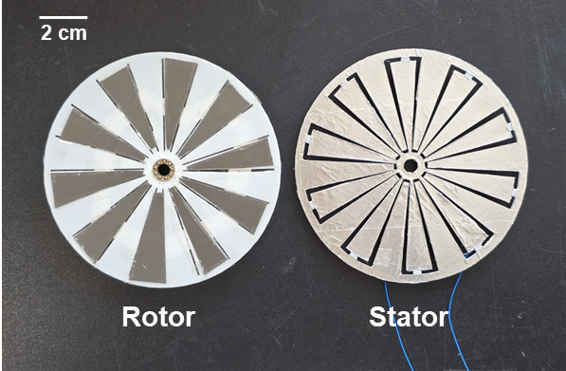
Figure S1. Photograph of surfaces of the rotor and the stator.

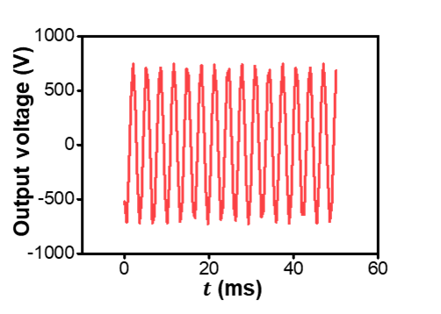
Figure S2. Enlarged view of the graph from Figure 1c.

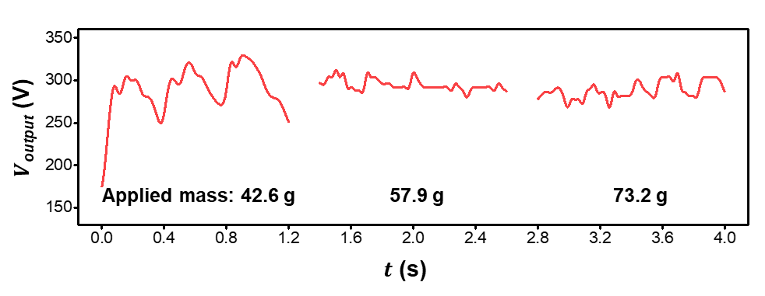
Figure S3. Upper envelope of the result shown in Figure 3g.

