Supplementary Information
A Robotic Patch-Clamp System with Real-Time Localization and Phase-Synchronized Capture of Dynamic In Vivo Cells Using Micropipette Resistance Modelling
Ruimin Li^{1,2}, Hao Chen^{1,2}, Bo Hu^{1,2}, Jinyu Qiu^{1,2}, Yuzhu Liu^{1,2}, Zijian Guo^{1,2}, Shouguo Wu^{1,2}, Mengya Liu^{1,2}, Ran Ding⁴, Shengkai Ding⁵, Yuanyuan Li⁵, Xiaogang Pang⁶, Hui Shen⁷, Qili Zhao^{1,2,3*}, and Xin Zhao^{1,2*}
¹National Key Laboratory of Intelligent Tracking and Forecasting for Infectious Diseases, Engineering Research Center of Trusted Behavior Intelligence, Ministry of Education, Tianjin Key Laboratory of Intelligent Robotics, Institute of Robotics and Automatic Information System, Nankai University, Tianjin 300350, China
²Institute of Intelligence Technology and Robotic Systems, Shenzhen Research Institute of Nankai University, Shenzhen 518083, China
³Beijing Advanced Innovation Center for Intelligent Robots and Systems, Beijing Institute of Technology, China
⁴Hong Kong Plexon Co., Ltd., Hong Kong, China.
⁵Laboratory of Traditional Chinese Medicine Neuroscience, Shandong University of Traditional Chinese Medicine, Jinan 250355, China
⁶Experimental Center, Shandong University of Traditional Chinese Medicine, Jinan 250355, China.
⁷Laboratory of Neurobiology, School of Basic Medical Sciences, Tianjin Medical University, Tianjin 300070, China.
* Corresponding Authors: Qili Zhao (zhaoqili@nankai.edu.cn) and Xin Zhao (zhaoxin@nankai.edu.cn)

List of contents:
- In vivo patch-clamp system
- Analytical model of series resistance
- Measurement of micropipette geometric parameters
- Model and simulations for micropipette resistance model
- Online calibration of the micropipette resistance model
- Implementation details of different filtering algorithms
- Representative current traces during successful patch-clamp seal formation

- In vivo patch-clamp system
The proposed in vivo patch-clamp manipulation system was developed using a conventional in vitro patch-clamp setup. By replacing the custom-designed mouse brain fixation device with a customized supporting platform, the system can be readily reconfigured to its original in vitro configuration. This modular design demonstrates the versatility and reusability of the system, enabling flexible adaptation for both in vivo and in vitro applications. It serves as a multi-purpose and highly adaptable device, providing a valuable reference for the design of future systems.
Figure S1. Photograph of the developed robotic in vivo patch-clamp system. (A) Overview of the system control rack showing the main control units, including the amplifier, A/D converter, data acquisition (DAQ) system, and Scientifica controller. (B) Experimental setup on the vibration-isolated platform, incorporating a custom-designed mouse brain fixation device, a Scientifica micromanipulator, and an Axon headstage for patch-clamp recordings. (C) Close-up view of the custom-designed mouse brain fixation device. (D) Top-down view of the head bar on the fixation device.
- Analytical model of series resistance
The electrolyte in the micropipette tip can be modeled as a series of infinitesimal cylindrical conductors with varying radii, as shown in Fig. S2. According to Ohm’s law and the definition of electrical resistivity, the differential resistance of an infinitesimal cylindrical conductor is given by:
$$\begin{aligned}{dR}_{s}=\frac{ρ}{πr^{2}}dl\#\left(1\right)\end{aligned}$$
in which $r=r_{i}+ltanθ$, $ρ$ is the electrical resistivity, $r$ denotes the local radius of the infinitesimal cylindrical conductor, and $dl$ is the infinitesimal length element along the micropipette axis. $R_{s}$ can be obtained from
$$\begin{aligned}R_{s}=\int_{0}^{z}{\frac{ρ}{π{\left(r_{i}+ltanθ\right)}^{2}}dl}=\frac{ρ}{π\tan\left(θ\right)}\left(\frac{1}{r_{i}}-\frac{1}{r_{i}+ztan\left(θ\right)}\right)\#\left(2\right)\end{aligned}$$
The length of the micropipette conical body is on the order of thousands of micrometers. Therefore, Equation 2 can be approximated as
$$\begin{aligned}R_{s}=\frac{ρ}{π\tan\left(θ\right)r_{i}}\#\left(3\right)\end{aligned}$$
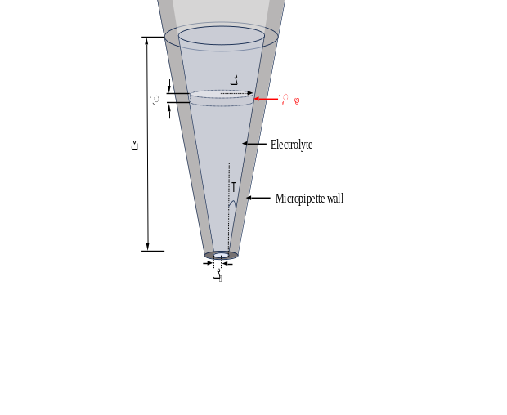
Figure S2. Schematic illustration of series resistance calculation
- Measurement of micropipette geometric parameters
Accurate characterization of micropipette geometry is essential for reliable finite element modelling (FEM) in COMSOL Multiphysics. We employed scanning electron microscopy (SEM) to quantify both the inner and outer radii of the micropipette openings. A representative SEM image is shown in Fig. S3A. Based on measurements from fifteen micropipettes, the average inner radius was 0.56 $±$ 0.09 μm and the average outer radius was 0.82$±$ 0.26 μm, as summarized in Fig. S3B. In addition, the cone angle of the tapered tip was determined using optical microscopy, with a typical image provided in Fig. S3C. The measured cone angle averaged ${2.93±0.24}^{°}$, with the distribution shown in Fig. S3D.
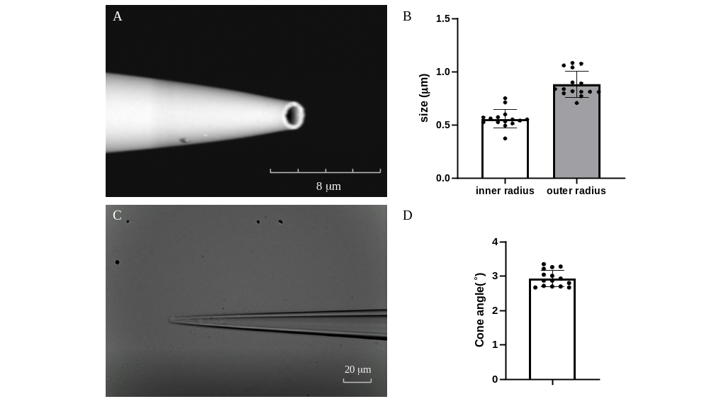
Figure S3. Measurement results of micropipette geometry. (A) A typical SEM image of the micropipette tip. (B) Statistical results of measurements for inner and outer radii of the micropipette opening. (C) A typical bright-field microscopic image of the micropipette neck. (D) Statistical results of measurements for the neck wall cone angle.

- Model and simulations for micropipette resistance model
The simulation geometry is presented in Fig. S4. Because the micropipette approaches the cell along the vertical axis, the system can be treated as axisymmetric; therefore, the spatial dimension was set to 2D axial symmetry. This approach and injection process involve multiple physical domains. The injection of the internal electrode solution from the micropipette into the in vivo environment was modeled using fluid dynamics. Given that the micropipette tip has an opening only a few micrometers in diameter, a laminar flow model was employed to describe the injection process [1]. Boundary B1 was defined as the inlet. Boundaries B2, B3, B4, and B7 were specified as no-slip walls. Boundaries B5 and B6 were treated as open boundaries to approximate an unbounded in vivo environment [2]. Domain D1 was defined as the fluid domain, which was used to simulate the living brain environment. The density and dynamic viscosity of the fluid solutions were set as ${10}^{3}$ kg/m³ [3] and${0.7×10}^{-3}$ Pa$∙$s [4], respectively.
In addition, a stationary electric current model was implemented to calculate the micropipette resistance. Boundary B1 was assigned as the anode, and boundaries B5 and B6 were set as the cathode. Boundary B1 was applied voltage of +5 mV. Boundaries B5 and B6 were set to 0 V. The conductivity of the solution was set as 0.5-1.5 S/m.
Furthermore, to capture the deformation of the cell membrane induced by the outflow from the micropipette tip, solid mechanics was incorporated into the multiphysics simulation. Boundary B8 corresponds to the cell membrane, and domain D2 was defined as an elastic material. The Young’s modulus was varied to investigate its effect on the resistance. The Poisson’s ratio and the density of the cell were set as 0.5 and 1000 kg/ m³ [5], respectively.
Fluid-structure interaction (FSI) was implemented to simulate the membrane deformation caused by the local fluid flow. The resulting deformation introduces additional distance between the micropipette tip and the membrane, thereby altering the measured micropipette resistance.
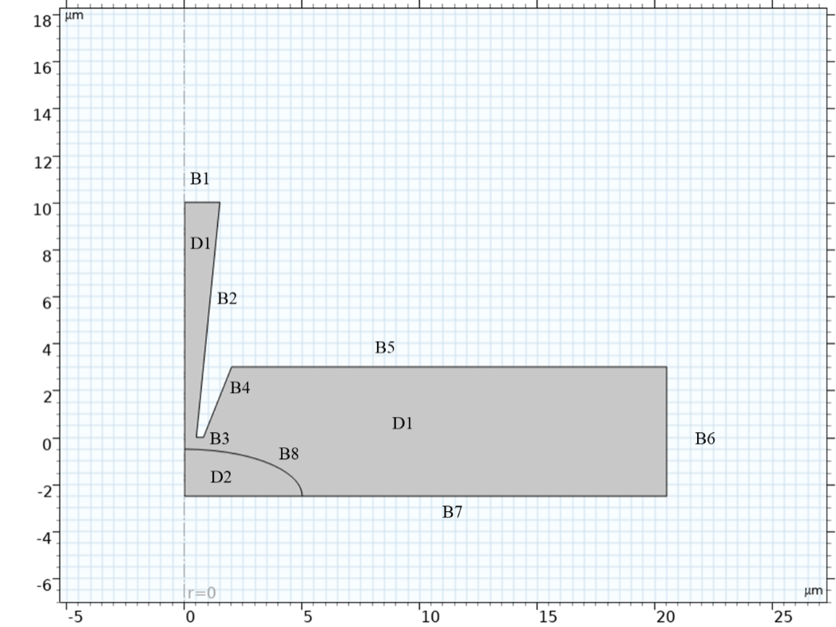
Figure S4. Geometric model of a micropipette positioned near a cell.
- Online calibration of the micropipette resistance model
We start from the theoretical resistance-distance expression (Eq. (25) in the manuscript):
$$\begin{aligned}R\left(d\right)=\frac{ρ}{0.65π{\left(d+\frac{0.165P+0.188}{\left(0.682E+4.395\right)d}\right)}^{1.2}}\ln\left(\frac{r_{o}}{r_{i}}\right)+\frac{ρ}{4.34r_{i}}+\frac{ρ}{r_{i}π\tan\left(θ\right)}\#\left(1\right)\end{aligned}$$
In Eq. (1), $\frac{ρln⁡(\frac{r_{o}}{r_{i}})}{0.65π}$ and $\frac{ρ}{4.34r_{i}}+\frac{ρ}{r_{i}π\tan\left(θ\right)}$ depend on micropipette geometry, while $\frac{0.165P+0.188}{\left(0.682E+4.395\right)}$ depends on the cell’s Young modulus $E$ and injection pressure $P$. These terms are treated as distance-independent constants during a single calibration episode. Thus, Eq. (1) can be rewritten as:
$$\begin{aligned}R_{a}\left(d\right)=\frac{c_{1}}{{\left(d+\frac{c_{2}}{d}\right)}^{1.2}}+R_{0}\#\left(2\right)\end{aligned}$$
where $c_{1}=\frac{ρln⁡(\frac{r_{o}}{r_{i}})}{0.65π}$, $c_{2}=\frac{0.165P+0.188}{\left(0.682E+4.395\right)}$ and $R_{0}=\frac{ρ}{4.34r_{i}}+\frac{ρ}{r_{i}π\tan\left(θ\right)}$ is the initial reference value independent of distance and has been recorded before.
Let $d_{0}$ denote the unknown initial separation. After a known incremental displacement $Δd$, the separation becomes $d_{0}-Δd$, yielding:
$$\begin{aligned}R\left(d_{0}-Δd\right)-R_{0}=\frac{c_{1}}{{\left(d_{0}-Δd+\frac{c_{2}}{d_{0}-Δd}\right)}^{1.2}}\#\left(3\right)\end{aligned}$$
Define $y=R\left(d_{0}-Δd\right)-R_{0}$. then $y$ is directly computed from online resistance measurements, and $Δd$ is known from the manipulator.
$$\begin{aligned}y=\frac{c_{1}}{{\left(d_{0}-Δd+\frac{c_{2}}{d_{0}-Δd}\right)}^{1.2}}\#\left(4\right)\end{aligned}$$
The unknown parameters to be calibrated are $c_{1}$, $c_{2}$, and $d_{0}$. We estimate these parameters by fitting the model-predicted y($Δd$; $c_{1}$, $c_{2}$, $d_{0}$) to the measured data using online least squares [6]. Practically, we move the micropipette downward with a fixed step size and record the corresponding resistance values. Notably, when approaching the cell, the measured resistance 𝑅 is not strictly constant. Therefore, at each step we acquire a 2-s resistance trace, extract the maximum value in each measurement cycle, and then take the average of these cycle-wise maxima to obtain a representative resistance value for that step. We then perform the above nonlinear least-squares fit on the collected $k$ ($y_{k}, {∆d}_{k}$) pairs to obtain the calibrated parameters.
Nnce $d$is estimated from the resistance-distance model, the cell’s motion (displacement) along the micropipette approaching axis can be computed as:
$$\begin{aligned}p=d_{0}-d\#\left(5\right)\end{aligned}$$
where $p$ denotes the relative cell displacement (motion) with respect to the initial state, and $d_{0}$ is the initial tip-to-membrane separation at the start of the online calibration stage.
- Implementation details of different filtering algorithms
Regarding the MDF-WFLC-KF (Multiple-Dominant-Frequency Weighted-Frequency Fourier Linear Combiner-Kalman Filter) method (workflow in Figure S5), the order of the Fourier series was set to 2 (M=2), as specified in Eq. (9) of the manuscript. For the estimation of the lower dominant frequency, the frequency adaptation factor was set to $μ_{ω}$ = 1e-4, and the weight adaptation factor was set to $μ_{w}$ = 1e-6. For the higher dominant frequency, the adaptation factor was set to $μ_{ω}=$ 5.1e-5 and the weight factor $μ_{w}$ = 5e-5. Additionally, the process noise covariance Q was set to 1e-2, and the measurement noise covariance R was set to 63.
One of the comparative filtering methods is the Extended Kalman Filter (EKF), a variant of the Kalman Filter (KF). It is used to estimate and filter the nonlinear components of the original signal, such as the frequency parameter in Eqs. (9) and (10). In this method, the original signal is also modeled as a truncated, time-varying Fourier series, with the series order M set to 2. The process noise covariance Q in the EKF was set to 1e-5, and the measurement noise covariance R was set to 1e-4.
The other comparative filtering method is MDF-WFLC (Multiple-Dominant-Frequency Weighted-Frequency Fourier Linear Combiner), which differs from MDF-WFLC-KF. Specifically, the weight factor of the Fourier series in MDF-WFLC is estimated by the WFLC, whereas in MDF-WFLC-KF it is estimated by the Kalman filter. For the lower dominant frequency, the frequency adaptation factor was set to $μ_{ω}$ = 1e-4 and the weight adaptation factor to $μ_{w}$ = 1e-6. For the higher dominant frequency, we set the adaptation factor $μ_{ω}=$ 5.1e-5 and the weight factor $μ_{w}$ = 5e-5.
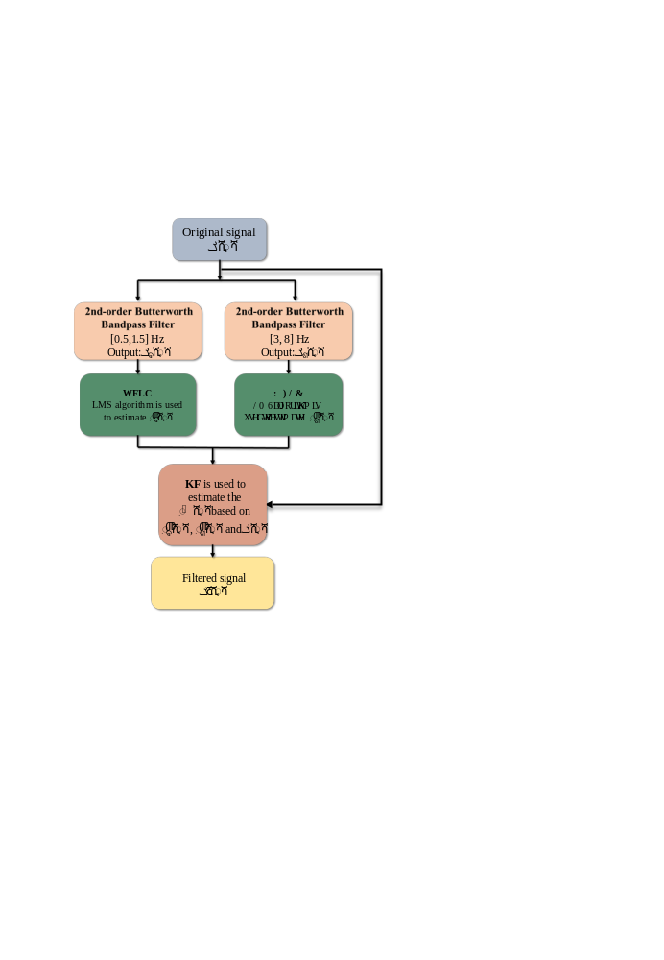
Figure S5. Workflow of the MDF-WFLC-KF algorithm.
- Representative current traces during successful patch-clamp seal formation
We provided representative segments of the raw current traces recorded by the data acquisition system (DAQS), as shown in the following figures. As described in the main text, the proximity between the micropipette tip and the cell membrane is inferred from the micropipette resistance. However, once the micropipette tip becomes sufficiently close to the cell, the resistance rises sharply toward the gigaohm scale (~1000 MΩ). Under such conditions, small resistance fluctuations in the lower range (e.g., <10 MΩ), which reflect subtle cellular micromotions, become visually negligible due to the extremely large dynamic range of the resistance signal. To more clearly reveal these fine fluctuations and their evolution during the approach process, we therefore present the current recordings acquired under a constant -70 mV voltage-clamp configuration. Because current is inversely proportional to resistance, cell-motion-induced variations remain clearly observable even when the resistance approaches the gigaohm level. Thus, the current traces are used to reflect the effectiveness of our proximity estimation and the rapid gigaseal formation during the approaching process. For transparency, all corresponding raw data have been provided in the supplementary file Data.csv. The data were downsampled to 1 kHz to facilitate storage and visualization while preserving the essential dynamics of the recorded signals.s
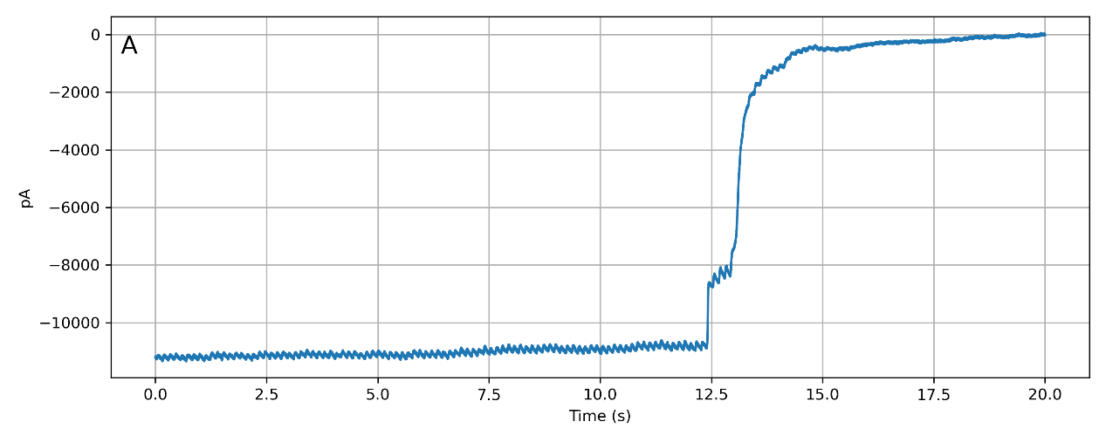
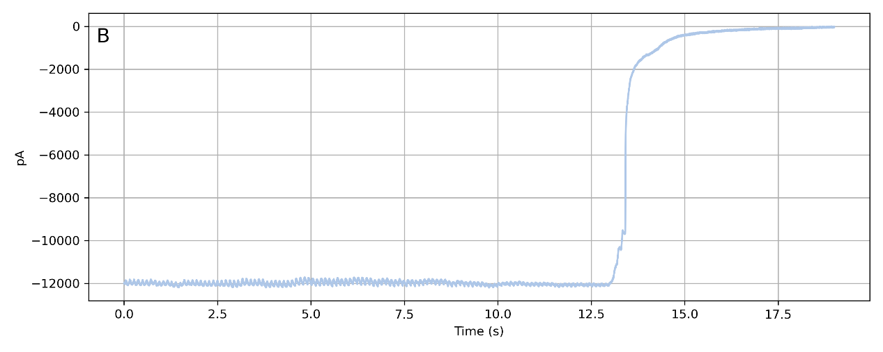
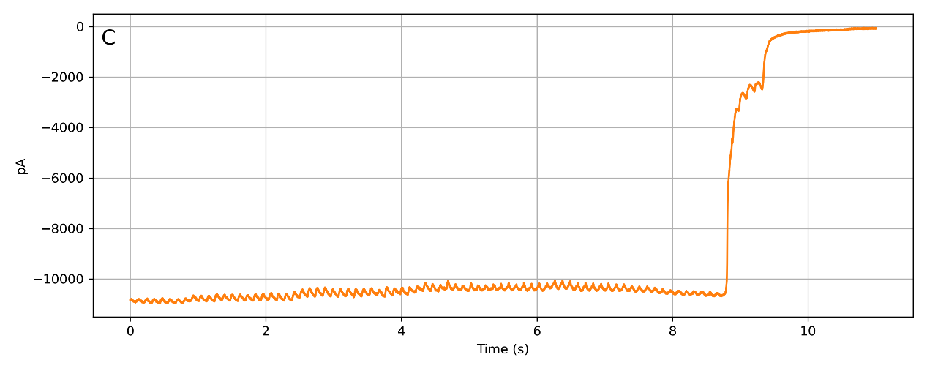
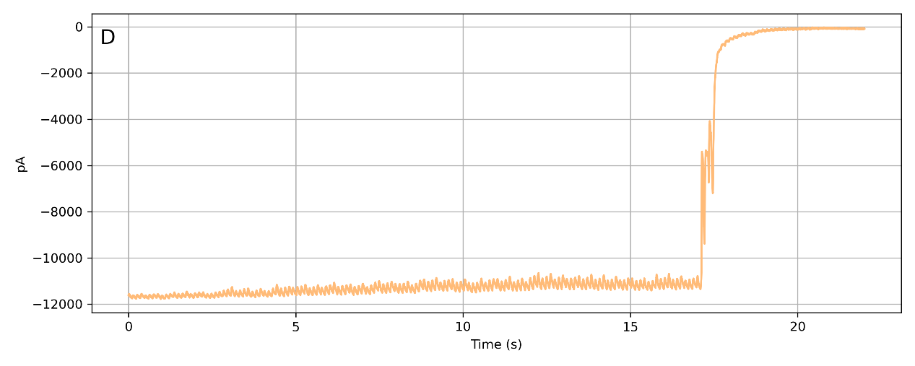
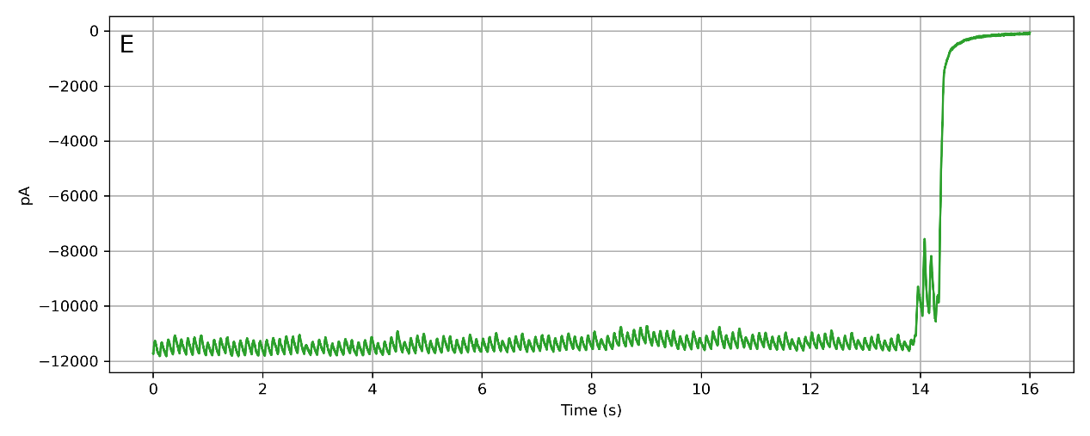
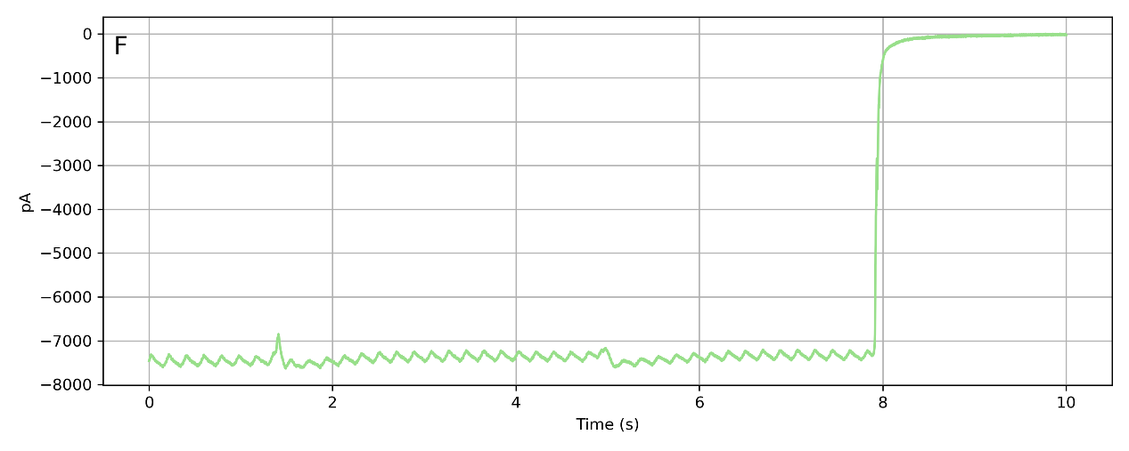
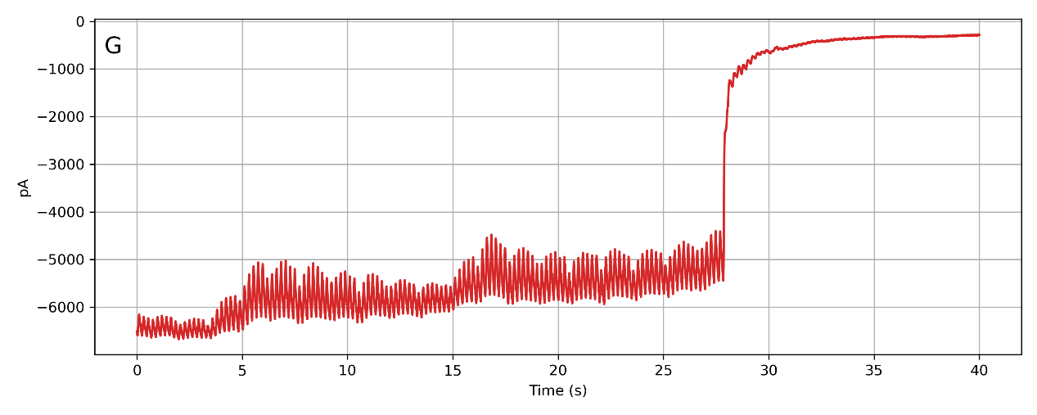
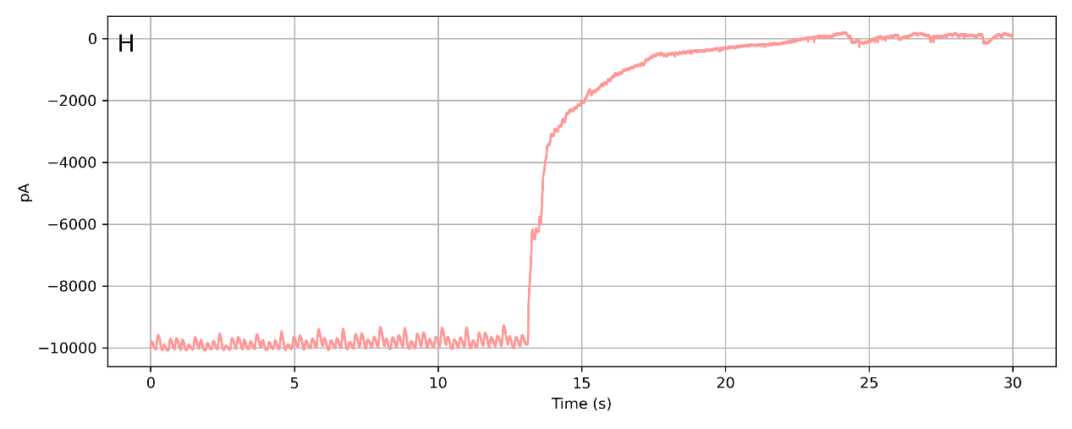
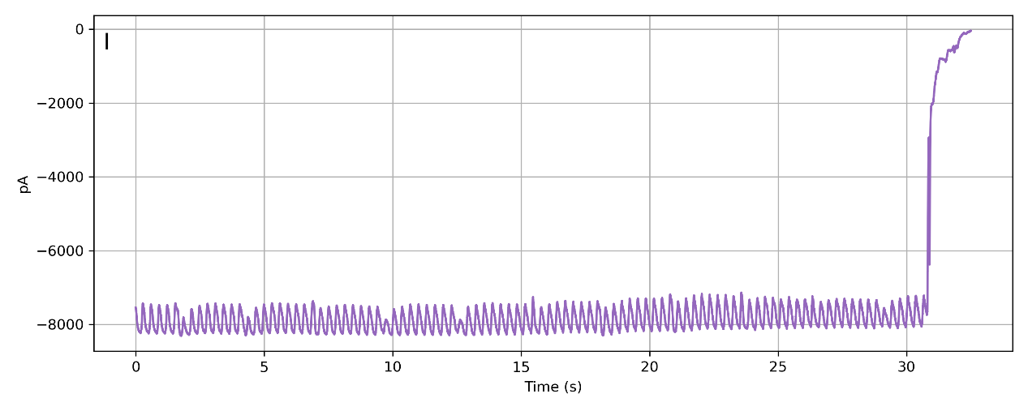
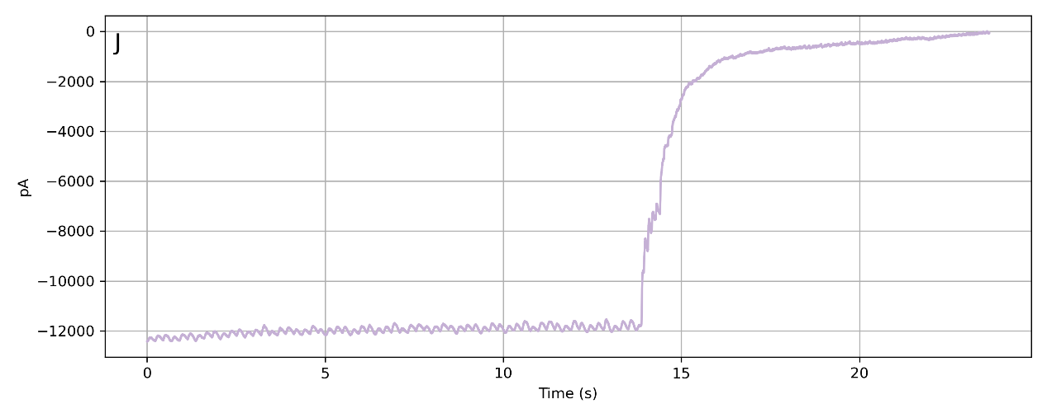
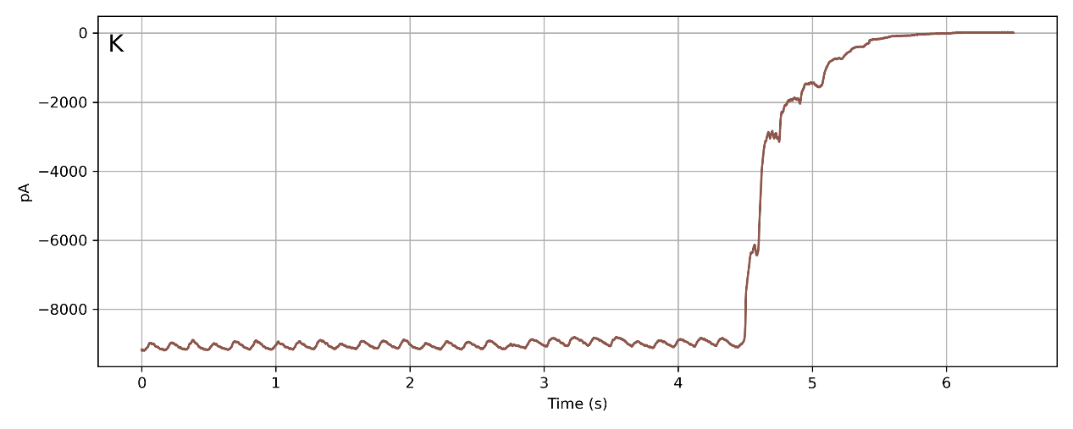
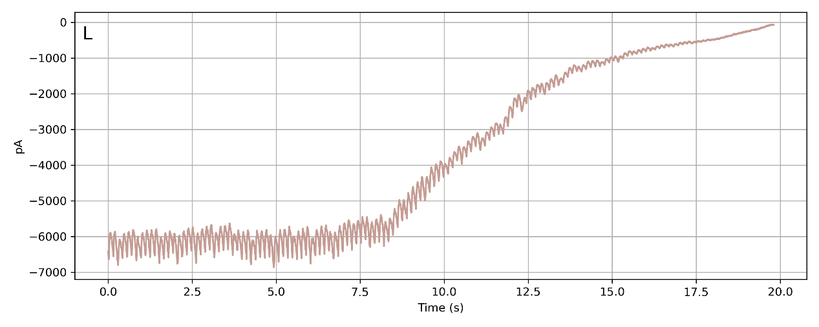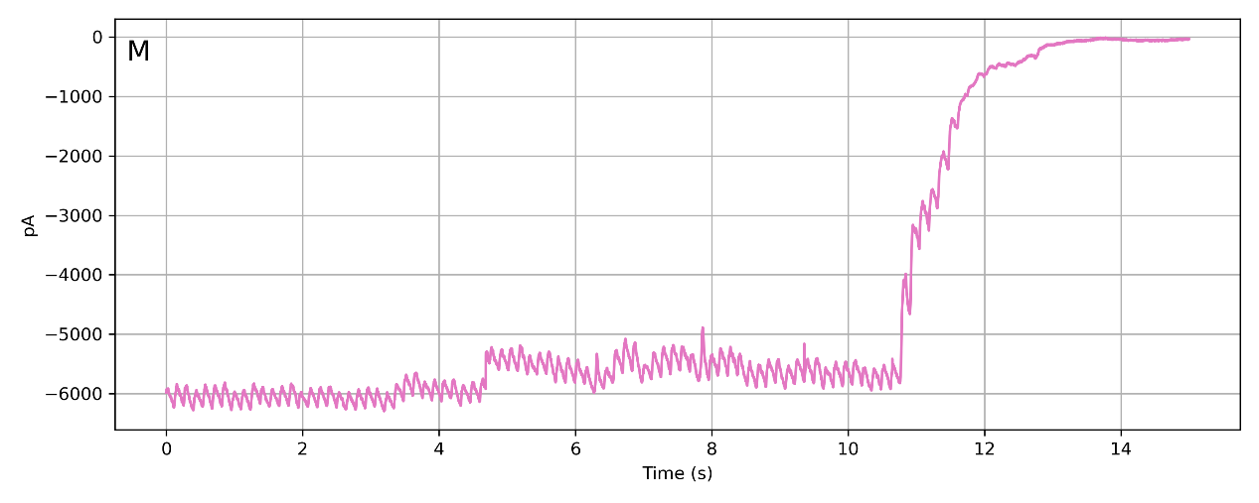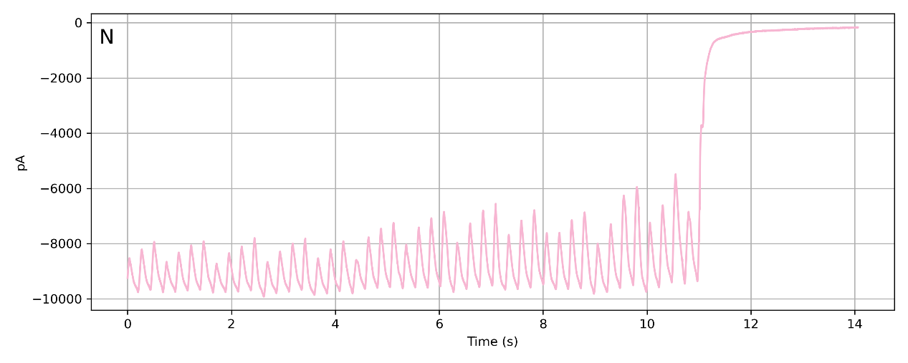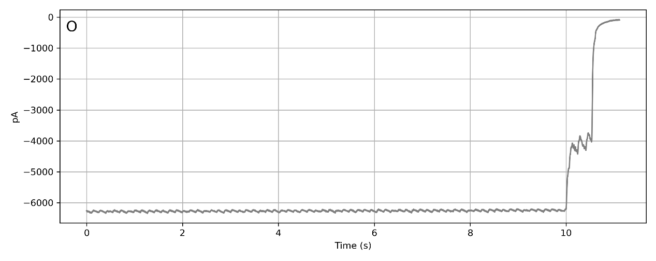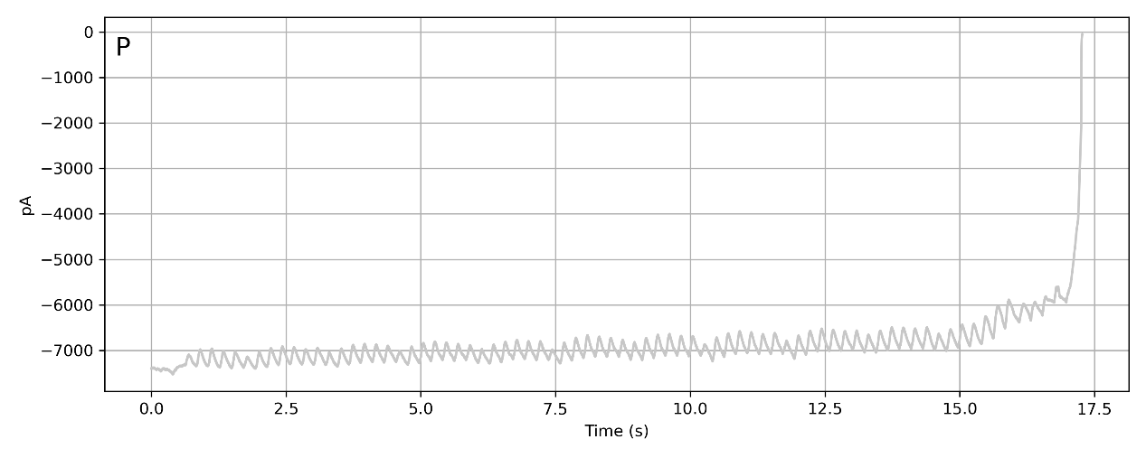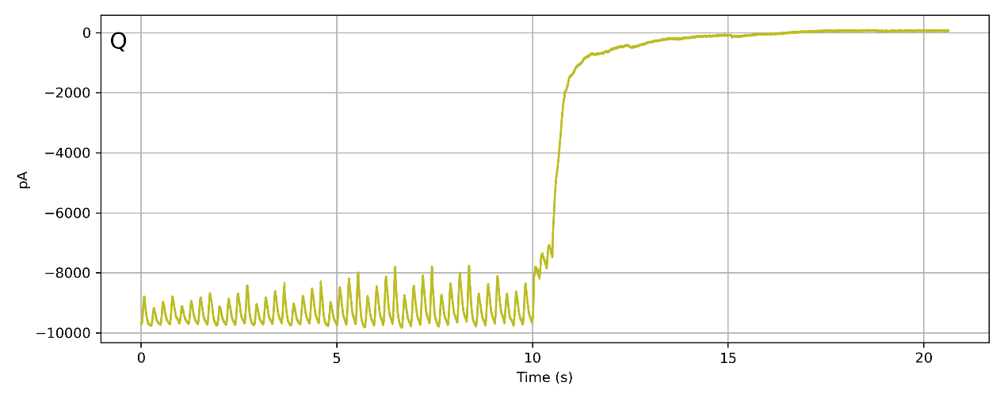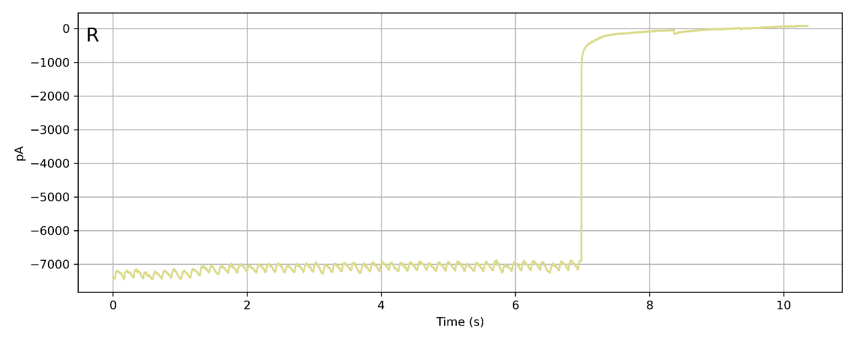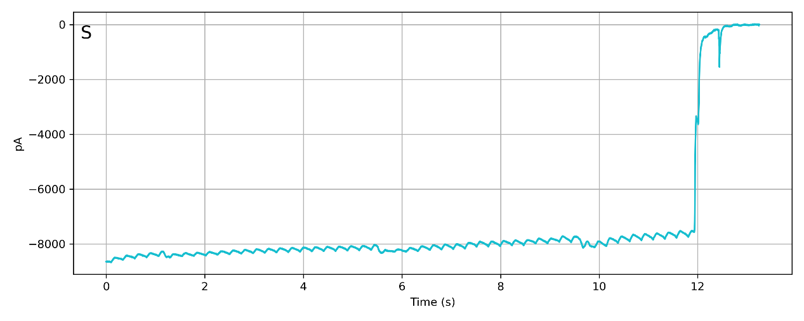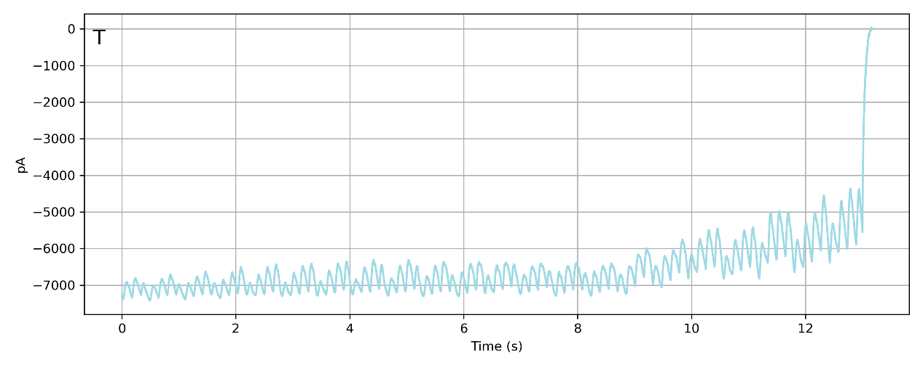
Figure S5. Representative current traces recorded under a −70 mV voltage-clamp configuration during in vivo patch-clamp seal process. The decrease in current reflects the rapid increase in micropipette resistance as the tip approaches the cell membranes.

References
[1] Schäffer, Tilman E. "Nanomechanics of molecules and living cells with scanning ion conductance microscopy." Analytical chemistry 85.15 (2013): 6988-6994.
[2] Teahan, James, et al. "Scanning ion conductance microscopy: Surface charge effects on electroosmotic flow delivery from a nanopipette." Analytical chemistry 93.36 (2021): 12281-12288.
[3] Guo, Jing, et al. "Brain maturation is associated with increasing tissue stiffness and decreasing tissue fluidity." Acta biomaterialia 99 (2019): 433-442.
[4] Rognes, Marie E., et al. "From brain physiology to brain physics." Mathematical Modelling of the Human Brain II: From Glymphatics to Deep Learning. Cham: Springer Nature Switzerland, 2025. 1-12.
[5] MacManus, David B., et al. "A viscoelastic analysis of the P56 mouse brain under large-deformation dynamic indentation." Acta Biomaterialia 48 (2017): 309-318.
[6] Fan, Haijin, Qing Song, and Zhao Xu. "Recurrent online kernel recursive least square algorithm for nonlinear modeling." IECON 2012-38th Annual Conference on IEEE Industrial Electronics Society. IEEE, 2012.

