A tumor-on-a-chip model reveals and targets reciprocal macrophage–NK cell crosstalk to advance immunotherapy screening

Xiahe Han¹, Qiurui Chen¹, Kangshuai Li², Jing Wu¹, Aoling Wang¹, Yunting Wang¹, Huajun Zhao¹*, and Wu Liu¹*
¹School of Pharmaceutical Sciences, Cheeloo College of Medicine, Shandong University; Jinan, Shandong 250012, China.
²Department of General Surgery, Qilu Hospital, Cheeloo College of Medicine, Shandong University, Jinan, Shandong, 250012, China
*Corresponding authors.
Email addresses: zhaohuajun89@sdu.edu.cn(H.Z.); wuliu@sdu.edu.cn(W.L.).
- Supporting figures
Fig. S1 Design of the TIMoC. Left panel: scale diagram and photograph of the complete chip (30 × 22 mm). Right panel: bright-field image of the microfluidic device with a magnified view of the trapezoidal microcolumns. The central chamber is a circular cavity with a diameter of 6 mm for housing the tumor microenvironment. It is flanked by two 1 mm-wide fluid channels that serve as bionic vascular cavities. These channels are separated by 0.5 mm-wide trapezoidal microcolumns, which function as a physical barrier to prevent matrix gel leakage into the fluid channels during injection.

Fig. S2 Establishment and functional validation of the endothelial lumen in the TIMoC.
- Schematic illustration of endothelial lumen formation and the 40 kDa FITC-dextran permeability assay within the chip.
- 3D fluorescence imaging confirming the formation of the vascular lumen formed by EA.hy926 cells (Calcein AM, green).
- Representative immunofluorescence images of tight junction (ZO-1, red) and endothelial (CD31, red) markers. Nuclei were stained with DAPI (blue).
- Fluorescence imaging of 40 kDa FITC-dextran diffusion in control (without lumen) and EA.hy926 (with lumen) channels at indicated time points (left). Quantitative analysis of relative fluorescence intensity at varying distances within the central chamber (right) verifies the integrity of the endothelial barrier.

Fig. S3 Characterization of FITC-dextran diffusion in the TIMoC.
- Fluorescence images showing the diffusion profile of Fluorescein isothiocyanate (FITC)-dextran over time in devices prepared with different Matrigel concentrations.
- Quantification of the relative fluorescence intensity across the central chamber for the different Matrigel concentrations shown in (A).
- Quantification of the relative fluorescence intensity under dynamic (perfused) versus static culture conditions.
Fig. S4 Establishment and validation of a hypoxic microenvironment in TIMOC.
- Schematic illustrating the modification of the standard TIMoC to create hypoxic conditions. An airtight glass coverslip (12 × 10 mm) was sealed over the central chamber and fluid channels to limit oxygen diffusion, establishing a physiologically relevant oxygen gradient.
- Representative immunofluorescence images of HIF-1α expression (green) in tumor cells under normoxic and hypoxic conditions. Nuclei are counterstained with DAPI (blue).
- Quantification of HIF-1α fluorescence intensity, confirming significant upregulation under hypoxia.

Fig. S5 NK cell migration and infiltration in TIMoC.
- Representative fluorescence image showing NK-92Mi cells (blue) migrating from the fluid channel into the central region containing Hep3B tumor cells (green).
- Quantification of NK cell infiltration into the tumor area, expressed as fluorescence intensity across the central chamber.
- Fluorescence image demonstrating the accumulation of NK-92Mi cells within the tumor region after 48 hours of culture.

Fig. S6 Long-term viability and function of tumor cells in TIMoC under perfusion.
A. Representative fluorescence images of GFP-Hep3B cells at indicated time points under dynamic (perfused) and static culture conditions.
B. Quantification of tumor cell growth, measured by GFP fluorescence intensity over 12 days.
C. Albumin secretion by Hep3B cells, assessed by ELISA, demonstrating enhanced hepatic function under dynamic perfusion.

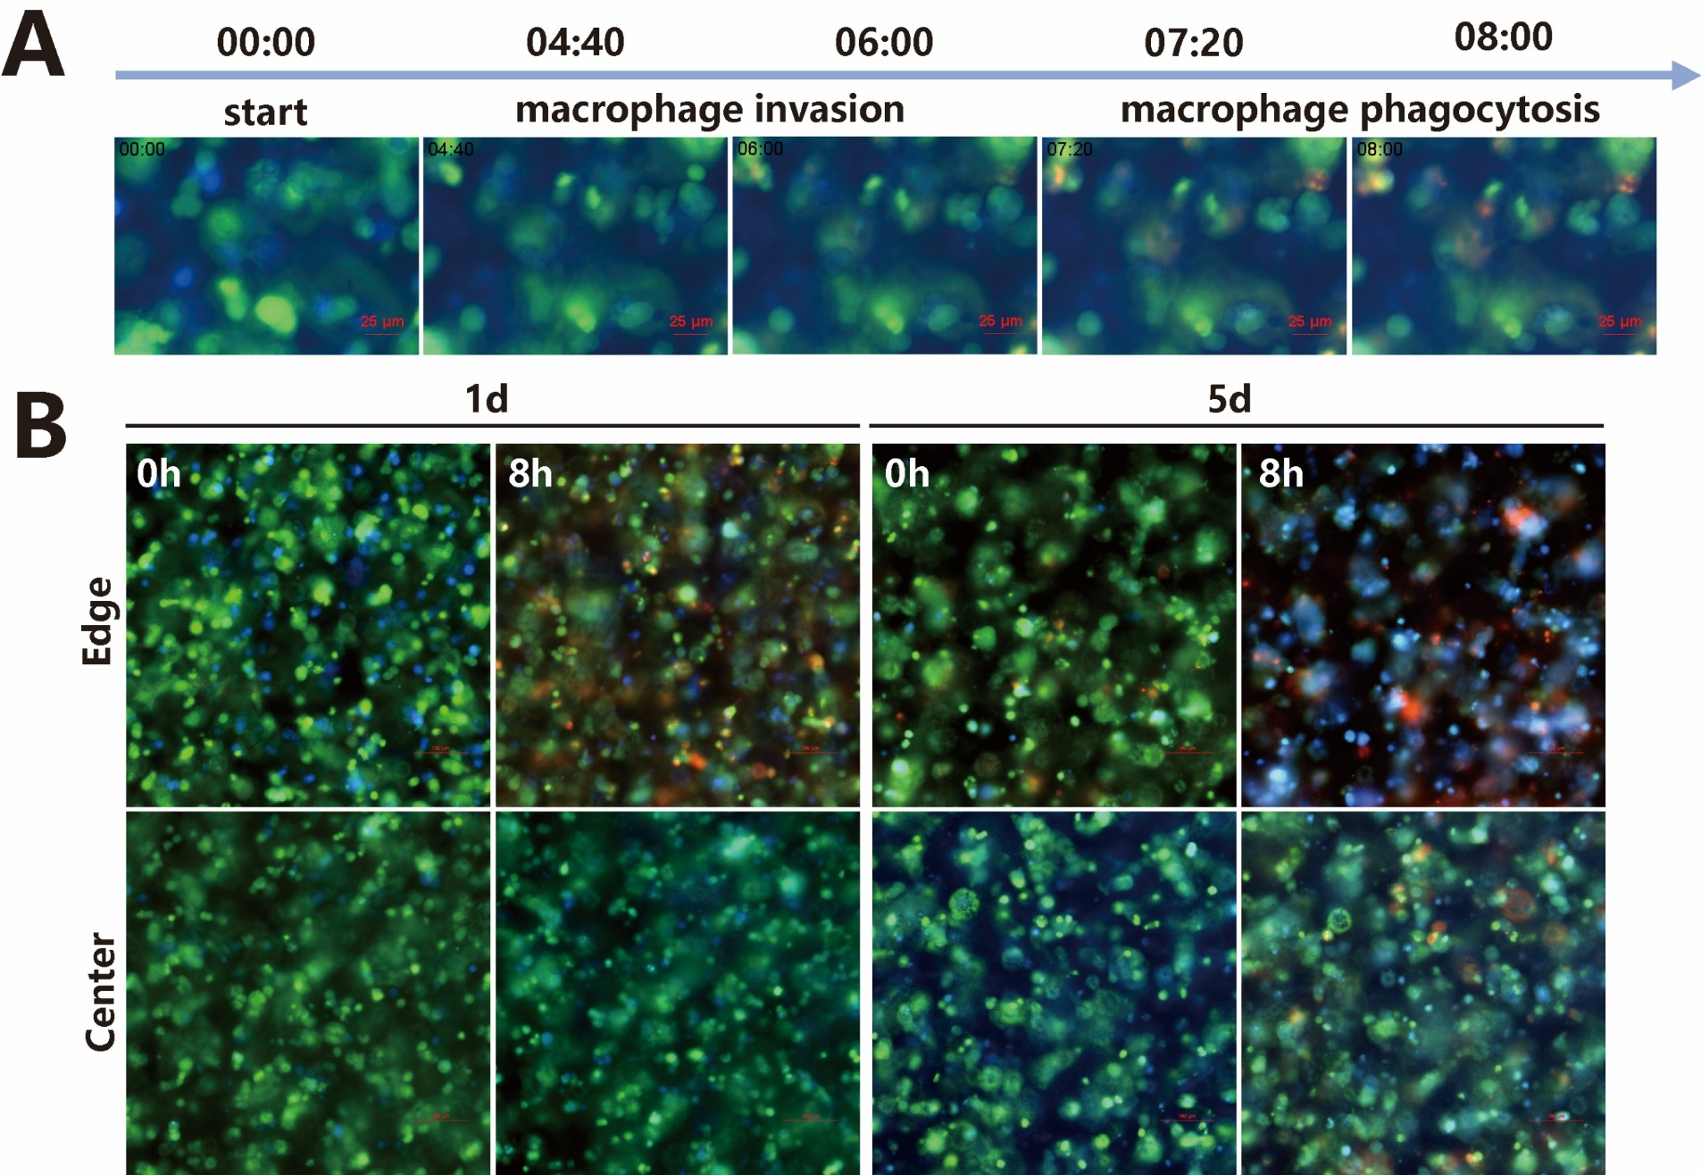
Fig. S7 Spatiotemporal analysis of macrophage phagocytosis in TIMoC.
A. Fluorescence time-series images showing the process of macrophage phagocytosis of tumor cells. Hep3B tumor cells were labeled with CMFDA (green), macrophages with CMAC (blue), and dead cells with propidium iodide (PI, red).
B. Representative fluorescence images of macrophage phagocytosis activity in the central (core) and peripheral (edge) regions of the TIMoC at day 1 and day 5.

Fig. S8 Comparison of macrophage polarization markers in traditional 2D culture versus the TIMoC platform. Representative flow cytometry plots and quantification of CD86 (top) and CD163 (down) expression on macrophages cultured in a petri dish versus the TIMoC system. Data demonstrate a significant shift towards an M2-like, pro-tumor phenotype in the physiologically relevant TIMoC microenvironment.

Fig. S9 Determination of optimal NK effector-to-target ratio
Tumor cells were cultured alone or co-cultured with NK cells at varying effector-to-target (E:T) ratios for 72 hours. Tumor cell viability was quantified in (A) traditional 2D culture and (B) the TIMoC model. NK cells exhibited enhanced cytotoxic sensitivity in the TIMoC model compared to 2D culture at equivalent E:T ratios. Based on the kinetic analysis of tumor cell killing, a 1:3 NK-to-tumor cell ratio was selected for subsequent experiments.

Fig. S10 Analysis of the cytotoxic ability changes of NK cells co-cultured with macrophages under conventional 2D culture conditions. NK cells were co-cultured alone and with M₀ and M₂ macrophages for 48 h, and then the cytotoxicity of NK cells against Hep3B cells was observed. Under the absence of tumor microenvironment stress, the cytotoxic ability of macrophages against NK cells was not significantly affected.

Fig. S11 Hypoxia modulates macrophage-NK cell crosstalk and spatial heterogeneity.
Quantification of tumor growth and spatial distribution under different oxygen conditions. Panels: relative changes in tumor cell fluorescence intensity in core versus perivascular regions, normalized to tumor-only controls. (A) normoxic conditions. (B) hypoxic conditions. Results demonstrate that hypoxia induces distinct spatial patterning in tumor-immune interactions.

Fig. S12 Analysis of tumor cell motility in TIMoC.
- Representative migration trajectories of Hep3B tumor cells under different culture conditions, obtained through real-time tracking.
- Quantitative analysis of migration parameters including velocity, accumulated distance, invasive rate, and directionality.

Fig. S13 Analysis of post-sort target cell purity.
A. Representative fluorescence images of the target cell population following FACS. Prior to the on-chip co-culture, target cells and non-target cells were labeled with CMFDA (green) and CM-DiI (red), respectively.
B. Quantitative analysis of the post-sort cell purity. The percentage of CMFDA-positive target cells in the sorted population exceeded 95%. Data presented as means ± SD (n = 4).

Fig. S14 Transcriptomic profiling of NK cells following macrophage interaction in TIMoC.
- Venn diagram showing the overlap of expressed genes between the Hep3B-NK co-culture and the Hep3B-macrophage-NK triculture.
- Volcano plot dispalying differentially expressed genes (DEGs) in NK cells from the triculture compared to the co-culture.
- Gene Ontology (GO) enrichment analysis of DEGs, categorizing enriched terms by biological process, cellular component, and molecular function.

Fig. S15 CD36-mediated lipid uptake impairs NK cell anti-tumor function in TIMoC.
- Expression of CD36 and PPARγ in NK cells following macrophage crosstalk within the TIMoC.
- Representative fluorescence images of GFP-Hep3B tumor cells after 48‑hour treatment with 100 μM of the CD36 inhibitor sulfo‑N‑succinimidyl oleate (SSO).
- Quantification of viable tumor area from (B), demonstrating that CD36 inhibition restores NK cell cytotoxic function in the presence of M2 macrophages.

Fig. S16. Perturbation analysis of the reciprocal dysfunction induced by macrophage-NK cell crosstalk.
- Flow cytometry analysis of IFN-γ and TNF expression in NK-92mi cells. Compared to the M2 macrophage co-culture group, the introduction of resting M0 macrophages effectively ameliorated the immunosuppressive microenvironment, leading to enhanced expression of IFN-γ and TNF in NK cells. Data are presented as mean±SD (n = 3).
- Flow cytometric analysis and quantification of the M1-associated marker CD86 and the M2-associated marker CD163 on macrophages. In the TIMoC, anti-TIGIT mAb directly acted on NK cells to relieve their suppression. Compared to the untreated triculture group, the addition of anti-TIGIT mAb significantly upregulated CD86 expression and downregulated CD163 levels, indicating a partial reversal of the immunosuppressive macrophage phenotype. Data are presented as mean±SD (n = 3).
Fig. S17 Representative mIHC images of tumor tissue from Patient #4.
A. Staining for PanCK (tumor cells), CD86 (M1 macrophages), and CD163 (M2 macrophages).
B. Staining for PanCK (tumor cells), CD68 (macrophages), and CD56 (NK cells).
Scale bars: 100 μm. The results indicate an immunosuppressive, macrophage-dominant microenvironment with depleted NK cell infiltration, characteristic of a "cold" tumor.

- Supporting tables
Table S1 Primer sequences for qPCR analysis
Gene | Species | Sequence (5’ to 3’)
IL-1β | human | F: GAGAATGACCTGAGCACCTTC  R: TGCAGTTCAGTGATCGTACAG
TNF-α | human | F: ACTTTGGAGTGATCGGCC  R: GCTTGAGGGTTTGCTACAAC
SIRPA | human | F: ATATTGTGGTGGGTGTGGTGT  R: TATGTGATATCATTTGTGTCCTGTG
IL-15 | human | F: TTTGGGCTGTTTCAGTGCAG  R: ACTTTGCAACTGGGGTGAAC
CD86 | human | F: CTGCTCATCTATACACGGTTACC  R: GGAAACGTCGTACAGTTCTGTG
CD163 | human | F: GCGGGAGAGTGGAAGTGAAAG  R: GTTACAAATCACAGAGACCGCT
CCL-2 | human | F: CAGCCAGATGCAATCAATGCC  R: TGGAATCCTGAACCCACTTCT
Arg-1 | human | F: TGGACAGACTAGGAATTGGCA  R: CCAGTCCGTCAACATCAAAACT
TREM2 | human | F: GGTCAGCACGCACAACTTG  R: CGCAGCGTAATGGTGAGAGT
TGF-β | human | F: CTAATGGTGGAAACCCACAACG  R: TATCGCCAGGAATTGTTGCTG
β-actin | human | F: AGCGAGCATCCCCCAAAGTT  R: GGGCACGAAGGCTCATCATT

