Supporting Information
A Fabrication-Aware Vectorized Generative Representation for Topology Optimization of Path-Defined MEMS Microstructures
Gong-Zeng Liu¹, Lin-Feng Zhao², Jie Zhang¹, Xiang Liu¹, Yi-Meng Lv¹, Tian-Yu Geng¹and Zai-Fa Zhou^{1,*}.
¹Key Laboratory of MEMS of the Ministry of Education, Southeast University, Nanjing 210096, China
²School of Integrated Circuits, Jiangnan University, Wuxi 214122, China
* Corresponding authors
E-mail address: zfzhou@seu.edu.cn (Zai-Fa Zhou)

Supplementary Note 1. Fabrication-aware vectorized generative representation
The proposed generative framework represents MEMS microstructures using a compact vectorized control variable, in which the topology vector Z and the width vector W jointly determine the final physical layout. Instead of directly optimizing a high-dimensional pixel map, the layout is decoded from this low-dimensional representation through a fabrication-aware generation procedure. This strategy restricts the search space to connected and manufacturable candidates while retaining sufficient topological diversity for performance optimization.
The topology-generation process is illustrated in Supplementary Fig. S1. A discrete set of DRC-compliant routing nodes is first initialized within the prescribed design window. These nodes define the feasible search graph for topology synthesis and ensure that subsequent routing operations satisfy basic spacing and boundary constraints. Starting from this feasible node set, partial routing paths are progressively generated under the control of the topology vector Z. Complementary routing branches are then introduced from the opposite side to complete the bilateral structure while preserving path continuity and spatial feasibility. Finally, the generated topology skeleton is converted into a physical layout by assigning a local linewidth profile along the path. Because the design-rule constraints are embedded in the decoding process, the generated structures do not require post hoc repair before finite-element evaluation or layout export. The complete latent-to-layout decoding procedure, including feasible-node construction, candidate filtering, latent-guided path selection, deterministic backtracking, local-linewidth assignment, and geometric refinement, is summarized in Algorithm S1.
Representative layouts decoded from different topology- and width-control vectors are shown in Supplementary Fig. S2. The examples demonstrate that different combinations of Z and W can produce substantially different routing morphologies, including compact, distributed, symmetric, and serpentine-like patterns. This confirms that the representation is not limited to small perturbations around a fixed template. Instead, it defines a structured design space in which a continuous control vector can be mapped to discrete, connected, and fabrication-compliant physical layouts.
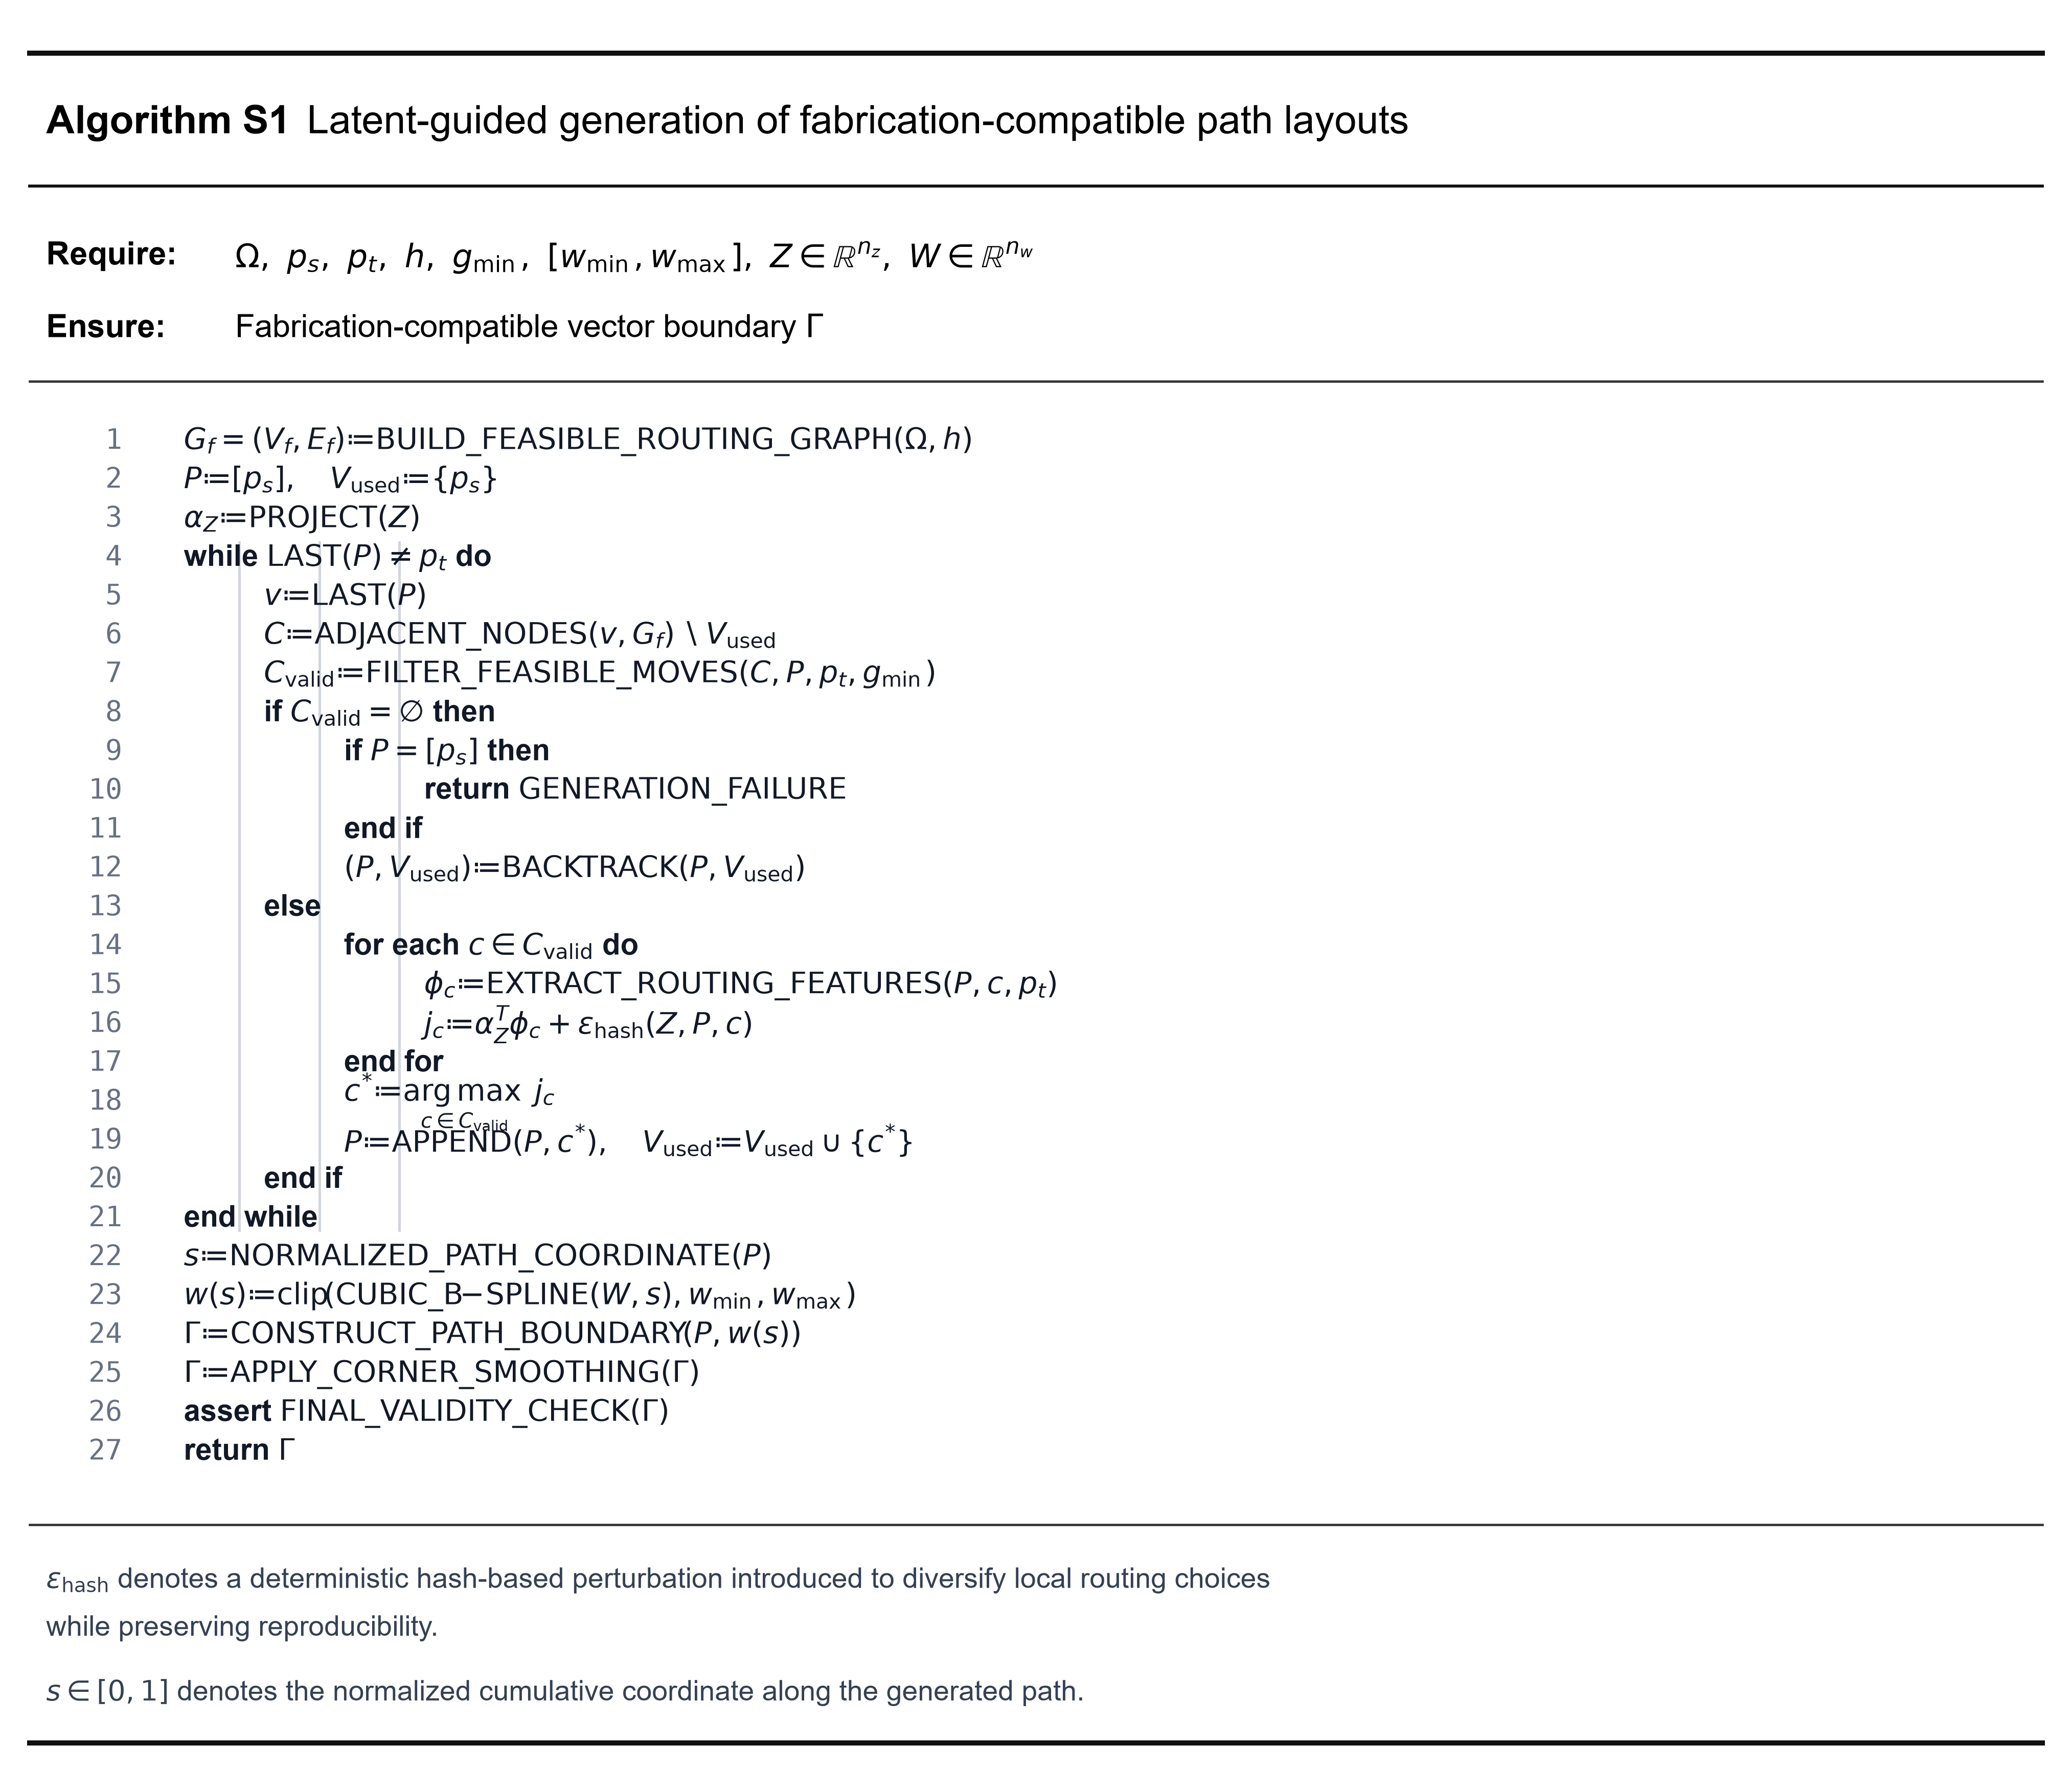
Supplementary Algorithm. S1 | Latent-guided generation of fabrication-compatible path layouts. Here, Ω denotes the prescribed design region, p_{s} and p_{t} denote the source and target terminals, h is the routing-grid resolution, g_{min} is the minimum spacing, and [w_{min} , w_{max}] defines the allowable linewidth range. At each routing step, infeasible candidate nodes are removed before latent-guided scoring. The topology-control vector Z modulates the routing-feature weights, while the deterministic hash-based perturbation introduces controlled local variation without compromising reproducibility. After the connected path skeleton has been completed, the width-control vector W is mapped through cubic B-spline interpolation along the normalized path coordinate to define the local linewidth distribution. The resulting physical boundary is subsequently smoothed and subjected to a final geometric-validity check.
The role of width modulation is further shown in Supplementary Fig. S3. Even when the global topology remains similar or closely related, variations in the width vector W lead to different local linewidth distributions. This indicates that the representation separates, but does not fully decouple, the control of topology and geometry. The topology vector Z mainly determines the routing skeleton and spatial deployment of the structure, whereas the width vector W adjusts the local and average metal coverage along the generated path. Such coordinated control is important for MEMS optimization because many device responses depend not only on the connectivity of the layout, but also on local resistance, heat generation, stiffness, and stress concentration.
After generation, each layout is processed through two synchronized data channels, as shown in Supplementary Fig. S4. The linewidth-assigned vector geometry is exported as a layout file for finite-element labeling, while the same geometry is rasterized into an image representation for CNN-based surrogate learning. Since both representations are derived from the same generated layout, the physical labels and image inputs maintain a one-to-one correspondence. This dual-channel data generation strategy allows high-fidelity simulation results to be used as supervised labels while preserving a morphology-based input format suitable for deep learning.
To evaluate the coverage and interpretability of the generated design space, several geometry-level descriptors were extracted from representative generated samples, including metal area ratio, coarse spatial coverage ratio, perimeter metal fraction, centerline length, and mean linewidth. Supplementary Fig. S5 shows the distribution of metal area ratio. The broad distribution indicates that the generator can produce layouts with different filling levels, rather than only generating minor geometric variations with nearly identical material usage.
Supplementary Fig. S6 shows the distribution of coarse spatial coverage ratio, which characterizes how broadly the generated metal routing occupies the design domain at a coarse spatial scale. The resulting distribution confirms that the generator can access both locally concentrated and spatially distributed layouts. This is important for topology optimization because different MEMS functions may require either localized response enhancement or global field redistribution.
Supplementary Fig. S7 presents the distribution of perimeter metal fraction. This descriptor reflects the extent to which the generated routing is deployed near the boundary region of the design domain. The observed variation indicates that the representation can generate both centrally concentrated and perimeter-rich structures. For electrothermal MEMS layouts, this capability is particularly useful because peripheral routing and local linewidth modulation can be used to redistribute Joule heating and suppress temperature nonuniformity.
Finally, Supplementary Fig. S8 summarizes the relationship between centerline length, metal area ratio, and mean linewidth. The positive correlation between centerline length and metal area ratio confirms that the generated design space remains physically interpretable: longer routing paths generally increase the metal filling ratio, while the width vector further adjusts the final metal coverage through local linewidth modulation. Therefore, the proposed representation provides a controllable and interpretable design space, rather than an unconstrained random pattern generator.
Together, Supplementary Figs. S1–S8 show that the proposed vectorized representation supports three key requirements for MEMS topology optimization: fabrication-aware generation, structural diversity, and geometry-level interpretability. These properties allow the subsequent surrogate-assisted optimization to be performed directly in the compact latent control space while ensuring that all decoded candidates remain connected and manufacturable.
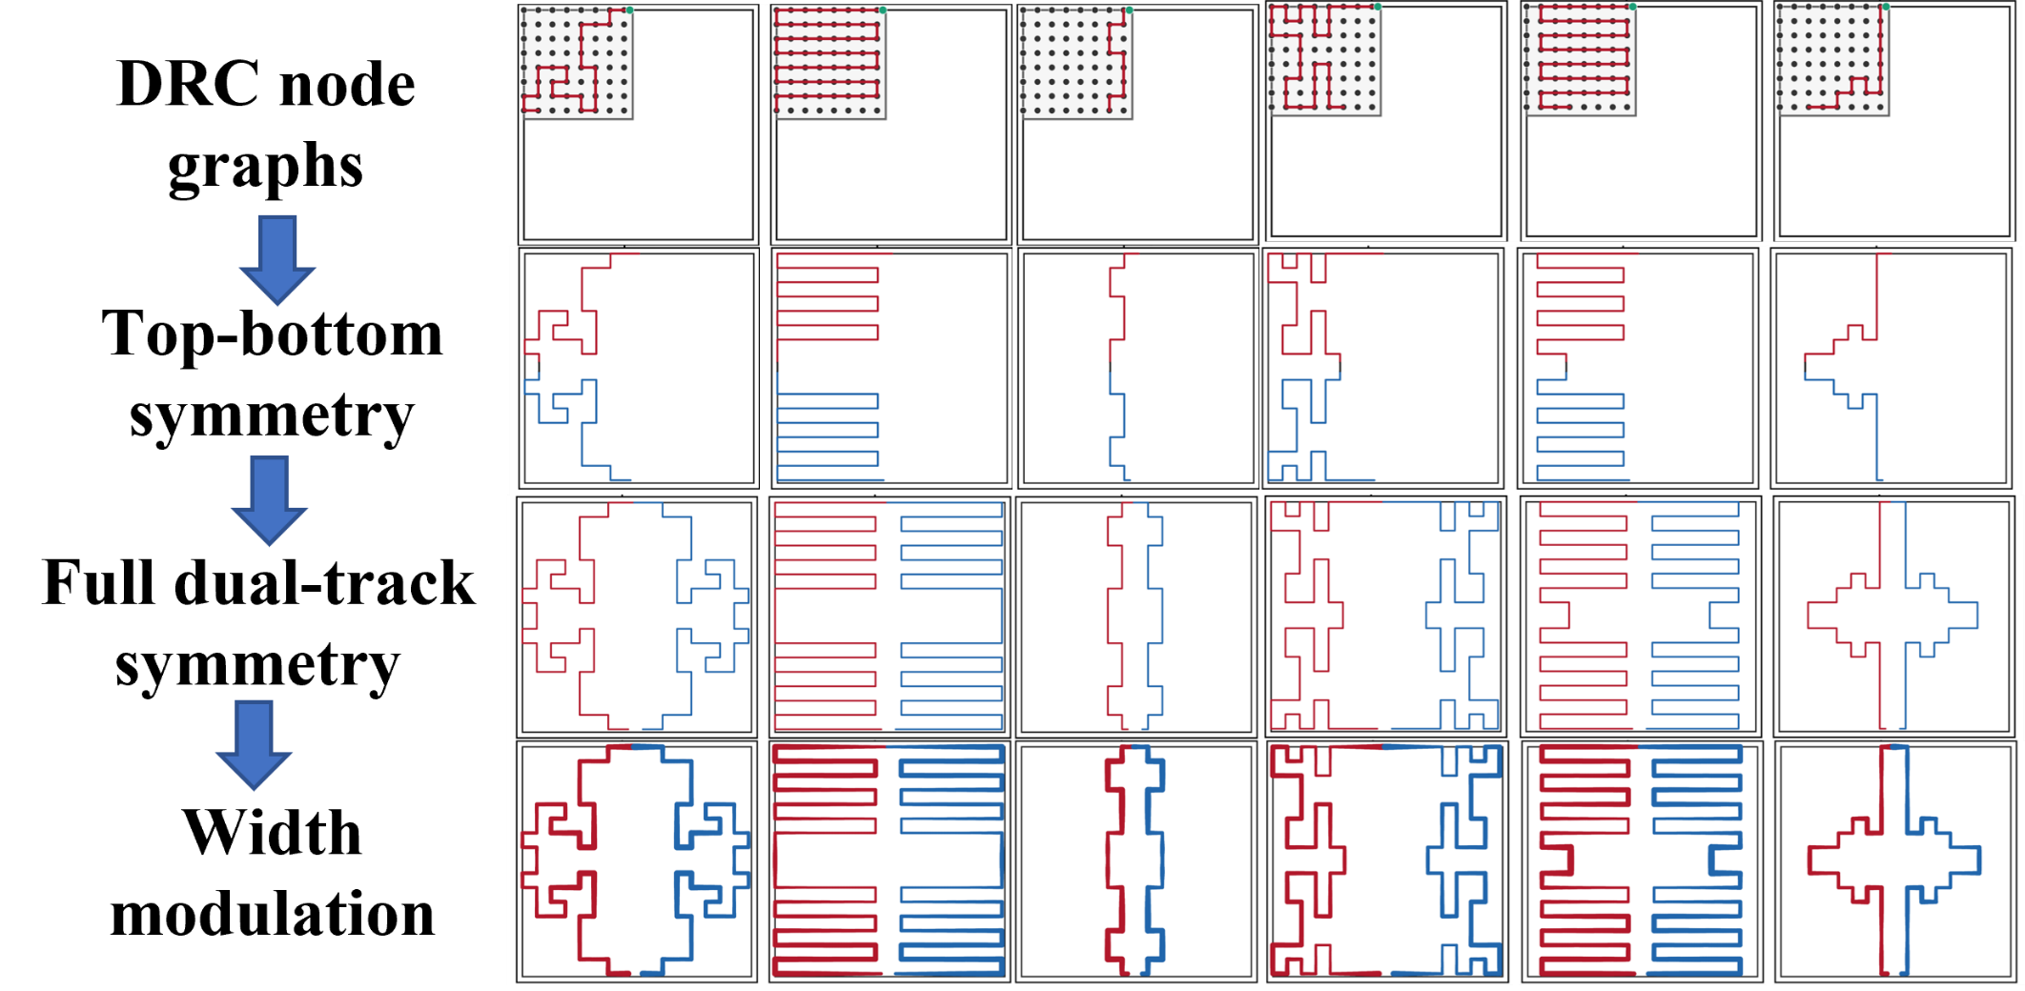

Supplementary Fig. S1 | Stage-wise illustration of representative topology generation patterns under the fabrication-aware vectorized representation. DRC-compliant routing nodes are first defined within the local design window, providing the discrete feasible space for topology growth. Partial routes are then generated from one side based on the topology-control vector, forming initial path skeletons with distinct local patterns. Complementary routes are subsequently introduced from the opposite side to complete the bilateral topology construction while preserving connectivity and spatial feasibility.Final connected layouts are obtained after path completion and width assignment, demonstrating diverse yet fabrication-compliant structural patterns under the unified generative scheme.

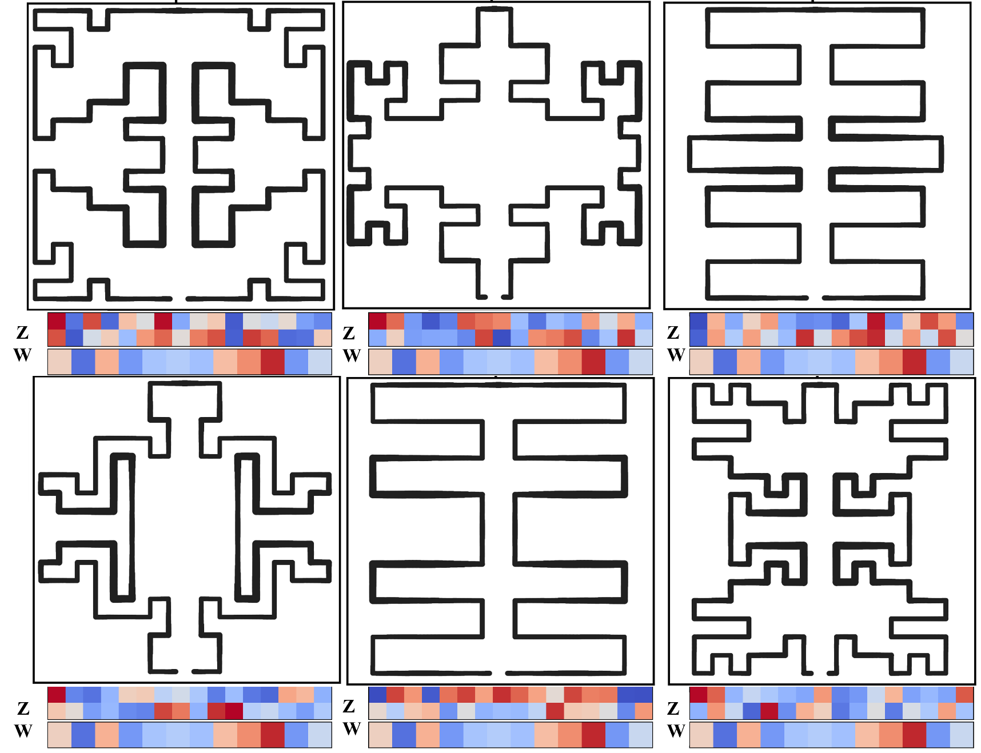
Supplementary Fig. S2 Representative generated layouts decoded from different topology and width control vectors.
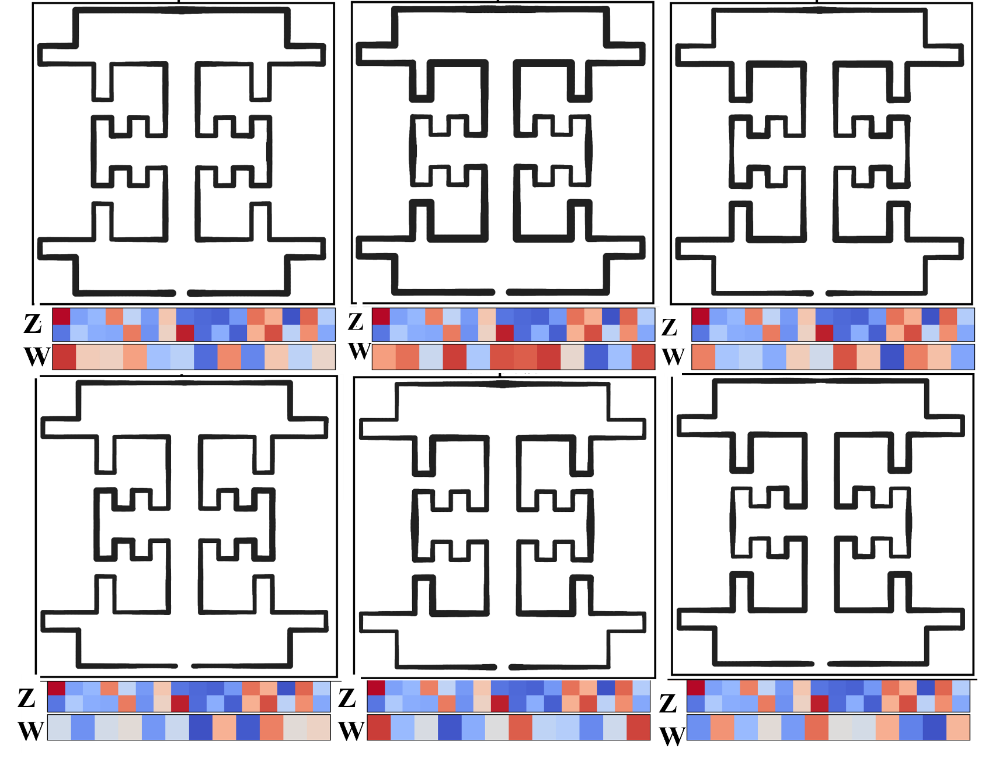
Supplementary Fig. S3 Width-modulated layout variants generated under fixed or closely related topological patterns.
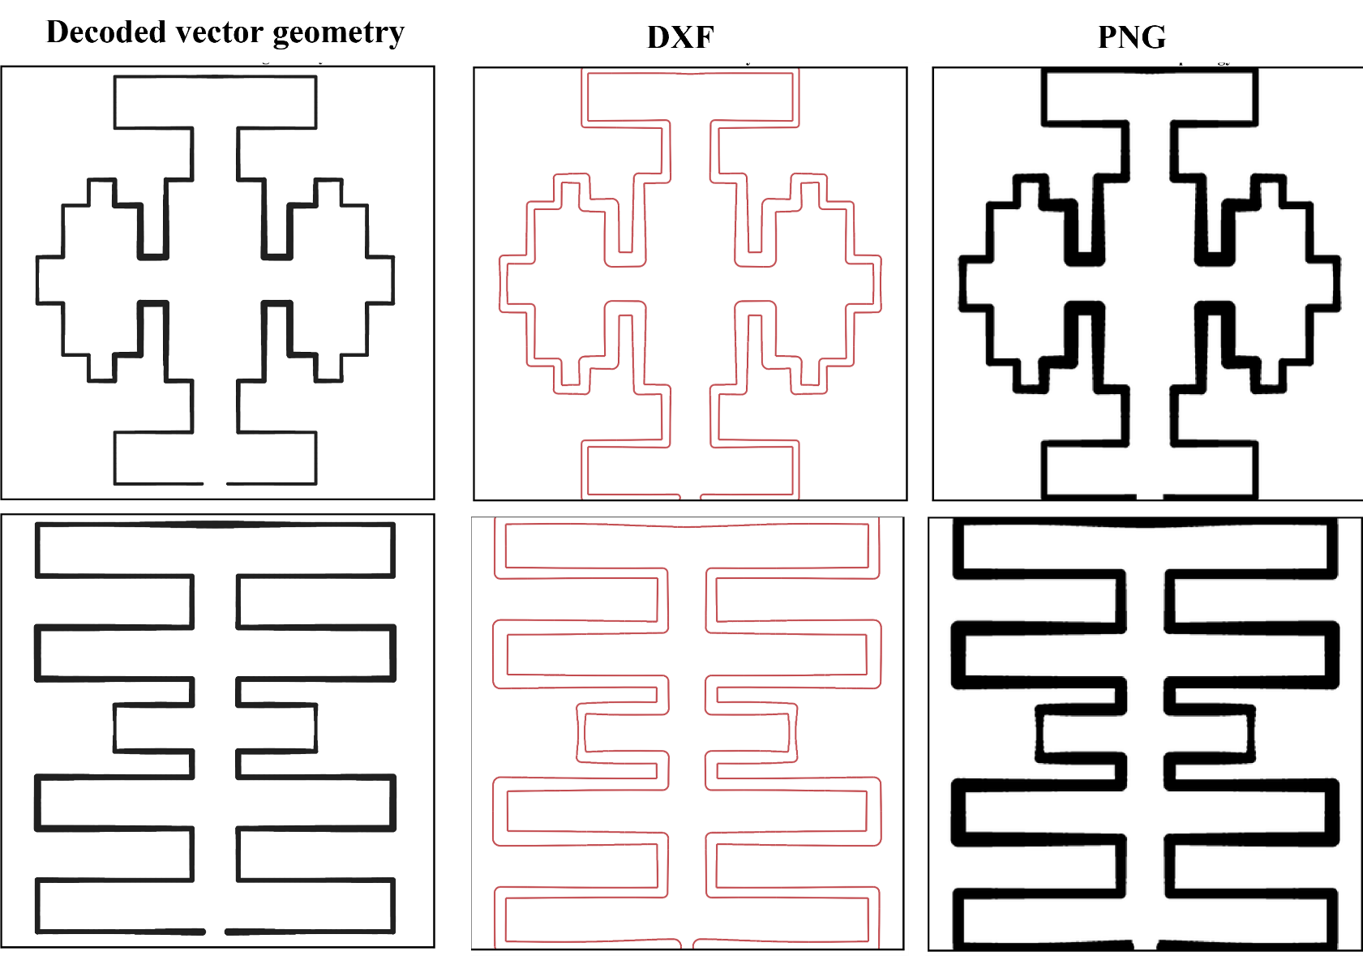
Supplementary Fig. S4 Conversion of generated topology skeletons into fabrication-ready layout representations.
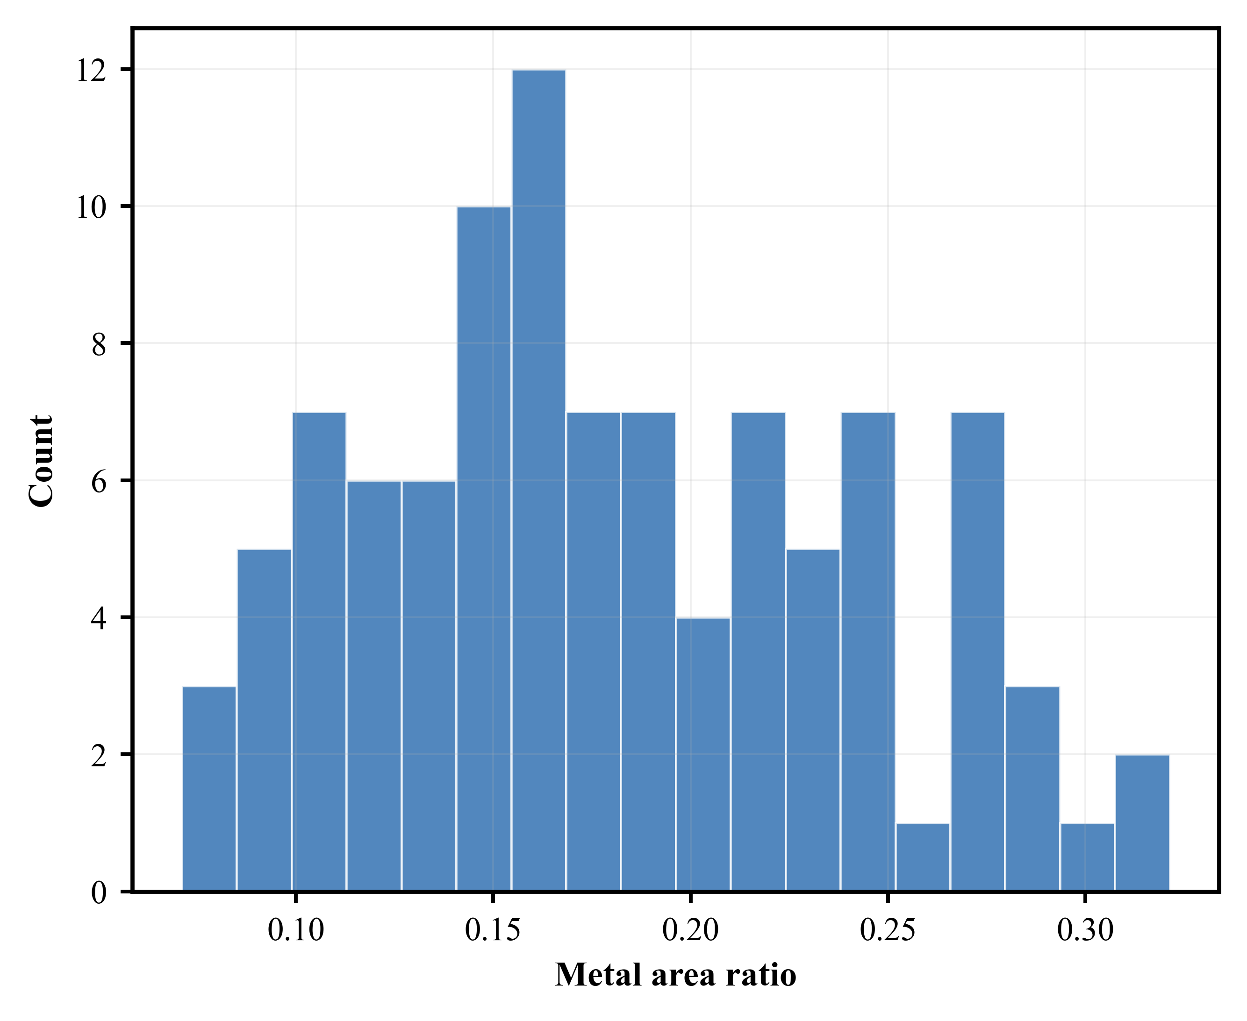
Supplementary Fig. S5 Distribution of metal area ratio among generated layout samples.
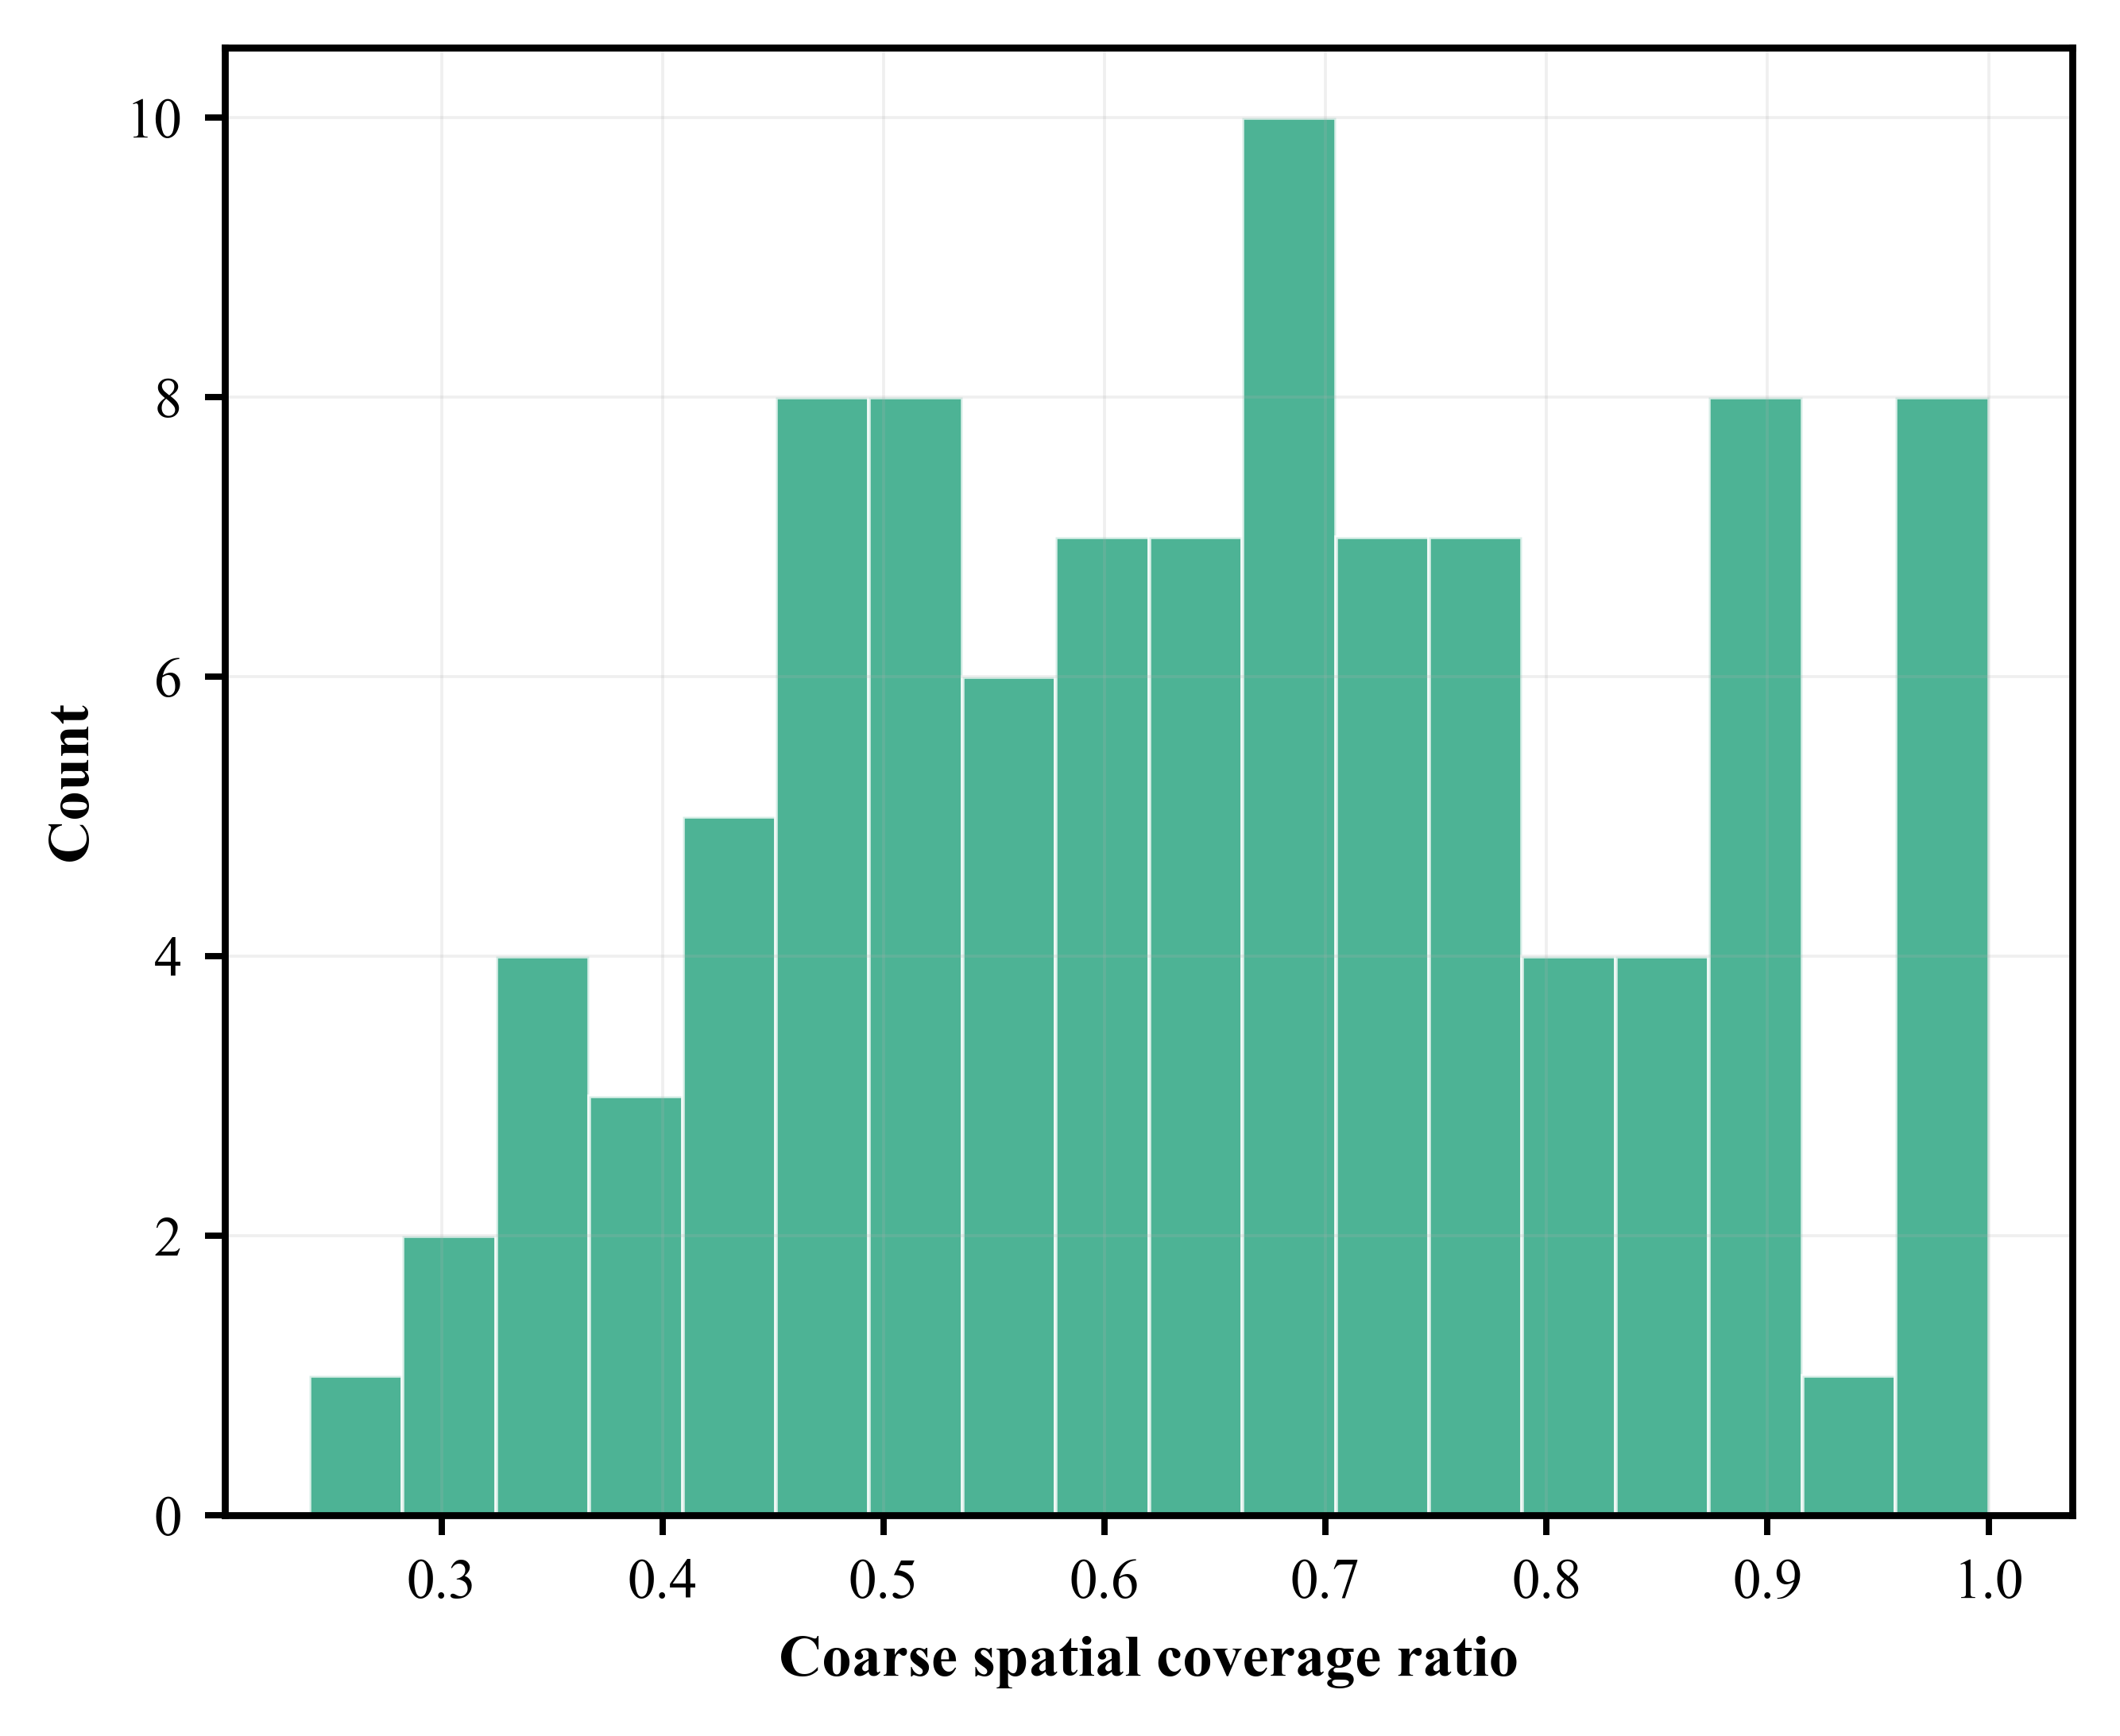
Supplementary Fig. S6 Distribution of coarse spatial coverage ratio among generated layout samples.
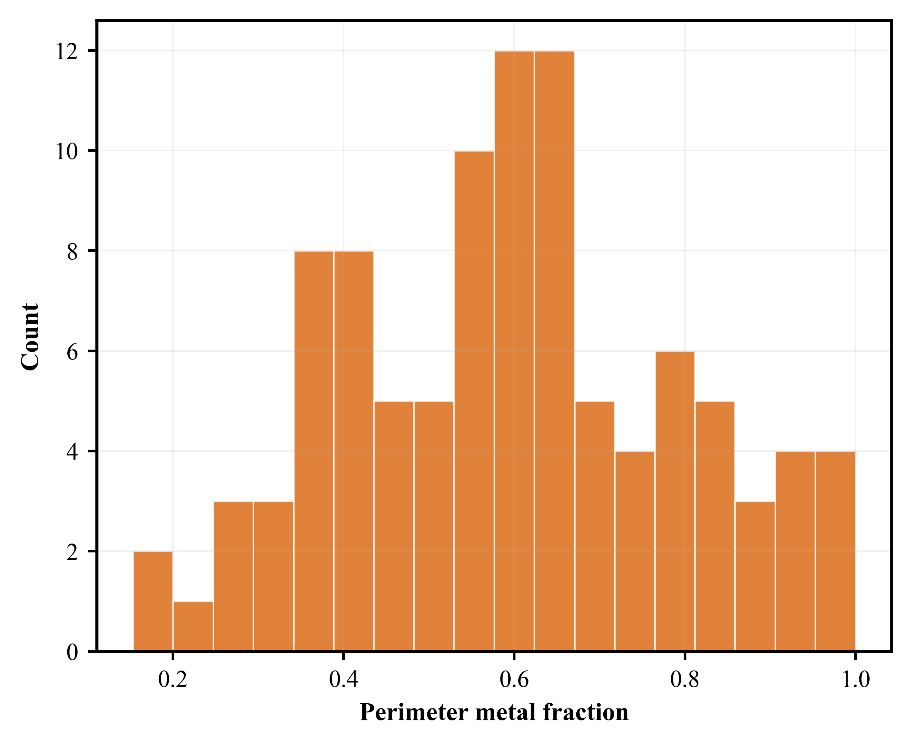
Supplementary Fig. S7 Distribution of perimeter metal fraction among generated layout samples.
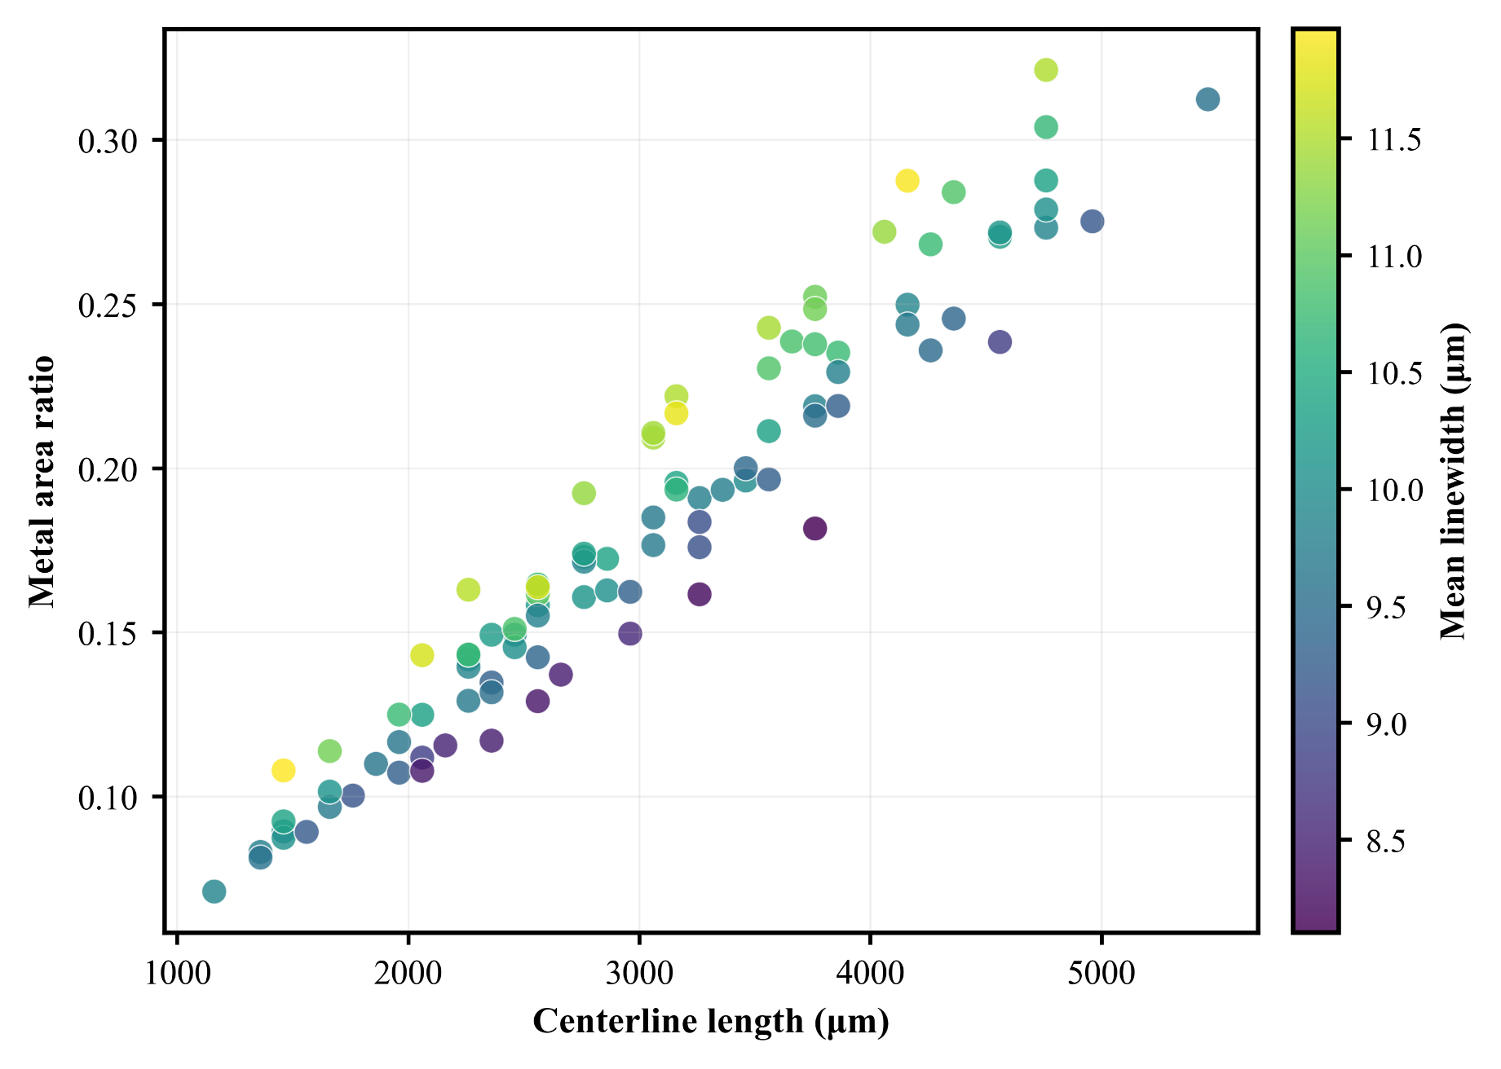
Supplementary Fig. S8 Relationship between centerline length, metal area ratio, and mean linewidth in generated layouts.

Supplementary Note 2. Finite-element model and data generation settings
Finite-element simulations were performed in COMSOL Multiphysics to generate electrothermal labels for the generated MEMS heater layouts. Each generated layout was exported as a DXF file and imported into a three-dimensional model as the outline of the Pt resistor. The imported pattern was extruded into a thin-film metal layer on a Corning 7740/Pyrex glass substrate. A stationary electrothermal analysis was then conducted by coupling electric-current conduction with heat transfer through Joule heating.
The Pt resistor was defined as the electrically conductive domain. One terminal was biased by a prescribed voltage and the opposite terminal was grounded. The resulting resistive loss was coupled into the thermal model as the heat source. Heat dissipation to the ambient environment was represented by a convective heat-flux boundary condition. For equal-power or equal-temperature comparisons, only the electrical excitation was adjusted, while the geometry, materials, meshing strategy, and thermal boundary conditions were kept unchanged. The temperature field was exported on a regular grid, and scalar quantities including power, terminal current, terminal voltage, and regional temperature statistics were extracted as finite-element labels. The model was based on a stationary 3D electrothermal COMSOL setup with Pt as the resistor material and Pyrex glass as the substrate.

Supplementary Note 3. Surrogate model and optimization implementation details
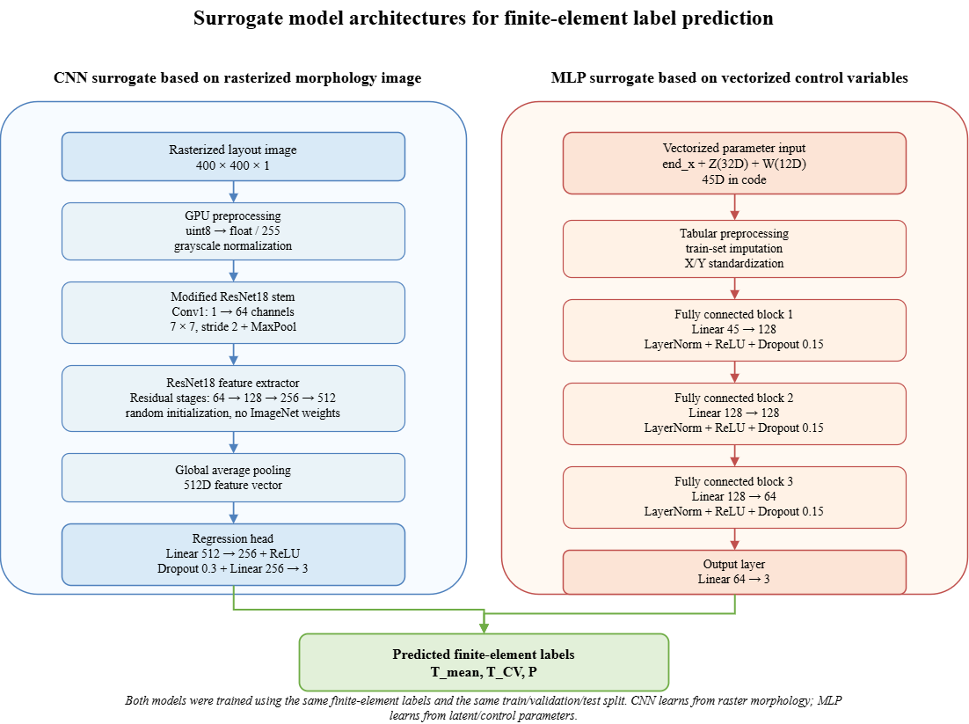
Supplementary Fig. S9 Implementation details of the image-based and vector-based surrogate models.
The surrogate-model training and data-processing tasks were performed on a high-performance workstation equipped with an Intel Xeon Platinum 8438C CPU, 512 GB system memory, and four NVIDIA GeForce RTX 5090 GPUs. The software environment was based on Windows 10 and Anaconda Python 3.10.19. Deep-learning models were implemented using PyTorch 2.7.1 with CUDA 12.8 and torchvision 0.22.1.
For the image-based surrogate, the input was a single-channel rasterized layout image with a resolution of 400×400. All images were preloaded into RAM as unsigned 8-bit tensors to avoid repeated disk access during mini-batch training. During training, the images were transferred to the GPU, converted to floating-point values, divided by 255, and normalized using a grayscale mean and standard deviation of 0.5. The network used a randomly initialized ResNet18 backbone. The first convolutional layer was modified from a three-channel input to a one-channel input, while the final fully connected layer was replaced by a regression head consisting of Linear(512, 256), ReLU, Dropout(0.3), and Linear(256, 3). A non-negative constraint was applied to the 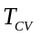output in physical space using ReLU or Softplus before transforming the prediction back to the standardized label space.
For the vector-based surrogate, the input features were read from the 44D parameter table and merged with the finite-element labels by design ID. The implemented feature vector consisted of 32 topology-control variables and 12 width-control variables, giving a 44-dimensional input. Missing feature values were imputed using the mean value calculated from the training set only. Both input features and target variables were standardized using training-set statistics. The MLP consisted of three hidden blocks with dimensions 128, 128, and 64. Each hidden block contained a linear layer, layer normalization, ReLU activation, and dropout with a dropout probability of 0.15. The output layer was Linear(64, 3), corresponding to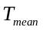, , and.Both models were trained using Smooth L1 loss with β=1.0 and the AdamW optimizer with a learning rate of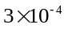, weight decay of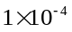, and gradient clipping threshold of 1.0. Automatic mixed precision was enabled when CUDA was available. Early stopping was applied with a patience of 200 epochs.
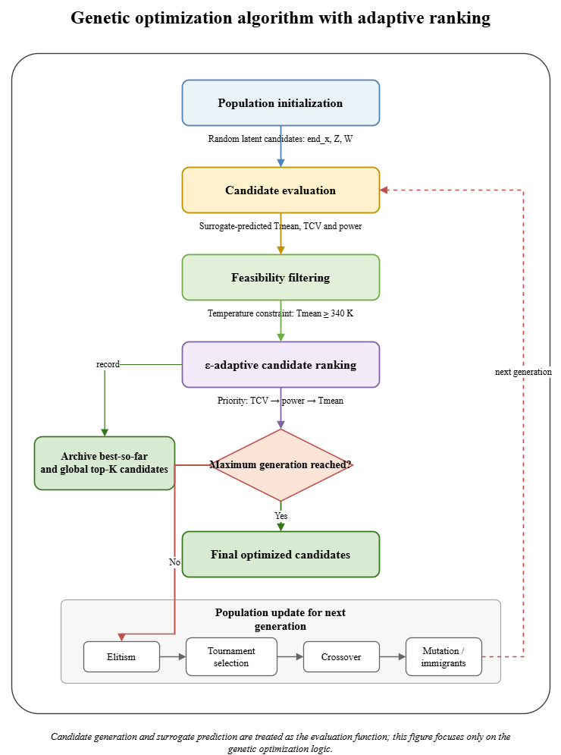
Supplementary Fig. S10 Genetic optimization procedure with adaptive candidate ranking.
The optimization algorithm initializes a latent population and iteratively evaluates candidate fitness using surrogate-predicted thermal labels. Candidates are first filtered by the temperature feasibility constraint and then ranked using an ε-adaptive strategy that prioritizes, followed by power and temperature within the near-optimal band. The ranked population is updated through elitism, tournament selection, crossover, mutation, and random immigrants. Best-so-far and global top-ranked candidates are archived during the search.

Supplementary Note 4. Fabrication process description
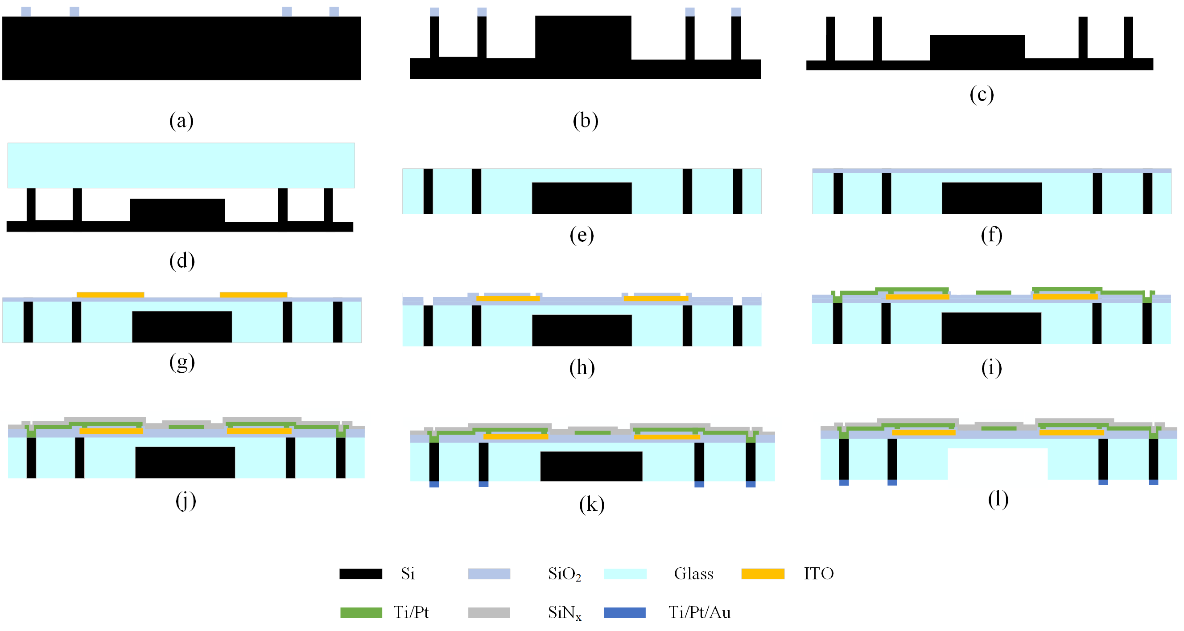
Supplementary Fig. S11 Fabrication process flow of the MEMS electrothermal device.
The fabrication process is summarized in Supplementary Fig. S11. A low-resistivity silicon wafer was first cleaned, and a SiO₂ hard mask was deposited and patterned on the wafer surface. The silicon substrate was then structured by two-step deep reactive ion etching to form the supporting silicon pillars, recessed regions, and the membrane-defined substrate profile. After removing the hard mask, the patterned silicon wafer was anodically bonded to a glass substrate. A subsequent glass-reflow process was used to fill the etched recesses and form a glass–silicon composite substrate. The bonded wafer was then thinned and polished to obtain a planar surface for subsequent thin-film processing.
After substrate preparation, an insulating SiO₂ layer was deposited on the front side to electrically isolate the functional films from the silicon structures. The ITO layer was then deposited, annealed, lithographically patterned, and etched to form the first thermoelectric material layer. A second SiO₂ insulation layer was deposited and patterned to define the interlayer electrical vias. The Ti/Pt metal stack was subsequently deposited and patterned to form the second thermoelectric material layer, heater, ambient temperature resistor, and interconnects. A SiO₂ passivation layer was deposited to protect the front-side functional structures. Ti/Pt/Au metal pads were then fabricated on the backside to provide low-resistance electrical contacts. Finally, rapid thermal annealing was performed to improve metal–semiconductor and metal–ITO contact properties, followed by backside DRIE release of the suspended glass membrane.

Supplementary Note 5. High-fidelity finite-element evaluation of representative intermediate candidates
To quantify the thermal-field evolution associated with the morphological changes shown in Fig. 4e, representative candidates from selected evolutionary stages were re-evaluated using the stationary three-dimensional electrothermal finite-element model described in Supplementary Note 2. The same geometry-import procedure, material properties, meshing strategy, thermal boundary conditions, heating-region definition, and performance-metric definitions were applied to all selected candidates. For direct comparison, all candidates were evaluated under the same prescribed total electrical power.
The corresponding steady-state temperature fields and quantitative thermal-uniformity metrics are presented in Supplementary Fig. S12. The evaluated metrics include the temperature coefficient of variation 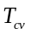and the effective uniform-temperature-area ratio 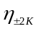, defined as the proportion of the heating region within ±2 K of its respective mean temperature. Under the same electrical power, these results illustrate how the progressive reorganization of the resistor path modifies the spatial temperature distribution and improves thermal-field uniformity during the evolutionary search.

Supplementary Fig. S12 High-fidelity finite-element evaluation of representative intermediate heater layouts. a, Representative layouts selected from Generations 1, 5, 60, and 110. b, Corresponding steady-state temperature fields.
The selected layouts represent characteristic evolutionary stages from the recorded optimization history and are included to establish the relationship between morphological evolution and thermal-performance improvement toward the final selected design.

Supplementary Note 6. Mechanical optimization validation and representational coverage of path-defined MEMS structures
For the compliant micro-spring case, the same B–Z–W representation and fabrication-aware decoding procedure were retained. B fixed the design boundary and terminal locations, while the searchable design vector consisted of the 32-dimensional topology-control vector Z and the 12-dimensional width-control vector W, resulting in a 44-dimensional continuous optimization space. The design region was 850×680 μm², with an allowable linewidth range of 25–50 μm and a prescribed minimum spacing of 35 μm. Connectivity, spacing, linewidth, and boundary requirements were enforced during decoding using the same generation procedure described in Supplementary Note 1.
Candidate layouts were evaluated during optimization using the same morphology-based surrogate-modeling strategy described for the thermal case, retrained using finite-element-derived mechanical responses of the micro-spring structures. The surrogate predicted the x-, y-, and z-direction displacements and the peak von Mises stress. The mechanical optimization considered two objectives: maximizing the target-direction displacement and minimizing the peak von Mises stress σ. A peak-stress limit of 2,000 MPa was imposed as a hard feasibility constraint, whereas the remaining displacement components were retained as predicted responses but were not included in the optimization objectives.
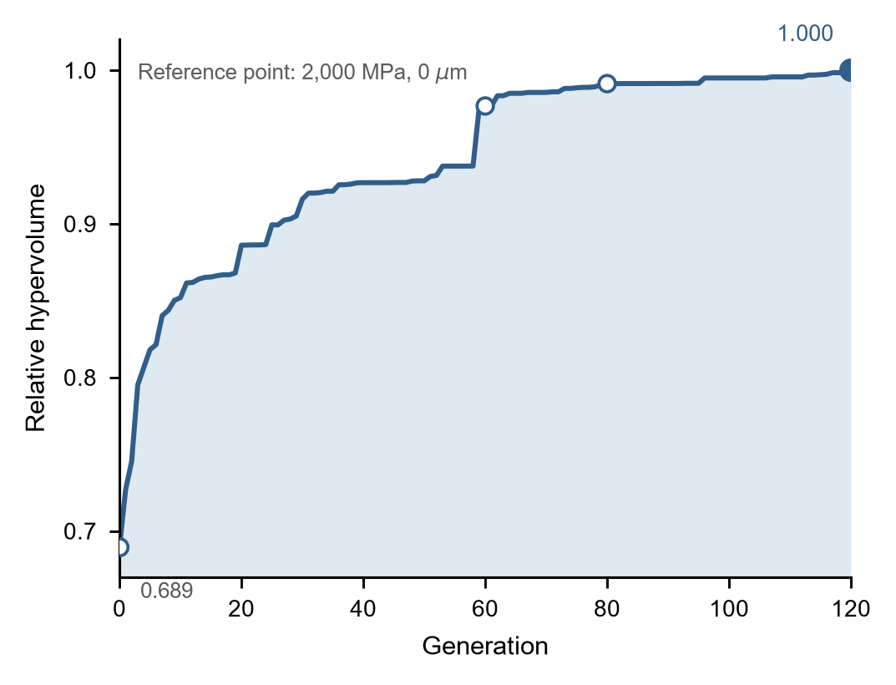
Supplementary Fig. S13 Hypervolume evolution during the multi-objective optimization of the compliant micro-spring. Relative hypervolume of the feasible non-dominated set over 120 generations, calculated using a reference point of 2,000 MPa in peak von Mises stress and 0 μm in target-direction displacement. The hypervolume is normalized by its final-generation value. The progressive increase and subsequent stabilization indicate convergence of the displacement–stress trade-off.
A constrained NSGA-Ⅱ search was performed using a population of 64 candidates for 120 generations. Feasible candidates were ranked through non-dominated sorting in the objective space, while niche sharing was used to maintain solution diversity along the non-dominated set. Tournament selection, crossover, mutation, elitist retention, and random immigrants were used to generate subsequent populations.
The final design was selected from the feasible non-dominated solutions of the final population. The two objective values were first normalized within the non-dominated set, and the candidate with the minimum Euclidean distance to the normalized ideal point was selected as the compromise solution. This procedure avoids selecting either the maximum-displacement or minimum-stress extreme and instead identifies a balanced displacement–stress solution for high-fidelity verification.
The relative hypervolume increased from 0.689 for the initial population to 1.000 at Generation 120 (Supplementary Fig. S13). Most of the improvement occurred during the earlier and intermediate stages of the search, followed by progressively smaller increments at later generations. The 120-generation setting was therefore retained as a conservative termination limit to ensure stabilization of the explored displacement–stress trade-off.
The reference awl-shaped serpentine micro-spring and the selected optimized design were subsequently reconstructed in COMSOL Multiphysics using three-dimensional solid-mechanics models. Both structures were confined to the same 850×680 μm² design region and extruded to a thickness of 100 μm. The reference beam centerline was expanded to a uniform width of 40 μm, whereas the optimized design was imported directly from its generated DXF geometry. Isotropic polycrystalline silicon was assigned to both structures, with a Young’s modulus of 169 GPa and a Poisson’s ratio of 0.23. One terminal was fully fixed, and a total force of 40 mN was applied to the opposite terminal along the positive y-direction. A stationary analysis was conducted using a free-triangular surface mesh swept through the structural thickness, with minimum and maximum element sizes of 1.505 and 85.38 μm, respectively. The maximum y-direction displacement at the loaded terminal and the peak von Mises stress over the complete structure were extracted as the principal mechanical responses. Identical material properties, thickness, boundary conditions, loading conditions, and meshing settings were used for the reference and optimized designs.
For the selected compromise design, the surrogate predicted a target-direction displacement of 522.19 μm and a peak von Mises stress of 1488.91 MPa. High-fidelity finite-element re-evaluation yielded 508.91 μm and 1541.3 MPa, corresponding to deviations of 2.61% and 3.40%, respectively. The high-fidelity finite-element values were used for the quantitative mechanical comparisons reported in the main manuscript.
Representation-level coverage under another path-defined MEMS boundary configuration was further examined using a proof-mass resonator configuration. A 5 mm×5 mm central proof mass and a 4 mm×4 mm quarter-domain were adopted for each elastic beam. The quarter-domain was discretized using a 16×16 routing grid, and each elastic beam connected the proof mass to an external anchor. The complete resonator was reconstructed through fourfold rotational symmetry.
For this configuration, B defined the proof mass, quarter-domain, prescribed terminals, and symmetry condition. Z controlled the connected beam path between the proof mass and the external anchor, while W provided an independent description of the local beam-width distribution. The same decoding mechanism was therefore applied under a different device boundary configuration without constructing a resonator-specific topology representation. These examples are included only to examine the representational coverage of the proposed formulation; no resonator-performance optimization or device-level mechanical validation is claimed.
Supplementary Fig. S14 Representative proof-mass MEMS resonator layouts generated using the proposed representation.

