Supplementary tables and figures

Supplementary Table 1 : Biotinylated miRNA duplexes used in experiments. These are based on the hairpin predictions annotated by miRBase, with minor modifications (Added 3' A on bio-miR-873-5p WT and bio-miR-873-5p Mut) to bring overhangs closer to recommendations in Wani and Cloonan².
miRNA | 3p Biotinylated strand | Sequence (5-3’) | Non-biotinylated strand | Sequence (5-3’)
miR-873 WT | bio-miR-873-5p WT | GCAGGAACUUGUGAGUCUCCUA | bio-miR-873-3p | GGAGACUGAUGAGUUCCCGGGA
miR-873 Mut | bio-miR-873-5p Mut | GCUGGAACUUGUGAGUCUCCUA | bio-miR-873-3p | GGAGACUGAUGAGUUCCCGGGA
cel-miR-67 | bio-cel-mir-67-3p | UCACAACCUCCUAGAAAGAGUAGA | bio-cel-mir-67-5p | CGCUCAUUCUGCCGGUUGUUAUG

Supplementary Table 2: List of filtered rare variations identified within protein-coding and regulatory regions in ASD cases and their parents. Original whole-exome sequencing data and individual identifiers are described in An, Cristino¹. Provided as an excel file.

Supplementary Table 3: Standardized scores (Z-scores) of binomial distribution tests to assess the enrichment of SNVs identified in ASD cases in gold-standard datasets for ASD risk genes and pathways. All gene lists (gold-standard and background datasets) used for Z-score calculations are also provided in the excel file.

Supplementary Table 4: Enrichment of genes having regulatory SNVs in co-expression modules described in Parikshak, Luo³. P-values were calculated with hypergeometric distribution in R, with BH multiple hypothesis correction. Only those genes included in both the Parikshak, Luo³, analysis and in the HGNC background were used in calculations, resulting in smaller module sizes. (*) significant enrichment in rare variants found in our ASD cases.

Module | Num Hits | Query Size | Module Size | Background Size | p-value | BH p-value
M1 | 107 | 2322 | 547 | 13803 | 0.047 | 0.20
M2 | 114 | 2322 | 622 | 13803 | 0.17 | 0.56
M3* | 165 | 2322 | 754 | 13803 | 0.00013 | 0.0022
M4 | 44 | 2322 | 288 | 13803 | 0.78 | 0.98
M5 | 126 | 2322 | 645 | 13803 | 0.035 | 0.20
M6 | 35 | 2322 | 254 | 13803 | 0.92 | 0.98
M8 | 28 | 2322 | 184 | 13803 | 0.75 | 0.98
M9 | 27 | 2322 | 187 | 13803 | 0.84 | 0.98
M10 | 3 | 2322 | 30 | 13803 | 0.90 | 0.98
M11 | 73 | 2322 | 428 | 13803 | 0.47 | 0.98
M12 | 35 | 2322 | 275 | 13803 | 0.98 | 0.98
M13 | 108 | 2322 | 635 | 13803 | 0.47 | 0.98
M14 | 62 | 2322 | 419 | 13803 | 0.88 | 0.98
M15 | 41 | 2322 | 269 | 13803 | 0.78 | 0.98
M16* | 91 | 2322 | 401 | 13803 | 0.0013 | 0.01
M17 | 127 | 2322 | 725 | 13803 | 0.32 | 0.90
M18 | 114 | 2322 | 715 | 13803 | 0.76 | 0.98

Supplementary Table 5: Table of rare variants in mature microRNAs including only those microRNAs having SNVs in cases. The variant within the mature microRNA is shown in red, with the 2-7bp canonical seed region in bold. The predicted target loss or gain shows number of genes specifically predicted using miRNA reference (target loss) and variant (target gain) alleles.
microRNA | Chr | Position | SNP id | gnomAD exome MAF | gnomAD genome MAF | CADD score | Effect on Mature microRNA | Number of targets miRNA reference | Number of targets miRNA variation | Target Loss (%) | Target Gain (%)
miR-873-5p | 9 | 28888941 | rs777143952 | 2.7E-05 | 6.6E-05 | 16.61 | GC[A=>U]GGAACUUGUGAGUCUCCU | 2481 | 2389 | 1896 (76%) | 1804 (74%)
miR-411-5p | 14 | 101489692 | rs751955845 | 1.8E-05 | - | 17.78 | UAGUAGACCGUAUAG[C=>U]GUACG | 430 | 478 | 183 (42%) | 231 (48%)
miR-668-3p | 14 | 101521654 | - | - | - | 22.8 | UGUCACUCGGCUCGGCC[C=>U]ACUAC | 2459 | 2586 | 401 (16%) | 528 (20%)
miR-323b-5p | 14 | 101522589 | rs75330474 | 1.8E-05 | 3.1E-04 | 15.27 | AGGUUGUCCGUGGUGAGUU[C=>U]GCA | 2264 | 2433 | 413 (18%) | 582 (24%)

Supplementary Table 6: Targeting of microRNA miR-873-5p. Pulldown assay results of miR-873-5p wild-type and mutant, as well as the predicted target genes of miR-873-5p. Provided as an excel file.

Supplementary Table 7: Functional annotation enrichment analysis of case f34-s1 rare variants (protein-coding and regulatory) in genes overlapping AXAS-ASD network and miR-873-5p target network.

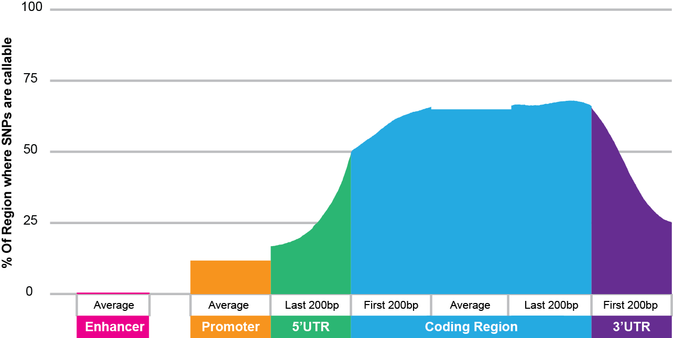
Supplementary Figure 1: Proportions of 5’UTR, 3’UTR, coding, promoter and enhancer regions that have sufficient read depth to detect SNVs (SNV-callable regions defined as having ≥ 20 reads in 90% samples), with distributions displayed relative to the start and end of the coding regions. Coverage was calculated across all UCSC transcripts on hg19. Introns were omitted from the calculations and are not shown on this diagram.

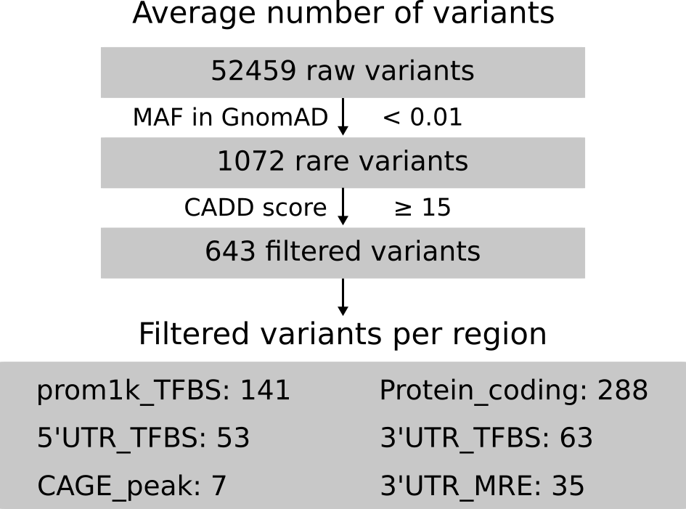

Supplementary Figure 2: Filtering steps showing average counts of SNVs per individual at each stage. The regulatory variants are defined as those within promoters (prom1k), transcription start site (CAGE_peak), 5’ and 3’ untranslated region (5’UTR and 3’UTR), and putative TFBSs or MREs.
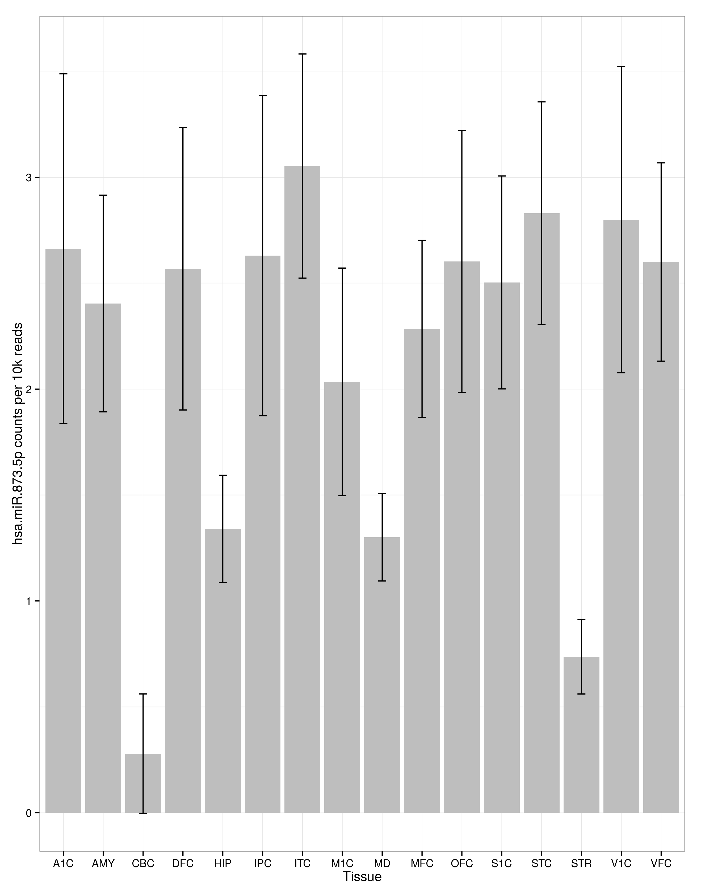

Supplementary Figure 3: Raw counts of miR-873-5p expression across different brain tissue types as described in BrainSpan database⁴. Error bars reflect 95% confidence interval. Tissue codes are as per BrainSpan designations, specifically; DFC: Dorsoflateral prefrontal cortex, VFC: Ventrolateral prefrontal cortex, MFC: Anterior (rostral) cingulate (medial prefrontal) cortex, OFC: Orbital frontal cortex, M1C: Primary motor cortex, S1C: Primary somatosensory cortex, IPC: Posteroinferior (ventral) parietal cortex, A1C: Primary auditory cortex, STC: Posterior (caudal) superior temporal cortex, ITC: Inferolateral temporal cortex, V1C: Primary visual cortex, HIP: Hippocampus, AMY: Amygdaloid complex, STR: Striatum, MD: Mediodorsal nucleus of thalamus, CBC: Cerebellar cortex.

Bovine NP_776829 DDFFYVGGSPSTADLPGSPVSNNFMGCLKEVVYKN
Human NP_001129131 DDFFYVGGSPSTADLPGSPVSNNFMGCLKEVVYKN
case 34.s1 DDFFYVGGSPSTADLPGSSVSNNFMGCLKEVVYKN
Mouse NP_796258 DDFFYVGGSPSTADLPGSPVSNNFMGCLKEVVYKN
Fish NP_001277105 DDFLYVGGSPSTADLPESPVSNNFMGCLREVVYKN

Supplementary Figure 4: Multiple protein alignment showing conservation vertebrate alpha neurexin 1 sequences surrounding Pro429Ser case 34.s1 (yellow) mutation. NCBI accession numbers provided.

References

1. An JY, Cristino AS, Zhao Q, Edson J, Williams SM, Ravine D et al. Towards a molecular characterization of autism spectrum disorders: an exome sequencing and systems approach. Translational psychiatry 2014; 4: e394.

2. Wani S, Cloonan N. Profiling direct mRNA-microRNA interactions using synthetic biotinylated microRNA-duplexes. BioRxiv 2014: 0-11.

3. Parikshak Neelroop N, Luo R, Zhang A, Won H, Lowe Jennifer K, Chandran V et al. Integrative Functional Genomic Analyses Implicate Specific Molecular Pathways and Circuits in Autism. Cell 2013; 155: 1008-1021.

4. Allen Brain Institute. BrainSpan: Atlas of the Developing Human Brain. 2011.

