Supplementary Materials for:

Polygenic predictors of age-related decline in cognitive ability

S. J. Ritchie et al.

Supplementary Method

Genome-wide association studies

Table S1 provides a list of the genome-wide association studies (GWASs) where we obtained the summary statistics used to calculate the polygenic scores (PGSs) in the Lothian Birth Cohort 1936 sample. In addition to our use of summary statistics from pre-existing genome-wide association studies, we ran four additional GWAS studies in the UK Biobank dataset for the following phenotypes (with the UK Biobank variable identifier in parentheses): educational attainment (specifically the attainment of a college or university degree as a binary variable; derived from variable 6138.0.0), grip strength (measured in kg on a dynamometer; variable 47.0.0), lung function (forced expiratory volume in 1 second; FEV₁; variable 3063.0.0) and smoking status (never, previous, or current smoker; variable 20116.0.0). Specific measurement details can be found at the UK Biobank website at the following URL: http://biobank.ctsu.ox.ac.uk/crystal/label.cgi. As noted in the main document, we updated the PGSs to take advantage of newer GWAS studies that appeared since we first ran our analysis; this meant that we no longer used the education data from UK Biobank since a new education GWAS had been published. We still describe it here for completeness, and the original results are shown in Table SXXX for comparison.

All the variables were corrected for age at the time of testing, sex, the genotype measurement batch (variable 22000), the genotyping array (either BiLEVE or Axiom, coded from variable 22000), the UK Biobank Assessment Centre (variable 54), along with 40 SNP principal components to adjust for potential population stratification. The correction was achieved by saving the residuals from a regression with the phenotype of interest as the dependent variable and the above covariates as the independent variables.

Each GWAS followed the procedure described in the Methods section of Luciano et al. (2018). Briefly, we used the imputed dataset (with over 92m variants referenced to the UK10K haplotype, 1000 Genomes Project phase 3, and Haplotype Reference Consortium panels) which was made available in UK Biobank. Quality control (see the Supplementary Note to ref^{S2}) resulted in a total of 18,485,882 imputed SNPs and a maximum of 329,821 participants. GWAS was conducted using BGENIE^{S1}. For each of the variables, residualized in the manner described above, we had the following sample sizes available: Educational attainment: n = 274,273; grip strength: n = 330,326; lung function: n = 302,605; smoking status: n = 330,918.

Manhattan plots, illustrating the individual SNP results for the latter three phenotypes, are provided below as Figures S1-S3. The plot for educational attainment (which, to repeat, was no longer used in the main analysis since it had been superseded by a further GWAS) can be found in the forthcoming ref.^{S3}. Summary statistics from each GWAS were passed to the PRSice software for polygenic score calculation, as described in the Method section of the main document.

Supplementary References

S1. Bycroft C, Freeman C, Petkova D, Band G, Elliott LT, Sharp K, Motyer A, Vukcevic D, Delaneau O, O'Connell J, Cortes A, Welsh A, McVean G, Leslie S, Donnelly P, Marchini J. Genome-wide genetic data on ~500,000 UK Biobank participants. bioRxiv. 2017;166298. doi: 10.1101/166298
S2. Luciano M, Hagenaars SP, Davies G, Hill WD, Clarke TK, Shirali M, Harris SE, Marioni RE, Liewald DC, Fawns-Ritchie C, Adams MJ, Howard DM, Lewis CM, Gale CR, McIntosh AM, Deary IJ. Association analysis in over 329,000 individuals identifies 116 independent variants influencing neuroticism. Nat Genet. 2018;50:6-11.
S3. Hill WD et al. (forthcoming). Genetic analyses of socioeconomic status in UK Biobank.
S4. Diedenhofen B, Musch, J. cocor: A comprehensive solution for the statistical comparison of correlations. PLOS ONE. 2015;10:e0121945.

Supplementary Tables

Table S1. Studies relating the phenotype of each selected polygenic score to cognitive decline, and the relevant genome-wide association study (GWAS) from which the summary statistics to calculate the PGS were derived. Also provided is the discovery sample size for each GWAS.
Polygenic Score | Authors and date; DOI |  | GWAS sample size
Polygenic Score | Phenotypic linkage study | GWAS | GWAS sample size
Education | Bosma et al. (2003); 10.1080/10715769800300191 | Lee et al. (2018); 10.1038/s41588-018-0147-3 | 1,131,881
Neuroticism | Hagger-Johnson et al. (2012); 10.1093/geronb/gbr151 | Luciano et al. (2018); 10.1038/s41588-017-0013-8 | 329,821
Conscientiousness | Wilson et al. (2015); 10.1037/pag0000013 | Lo et al. (2017);  10.1038/ng.3736 | 76,551
Alzheimer’s disease | Albert et al. (2011); 10.1016/j.jalz.2011.03.008 | Marioni et al. (2018); 10.1038/s41398-018-0150-6 | 25,580 cases; 48,466 controls
Schizophrenia | Reichenberg et al. (2005); 10.1001/archpsyc.62.12.1297 | Pardiñas et al. (2018); 10.1038/s41588-018-0059-2 | 11,260 cases; 24,542 controls
Major depressive disorder | Paterniti et al. (2002); 10.1192/bjp.181.5.406 | Wray et al. (2018); 10.1038/s41588-018-0090-3 | 135,458 cases; 344,901 controls
Coronary artery disease | Qiu & Fratiglioni (2015); 10.1038/nrcardio.2014.223 | Nikpay et al. (2015); 10.1038/ng.3396 | 60,801 cases; 123,504 controls
Stroke | Brainin et al. (2015); 10.1111/ene.12626 | Malik et al. (2018); 10.1038/s41588-018-0058-3 | 67,162 cases; 454,450 controls
Type 2 diabetes | Feinkohl et al. (2015); 10.1186/s13195-015-0130-5 | Scott et al. (2017); 10.2337/db16-1253 | 26,676 cases; 132,532 controls
Smoking | Anstey et al. (2007); 10.1093/aje/kwm116 | UK Biobank | 330,918
Height | Case & Paxson (2008); 10.1257/aer.98.2.463 | Wood et al. (2014); 10.1038/ng.3097 | 253,288
BMI | Gunstad et al. (2010); 10.1159/000297742 | Yengo et al. (2018); 10.1101/274654 | 681,275
FEV₁ | Richards et al. (2005); 10.1097/01.psy.0000170337.51848.68 | UK Biobank | 302,605
Grip strength | Auyeung et al. (2011); 10.1007/s12603-011-0110-9 | UK Biobank | 330,326
Note: For the four GWAS that were performed in UK Biobank for the present analysis, details can be found in the Supplementary Method section above.

Table S2. Pearson correlations between polygenic scores in the Lothian Birth Cohort 1936.
Polygenic Score | 1. | 2. | 3. | 4. | 5. | 6. | 7. | 8. | 9. | 10. | 11. | 12. | 13.
1. Education | -
2. Neuroticism | –.14*** | -
3. Conscientiousness | –.01 | –.04 | -
4. Alzheimer’s disease | –.04 | .01 | –.02 | -
5. Schizophrenia | –.06 | .08** | –.07* | .04 | -
6. Major depressive disorder | –.09** | .23*** | –.10** | .01 | .18*** | -
7. Coronary artery disease | –.14*** | .004 | –.03 | .02 | .06 | .09** | -
8. Stroke | –.12*** | .03 | –.04 | –.03 | .07* | .07* | .06 | -
9. Type 2 diabetes | –.09** | –.02 | –.02 | .01 | .10** | .04 | .11*** | .09** | -
10. Smoking | –.25*** | .06* | –.01 | –.01 | .12*** | .14*** | .08** | .08* | .07* | -
11. Height | .08** | –.04 | .02 | .01 | –.15*** | –.09** | –.03 | –.10** | –.14*** | –.04 | -
12. BMI | –.26*** | –.09** | –.05 | .01 | .01 | .07* | .10** | .09** | .23*** | .18*** | –.10** | -
13. FEV₁ | .13*** | .09** | –.07* | .00 | .13*** | .03 | –.01 | .05 | –.04 | –.13*** | –.07* | –.14*** | -
14. Grip strength | .03 | –.12*** | .05 | –.07* | .03 | –.07* | .03 | .03 | –.02 | –.03 | –.04 | .04 | .15***
Note: n = 1,005 for all correlations. *p < .05, **p < .01, ***p < .001.

Table S3. Descriptive statistics for each cognitive test at each wave of the study.
Test | Wave 1  (70 years) |  | Wave 2  (73 years) |  | Wave 3  (76 years) |  | Wave 4  (79 years)
Test | Mean (SD) | N | Mean (SD) | N | Mean (SD) | N | Mean (SD) | N
Matrix reasoning | 13.49 (5.13) | 1086 | 13.17 (4.96) | 863 | 13.04 (4.91) | 689 | 12.90 (5.03) | 535
Block design | 33.79 (10.32) | 1085 | 33.64 (10.08) | 864 | 32.18 (9.95) | 691 | 31.20 (9.63) | 535
Spatial span | 7.36 (1.42) | 1084 | 7.35 (1.38) | 861 | 7.31 (1.36) | 690 | 7.07 (1.36) | 536
Logical memory | 71.46 (17.96) | 1087 | 74.30 (17.88) | 864 | 74.58 (19.20) | 688 | 72.71 (20.39) | 542
Verbal paired associates | 26.44 (9.13) | 1050 | 27.18 (9.46) | 843 | 26.41 (9.56) | 663 | 27.14 (9.55) | 497
Digit span backwards | 7.73 (2.26) | 1090 | 7.81 (2.29) | 866 | 7.77 (2.37) | 695 | 7.56 (2.18) | 548
NART | 34.48 (8.15) | 1089 | 34.38 (8.18) | 864 | 35.02 (8.03) | 695 | 35.59 (8.19) | 546
WTAR | 41.02 (7.17) | 1089 | 41.01 (6.97) | 864 | 41.09 (7.02) | 694 | 41.63 (7.03) | 546
Verbal fluency | 42.42 (12.54) | 1087 | 43.18 (12.94) | 865 | 42.90 (12.76) | 696 | 43.61 (13.33) | 547
Digit-symbol substitution | 56.60 (12.93) | 1086 | 56.40 (12.31) | 862 | 53.81 (12.93) | 685 | 49.70 (38.06) | 535
Symbol search | 24.71 (6.39) | 1086 | 24.61 (6.18) | 862 | 24.60 (6.46) | 687 | 19.25 (56.65) | 529
Inspection time | 112.14 (11.00) | 1041 | 111.22 (11.79) | 838 | 110.14 (12.55) | 654 | 105.06 (43.14) | 465
Choice reaction time (ms) | 64.21 (0.09) | 1084 | 64.93 (8.98) | 865 | 67.88 (10.28) | 685 | 70.60 (11.36) | 543

Table S4. Correlation matrix for all cognitive test scores.

See attached Excel Spreadsheet: “TableS4_cormat.xlsx”, available at this study’s associated Open Science Framework page https://osf.io/hquy9/. The first sheet, cormat_r, provides the correlations (Pearson’s r), and the second sheet, cormat_n, provides the effective sample size for each correlation (the diagonal has the total n of each variable at wave 1, and corresponds to Table S2).

Key to variable names:
matreas = Matrix Reasoning
blkdes = Block Design
span = Spatial Span
lm = Logical Memory
vpa = Verbal Paired Associates
digback = Digit Span Backwards
nart = National Adult Reading Test
wtar = Wechsler Test of Adult Reading
vf = Verbal Fluency
digsym = Digit-Symbol Substitution
symsear = Symbol Search
it = Inspection Time
crt = Choice Reaction Time

Note: the variable suffix “_w1” refers to wave 1, and so on for the four waves.

Table S5. Associations of polygenic scores that were significant in the main analysis with general cognitive outcomes, corrected for APOE e4 status.
Polygenic score | Cognitive outcome | Polygenic score association |  |  | APOE e4 association
Polygenic score | Cognitive outcome | Std. β | SE | p-value | Std. β | SE | p-value
Education | Level | .269 | .031 | 1.35×10⁻¹⁷ | –.171 | .068 | .012
Schizophrenia | Level | –.139 | .035 | 9.86×10⁻⁰⁵ | –.132 | .070 | .056
Schizophrenia | Slope | –.090 | .036 | .013 | –.328 | .071 | 4.31×10⁻⁰⁶
Coronary artery disease | Level | –.092 | .032 | .004 | –.125 | .070 | .073
Type 2 diabetes | Level | –.074 | .033 | .024 | –.132 | .070 | .060
Smoking | Level | –.163 | .033 | 6.77×10⁻⁰⁷ | –.143 | .069 | .039
Height | Level | .084 | .034 | .016 | –.126 | .070 | .071
BMI | Level | –.117 | .033 | 5.62×10⁻⁰⁴ | –.117 | .070 | .094
Note: All of the models in this table were run in a regression using cognitive factor scores extracted from the structural equation model shown in Figure 1. All variables corrected for age and sex, and all models also included four multidimensional scaling components.

Table S6. Results from a simultaneous model of all polygenic scores predicting general cognitive level and general cognitive slope.
Polygenic score | General cognitive level |  |  | General cognitive slope
Polygenic score | Std. β | SE | p-value | Std. β | SE | p-value
Education | .217 | .032 | 7.44×10⁻¹¹ | .025 | .035 | .466
Neuroticism | .001 | .035 | .979 | .008 | .038 | .825
Conscientiousness | –.017 | .031 | .582 | .008 | .033 | .803
Alzheimer’s disease | –.003 | .030 | .921 | –.047 | .033 | .149
Schizophrenia | –.109 | .034 | .001 | –.089 | .037 | .016
Major depressive disorder | .023 | .032 | .483 | –.010 | .034 | .763
Coronary artery disease | –.051 | .031 | .097 | –.014 | .033 | .680
Stroke | –.007 | .032 | .830 | –.012 | .033 | .714
Type 2 diabetes | –.035 | .034 | .273 | –.010 | .034 | .775
Smoking | –.090 | .033 | .006 | –.030 | .035 | .390
Height | .042 | .034 | .212 | –.007 | .036 | .857
BMI | –.036 | .034 | .282 | –.022 | .036 | .539
FEV₁ | .038 | .033 | .254 | .040 | .035 | .256
Grip strength | –.052 | .031 | .100 | .007 | .033 | .843
Note: Rows in bold are effects that survived false discovery rate correction for multiple testing. All variables corrected for age and sex, and all models also included four multidimensional scaling components.

Table S7. Results from the mediation model where education mediates the path between the education-linked polygenic score and cognitive change across the lifespan (see Figure S7).
Path | Std. β | SE | p-value
Education PGS -> Years of Education (a) | .273 | .030 | 2.61×10⁻²⁰
Years of Education -> g age 70 (b) | .271 | .029 | 5.45×10⁻²¹
Education PGS -> g age 70 (c) | .068 | .026 | .018
Age 11 IQ -> g age 70 | .744 | .021 | 4.07×10⁻²⁸⁴
Indirect path (a*b) | .019 | .007 | .008
Total paths (a*b + c) | .291 | .030 | 7.54×10⁻²²
Proportion of mediation (Indirect/Total) | .064 | .023 | .018

Table S8. Associations between each polygenic score the baseline level and slope of general cognitive ability, with polygenic scores calculated at the p < .01 threshold.
Polygenic score | Association with baseline g |  |  |  | Association with g slope
Polygenic score | Std. β | SE | p-value | Δ | Std. β | SE | p-value | Δ
Education | .291 | .033 | 3.69×10⁻¹⁹ | –.011 | .022 | .044 | .623 | –.016
Neuroticism | –.002 | .032 | .474 | –.030 | .011 | .032 | .728 | –.015
Conscientiousness | –.035 | .035 | .317 | –.045 | –.071 | .044 | .107 | –.086
Alzheimer’s disease | –.056 | .035 | .110 | –.039 | –.109 | .043 | .012 | –.036
Schizophrenia | –.135 | .045 | .002 | +.001 | –.073 | .055 | .185 | +.037
Major depressive disorder | –.044 | .036 | .223 | –.007 | .037 | .045 | .813 | +.045
Coronary artery disease | .031 | .035 | .377 | +.139 | –.059 | .044 | .176 | –.048
Stroke | –.019 | .035 | .580 | +.040 | –.043 | .044 | .322 | –.027
Type 2 diabetes | –.108 | .035 | .002 | –.019 | .012 | .043 | .282 | +.028
Smoking | –.150 | .036 | 3.35×10⁻⁰⁵ | –.028 | –.037 | .046 | .425 | –.002
Height | .079 | .036 | .029 | +.022 | –.012 | .046 | .792 | –.001
BMI | –.139 | .037 | 1.78×10⁻⁰⁴ | –.004 | .057 | .047 | .226 | +.029
FEV₁ | .020 | .041 | .633 | +.054 | .001 | .052 | .988 | –.050
Grip strength | .013 | .035 | .722 | +.055 | ~.000 | .044 | .995 | –.035
Note. Δ refers to the difference in the standardized β of the association between the p = 1.00 threshold score and the score calculated at this threshold (p = .01).

Table S9. Comparisons between genotypic (polygenic risk score) predictors and phenotypic predictors in their associations with baseline general intelligence (g) at age 70 years and change in general intelligence from age 70 to 79 years.
Predictor | Phenotypic variable | Association with baseline g |  |  |  |  |  |  | Association with g slope
Predictor | Phenotypic variable | Genotype |  |  | Phenotype |  |  | Comparison | Genotype |  |  | Phenotype |  |  | Comparison
Predictor | Phenotypic variable | Std. β | SE | p-value | Std. β | SE | p-value | p-value | Std. β | SE | p-value | Std. β | SE | p-value | p-value
Education | Years of education | .302 | .032 | 1.31×10⁻²⁰ | .537 | .027 | 1.11×10⁻⁸⁸ | 3.08×10⁻¹³ | .006 | .044 | .888 | –.045 | .043 | .291 | .178
Neuroticism | NEO-PI-R Neuroticism | –.077 | .039 | .047 | –.206 | .036 | 1.11×10⁻⁰⁸ | .0017 | –.004 | .048 | .929 | –.041 | .045 | .364 | .377
Conscientiousness | NEO-PI-R Conscientiousness | –.017 | .035 | .634 | –.017 | .038 | .649 | 1.00 | .015 | .044 | .726 | .099 | .044 | .025 | .049
Alzheimer’s disease | MMSE | –.017 | .035 | .634 | .551 | .025 | 1.65×10⁻¹¹⁰ | 1.68×10⁻⁴⁶ | –.073 | .044 | .094 | .146 | .044 | .001 | 1.37×10⁻⁰⁶
Major depressive disorder | HADS depression score | –.037 | .035 | .290 | –.039 | .035 | .259 | .964 | –.008 | .044 | .856 | –.007 | .043 | .872 | .982
Coronary artery disease | Cardiovascular disease | –.108 | .035 | .002 | –.110 | .035 | .001 | .961 | –.011 | .044 | .808 | –.007 | .044 | .872 | .924
Stroke | Stroke | –.056 | .035 | .109 | –.057 | .035 | .103 | .981 | –.016 | .043 | .719 | –.011 | .043 | .790 | .905
Type 2 diabetes | Type 2 diabetes | –.089 | .035 | .012 | –.089 | .035 | .010 | 1.00 | –.010 | .045 | .826 | –.008 | .044 | .853 | .961
Smoking | Smoking | –.178 | .035 | 3.66×10⁻⁰⁷ | –.176 | .034 | 2.09×10⁻⁰⁷ | .966 | –.035 | .045 | .438 | –.020 | .043 | .654 | .753
Height | Height | .093 | .035 | .008 | .093 | .035 | .007 | 1.00 | .009 | .045 | .833 | .004 | .044 | .937 | .890
BMI | BMI | –.135 | .036 | 1.76×10⁻⁰⁷ | –.130 | .035 | 1.67×10⁻⁰⁴ | .890 | .028 | .045 | .540 | .038 | .044 | .387 | .784
FEV₁ | FEV₁ | .074 | .037 | .048 | .053 | .035 | .127 | .600 | .051 | .047 | .277 | .042 | .043 | .337 | .822
Grip strength | Grip strength | –.041 | .036 | .255 | –.046 | .035 | .184 | .044 | .035 | .044 | .425 | .033 | .043 | .447 | .963
Note: Genotypic values are reproduced from Table 3 in the main document. Values in bold survived False Discovery Rate correction of their p-values. Schizophrenia is not included because the phenotype we used to test it (see Table 3), Block Design, is included in the cognitive model. For the comparison between the genotypic and phenotypic predictions, we used Williams’s test (using the cocor package for R^{S4}), treating the standardized β-values as correlation coefficients and taking into account the dependency between the genotypic and phenotypic predictors.

Table S10. Results from Cox proportional hazard models predicting time to mortality from each polygenic score (or APOE e4 status).
Genetic variable | Hazard ratio | SE | p-value
APOE e4 | 1.003 | .141 | .981
Education | 0.941 | .064 | .340
Neuroticism | 1.008 | .070 | .147
Conscientiousness | 0.941 | .064 | .338
Alzheimer’s disease | 0.909 | .063 | .134
Schizophrenia | 1.095 | .071 | .203
Major depressive disorder | 1.006 | .064 | .930
Coronary artery disease | 1.058 | .064 | .380
Stroke | 1.024 | .064 | .709
Type 2 diabetes | 0.999 | .065 | .988
Smoking | 1.083 | .066 | .221
Height | 0.928 | .071 | .295
BMI | 1.174 | .068 | .018
FEV₁ | 0.946 | .069 | .416
Grip strength | 0.951 | .65 | .433
Note: All models also adjusted for sex and for four multidimensional scaling components (to adjust for population stratification).

Table S11. Estimates from the previous iterations of specific polygenic scores (that is, calculated on the basis of previous, smaller GWAS studies), updated after the initial analysis.
Genetic variable | Association with baseline g |  |  | Association with g slope
Genetic variable | Std. β | SE | p-value | Std. β | SE | p-value
Education | .264 | .033 | 1.54×10⁻¹⁵ | .031 | .043 | .474
Alzheimer’s disease | –.035 | .035 | .316 | .002 | .045 | .957
Major depressive disorder | –.034 | .035 | .342 | –.049 | .044 | .267
Stroke | .026 | .036 | .463 | .046 | .044 | .295
Type 2 diabetes | –.043 | .032 | .171 | –.019 | .032 | .550
Height | .101 | .038 | .008 | –.011 | .049 | .826
BMI | –.109 | .035 | .002 | –.014 | .044 | .746
Note: The references/DOIs for the previous GWASs are the following. Education: in-house UK Biobank study as described above; Alzheimer’s disease: 10.1038/ng.2802; Major depressive disorder: 10.1038/mp.2012.21; Stroke: 10.1016/S1474-4422(12)70234-X; Type 2 diabetes: 10.1038/ng.2383; BMI: 10.1038/nature14177. The GWAS studies used in the main analysis are referenced in Table S1.
Supplementary Figures

Figure S1. Genome-wide association Manhattan plot for grip strength in UK Biobank.

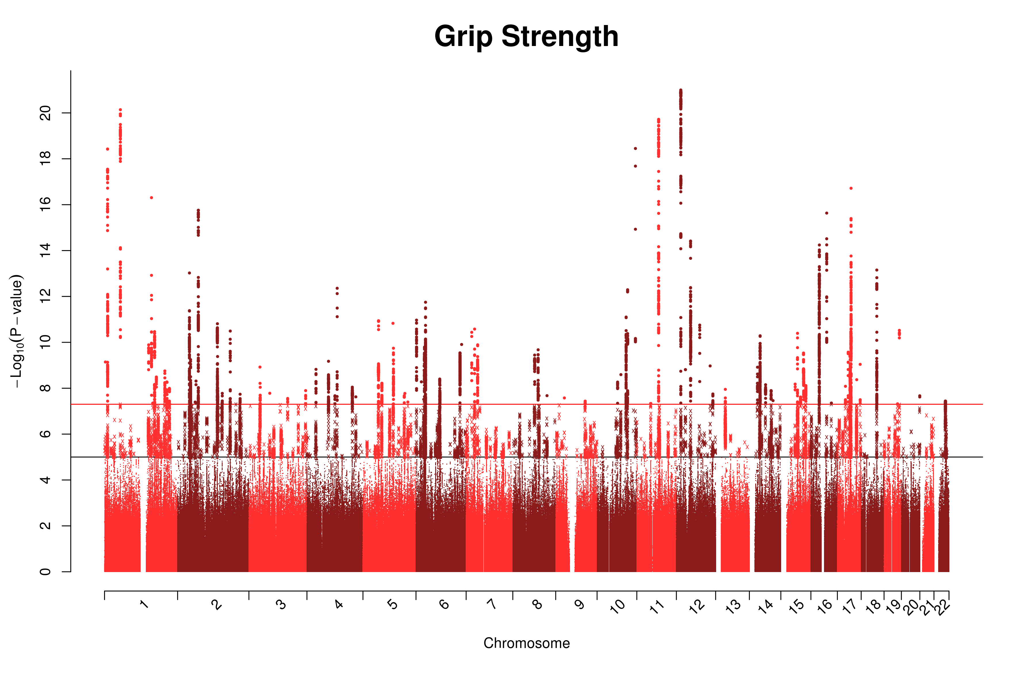

Figure S2. Genome-wide association Manhattan plot for lung function (forced expiratory volume in 1 second; FEV₁) in UK Biobank.
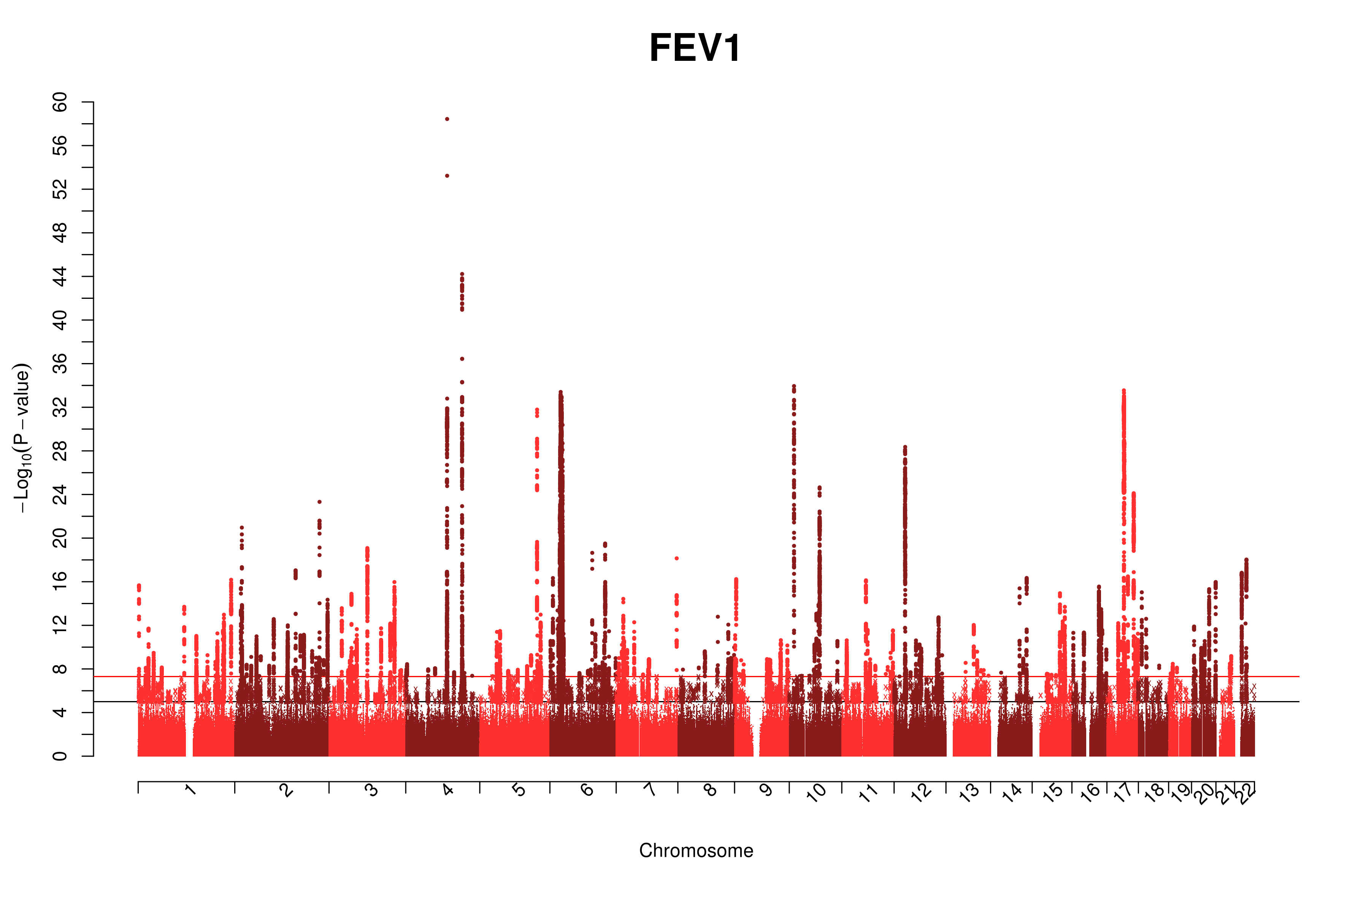

Figure S3. Genome-wide association Manhattan plot for smoking status in UK Biobank.
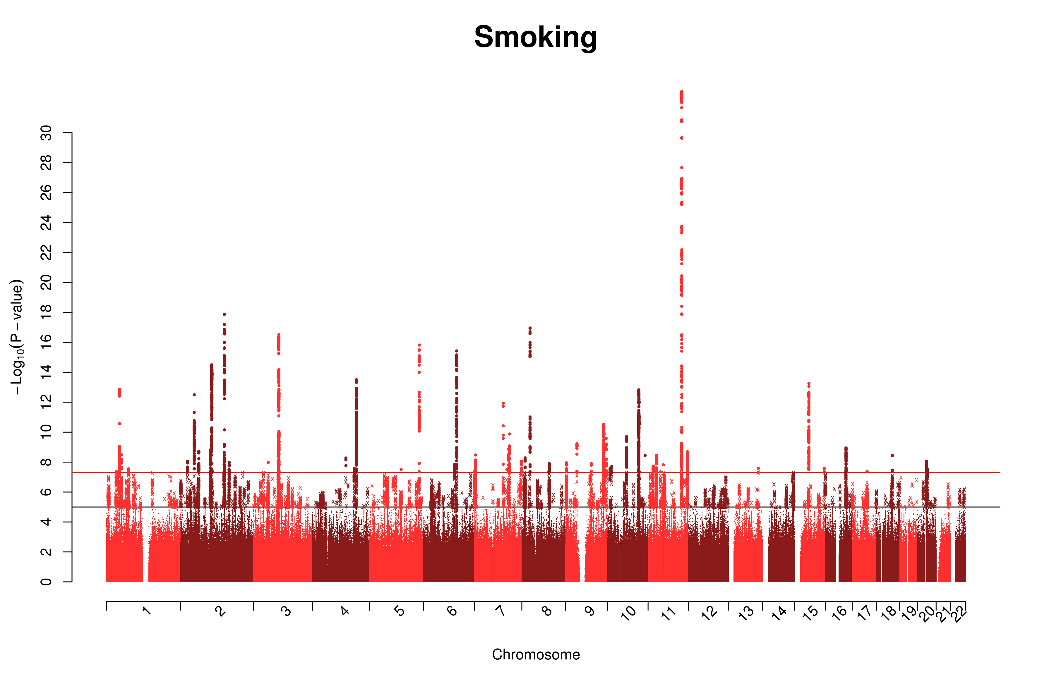

Figure S4. Ageing trajectories of standardized scores on the raw data from each cognitive test, with intercept (at the youngest age) set to zero, showing all data points. The black line denotes the mean change from the original point across the four waves of data collection.
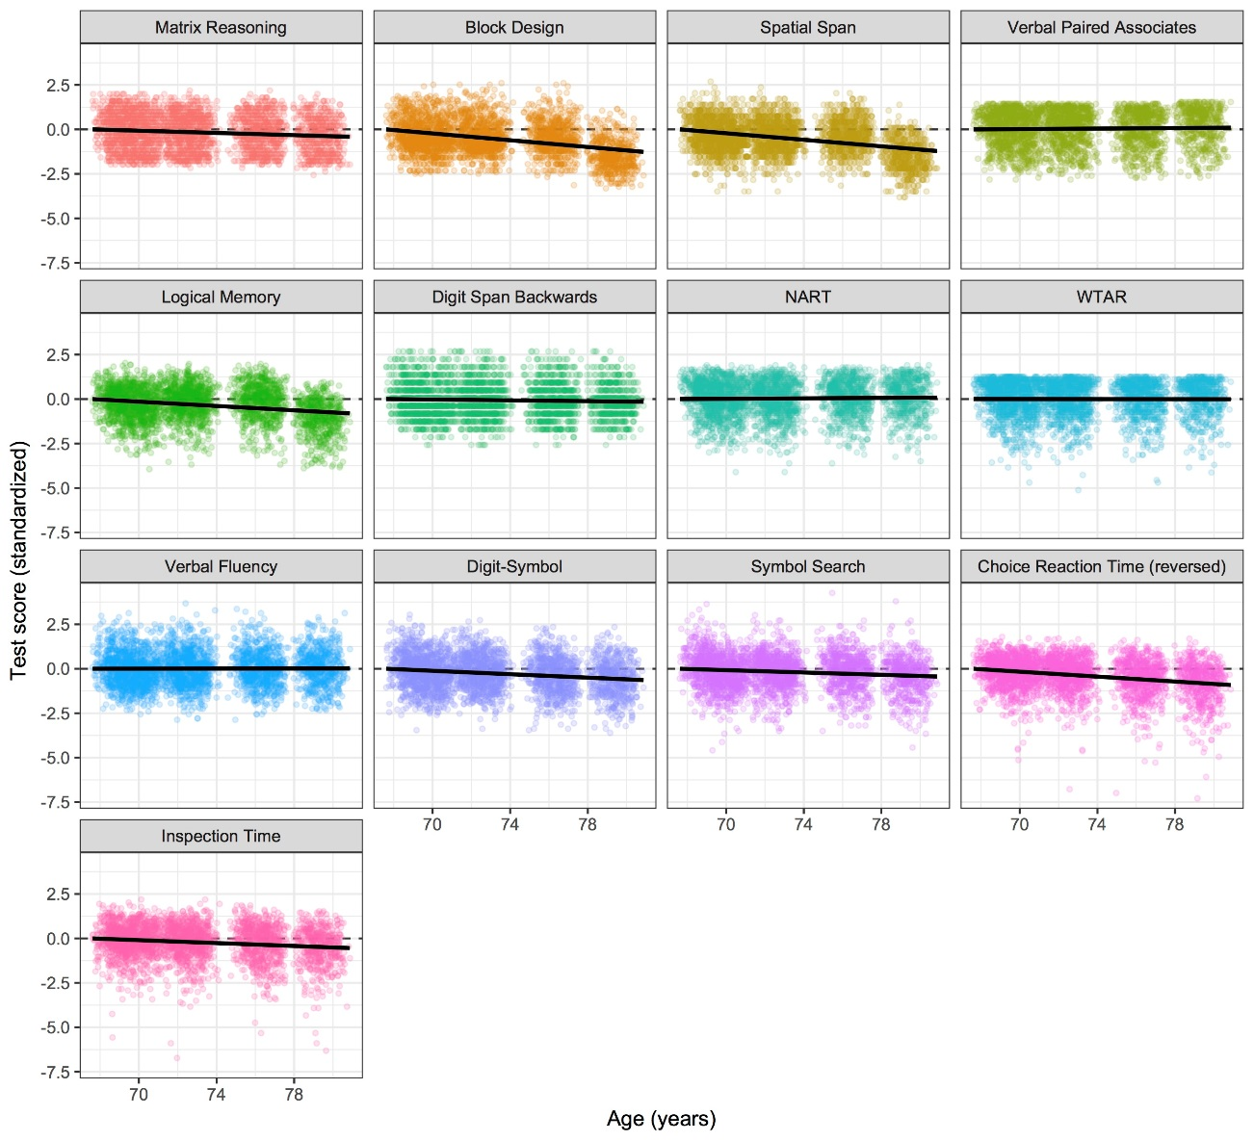
Figure S5. Standardized factor loadings for the structural model of the baseline “factors of curves” model. All tests were corrected for sex and for age in days at the testing wave, but no other covariates or predictors were included. Note that the paths estimated as 1 were fixed to this value due to the model estimating negative (but near-zero) residual variances for these parameters; the loadings were thus fixed to 1 to allow the model to converge on estimates that were within standardized bounds.
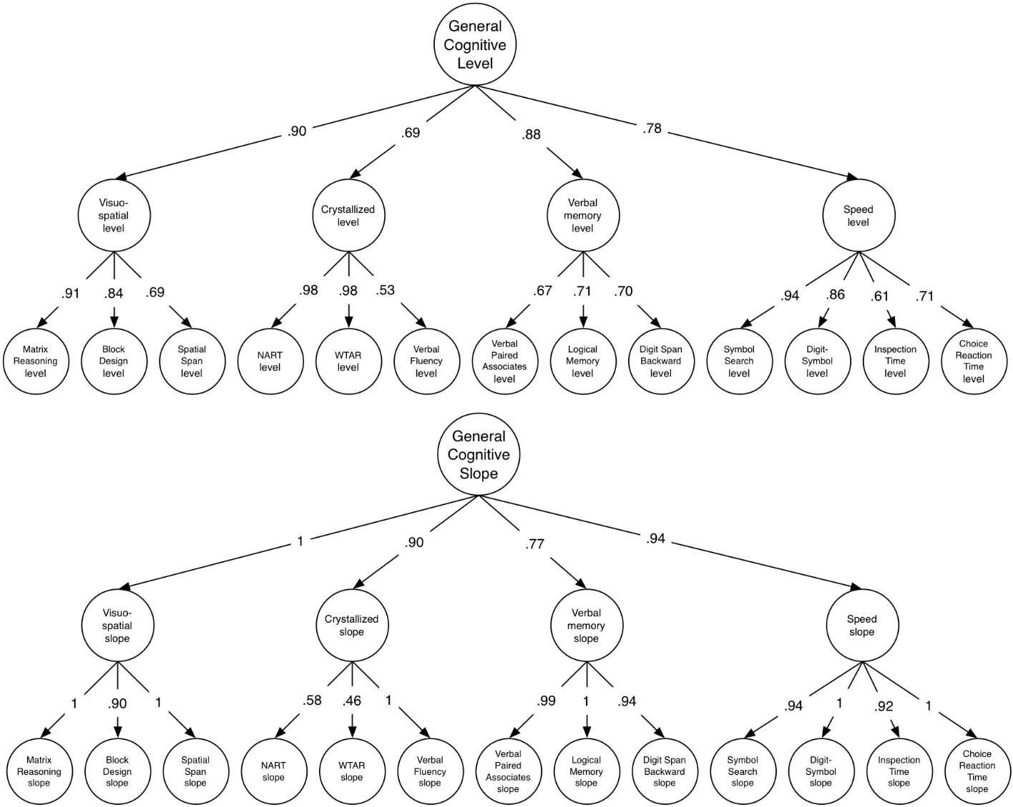

Figure S6. Standardized factor loadings for the age-70 model used to estimate lifetime cognitive change. No covariates were included in the model shown in this figure.
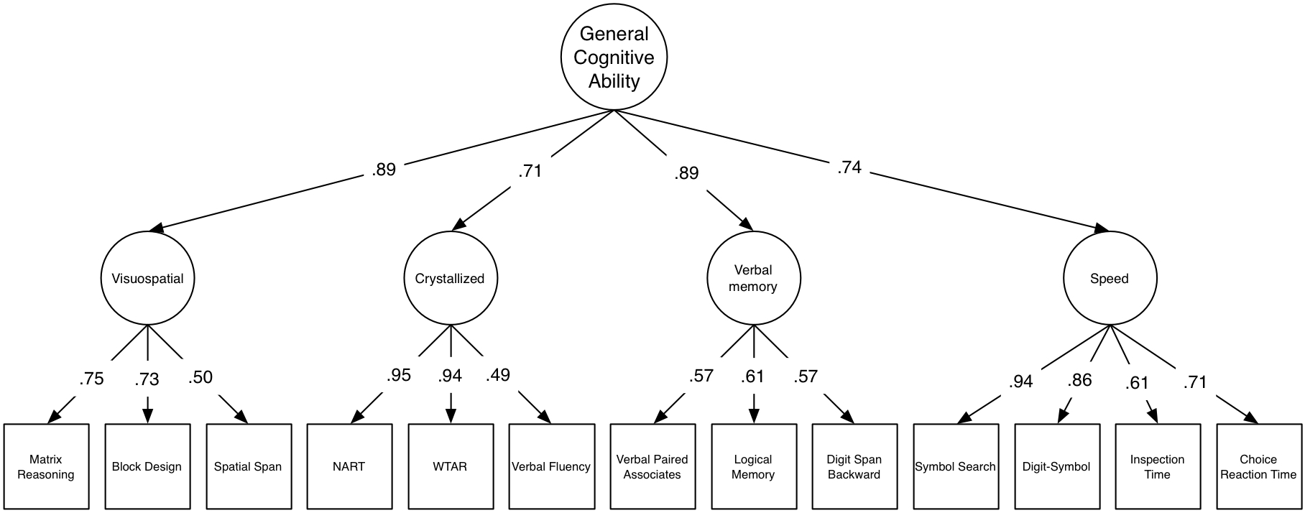

Figure S7. Mediation model where education mediates the path between the education-linked polygenic score and cognitive change across the lifespan. Note that g (general cognitive ability) age 70 is a latent variable indicated using the same higher-order model shown in Figure S6, but for illustrative purposes the cognitive tests and their structure are not shown here. Paths a and b represent the indirect path between the education polygenic score (PGS) and g age 70; path c is the direct path.
