Supplementary Figure 1. Associations with FLT1 expression
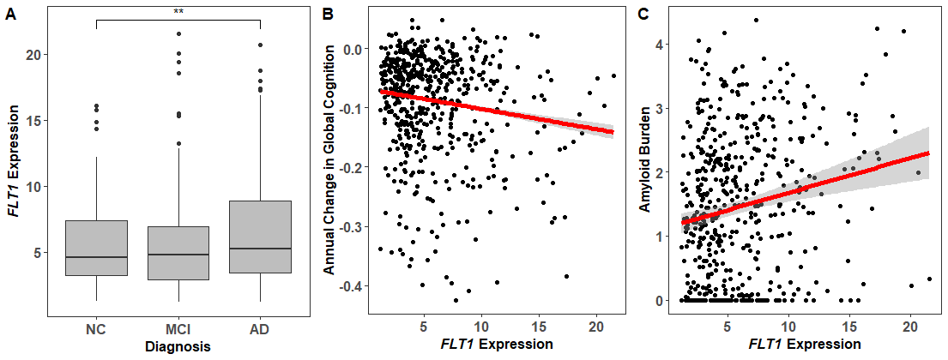
FLT1 expression associates with (A) clinical diagnosis, (B) longitudinal cognition, and (C) amyloid pathology. Note: ** indicates p-value < 0.05; NC = normal cognition, MCI = mild cognitive impairment, AD = Alzheimer’s disease.

Supplementary Figure 2. Associations with FLT4 expression

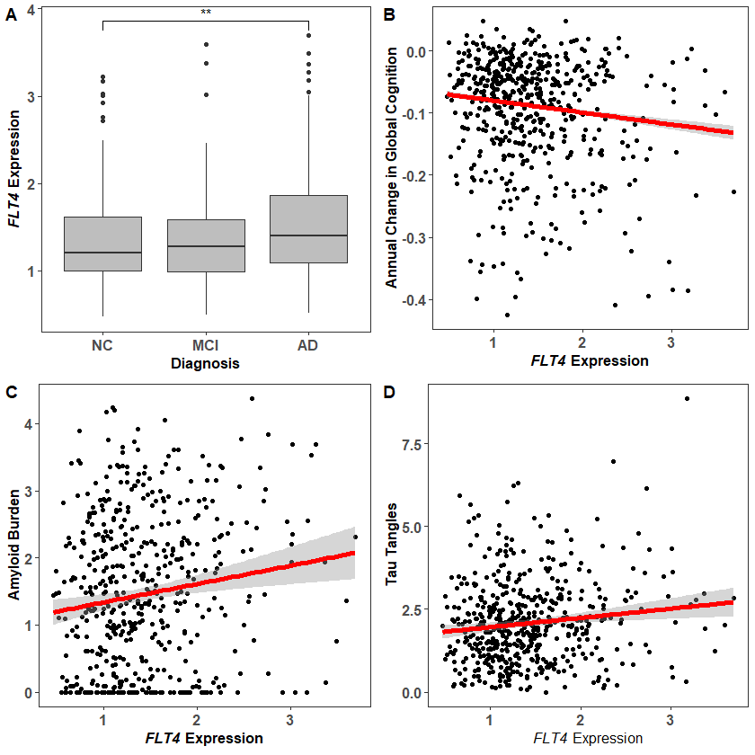
FLT4 expression associates with (A) clinical diagnosis, (B) longitudinal cognition, and (C) amyloid and (D) tau pathology. Note: ** indicates p-value < 0.05; NC = normal cognition, MCI = mild cognitive impairment, AD = Alzheimer’s disease.

Supplementary Figure 3. Associations with PGF expression

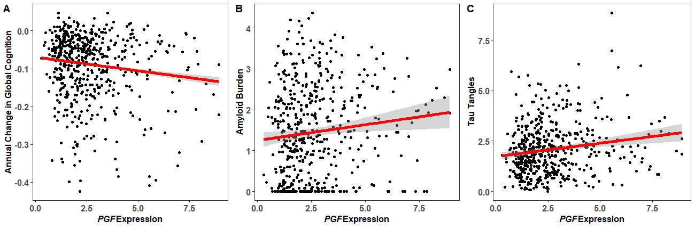
PGF expression associates with (A) longitudinal cognition as well as (B) amyloid and (C) tau pathology.

Supplementary Figure 4. Correlations between VEGF expression and expression of cell-type markers

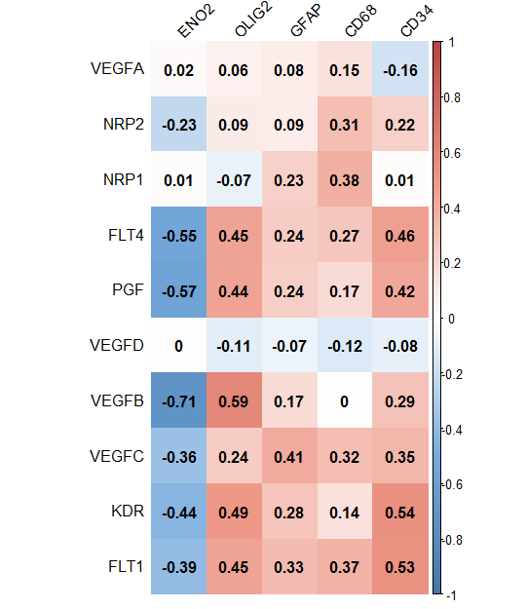
Correlations between expression of VEGF genes and cell-type markers (ENO2 [neurons], CD68 [microglia], OLIG2 [oligodendrocytes], GFAP [astrocytes], and CD34 [endothelial cells]). Correlations were calculated using Pearson’s R and range from -1 (blue color) to 1 (red color).

