Supplementary Figures

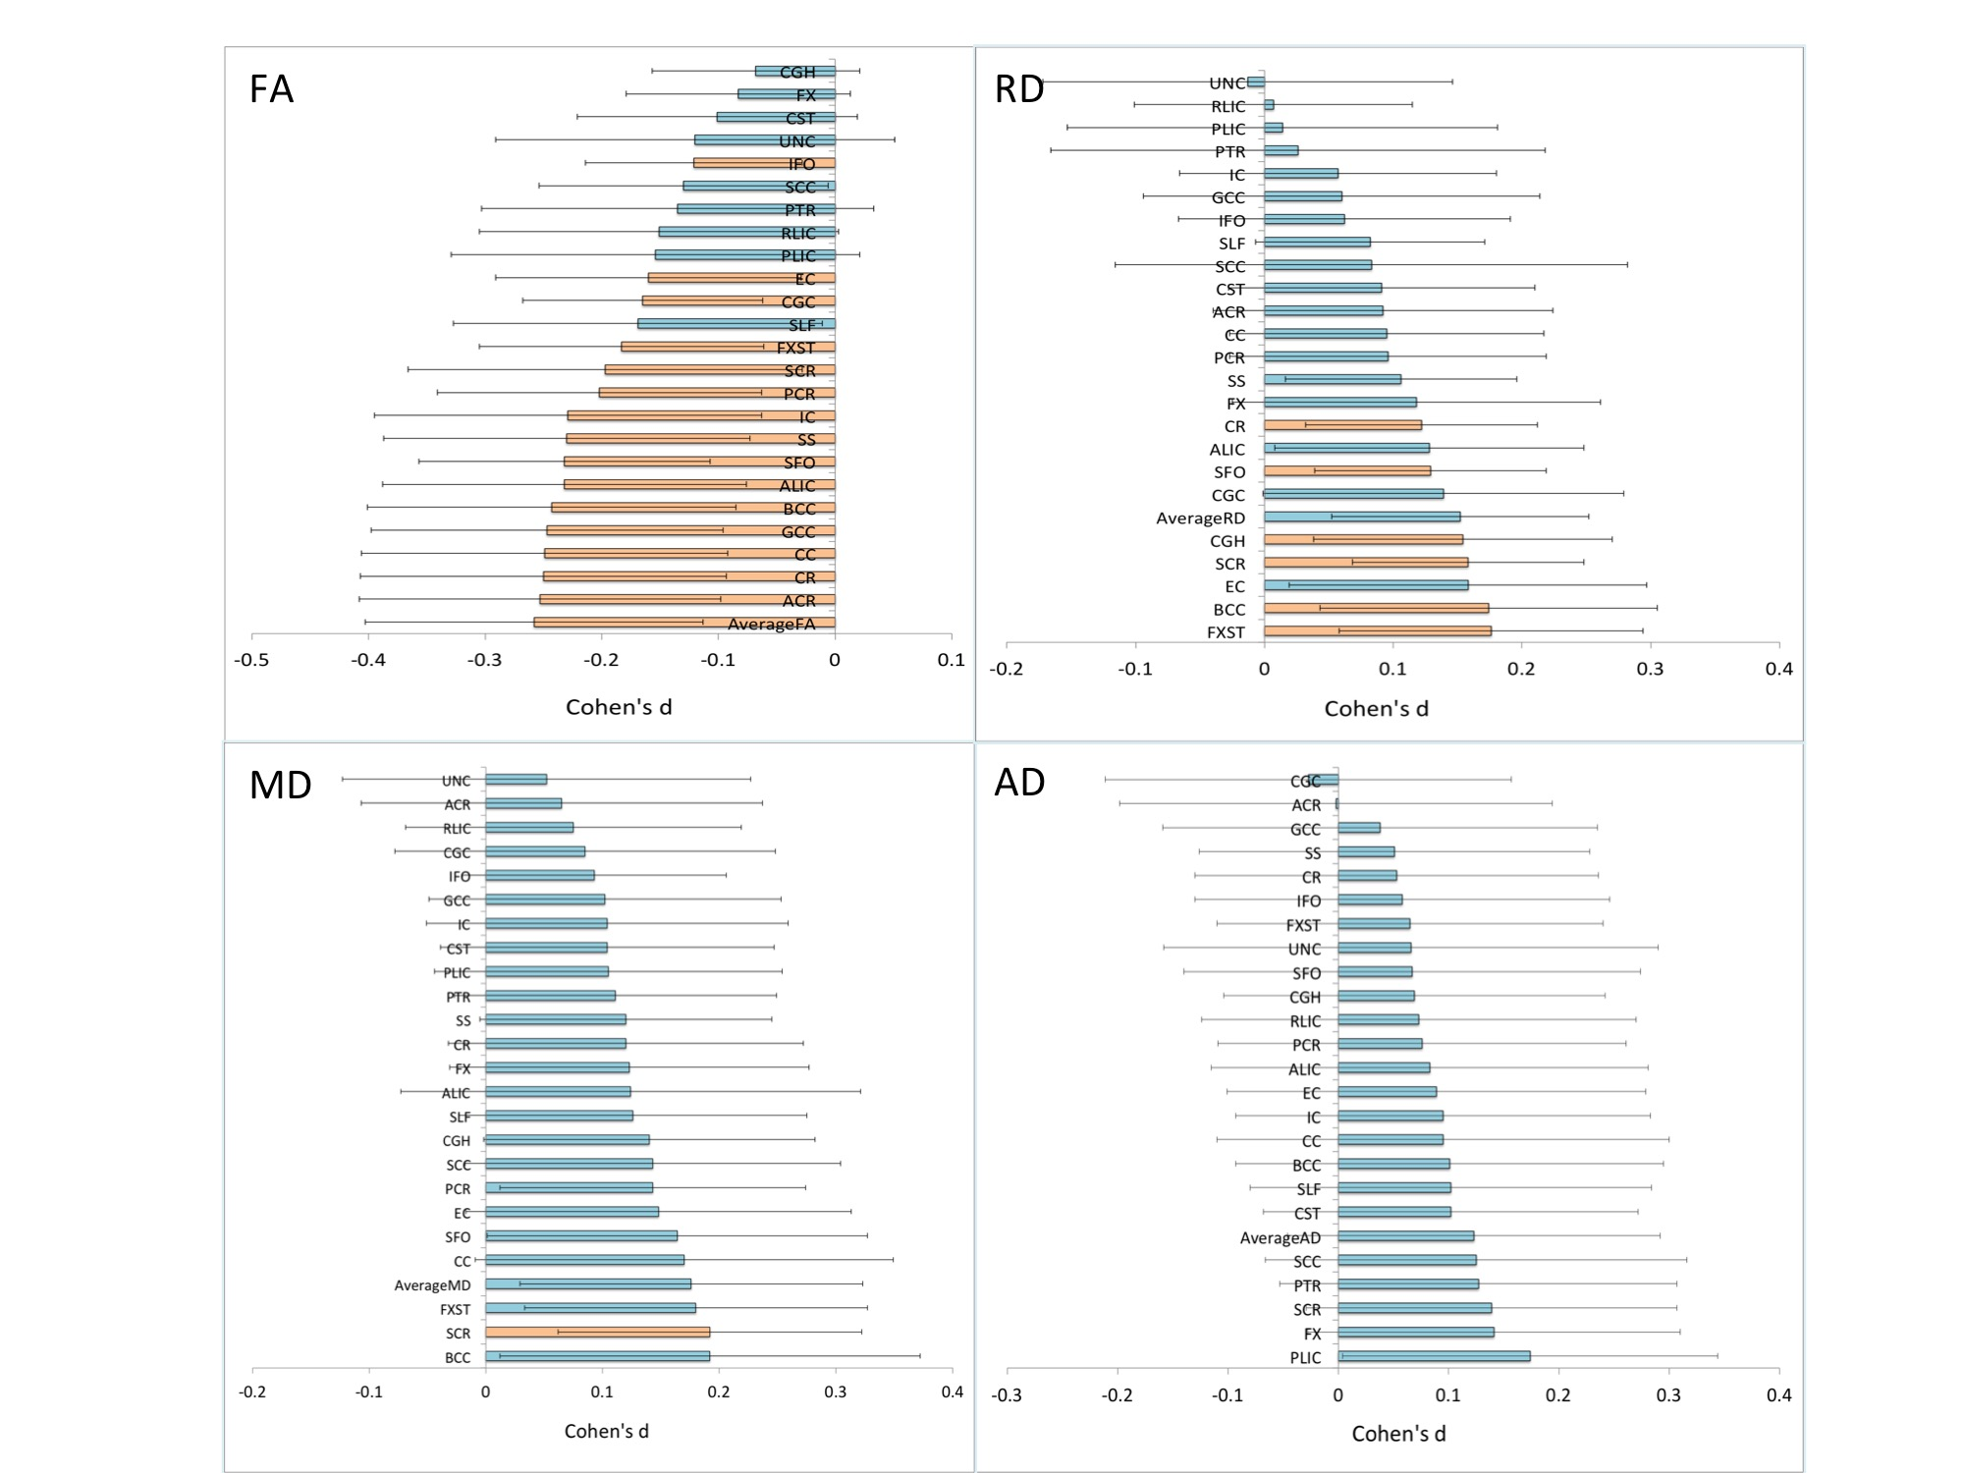

Supplementary figure 1. Cohen’s d effect sizes, after meta-analysis, for FA, AD, MD and RD differences between adult MDD patients and healthy controls, including age, sex, age×sex, age² and age²×sex, as covariates. Error bars represent the 95% confidence interval. Significant regions after FDR correction in orange.

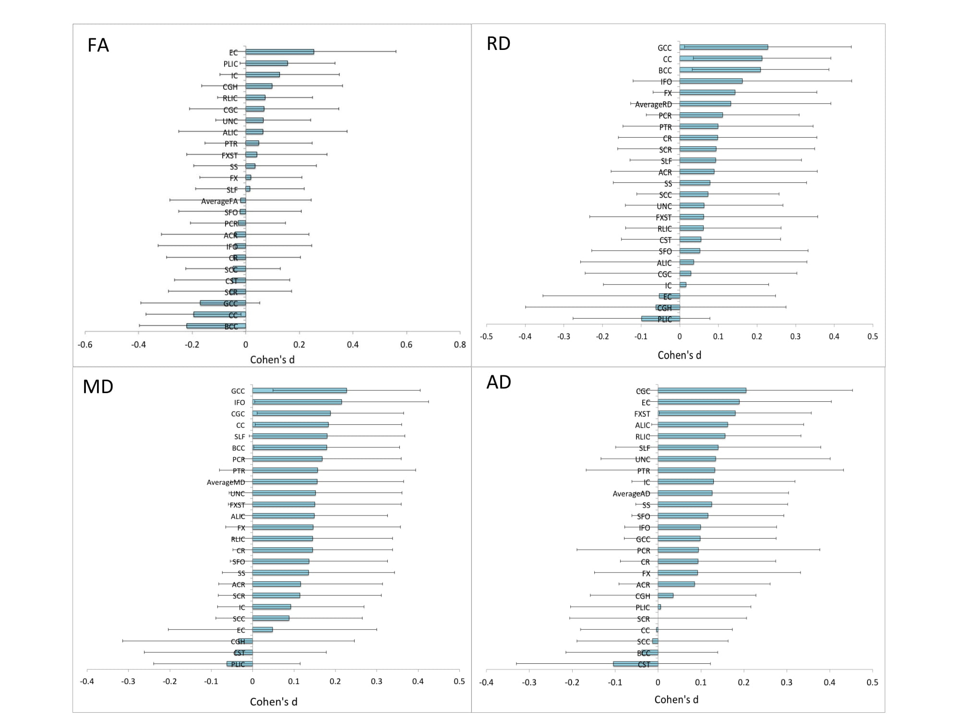

Supplementary figure 2. Cohen’s d effect sizes, after meta-analysis, for FA, AD, MD and RD differences between adolescent MDD patients and healthy controls, including age, sex, age×sex, age² and age²×sex, as covariates. Error bars represent the 95% confidence interval. Significant regions after FDR correction in orange.

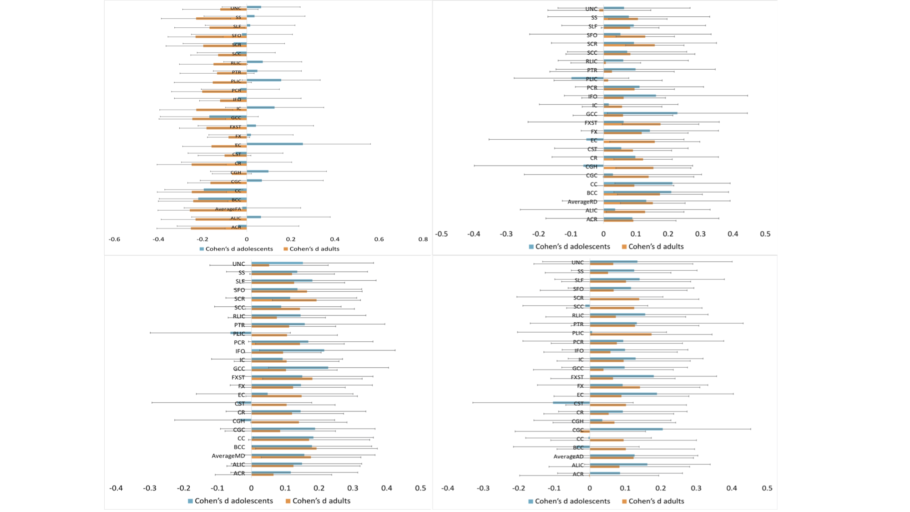

Supplementary figure 3. Cohen’s d effect sizes, after meta-analysis, for FA, AD, MD and RD differences between MDD patients and healthy controls in adults and adolescents, including age, sex, age×sex, age² and age²×sex, as covariates. Error bars represent the 95% confidence interval.

