Supplementary materials

Allele-Specific Expression and High-Throughput Reporter Assay Reveal Functional Genetic Variants Associated with Alcohol Use Disorder
Xi Rao^{1*}, Kriti S. Thapa^{2*}, Andy B Chen¹, Hai Lin¹, Hongyu Gao¹, Jill L Reiter¹, Katherine A. Hargreaves³, Joseph Ipe³, Dongbing Lai¹, Xiaoling Xuei¹, Yue Wang¹, Hongmei Gu², Manav Kapoor⁴, Sean P. Farris⁵, Tatiana Foroud¹, Alison M. Goate⁴, Todd C Skaar³, R. Dayne Mayfield⁵, Howard J. Edenberg^{1,2}, Yunlong Liu¹

¹Department of Medical & Molecular Genetics, Indiana University School of Medicine, Indianapolis, Indiana.
²Department of Biochemistry & Molecular Biology, Indiana University School of Medicine, Indianapolis, Indiana.
³Division of Clinical Pharmacology, Department of Medicine, Indiana University School of Medicine, Indianapolis, Indiana.
⁴Ronald M. Loeb Center for Alzheimer's Disease, Department of Neuroscience, Icahn School of Medicine at Mount Sinai, New York, New York, USA.
⁵Waggoner Center for Alcohol and Addiction Research, University of Texas at Austin, Austin, TX 78712, United States.

*These authors contributed equally to this work.

*Correspondence:
Yunlong Liu, Ph.D.
Department of Medical and Molecular Genetics
Indiana University School of Medicine
410 West 10th Street, Suite 5000
Indianapolis, IN 46202
TEL: +1 317 278-9220
Fax: +1 317 278-9217
Email: yunliu@iu.edu

Revised PASSPORT-seq assay
The PASSPORT-seq assay was carried out essentially as previously described [1] but with some modifications, described below, to increase accuracy.
Oligonucleotides
874 single-stranded DNA oligos (437 reference and 437 variants) were commercially synthesized in parallel as a single pool (Oligomix®, LC Sciences, Houston, TX). Each oligo was 91 nt long with the SNP in the center of the sequence and flanked by 25 nt on each side identical to the genomic context of the SNP, and with complementary regions from the vector on both ends (5’ end GCCGTGTAATTCTAGGAGCTC; 3’ end CGTTCTAGAGTCGGGGCGG) to allow cloning by the NEBuilder® HiFi DNA assembly reaction (New England Biolabs (NEB), Ipswich, MA). A list of the oligonucleotides is provided in Supplementary Table 4. About seven nanograms of the oligonucleotide pool was amplified by PCR using 0.5 µM of primers HJ7207 (5’ GCCGTGTAATTCTAGGAGCTC 3’) and HJ7208 (5’ GCCCCGACTCTAGAACG 3’) and Invitrogen Platinum SuperFi DNA Polymerase (Thermo Fisher Scientific, Waltham, MA) in a 20 µL reaction. The PCR conditions were: 98 °C for 30 s, 25 cycles of 98 °C for 5 s, 65 °C for 10 s and 72 °C for 10 s, with a final extension at 72 °C for 5 min. The size of the PCR product was verified on a 2% agarose gel.
PASSPORT-seq library construction
The pIS-0 vector (12178, Addgene, Cambridge, MA) [2] (Figure S1) was linearized with SacI-HF® and BmtI-HF® restriction enzymes (NEB). The linearized plasmid was separated on a 0.8% agarose gel, excised and purified using QIAquick gel extraction kit (Qiagen, Germantown, MD). 50 ng of the linearized plasmid and 2 µL of the amplified double-stranded oligonucleotide pool were assembled using NEBuilder® HiFi DNA assembly kit (NEB) following manufacturer’s instructions. Two µL of the undiluted assembled product were transformed into 50 µL chemically competent NEB® 5-alpha Competent E. coli cells (NEB) per manufacturer’s protocol. Three independent plasmid assemblies were performed with a total of six transformations (four transformations from the first assembly and one transformation each from the second and third assemblies). The cells from each transformation were plated onto five 100 mm LB-agar plates containing 100 µg/ml ampicillin. Following incubation overnight at 37 °C, the colonies were dislodged from the plates by adding 1 mL sterile water per plate and collected using L-shaped cell spreaders (Thermo Fisher Scientific). A total of ~20,000 colonies were collected. Plasmid DNAs from the colonies of each plate were isolated using PureLink® HiPure Plasmid Filter Midiprep Kit (Thermo Fisher Scientific) or QIAprep Spin Miniprep Kit (Qiagen). The DNAs were pooled to create a single plasmid library. DNA concentrations were measured using the Qubit™ double stranded DNA Broad Range assay kit (Thermo Fisher Scientific) and a NanoDropTM 2000 spectrophotometer (Thermo Fisher Scientific).
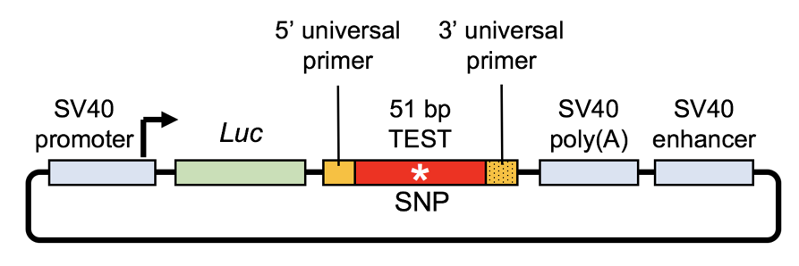
Figure S1. Map of pIS-0 reporter vector used in PASSPORT-seq assay. Test fragments (51 bp with the variant at position 25, flanked by 5’ and 3’ universal primers) were cloned downstream of the firefly luciferase (Luc+) gene within the 3’UTR.
Sanger sequencing
Plasmids from 60 individual colonies were isolated using QIAprep® Spin miniprep columns (Qiagen) and sequenced using primer HJ7209 (5’ GTGGTTTGTCCAAACTCATC 3’) by Sanger sequencing (Genewiz, South Plainfield, NJ) to determine the representation of the constructs.
Culturing and transfection of SH-SY5Y and SK-N-BE(2) cells
Two neuroblastoma cells lines, SH-SY5Y (CRl-2266, ATCC, Manassas, VA) and SK-N-BE(2) (CRL-2271, ATCC) were cultured in a 1:1 mixture of EMEM (ATCC) and F12K medium (10025-CV, Thermo Fisher Scientific) with 10% (vol/vol) fetal bovine serum (ATCC) and 1% penicillin and streptomycin. Cells were used as received from the manufacturer. Cells were plated at a density of 9 x 10⁵ per well in a 9.5 cm² Corning® CellBIND® 6-well dishes (Corning, Corning, NY). 24 h after seeding (~70-80% confluence), the medium was changed to a similar medium but without antibiotics. Cells were transfected with 1.5 µg of plasmid library using 6 µL of X-tremeGENE HP DNA transfection reagent (4:1 reagent-to-DNA ratio; Millipore Sigma, St. Louis, MO) in 200 µL Opti-MEM reduced serum medium (Thermo Fisher Scientific). At 42 h post transfection, cells were washed once with 2 mL cold 1X phosphate-buffered saline and resuspended in 700 µL of QIAzol Lysis Reagent (Qiagen). Cells were harvested and combined from two wells of a 6-well dish for RNA and DNA isolation.
RNA and DNA isolation and cDNA synthesis
Both plasmid DNA and total RNA were isolated from transiently transfected cells using miRNeasy mini kit (Qiagen) per manufacturer’s instructions. After the upper aqueous phase was collected for RNA isolation, DNA was extracted from the interphase and the lower phenol-chloroform phase using ethanol precipitation and resuspended in 100 µL of 8 mM NaOH. The plasmid DNA was then purified using QIAprep® Spin miniprep columns (Qiagen). RNA was purified from the upper aqueous phase using miRNeasy mini kit columns (Qiagen), with on-column DNase treatment. The RNA quantity was measured using a NanoDropTM 2000 spectrophotometer (Thermo Fisher Scientific), and 1 µg of total RNA was used for cDNA synthesis using QuantiTech Reverse Transcription kit (Qiagen) with one of the four reporter-RNA specific primers (HJ7210-HJ7213, Table S1) in a 20 µL reaction.
Generating barcoded sequencing libraries from cDNAs and plasmid DNAs
For generating sequencing libraries, PCR primers containing the flanking sequences from the vector (universal primer, 22 bp RP or FP), a set of unique molecular indices (UMIs, 10 random nucleotides, to reduce PCR bias) and a sample barcode (BC, 9-12 bp with staggered sequences, to reduce low sequencing complexity problems) were used (Table S1, Figure S2). Partial Illumina adapter sequences (20 bp R1 or 21 bp R2) were also included on the primers to facilitate the library preparation (Table S1, Figure S2). The first PCR was performed using 2 µL of unpurified cDNA and adding 0.1 µM of one of the primers (HJ7214-HJ7219; Table S1; the primer carried over from cDNA synthesis was also present) in a 20 µL reaction using the following conditions: 98 °C for 30 s, 10 cycles of 98 °C for 5 s, 65 °C for 10 s, with a final extension at 72 °C for 5 min.
Table S1. Primers used for barcoding cDNAs and plasmid DNAs
Name | Description | Sequence
HJ7210 | 1st strand-cDNA | ACA CGA CGC TCT TCC GAT CTN TAG GCT CTN NNN NNN NNN CGG CCG CCC CGA CTC TAG AAC G
HJ7211 | 1st strand-cDNA | ACA CGA CGC TCT TCC GAT CTN NGA AGA CTG NNN NNN NNN NCG GCC GCC CCG ACT CTA GAA CG
HJ7212 | 1st strand-cDNA | ACA CGA CGC TCT TCC GAT CTN NNC ATT GCA CNN NNN NNN NNC GGC CGC CCC GAC TCT AGA ACG
HJ7213 | 1st strand-cDNA | ACA CGA CGC TCT TCC GAT CTN CGG AAG AAN NNN NNN NNN CGG CCG CCC CGA CTC TAG AAC G
HJ7214 | 2nd strand | CAG ACG TGT GCT CTT CCG ATC NAA TCC AGG CGC CGT GTA ATT CTA GGA GCT C
HJ7215 | 2nd strand | CAG ACG TGT GCT CTT CCG ATC NNT GAG GAG ACG CCG TGT AAT TCT AGG AGC TC
HJ7216 | 2nd strand | CAG ACG TGT GCT CTT CCG ATC NNN GAC TTG GAC GCC GTG TAA TTC TAG GAG CTC
HJ7217 | 2nd strand | CAG ACG TGT GCT CTT CCG ATC NTC TCA CCA CGC CGT GTA ATT CTA GGA GCT C
HJ7218 | 2nd strand | CAG ACG TGT GCT CTT CCG ATC NNG TGC GTT ACG CCG TGT AAT TCT AGG AGC TC
HJ7219 | 2nd strand | CAG ACG TGT GCT CTT CCG ATC NNN TCA TCG AGC GCC GTG TAA TTC TAG GAG CTC
HJ7220 | Passport-Seq-PCR | ACA CGA CGC TCT TCC GAT CT
HJ7221 | Passport-Seq-PCR | CAG ACG TGT GCT CTT CCG ATC
The PCR products were purified using HP PCR product purification kit (Millipore Sigma) and eluted in 20 µL TE (10 mM Tris-HCl, 1 mM EDTA, pH 8.0). 9.2 µL of the products from the initial PCR was then used as template for the second PCR using 0.2 µM primers HJ7220 (5’ ACA CGA CGC TCT TCC GAT CT 3’) and HJ7221 (5’ CAG ACG TGT GCT CTT CCG ATC 3’) under the following conditions: 98 °C for 30 s, 15-17 cycles of 98 °C for 5 s, 65 °C for 10 s, with a final extension at 72 °C for 5 min. After the second PCR, the products were purified using the HP PCR product purification kit (Millipore Sigma), and eluted in 20 µL low TE (0.1X TE). For controls, the extracted plasmid DNAs were used as template: ~150 pg of the template was used for the first PCR using one of the HJ7210-7213 primers and one of the HJ7214-HJ7219 primers, both at 0.1 µM, with the similar conditions as for the cDNAs. Similarly, after column purification, 2 µL of the template from first PCR was used for the second PCR with similar conditions as for the cDNAs. All the products were analyzed by Agilent 2100 Bioanalyzer (Agilent Technologies, Santa Clara, CA) using high sensitivity DNA assay kit (Agilent Technologies) and the Qubit™ double stranded DNA Broad Range assay kit (Thermo Fisher Scientific) before pooling for library preparation.
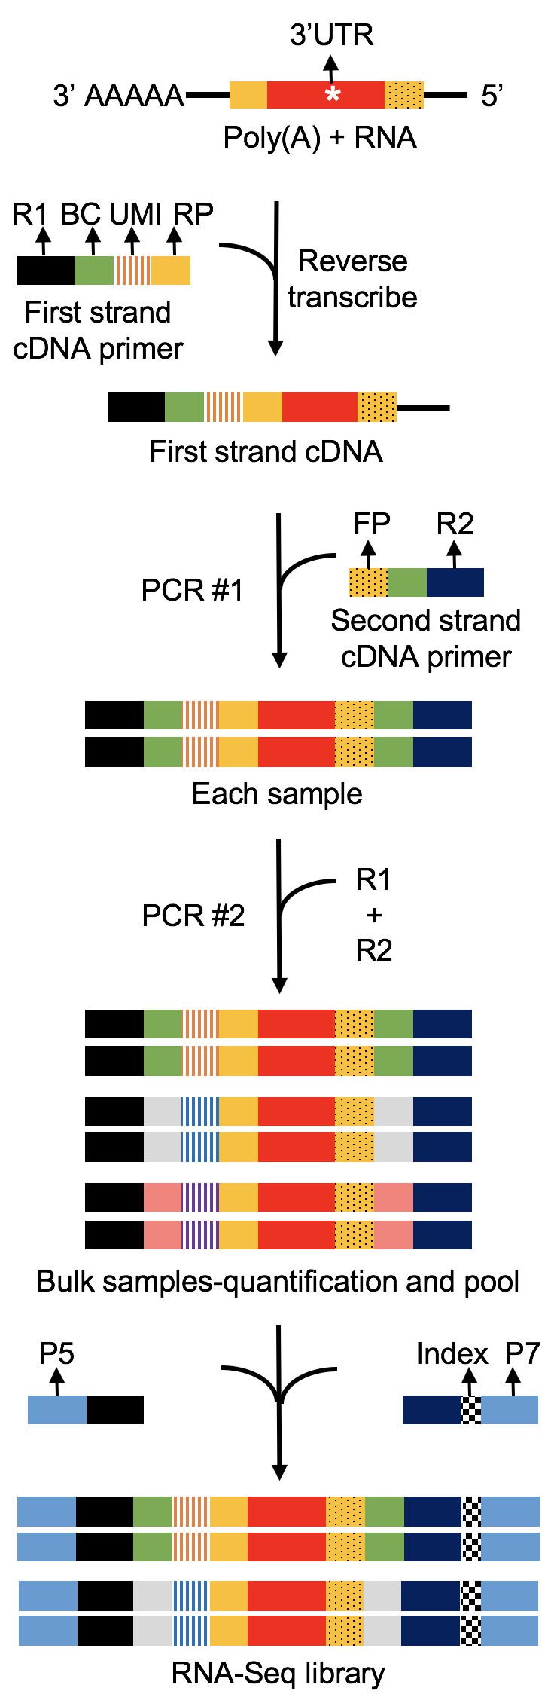 | Figure S2. Modified library preparation for PASSPORT-seq. First strand cDNA primers/ reverse transcription primers, HJ7210-7213 (R1=20 bp Read 1(partial Illumina adapter sequence), BC=9-12 bp sample barcode with staggered Ns, UMI=10 bp unique molecular indices, RP=22 bp universal reverse primer). Second strand cDNA primers, HJ7214-7219 (FP=22 bp universal forward primer, R2=21 bp Read 2 (partial Illumina adapter sequence). PCR amplification primers, HJ7220= 20 bp Read 1 (R1) and HJ7221= 21 bp Read 2 (R2). Library primers, P5 and P7 (partial Illumina i5 and i7 indexing primers).

Library preparation and sequencing
The PCR fragments consisting of uniquely barcoded cDNAs and plasmid DNAs for each biological replicate were pooled together for each cell line (SH-SY5Y and SK-N-BE(2)). Next-generation sequencing libraries were prepared with 50 ng of PCR fragments in each reaction using Illumina TruSeq Nano DNA Low Throughput Library Prep Kit (FC-121-4001, Illumina, Inc., San Diego, CA). Because the PCR fragments already had adaptor sequences, DNA fragmentation, end-repair, dA-tailing, and adaptor ligation were omitted from the normal protocol. The PCR fragments were directly amplified using Illumina index adaptors (i5 and i7 indexing primers), using PCR conditions of 72 °C for 3 min, 98 °C for 30 s, followed by 5 cycles of 98 °C for 20 s, 60 °C for 15 s and 72 °C for 30 s, ending with 72 °C for 5 min. Each resulting library was quantified and the quality was accessed by Qubit™ double stranded DNA Broad Range assay kit (Thermo Fisher Scientific) and Agilent 2100 Bioanalyzer (Agilent Technologies), and both libraries were pooled in equal molarity. Five µL of 3 nM pooled libraries, including 10% PhiX (Illumina), were then denatured, neutralized and applied to the cBot for flow cell deposition and cluster amplification before loading on to a lane of HiSeq 4000 (Illumina, Inc) for 75 nt paired-end sequencing. More than 360 million paired-end reads were generated, 96% of which reached Q30 (Phred quality score, 99.9% base call accuracy).
Sequencing data analysis
FASTQ files for DNA sequences were demultiplexed based upon the DNA barcodes identifying DNA source and replicate number using cutadapt, and the barcode and adapter sequences were trimmed from each read. The UMI was trimmed and stored in the read name using umi_tools. Using bwa mem, reads were mapped to chromosomes defined by the reference and alternative sequence for each SNP of interest. Finally, umi_tools was used to count the number of UMI-unique reads for each sequence. The overall workflow for data processing and analysis is depicted in Figure S3.

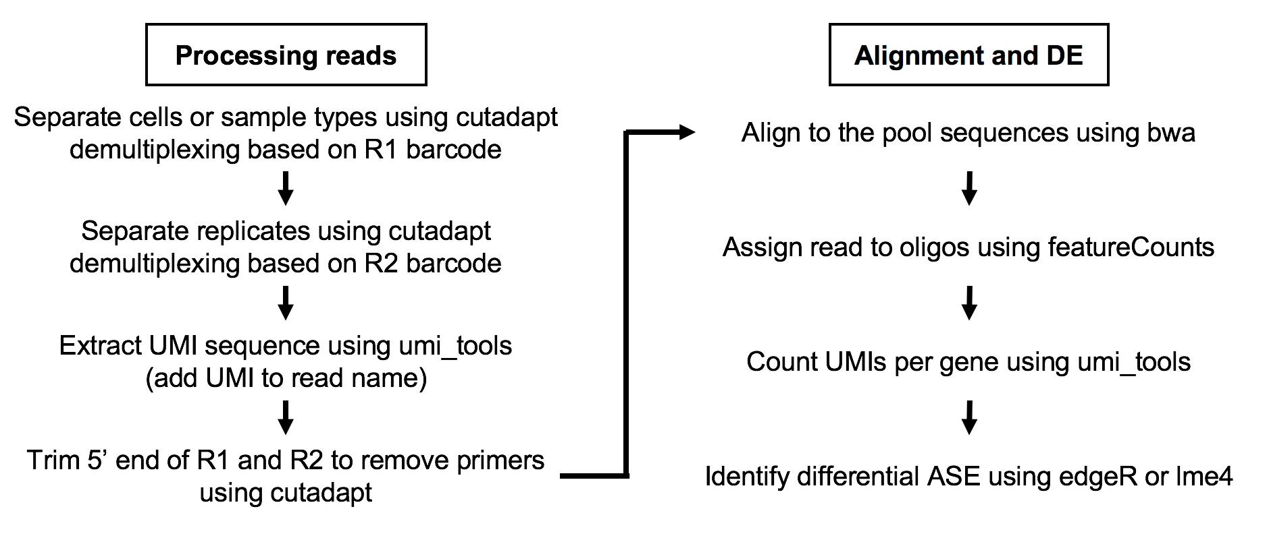
Figure S3. Workflow for data processing and analysis pipeline for PASSPORT-seq. Left panel, processing the reads, R1=Read1, R2=Read2. Right panel, sequencing processing and statistical model for identifying functional variants.

Data analysis of ethanol treated and untreated SK-N-BE(2) cells
Similar as data processing for the brain RNA-seq data, the raw RNA-seq reads for the SK-N-BE(2) cells were aligned to human genome 19 (hg19) using STAR aligner version 2.5.3.a [15]. FastQC (https://www.bioinformatics.babraham.ac.uk/projects/fastqc/) was used to evaluate RNA sequence quality. To count the reference and alternative alleles in ethanol-treatment RNA sequencing data, reads for each SNP of interest were extracted from the bam files using bedtools intersect. Then the reference and alternative alleles were counted using the pysam module of Python. A generalized linear mixed effect model was used to quantify the interaction between the alternative allele frequency of a SNP and ethanol treatment:
$$⁡log(μ)=β_{0}+β_{1}X_{1}+β_{2}X_{2}+β_{12}X_{1}X_{2}+bX_{S}+$$

where $μ$ is the expected number of sequencing reads for one allele (reference or alternative), X₁ is the allele type (0: reference allele, and 1: alternative allele), X₂ is the subject study group (0: control group, 1: 10mM ethanol treatment group, and 2: 20mM ethanol treatment group), and X_{S} is the sample ID. In this model, $β_{0}$, $β_{1}$, $β_{2}$, and $β_{12}$ are fixed effect parameters, while b is a random effect that models the differences between study groups. In this model, the null hypothesis (H₀) is: $β_{12}$= 0. Rejecting the null hypothesis indicates that the allelic imbalance differs between control and ethanol treatment group in a dose-response manner.

Power estimation for the ASE analysis.
Power estimation was conducted by simulating sample read counts and applying the negative binomial model with random effects. Reads are drawn depending on the varying combinations of conditions to be tested:
- Effect size, differences in the allele frequency between groups (0.1 and 0.2)
- Standard deviation on the allele frequency in each group (0.05, 0.1, 0.2)
- Number of read coverage for each heterozygous site (10, 25, 50, 100, 1000)
- Number of subjects with heterozygous variants in each group (3 – 60)
After performing 1000 permutation tests of each condition, the proportion of permutations where the model-derived p-value < 0.01 was calculated. The power was estimated based on the number of tests when the null hypothesis was rejected (Figure S4). The number of samples needed to achieve a power of 0.8 was estimated in Table S2.
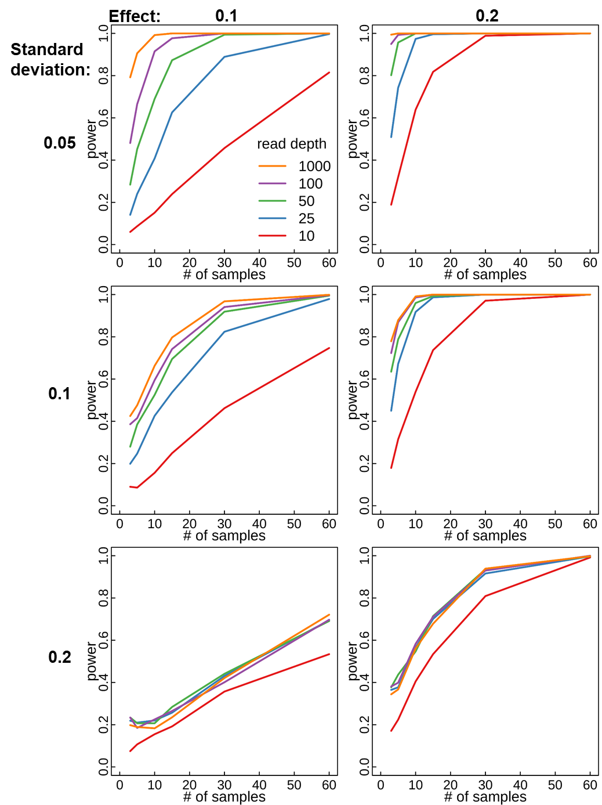
Figure S4. Power analysis estimation for ASE. Estimated power of simulated samples (1000 permutations) under varying conditions: effect size (0.1, 0.2), standard deviation (0.05, 0.1, 0.2), read depth (10, 25, 50, 100, 1000), and sample numbers (3, 5, 10, 15, 30, 60). Power was estimated by calculating the proportion of simulations with p < 0.01 under each condition.

Table S2. Number of samples needed to achieve power=0.8 under each simulation condition
 |  | Read Count
SD | effect | 10 | 25 | 50 | 100 | 1000
0.05 | 0.1 | 59 | 25 | 13 | 8 | 4
0.05 | 0.2 | 15 | 7 | 3 | 3 | 3
0.1 | 0.1 | 66 | 29 | 22 | 20 | 16
0.1 | 0.2 | 20 | 8 | 6 | 5 | 4
0.2 | 0.1 | 116 | 81 | 77 | 74 | 77
0.2 | 0.2 | 30 | 22 | 22 | 22 | 22

From the RNA-sequencing data of the four brain regions, SNPs with at least 5 heterozygous patients in both control and AUD groups with 10 or more reads at the locus were identified (81,799 total SNPs). The number of SNPs with average reads greater than N (for N = 10, 25, 50, 100, 100) and mean standard deviation less than SD (for SD = 0.05, 0.1, 0.2) are listed in Table S3.
Table S3. Number of SNPs with mean read count greater than N and mean standard deviation less than SD
 | Average Read Count (N)
SD | 10 | 25 | 50 | 100 | 1000
0.05 | 2785 | 2600 | 2368 | 2070 | 168
0.1 | 18415 | 17137 | 13536 | 7762 | 323
0.2 | 74666 | 53103 | 30754 | 14536 | 465

The current study utilized RNA-seq data from 30 AUD and 30 control patients to identify genes with ASE. To evaluate the allelic imbalance, for each SNP, only heterozygous patients were included, which decreased the group sample sizes. A power analysis was conducted to evaluate how read depth, sample size, and patient variance could affect the power of showing significant ASE. The analysis revealed that though increasing read depth improves the power at lower sample size, at larger sample sizes, the improvement was not as pronounced. In our study, most of the ASE comparisons were derived from comparing less than 10 samples in each group. The analysis shows that for future work, increased sample size will have the greatest impact on improving the ability to detect ASE; further increases in read depth may only provide marginal benefits.

References
1. Ipe, J., et al., PASSPORT-seq: A Novel High-Throughput Bioassay to Functionally Test Polymorphisms in Micro-RNA Target Sites. Front Genet, 2018. 9: p. 219.
2. Yekta, S., I.H. Shih, and D.P. Bartel, MicroRNA-directed cleavage of HOXB8 mRNA. Science, 2004. 304(5670): p. 594-6.

