Supplementary Information

Supplementary methods

Phenotype Creation in the UK Biobank
(1) Any anxiety diagnosis
Participants self-reported receiving a professional diagnosis of one or more of the following anxiety disorders: Social anxiety; any other specific phobia (e.g. disabling fear of heights, or spiders); panic attacks; anxiety, nerves or generalised anxiety disorder or agoraphobia. Participants were excluded from this analysis if they reported a professional diagnosis of any of the following: schizophrenia; bipolar disorder; attention deficit hyperactivity disorder; autistic spectrum disorder; eating disorder.
The proportion of each of the anxiety disorders included in this phenotype are as follows:
62% report a diagnosis of “Anxiety, nerves or generalised anxiety disorder”
5.5% report a diagnosis of social anxiety disorder or social phobia
6% report a diagnosis of a specific phobia
24.5% report a diagnosis of panic attacks
2% report a diagnosis of agoraphobia.
Note that individuals might report more than one disorder.

UK Biobank item codes used for this definition:
f.20544.0.1 to f.20544.0.16

(2) Probable lifetime generalised anxiety disorder (GAD)
Participants were assessed as having probable generalised anxiety disorder if they met the following criteria:
i. Report having worried more than most people would in the same situation OR
have had stronger worry than most people during their worst period of anxiety.
AND
ii. Have had at least one time in their lives where they have felt worried, tense, or
anxious most of the time for at least a month
AND
iii. This frequent and persistent worrying has persisted 6 months or more
AND
iv. Report having worried most days during their worst period of anxiety
AND
v. EITHER had many different worries on their mind at the same time during the
worst of their OR worried about more than one thing during the worst period of
anxiety.
AND
vi. Found it difficult to stop worrying OR were often unable to stop worrying OR
often found themselves unable to control their worry.
AND
vii. Suffered 3 or more somatic symptoms of anxiety during the worst period of
anxiety (these include feelings of restlessness; feeling easily tired; having trouble
falling or staying asleep; feeling keyed up or on edge; increased irritability;
experiencing tense, sore or aching muscles; having difficulty concentrating)
AND
viii. Their anxiety resulted in significant impairment in roles or normal function
AND
ix. They were not already classified as anxiety cases for the “Lifetime Anxiety Disorder” analysis

UK Biobank item codes used for this definition:
f.20421.0.0 f.20420.0.0 f.20538.0.0 f.20540.0.0 f.20543.0.0 f.20541.0.0
f.20539.0.0 f.20537.0.0 f.20423.0.0 f.20429.0.0 f.20419.0.0 f.20422.0.0
f.20417.0.0 f.20427.0.0 f.20418.0.0

(3) Current anxiety symptoms
The 7 item Generalised Anxiety Disorder 7 (GAD-7) ¹ screening tool was administered to 157 366 participants who took part in the UK Biobank online mental health follow up. Of these, 126 443 individuals were of Western European descent, and all phenotypes were restricted to this sample for case and control definition. This measure assesses generalised anxiety symptoms (such as inappropriate worry) that have been experienced over the preceding two-week period.
Where participants missed more than 2 items on the GAD-7, they were excluded from analyses. If participants missed one or two items, the score for the missing item/s was imputed as the average score for all completed items. A total score was then created for all participants and used in subsequent analyses as a quantitative phenotype.
Participants who scored 10 or more on the GAD-7 total score were considered to have “current anxiety symptoms” and were used as cases for these subsequent analyses. This is a typical cut off point for some symptom severity using this screening measure ¹.
For sensitivity analyses exploring the dimensionality of anxiety symptoms, participants scoring between 5 and 10 on the GAD-7 total score were classed as having mild current GAD symptoms, scoring between 10 and 15 were classed as having moderate current GAD symptoms, and 15 or higher were classed as having severe current GAD symptoms. See Supplementary Table 1 for the total sample for each of these analyses.

UK Biobank item codes used for this definition:
f.20505.0.0 f.20512.0.0 f.2050.0.0 f.20509.0.0 f.20516.0.0 f.20515.0.0
f.20520.0.0

(4) GAD-7 total score:
126 443 individuals of western European descent completed the GAD-7 screening tool. Of these, 50% obtained a total score of 0, resulting in an extreme positive skew of this measure that was not easily corrected. This measure did not conform to assumptions of normality required for the association analyses undertaken in GWAS, and thus it was considered that any secondary analyses resulting from this would not be interpretable, and analyses treating GAD-7 as a continuous measure were not included.

(5) Screened Controls
All case phenotypes were compared against a subset of screened healthy controls. Healthy controls were screened for any self-reported or probable disorder based on their responses to the mental health online follow up self-report diagnoses, symptom measures and CIDI screeners for all available disorders (Generalised Anxiety Disorder, Major Depressive Disorder). In addition, healthy controls did not report seeking any treatment for any psychiatric disorder and were not prescribed psychotropic medication that might be indicative of a psychiatric disorder.

Brief description of the iPSYCH cohort and analyses
As described this includes anxiety cases and controls from the Lundbeck Foundation Initiative for Integrative Psychiatric Research (iPSYCH; http://ipsych.au.dk) that were specifically selected to match the same anxiety inclusion and exclusion criteria used in the present UK Biobank analysis. Genotypes for the primary Denmark cohort came from Guthrie cards held by the Danish Neonatal Screening Biobank at Statens Serum Institut. Samples from this biobank are linked to the Danish register system via the unique Danish personal identification number. The individuals were born between 1981 and 2005 and had to be alive and a resident of Denmark on their first birthday and have a known mother. Specifically, this analysis included those cases who met criteria for lifetime diagnosis of one of the five core anxiety phenotypes and did not meet criteria lifetime diagnosis of schizophrenia; bipolar disorder; autistic spectrum disorder; attention deficit hyperactivity disorder; or eating disorders (n = 2829), and controls (n = 10,386). Diagnoses were assigned by psychiatrists at inpatient and outpatient psychiatric services, and were identified using the Danish Psychiatric Central Research Register ². Controls were randomly selected from the same nationwide birth cohort. The DNA from the dried blood spots was extracted, whole-genome amplified in triplicates and genotyped in 23 batches based on birth year. The first wave (batch) contains the youngest participants (born in 2004) and wave 23 consists of the oldest participants (born in 1981).
Genotyping was performed on Illumina’s PsychChip array at the Broad Institute of MIT and Harvard. GenCall³ and Birdseed⁴ were used to call variants with MAF > 0.01. Callsets were merged after pre-QC on individual call sets. Data processing and GWAS analyses were performed on secure servers at the GenomeDK high-performance computing cluster (http://genome.au.dk).

DNA preparation, genotyping, genotype calling, quality control methods, and imputation were performed on the broader iPSYCH cohort waves, which also included psychiatric cases with non-AN diagnoses (schizophrenia, depression, anorexia nervosa, bipolar disorder, autism spectrum disorder, and attention-deficit/hyperactivity disorder). The full iPSYCH cohort described contains ~86 000 individuals, including about 57 000 cases with at least one of the noted psychiatric disorders and around 30,000 controls who do not have any of the noted psychiatric disorders that are investigated in iPSYCH. Each wave that was processed had ~3 500 participants. More information about the iPSYCH study can be found here ⁵. Ancestry principal components and principal components that captured batch effects and other possible sources of variation were included as covariates.

Additional Genotype and Sample QC
Several QC steps were taken in addition to the UK Biobank QC pipeline.
Sample QC
Individuals were identified as biologically male if they had X-chromosome heterogeneity > 0.9, and as biologically female if they had X-chromosome heterogeneity > 0.5. Individuals were excluded from analyses if there was a discrepancy between their self-reported and biological sex based on these thresholds (401 individuals removed).
One member of any related pair was removed from further analyses (Kinship-based INference for Genome-wide association studies; KING ≥ 0.044). Individuals were also removed if overall genotype missingness was ≥ 0.02. Analyses were restricted to individuals of European descent as assessed through 4 means clustering (n = 462 065).

Genomic analyses were restricted to individuals of Western European descent as identified by 4 means clustering, based on the top principal components derived from the whole sample.

Genotype QC
In addition to UK Biobank genotype QC, variants were removed if HWE ≤ 1x10⁻⁶, GENO ≤ 0.02.

SNP heritability estimates
Conversion of the point estimate of heritability derived from BOLT-LMM ⁶ to the liability scale was undertaken as per procedures described in Lee et al. 2012 ⁷. Standard errors were converted to variances estimates, and converted to the liability scale as per procedure described in Lee et al. (2011) ⁸.
Genetic correlations
Genetic correlations were performed against all traits available on LD hub on the 11 August 2018, with the exception of the 597 unpublished UK biobank trait GWAS.
Gene-wise analysis
Gene based enrichment analyses were used to consider possible associations between “Lifetime Anxiety Disorder” at the aggregate gene level that may not be detectable at the SNP level in highly polygenic traits. MAGMA performs multiple regression on biologically informed gene sets with the outcome trait, while accounting for LD structure between SNPs ⁹. Gene-sets were annotated according to proximity, including the gene region +/- 500 Mb.

Polygenic prediction of anxiety
Polygenic scores were created for each target sample using clumping to obtain SNPs in linkage equilibrium with an r² < 0.1 within a 2500 kb window. Polygenic scores were created using all remaining SNPs at each of eight different p-value thresholds (0.001, 0.05, 0.1, 0.2, 0.3, 0.4, 0.5, 1). Logistic regression models were run in PRSice-2¹⁰ to assess the association between polygenic scores created at each threshold and "Lifetime Anxiety Disorder" case/control status, again with the same controls as in the main analysis. Ten thousand permutations were run for each subgroup to derive an empirical p-value robust to multiple testing.

Partition heritability
SNP heritability was partitioned using the “baseline model”, consisting of 53 functional categories, fully described elsewhere ¹¹.

Supplementary results

Partitioned heritability
There was a significant enrichment of SNP heritability for “Lifetime Anxiety Disorder” in regions of the genome known to be highly conserved across 29 Eutherian mammals ³⁰, with 2.6% of SNPs accounting for 34% of the heritability (se = 0.08; Enrichment metric 13.01, Enrichment se = 3.01, Enrichment p = 0.0001, coefficient p = 6.7x10⁻⁰⁵). See Supplementary Figure 8 for a bar plot showing relative enrichment of the SNP h² across the 53 baseline genomic regions tested.

Exploration of TMEM106B gene locus
Steps were taken to ascertain whether the locus on chromosome 7 associated with “Lifetime Anxiety Disorder” is part of the same locus as variant rs1990620 previously found to play a putatively causal role in downstream expression of the TMEM106B and related cellular damage in frontotemporal degeneration ¹². (1) A region plot of the TMEM106B locus was created tagging rs1990620 to establish whether this SNP is in high linkage disequilibrium with rs3807866. (2) Associations analyses were performed using SNPtest ¹³ conditioning on the putatively causal variant rs1990620 and (3) on the index variant rs3807866 to test whether these SNPs were independently associated with “Lifetime Anxiety Disorder” in the UK Biobank, or part of the same locus.

The putatively causal variant, rs1990620, identified by Gallagher et al. 2017 was found to be in high linkage disequilibrium with the index variant rs3807866 annotated to the TMEM106B gene associated with “Lifetime Anxiety Disorder” (see Supplementary Figure 9). When analyses of this region on chromosome 7 were adjusted for the effects of either this variant or the index variant identified in the “Lifetime Anxiety Disorder” genome wide association (rs3807866), no association with the “Lifetime Anxiety Disorder” phenotype remained (see Supplementary Figure 10). This indicates that the locus identified by Gallagher et al., 2017 is, in essence, the same locus which we find.

Supplementary Figures:
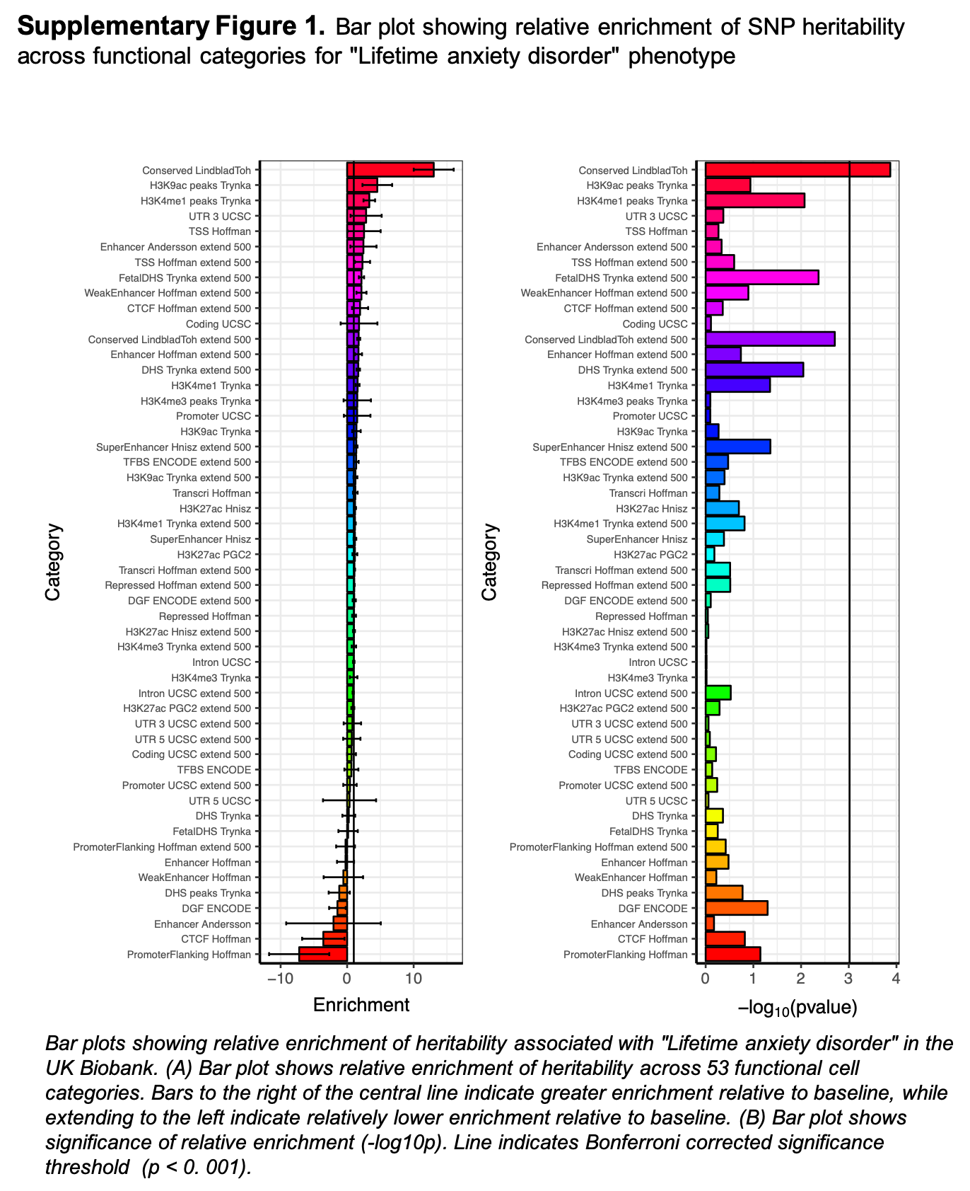

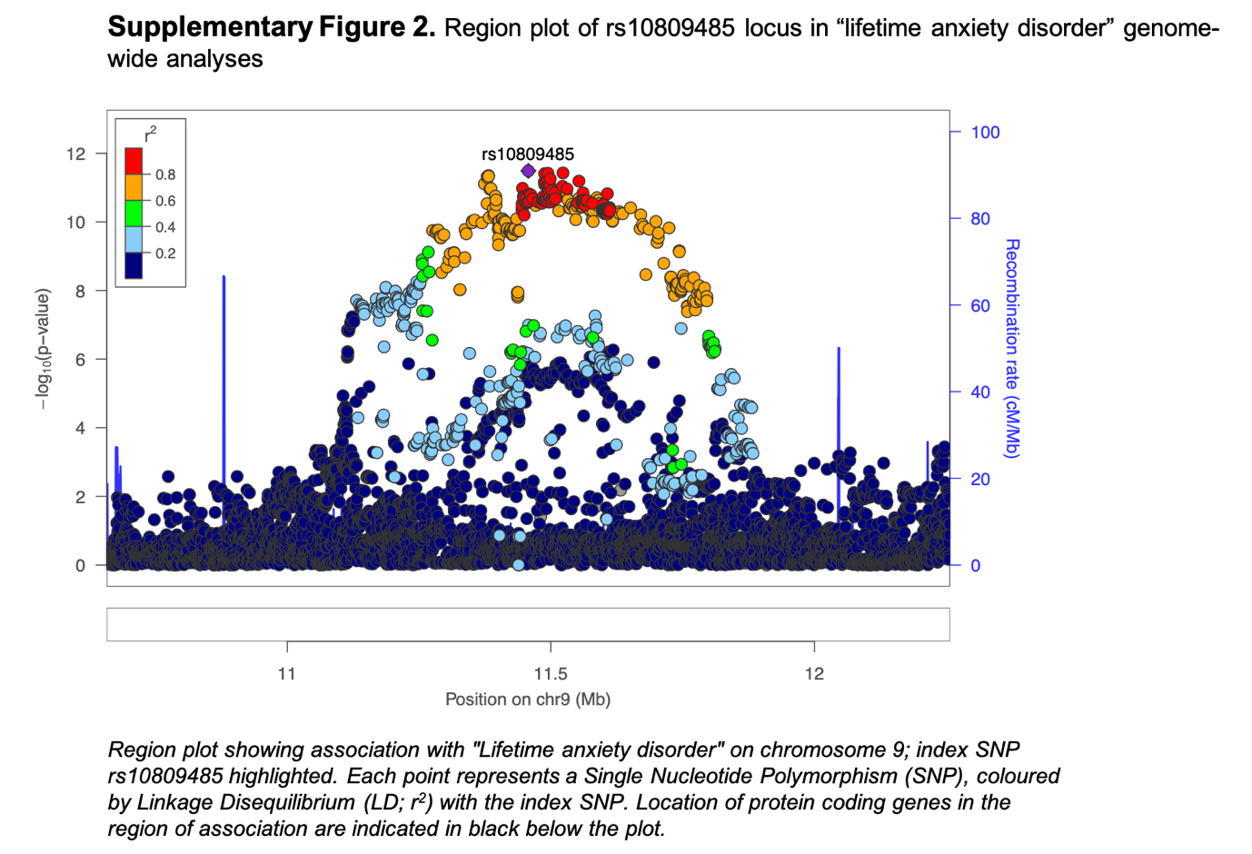

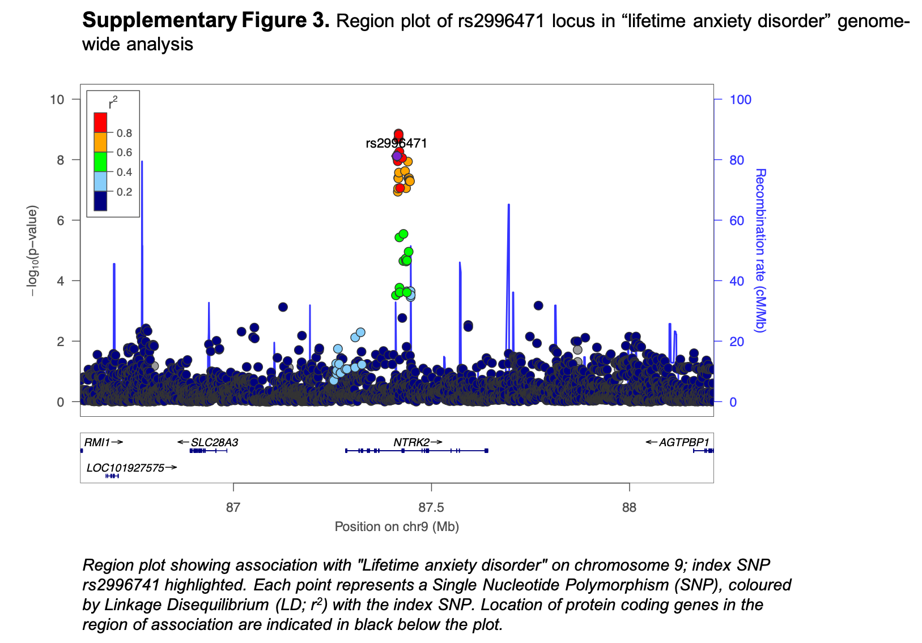

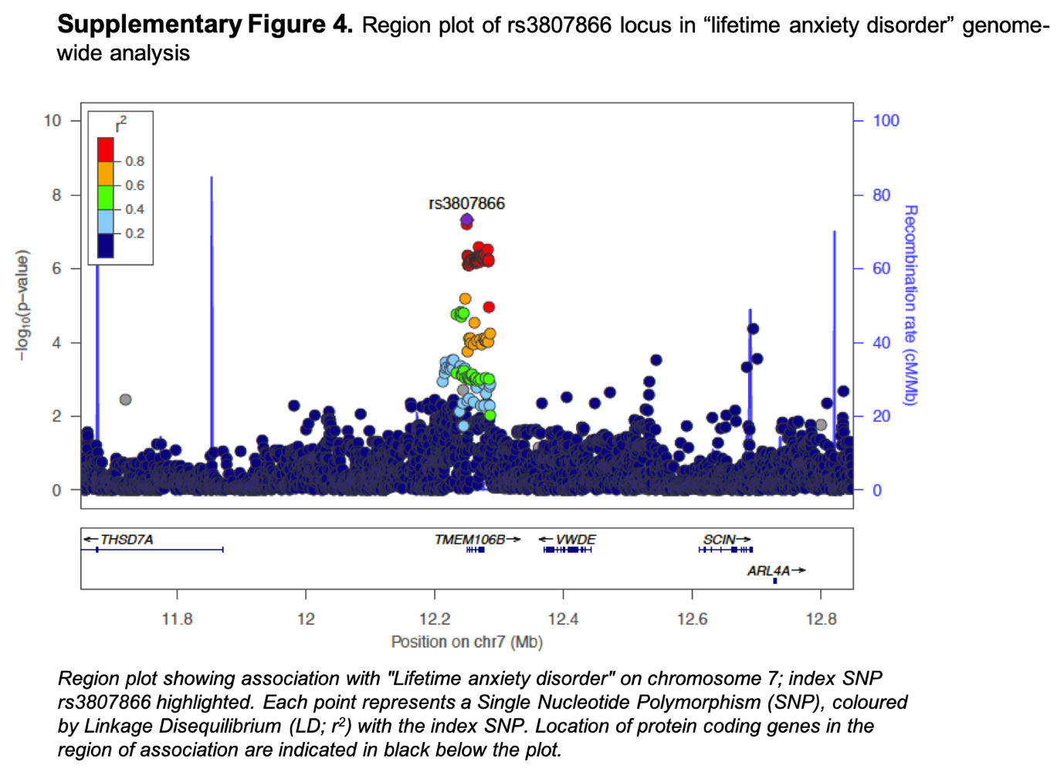

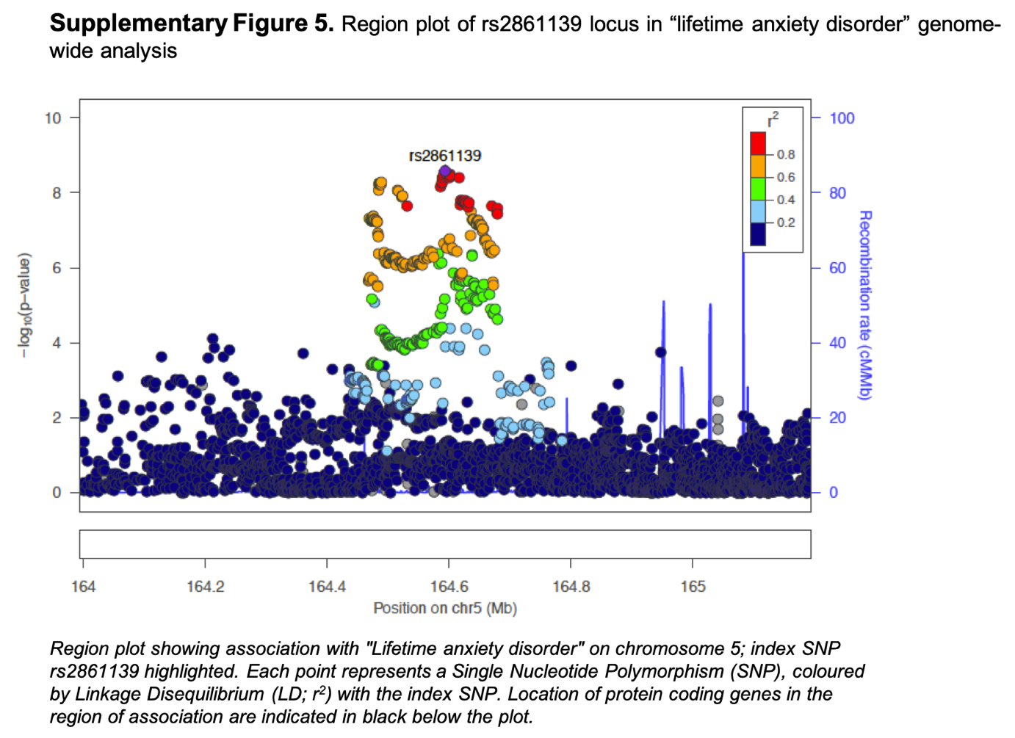
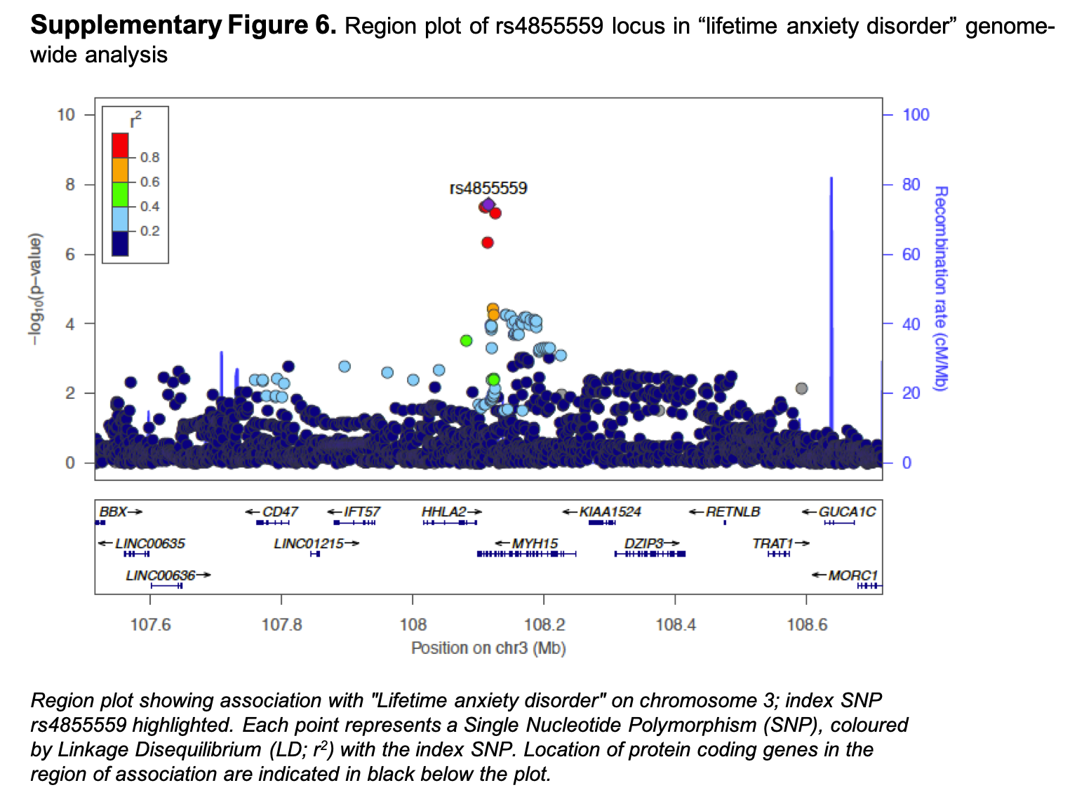

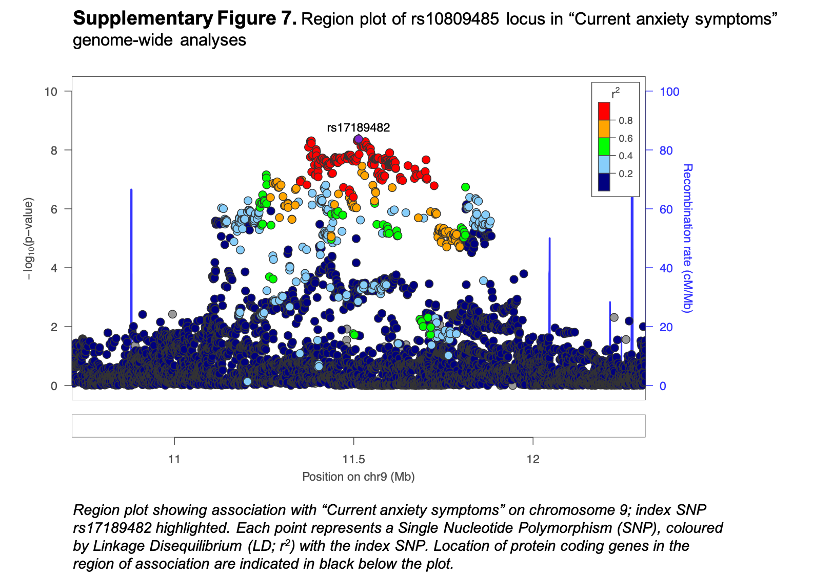
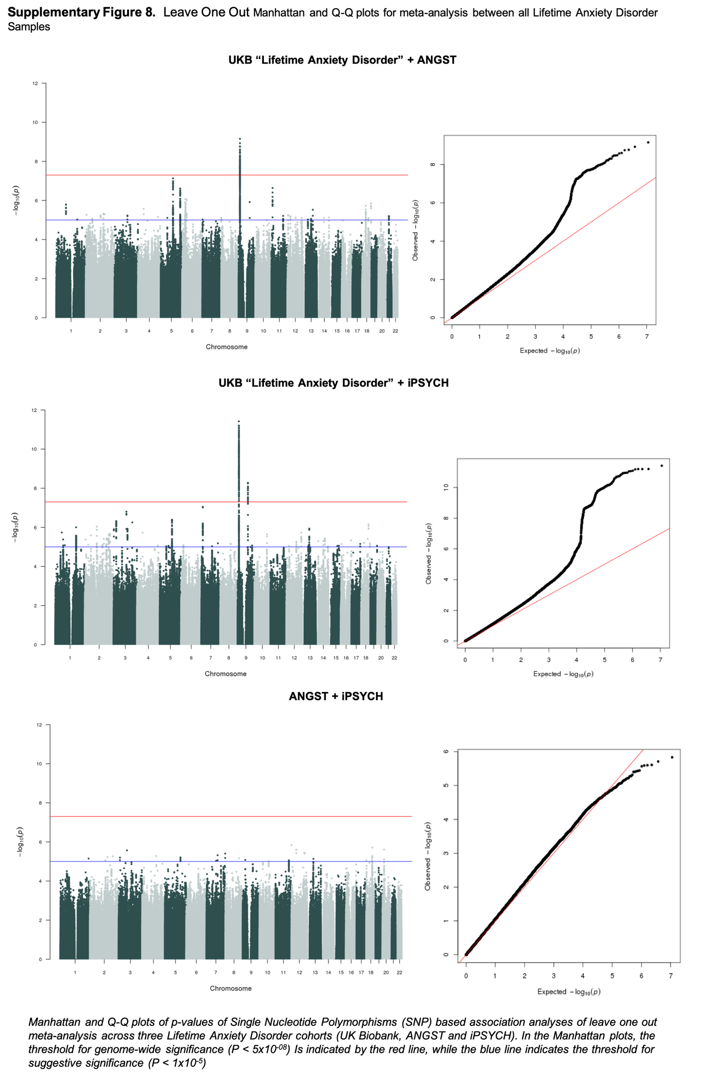
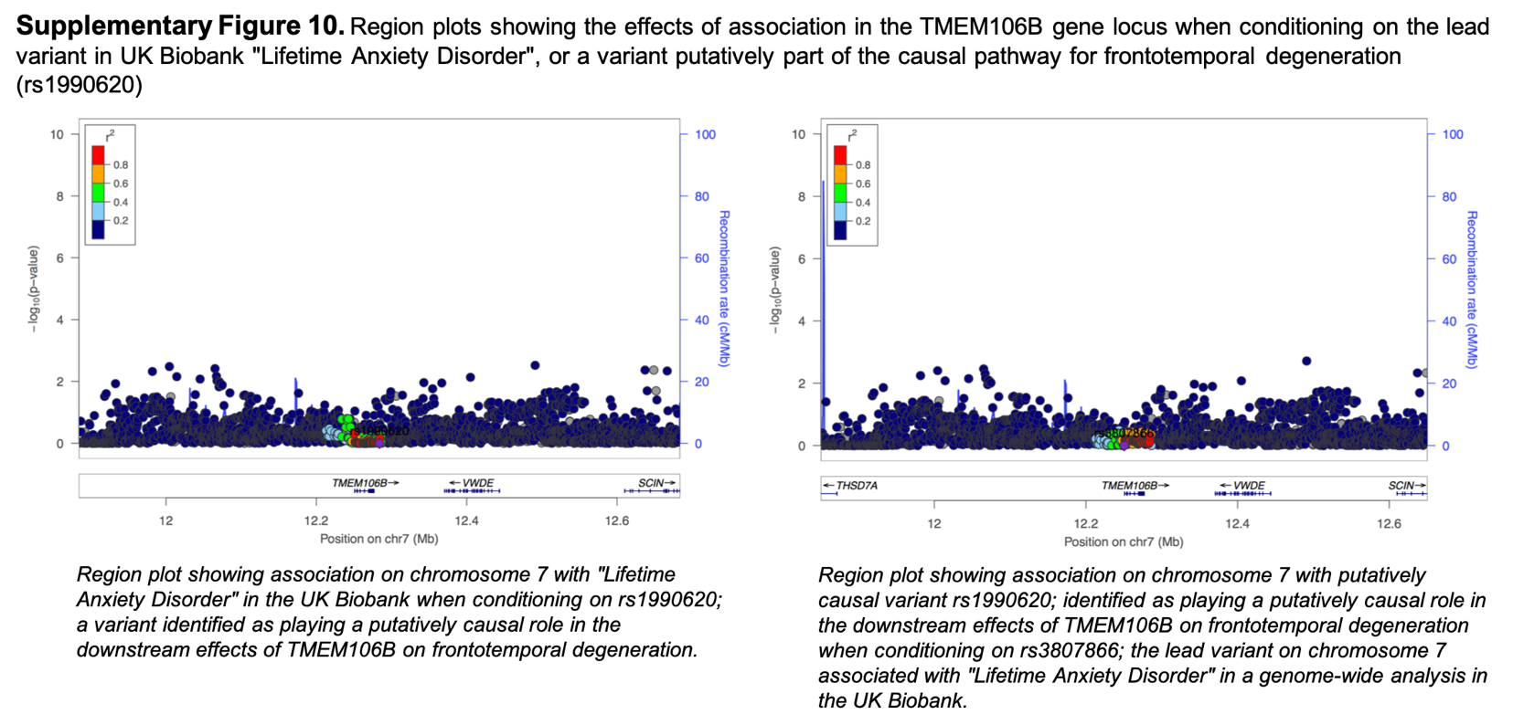
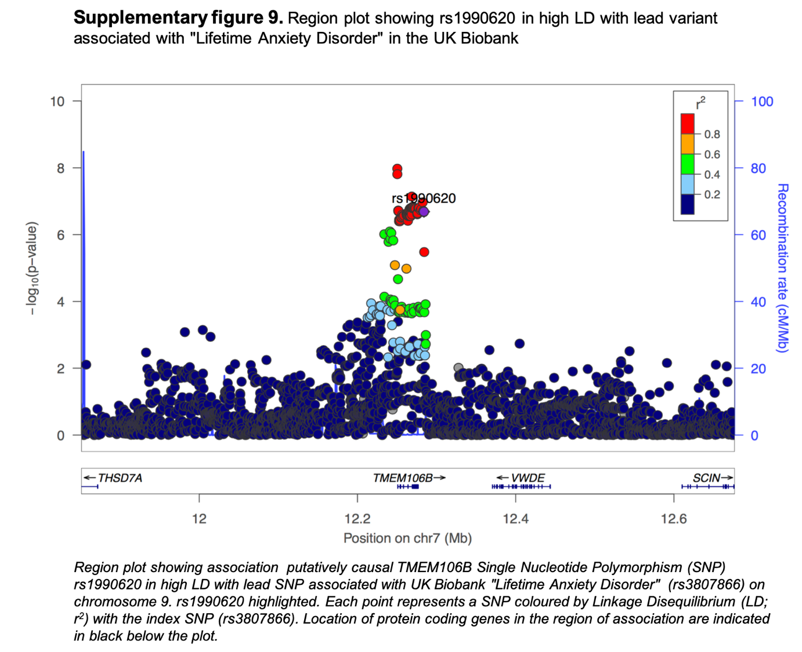

References

1 Spitzer RL, Kroenke K, Williams JBW, Löwe B. A brief measure for assessing generalized anxiety disorder: the GAD-7. Arch Intern Med 2006; 166: 1092–1097.
2 Mors O, Perto GP, Mortensen PB. The danish psychiatric central research register. Scand J Public Health 2011; 39: 54–57.
3 Akhunov E, Nicolet C, Dvorak J. Single nucleotide polymorphism genotyping in polyploid wheat with the Illumina GoldenGate assay. Theor Appl Genet 2009; 119: 507–517.
4 Korn JM, Kuruvilla FG, McCarroll SA, Wysoker A, Nemesh J, Cawley S et al. Integrated genotype calling and association analysis of SNPs, common copy number polymorphisms and rare CNVs. Nat Genet 2008; 40: 1253–1260.
5 Pedersen CB, Bybjerg-Grauholm J, Pedersen MG, Grove J, Agerbo E, Bækvad-Hansen M et al. The iPSYCH2012 case-cohort sample: new directions for unravelling genetic and environmental architectures of severe mental disorders. Mol Psychiatry 2018; 23: 6–14.
6 Loh P-R, Tucker G, Bulik-Sullivan BK, Vilhjálmsson BJ, Finucane HK, Salem RM et al. Efficient Bayesian mixed-model analysis increases association power in large cohorts. Nat Genet 2015; 47: 284–290.
7 Lee SH, Goddard ME, Wray NR, Visscher PM. A better coefficient of determination for genetic profile analysis. Genet Epidemiol 2012; 36: 214–224.
8 Lee SH, Wray NR, Goddard ME, Visscher PM. Estimating missing heritability for disease from genome-wide association studies. Am J Hum Genet 2011; 88: 294–305.
9 de Leeuw CA, Mooij JM, Heskes T, Posthuma D. MAGMA: generalized gene-set analysis of GWAS data. PLoS Comput Biol 2015; 11: e1004219.
10 Euesden J, Lewis CM, O’Reilly PF. PRSice: Polygenic Risk Score software. Bioinformatics 2015; 31: 1466–1468.
11 Finucane HK, Bulik-Sullivan B, Gusev A, Trynka G, Reshef Y, Loh P-R et al. Partitioning heritability by functional category using GWAS summary statistics. BioRxiv 2015. doi:10.1101/014241.
12 Gallagher MD, Posavi M, Huang P, Unger TL, Berlyand Y, Gruenewald AL et al. A Dementia-Associated Risk Variant near TMEM106B Alters Chromatin Architecture and Gene Expression. Am J Hum Genet 2017; 101: 643–663.
13 Marchini J, Howie B, Myers S, McVean G, Donnelly P. A new multipoint method for genome-wide association studies by imputation of genotypes. Nat Genet 2007; 39: 906–913.

