Supplementary Material

Supplementary Table 1. Baseline (Wave 2) characteristics of participants who attended neuroimaging at Wave 2, Wave 3 and Wave 4.
 | Wave 2 |  | Wave 3 |  | Wave 4
 | M (SD) | N | M(SD) | N | M(SD) | N
Age (years) | 72.50 (0.70) | 731 | 72.50 (0.71) | 488 | 72.52 (0.72) | 386
Sex M:F | 388:343 | 731 | 260:228 | 488 | 206:180 | 386
APOE e4 carriers (N:Y) | 490:205 | 695 | 320:144 | 464 | 261:107 | 368
Cortical Volume (mm³) | 398508 (37288) | 629 | 403474 (36824) | 453 | 403962 (37215) | 359
Matrix Reasoning | 13.36 (4.92) | 729 | 13.63 (4.91) | 486 | 14.08 (4.84) | 384
Block Design | 34.00 (10.07) | 729 | 34.74 (10.29) | 488 | 34.98 (10.24) | 385
Spatial Span Total | 14.75 (2.77) | 728 | 14.83 (2.71) | 484 | 14.89 (10.24) | 385
Symbol Search | 24.62 (6.19) | 729 | 25.09 (5.97) | 486 | 25.68 (5.47) | 383
Digit Symbol | 56.29 (12.42) | 729 | 57.45 (12.08) | 486 | 58.54 (11.79) | 383
Inspection Time | 111.37 (11.75) | 714 | 111.92 (11.76) | 478 | 112.69 (11.59) | 380
4-Choice Reaction Time | 0.65 (0.09) | 730 | 0.64 (0.08) | 487 | 0.63 (0.08) | 385
Logical Memory | 74.45 (17.93) | 729 | 75.47 (17.29) | 488 | 77.02 (16.56) | 386
Verbal Pairs | 27.18 (9.57) | 713 | 27.52 (9.59) | 477 | 28.50 (9.19) | 379
Digit Span Backwards | 7.86 (2.32) | 731 | 7.90 (2.31) | 488 | 8.06 (2.29) | 386
Note. Showing data at Wave 2 for participants who attended the imaging assessment across Wave 2 to 4 (brain imaging data was not collected at Wave 1 of the study).

Supplementary Table 2. Baseline (Wave 2) characteristics of participants who attended Wave 2 but not Wave 3, and Wave 3 but not Wave 4.
 | MRI Wave 2, but not Wave 3 |  | MRI Wave 3, but not Wave 4
 | M (SD) | N | M(SD) | N
Age (years) | 72.52 (0.71) | 250 | 72.49 (0.69) | 132
Sex M:F | 130:120 | 250 | 68:64 | 132
APOE e4 carriers (N:Y) | 175:63 | 236 | 81:44 | 125
Cortical Volume (mm³) | 385726 (35485) ª | 176 | 400607 (34853) | 116
Matrix Reasoning | 12.72 (4.90) ª | 250 | 12.27 (4.86)^{b} | 132
Block Design | 32.37 (9.46) ª | 248 | 33.47 (10.02) | 132
Spatial Span Total | 14.57 (2.90) | 250 | 14.48 (2.53) | 130
Symbol Search | 23.62 (6.59) ª | 249 | 23.50 (6.83) ^{b} | 132
Digit Symbol | 53.83 (12.82) ª | 249 | 53.97 (12.19) ^{b} | 132
Inspection Time | 110.35 (11.68) | 241 | 109.52 (12.21) ^{b} | 126
4-Choice Reaction Time | 0.66 (0.10) ª | 250 | 0.67 (0.09) ^{b} | 132
Logical Memory | 71.83 (19.43) ª | 248 | 71.20 (19.20) ^{b} | 132
Verbal Pairs | 26.28 (9.60) | 241 | 24.84 (10.28) ^{b} | 128
Digit Span Backwards | 7.73 (2.36) | 250 | 7.41 (2.28) ^{b} | 132

Note. Showing data for participants at Wave 2 who attended neuroimaging at Wave 2 but not Wave 3, and Wave 3 but not Wave 4. ª denotes a significant difference (p < 0.05, uncorrected) in the imaging sample between Wave 2 values for those who attended Wave 2 and 3 versus those who attended Wave 2 but not Wave 3 – that is, a difference between the values shown in Supplementary Table 1, column 2, and column 1 this table; ^{b} denotes a significant difference (p < 0.05, uncorrected) in the imaging sample between Wave 2 values for those who attended Wave 3 and 4 versus those who attended Wave 3 but not Wave 4 – that is, a difference between the values shown in Supplementary Table 1, column 3, and column 2 this table.
Supplementary Table 3. Estimates of regional cortical change.
 | Hemi | β | SE | p | % loss p.a.
GLOBAL
Volume (cm³) |  | -3.475 | 0.130 | <0.001 | 0.872
REGIONAL VOLUME
Banks STS | L | -1.580 | 0.123 | 0.000 | -0.761
 | R | -1.649 | 0.105 | 0.000 | -0.840
Caudal ACC | L | -0.306 | 0.109 | 0.005 | -0.211
 | R | -0.705 | 0.123 | 0.000 | -0.410
Caudal Middle Frontal | L | -4.505 | 0.294 | 0.000 | -0.844
 | R | -3.889 | 0.272 | 0.000 | -0.772
Cuneus | L | -2.260 | 0.137 | 0.000 | -0.864
 | R | -2.828 | 0.135 | 0.000 | -1.026
Entorhinal | L | -1.947 | 0.202 | 0.000 | -1.059
 | R | -1.982 | 0.163 | 0.000 | -1.147
Frontal Pole | L | -1.596 | 0.073 | 0.000 | -1.892
 | R | -1.900 | 0.092 | 0.000 | -1.720
Fusiform | L | -7.041 | 0.547 | 0.000 | -0.787
 | R | -7.071 | 0.493 | 0.000 | -0.821
Inferior Parietal | L | -13.632 | 0.543 | 0.000 | -1.215
 | R | -15.137 | 0.605 | 0.000 | -1.141
Inferior Temporal | L | -10.440 | 0.503 | 0.000 | -1.048
 | R | -10.652 | 0.477 | 0.000 | -1.105
Insula | L | -1.717 | 0.314 | 0.000 | -0.265
 | R | -1.946 | 0.376 | 0.000 | -0.297
Isthmus Cingulate | L | -1.506 | 0.145 | 0.000 | -0.604
 | R | -1.419 | 0.131 | 0.000 | -0.620
Lateral Occipital | L | -13.191 | 0.453 | 0.000 | -1.224
 | R | -13.365 | 0.435 | 0.000 | -1.228
Lateral Orbitofrontal | L | -6.154 | 0.370 | 0.000 | -0.908
 | R | -5.546 | 0.365 | 0.000 | -0.837
Lingual | L | -4.641 | 0.287 | 0.000 | -0.789
 | R | -5.112 | 0.288 | 0.000 | -0.849
Medial Orbitofrontal | L | -4.520 | 0.335 | 0.000 | -0.877
 | R | -3.724 | 0.327 | 0.000 | -0.761
Middle Temporal | L | -10.108 | 0.442 | 0.000 | -1.107
 | R | -11.366 | 0.496 | 0.000 | -1.093
Paracentral | L | -1.770 | 0.158 | 0.000 | -0.586
 | R | -1.995 | 0.158 | 0.000 | -0.596
Parahippocampal | L | -1.418 | 0.171 | 0.000 | -0.770
 | R | -1.119 | 0.148 | 0.000 | -0.660
IFG Pars Opercularis | L | -2.633 | 0.173 | 0.000 | -0.660
 | R | -2.501 | 0.156 | 0.000 | -0.748
IFG Pars Orbitalis | L | -2.402 | 0.127 | 0.000 | -1.246
 | R | -3.007 | 0.133 | 0.000 | -1.301
IFG Pars Triangularis | L | -2.654 | 0.151 | 0.000 | -0.897
 | R | -3.153 | 0.162 | 0.000 | -0.901
Pericalcarine | L | -1.027 | 0.082 | 0.000 | -0.594
 | R | -1.027 | 0.098 | 0.000 | -0.531
Postcentral | L | -5.640 | 0.389 | 0.000 | -0.659
 | R | -5.378 | 0.398 | 0.000 | -0.667
Posterior Cingulate | L | -1.390 | 0.184 | 0.000 | -0.502
 | R | -1.610 | 0.169 | 0.000 | -0.587
Precentral | L | -9.581 | 0.572 | 0.000 | -0.846
 | R | -9.874 | 0.557 | 0.000 | -0.875
Precuneus | L | -6.721 | 0.408 | 0.000 | -0.807
 | R | -6.621 | 0.391 | 0.000 | -0.779
Rostral ACC | L | -0.986 | 0.140 | 0.000 | -0.430
 | R | -0.447 | 0.132 | 0.001 | -0.242
Rostral Middle Frontal | L | -13.632 | 0.631 | 0.000 | -1.066
 | R | -13.553 | 0.616 | 0.000 | -1.018
Superior Frontal | L | -15.113 | 0.810 | 0.000 | -0.790
 | R | -14.234 | 0.769 | 0.000 | -0.774
Superior Parietal | L | -13.907 | 0.662 | 0.000 | -1.177
 | R | -12.900 | 0.638 | 0.000 | -1.095
Superior Temporal | L | -8.502 | 0.459 | 0.000 | -0.872
 | R | -8.426 | 0.461 | 0.000 | -0.880
Supramarginal | L | -8.396 | 0.419 | 0.000 | -0.887
 | R | -7.141 | 0.391 | 0.000 | -0.792
Temporal Pole | L | -3.913 | 0.266 | 0.000 | -1.444
 | R | -3.323 | 0.245 | 0.000 | -1.337
Transverse Temporal | L | -1.032 | 0.055 | 0.000 | -1.043
 | R | -0.808 | 0.045 | 0.000 | -1.050
Note. Unstandardised estimates of annual change in cortical regional volume. ACC: anterior cingulate cortex; L: left; R: right.

Supplementary Table 4. Loadings of an exploratory analysis using Schmid-Leiman transform of left hemisphere ROI growth curves.
Region of Interest | g | F1 | F2
Lateralorbitofrontal | 0.60 | 0.77
Temporalpole | 0.65 | 0.75
Entorhinal | 0.68 | 0.70
Parsorbitalis | 0.72 | 0.69
Frontalpole | 0.68 | 0.67
Parstriangularis | 0.78 | 0.59
Insula | 0.77 | 0.58
Rostralmiddlefrontal | 0.81 | 0.56
Parahippocampal | 0.80 | 0.53
Rostralanteriorcingulate | 0.83 | 0.51
Superiortemporal | 0.83 | 0.50
Middletemporal | 0.83 | 0.49
Fusiform | 0.83 | 0.49
Parsopercularis | 0.83 | 0.48
Inferiortemporal | 0.83 | 0.47
Medialorbitofrontal | 0.84 | 0.45 | 0.31
Superiorfrontal | 0.84 | 0.41 | 0.35
Transversetemporal | 0.84 | 0.38 | 0.38
Caudalanteriorcingulate | 0.83 | 0.38 | 0.38
Caudalmiddlefrontal | 0.84 | 0.36 | 0.41
Precentral | 0.84 | 0.36 | 0.40
Cuneus | 0.58 |  | 0.78
Superiorparietal | 0.69 |  | 0.71
Lateraloccipital | 0.74 |  | 0.68
Precuneus | 0.75 |  | 0.66
Lingual | 0.75 |  | 0.64
Inferiorparietal | 0.77 |  | 0.64
Paracentral | 0.77 |  | 0.62
Isthmuscingulate | 0.79 |  | 0.59
Posteriorcingulate | 0.82 |  | 0.53
Postcentral | 0.82 |  | 0.52
Supramarginal | 0.83 |  | 0.48
Banksttsts | 0.83 |  | 0.47
Pericalcarine
Note. Loadings for left hemisphere ROIs; values <0.3 not shown (pericalcarine does not load on any of the three factors). Eigenvalues are: g = 20.1, F1 = 6.60, F2 = 6.00. Prior to the S-L transformation, general factor loadings of F1 and F2 on g were constrained to equality, and F1 ~ F2 r = 0.544. The S-L transform takes a factor or PC solution, transforms it to an oblique solution, factors the oblique solution to find a higher order (g) factor, and then residualizes g out of the group factors.

Supplementary Table 5. Loadings of an exploratory analysis using a three-factor Schmid-Leiman transform of left hemisphere ROI growth curves.
Region of Interest | g | F1 | F2 | F3
Lateralorbitofrontal | 0.96
Temporalpole | 0.99
Entorhinal | 0.95
Parsorbitalis | 1
Frontalpole | 0.97
Parstriangularis | 0.98
Insula | 0.98
Rostralmiddlefrontal | 0.97
Parahippocampal | 0.93
Rostralanteriorcingulate | 0.94 |  | 0.33
Superiortemporal | 0.94 |  | 0.34
Middletemporal | 0.93 |  | 0.35
Fusiform | 0.92 |  | 0.36
Parsopercularis | 0.93 |  | 0.36
Inferiortemporal | 0.92 |  | 0.39
Medialorbitofrontal | 0.91 |  | 0.41
Superiorfrontal | 0.89 |  | 0.46
Transversetemporal | 0.87 |  | 0.49
Caudalanteriorcingulate | 0.84 |  | 0.52
Caudalmiddlefrontal | 0.85 |  | 0.52
Precentral | 0.86 |  | 0.51
Cuneus |  |  | 0.96
Superiorparietal | 0.44 |  | 0.89
Lateraloccipital | 0.51 |  | 0.85
Precuneus | 0.55 |  | 0.84
Lingual | 0.55 |  | 0.83
Inferiorparietal | 0.59 |  | 0.81
Paracentral | 0.61 |  | 0.77
Isthmuscingulate | 0.63 |  | 0.77
Posteriorcingulate | 0.73 |  | 0.68
Postcentral | 0.75 |  | 0.66
Supramarginal | 0.78 |  | 0.62
Banksttsts | 0.78 |  | 0.62
Pericalcarine | 0.96
Note. Loadings for left hemisphere ROIs; values <0.3 not shown. Eigenvalues are: g = 22.7, F1 = 0.0, F2 = 9.8, F3 = 1.3.

Supplementary Table 6. Loadings of an exploratory analysis using a four-factor Schmid-Leiman transform of left hemisphere ROI growth curves.
Region of Interest | g | F1 | F2 | F3 | F4
Lateralorbitofrontal | 0.95
Temporalpole | 0.98
Entorhinal | 0.98
Parsorbitalis | 0.97
Frontalpole | 0.91 | 0.40
Parstriangularis | 0.92
Insula | 0.94
Rostralmiddlefrontal | 0.91 |  | 0.35
Parahippocampal | 0.89 |  | 0.39
Rostralanteriorcingulate | 0.88 |  | 0.44
Superiortemporal | 0.88 |  | 0.45
Middletemporal | 0.87 |  | 0.46
Fusiform | 0.87 |  | 0.47
Parsopercularis | 0.87 |  | 0.47
Inferiortemporal | 0.86 |  | 0.49
Medialorbitofrontal | 0.84 |  | 0.52
Superiorfrontal | 0.82 |  | 0.55
Transversetemporal | 0.80 |  | 0.59
Caudalanteriorcingulate | 0.78 |  | 0.62
Caudalmiddlefrontal | 0.77 |  | 0.62
Precentral | 0.78 |  | 0.60
Cuneus |  |  | 0.97
Superiorparietal | 0.34 |  | 0.93
Lateraloccipital | 0.42 |  | 0.90
Precuneus | 0.46 |  | 0.89
Lingual | 0.47 |  | 0.89
Inferiorparietal | 0.50 |  | 0.86
Paracentral | 0.52 |  | 0.82
Isthmuscingulate | 0.56 |  | 0.84
Posteriorcingulate | 0.65 |  | 0.76
Postcentral | 0.66 |  | 0.73
Supramarginal | 0.70 |  | 0.71
Banksttsts | 0.71 |  | 0.70
Pericalcarine |  |  |  | 1
Note. Loadings for left hemisphere ROIs; values <0.3 not shown. Eigenvalues are: g = 19.75, F1 = 0.62, F2 = 12.21, F3 = 1.27, F4 = 0.07.

Supplementary Table 7. Loadings of an exploratory analysis using Schmid-Leiman transform of right hemisphere ROI growth curves.
Region of Interest | g | F1 | F2
Lateralorbitofrontal | 0.47 | 0.84
Temporalpole | 0.37 | 0.85
Entorhinal | 0.48 | 0.84
Parsorbitalis | 0.60 | 0.80
Frontalpole | 0.34 | 0.65
Parstriangularis | 0.65 | 0.75
Insula | 0.55 | 0.76
Rostralmiddlefrontal | 0.63 | 0.76
Parahippocampal | 0.56 | 0.77
Rostralanteriorcingulate | 0.58 | 0.81
Superiortemporal | 0.63 | 0.78
Middletemporal | 0.61 | 0.79
Fusiform | 0.64 | 0.77
Parsopercularis | 0.66 | 0.74
Inferiortemporal | 0.63 | 0.78
Medialorbitofrontal | 0.60 | 0.80
Superiorfrontal | 0.68 | 0.72
Transversetemporal | 0.69 | 0.69
Caudalanteriorcingulate | 0.62 | 0.77
Caudalmiddlefrontal | 0.70 | 0.68
Precentral | 0.70 | 0.68
Cuneus | 0.67 | 0.71
Superiorparietal | 0.71 | 0.65
Lateraloccipital | 0.73 | 0.59 | 0.34
Precuneus | 0.70 | 0.67
Lingual | 0.64 | 0.54
Inferiorparietal | 0.73 | 0.59 | 0.34
Paracentral | 0.74 | 0.56 | 0.38
Isthmuscingulate | 0.71 | 0.53 | 0.38
Posteriorcingulate | 0.74 | 0.46 | 0.49
Postcentral | 0.74 | 0.43 | 0.51
Supramarginal | 0.73 | 0.33 | 0.60
Banksttsts | 0.71 |  | 0.68
Pericalcarine |  |  | 0.59
Note. Loadings for right hemisphere ROIs; values <0.3 not shown (pericalcarine does not load on any of the three factors). Eigenvalues are: g = 20.1, F1 = 6.60, F2 = 6.00. Prior to the S-L transformation, general factor loadings of F1 and F2 on g were constrained to equality, and F1 ~ F2 r = 0.383. The S-L transform takes a factor or PC solution, transforms it to an oblique solution, factors the oblique solution to find a higher order (g) factor, and then residualizes g out of the group factors.

Supplementary Table 8. Comparisons of factor structure between left and right hemispheres as identified by the exploratory Schmid-Leiman analysis of ROI slopes and intercepts.
 | LOADINGS
Correspondence | General Factor | Factor 1 | Factor 2
SLOPES
Left vs Right Hemisphere
Pearson’s | 0.78 | 0.70 | 0.61
Factor Congruence | 0.99 | 0.87 | 0.73
INTERCEPTS
Left vs Right Hemisphere
Pearson’s r | 0.97 | 0.76 | 0.90
Factor Congruence | 1.00 | 0.92 | 0.91
SLOPES versus INTERCEPTS
Left vs Left & Right vs Right Hemisphere
Pearson’s r | L (0.05) R (0.04) | L (0.29) R (0.51) | L (0.32) R (0.67)
Factor Congruence | L (0.91) R (0.93) | L (0.74) R (0.86) | L (0.45) R (0.70)
Note. Standardised loadings are reported; L = left hemisphere; R = right hemisphere.

Supplementary Table 9. Loadings of an exploratory factor analysis using Schmid-Leiman transform of left-right averaged ROI growth curves.
Region of Interest | g | F1 | F2
Lateralorbitofrontal | 0.53 | 0.80
Temporalpole | 0.56 | 0.79
Entorhinal | 0.60 | 0.77
Frontalpole | 0.50 | 0.75
Parsorbitalis | 0.68 | 0.73
Rostralanteriorcingulate | 0.75 | 0.65
Rostralmiddlefrontal | 0.75 | 0.64
Parahippocampal | 0.75 | 0.64
Medialorbitofrontal | 0.76 | 0.64
Fusiform | 0.76 | 0.63
Superiortemporal | 0.77 | 0.61
Parstriangularis | 0.77 | 0.61
Inferiortemporal | 0.78 | 0.60
Middletemporal | 0.78 | 0.60
Caudalanteriorcingulate | 0.78 | 0.60
Insula | 0.78 | 0.59
Parsopercularis | 0.79 | 0.57
Superiorfrontal | 0.79 | 0.56
Transversetemporal | 0.81 | 0.51
Precentral | 0.81 | 0.50 | 0.31
Caudalmiddlefrontal | 0.81 | 0.49 | 0.31
Bankssts | 0.81 | 0.48 | 0.32
Posteriorcingulate | 0.81 | 0.45 | 0.37
Supramarginal | 0.82 | 0.43 | 0.38
Postcentral | 0.82 | 0.40 | 0.41
Isthmuscingulate | 0.78 | 0.31 | 0.47
Paracentral | 0.81 | 0.31 | 0.50
Inferiorparietal | 0.80 |  | 0.53
Lingual | 0.78 |  | 0.55
Precuneus | 0.78 |  | 0.59
Lateraloccipital | 0.77 |  | 0.62
Superiorparietal | 0.74 |  | 0.67
Cuneus | 0.61 |  | 0.78
Pericalcarine |  |  | 0.38
Note. Loadings for ROI volumes (average of left and right); values <0.3 not shown. Prior to the S-L transformation, general factor loadings of F1 and F2 on g were constrained to equality, and F1 ~ F2 r = 0.501. The S-L transform takes a factor or PC solution, transforms it to an oblique solution, factors the oblique solution to find a higher order (g) factor, and then residualizes g out of the group factors.

Supplementary Table 10. Comparisons of factor structure of ROI slopes and intercepts (left and right averaged volumes) identified by the exploratory Schmid-Leiman analysis.
 | LOADINGS
Correspondence | General Factor | Factor 1 | Factor 2
SLOPES versus INTERCEPTS
Pearson’s r | 0.30 | 0.53 | 0.54
Factor Congruence | 0.95 | 0.88 | 0.60

Supplementary Table 11. Comparison of Schmid-Leiman factor loadings of bilateral cortical volumes in the main sample and the dementia/MMSE sensitivity sample.
Correspondence | General Factor | Factor 1 | Factor 2
SLOPES vs SLOPES
Pearson’s r | >0.99 | 0.98 | 0.96
Factor Congruence | 1.00 | 1.00 | 1.00
INTERCEPTS versus INTERCEPTS
Pearson’s r | 0.92 | 0.71 | 0.92
Factor Congruence | 1.00 | 1.00 | 1.00
Note. Sensitivity sample removed individuals with a self-reported diagnosis of dementia at any wave or a score of MMSE <24. See also Supplementary Figure 5.

Supplementary Table 12. Comparison of Schmid-Leiman factor loadings of bilateral cortical volumes in the main sample and the stroke sensitivity sample.
Correspondence | General Factor | Factor 1 | Factor 2
SLOPES vs SLOPES
Pearson’s r | 0.91 | 0.82 | 0.77
Factor Congruence | 1.00 | 0.92 | 0.84
INTERCEPTS versus INTERCEPTS
Pearson’s r | 0.95 | 0.90 | >0.99
Factor Congruence | 1.00 | 1.00 | 1.00
Note. Sensitivity sample removed individuals with stroke at any wave. See also Supplementary Figure 6. Unique participants in the whole sample with a stroke at any wave was N = 119, this equated to a removal of N = 108, N = 64 and N = 48 participants with QC’d FreeSurfer data at Waves 2, 3 & 4, respectively (i.e. many with stroke attended >1 wave).
Supplementary Table 13. Loadings from a confirmatory factor analysis of ROI growth curves.
Region of Interest | g | F1 | F2
Lateralorbitofrontal | 0.39 | 0.92
Temporalpole | 0.52 | 0.81
Frontalpole | 0.65 | 0.76
Parsorbitalis | 0.48 | 0.70
Medialorbitofrontal | 0.82 | 0.57
Fusiform | 0.83 | 0.56
Parahippocampal | 0.67 | 0.54
Rostralmiddlefrontal | 0.81 | 0.51
Inferiortemporal | 0.78 | 0.51
Middletemporal | 0.89 | 0.48
Superiortemporal | 0.88 | 0.47
Entorhinal | 0.45 | 0.46
Parstriangularis | 0.90 | 0.45
Rostralanteriorcingulate | 0.79 | 0.42
Insula | 0.92 | 0.39
Superiorfrontal | 0.97 | 0.26
Transversetemporal | 0.97 | 0.25
Caudalanteriorcingulate | 0.98 | 0.22
Parsopercularis | 0.84 | 0.22
Caudalmiddlefrontal | 0.97 | 0.17 | 0.08
Postcentral | 0.76 | 0.15 | 0.31
Precentral | 0.96 | 0.14 | 0.14
Bankssts | 0.79 | 0.13
Posteriorcingulate | 1.00
Supramarginal | 0.94 |  | 0.08
Paracentral | 0.92 |  | 0.39
Isthmuscingulate | 0.91
Inferiorparietal | 0.91 |  | 0.42
Precuneus | 0.87 |  | 0.44
Lingual | 0.80 |  | 0.26
Lateraloccipital | 0.77 |  | 0.42
Superiorparietal | 0.52 |  | 0.72
Cuneus | 0.35 |  | 0.89
Pericalcarine
Note. Standardised factor loadings reported. Confirmatory factor analysis imposed the factor loading pattern identified from the exploratory analysis, but freely estimated loading magnitudes. Loadings of the paracentral, posterior cingulate and isthmus cingulate were initially found to load on the Schmid-Leiman Factor 1, but were non-significant in the CFA, and so were set to zero. F1 and F2 are orthogonal to the general factor and correlated with one another at r = -0.254 (p < 0.001).

Supplementary Table 14. Model fit indices for CFAs for cognitive and cortical growth curves (separate measurement models).
 | RMSEA | CFI | TLI | SRMR
Cortical ROIs | 0.045 | 0.936 | 0.921 | 0.029
g | 0.035 | 0.966 | 0.965 | 0.065
Visuospatial | 0.029 | 0.933 | 0.992 | 0.037
Processing Speed | 0.034 | 0.924 | 0.910 | 0.054
Memory | 0.037 | 0.934 | 0.921 | 0.050
Note. RMSEA: root mean squared error of approximation, CFI: comparative fit index, TLI: Tucker Lewis Index, SRMR: standardized root mean square residual.

Supplementary Table 15. Model fit indices for bifactor growth curve SEMs between cortical volumes, APOE, and cognitive functions.
 | RMSEA | CFI | TLI | SRMR
APOE status | 0.035 | 0.937 | 0.923 | 0.029
g | 0.031 | 0.931 | 0.922 | 0.049
Visuospatial | 0.037 | 0.933 | 0.919 | 0.048
Processing Speed | 0.034 | 0.923 | 0.909 | 0.054
Memory | 0.037 | 0.933 | 0.920 | 0.050
Note. RMSEA: root mean squared error of approximation, CFI: comparative fit index, TLI: Tucker Lewis Index, SRMR: standardized root mean square residual.

Supplementary Figure 1. Cortical regions of interest.
Note. Volumetric parcellation scheme used to identify regions of interest, according to the Desikan-Killiany atlas (Desikan et al., 2006).

Supplementary Figure 2.
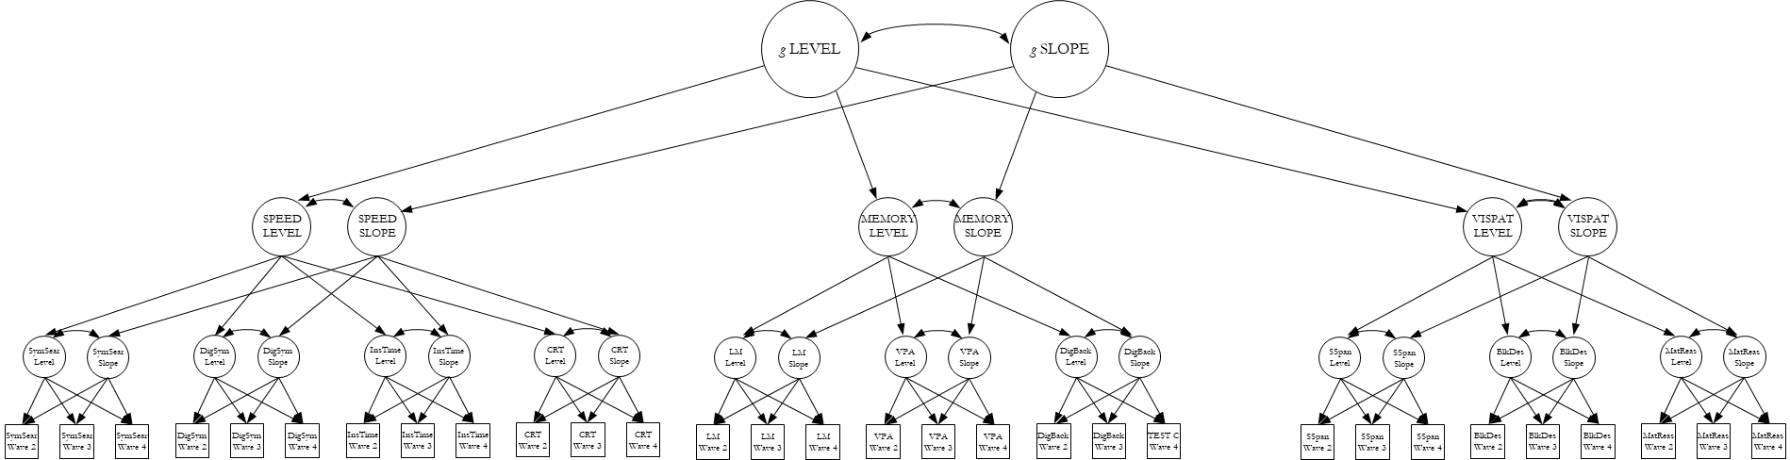
Note. Representation of a latent growth curve analysis in a hierarchical model of cognitive functioning. Manifest variables (i.e. measured test scores) are shown as squares, latent variables are shown as ellipses. The levels and slopes of the cognitive domains of processing speed (SPEED), memory and visuospatial ability (VISPAT) are indicated by the latent levels and changes of measured cognitive test scores across time. A superordinate latent measure of general cognitive ability (‘g’) accounts for the fact that the levels and changes across cognitive test scores in different domains are all positively correlated.
Supplementary Figure 3. Changes in regional cortical volume across the 8th decade, by hemisphere.
Note. Regional volumes (y-axis; mm³) are shown as age trajectories (x-axis; years) for each participant at each region of interest. Regression lines allowing a quadratic term, with 95% confidence intervals are shown for left and right hemispheres (blue and red, respectively). Unstandardised coefficients are reported in Supplementary Table 3.

Supplementary Figure 4. Correlation matrices and density plots of freely-estimated regional intercepts and slopes; left and right hemisphere comparison.
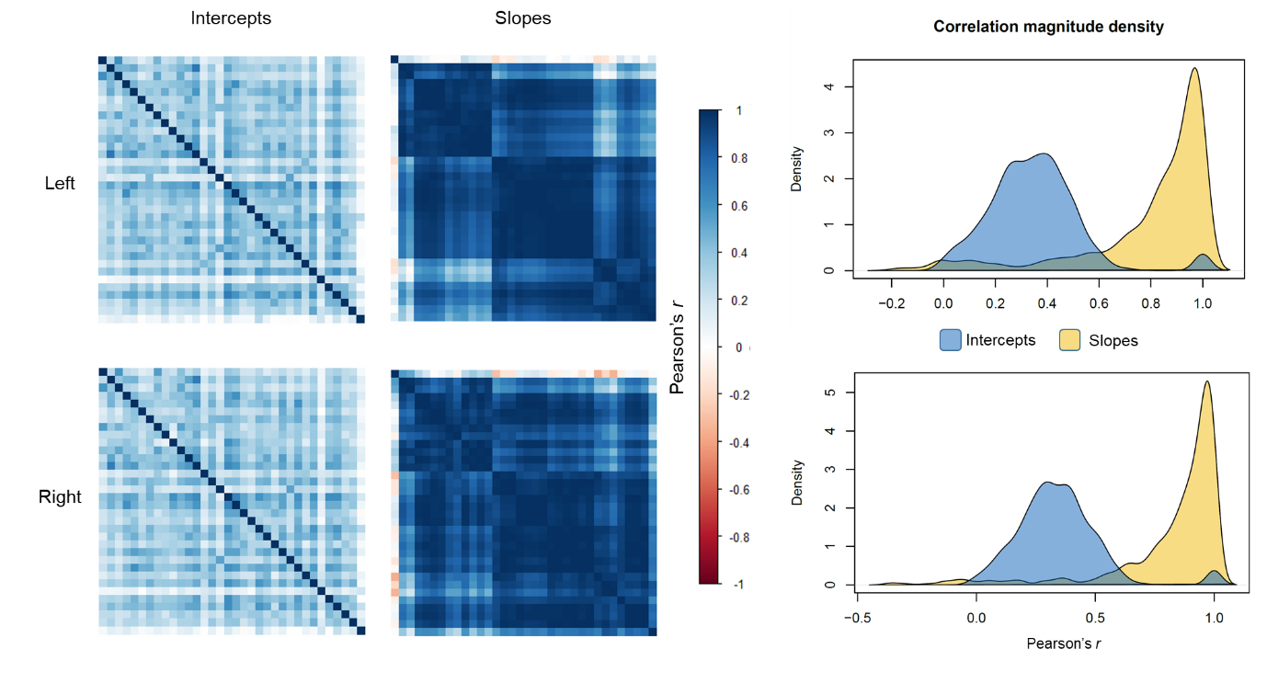
Note. Left: heatmaps of the correlations among freely-estimated latent intercepts and slopes for the left (top row) and right (bottom row) hemispheres; intercept axes are fixed according to the hierarchically-clustered slope matrix. Right: density plots of the correlation magnitudes among freely-estimated intercepts and slopes for the left (top) and right (bottom) hemispheres.

Supplementary Figure 5. Sensitivity analysis: difference in correlation magnitudes among intercepts and slopes of bilateral regional volumes before and after removing those with dementia or MMSE<24.
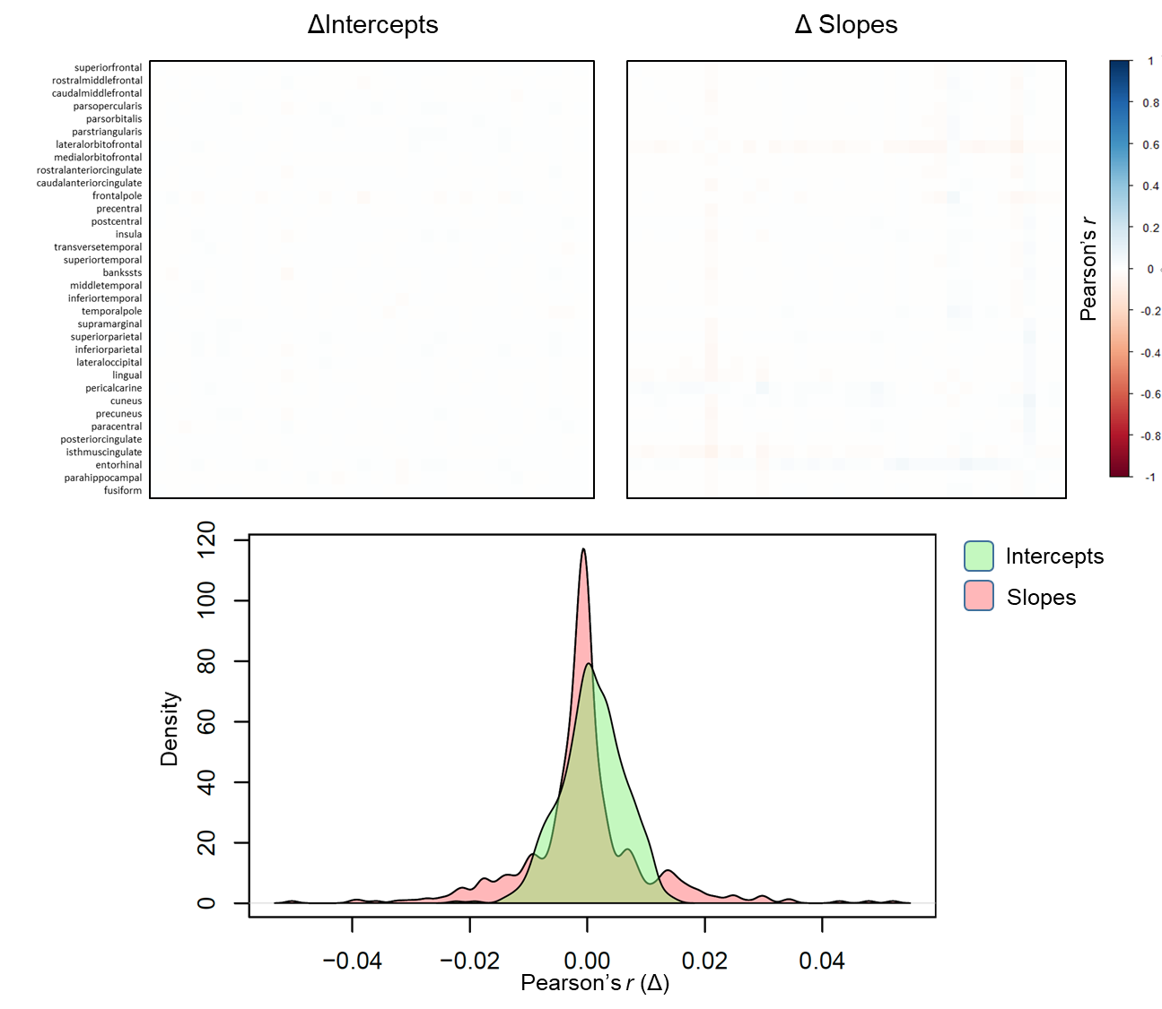
Note. Raw differences (Δ) between correlation magnitudes are shown for intercepts and slopes (top). The density plot shows the Δ distributions. Alongside the similarity of the resultant factor structure (see Supplementary Table 11), these results indicate that possible dementia cases are unlikely to have been driving the observed ageing patterns.
Supplementary Figure 6. Sensitivity analysis: difference in correlation magnitudes among intercepts and slopes of bilateral regional volumes before and after removing those with stroke.
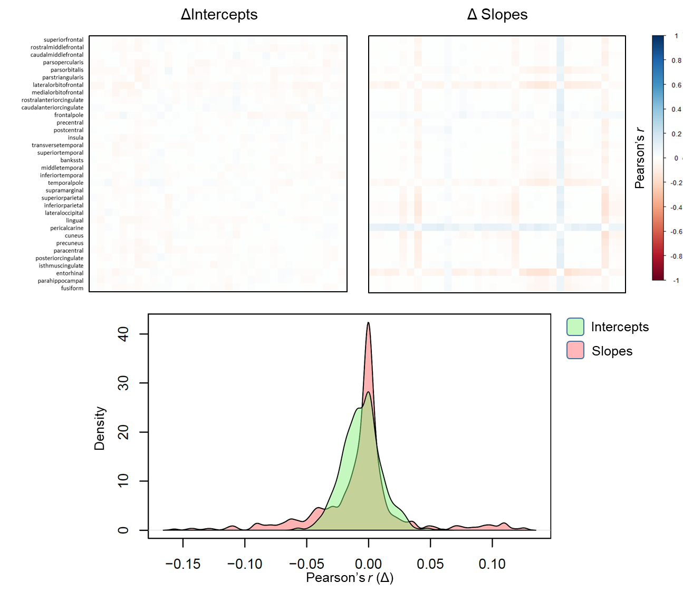
Note. Raw differences (Δ) between correlation magnitudes are shown for intercepts and slopes (top). The density plot shows the Δ distributions. Alongside the similarity of the resultant factor structure (see Supplementary Table 12), these results indicate that stroke cases are unlikely to have been driving the observed ageing patterns.

Supplementary Figure 7. Correspondence between standardised loadings for factors of cortical change estimated via exploratory and confirmatory factor analyses.
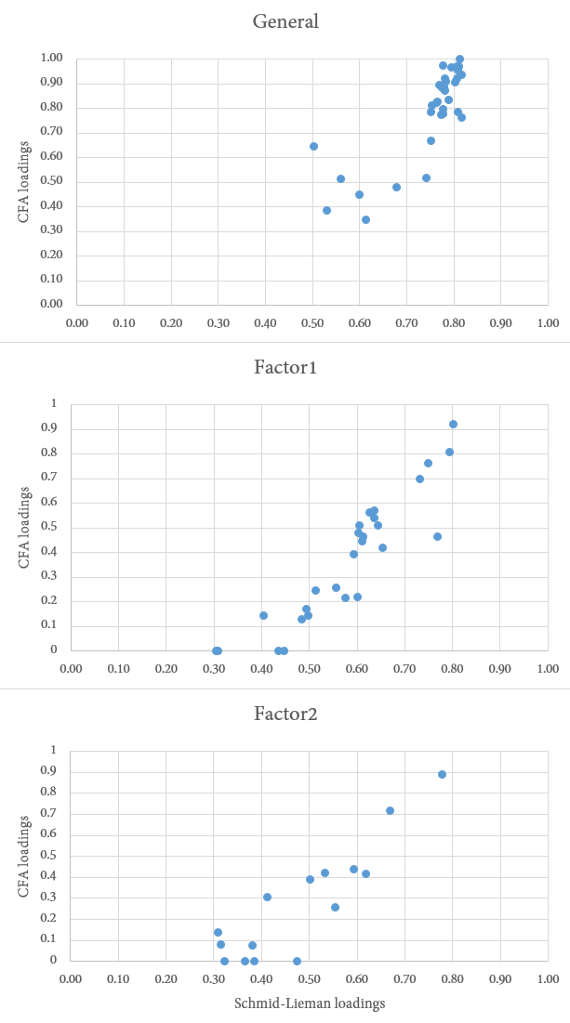
Note. X and Y axes denote standardised factor loadings from the exploratory Schmid-Leiman (X) and CFA (Y). Correlations (Pearson’s r) between EFA and CFA loadings for each factor were: General = 0.856, Factor 1 = 0.831, Factor 2 = 0.826.

