SUPPLEMENTARY APPENDIX

Supplementary text
We obtained the following data for each patient at the time of the hospitalization through electronic health records [17, 18]: sex; age, which was categorized based on the OpenSAFELY study results [17] (i.e. 18-50, 51-70, 71-80, 81+); hospital, which was categorized into 4 classes following the administrative clustering of AP-HP hospitals in Paris and its suburbs based on their geographical location (i.e., AP-HP Centre – Paris University, Henri Mondor University Hospitals and at home hospitalization; AP-HP Nord and Hôpitaux Universitaires Paris Seine-Saint-Denis; AP-HP Paris Saclay University; and AP-HP Sorbonne University); obesity, defined as having a body-mass index higher than 30 kg/m² or an International Statistical Classification of Diseases and Related Health Problems (ICD-10) diagnosis code for obesity (E66.0, E66.1, E66.2, E66.8, E66.9); self-reported current smoking status; any medical condition associated with increased risk of severe COVID-19 [17, 20–22] based on ICD-10 diagnosis codes, including diabetes mellitus (E11), diseases of the circulatory system (I00-I99), diseases of the respiratory system (J00-J99), neoplasms (C00-D49), and diseases of the blood and blood-forming organs and certain disorders involving the immune mechanism (D5-D8); any medication prescribed according to compassionate use or as part of a clinical trial (e.g. hydroxychloroquine, azithromycin, remdesivir, tocilizumab, sarilumab, or dexamethasone) [23]; clinical severity of COVID-19 at admission, defined as having at least one of the following criteria [24, 25]: respiratory rate > 24 breaths/min or < 12 breaths/min, resting peripheral capillary oxygen saturation in ambient air < 90% , temperature > 40°C, or systolic blood pressure < 100 mm Hg; and biological severity of COVID-19 at admission, defined as having at least one of the following criteria: high neutrophil-to-lymphocyte ratio or low lymphocyte-to-C-reactive protein ratio (both variables were dichotomized at the median of the values observed in the full sample), or plasma lactate levels higher than 2 mmol/L. For these two variables assessing the clinical and biological severity of COVID-19, a third category for missing data was added.
To take into account possible confounding by indication bias for antidepressants, we recorded whether patients had any current mood or anxiety disorder (F30-F48) or any other current psychiatric disorder (F00-F29 and F50-F99) based on ICD-10 diagnosis codes, and whether they were prescribed any benzodiazepine or Z-drug, any mood stabilizer (i.e. lithium or antiepileptic medications with mood stabilizing effects), or any antipsychotic medication.
All medical notes and prescriptions are computerized in Greater Paris University hospitals. Medications including their dosage, frequency, date, and mode of administration were identified from medication administration data or scanned hand-written medical prescriptions, through two deep learning models based on BERT contextual embeddings [18], one for the medications and another for their mode of administration. The model was trained on the APmed corpus [19], a previously annotated dataset for this task. Extracted medications names were then normalized to the Anatomical Therapeutic Chemical (ATC) terminology using approximate string matching.

Supplementary Figure 1a. Kaplan-Meier curves of the composite endpoint of intubation or death in the full sample (A, C) and in the matched analytic samples using a 2:1 ratio (B, D) of patients who had been admitted with Covid-19, according to exposure to individual SSRI medications. The shaded areas represent pointwise 95% confidence intervals. SSRIs, selective serotonin reuptake inhibitors.

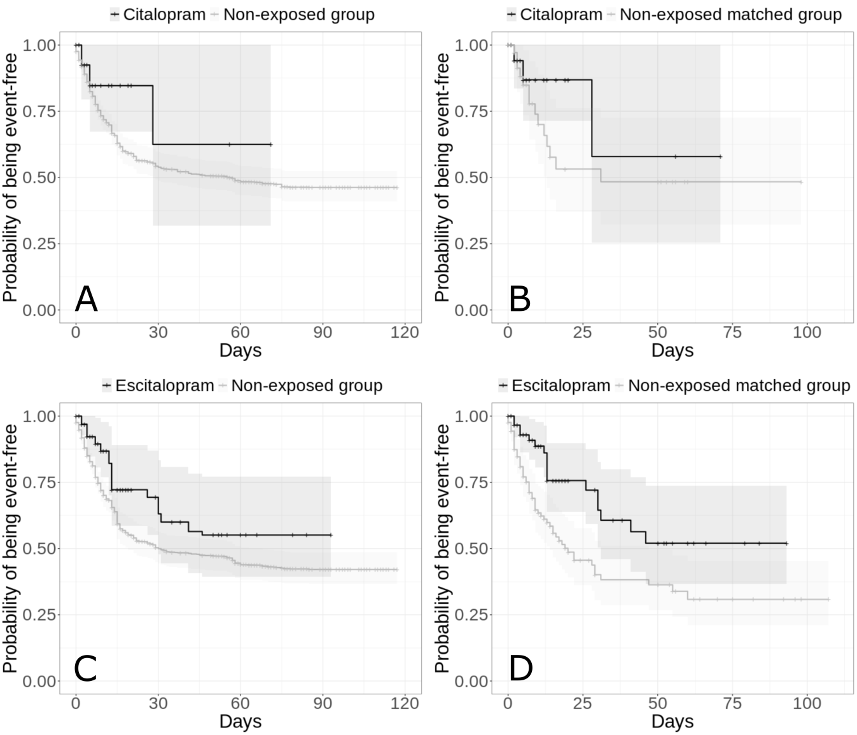
Supplementary Figure 1b. Kaplan-Meier curves of the composite endpoint of intubation or death in the full sample (E, G) and in the matched analytic samples using a 2:1 ratio (B, H) of patients who had been admitted with Covid-19, according to exposure to individual SSRI medications. The shaded areas represent pointwise 95% confidence intervals. SSRIs, selective serotonin reuptake inhibitors.

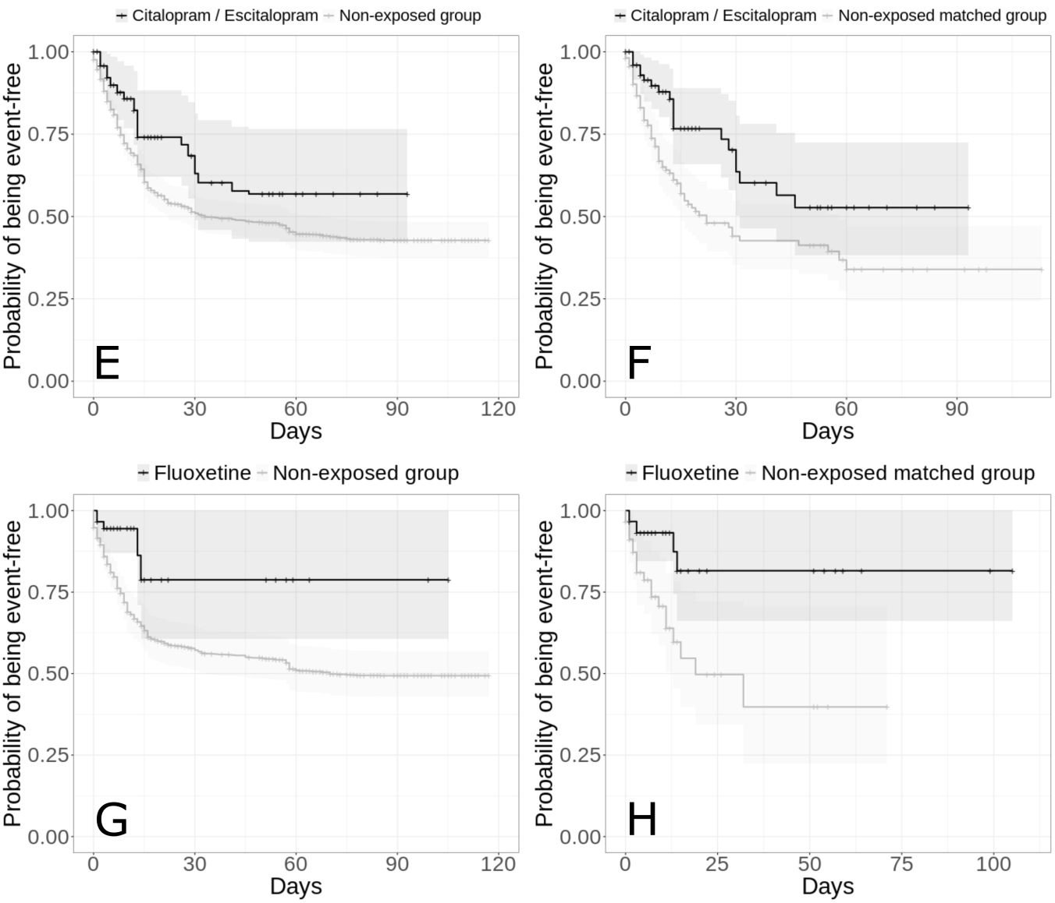
Supplementary Figure 1c. Kaplan-Meier curves of the composite endpoint of intubation or death in the full sample (I, K) and in the matched analytic samples using a 2:1 ratio (J, L) of patients who had been admitted with Covid-19, according to exposure to individual SSRI medications. The shaded areas represent pointwise 95% confidence intervals. SSRIs, selective serotonin reuptake inhibitors.

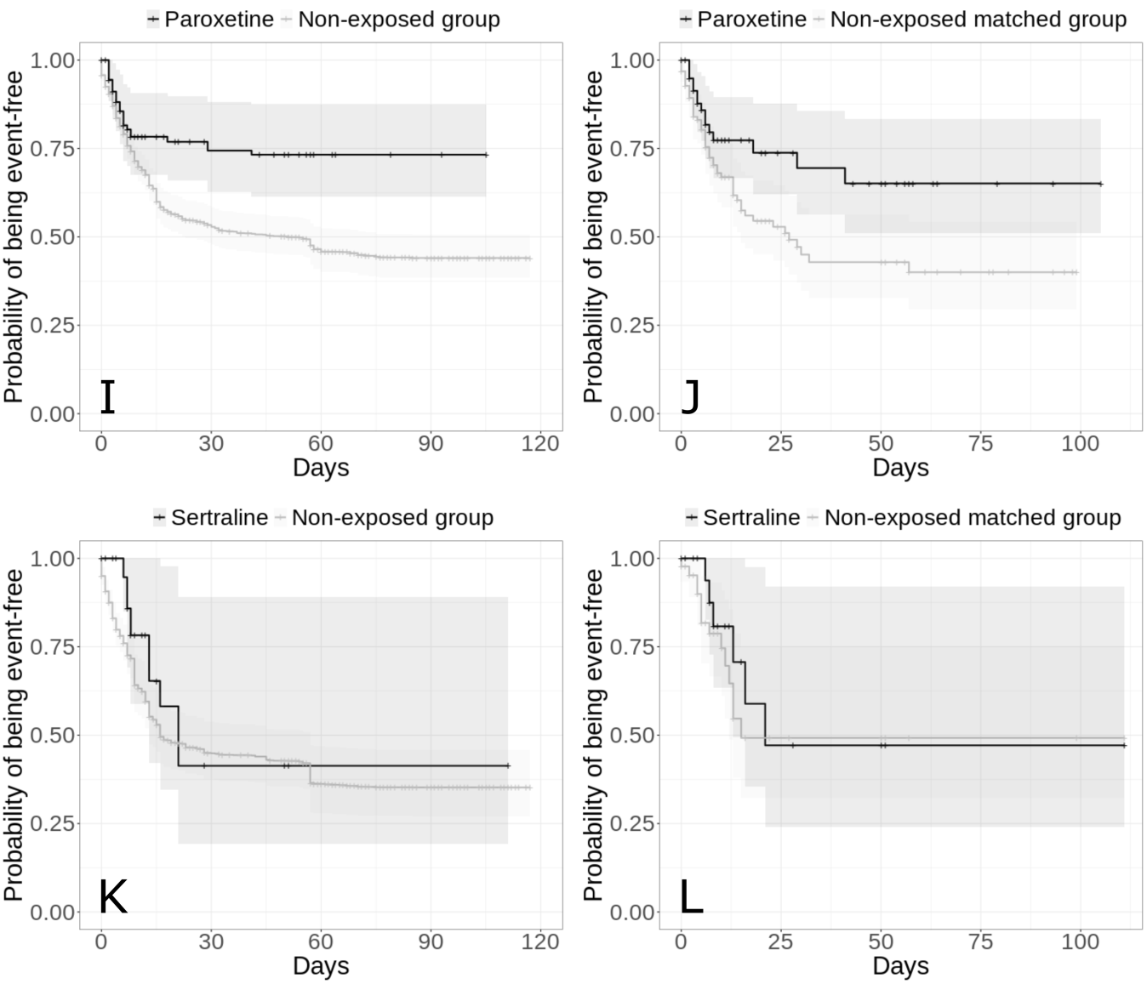
Supplementary Figure 2. Kaplan-Meier curves of the composite endpoint of intubation or death in the full sample (A, C) and in the matched analytic samples using a 2:1 ratio (B, D) of patients who had been admitted with Covid-19, according to exposure to individual SNRI medications. The shaded areas represent pointwise 95% confidence intervals. SNRIs, serotonin–norepinephrine reuptake inhibitors.

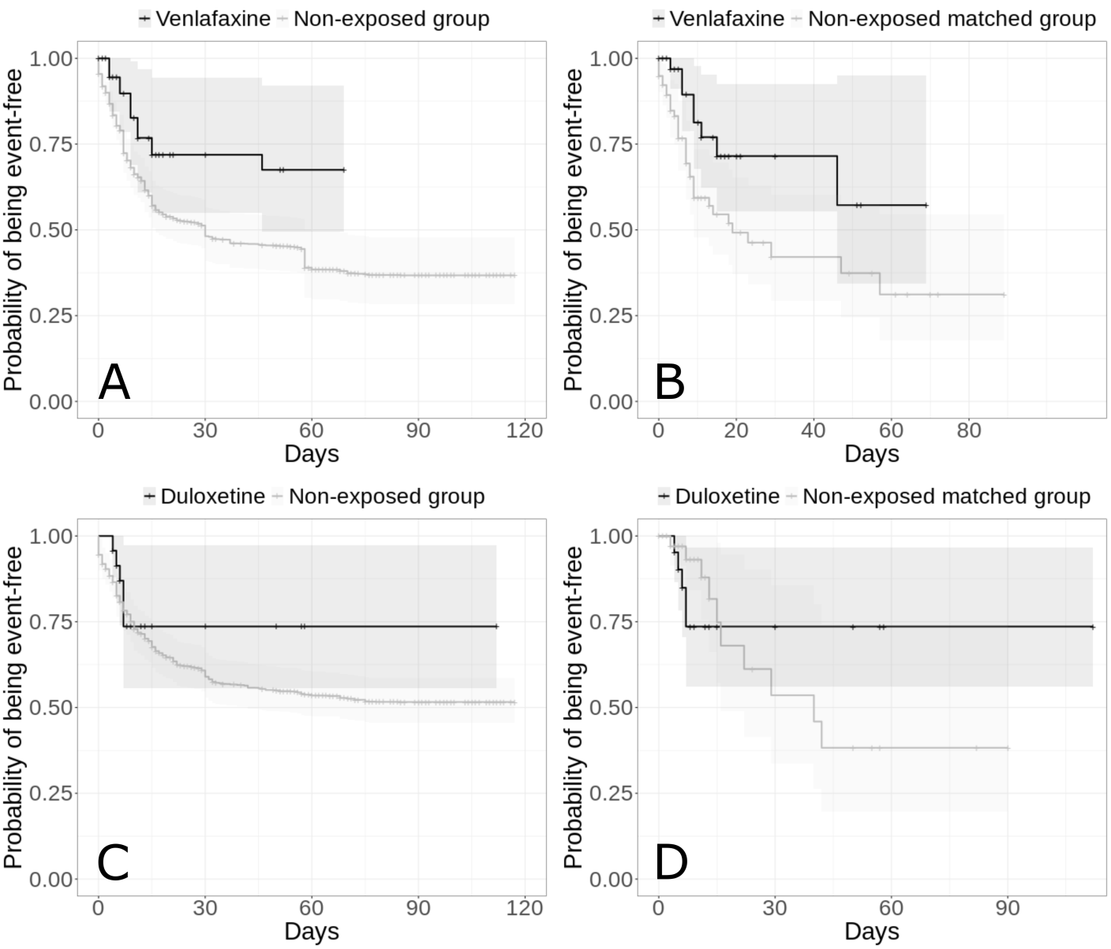
Supplementary Figure 3. Kaplan-Meier curves of the composite endpoint of intubation or death in the full sample (A, C) and in the matched analytic samples using a 2:1 ratio (B, D) of patients who had been admitted with Covid-19, according to exposure to individual tricyclic antidepressant medications. The shaded areas represent pointwise 95% confidence intervals.
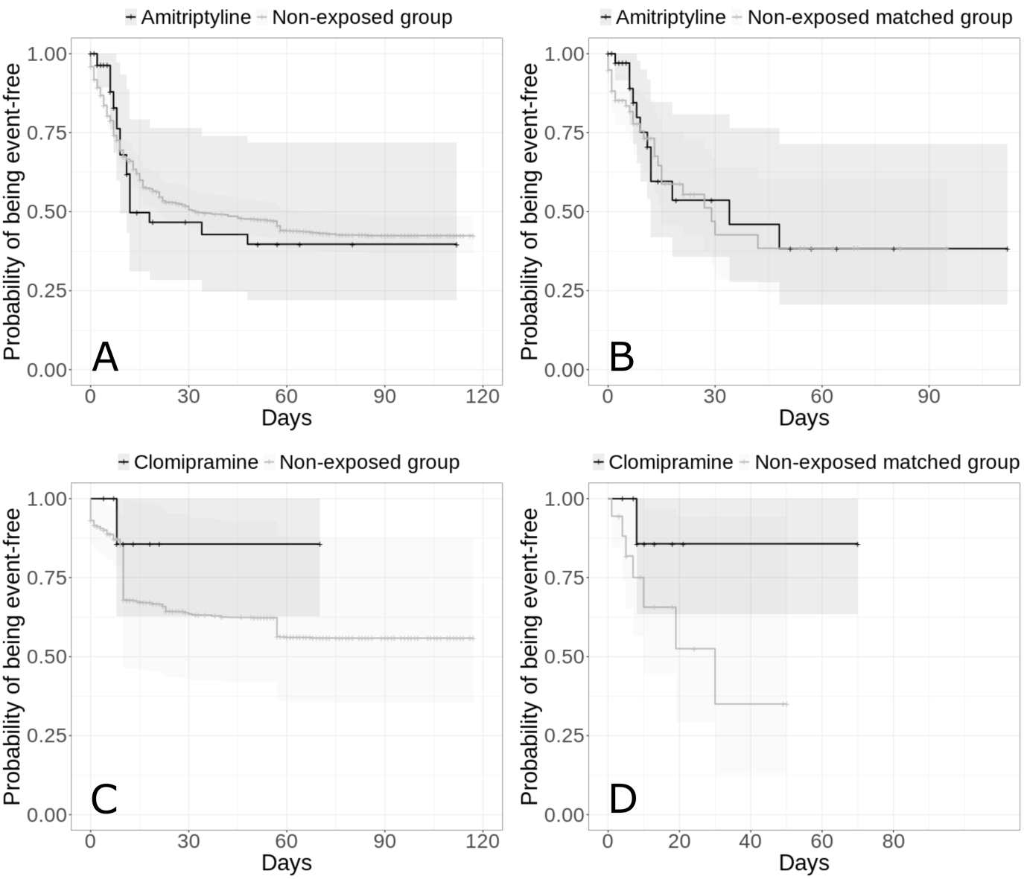
Supplementary Figure 4. Kaplan-Meier curves of the composite endpoint of intubation or death in the full sample (A) and in the matched analytic sample using a 2:1 ratio (B) of patients who had been admitted with Covid-19, according to mianserin exposure (tetracyclic antidepressant). The shaded areas represent pointwise 95% confidence intervals.
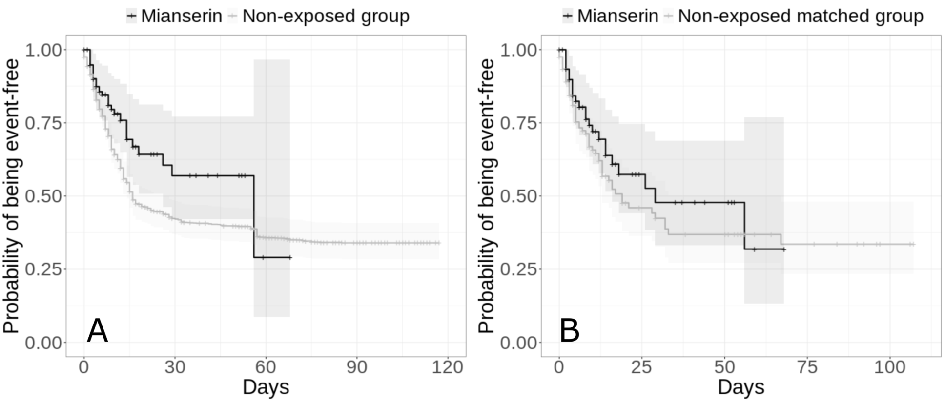

Supplementary Figure 5. Kaplan-Meier curves of the composite endpoint of intubation or death in the full sample (A) and in the matched analytic sample using a 2:1 ratio (B) of patients who had been admitted with Covid-19, according to mirtazapine exposure (α2-antagonist antidepressant). The shaded areas represent pointwise 95% confidence intervals.
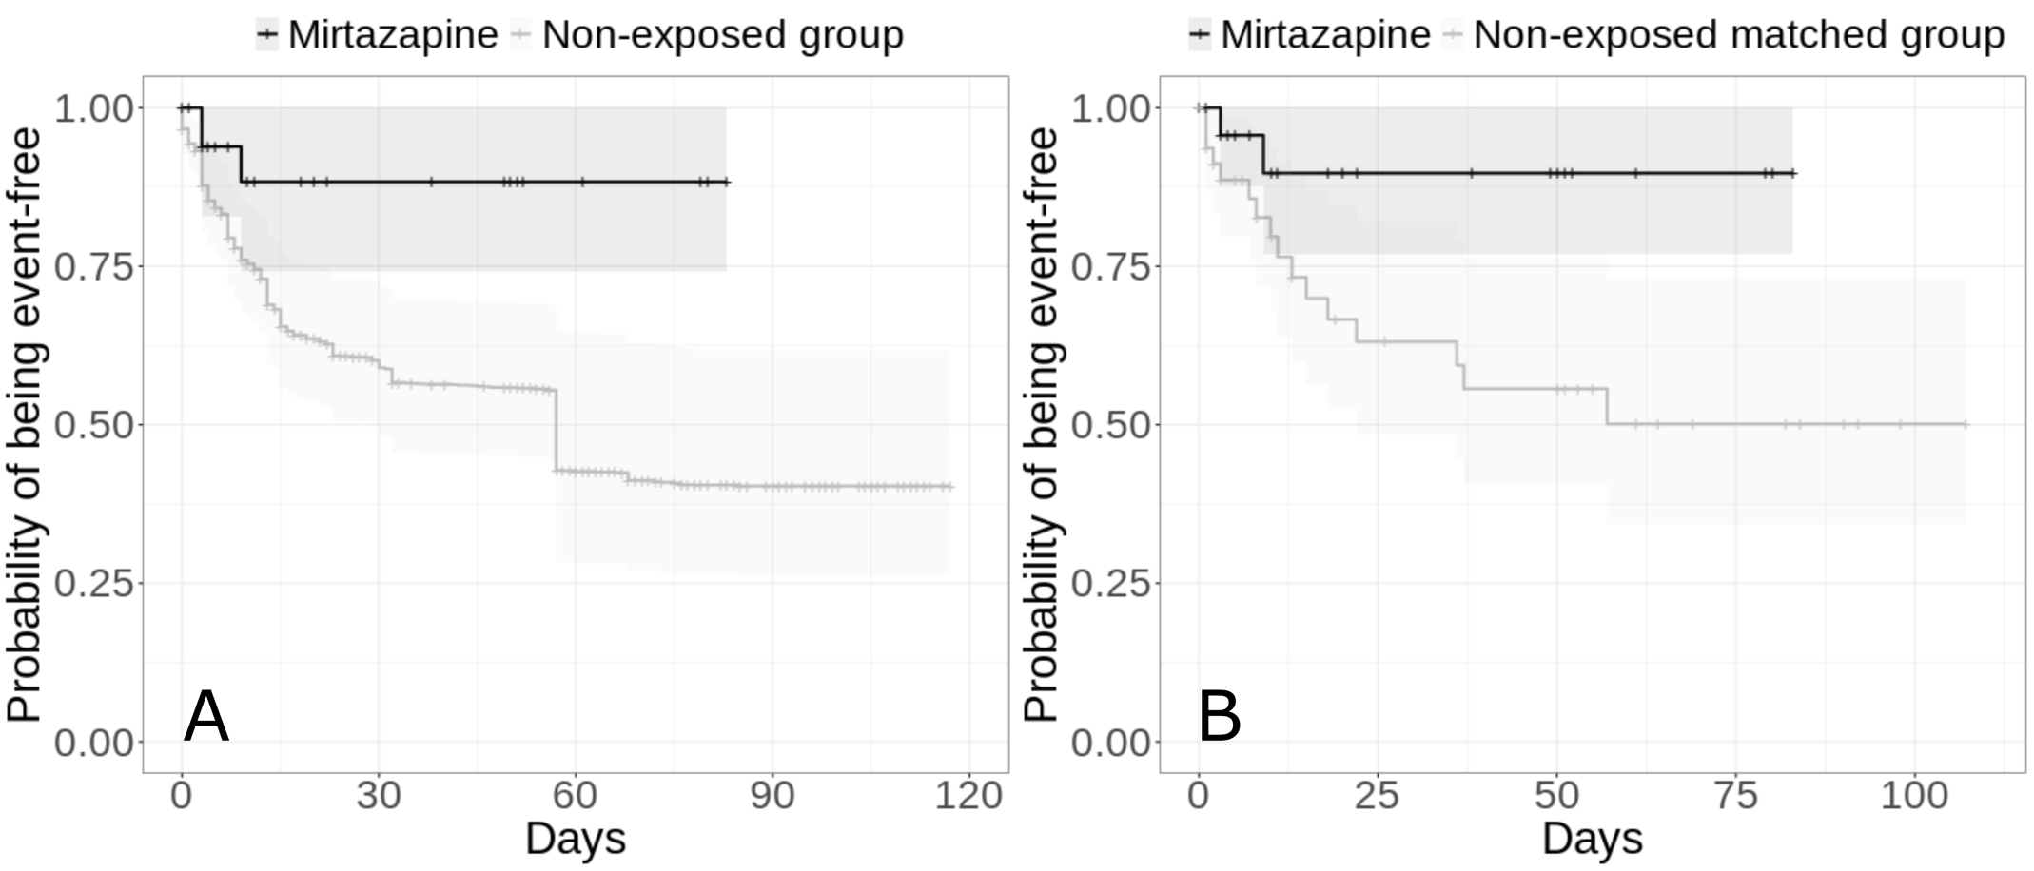

Supplementary Table 1. Absolute and fluoxetine-equivalent doses by antidepressant medication.

 |  | Absolute dose (milligrams) |  |  |  |  | Fluoxetine-equivalent dose (milligrams) ¥
 |  | Range | Mean (SD) | Median (SD) |  |  |  | Range | Mean (SD) | Median (SD)
Any antidepressant (n=345) |  | - | - | - |  |  |  | 1.64 – 81.22 | 21.60 (14.05) | 20.19 (14.05)
SSRIs (n=195) |  | - | - | - |  |  |  | 10.00 – 81.22 | 24.14 (11.14) | 22.22 (11.14)
Other antidepressants (n=150) |  | - | - | - |  |  |  | 1.64 – 80.32 | 16.95 (15.32) | 11.87 (15.32)
SNRIs (n=59) |  | - | - | - |  |  |  | 10.04 – 80.32 | 30.78 (19.23) | 20.08 (19.23)
Tricyclic antidepressants (n=49) |  | - | - | - |  |  |  | 1.64 – 49.06 | 8.10 (9.18) | 4.61 (9.18)
Tetracyclic antidepressants (n=62) |  | - | - | - |  |  |  | 3.96 – 31.65 | 10.26 (6.07) | 11.87 (6.07)
α2-antagonist antidepressant (n=25) |  | - | - | - |  |  |  | 11.79 – 35.36 | 17.45 (7.70) | 11.79 (7.70)
SSRIs
 | Citalopram (n=21) | 10.00 – 20.00 | 15.29 (5.14) | 20.00 (5.14) |  |  |  | 11.11 – 22.22 | 16.99 (5.72) | 22.22 (5.72)
 | Escitalopram (n=63) | 5.00 – 20.00 | 11.20 (4.55) | 10.00 (4.55) |  |  |  | 11.11 – 44.44 | 24.89 (10.11) | 22.22 (10.11)
 | Fluoxetine (n=30) | 10.00 – 40.00 | 19.63 (5.18) | 20.00 (5.18) |  |  |  | - | - | -
 | Paroxetine (n=63) | 10.00 – 40.00 | 21.15 (7.32) | 20.00 (7.32) |  |  |  | 11.76 – 47.06 | 24.89 (8.61) | 23.53 (8.61)
 | Sertraline (n=22) | 25.00 – 200.00 | 77.78 (51.37) | 50.00 (51.37) |  |  |  | 10.15 – 81.22 | 31.58 (20.86) | 20.30 (20.86)
 | Vortioxetine (n=2) | 5.00 – 15.00 | 10.00 (7.07) | 10.00 (7.07) |  |  |  | 11.11 – 33.33 | 22.22 (15.71) | 22.22 (15.71)
SNRIs
 | Venlafaxine (n=39) | 37.50 – 300.00 | 102.02 (69.61) | 75.00 (69.61) |  |  |  | 10.04 – 80.32 | 27.32 (18.64) | 20.08 (18.64)
 | Duloxetine (n=21) | 30.00 – 120.00 | 54.71 (28.53) | 60.00 (28.53) |  |  |  | 20.00 – 80.00 | 36.47 (19.02) | 40.00 (19.02)
Tricyclic antidepressants
 | Amitriptyline (n=39) | 5.00 – 150.00 | 25.88 (30.33) | 15.00 (30.33) |  |  |  | 1.64 – 49.06 | 8.47 (9.92) | 4.91 (9.92)
 | Clomipramine (n=9) | 5.00 – 25.00 | 14.29 (7.73) | 12.50 (7.73) |  |  |  | 1.72 – 8.61 | 4.92 (2.66) | 4.31 (2.66)
 | Dosulepine (n=1) | 50.00 – 50.00 | 50.00 (NA) | 50.00 (NA) |  |  |  | 17.80 – 17.80 | 17.80 (NA) | 17.80 (NA)
Tetracyclic antidepressant
 | Mianserin (n=62) | 10.00 – 80.00 | 25.93 (15.35) | 30.00 (15.35) |  |  |  | 3.96 – 31.65 | 10.26 (6.07) | 11.87 (6.07)
α2-antagonist antidepressant
 | Mirtazapine (n=25) | 15.00 – 45.00 | 22.20 (9.80) | 15.00 (9.80) |  |  |  | 11.79 – 35.36 | 17.45 (7.70) | 11.79 (7.70)

¥ Individual medication absolute doses were converted into fluoxetine-equivalent doses. Information was lacking to confidently assess doses in 55 participants (15.9%), who were excluded from these analyses.
Abbreviations: SSRIs, selective serotonin reuptake inhibitors; SNRIs, serotonin–norepinephrine reuptake inhibitors.

Supplementary Table 2. Time to follow-up by antidepressant medication.

 |  | Range | Mean (SD) | Median (SD)
No antidepressant (n=6,885) |  | 1 – 117 | 18.4 (27.4) | 4.0 (27.4)
Any antidepressant (n=345) |  | 1 – 112 | 19.4 (22.8) | 10.0 (22.8)
SSRIs (n=195) |  | 1 – 111 | 21.1 (24.5) | 11.0 (24.5)
Other antidepressants (n=150) |  | 1 – 112 | 17.1 (20.4) | 10.0 (20.4)
SNRIs (n=59) |  | 1 – 112 | 16.7 (21.1) | 9.0 (21.1)
Tricyclic antidepressants (n=49) |  | 1 – 112 | 17.0 (23.8) | 8.0 (23.8)
Tetracyclic antidepressants (n=62) |  | 1 – 68 | 16.0 (16.7) | 10.0 (16.7)
α2-antagonist antidepressant (n=25) |  | 1 – 83 | 27.2 (27.6) | 11.0 (27.6)
SSRIs
 | Citalopram (n=21) | 1 – 71 | 13.3 (18.5) | 6.0 (18.5)
 | Escitalopram (n= 63) | 1 – 93 | 22.6 (23.2) | 13.0 (23.2)
 | Fluoxetine (n=30) | 1 – 105 | 25.5 (28.4) | 13.5 (28.4)
 | Paroxetine (n=63) | 1 – 105 | 21.6 (25.4) | 8.0 (25.4)
 | Sertraline (n=22) | 1 – 111 | 17.6 (25.0) | 8.5 (25.0)
 | Vortioxetine (n=2)
SNRIs
 | Venlafaxine (n=39) | 7 – 49 | 28.0 (29.7) | 28.0 (29.7)
 | Duloxetine (n=21) | 4 – 112 | 20.8 (27.1) | 8.0 (27.1)
Tricyclic antidepressants
 | Amitriptyline (n=39) | 1 – 112 | 17.3 (24.9) | 7.0 (24.9)
 | Clomipramine (n=9) | 4 – 70 | 17.7 (20.4) | 10.0 (20.4)
 | Dosulepine (n=1) | 1 – 1 | 1.0 (NA) | 1.0 (NA)
Tetracyclic antidepressant
 | Mianserin (n=62) | 1 – 68 | 16.0 (16.7) | 10.0 (16.7)
α2-antagonist antidepressant
 | Mirtazapine (n=25) | 1 – 83 | 27.2 (27.6) | 11.0 (27.6)

Abbreviations: SSRIs, selective serotonin reuptake inhibitors; SNRIs, serotonin–norepinephrine reuptake inhibitors.

Supplementary Table 3. Characteristics of patients receiving or not receiving antidepressants in the matched and unmatched analytic samples.

 | Exposed to any antidepressant  N = 345 | Not exposed to any antidepressant  N = 6,885 | Non-exposed matched group  N = 345 | Exposed to any antidepressant  vs.  Not exposed to any antidepressant | Exposed to any antidepressant  vs.  Not exposed to antidepressants | Exposed to any antidepressant  vs.  Non-exposed matched group
 |  |  |  | Crude analysis | Analysis weighted by inverse-probability-weighting weights | Matched analytic sample analysis
 | N (%) | N (%) | N (%) | Chi-square test  (p-value) | Weighted Chi-square test  (p-value) | Chi-square test  (p-value)
Characteristics
Age (years) |  |  |  | 267.85 (<0.001*) | 49.10 (<0.001*) | 1.65 (0.649)
18-50 | 27 (7.83%) | 2676 (38.9%) | 34 (9.86%)
51-70 | 98 (28.4%) | 2410 (35.0%) | 105 (30.4%)
71-80 | 84 (24.3%) | 841 (12.2%) | 75 (21.7%)
81+ | 136 (39.4%) | 958 (13.9%) | 131 (38.0%)
Sex |  |  |  | 14.8 (<0.001*) | 22.23 (<0.001*) | 12.3 (<0.001*)
Women | 205 (59.4%) | 3350 (48.7%) | 158 (45.8%)
Men | 140 (40.6%) | 3535 (51.3%) | 187 (54.2%)
Hospital |  |  |  | 56.52 (<0.001*) | 7.80 (0.050*) | 2.06 (0.561)
AP-HP Centre – Paris University, Henri Mondor University Hospitals and at home hospitalization | 48 (13.9%) | 2180 (31.7%) | 50 (14.5%)
AP-HP Nord and Hôpitaux Universitaires Paris Seine-Saint-Denis | 129 (37.4%) | 2391 (34.7%) | 140 (40.6%)
AP-HP Paris Saclay University | 75 (21.7%) | 1087 (15.8%) | 78 (22.6%)
AP-HP Sorbonne University | 93 (27.0%) | 1227 (17.8%) | 77 (22.3%)
Obesity ^{α} |  |  |  | 31.37 (<0.001*) | 8.22 (0.004*) | 2.56 (0.109)
Yes | 80 (23.2%) | 868 (12.6%) | 62 (18.0%)
No | 265 (76.8%) | 6017 (87.4%) | 283 (82.0%)
Smoking ^{β} |  |  |  | 32.61 (<0.001*) | 0.43 (0.514) | 0.39 (0.534)
Yes | 59 (17.1%) | 560 (8.1%) | 52 (15.1%)
No | 286 (82.9%) | 6325 (91.9%) | 293 (84.9%)
Any medical condition associated with increased risk of severe COVID-19 ^{γ} |  |  |  | 71.04 (<0.001*) | 3.15 (0.076) | 0.72 (0.397)
Yes | 193 (55.9%) | 2317 (33.7%) | 205 (59.4%)
No | 152 (44.1%) | 4568 (66.3%) | 140 (40.6%)
Medication according to compassionate use or as part of a clinical trial ^{ϴ} |  |  |  | 8.5 (0.004*) | 0.05 (0.817) | 1.03 (0.310)
Yes | 81 (23.5%) | 1185 (17.2%) | 69 (20.0%)
No | 264 (76.5%) | 5700 (82.8%) | 276 (80.0%)
Any current mood or anxiety disorder £ |  |  |  | 201.6 (<0.001*) | 42.51 (<0.001*) | <0.01 (>0.99)
Yes | 38 (11.0%) | 76 (1.1%) | 38 (11.0%)
No | 307 (89.0%) | 6809 (98.9%) | 307 (89.0%)
Any other current psychiatric disorder ¥ |  |  |  | 83.91 (<0.001*) | 14.57 (<0.001*) | <0.01 (>0.99)
Yes | 46 (13.3%) | 235 (3.4%) | 46 (13.3%)
No | 299 (86.7%) | 6650 (96.6%) | 299 (86.7%)
Any benzodiazepine or Z-drug |  |  |  | 683.84 (<0.001*) | 171.35 (<0.001*) | 0.84 (0.360)
Yes | 172 (49.9%) | 513 (7.5%) | 159 (46.1%)
No | 173 (50.1%) | 6372 (92.5%) | 186 (53.9%)
Any mood stabilizer medication ^{Ω} |  |  |  | 389.03 (<0.001*) | 73.07 (<0.001*) | 0.13 (0.716)
Yes | 81 (23.5%) | 188 (2.7%) | 76 (22.0%)
No | 264 (76.5%) | 6697 (97.3%) | 269 (78.0%)
Any antipsychotic medication |  |  |  | 261.5 (<0.001*) | 67.03 (<0.001*) | <0.01 (>0.99)
Yes | 64 (18.6%) | 173 (2.5%) | 64 (18.6%)
No | 281 (81.4%) | 6712 (97.5%) | 281 (81.4%)
Clinical severity of Covid-19 at admission ^{µ} |  |  |  | 103.88 (<0.001*) | 17.92 (<0.001*) | 0.53 (0.767)
Yes | 99 (28.7%) | 1415 (20.6%) | 107 (31.0%)
No | 150 (43.5%) | 1673 (24.3%) | 142 (41.2%)
Missing | 96 (27.8%) | 3797 (55.1%) | 96 (27.8%)
Biological severity of Covid-19 at admission ^{κ} |  |  |  | 112.19 (<0.001*) | 10.04 (0.007*) | 0.18 (0.916)
Yes | 172 (49.9%) | 2213 (32.1%) | 177 (51.3%)
No | 123 (35.7%) | 1693 (24.6%) | 118 (34.2%)
Missing | 50 (14.5%) | 2979 (43.3%) | 50 (14.5%)

^{α} Defined as having a body-mass index higher than 30 kg/m² or an International Statistical Classification of Diseases and Related Health Problems (ICD-10) diagnosis code for obesity (E66.0, E66.1, E66.2, E66.8, E66.9).
^{β} Smoking status was self-reported.
^{γ} Assessed using ICD-10 diagnosis codes for diabetes mellitus (E11), diseases of the circulatory system (I00-I99), diseases of the respiratory system (J00-J99), neoplasms (C00-D49), and diseases of the blood and blood-forming organs and certain disorders involving the immune mechanism (D5-D8).
^{ϴ} Any medication prescribed as part of a clinical trial or according to compassionate use (e.g., hydroxychloroquine, azithromycin, remdesivir, tocilizumab, sarilumab, or dexamethasone).
£ Assessed using ICD-10 diagnosis codes for mood and anxiety disorders (F30-F48).
¥ Assessed using ICD-10 diagnosis codes (F00-F29 and F50-F99).
^{Ω} Included lithium or antiepileptic medications with mood stabilizing properties.
^{µ} Defined as having at least one of the following criteria: respiratory rate > 24 breaths/min or < 12 breaths/min, resting peripheral capillary oxygen saturation in ambient air < 90%, temperature > 40°C, or systolic blood pressure < 100 mm Hg.
^{κ} Defined as having at least one of the following criteria: high neutrophil-to-lymphocyte ratio, low lymphocyte-to-C-reactive protein (both variables were dichotomized at the median of the values observed in the full sample), and plasma lactate levels higher than 2 mmol/L.
* p-value is significant (p<0.05).

Supplementary Table 4. Characteristics of patients receiving SSRIs or not receiving any antidepressant in the matched and unmatched analytic samples.

 | Exposed to any SSRI  N = 195 | Not exposed to any antidepressant  N = 6,885 | Non-exposed matched group  N = 195 | Exposed to any SSRI  vs.  Not exposed to any antidepressant | Exposed to any SSRI  vs.  Not exposed to antidepressants | Exposed to any SSRI  vs.  Non-exposed matched group
 |  |  |  | Crude analysis | Analysis weighted by inverse-probability-weighting weights | Matched analytic sample analysis
 | N (%) | N (%) | N (%) | Chi-square test  (p-value) | Weighted Chi-square test  (p-value) | Chi-square test  (p-value)
Characteristics
Age (years) |  |  |  | 138.93 (<0.001*) | 37.08 (<0.001*) | 0.85 (0.837)
18-50 | 19 (9.74%) | 2676 (38.9%) | 24 (12.3%)
51-70 | 55 (28.2%) | 2410 (35.0%) | 55 (28.2%)
71-80 | 49 (25.1%) | 841 (12.2%) | 44 (22.6%)
81+ | 72 (36.9%) | 958 (13.9%) | 72 (36.9%)
Sex |  |  |  | 12.08 (0.001*) | 14.39 (<0.001*) | 3.38 (0.066)
Women | 120 (61.5%) | 3350 (48.7%) | 101 (51.8%)
Men | 75 (38.5%) | 3535 (51.3%) | 94 (48.2%)
Hospital |  |  |  | 39.6 (<0.001*) | 13.49 (0.004*) | 1.04 (0.792)
AP-HP Centre – Paris University, Henri Mondor University Hospitals and at home hospitalization | 22 (11.3%) | 2180 (31.7%) | 25 (12.8%)
AP-HP Nord and Hôpitaux Universitaires Paris Seine-Saint-Denis | 79 (40.5%) | 2391 (34.7%) | 80 (41.0%)
AP-HP Paris Saclay University | 41 (21.0%) | 1087 (15.8%) | 45 (23.1%)
AP-HP Sorbonne University | 53 (27.2%) | 1227 (17.8%) | 45 (23.1%)
Obesity ^{α} |  |  |  | 17.59 (<0.001*) | 9.72 (0.002*) | 0.55 (0.458)
Yes | 45 (23.1%) | 868 (12.6%) | 38 (19.5%)
No | 150 (76.9%) | 6017 (87.4%) | 157 (80.5%)
Smoking ^{β} |  |  |  | 15.89 (<0.001*) | 0.39 (0.534) | 0.51 (0.477)
Yes | 32 (16.4%) | 560 (8.1%) | 26 (13.3%)
No | 163 (83.6%) | 6325 (91.9%) | 169 (86.7%)
Any medical condition associated with increased risk of severe COVID-19 ^{γ} |  |  |  | 31.77 (<0.001*) | 1.59 (0.208) | 0.84 (0.359)
Yes | 104 (53.3%) | 2317 (33.7%) | 114 (58.5%)
No | 91 (46.7%) | 4568 (66.3%) | 81 (41.5%)
Medication according to compassionate use or as part of a clinical trial ^{ϴ} |  |  |  | 4.94 (0.026*) | 0.78 (0.378) | 0.13 (0.716)
Yes | 46 (23.6%) | 1185 (17.2%) | 42 (21.5%)
No | 149 (76.4%) | 5700 (82.8%) | 153 (78.5%)
Any current mood or anxiety disorder £ |  |  |  | 124.04 (<0.001*) | 26.45 (<0.001*) | <0.01 (>0.99)
Yes | 21 (10.8%) | 76 (1.1%) | 21 (10.8%)
No | 174 (89.2%) | 6809 (98.9%) | 174 (89.2%)
Any other current psychiatric disorder ¥ |  |  |  | 78.32 (<0.001*) | 14.43 (<0.001*) | <0.01 (>0.99)
Yes | 31 (15.9%) | 235 (3.4%) | 31 (15.9%)
No | 164 (84.1%) | 6650 (96.6%) | 164 (84.1%)
Any benzodiazepine or Z-drug |  |  |  | 435.24 (<0.001*) | 137.37 (<0.001*) | 0.26 (0.612)
Yes | 98 (50.3%) | 513 (7.5%) | 92 (47.2%)
No | 97 (49.7%) | 6372 (92.5%) | 103 (52.8%)
Any mood stabilizer medication ^{Ω} |  |  |  | 186.73 (<0.001*) | 32.26 (<0.001*) | 0.02 (0.899)
Yes | 40 (20.5%) | 188 (2.7%) | 38 (19.5%)
No | 155 (79.5%) | 6697 (97.3%) | 157 (80.5%)
Any antipsychotic medication |  |  |  | 193.67 (<0.001*) | 59.87 (<0.001*) | <0.01 (>0.99)
Yes | 39 (20.0%) | 173 (2.5%) | 39 (20.0%)
No | 156 (80.0%) | 6712 (97.5%) | 156 (80.0%)
Clinical severity of Covid-19 at admission ^{µ} |  |  |  | 52.53 (<0.001*) | 14.65 (0.001*) | 0.19 (0.911)
Yes | 58 (29.7%) | 1415 (20.6%) | 61 (31.3%)
No | 80 (41.0%) | 1673 (24.3%) | 76 (39.0%)
Missing | 57 (29.2%) | 3797 (55.1%) | 58 (29.7%)
Biological severity of Covid-19 at admission ^{κ} |  |  |  | 67.54 (<0.001*) | 12.58 (0.002*) | 0.58 (0.748)
Yes | 92 (47.2%) | 2213 (32.1%) | 96 (49.2%)
No | 76 (39.0%) | 1693 (24.6%) | 69 (35.4%)
Missing | 27 (13.8%) | 2979 (43.3%) | 30 (15.4%)

^{α} Defined as having a body-mass index higher than 30 kg/m² or an International Statistical Classification of Diseases and Related Health Problems (ICD-10) diagnosis code for obesity (E66.0, E66.1, E66.2, E66.8, E66.9).
^{β} Smoking status was self-reported.
^{γ} Assessed using ICD-10 diagnosis codes for diabetes mellitus (E11), diseases of the circulatory system (I00-I99), diseases of the respiratory system (J00-J99), neoplasms (C00-D49), and diseases of the blood and blood-forming organs and certain disorders involving the immune mechanism (D5-D8).
^{ϴ} Any medication prescribed as part of a clinical trial or according to compassionate use (e.g., hydroxychloroquine, azithromycin, remdesivir, tocilizumab, sarilumab, or dexamethasone).
£ Assessed using ICD-10 diagnosis codes for mood and anxiety disorders (F30-F48).
¥ Assessed using ICD-10 diagnosis codes (F00-F29 and F50-F99).
^{Ω} Included lithium or antiepileptic medications with mood stabilizing properties.
^{µ} Defined as having at least one of the following criteria: respiratory rate > 24 breaths/min or < 12 breaths/min, resting peripheral capillary oxygen saturation in ambient air < 90%, temperature > 40°C, or systolic blood pressure < 100 mm Hg.
^{κ} Defined as having at least one of the following criteria: high neutrophil-to-lymphocyte ratio, low lymphocyte-to-C-reactive protein (both variables were dichotomized at the median of the values observed in the full sample), and plasma lactate levels higher than 2 mmol/L.
* p-value is significant (p<0.05).

Supplementary Table 5. Characteristics of patients receiving any non-SSRI antidepressant or not receiving any antidepressant in the matched and unmatched analytic samples.

 | Exposed to any non-SSRI antidepressant  N = 150 | Not exposed to any antidepressant  N = 6,885 | Non-exposed matched group  N = 150 | Exposed to any non-SSRI antidepressant  vs.  Not exposed to any antidepressant | Exposed to any non-SSRI antidepressant  vs.  Not exposed to antidepressants | Exposed to any non-SSRI antidepressant  vs.  Non-exposed matched group
 |  |  |  | Crude analysis | Analysis weighted by inverse-probability-weighting weights | Matched analytic sample analysis
 | N (%) | N (%) | N (%) | Chi-square test  (p-value) | Weighted Chi-square test  (p-value) | Chi-square test  (p-value)
Characteristics
Age (years) |  |  |  | 143.07 (<0.001*) | 33.40 (<0.001*) | 0.37 (0.947)
18-50 | 8 (5.33%) | 2676 (38.9%) | 10 (6.67%)
51-70 | 43 (28.7%) | 2410 (35.0%) | 44 (29.3%)
71-80 | 35 (23.3%) | 841 (12.2%) | 32 (21.3%)
81+ | 64 (42.7%) | 958 (13.9%) | 64 (42.7%)
Sex |  |  |  | 3.46 (0.063) | 18.20 (<0.001*) | 5.33 (0.021*)
Women | 85 (56.7%) | 3350 (48.7%) | 64 (42.7%)
Men | 65 (43.3%) | 3535 (51.3%) | 86 (57.3%)
Hospital |  |  |  | 20.43 (<0.001*) | 5.19 (0.158) | 0.4 (0.941)
AP-HP Centre – Paris University, Henri Mondor University Hospitals and at home hospitalization | 26 (17.3%) | 2180 (31.7%) | 25 (16.7%)
AP-HP Nord and Hôpitaux Universitaires Paris Seine-Saint-Denis | 50 (33.3%) | 2391 (34.7%) | 54 (36.0%)
AP-HP Paris Saclay University | 34 (22.7%) | 1087 (15.8%) | 35 (23.3%)
AP-HP Sorbonne University | 40 (26.7%) | 1227 (17.8%) | 36 (24.0%)
Obesity ^{α} |  |  |  | 14.15 (<0.001*) | 2.85 (0.092) | 4.36 (0.037*)
Yes | 35 (23.3%) | 868 (12.6%) | 20 (13.3%)
No | 115 (76.7%) | 6017 (87.4%) | 130 (86.7%)
Smoking ^{β} |  |  |  | 17.42 (<0.001*) | 0.98 (0.322) | 0.02 (0.879)
Yes | 27 (18.0%) | 560 (8.1%) | 25 (16.7%)
No | 123 (82.0%) | 6325 (91.9%) | 125 (83.3%)
Any medical condition associated with increased risk of severe COVID-19 ^{γ} |  |  |  | 41.89 (<0.001*) | 0.92 (0.336) | 0.06 (0.813)
Yes | 89 (59.3%) | 2317 (33.7%) | 92 (61.3%)
No | 61 (40.7%) | 4568 (66.3%) | 58 (38.7%)
Medication according to compassionate use or as part of a clinical trial ^{ϴ} |  |  |  | 3.42 (0.064) | 0.69 (0.408) | 0.72 (0.395)
Yes | 35 (23.3%) | 1185 (17.2%) | 28 (18.7%)
No | 115 (76.7%) | 5700 (82.8%) | 122 (81.3%)
Any current mood or anxiety disorder £ |  |  |  | 110.05 (<0.001*) | 38.64 (<0.001*) | <0.01 (>0.99)
Yes | 17 (11.3%) | 76 (1.1%) | 17 (11.3%)
No | 133 (88.7%) | 6809 (98.9%) | 133 (88.7%)
Any other current psychiatric disorder ¥ |  |  |  | 16.71 (<0.001*) | 1.79 (0.181) | <0.01 (>0.99)
Yes | 15 (10.0%) | 235 (3.4%) | 15 (10.0%)
No | 135 (90.0%) | 6650 (96.6%) | 135 (90.0%)
Any benzodiazepine or Z-drug |  |  |  | 331.26 (<0.001*) | 91.14 (<0.001*) | 0.01 (0.908)
Yes | 74 (49.3%) | 513 (7.5%) | 72 (48.0%)
No | 76 (50.7%) | 6372 (92.5%) | 78 (52.0%)
Any mood stabilizer medication ^{Ω} |  |  |  | 274.4 (<0.001*) | 53.16 (<0.001*) | <0.01 (>0.99)
Yes | 41 (27.3%) | 188 (2.7%) | 41 (27.3%)
No | 109 (72.7%) | 6697 (97.3%) | 109 (72.7%)
Any antipsychotic medication |  |  |  | 102.41 (<0.001*) | 25.61 (<0.001*) | <0.01 (>0.99)
Yes | 25 (16.7%) | 173 (2.5%) | 25 (16.7%)
No | 125 (83.3%) | 6712 (97.5%) | 125 (83.3%)
Clinical severity of Covid-19 at admission ^{µ} |  |  |  | 55.78 (<0.001*) | 12.71 (0.002*) | '0.58 (0.748)'
Yes | 41 (27.3%) | 1415 (20.6%) | 47 (31.3%)
No | 70 (46.7%) | 1673 (24.3%) | 66 (44.0%)
Missing | 39 (26.0%) | 3797 (55.1%) | 37 (24.7%)
Biological severity of Covid-19 at admission ^{κ} |  |  |  | 49.77 (<0.001*) | 4.43 (0.109) | 0.14 (0.932)
Yes | 80 (53.3%) | 2213 (32.1%) | 78 (52.0%)
No | 47 (31.3%) | 1693 (24.6%) | 50 (33.3%)
Missing | 23 (15.3%) | 2979 (43.3%) | 22 (14.7%)

^{α} Defined as having a body-mass index higher than 30 kg/m² or an International Statistical Classification of Diseases and Related Health Problems (ICD-10) diagnosis code for obesity (E66.0, E66.1, E66.2, E66.8, E66.9).
^{β} Smoking status was self-reported.
^{γ} Assessed using ICD-10 diagnosis codes for diabetes mellitus (E11), diseases of the circulatory system (I00-I99), diseases of the respiratory system (J00-J99), neoplasms (C00-D49), and diseases of the blood and blood-forming organs and certain disorders involving the immune mechanism (D5-D8).
^{ϴ} Any medication prescribed as part of a clinical trial or according to compassionate use (e.g., hydroxychloroquine, azithromycin, remdesivir, tocilizumab, sarilumab, or dexamethasone).
£ Assessed using ICD-10 diagnosis codes for mood and anxiety disorders (F30-F48).
¥ Assessed using ICD-10 diagnosis codes (F00-F29 and F50-F99).
^{Ω} Included lithium or antiepileptic medications with mood stabilizing properties.
^{µ} Defined as having at least one of the following criteria: respiratory rate > 24 breaths/min or < 12 breaths/min, resting peripheral capillary oxygen saturation in ambient air < 90%, temperature > 40°C, or systolic blood pressure < 100 mm Hg.
^{κ} Defined as having at least one of the following criteria: high neutrophil-to-lymphocyte ratio, low lymphocyte-to-C-reactive protein (both variables were dichotomized at the median of the values observed in the full sample), and plasma lactate levels higher than 2 mmol/L.
* p-value is significant (p<0.05).

Supplementary Table 6. Characteristics of patients receiving SNRIs or not receiving any antidepressant in the matched and unmatched analytic samples.

 | Exposed to any SNRI  N = 59 | Not exposed to any antidepressant  N = 6,885 | Non-exposed matched group  N = 59 | Exposed to any SNRI  vs.  Not exposed to any antidepressant | Exposed to any SNRI  vs.  Not exposed to antidepressants | Exposed to any SNRI  vs.  Non-exposed matched group
 |  |  |  | Crude analysis | Analysis weighted by inverse-probability-weighting weights | Matched analytic sample analysis
 | N (%) | N (%) | N (%) | Chi-square test  (p-value) | Weighted Chi-square test  (p-value) | Chi-square test  (p-value)
Characteristics
Age (years) |  |  |  | 39.37 (<0.001*) | 27.46 (<0.001*) | 0.46 (0.928)
18-50 | 2 (3.39%) | 2676 (38.9%) | 3 (5.08%)
51-70 | 24 (40.7%) | 2410 (35.0%) | 21 (35.6%)
71-80 | 15 (25.4%) | 841 (12.2%) | 16 (27.1%)
81+ | 18 (30.5%) | 958 (13.9%) | 19 (32.2%)
Sex |  |  |  | 5.19 (0.023*) | 19.75 (<0.001*) | 4.9 (0.027*)
Women | 38 (64.4%) | 3350 (48.7%) | 25 (42.4%)
Men | 21 (35.6%) | 3535 (51.3%) | 34 (57.6%)
Hospital |  |  |  | 2.65 (0.448) | 9.35 (0.025*) | 0.24 (0.972)
AP-HP Centre – Paris University, Henri Mondor University Hospitals and at home hospitalization | 13 (22.0%) | 2180 (31.7%) | 13 (22.0%)
AP-HP Nord and Hôpitaux Universitaires Paris Seine-Saint-Denis | 23 (39.0%) | 2391 (34.7%) | 24 (40.7%)
AP-HP Paris Saclay University | 10 (16.9%) | 1087 (15.8%) | 11 (18.6%)
AP-HP Sorbonne University | 13 (22.0%) | 1227 (17.8%) | 11 (18.6%)
Obesity ^{α} |  |  |  | 9.82 (0.002*) | 0.09 (0.759) | 1.23 (0.267)
Yes | 16 (27.1%) | 868 (12.6%) | 10 (16.9%)
No | 43 (72.9%) | 6017 (87.4%) | 49 (83.1%)
Smoking ^{β} |  |  |  | 20.81 (<0.001*) | 11.48 (0.001*) | <0.01 (>0.99)
Yes | 15 (25.4%) | 560 (8.1%) | 14 (23.7%)
No | 44 (74.6%) | 6325 (91.9%) | 45 (76.3%)
Any medical condition associated with increased risk of severe COVID-19 ^{γ} |  |  |  | 16.08 (<0.001*) | 0.10 (0.755) | 0.14 (0.710)
Yes | 35 (59.3%) | 2317 (33.7%) | 32 (54.2%)
No | 24 (40.7%) | 4568 (66.3%) | 27 (45.8%)
Medication according to compassionate use or as part of a clinical trial ^{ϴ} |  |  |  | 0.65 (0.422) | 5.70 (0.017*) | <0.01 (>0.99)
Yes | 13 (22.0%) | 1185 (17.2%) | 13 (22.0%)
No | 46 (78.0%) | 5700 (82.8%) | 46 (78.0%)
Any current mood or anxiety disorder £ |  |  |  | 107.47 (<0.001*) | 45.83 (<0.001*) | <0.01 (>0.99)
Yes | 10 (16.9%) | 76 (1.1%) | 10 (16.9%)
No | 49 (83.1%) | 6809 (98.9%) | 49 (83.1%)
Any other current psychiatric disorder ¥ |  |  |  | 10.04 (0.002*) | 0.02 (0.902) | <0.01 (>0.99)
Yes | 7 (11.9%) | 235 (3.4%) | 7 (11.9%)
No | 52 (88.1%) | 6650 (96.6%) | 52 (88.1%)
Any benzodiazepine or Z-drug |  |  |  | 158.54 (<0.001*) | 43.27 (<0.001*) | 0.03 (0.854)
Yes | 31 (52.5%) | 513 (7.5%) | 29 (49.2%)
No | 28 (47.5%) | 6372 (92.5%) | 30 (50.8%)
Any mood stabilizer medication ^{Ω} |  |  |  | 165.66 (<0.001*) | 58.25 (<0.001*) | <0.01 (>0.99)
Yes | 19 (32.2%) | 188 (2.7%) | 19 (32.2%)
No | 40 (67.8%) | 6697 (97.3%) | 40 (67.8%)
Any antipsychotic medication |  |  |  | 42.05 (<0.001*) | 35.02 (<0.001*) | <0.01 (>0.99)
Yes | 10 (16.9%) | 173 (2.5%) | 10 (16.9%)
No | 49 (83.1%) | 6712 (97.5%) | 49 (83.1%)
Clinical severity of Covid-19 at admission ^{µ} |  |  |  | 24.2 (<0.001*) | 8.92 (0.012*) | 0.22 (0.895)
Yes | 12 (20.3%) | 1415 (20.6%) | 14 (23.7%)
No | 30 (50.8%) | 1673 (24.3%) | 28 (47.5%)
Missing | 17 (28.8%) | 3797 (55.1%) | 17 (28.8%)
Biological severity of Covid-19 at admission ^{κ} |  |  |  | 29.59 (<0.001*) | 19.78 (<0.001*) | 1.95 (0.377)
Yes | 33 (55.9%) | 2213 (32.1%) | 29 (49.2%)
No | 21 (35.6%) | 1693 (24.6%) | 20 (33.9%)
Missing | 5 (8.47%) | 2979 (43.3%) | 10 (16.9%)

^{α} Defined as having a body-mass index higher than 30 kg/m² or an International Statistical Classification of Diseases and Related Health Problems (ICD-10) diagnosis code for obesity (E66.0, E66.1, E66.2, E66.8, E66.9).
^{β} Smoking status was self-reported.
^{γ} Assessed using ICD-10 diagnosis codes for diabetes mellitus (E11), diseases of the circulatory system (I00-I99), diseases of the respiratory system (J00-J99), neoplasms (C00-D49), and diseases of the blood and blood-forming organs and certain disorders involving the immune mechanism (D5-D8).
^{ϴ} Any medication prescribed as part of a clinical trial or according to compassionate use (e.g., hydroxychloroquine, azithromycin, remdesivir, tocilizumab, sarilumab, or dexamethasone).
£ Assessed using ICD-10 diagnosis codes for mood and anxiety disorders (F30-F48).
¥ Assessed using ICD-10 diagnosis codes (F00-F29 and F50-F99).
^{Ω} Included lithium or antiepileptic medications with mood stabilizing properties.
^{µ} Defined as having at least one of the following criteria: respiratory rate > 24 breaths/min or < 12 breaths/min, resting peripheral capillary oxygen saturation in ambient air < 90%, temperature > 40°C, or systolic blood pressure < 100 mm Hg.
^{κ} Defined as having at least one of the following criteria: high neutrophil-to-lymphocyte ratio, low lymphocyte-to-C-reactive protein (both variables were dichotomized at the median of the values observed in the full sample), and plasma lactate levels higher than 2 mmol/L.
* p-value is significant (p<0.05).

Supplementary Table 7. Characteristics of patients receiving α2-antagonist antidepressants or not receiving any antidepressant in the matched and unmatched analytic samples.

 | Exposed to α2-antagonist antidepressants  N = 25 | Not exposed to any antidepressant  N = 6,885 | Non-exposed matched group  N = 25 | Exposed to α2-antagonist antidepressants  vs.  Not exposed to any antidepressant | Exposed to α2-antagonist antidepressants  vs.  Not exposed to antidepressants | Exposed α2-antagonist antidepressants  vs.  Non-exposed matched group
 |  |  |  | Crude analysis | Analysis weighted by inverse-probability-weighting weights | Matched analytic sample analysis
 | N (%) | N (%) | N (%) | Chi-square test  (p-value) | Weighted Chi-square test  (p-value) | Chi-square test  (p-value)
Characteristics
Age (years) |  |  |  | 69.14 (<0.001*) | 16.60 (0.001*) | 1.12 (0.772)
18-50 | 1 (4.00%) | 2676 (38.9%) | 1 (4.00%)
51-70 | 1 (4.00%) | 2410 (35.0%) | 3 (12.0%)
71-80 | 6 (24.0%) | 841 (12.2%) | 5 (20.0%)
81+ | 17 (68.0%) | 958 (13.9%) | 16 (64.0%)
Sex |  |  |  | 1.77 (0.183) | 36.57 (<0.001*) | 1.29 (0.256)
Women | 16 (64.0%) | 3350 (48.7%) | 11 (44.0%)
Men | 9 (36.0%) | 3535 (51.3%) | 14 (56.0%)
Hospital |  |  |  | 5.49 (0.139) | 7.25 (0.064) | 1.3 (0.729)
AP-HP Centre – Paris University, Henri Mondor University Hospitals and at home hospitalization | 6 (24.0%) | 2180 (31.7%) | 3 (12.0%)
AP-HP Nord and Hôpitaux Universitaires Paris Seine-Saint-Denis | 6 (24.0%) | 2391 (34.7%) | 7 (28.0%)
AP-HP Paris Saclay University | 8 (32.0%) | 1087 (15.8%) | 10 (40.0%)
AP-HP Sorbonne University | 5 (20.0%) | 1227 (17.8%) | 5 (20.0%)
Obesity ^{α} |  |  |  | 0.04 (0.835) | 1.76 (0.185) | 0.19 (0.663)
Yes | 4 (16.0%) | 868 (12.6%) | 2 (8.00%)
No | 21 (84.0%) | 6017 (87.4%) | 23 (92.0%)
Smoking ^{β} |  |  |  | 1.14 (0.285) | 24.22 (<0.001*) | <0.01 (>0.99)
Yes | 4 (16.0%) | 560 (8.1%) | 4 (16.0%)
No | 21 (84.0%) | 6325 (91.9%) | 21 (84.0%)
Any medical condition associated with increased risk of severe COVID-19 ^{γ} |  |  |  | <0.01 (>0.99) | 4.97 (0.026*) | <0.01 (>0.99)
Yes | 8 (32.0%) | 2317 (33.7%) | 8 (32.0%)
No | 17 (68.0%) | 4568 (66.3%) | 17 (68.0%)
Medication according to compassionate use or as part of a clinical trial ^{ϴ} |  |  |  | 2.20 (0.138) | 9.89 (0.002*) | 0.89 (0.346)
Yes | 1 (4.00%) | 1185 (17.2%) | 4 (16.0%)
No | 24 (96.0%) | 5700 (82.8%) | 21 (84.0%)
Any current mood or anxiety disorder £ |  |  |  | 17.41 (<0.001*) | 26.85 (<0.001*) | <0.01 (>0.99)
Yes | 3 (12.0%) | 76 (1.1%) | 3 (12.0%)
No | 22 (88.0%) | 6809 (98.9%) | 22 (88.0%)
Any other current psychiatric disorder ¥ |  |  |  | <0.01 (>0.99) | 21.18 (<0.001*) | <0.01 (>0.99)
Yes | 1 (4.0%) | 235 (3.4%) | 1 (4.0%)
No | 24 (96.0%) | 6650 (96.6%) | 24 (96.0%)
Any benzodiazepine or Z-drug |  |  |  | 104.82 (<0.001*) | 125.39 (<0.001*) | <0.01 (>0.99)
Yes | 16 (64.0%) | 513 (7.5%) | 15 (60.0%)
No | 9 (36.0%) | 6372 (92.5%) | 10 (40.0%)
Any mood stabilizer medication ^{Ω} |  |  |  | 137.29 (<0.001*) | 97.03 (<0.001*) | <0.01 (>0.99)
Yes | 11 (44.0%) | 188 (2.7%) | 10 (40.0%)
No | 14 (56.0%) | 6697 (97.3%) | 15 (60.0%)
Any antipsychotic medication |  |  |  | 73.74 (<0.001*) | 14.94 (<0.001*) | <0.01 (>0.99)
Yes | 8 (32.0%) | 173 (2.51%) | 8 (32.0%)
No | 17 (68.0%) | 6712 (97.5%) | 17 (68.0%)
Clinical severity of Covid-19 at admission ^{µ} |  |  |  | 5.63 (0.060) | 12.29 (0.002*) | 0.15 (0.928)
Yes | 5 (20.0%) | 1415 (20.6%) | 6 (24.0%)
No | 11 (44.0%) | 1673 (24.3%) | 11 (44.0%)
Missing | 9 (36.0%) | 3797 (55.1%) | 8 (32.0%)
Biological severity of Covid-19 at admission ^{κ} |  |  |  | 7.55 (0.023*) | 18.60 (<0.001*) | 0.10 (0.952)
Yes | 12 (48.0%) | 2213 (32.1%) | 13 (52.0%)
No | 9 (36.0%) | 1693 (24.6%) | 8 (32.0%)
Missing | 4 (16.0%) | 2979 (43.3%) | 4 (16.0%)

^{α} Defined as having a body-mass index higher than 30 kg/m² or an International Statistical Classification of Diseases and Related Health Problems (ICD-10) diagnosis code for obesity (E66.0, E66.1, E66.2, E66.8, E66.9).
^{β} Smoking status was self-reported.
^{γ} Assessed using ICD-10 diagnosis codes for diabetes mellitus (E11), diseases of the circulatory system (I00-I99), diseases of the respiratory system (J00-J99), neoplasms (C00-D49), and diseases of the blood and blood-forming organs and certain disorders involving the immune mechanism (D5-D8).
^{ϴ} Any medication prescribed as part of a clinical trial or according to compassionate use (e.g., hydroxychloroquine, azithromycin, remdesivir, tocilizumab, sarilumab, or dexamethasone).
£ Assessed using ICD-10 diagnosis codes for mood and anxiety disorders (F30-F48).
¥ Assessed using ICD-10 diagnosis codes (F00-F29 and F50-F99).
^{Ω} Included lithium or antiepileptic medications with mood stabilizing properties.
^{µ} Defined as having at least one of the following criteria: respiratory rate > 24 breaths/min or < 12 breaths/min, resting peripheral capillary oxygen saturation in ambient air < 90%, temperature > 40°C, or systolic blood pressure < 100 mm Hg.
^{κ} Defined as having at least one of the following criteria: high neutrophil-to-lymphocyte ratio, low lymphocyte-to-C-reactive protein (both variables were dichotomized at the median of the values observed in the full sample), and plasma lactate levels higher than 2 mmol/L.
* p-value is significant (p<0.05).

Supplementary Table 8. Characteristics of patients receiving Citalopram or Escitalopram or not receiving any antidepressant in the matched and unmatched analytic samples.

 | Exposed to Citalopram or Escitalopram  N = 82 | Not exposed to any antidepressant  N = 6,885 | Non-exposed matched group  N = 164 | Exposed to Citalopram or Escitalopram vs.  Not exposed to any antidepressant | Exposed to Citalopram or Escitalopram  vs.  Not exposed to antidepressants | Exposed to Citalopram or Escitalopram vs.  Non-exposed matched group
 |  |  |  | Crude analysis | Analysis weighted by inverse-probability-weighting weights | Matched analytic sample analysis
 | N (%) | N (%) | N (%) | Chi-square test  (p-value) | Weighted Chi-square test  (p-value) | Chi-square test  (p-value)
Characteristics
Age (years) |  |  |  | '01.02 (<0.001*) | 41.84 (<0.001*) | 1.20 (0.752)
18-50 | 3 (3.66%) | 2676 (38.9%) | 10 (6.10%)
51-70 | 19 (23.2%) | 2410 (35.0%) | 44 (26.8%)
71-80 | 23 (28.0%) | 841 (12.2%) | 43 (26.2%)
81+ | 37 (45.1%) | 958 (13.9%) | 67 (40.9%)
Sex |  |  |  | 7.65 (0.006*) | 20.06 (<0.001*) | 3.14 (0.076)
Women | 53 (64.6%) | 3350 (48.7%) | 85 (51.8%)
Men | 29 (35.4%) | 3535 (51.3%) | 79 (48.2%)
Hospital |  |  |  | 20.09 (<0.001*) | 22.74 (<0.001*) | 1.30 (0.729)
AP-HP Centre – Paris University, Henri Mondor University Hospitals and at home hospitalization | 8 (9.76%) | 2180 (31.7%) | 20 (12.2%)
AP-HP Nord and Hôpitaux Universitaires Paris Seine-Saint-Denis | 35 (42.7%) | 2391 (34.7%) | 67 (40.9%)
AP-HP Paris Saclay University | 15 (18.3%) | 1087 (15.8%) | 37 (22.6%)
AP-HP Sorbonne University | 24 (29.3%) | 1227 (17.8%) | 40 (24.4%)
Obesity ^{α} |  |  |  | 0.15 (0.702) | 0.09 (0.762) | <0.01 (>0.99)
Yes | 12 (14.6%) | 868 (12.6%) | 24 (14.6%)
No | 70 (85.4%) | 6017 (87.4%) | 140 (85.4%)
Smoking ^{β} |  |  |  | 1.28 (0.258) | 0.63 (0.427) | 0.27 (0.602)
Yes | 10 (12.2%) | 560 (8.1%) | 15 (9.15%)
No | 72 (87.8%) | 6325 (91.9%) | 149 (90.9%)
Any medical condition associated with increased risk of severe COVID-19 ^{γ} |  |  |  | 11.94 (0.001*) | 0.40 (0.525) | 0.25 (0.618)
Yes | 43 (52.4%) | 2317 (33.7%) | 93 (56.7%)
No | 39 (47.6%) | 4568 (66.3%) | 71 (43.3%)
Medication according to compassionate use or as part of a clinical trial ^{ϴ} |  |  |  | 1.62 (0.203) | 2.62 (0.106) | 0.25 (0.617)
Yes | 19 (23.2%) | 1185 (17.2%) | 32 (19.5%)
No | 63 (76.8%) | 5700 (82.8%) | 132 (80.5%)
Any current mood or anxiety disorder £ |  |  |  | 72.92 (<0.001*) | 30.50 (<0.001*) | <0.01 (>0.99)
Yes | 10 (12.2%) | 76 (1.1%) | 20 (12.2%)
No | 72 (87.8%) | 6809 (98.9%) | 144 (87.8%)
Any other current psychiatric disorder ¥ |  |  |  | 47.65 (<0.001*) | 12.89 (<0.001*) | <0.01 (>0.99)
Yes | 15 (18.3%) | 235 (3.41%) | 31 (18.9%)
No | 67 (81.7%) | 6650 (96.6%) | 133 (81.1%)
Any benzodiazepine or Z-drug |  |  |  | 133.98 (<0.001*) | 73.35 (<0.001*) | 0.02 (0.891)
Yes | 35 (42.7%) | 513 (7.5%) | 67 (40.9%)
No | 47 (57.3%) | 6372 (92.5%) | 97 (59.1%)
Any mood stabilizer medication ^{Ω} |  |  |  | 97.74 (<0.001*) | 17.27 (<0.001*) | 0.08 (0.779)
Yes | 18 (22.0%) | 188 (2.7%) | 32 (19.5%)
No | 64 (78.0%) | 6697 (97.3%) | 132 (80.5%)
Any antipsychotic medication |  |  |  | 19.61 (<0.001*) | 10.88 (0.001*) | <0.01 (>0.99)
Yes | 9 (11.0%) | 173 (2.5%) | 18 (11.0%)
No | 73 (89.0%) | 6712 (97.5%) | 146 (89.0%)
Clinical severity of Covid-19 at admission ^{µ} |  |  |  | 18.03 (<0.001*) | 0.67 (0.715) | 0.30 (0.861)
Yes | 25 (30.5%) | 1415 (20.6%) | 55 (33.5%)
No | 31 (37.8%) | 1673 (24.3%) | 57 (34.8%)
Missing | 26 (31.7%) | 3797 (55.1%) | 52 (31.7%)
Biological severity of Covid-19 at admission ^{κ} |  |  |  | 44.93 (<0.001*) | 17.538 (<0.001*) | 2.08 (0.353)
Yes | 38 (46.3%) | 2213 (32.1%) | 86 (52.4%)
No | 38 (46.3%) | 1693 (24.6%) | 61 (37.2%)
Missing | 6 (7.32%) | 2979 (43.3%) | 17 (10.4%)

^{α} Defined as having a body-mass index higher than 30 kg/m² or an International Statistical Classification of Diseases and Related Health Problems (ICD-10) diagnosis code for obesity (E66.0, E66.1, E66.2, E66.8, E66.9).
^{β} Smoking status was self-reported.
^{γ} Assessed using ICD-10 diagnosis codes for diabetes mellitus (E11), diseases of the circulatory system (I00-I99), diseases of the respiratory system (J00-J99), neoplasms (C00-D49), and diseases of the blood and blood-forming organs and certain disorders involving the immune mechanism (D5-D8).
^{ϴ} Any medication prescribed as part of a clinical trial or according to compassionate use (e.g., hydroxychloroquine, azithromycin, remdesivir, tocilizumab, sarilumab, or dexamethasone).
£ Assessed using ICD-10 diagnosis codes for mood and anxiety disorders (F30-F48).
¥ Assessed using ICD-10 diagnosis codes (F00-F29 and F50-F99).
^{Ω} Included lithium or antiepileptic medications with mood stabilizing properties.
^{µ} Defined as having at least one of the following criteria: respiratory rate > 24 breaths/min or < 12 breaths/min, resting peripheral capillary oxygen saturation in ambient air < 90%, temperature > 40°C, or systolic blood pressure < 100 mm Hg.
^{κ} Defined as having at least one of the following criteria: high neutrophil-to-lymphocyte ratio, low lymphocyte-to-C-reactive protein (both variables were dichotomized at the median of the values observed in the full sample), and plasma lactate levels higher than 2 mmol/L.
* p-value is significant (p<0.05).

Supplementary Table 9. Characteristics of patients receiving Escitalopram or not receiving any antidepressant in the matched and unmatched analytic samples.

 | Exposed to Escitalopram  N = 63 | Not exposed to any antidepressant  N = 6,885 | Non-exposed matched group  N = 126 | Exposed to Escitalopram vs.  Not exposed to any antidepressant | Exposed to Escitalopram  vs.  Not exposed to antidepressants | Exposed to Escitalopram vs.  Non-exposed matched group
 |  |  |  | Crude analysis | Analysis weighted by inverse-probability-weighting weights | Matched analytic sample analysis
 | N (%) | N (%) | N (%) | Chi-square test  (p-value) | Weighted Chi-square test  (p-value) | Chi-square test  (p-value)
Characteristics
Age (years) |  |  |  | 88.64 (<0.001*) | 41.74 (<0.001*) | 1.40 (0.706)
18-50 | 2 (3.17%) | 2676 (38.9%) | 8 (6.35%)
51-70 | 12 (19.0%) | 2410 (35.0%) | 29 (23.0%)
71-80 | 21 (33.3%) | 841 (12.2%) | 38 (30.2%)
81+ | 28 (44.4%) | 958 (13.9%) | 51 (40.5%)
Sex |  |  |  | 8.83 (0.003*) | 32.19 (<0.001*) | 1.74 (0.188)
Women | 43 (68.3%) | 3350 (48.7%) | 72 (57.1%)
Men | 20 (31.7%) | 3535 (51.3%) | 54 (42.9%)
Hospital |  |  |  | 16.11 (0.001*) | 19.58 (<0.001*) | 0.39 (0.942)
AP-HP Centre – Paris University, Henri Mondor University Hospitals and at home hospitalization | 7 (11.1%) | 2180 (31.7%) | 14 (11.1%)
AP-HP Nord and Hôpitaux Universitaires Paris Seine-Saint-Denis | 23 (36.5%) | 2391 (34.7%) | 44 (34.9%)
AP-HP Paris Saclay University | 13 (20.6%) | 1087 (15.8%) | 31 (24.6%)
AP-HP Sorbonne University | 20 (31.7%) | 1227 (17.8%) | 37 (29.4%)
Obesity ^{α} |  |  |  | 0.34 (0.558) | 0.97 (0.324) | <0.01 (>0.99)
Yes | 10 (15.9%) | 868 (12.6%) | 19 (15.1%)
No | 53 (84.1%) | 6017 (87.4%) | 107 (84.9%)
Smoking ^{β} |  |  |  | 2.38 (0.123) | 1.26 (0.261) | 0.54 (0.461)
Yes | 9 (14.3%) | 560 (8.13%) | 12 (9.52%)
No | 54 (85.7%) | 6325 (91.9%) | 114 (90.5%)
Any medical condition associated with increased risk of severe COVID-19 ^{γ} |  |  |  | 10.62 (0.001*) | 0.01 (0.920) | 0.22 (0.640)
Yes | 34 (54.0%) | 2317 (33.7%) | 74 (58.7%)
No | 29 (46.0%) | 4568 (66.3%) | 52 (41.3%)
Medication according to compassionate use or as part of a clinical trial ^{ϴ} |  |  |  | 4.86 (0.027*) | 6.51 (0.011) | 0.43 (0.513)
Yes | 18 (28.6%) | 1185 (17.2%) | 29 (23.0%)
No | 45 (71.4%) | 5700 (82.8%) | 97 (77.0%)
Any current mood or anxiety disorder £ |  |  |  | 60.90 (<0.001*) | 22.40 (<0.001*) | <0.01 (>0.99)
Yes | 8 (12.7%) | 76 (1.1%) | 16 (12.7%)
No | 55 (87.3%) | 6809 (98.9%) | 110 (87.3%)
Any other current psychiatric disorder ¥ |  |  |  | 58.59 (<0.001*) | 16.15 (<0.001*) | <0.01 (>0.99)
Yes | 14 (22.2%) | 235 (3.4%) | 29 (23.0%)
No | 49 (77.8%) | 6650 (96.6%) | 97 (77.0%)
Any benzodiazepine or Z-drug |  |  |  | 113.89 (<0.001*) | 72.4 (<0.001*) | <0.01 (>0.99)
Yes | 28 (44.4%) | 513 (7.5%) | 56 (44.4%)
No | 35 (55.6%) | 6372 (92.5%) | 70 (55.6%)
Any mood stabilizer medication ^{Ω} |  |  |  | 90.51 (<0.001*) | 17.62 (<0.001*) | <0.01 (>0.99)
Yes | 15 (23.8%) | 188 (2.7%) | 29 (23.0%)
No | 48 (76.2%) | 6697 (97.3%) | 97 (77.0%)
Any antipsychotic medication |  |  |  | 21.67 (<0.001*) | 13.62 (<0.001*) | <0.01 (>0.99)
Yes | 8 (12.7%) | 173 (2.5%) | 16 (12.7%)
No | 55 (87.3%) | 6712 (97.5%) | 110 (87.3%)
Clinical severity of Covid-19 at admission ^{µ} |  |  |  | 13.82 (0.001*) | 2.11 (0.348) | 0.29 (0.863)
Yes | 20 (31.7%) | 1415 (20.6%) | 45 (35.7%)
No | 23 (36.5%) | 1673 (24.3%) | 43 (34.1%)
Missing | 20 (31.7%) | 3797 (55.1%) | 38 (30.2%)
Biological severity of Covid-19 at admission ^{κ} |  |  |  | 37.99 (<0.001*) | 24.42 (<0.001*) | 3.39 (0.184)
Yes | 28 (44.4%) | 2213 (32.1%) | 68 (54.0%)
No | 31 (49.2%) | 1693 (24.6%) | 45 (35.7%)
Missing | 4 (6.35%) | 2979 (43.3%) | 13 (10.3%)

^{α} Defined as having a body-mass index higher than 30 kg/m² or an International Statistical Classification of Diseases and Related Health Problems (ICD-10) diagnosis code for obesity (E66.0, E66.1, E66.2, E66.8, E66.9).
^{β} Smoking status was self-reported.
^{γ} Assessed using ICD-10 diagnosis codes for diabetes mellitus (E11), diseases of the circulatory system (I00-I99), diseases of the respiratory system (J00-J99), neoplasms (C00-D49), and diseases of the blood and blood-forming organs and certain disorders involving the immune mechanism (D5-D8).
^{ϴ} Any medication prescribed as part of a clinical trial or according to compassionate use (e.g., hydroxychloroquine, azithromycin, remdesivir, tocilizumab, sarilumab, or dexamethasone).
£ Assessed using ICD-10 diagnosis codes for mood and anxiety disorders (F30-F48).
¥ Assessed using ICD-10 diagnosis codes (F00-F29 and F50-F99).
^{Ω} Included lithium or antiepileptic medications with mood stabilizing properties.
^{µ} Defined as having at least one of the following criteria: respiratory rate > 24 breaths/min or < 12 breaths/min, resting peripheral capillary oxygen saturation in ambient air < 90%, temperature > 40°C, or systolic blood pressure < 100 mm Hg.
^{κ} Defined as having at least one of the following criteria: high neutrophil-to-lymphocyte ratio, low lymphocyte-to-C-reactive protein (both variables were dichotomized at the median of the values observed in the full sample), and plasma lactate levels higher than 2 mmol/L.
* p-value is significant (p<0.05).

Supplementary Table 10. Characteristics of patients receiving Fluoxetine or not receiving any antidepressant in the matched and unmatched analytic samples.

 | Exposed to Fluoxetine  N = 30 | Not exposed to any antidepressant  N = 6,885 | Non-exposed matched group  N = 60 | Exposed to Fluoxetine vs.  Not exposed to any antidepressant | Exposed to Fluoxetine  vs.  Not exposed to antidepressants | Exposed to Fluoxetine vs.  Non-exposed matched group
 |  |  |  | Crude analysis | Analysis weighted by inverse-probability-weighting weights | Matched analytic sample analysis
 | N (%) | N (%) | N (%) | Chi-square test  (p-value) | Weighted Chi-square test  (p-value) | Chi-square test  (p-value)
Characteristics
Age (years) |  |  |  | 9.42 (0.024*) | 0.60 (0.895) | 0.91 (0.822)
18-50 | 4 (13.3%) | 2676 (38.9%) | 13 (21.7%)
51-70 | 13 (43.3%) | 2410 (35.0%) | 23 (38.3%)
71-80 | 7 (23.3%) | 841 (12.2%) | 13 (21.7%)
81+ | 6 (20.0%) | 958 (13.9%) | 11 (18.3%)
Sex |  |  |  | 2.02 (0.155) | <0.01 (0.947) | 3.48 (0.062)
Women | 19 (63.3%) | 3350 (48.7%) | 24 (40.0%)
Men | 11 (36.7%) | 3535 (51.3%) | 36 (60.0%)
Hospital |  |  |  | 13.27 (0.004*) | 20.879 (<0.001*) | 1.22 (0.747)
AP-HP Centre – Paris University, Henri Mondor University Hospitals and at home hospitalization | 2 (6.67%) | 2180 (31.7%) | 8 (13.3%)
AP-HP Nord and Hôpitaux Universitaires Paris Seine-Saint-Denis | 14 (46.7%) | 2391 (34.7%) | 25 (41.7%)
AP-HP Paris Saclay University | 10 (33.3%) | 1087 (15.8%) | 17 (28.3%)
AP-HP Sorbonne University | 4 (13.3%) | 1227 (17.8%) | 10 (16.7%)
Obesity ^{α} |  |  |  | 17.79 (<0.001*) | 60.40 (<0.001*) | 1.95 (0.162)
Yes | 12 (40.0%) | 868 (12.6%) | 14 (23.3%)
No | 18 (60.0%) | 6017 (87.4%) | 46 (76.7%)
Smoking ^{β} |  |  |  | 4.13 (0.042*) | 28.76 (<0.001*) | 0.55 (0.458)
Yes | 6 (20.0%) | 560 (8.1%) | 7 (11.7%)
No | 24 (80.0%) | 6325 (91.9%) | 53 (88.3%)
Any medical condition associated with increased risk of severe COVID-19 ^{γ} |  |  |  | 1.72 (0.190) | 12.45 (<0.001*) | 0.45 (0.501)
Yes | 14 (46.7%) | 2317 (33.7%) | 34 (56.7%)
No | 16 (53.3%) | 4568 (66.3%) | 26 (43.3%)
Medication according to compassionate use or as part of a clinical trial ^{ϴ} |  |  |  | 0.41 (0.520) | 1.94 (0.164) | 0.23 (0.634)
Yes | 7 (23.3%) | 1185 (17.2%) | 10 (16.7%)
No | 23 (76.7%) | 5700 (82.8%) | 50 (83.3%) |  |  | <0.01 (>0.99)
Any current mood or anxiety disorder £ |  |  |  | 4.05 (0.044*) | 1.22 (0.269)
Yes | 2 (6.67%) | 76 (1.1%) | 4 (6.67%)
No | 28 (93.3%) | 6809 (98.9%) | 56 (93.3%)
Any other current psychiatric disorder ¥ |  |  |  | <0.01 (>0.99) | 4.40 (0.036*) | <0.01 (>0.99)
Yes | 1 (3.33%) | 235 (3.4%) | 2 (3.33%)
No | 29 (96.7%) | 6650 (96.6%) | 58 (96.7%)
Any benzodiazepine or Z-drug |  |  |  | 49.74 (<0.001*) | 59.33 (<0.001*) | 0.01 (0.94)
Yes | 13 (43.3%) | 513 (7.5%) | 24 (40.0%)
No | 17 (56.7%) | 6372 (92.5%) | 36 (60.0%)
Any mood stabilizer medication ^{Ω} |  |  |  | 26.64 (<0.001*) | 8.48 (0.004*) | <0.01 (>0.99)
Yes | 6 (20.0%) | 188 (2.7%) | 12 (20.0%)
No | 24 (80.0%) | 6697 (97.3%) | 48 (80.0%)
Any antipsychotic medication |  |  |  | 29.62 (<0.001*) | 34.21 (<0.001*) | <0.01 (>0.99)
Yes | 6 (20.0%) | 173 (2.5%) | 12 (20.0%)
No | 24 (80.0%) | 6712 (97.5%) | 48 (80.0%)
Clinical severity of Covid-19 at admission ^{µ} |  |  |  | 9.79 (0.007*) | 14.88 (0.001*) | 0.72 (0.698)
Yes | 10 (33.3%) | 1415 (20.6%) | 15 (25.0%)
No | 12 (40.0%) | 1673 (24.3%) | 28 (46.7%)
Missing | 8 (26.7%) | 3797 (55.1%) | 17 (28.3%)
Biological severity of Covid-19 at admission ^{κ} |  |  |  | 8.94 (0.011*) | 0.56 (0.756) | 0.85 (0.654)
Yes | 13 (43.3%) | 2213 (32.1%) | 29 (48.3%)
No | 12 (40.0%) | 1693 (24.6%) | 25 (41.7%)
Missing | 5 (16.7%) | 2979 (43.3%) | 6 (10.0%)

^{α} Defined as having a body-mass index higher than 30 kg/m² or an International Statistical Classification of Diseases and Related Health Problems (ICD-10) diagnosis code for obesity (E66.0, E66.1, E66.2, E66.8, E66.9).
^{β} Smoking status was self-reported.
^{γ} Assessed using ICD-10 diagnosis codes for diabetes mellitus (E11), diseases of the circulatory system (I00-I99), diseases of the respiratory system (J00-J99), neoplasms (C00-D49), and diseases of the blood and blood-forming organs and certain disorders involving the immune mechanism (D5-D8).
^{ϴ} Any medication prescribed as part of a clinical trial or according to compassionate use (e.g., hydroxychloroquine, azithromycin, remdesivir, tocilizumab, sarilumab, or dexamethasone).
£ Assessed using ICD-10 diagnosis codes for mood and anxiety disorders (F30-F48).
¥ Assessed using ICD-10 diagnosis codes (F00-F29 and F50-F99).
^{Ω} Included lithium or antiepileptic medications with mood stabilizing properties.
^{µ} Defined as having at least one of the following criteria: respiratory rate > 24 breaths/min or < 12 breaths/min, resting peripheral capillary oxygen saturation in ambient air < 90%, temperature > 40°C, or systolic blood pressure < 100 mm Hg.
^{κ} Defined as having at least one of the following criteria: high neutrophil-to-lymphocyte ratio, low lymphocyte-to-C-reactive protein (both variables were dichotomized at the median of the values observed in the full sample), and plasma lactate levels higher than 2 mmol/L.
* p-value is significant (p<0.05).

Supplementary Table 11. Characteristics of patients receiving Paroxetine or not receiving any antidepressant in the matched and unmatched analytic samples.

 | Exposed to Paroxetine  N = 63 | Not exposed to any antidepressant  N = 6,885 | Non-exposed matched group  N = 126 | Exposed to Paroxetine vs.  Not exposed to any antidepressant | Exposed to Paroxetine  vs.  Not exposed to antidepressants | Exposed to Paroxetine vs.  Non-exposed matched group
 |  |  |  | Crude analysis | Analysis weighted by inverse-probability-weighting weights | Matched analytic sample analysis
 | N (%) | N (%) | N (%) | Chi-square test  (p-value) | Weighted Chi-square test  (p-value) | Chi-square test  (p-value)
Characteristics
Age (years) |  |  |  | 38.59 (<0.001*) | 35.70 (<0.001*) | 0.17 (0.982)
18-50 | 6 (9.52%) | 2676 (38.9%) | 13 (10.3%)
51-70 | 21 (33.3%) | 2410 (35.0%) | 44 (34.9%)
71-80 | 14 (22.2%) | 841 (12.2%) | 25 (19.8%)
81+ | 22 (34.9%) | 958 (13.9%) | 44 (34.9%)
Sex |  |  |  | 0.51 (0.476) | 0.89 (0.344) | 0.77 (0.382)
Women | 34 (54.0%) | 3350 (48.7%) | 58 (46.0%)
Men | 29 (46.0%) | 3535 (51.3%) | 68 (54.0%)
Hospital |  |  |  | 12.9 (0.005*) | 6.29 (0.098) | 2.19 (0.534)
AP-HP Centre – Paris University, Henri Mondor University Hospitals and at home hospitalization | 9 (14.3%) | 2180 (31.7%) | 19 (15.1%)
AP-HP Nord and Hôpitaux Universitaires Paris Seine-Saint-Denis | 23 (36.5%) | 2391 (34.7%) | 45 (35.7%)
AP-HP Paris Saclay University | 11 (17.5%) | 1087 (15.8%) | 32 (25.4%)
AP-HP Sorbonne University | 20 (31.7%) | 1227 (17.8%) | 30 (23.8%)
Obesity ^{α} |  |  |  | 2.94 (0.086) | 0.37 (0.542) | 0.11 (0.741)
Yes | 13 (20.6%) | 868 (12.6%) | 22 (17.5%)
No | 50 (79.4%) | 6017 (87.4%) | 104 (82.5%)
Smoking ^{β} |  |  |  | 14.54 (<0.001*) | 4.98 (0.026*) | <0.01 (>0.99)
Yes | 14 (22.2%) | 560 (8.1%) | 27 (21.4%)
No | 49 (77.8%) | 6325 (91.9%) | 99 (78.6%)
Any medical condition associated with increased risk of severe COVID-19 ^{γ} |  |  |  | 7.45 (0.006*) | 1.74 (0.187) | 0.32 (0.57)
Yes | 32 (50.8%) | 2317 (33.7%) | 71 (56.3%)
No | 31 (49.2%) | 4568 (66.3%) | 55 (43.7%)
Medication according to compassionate use or as part of a clinical trial ^{ϴ} |  |  |  | 2.38 (0.123) | 0.03 (0.870) | 0.03 (0.862)
Yes | 16 (25.4%) | 1185 (17.2%) | 35 (27.8%)
No | 47 (74.6%) | 5700 (82.8%) | 91 (72.2%)
Any current mood or anxiety disorder £ |  |  |  | 31.07 (<0.001*) | 13.53 (<0.001*) | <0.01 (>0.99)
Yes | 6 (9.52%) | 76 (1.1%) | 12 (9.52%)
No | 57 (90.5%) | 6809 (98.9%) | 114 (90.5%)
Any other current psychiatric disorder ¥ |  |  |  | 32.07 (<0.001*) | 9.23 (0.002*) | <0.01 (>0.99)
Yes | 11 (17.5%) | 235 (3.4%) | 22 (17.5%)
No | 52 (82.5%) | 6650 (96.6%) | 104 (82.5%)
Any benzodiazepine or Z-drug |  |  |  | 205.06 (<0.001*) | 90.71 (<0.001*) | 0.13 (0.718)
Yes | 36 (57.1%) | 513 (7.5%) | 67 (53.2%)
No | 27 (42.9%) | 6372 (92.5%) | 59 (46.8%)
Any mood stabilizer medication ^{Ω} |  |  |  | 65.01 (<0.001*) | 41.81 (<0.001*) | <0.01 (>0.99)
Yes | 13 (20.6%) | 188 (2.7%) | 26 (20.6%)
No | 50 (79.4%) | 6697 (97.3%) | 100 (79.4%)
Any antipsychotic medication |  |  |  | 115.05 (<0.001*) | 32.34 (<0.001*) | <0.01 (>0.99)
Yes | 16 (25.4%) | 173 (2.5%) | 32 (25.4%)
No | 47 (74.6%) | 6712 (97.5%) | 94 (74.6%)
Clinical severity of Covid-19 at admission ^{µ} |  |  |  | 22.2 (<0.001*) | 15.86 (<0.001*) | 0.89 (0.641)
Yes | 15 (23.8%) | 1415 (20.6%) | 35 (27.8%)
No | 30 (47.6%) | 1673 (24.3%) | 51 (40.5%)
Missing | 18 (28.6%) | 3797 (55.1%) | 40 (31.7%)
Biological severity of Covid-19 at admission ^{κ} |  |  |  | 29.06 (<0.001*) | 31.45 (<0.001*) | 1.47 (0.480)
Yes | 33 (52.4%) | 2213 (32.1%) | 75 (59.5%)
No | 24 (38.1%) | 1693 (24.6%) | 37 (29.4%)
Missing | 6 (9.52%) | 2979 (43.3%) | 14 (11.1%)

^{α} Defined as having a body-mass index higher than 30 kg/m² or an International Statistical Classification of Diseases and Related Health Problems (ICD-10) diagnosis code for obesity (E66.0, E66.1, E66.2, E66.8, E66.9).
^{β} Smoking status was self-reported.
^{γ} Assessed using ICD-10 diagnosis codes for diabetes mellitus (E11), diseases of the circulatory system (I00-I99), diseases of the respiratory system (J00-J99), neoplasms (C00-D49), and diseases of the blood and blood-forming organs and certain disorders involving the immune mechanism (D5-D8).
^{ϴ} Any medication prescribed as part of a clinical trial or according to compassionate use (e.g., hydroxychloroquine, azithromycin, remdesivir, tocilizumab, sarilumab, or dexamethasone).
£ Assessed using ICD-10 diagnosis codes for mood and anxiety disorders (F30-F48).
¥ Assessed using ICD-10 diagnosis codes (F00-F29 and F50-F99).
^{Ω} Included lithium or antiepileptic medications with mood stabilizing properties.
^{µ} Defined as having at least one of the following criteria: respiratory rate > 24 breaths/min or < 12 breaths/min, resting peripheral capillary oxygen saturation in ambient air < 90%, temperature > 40°C, or systolic blood pressure < 100 mm Hg.
^{κ} Defined as having at least one of the following criteria: high neutrophil-to-lymphocyte ratio, low lymphocyte-to-C-reactive protein (both variables were dichotomized at the median of the values observed in the full sample), and plasma lactate levels higher than 2 mmol/L.
* p-value is significant (p<0.05).

Supplementary Table 12. Characteristics of patients receiving Venlafaxine or not receiving any antidepressant in the matched and unmatched analytic samples.

 | Exposed to Venlafaxine  N = 39 | Not exposed to any antidepressant  N = 6,885 | Non-exposed matched group  N = 78 | Exposed to Venlafaxine vs.  Not exposed to any antidepressant | Exposed to Venlafaxine  vs.  Not exposed to antidepressants | Exposed to Venlafaxine vs.  Non-exposed matched group
 |  |  |  | Crude analysis | Analysis weighted by inverse-probability-weighting weights | Matched analytic sample analysis
 | N (%) | N (%) | N (%) | Chi-square test  (p-value) | Weighted Chi-square test  (p-value) | Chi-square test  (p-value)
Characteristics
Age (years) |  |  |  | 29.47 (<0.001*) | 30.91 (<0.001*) | 1.70 (0.637)
18-50 | 1 (2.56%) | 2676 (38.9%) | 7 (8.97%)
51-70 | 15 (38.5%) | 2410 (35.0%) | 27 (34.6%)
71-80 | 10 (25.6%) | 841 (12.2%) | 19 (24.4%)
81+ | 13 (33.3%) | 958 (13.9%) | 25 (32.1%)
Sex |  |  |  | 2.09 (0.149) | 33.34 (<0.001*) | 1.89 (0.170)
Women | 24 (61.5%) | 3350 (48.7%) | 36 (46.2%)
Men | 15 (38.5%) | 3535 (51.3%) | 42 (53.8%)
Hospital |  |  |  | 1.33 (0.722) | 24.46 (<0.001*) | 0.89 (0.827)
AP-HP Centre – Paris University, Henri Mondor University Hospitals and at home hospitalization | 9 (23.1%) | 2180 (31.7%) | 15 (19.2%)
AP-HP Nord and Hôpitaux Universitaires Paris Seine-Saint-Denis | 15 (38.5%) | 2391 (34.7%) | 31 (39.7%)
AP-HP Paris Saclay University | 7 (17.9%) | 1087 (15.8%) | 19 (24.4%)
AP-HP Sorbonne University | 8 (20.5%) | 1227 (17.8%) | 13 (16.7%)
Obesity ^{α} |  |  |  | 2.95 (0.086) | 2.31 (0.128) | 0.91 (0.340)
Yes | 9 (23.1%) | 868 (12.6%) | 11 (14.1%)
No | 30 (76.9%) | 6017 (87.4%) | 67 (85.9%)
Smoking ^{β} |  |  |  | 18.08 (<0.001*) | 5.13 (0.023*) | 0.29 (0.592)
Yes | 11 (28.2%) | 560 (8.1%) | 17 (21.8%)
No | 28 (71.8%) | 6325 (91.9%) | 61 (78.2%)
Any medical condition associated with increased risk of severe COVID-19 ^{γ} |  |  |  | 12.26 (<0.001*) | 0.12 (0.731) | <0.01 (>0.99)
Yes | 24 (61.5%) | 2317 (33.7%) | 48 (61.5%)
No | 15 (38.5%) | 4568 (66.3%) | 30 (38.5%)
Medication according to compassionate use or as part of a clinical trial ^{ϴ} |  |  |  | <0.01 (>0.99) | 2.05 (0.152) | <0.01 (>0.99)
Yes | 7 (17.9%) | 1185 (17.2%) | 14 (17.9%)
No | 32 (82.1%) | 5700 (82.8%) | 64 (82.1%)
Any current mood or anxiety disorder £ |  |  |  | 136.83 (<0.001*) | 39.77 (<0.001*) | <0.01 (>0.99)
Yes | 9 (23.1%) | 76 (1.1%) | 18 (23.1%)
No | 30 (76.9%) | 6809 (98.9%) | 60 (76.9%)
Any other current psychiatric disorder ¥ |  |  |  | 3.59 (0.058) | 4.14 (0.042*) | <0.01 (>0.99)
Yes | 4 (10.3%) | 235 (3.4%) | 8 (10.3%)
No | 35 (89.7%) | 6650 (96.6%) | 70 (89.7%)
Any benzodiazepine or Z-drug |  |  |  | 165.86 (<0.001*) | 48.784 (<0.001*) | 0.22 (0.641)
Yes | 25 (64.1%) | 513 (7.5%) | 45 (57.7%)
No | 14 (35.9%) | 6372 (92.5%) | 33 (42.3%)
Any mood stabilizer medication ^{Ω} |  |  |  | 118.22 (<0.001*) | 61.73 (<0.001*) | 0.13 (0.721)
Yes | 13 (33.3%) | 188 (2.7%) | 22 (28.2%)
No | 26 (66.7%) | 6697 (97.3%) | 56 (71.8%)
Any antipsychotic medication |  |  |  | 42.54 (<0.001*) | 64.55 (<0.001*) | <0.01 (>0.99)
Yes | 8 (20.5%) | 173 (2.5%) | 16 (20.5%)
No | 31 (79.5%) | 6712 (97.5%) | 62 (79.5%)
Clinical severity of Covid-19 at admission ^{µ} |  |  |  | 9.74 (0.008*) | 2.469 (<0.001*) | <0.01 (>0.99)
Yes | 11 (28.2%) | 1415 (20.6%) | 22 (28.2%)
No | 16 (41.0%) | 1673 (24.3%) | 32 (41.0%)
Missing | 12 (30.8%) | 3797 (55.1%) | 24 (30.8%)
Biological severity of Covid-19 at admission ^{κ} |  |  |  | 23.76 (<0.001*) | 15.71 (<0.001*) | 1.27 (0.530)
Yes | 23 (59.0%) | 2213 (32.1%) | 42 (53.8%)
No | 14 (35.9%) | 1693 (24.6%) | 27 (34.6%)
Missing | 2 (5.13%) | 2979 (43.3%) | 9 (11.5%)

^{α} Defined as having a body-mass index higher than 30 kg/m² or an International Statistical Classification of Diseases and Related Health Problems (ICD-10) diagnosis code for obesity (E66.0, E66.1, E66.2, E66.8, E66.9).
^{β} Smoking status was self-reported.
^{γ} Assessed using ICD-10 diagnosis codes for diabetes mellitus (E11), diseases of the circulatory system (I00-I99), diseases of the respiratory system (J00-J99), neoplasms (C00-D49), and diseases of the blood and blood-forming organs and certain disorders involving the immune mechanism (D5-D8).
^{ϴ} Any medication prescribed as part of a clinical trial or according to compassionate use (e.g., hydroxychloroquine, azithromycin, remdesivir, tocilizumab, sarilumab, or dexamethasone).
£ Assessed using ICD-10 diagnosis codes for mood and anxiety disorders (F30-F48).
¥ Assessed using ICD-10 diagnosis codes (F00-F29 and F50-F99).
^{Ω} Included lithium or antiepileptic medications with mood stabilizing properties.
^{µ} Defined as having at least one of the following criteria: respiratory rate > 24 breaths/min or < 12 breaths/min, resting peripheral capillary oxygen saturation in ambient air < 90%, temperature > 40°C, or systolic blood pressure < 100 mm Hg.
^{κ} Defined as having at least one of the following criteria: high neutrophil-to-lymphocyte ratio, low lymphocyte-to-C-reactive protein (both variables were dichotomized at the median of the values observed in the full sample), and plasma lactate levels higher than 2 mmol/L.
* p-value is significant (p<0.05).

Supplementary Table 13. Characteristics of patients receiving Mirtazapine or not receiving any antidepressant in the matched and unmatched analytic samples.

 | Exposed to Mirtazapine  N = 25 | Not exposed to any antidepressant  N = 6,885 | Non-exposed matched group  N = 50 | Exposed to Mirtazapine vs.  Not exposed to any antidepressant | Exposed to Mirtazapine  vs.  Not exposed to antidepressants | Exposed to Mirtazapine vs.  Non-exposed matched group
 |  |  |  | Crude analysis | Analysis weighted by inverse-probability-weighting weights | Matched analytic sample analysis
 | N (%) | N (%) | N (%) | Chi-square test  (p-value) | Weighted Chi-square test  (p-value) | Chi-square test  (p-value)
Characteristics
Age (years) |  |  |  | 69.14 (<0.001*) | 16.60 (0.001*) | 2.39 (0.495)
18-50 | 1 (4.00%) | 2676 (38.9%) | 4 (8.00%)
51-70 | 1 (4.00%) | 2410 (35.0%) | 7 (14.0%)
71-80 | 6 (24.0%) | 841 (12.2%) | 11 (22.0%)
81+ | 17 (68.0%) | 958 (13.9%) | 28 (56.0%)
Sex |  |  |  | 1.77 (0.183) | 36.57 (<0.001*) | 1.50 (0.220)
Women | 16 (64.0%) | 3350 (48.7%) | 23 (46.0%)
Men | 9 (36.0%) | 3535 (51.3%) | 27 (54.0%)
Hospital |  |  |  | 5.49 (0.139) | 7.25 (0.064) | 0.84 (0.839)
AP-HP Centre – Paris University, Henri Mondor University Hospitals and at home hospitalization | 6 (24.0%) | 2180 (31.7%) | 10 (20.0%)
AP-HP Nord and Hôpitaux Universitaires Paris Seine-Saint-Denis | 6 (24.0%) | 2391 (34.7%) | 17 (34.0%)
AP-HP Paris Saclay University | 8 (32.0%) | 1087 (15.8%) | 15 (30.0%)
AP-HP Sorbonne University | 5 (20.0%) | 1227 (17.8%) | 8 (16.0%)
Obesity ^{α} |  |  |  | 0.04 (0.835) | 1.76 (0.185) | 0.01 (0.904)
Yes | 4 (16.0%) | 868 (12.6%) | 6 (12.0%)
No | 21 (84.0%) | 6017 (87.4%) | 44 (88.0%)
Smoking ^{β} |  |  |  | 1.14 (0.285) | 24.22 (<0.001*) | 0.01 (0.904)
Yes | 4 (16.0%) | 560 (8.1%) | 6 (12.0%)
No | 21 (84.0%) | 6325 (91.9%) | 44 (88.0%)
Any medical condition associated with increased risk of severe COVID-19 ^{γ} |  |  |  | <0.01 (>0.99) | 4.97 (0.026*) | <0.01 (>0.99)
Yes | 8 (32.0%) | 2317 (33.7%) | 16 (32.0%)
No | 17 (68.0%) | 4568 (66.3%) | 34 (68.0%)
Medication according to compassionate use or as part of a clinical trial ^{ϴ} |  |  |  | 2.20 (0.138) | 9.89 (0.002*) | 0.86 (0.355)
Yes | 1 (4.00%) | 1185 (17.2%) | 7 (14.0%)
No | 24 (96.0%) | 5700 (82.8%) | 43 (86.0%)
Any current mood or anxiety disorder £ |  |  |  | 17.41 (<0.001*) | 26.85 (<0.001*) | <0.01 (>0.99)
Yes | 3 (12.0%) | 76 (1.1%) | 6 (12.0%)
No | 22 (88.0%) | 6809 (98.9%) | 44 (88.0%)
Any other current psychiatric disorder ¥ |  |  |  | <0.01 (>0.99) | 21.18 (<0.001*) | <0.01 (>0.99)
Yes | 1 (4.00%) | 235 (3.4%) | 2 (4.00%)
No | 24 (96.0%) | 6650 (96.6%) | 48 (96.0%)
Any benzodiazepine or Z-drug |  |  |  | 104.82 (<0.001*) | 125.39 (<0.001*) | 0.01 (0.933)
Yes | 16 (64.0%) | 513 (7.45%) | 30 (60.0%)
No | 9 (36.0%) | 6372 (92.5%) | 20 (40.0%)
Any mood stabilizer medication ^{Ω} |  |  |  | 137.29 (<0.001*) | 97.03 (<0.001*) | <0.01 (>0.99)
Yes | 11 (44.0%) | 188 (2.7%) | 21 (42.0%)
No | 14 (56.0%) | 6697 (97.3%) | 29 (58.0%)
Any antipsychotic medication |  |  |  | 73.74 (<0.001*) | 14.94 (<0.001*) | <0.01 (>0.99)
Yes | 8 (32.0%) | 173 (2.5%) | 15 (30.0%)
No | 17 (68.0%) | 6712 (97.5%) | 35 (70.0%)
Clinical severity of Covid-19 at admission ^{µ} |  |  |  | 5.63 (0.060) | 12.29 (0.002*) | 0.32 (0.852)
Yes | 5 (20.0%) | 1415 (20.6%) | 12 (24.0%)
No | 11 (44.0%) | 1673 (24.3%) | 23 (46.0%)
Missing | 9 (36.0%) | 3797 (55.1%) | 15 (30.0%)
Biological severity of Covid-19 at admission ^{κ} |  |  |  | 7.55 (0.023*) | 18.60 (<0.001*) | 0.25 (0.881)
Yes | 12 (48.0%) | 2213 (32.1%) | 26 (52.0%)
No | 9 (36.0%) | 1693 (24.6%) | 18 (36.0%)
Missing | 4 (16.0%) | 2979 (43.3%) | 6 (12.0%)

^{α} Defined as having a body-mass index higher than 30 kg/m² or an International Statistical Classification of Diseases and Related Health Problems (ICD-10) diagnosis code for obesity (E66.0, E66.1, E66.2, E66.8, E66.9).
^{β} Smoking status was self-reported.
^{γ} Assessed using ICD-10 diagnosis codes for diabetes mellitus (E11), diseases of the circulatory system (I00-I99), diseases of the respiratory system (J00-J99), neoplasms (C00-D49), and diseases of the blood and blood-forming organs and certain disorders involving the immune mechanism (D5-D8).
^{ϴ} Any medication prescribed as part of a clinical trial or according to compassionate use (e.g., hydroxychloroquine, azithromycin, remdesivir, tocilizumab, sarilumab, or dexamethasone).
£ Assessed using ICD-10 diagnosis codes for mood and anxiety disorders (F30-F48).
¥ Assessed using ICD-10 diagnosis codes (F00-F29 and F50-F99).
^{Ω} Included lithium or antiepileptic medications with mood stabilizing properties.
^{µ} Defined as having at least one of the following criteria: respiratory rate > 24 breaths/min or < 12 breaths/min, resting peripheral capillary oxygen saturation in ambient air < 90%, temperature > 40°C, or systolic blood pressure < 100 mm Hg.
^{κ} Defined as having at least one of the following criteria: high neutrophil-to-lymphocyte ratio, low lymphocyte-to-C-reactive protein (both variables were dichotomized at the median of the values observed in the full sample), and plasma lactate levels higher than 2 mmol/L.
* p-value is significant (p<0.05).

Supplementary Table 14. Crude association between antidepressant use and the composite endpoint of intubation or death, stratified by age.

Age |  | End-point event / N (%) | Chi-square (p-value) | HR (95% CI) / p-value
18-50 | Antidepressant | 1 / 27 (3.7%) | NA | Ref.
 | No antidepressant | 126 / 2676 (4.7%) | NA | 0.56 (0.08 – 3.98 ; 0.558)
51-70 | Antidepressant | 17 / 98 (17.3%) | <0.01 (>0.99) | Ref.
 | No antidepressant | 406 / 2410 (16.8%) | <0.01 (>0.99) | 0.78 (0.48 – 1.27 ; 0.323)
71-80 | Antidepressant | 22 / 84 (26.2%) | 2.36 (0.124) | Ref.
 | No antidepressant | 296 / 841 (35.2%) | 2.36 (0.124) | 0.66 (0.43 – 1.02 ; 0.060)
81+ | Antidepressant | 44 / 136 (32.4%) | 1.18 (0.278) | Ref.
 | No antidepressant | 360 / 958 (37.6%) | 1.18 (0.278) | 0.83 (0.62 – 1.12 ; 0.231)

Supplementary Table 15. Association between antidepressant use and the composite endpoint of intubation or death in the full sample and in the matched analytic samples, by gender.

 | Full sample |  |  |  | Matched analytic samples
 | Number of events / Number of patients in the exposed groups | Unadjusted cox regression | Multivariable Cox regression analysis | Analysis weighted by inverse-probability-weighting weights | Number of events / Number of patients in the matched control groups | Univariate Cox regression in the matched analytic samples ^{α}
 | Events / N (%) | HR (95% CI; p-value) | HR (95% CI; p-value) | HR (95% CI; p-value) | Events / N (%) | HR (95% CI; p-value)
Women (n=3 555)
No antidepressant (n=3 350) | 368 / 3 350 (11.0) | Ref. | Ref. | Ref. | Ref. | Ref.
Any antidepressant (n=205) | 40 / 205 (19.5) | 1.37 (0.98 – 1.90; 0.062) | 0.58 (0.41 – 0.83; 0.003*) | 0.52 (0.35 – 0.78; 0.002*) | 72 / 205 (35.1) | 0.50 (0.34 – 0.73; <0.001*)
Men (n=3 675)
No antidepressant (n=3 535) | 820 / 3 535 (23.2) | Ref. | Ref. | Ref. | Ref. | Ref.
Any antidepressant (n=140) | 44 / 140 (31.4) | 1.05 (0.78 – 1.42; 0.738) | 0.59 (0.44 – 0.80 ; 0.001*) | 0.55 (0.38 – 0.78; 0.001*) | 73 / 140 (52.1) | 0.49 (0.33 – 0.69; <0.001*)
* p-value is significant (p<0.05).
Abbreviations: HR, hazard ratio; CI, confidence interval.
^{α} A 1:1 ratio was used (one control for each exposed case).

Supplementary Table 16. Effect of baseline characteristics on the association between exposure to any antidepressant and the composite endpoint of intubation or death in the cohort of adult patients who had been admitted with Covid-19 (N=7,230).

 | Multivariable Cox Regression models including successively all characteristics and the corresponding interaction term (characteristic*antidepressant exposure)
 | HR (95% CI; p-value)
Characteristics
Age (years)
18-50 | Ref.
51-70 | 2.02 (0.24 – 19.96; 0.517)
71-80 | 2.05 (0.25 – 16.78; 0.503)
81+ | 2.11 (0.26 – 16.88; 0.482)
Sex
Women | Ref.
Men | 0.94 (0.62 – 1.44; 0.786)
Hospital
AP-HP Centre – Paris University, Henri Mondor University Hospitals and at home hospitalization | Ref.
AP-HP Nord and Hôpitaux Universitaires Paris Seine-Saint-Denis | 0.89 (0.49 – 1.63 ; 0.707)
AP-HP Paris Saclay University | 0.79 (0.42 – 1.48; 0.457)
AP-HP Sorbonne University | 0.67 (0.36 – 1.25; 0.210)
Obesity α
Yes | 0.83 (0.49 – 1.42; 0.503)
No | Ref.
Smoking ^{β}
Yes | 1.11 (0.66 – 1.86; 0.688)
No | Ref.
Any medical condition associated with increased risk of severe COVID-19 ^{γ}
Yes | 1.46 (0.84 – 2.53; 0.178)
No | Ref.
Medication according to compassionate use or as part of a clinical trial ^{ϴ}
Yes | 1.09 (0.67 – 1.76; 0.728)
No | Ref.
Any current mood or anxiety disorder £
Yes | 0.54 (0.28 – 1.04; 0.067)
No | Ref.
Any other current psychiatric disorder ¥
Yes | 0.67 (0.38 – 1.17; 0.154)
No | Ref.
Any benzodiazepine or Z-drug
Yes | 0.77 (0.49 – 1.20; 0.248)
No | Ref.
Any mood stabilizer medication ^{Ω}
Yes | 0.72 (0.38 – 1.35; 0.301)
No | Ref.
Any antipsychotic medication
Yes | 0.86 (0.47 – 1.56; 0.613)
No | Ref.
Clinical severity of Covid-19 at admission ^{µ}
Yes | 0.79 (0.49 – 1.29; 0.345)
No | Ref.
Missing | 1.05 (0.59 – 1.86; 0.874)
Biological severity of Covid-19 at admission ^{κ}
Yes | 1.02 (0.63 – 1.66; 0.945)
No | Ref.
Missing | 1.88 (0.88 – 3.99; 0.101)

^{α} Defined as having a body-mass index higher than 30 kg/m² or an International Statistical Classification of Diseases and Related Health Problems (ICD-10) diagnosis code for obesity (E66.0, E66.1, E66.2, E66.8, E66.9).
^{β} Smoking status was self-reported.
^{γ} Assessed using ICD-10 diagnosis codes for diabetes mellitus (E11), diseases of the circulatory system (I00-I99), diseases of the respiratory system (J00-J99), neoplasms (C00-D49), and diseases of the blood and blood-forming organs and certain disorders involving the immune mechanism (D5-D8).
^{ϴ} Any medication prescribed as part of a clinical trial or according to compassionate use (e.g., hydroxychloroquine, azithromycin, remdesivir, tocilizumab, sarilumab, or dexamethasone).
£ Assessed using ICD-10 diagnosis codes for mood and anxiety disorders (F30-F48).
¥ Assessed using ICD-10 diagnosis codes (F00-F29 and F50-F99).
^{Ω} Included lithium or antiepileptic medications with mood stabilizing properties.
^{µ} Defined as having at least one of the following criteria: respiratory rate > 24 breaths/min or < 12 breaths/min, resting peripheral capillary oxygen saturation in ambient air < 90%, temperature > 40°C, or systolic blood pressure < 100 mm Hg.
^{κ} Defined as having at least one of the following criteria: high neutrophil-to-lymphocyte ratio, low lymphocyte-to-C-reactive protein (both variables were dichotomized at the median of the values observed in the full sample), and plasma lactate levels higher than 2 mmol/L.
* p-value is significant (p<0.05).
Abbreviations: HR, hazard ratio; CI, confidence interval.
Supplementary Table 17. Comparing exposure to any antidepressant only in the past 3 months before hospital admission and during the hospitalization for the risk of intubation or death in the full sample.

 | Full sample
 | Number of events / Number of patients in the exposed groups | Crude Cox regression analysis | Multivariable Cox regression analysis | Analysis weighted by inverse-probability-weighting weights
 | N / % | HR  (95% CI; p-value) | HR  (95% CI; p-value) | HR  (95% CI; p-value)
No antidepressant during the hospitalization and in the past 3 months | 1133 / 6726 (16.8%) | 0.85 (0.69 – 1.06; 0.149) | 1.64 (1.30 – 2.06; <0.001*) | 1.55 (1.14 – 2.09; 0.005*)
Any antidepressant in the past 3 months but not during the hospitalization | 55 / 159 (34.6%) | 1.04 (0.72 – 1.50; 0.845) | 1.81 (1.25 – 2.62 ; 0.002*) | 1.65 (1.01 – 2.71; 0.045*)
Any antidepressant during the hospitalization | 84 / 345 (24.3%) | Ref. | Ref. | Ref.

* p-value is significant (p<0.05).
Abbreviations: HR, hazard ratio; CI, confidence interval; SSRIs, selective serotonin reuptake inhibitors; SNRIs, serotonin–norepinephrine reuptake inhibitors.

Supplementary Table 18. Comparing the associations of antidepressant use and diazepam use with the endpoint of intubation or death in the full sample and in the matched analytic samples.

 | Number of events / Number of patients in the exposed groups | Crude Cox regression analysis | Multivariable Cox regression analysis | Analysis weighted by inverse-probability-weighting weights | Number of events / Number of patients in the matched control groups | Univariate Cox regression in the matched analytic sample (1:1)
 | N (%) | HR (95% CI; p-value) | HR (95% CI; p-value) | HR (95% CI; p-value) | N (%) | HR (95% CI; p-value)
Diazepam | 25 / 60 (41.7%) | Ref. | Ref. | Ref. | 25 / 60 (41.7%) | Ref.
Any antidepressant | 79 / 330 (23.9%) | 0.50 (0.32 – 0.77; 0.002*) | 0.54 (0.32 – 0.91; 0.021*) | 0.47 (0.25 – 0.88; 0.018*) | 79 / 330 (23.9%) | 0.44 (0.28 – 0.69; <0.001*)
Any antidepressant and diazepam | 5 / 15 (33.3%) | 0.81 (0.34 – 1.90; 0.622) | 0.54 (0.23 – 1.28; 0.162) | 0.80 (0.31 – 2.04; 0.641) | 5 / 15 (33.3%) | 0.68 (0.26 – 1.79; 0.438)
No antidepressant or diazepam | 1163 / 6825 (17.0%) | 0.43 (0.29 – 0.64; <0.001*) | 0.88 (0.54 – 1.45; 0.621) | 0.86 (0.48 – 1.52; 0.595) | 163 / 405 (40.2%) | 0.85 (0.56 – 1.30; 0.451)

* p-value is significant (p<0.05).

Supplementary Table 19. Association between antidepressant dose and the endpoint of intubation or death. ¥

 | Full sample |  |  | Matched analytic samples
 | Number of events / Number of patients in the exposed groups | Multivariable Cox regression analysis | Analysis weighted by inverse-probability-weighting weights | Number of events / Number of patients in the matched control groups | Univariate Cox regression in matched analytic samples
 | N / % | HR (95% CI; p-value) | HR (95% CI; p-value) | N / % | HR (95% CI; p-value)
Any antidepressant (n=290)
Low dosage | 32 / 150 (21.3%) | Ref. | Ref. | 32 / 150 (21.3%) | Ref.
High dosage ^{α} | 37 / 140 (26.4%) | 1.28 (0.81 – 20.2; 0.288) | 1.15 (0.67 – 1.96; 0.616) | 37 / 140 (26.4%) | 1.34 (0.84 – 2.16; 0.222)
No antidepressant | 1,188 / 6,885 (17.3%) | 1.99 (1.38 – 2.85; <0.001*) | 1.91 (1.29 – 2.81; 0.001*) | 136 / 345 (39.4%) | 2.21 (1.50 – 3.25; <0.001*)
SSRIs (n=162)
Low dosage | 19 / 96 (19.8%) | Ref. | Ref. | 19 / 96 (19.8%) | Ref.
High dosage ^{α} | 18 / 66 (27.3%) | 1.35 (0.76 – 2.42; 0.309) | 1.15 (0.55 – 2.40; 0.712) | 18 / 66 (27.3%) | 1.55 (0.81 – 2.95; 0.184)
No antidepressant | 1,188 / 6,885 (17.3%) | 2.23 (1.44 – 3.44; <0.001*) | 2.06 (1.25 – 3.39; 0.005*) | 83 / 195 (42.6%) | 2.68 (1.63 – 4.42; <0.001*)
Non-SSRI antidepressants (n=131)
Low dosage | 20 / 77 (26.0%) | Ref. | Ref. | 20 / 77 (26.0%) | Ref.
High dosage ^{α} | 12 / 54 (22.2%) | 0.97 (0.48 – 2.00; 0.950) | 0.84 (0.39 – 1.81; 0.655) | 12 / 54 (22.2%) | 0.85 (0.41 – 1.73; 0.649)
No antidepressant | 1,188 / 6,885 (17.3%) | 1.67 (1.07 – 2.65; 0.023*) | 1.52 (0.95 – 2.42; 0.080) | 56 / 150 (37.3%) | 1.54 (0.92 – 2.56; 0.100)
SNRIs (n=47)
Low dosage | 5 / 27 (18.5%) | Ref. | Ref. | 5 / 27 (18.5%) | Ref.
High dosage ^{α} | 4 / 20 (20.0%) | 0.94 (0.29 – 30.1; 0.916) | 0.68 (0.16 – 2.92; 0.608) | 4 / 20 (20.0%) | 1.03 (0.28 – 3.85; 0.963)
No antidepressant | 1,188 / 6,885 (17.3%) | 1.96 (0.88 – 4.34; 0.099) | 1.84 (0.72 – 4.70; 0.203) | 26 / 59 (44.1%) | 2.59 (0.99 – 6.77; 0.052)
Tricyclic antidepressants (n=42)
Low dosage | 8 / 23 (34.8%) | Ref. | Ref. | 8 / 23 (34.8%) | Ref.
High dosage α | 3 / 19 (15.8%) | 0.98 (0.28 – 3.41; 0.971) | 0.48 (0.11 – 2.00; 0.311) | 3 / 19 (15.8%) | 0.73 (0.19 – 2.79; 0.649)
No antidepressant | 1,188 / 6,885 (17.3%) | 1.37 (0.63 – 3.00; 0.427) | 0.79 (0.40 – 1.57; 0.499) | 17 / 49 (34.7%) | 1.11 (0.48 – 2.57; 0.814)
Tetracyclic antidepressants (n=59)
Low dosage | 17 / 51 (33.3%) | Ref. | Ref. | 17 / 51 (33.3%) | Ref.
High dosage ^{α} | 5 / 8 (62.5%) | 2.33 (1.19 – 4.58; 0.014*) | 2.80 (1.14 – 6.92; 0.025*) | 5 / 8 (62.5%) | 2.54 (0.93 – 6.95; 0.069)
No antidepressant | 1,188 / 6,885 (17.3%) | 1.52 (0.96 – 2.42; 0.075) | 1.71 (0.98 – 2.96; 0.057) | 28 / 62 (45.2%) | 1.54 (0.84 – 2.81; 0.164)
α2-antagonist antidepressant (n=25)
Low dosage | 1 / 15 (6.7%) | Ref. | Ref. | 1 / 15 (6.7%) | Ref.
High dosage ^{α} | 1 / 10 (10.0%) | 2.92 (0.18 – 47.84; 0.453) | 1.03 (0.06 – 16.70; 0.984) | 1 / 10 (10.0%) | 1.30 (0.08 – 20.86; 0.853)
No antidepressant | 1,188 / 6,885 (17.3%) | 8.56 (1.16 – 62.85; 0.035*) | 4.66 (0.62 – 35.02; 0.134) | 7 / 25 (28.0%) | 4.38 (0.54 – 35.65; 0.167)

¥ Information was lacking to confidently assess antidepressant doses in 55 participants (15.9%), who were excluded from these analyses.
^{α} High dosage was defined as having a dosage equal or higher than the median of values in patients receiving an antidepressant.
* p-value is significant (p<0.05).
Abbreviations: HR, hazard ratio; CI, confidence interval; SSRIs, selective serotonin reuptake inhibitors; SNRIs, serotonin–norepinephrine reuptake inhibitors.

Supplementary Table 20. Association of exposure to at least two antidepressants with the composite endpoint of intubation or death among patients receiving antidepressants.
 |  | Crude Cox regression analysis | Multivariable  Cox regression analysis | Analysis weighted by inverse-probability-weighting weights
 | Number of events /  Number of patients  (N / %) | HR (95% CI; p-value) | HR (95% CI; p-value) | HR (95% CI; p-value)
One antidepressant (n=298) | 72 / 298 (24.2%) | Ref. | Ref. | Ref.
At least two antidepressants (n=47) | 12 / 47 (25.5%) | 0.99 (0.54 – 1.82; 0.970) | 0.95 (0.47 – 1.91; 0.883) | 1.12 (0.58 – 2.36; 0.64)

* p-value is significant (p<0.05).
Abbreviations: HR, hazard ratio; CI, confidence interval; SSRIs, selective serotonin reuptake inhibitors; SNRIs, serotonin–norepinephrine reuptake inhibitors.

Supplementary Table 21. Associations of exposures to an antidepressant and each antidepressant class with the endpoints of death and intubation separately, in the full sample and in the matched analytic samples.

 | Full sample |  |  |  | Matched analytic samples
 | Number of events / Number of patients in the exposed groups | Crude Cox regression analysis | Multivariable Cox regression analysis | Analysis weighted by inverse-probability-weighting weights | Number of events / Number of patients in the matched control groups | Univariate Cox regression in matched analytic samples
 | N / % | HR (95% CI;  p-value) | HR (95% CI;  p-value) | HR (95% CI;  p-value) | N / % | HR (95% CI;  p-value)
No antidepressant
Death | 866 / 6,885 (12.6%) | Ref. | Ref. | Ref. | Ref. | Ref.
Intubation | 507 / 6,885 (7.4%) | Ref. | Ref. | Ref. | Ref. | Ref.
Any antidepressant
Death | 76 / 345 (22.0%) | 1.43 (1.13 – 1.81; 0.003*) | 0.66 (0.51 – 0.86 ; 0.002*) | 0.64 (0.48 – 0.86 ; 0.003*) | 118 / 345 (34.2%) | 0.61 (0.45 – 0.81 ; <0.001*)
Intubation | 10 / 345 (2.9%) | 0.37 (0.18 – 0.77; 0.008*) | 0.35 (0.17 – 0.73 ; 0.005*) | 0.29 (0.14 – 0.59 ; 0.001*) | 27 / 345 (7.8%) | 0.34 (0.17 – 0.71 ; 0.004*)
SSRIs
Death | 41 / 195 (21.0%) | 1.31 (0.96 – 1.80; 0.088) | 0.59 (0.43 – 0.81; 0.001*) | 0.60 (0.41 – 0.87; 0.007*) | 71 / 195 (36.4%) | 0.53 (0.36 – 0.78; 0.001*)
Intubation | 5 / 195 (2.6%) | 0.30 (0.12 – 0.73; 0.008*) | 0.26 (0.11 – 0.63; 0.003*) | 0.39 (0.10 – 0.59; 0.002*) | 18 / 195 (9.2%) | 0.26 (0.10 – 0.70; 0.008*)
Non-SSRI antidepressants
Death | 35 / 150 (23.3%) | 1.60 (1.14 – 2.24; 0.007*) | 0.73 (0.50 – 1.06; 0.098) | 0.74 (0.50 – 1.09; 0.123) | 51 / 150 (34.0%) | 0.70 (0.45 – 1.07; 0.100)
Intubation | 5 / 150 (3.3%) | 0.35 (0.14 – 0.84; 0.019*) | 0.37 (0.15 – 0.91; 0.030*) | 0.37 (0.14 – 0.98; 0.045*) | 9 / 150 (6.0%) | 0.53 (0.18 – 1.59; 0.258)
SNRIs
Death | 13 / 59 (22.0%) | 1.58 (0.91 – 2.73; 0.103) | 0.68 (0.38 – 1.21; 0.187) | 0.81 (0.44 – 1.48; 0.485) | 25 / 59 (42.4%) | 0.50 (0.25 – 0.97; 0.041*)
Intubation | 0 / 59 (0.0%) | NA | NA | NA | 3 / 59 (5.1%) | NA
Tricyclic antidepressants
Death | 10 / 49 (20.4%) | 1.46 (0.78 – 2.72; 0.238) | 0.74 (0.36 – 1.54; 0.421) | 0.98 (0.49 – 1.98; 0.963) | 14 / 49 (28.6%) | 0.87 (0.39 – 1.97; 0.740)
Intubation | 4 / 49 (8.2%) | 1.97 (0.74 – 5.28; 0.177) | 1.80 (0.79 – 4.08; 0.160) | 0.87 (0.27 – 2.85; 0.823) | 4 / 49 (8.2%) | 1.08 (0.27 – 4.36; 0.909)
Tetracyclic antidepressants
Death | 22 / 62 (35.5%) | 2.40 (1.57 – 3.67; <0.001*) | 0.86 (0.55 – 1.33; 0.490) | 0.70 (0.42 – 1.15; 0.154) | 28 / 62 (45.2%) | 0.80 (0.46 – 1.41; 0.446)
Intubation | 1 / 62 (1.6%) | 0.17 (0.02 – 1.18; 0.073) | 0.26 (0.03 – 2.12; 0.210) | 0.37 (0.05 – 2.70; 0.328) | 3 / 62 (4.8%) | 0.31 (0.03 – 3.02; 0.316)
α2-antagonist antidepressants
Death | 2 / 25 (8.0%) | 0.45 (0.11 – 1.78; 0.253) | 0.22 (0.05 – 0.91; 0.036*) | 0.25 (0.06 – 1.07; 0.062) | 6 / 25 (24.0%) | 0.31 (0.06 – 1.56; 0.157)
Intubation | 0 / 25 (0.0%) | NA | NA | NA | 1 / 25 (4.0%) | NA

* p-value is significant (p<0.05).
Abbreviations: HR, hazard ratio; CI, confidence interval; SSRIs, selective serotonin reuptake inhibitors; SNRIs, serotonin–norepinephrine reuptake inhibitors.

Supplementary Table 22. Associations of exposures to any antidepressant, SSRIs and non-SSRI antidepressants and the composite endpoint of intubation or death among the 577 patients admitted to ICUs.

 |  |  | Full sample |  |  | Matched analytic samples
 | Number of events / Number of patients in the exposed groups | Crude Cox regression analysis |  | Multivariable Cox regression analysis | Analysis weighted by inverse-probability-weighting weights | Number of events / Number of patients in the matched control groups | Univariate Cox regression in matched analytic samples
 | N / % | HR  (95% CI; p-value) |  | HR  (95% CI; p-value) | HR  (95% CI; p-value) | N / % | HR  (95% CI; p-value)
No antidepressant (n=565) | 513 / 565 (90.8%) | Ref. |  | Ref. | Ref. | Ref. | Ref.
Any antidepressant (n=12) | 10 / 12 (83.3%) | 0.33 (0.21 – 0.53 ; <0.001*) |  | 0.33 (0.20 – 0.54 ; <0.001*) | 0.43 (0.24 – 0.78 ;  0.005*) | 21 / 24 (87.5%) | 0.41 (0.18 – 0.91 ; 0.028*)
SSRIs (n=7) | 5 / 7 (71.4%) | 0.30 (0.15 – 0.60; 0.001*) |  | 0.30 (0.17 – 0.55; <0.001*) | 0.37 (0.13 – 1.04;  0.058) | 13 / 14 (92.9%) | 0.23 (0.10 – 0.55;  0.001*)
Non-SSRI antidepressants^{α} (n=5) | 5 / 5 (100%) | 0.60 (0.25 – 1.45; 0.258) |  | 0.54 (0.21 – 1.39; 0.201) | 0.44 (0.18 – 1.11; 0.082) | 8 / 10 (80.0%) | 0.44 (0.11 – 1.71 ; 0.236)

^{α} SNRIs, tricyclic antidepressants, tetracyclic antidepressants or α2-antagonist antidepressants.
* p-value is significant (p<0.05).
Abbreviations: HR, hazard ratio; CI, confidence interval; SSRIs, selective serotonin reuptake inhibitors; SNRIs, serotonin–norepinephrine reuptake inhibitors.

Supplementary Table 23. Associations of date of hospitalization with the composite endpoint of intubation or death in the cohort of adult patients who had been admitted for Covid-19 (N=7 230).

 |  |  |  | Composite endpoint of intubation or death
 | Full sample (n=7 230) | With the endpoint (n=1 272) | Without the endpoint  (n=5 958) | Crude analysis | Multivariable analysis^{α}
 | N (%) | N (%) | N (%) | HR (95% CI; p-value) | HR (95% CI; p-value)
Date of hospitalization^{ϴ}
From January 24th to March 24 th | 3 565 | 583 | 2 810 | Ref. | Ref.
From March 25 th to April 1st | 3 661 | 642 | 3 019 | 1.32 (1.17 – 1.48; <0.001*) | 1.15 (1.01 – 1.29; 0.030*)

^{ϴ} The variable was dichotomized at the median value.
^{α} Adjusted for sex, age, hospital, obesity, self-reported current smoking status, any medical condition, any medication prescribed according to compassionate use or as part of a clinical trial, clinical and biological markers of disease severity at admission, any current mood or anxiety disorder, any other current psychiatric disorder, any benzodiazepine or Z-drug, any mood stabilizer, and any antipsychotic medication.
Abbreviations: HR, hazard ratio; CI, confidence interval.

Supplementary Table 24. Date of hospitalization among patients receiving or not receiving antidepressants in the full sample and in the matched analytic sample.

 | Exposed to any antidepressant  N = 345 | Not exposed to any antidepressant  N = 6,885 | Non-exposed matched group  N = 345 | Exposed to any antidepressant  vs.  Not exposed to any antidepressant | Exposed to any antidepressant  vs.  Not exposed to antidepressants | Exposed to any antidepressant  vs.  Non-exposed matched group
 |  |  |  | Crude analysis | Analysis weighted by inverse-probability-weighting weights | Matched analytic sample analysis
 | N (%) | N (%) | N (%) | Chi-square test  (p-value) | Weighted Chi-square test  (p-value) | Chi-square test  (p-value)
Date of hospitalization^{ϴ} |  |  |  | 0.33 (0.566) | 0.12 (0.729) | 0.02 (0.879)
From January 24th to March 24 th | 3 393 (49.3%) | 176 (51.0%) | 173 (50.1%)
From March 25 th to April 1st | 3 492 (50.7%) | 169 (49.0%) | 172 (49.9%)

^{ϴ} The variable was dichotomized at the median value.

Supplementary Table 25. Associations of antidepressant use with the composite endpoint of intubation or death in the full sample and in the matched analytic sample, while adjusting for date of hospitalization in addition.

 | Full sample |  |  |  |  | Matched analytic samples
 | Number of events / Number of patients in the exposed groups | Unadjusted cox regression | Multivariable Cox regression analysis | Analysis weighted by inverse-probability-weighting weights | Number of events / Number of patients in the matched control groups |  | Univariate Cox regression in the matched analytic samples ^{α}
 | Events / N (%) | HR (95% CI; p-value) | HR (95% CI; p-value) | HR (95% CI; p-value) | Events / N (%) |  | HR (95% CI; p-value)
No antidepressant (n=6 885) | 1 188 / 6 885 (17.3) | Ref. | Ref. | Ref. | Ref. |  | Ref.
Any antidepressant (n=345) | 84 / 345 (24.3) | 1.16 (0.94 – 1.44; 0.172) | 0.60 (0.48 – 0.76 ; <0.001*) | 0.56 (0.43 – 0.74 ; <0.001*) | 136 / 345 (39.4) |  | 0.53 (0.40 – 0.69 ; <0.001*)

Supplementary Table 26. Associations of antidepressant use with the composite endpoint of intubation or death in the full sample and in the matched analytic sample, after excluding individuals receiving any antipsychotic medication.

 | Full sample |  |  |  | Matched analytic samples
 | Number of events / Number of patients in the exposed groups | Unadjusted cox regression | Multivariable Cox regression analysis | Analysis weighted by inverse-probability-weighting weights | Number of events / Number of patients in the matched control groups | Univariate Cox regression in the matched analytic samples ^{α}
 | Events / N (%) | HR (95% CI; p-value) | HR (95% CI; p-value) | HR (95% CI; p-value) | Events / N (%) | HR (95% CI; p-value)
No antidepressant (n=6 712) | 1 112 / 6 712 (16.7%) | Ref. | Ref. | Ref. | Ref. | Ref.
Any antidepressant (n=281) | 65 / 281 (23.1%) | 1.15 (0.91 – 1.46; 0.252) | 0.62 (0.49 – 0.80, <0.001*) | 0.55 (0.41 – 0.75 ; <0.001*) | 111 / 281 (39.5%) | 0.50 (0.37 – 0.68 ; <0.001*)

