Title: What Genes are Differentially Expressed in Individuals with Schizophrenia? A systematic review.

Supplementary information

Literature search information
In our effort to find all of the studies that had investigated differential expression of genes in schizophrenia, we searched PubMed, EMBASE, and Web of Science electronic bibliographic databases with the following search terms:

PubMed:
"Schizophrenia"[MeSH] AND ("Transcriptome"[MeSH] OR "Transcription"[MeSH] OR "Sequence Analysis, RNA"[MeSH] OR "Microarray Analysis"[MeSH]) AND "humans"[MeSH Terms] AND "case-control studies"[MeSH Terms]) AND "humans"[MeSH Terms]

EmBase:
('schizophrenia'/exp OR schizophrenia) AND ('transcriptome'/exp OR transcriptome OR 'microarray analysis'/exp OR 'microarray analysis' OR 'rna sequence'/exp OR 'rna sequence' OR 'gene expression'/exp OR 'gene expression') AND ('case control study'/exp OR 'case control study') AND 'human'/de AND 'article'/it

Web of Science:
TS=(Schizophr* AND (Transcriptome OR Transcription OR "Microarray Analysis" OR "RNA sequence") )) AND LANGUAGE: (English) AND DOCUMENT TYPES: (Article)
Refined by: TOPIC: (case control)
Timespan: 2000-2020

We included case-control studies comparing the transcriptome of individuals diagnosed with schizophrenia (using any recognized standard diagnostic criteria) to healthy controls. Intervention studies were excluded. Only human studies were included, and animal studies were excluded. Studies were limited to English language publications. We considered all measures of effect, which were typically regression beta coefficients or ratio measures (e.g., fold change in expression between cases and controls). No other outcomes were considered.

Data extraction and coding
Data was extracted using a standard coding form for the studies that met inclusion criteria. Extracted information included:
Sample size, including the number of cases and controls
Diagnosis
Type of tissue used
Methodology (how gene expression was measured)
Covariates
Age range
% male and female
Major findings

It was required that gene nomenclature was standardized in order to compare results across studies. The majority of studies reported their results using HUGO gene symbols, so studies that used alternative nomenclature (i.e., gene name, Ensembl ID) were converted to HUGO symbols via Bioconductor R Packages, the DAVID Gene ID Conversion Tool (https://david.abcc.ncifcrf.gov/conversion.jsp), or BioMart (http://www.biomart.org/).

Data collection forms and analytic code are available upon request from the corresponding author.

Supplementary table 1: 6771 unique genes reported as statistically significantly differentially expressed in schizophrenia cases
The list of genes found to be statistically significantly differentially expressed in any of the studies reviewed here is shown in supplementary table 1.

Supplementary table 2: Study covariates
As noted in the main manuscript, there are several factors that may impact gene expression that should be included in gene expression studies.¹ We recorded whether the studies reviewed considered age, sex, race, or genetic ancestry principal components, medication usage, smoking status, and batch as covariates. In addition, for the post-mortem brain studies, we recorded if the authors reported the cause of death and post-mortem interval. This information is shown in supplementary table 2.

Supplementary table 3: Genes with differential expression reported in three or more schizophrenia gene expression studies and also in current versus never smokers
The Huan et al.² meta-analysis of transcriptome-wide gene expression using whole blood-derived RNA in six cohorts (N=10,233 European ancestry participants) identified associations between smoking and altered gene expression levels. They identified 1270 differentially expressed genes in current versus never smokers at a false discovery rate (FDR)<0.1. The overlap between those genes and the genes found in three or more studies in this review are shown in Supplementary Table 3. The meta-analytic results from Huan et al. are presented.

Supplementary table 4: PRSIMA 2020 Checklist

Supplementary figure 1 is an expanded version of the expression summary by tissue plot that appears in the main manuscript. This plot includes genes that are differentially expressed in three or more studies. Genes that appear three times are shown in green, four times are shown in blue, and five times are shown in purple. A consistent direction of expression is indicated by the darker shade.

Supplementary figure 2 shows genes that were differentially expressed in three or more studies by the technology used to quantify gene expression. As in supplementary figure 1, genes that appear three times are shown in green, four times are shown in blue, and five times are shown in purple. A consistent direction of expression is indicated by the darker shade.

Supplementary Table 2: Study Covariates
 | Author | Year | Sex/  gender | Race/  ethnicity | Ancestry  PCs | Smoking status | Medication  usage | Sample quality | Batch Effects | Cause of death | Post-mortem interval
Blood | Bousman³ | 2010 | Yes | No | No | No | Yes | No | No | N/A | N/A
Blood | Chen⁴ | 2016 | Yes | Yes | No | No | No | No | No | N/A | N/A
Blood | Gardiner⁵ | 2012 | Yes | No | No | No | No | Yes | Yes | N/A | N/A
Blood | Kuzman⁶ | 2009 | Yes | No | No | No | No | No | No | N/A | N/A
Blood | Lee⁷ | 2012 | Yes | Yes | No | No | No | No | No | N/A | N/A
Blood | Leirer⁸ | 2019 | Yes | Yes | No | No | No | No | No | N/A | N/A
Blood | Wei⁹ | 2015 | Yes | No | No | Yes | No | No | No | N/A | N/A
Blood | Wu¹⁰ | 2016 | No | No | No | No | No | Yes | No | N/A | N/A
Blood | Yu¹¹ | 2015 | Yes | No | No | No | No | No | No | N/A | N/A
Blood | Zhang¹² | 2015 | No | No | No | No | No | No | No | N/A | N/A
Brain | Altar¹³ | 2005 | Yes | Yes | No | No | No | Yes | No | Yes | Yes
Brain | Collado-Torres¹⁴ | 2019 | Yes | Yes | Yes | No | No | Yes | No | No | Yes
Brain | Harris¹⁵ | 2008 | Yes | No | No | No | Yes | Yes | No | No | Yes
Brain | Hauberg¹⁶ | 2019 | Yes | No | Yes | No | No | Yes | Yes | No | Yes
Brain | Huckins¹⁷ | 2019 | No | No | Yes | No | No | Yes | Yes | No | No
Brain | Hwang¹⁸ | 2013 | Yes | No | No | Yes | Yes | Yes | No | No | Yes
Brain | Liu¹⁹ | 2018 | Yes | No | No | No | No | No | No | Yes | No
Brain | Mudge²⁰ | 2008 | N/A | No | No | No | No | Yes | Yes | Yes | Yes
Brain | Schmitt²¹ | 2012 | Yes | No | Yes | No | Yes | Yes | No | No | Yes
Brain | Sellmann²² | 2014 | No | No | Yes | No | No | No | No | No | No
Brain | Tian²³ | 2018 | Yes | No | No | No | No | No | No | No | Yes
Brain | Wu²⁴ | 2012 | Yes | No | No | No | No | No | No | No | No
Other | Cattane²⁵ | 2015 | No | No | No | No | No | No | Yes | N/A | N/A
Other | Lin²⁶ | 2016 | No | No | No | No | No | No | Yes | N/A | N/A
Other | Sanders²⁷ | 2017 | Yes | No | No | No | No | Yes | Yes | N/A | N/A
Other | Sanders²⁸ | 2013 | Yes | No | Yes | No | No | Yes | Yes | N/A | N/A

Supplementary Table 3: Genes with differential expression reported in three or more schizophrenia gene expression studies and also in current versus never smokers

Gene Symbol | Entrez Gene ID | CHR | Meta Beta | Meta SE | Meta z-value | Meta p-value | Meta FDR
ATP1B1 | 481 | 1 | -0.0219675 | 0.00610949 | -3.5956276 | 0.00032361 | 0.01365255
BIRC3 | 330 | 11 | 0.03999906 | 0.00806266 | 4.96102409 | 7.01E-07 | 8.15E-05
CD47 | 961 | 3 | -0.0320851 | 0.00987904 | -3.2477933 | 0.00116304 | 0.03488001
FBXO32 | 114907 | 8 | 0.01405881 | 0.00489938 | 2.86950834 | 0.00411111 | 0.08686612
GBP2 | 2634 | 1 | -0.0511487 | 0.01698621 | -3.011191 | 0.00260225 | 0.06320206
HINT1 | 3094 | 5 | 0.09083224 | 0.02038169 | 4.45656059 | 8.33E-06 | 0.00068526
HSP90AB1 | 3326 | 6 | 0.04997625 | 0.0131471 | 3.80131265 | 0.00014393 | 0.00721152
JAZF1 | 221895 | 7 | -0.0671311 | 0.01829879 | -3.6686094 | 0.00024387 | 0.01087337
MED28 | 80306 | 4 | 0.05044621 | 0.01103808 | 4.57019775 | 4.87E-06 | 0.00042919
MT2A | 4502 | 16 | -0.0755701 | 0.02649979 | -2.8517247 | 0.00434827 | 0.09013243
NRGN | 4900 | 11 | -0.1176167 | 0.03078901 | -3.8200854 | 0.00013341 | 0.00683417
PTGS1 | 5742 | 9 | -0.0266525 | 0.00883439 | -3.0169071 | 0.00255368 | 0.06223544
RAB3IP | 117177 | 12 | 0.02688748 | 0.00850465 | 3.16150489 | 0.00156956 | 0.04387432
RPL35 | 11224 | 9 | 0.05829652 | 0.01408656 | 4.1384505 | 3.50E-05 | 0.00227978
RPS14 | 6208 | 5 | 0.06889929 | 0.01056334 | 6.52249054 | 6.91E-11 | 1.97E-08
RPS5 | 6193 | 19 | 0.06458133 | 0.01575902 | 4.09805487 | 4.17E-05 | 0.00266117
RPS9 | 6203 | 19 | 0.05075256 | 0.01230118 | 4.12582913 | 3.69E-05 | 0.00238373
SLC25A37 | 51312 | 8 | -0.0907374 | 0.02134356 | -4.2512764 | 2.13E-05 | 0.001478
SNCA | 6622 | 4 | -0.1110488 | 0.02429895 | -4.5701077 | 4.87E-06 | 0.00042919
SNHG5 | 387066 | 6 | 0.07924249 | 0.02359984 | 3.35775501 | 0.00078578 | 0.02672724
TMEM204 | 79652 | 16 | 0.08906825 | 0.01687173 | 5.27914029 | 1.30E-07 | 1.88E-05
TPM2 | 7169 | 9 | 0.01713145 | 0.00581416 | 2.94650769 | 0.00321384 | 0.07320682
UQCRH | 7388 | 1 | 0.03837091 | 0.01219087 | 3.14751286 | 0.00164666 | 0.04537259
ZNF358 | 140467 | 19 | 0.04261642 | 0.01365527 | 3.12087748 | 0.00180313 | 0.04830542
CHR=Chromosome; FDR=False discovery rate; SE=Standard error

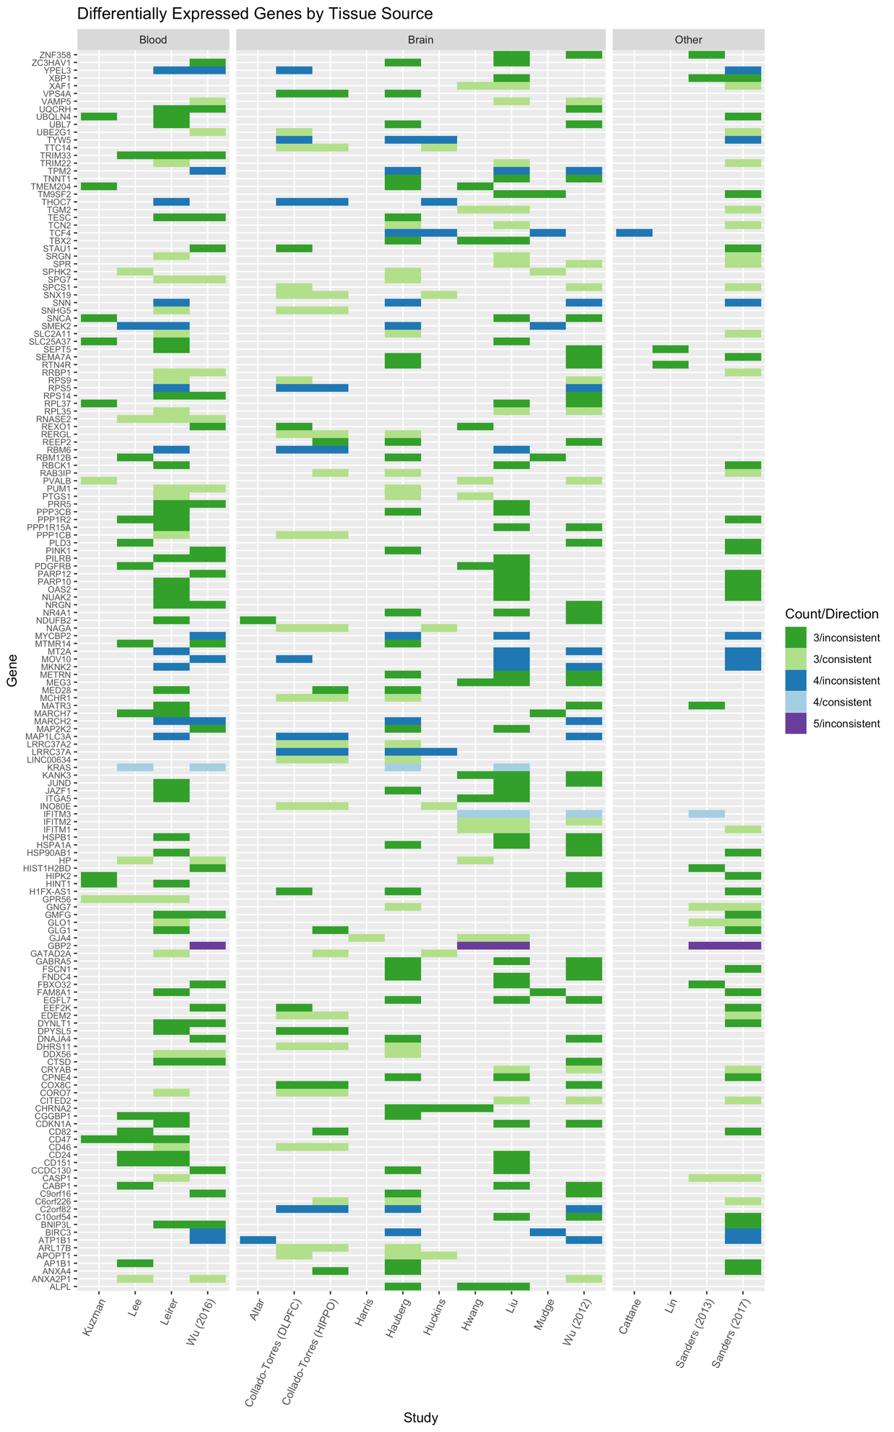
Supplementary Figure 1: Differentially expressed genes by tissue source
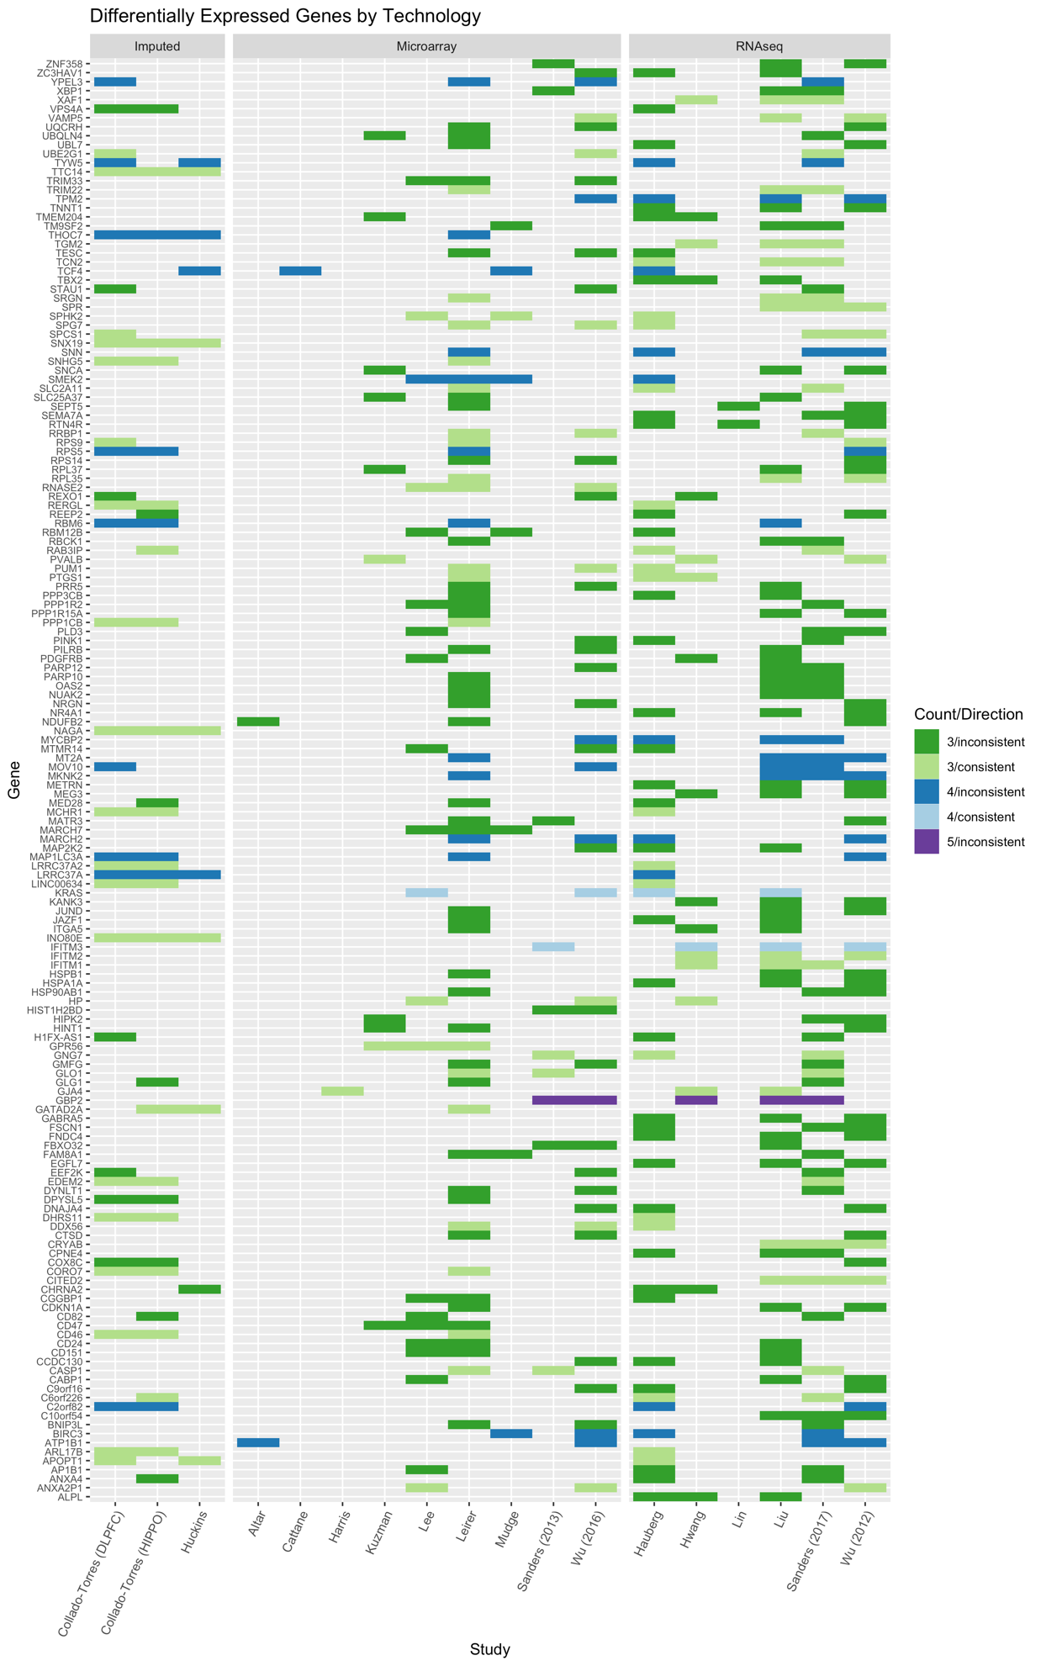
Supplementary Figure 2: Differentially expressed genes by the technology used to quantify gene expression

References
1. Mele M, Ferreira PG, Reverter F, DeLuca DS, Monlong J, Sammeth M et al. Human genomics. The human transcriptome across tissues and individuals. Science 2015; 348(6235): 660-665.

2. Huan T, Joehanes R, Schurmann C, Schramm K, Pilling LC, Peters MJ et al. A whole-blood transcriptome meta-analysis identifies gene expression signatures of cigarette smoking. Hum Mol Genet 2016; 25(21): 4611-4623.

3. Bousman CA, Chana G, Glatt SJ, Chandler SD, Lucero GR, Tatro E et al. Preliminary evidence of ubiquitin proteasome system dysregulation in schizophrenia and bipolar disorder: convergent pathway analysis findings from two independent samples. Am J Med Genet B Neuropsychiatr Genet 2010; 153B(2): 494-502.

4. Chen S, Sun X, Niu W, Kong L, He M, Li W et al. Aberrant Expression of Long Non-Coding RNAs in Schizophrenia Patients. Med Sci Monit 2016; 22: 3340-3351.

5. Gardiner E, Beveridge NJ, Wu JQ, Carr V, Scott RJ, Tooney PA et al. Imprinted DLK1-DIO3 region of 14q32 defines a schizophrenia-associated miRNA signature in peripheral blood mononuclear cells. Mol Psychiatry 2012; 17(8): 827-840.

6. Kuzman MR, Medved V, Terzic J, Krainc D. Genome-wide expression analysis of peripheral blood identifies candidate biomarkers for schizophrenia. J Psychiatr Res 2009; 43(13): 1073-1077.

7. Lee J, Goh LK, Chen G, Verma S, Tan CH, Lee TS. Analysis of blood-based gene expression signature in first-episode psychosis. Psychiatry Res 2012; 200(1): 52-54.

8. Leirer DJ, Iyegbe CO, Di Forti M, Patel H, Carra E, Fraietta S et al. Differential gene expression analysis in blood of first episode psychosis patients. Schizophr Res 2019; 209: 88-97.

9. Wei H, Yuan Y, Liu S, Wang C, Yang F, Lu Z et al. Detection of circulating miRNA levels in schizophrenia. Am J Psychiatry 2015; 172(11): 1141-1147.

10. Wu JQ, Green MJ, Gardiner EJ, Tooney PA, Scott RJ, Carr VJ et al. Altered neural signaling and immune pathways in peripheral blood mononuclear cells of schizophrenia patients with cognitive impairment: A transcriptome analysis. Brain Behav Immun 2016; 53: 194-206.

11. Yu HC, Wu J, Zhang HX, Zhang GL, Sui J, Tong WW et al. Alterations of miR-132 are novel diagnostic biomarkers in peripheral blood of schizophrenia patients. Prog Neuropsychopharmacol Biol Psychiatry 2015; 63: 23-29.

12. Zhang F, Xu Y, Shugart YY, Yue W, Qi G, Yuan G et al. Converging evidence implicates the abnormal microRNA system in schizophrenia. Schizophr Bull 2015; 41(3): 728-735.

13. Altar CA, Jurata LW, Charles V, Lemire A, Liu P, Bukhman Y et al. Deficient hippocampal neuron expression of proteasome, ubiquitin, and mitochondrial genes in multiple schizophrenia cohorts. Biol Psychiatry 2005; 58(2): 85-96.

14. Collado-Torres L, Burke EE, Peterson A, Shin J, Straub RE, Rajpurohit A et al. Regional Heterogeneity in Gene Expression, Regulation, and Coherence in the Frontal Cortex and Hippocampus across Development and Schizophrenia. Neuron 2019; 103(2): 203-216 e208.

15. Harris LW, Wayland M, Lan M, Ryan M, Giger T, Lockstone H et al. The cerebral microvasculature in schizophrenia: a laser capture microdissection study. PLoS One 2008; 3(12): e3964.

16. Hauberg ME, Fullard JF, Zhu L, Cohain AT, Giambartolomei C, Misir R et al. Differential activity of transcribed enhancers in the prefrontal cortex of 537 cases with schizophrenia and controls. Mol Psychiatry 2019; 24(11): 1685-1695.

17. Huckins LM, Dobbyn A, Ruderfer DM, Hoffman G, Wang W, Pardinas AF et al. Gene expression imputation across multiple brain regions provides insights into schizophrenia risk. Nat Genet 2019; 51(4): 659-674.

18. Hwang Y, Kim J, Shin JY, Kim JI, Seo JS, Webster MJ et al. Gene expression profiling by mRNA sequencing reveals increased expression of immune/inflammation-related genes in the hippocampus of individuals with schizophrenia. Transl Psychiatry 2013; 3: e321.

19. Liu Y, Chang X, Hahn CG, Gur RE, Sleiman PAM, Hakonarson H. Non-coding RNA dysregulation in the amygdala region of schizophrenia patients contributes to the pathogenesis of the disease. Transl Psychiatry 2018; 8(1): 44.

20. Mudge J, Miller NA, Khrebtukova I, Lindquist IE, May GD, Huntley JJ et al. Genomic convergence analysis of schizophrenia: mRNA sequencing reveals altered synaptic vesicular transport in post-mortem cerebellum. PLoS One 2008; 3(11): e3625.

21. Schmitt A, Leonardi-Essmann F, Durrenberger PF, Wichert SP, Spanagel R, Arzberger T et al. Structural synaptic elements are differentially regulated in superior temporal cortex of schizophrenia patients. Eur Arch Psychiatry Clin Neurosci 2012; 262(7): 565-577.

22. Sellmann C, Villarin Pildain L, Schmitt A, Leonardi-Essmann F, Durrenberger PF, Spanagel R et al. Gene expression in superior temporal cortex of schizophrenia patients. Eur Arch Psychiatry Clin Neurosci 2014; 264(4): 297-309.

23. Tian T, Wei Z, Chang X, Liu Y, Gur RE, Sleiman PMA et al. The Long Noncoding RNA Landscape in Amygdala Tissues from Schizophrenia Patients. EBioMedicine 2018; 34: 171-181.

24. Wu JQ, Wang X, Beveridge NJ, Tooney PA, Scott RJ, Carr VJ et al. Transcriptome sequencing revealed significant alteration of cortical promoter usage and splicing in schizophrenia. PLoS One 2012; 7(4): e36351.

25. Cattane N, Minelli A, Milanesi E, Maj C, Bignotti S, Bortolomasi M et al. Altered gene expression in schizophrenia: findings from transcriptional signatures in fibroblasts and blood. PLoS One 2015; 10(2): e0116686.

26. Lin M, Pedrosa E, Hrabovsky A, Chen J, Puliafito BR, Gilbert SR et al. Integrative transcriptome network analysis of iPSC-derived neurons from schizophrenia and schizoaffective disorder patients with 22q11.2 deletion. BMC Syst Biol 2016; 10(1): 105.

27. Sanders AR, Drigalenko EI, Duan J, Moy W, Freda J, Goring HHH et al. Transcriptome sequencing study implicates immune-related genes differentially expressed in schizophrenia: new data and a meta-analysis. Transl Psychiatry 2017; 7(4): e1093.

28. Sanders AR, Goring HH, Duan J, Drigalenko EI, Moy W, Freda J et al. Transcriptome study of differential expression in schizophrenia. Hum Mol Genet 2013; 22(24): 5001-5014.

