Supplementary Figure 2
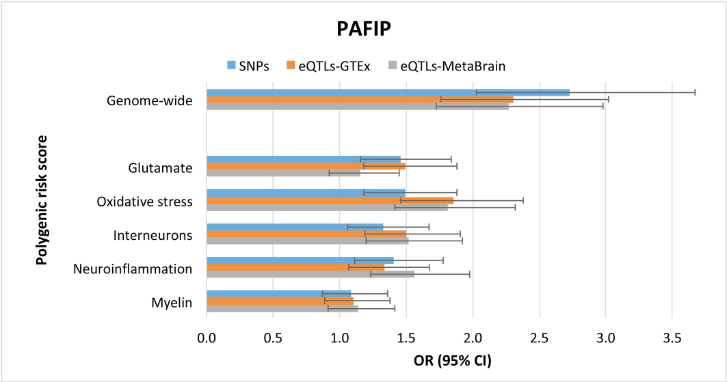

Results for the PAFIP study and polygenic risk scores (GW-PRSs and pathway-PRSs) analyses at pt ≤ 0.05. Early psychosis status (dependent variable) was regressed on the polygenic risk scores using logistic regressions and including the first five ancestry-informative genetic principal components as covariates. Horizontal bars show the Odds Ratio estimates (OR), and error bars indicate 95% confidence intervals (95% CI).

