Supplementary Information
S1 Table. Number of participants with full and missing data on the covariate variables at baseline age 70
S2 Table. Longitudinal cognitive test scores for completers only (N = 431)
S3 Table. Cognitive test scores at 70 years and 82 years by APOE e4 carrier status
S4 Table. Latent growth curve model: unstandardized means and variances for the intercept and slope of each cognitive test (slopes refer to change from age 70 to age 82)
S5 Table. Model fit indices for the latent growth curve models
S6 Table. Sensitivity analysis (N = 1067); predictors of intercepts (age 70) and slopes of change (age 70 to 82) where predictors are entered simultaneously, excluding participants with self-reported dementia (N = 24) at any point across the follow-up period
S7 Table. Sensitivity analysis (N = 1045); predictors of intercepts (age 70) and slopes of change (age 70 to 82) where predictors are entered simultaneously, excluding participants with low MMSE (N = 46) at any point across the follow-up period
S8 Table. Sensitivity analysis (N = 688); predictors of intercepts (age 70) and slopes of change (age 70 to 82) where predictors are entered simultaneously, excluding participants (N = 403) who died at any point across the follow-up period
S9 Table. Path (SEM) model parameters (standardised coefficients (Estimate), standard errors (SE), and P-values)
S1 Figure. LBC1936 recruitment and attrition flowchart. Flowchart showing waves of testing and attrition between waves in the LBC1936 study. Deaths were ascertained using linkage data obtained via the National Health Service Central Register up to April 2021, provided by the National Records of Scotland. Number of deaths (N = 403) is correct at the time of analysis, i.e. after wave 5 assessment, and therefore include deaths among the completers and non-completers.
S2 Figure. Path (SEM) diagram. Path (SEM) diagram including variables from early-life (age 11 IQ, education, APOE e4), mid-life (adult SES) and older age (smoking, alcohol, physical activity, BMI, depressive symptoms, CVD, diabetes, stroke). Age and sex were included in the path model but not shown to reduce visual clutter. All model predictors were regressed on a latent variable of general cognitive function (g) intercept and slope, estimated within the model. Single-headed arrows represent regression pathways. Double-headed arrows represent covariances.
S3 Figure. Raw data regression plots for each cognitive test. Plots of fitted (non-linear) regression lines through the raw data using ‘loess’ smoothing (ggplot2 in R), normalised for baseline score, to illustrate the differences in trajectories of cognitive change with age by APOEe4 carrier status (with shaded 95% confidence intervals). The black line is the regression line for the full sample. Red = non-carrier, blue = carrier.

S1 Table. Number of participants with full and missing data on the covariate variables at baseline age 70
 | Overall  (N = 1,091) | Missing
Characteristic | N | N
Age, yrs | 1091 | 0
Education, yrs | 1091 | 0
Age 11 IQ | 1028 | 63
Adult SES | 1070 | 21
Physical activity | 961 | 130
Body mass index | 1089 | 2
Alcohol intake, units | 1091 | 0
Depressive symptoms | 1085 | 5
Female | 1091 | 0
Lives alone | 1079 | 12
Current smoker | 1091 | 0
APOE e4 carrier | 1028 | 63
CVD | 1091 | 0
Diabetes | 1091 | 0
Stroke | 1091 | 0

S2 Table. Longitudinal cognitive test scores for completers only (N = 431)
 | 70 years |  | 73 years |  | 76 years |  | 79 years |  | 82 years
Cognitive test | N | M (SD) | N | M (SD) | N | M (SD) | N | M (SD) | N | M (SD)
Block Design | 429 | 36.0 (10.0) | 430 | 35.3 (10.3) | 423 | 33.5 (9.9) | 415 | 32.5 (9.5) | 420 | 29.9 (9.6)
Matrix Reasoning | 430 | 14.7 (5.0) | 430 | 14.2 (4.9) | 423 | 13.8 (4.9) | 419 | 13.4 (5.0) | 418 | 12.9 (5.2)
Spatial Span | 428 | 7.6 (1.4) | 428 | 7.5 (1.3) | 421 | 7.5 (1.4) | 419 | 7.2 (1.4) | 421 | 6.9 (1.4)
Digit-symbol Coding | 429 | 60.0 (12.0) | 429 | 59.7 (11.6) | 418 | 57.1 (11.8) | 412 | 53.4 (12.0) | 418 | 51.0 (12.8)
Symbol Search | 430 | 25.9 (6.6) | 429 | 25.9 (5.8) | 421 | 25.9 (6.1) | 414 | 23.6 (6.2) | 415 | 22.2 (6.9)
Choice Reaction Time (secs) | 430 | 0.622 (0.076) | 430 | 0.633 (0.077) | 420 | 0.663 (0.049) | 419 | 0.691 (0.10) | 423 | 0.722 (0.120)
Inspection Time | 423 | 114.1 (10.0) | 425 | 112.8 (11.5) | 411 | 111.5 (11.7) | 375 | 108.7 (11.8) | 382 | 106.0 (12.7)
Logical Memory | 431 | 74.6 (17.2) | 431 | 76.9 (17.0) | 423 | 77.1 (17.2) | 419 | 75.7 (18.2) | 421 | 72.1 (21.5)
Verbal Pairs | 423 | 28.2 (8.3) | 423 | 28.8 (8.8) | 408 | 28.0 (8.8) | 397 | 28.2 (9.0) | 380 | 27.4 (9.5)
Digits Backwards | 431 | 8.1 (2.4) | 431 | 8.2 (2.3) | 425 | 8.1 (2.4) | 422 | 7.7 (2.2) | 426 | 7.2 (2.3)
NART | 430 | 35.7 (7.8) | 429 | 35.3 (7.7) | 425 | 35.9 (7.7) | 420 | 36.0 (8.0) | 426 | 36.0 (7.8)
WTAR | 430 | 42.2 (6.7) | 429 | 42.0 (6.4) | 425 | 41.8 (6.7) | 420 | 42.0 (6.7) | 426 | 42.2 (6.6)
Verbal Fluency | 431 | 43.6 (12.5) | 431 | 44.5 (12.3) | 425 | 44.0 (12.2) | 420 | 44.9 (12.4) | 426 | 44.6 (12.7)
Note: NART, National Adult Reading Test; WTAR, Wechsler Test of Adult Reading
All tests are positively scored (i.e. higher scores = better performance) with the exception of Choice Reaction Time (in seconds) which is negatively scored (i.e. higher scores = slower performance).

S3 Table. Cognitive test scores at 70 years and 82 years by APOE e4 carrier status
 | 70 years |  |  |  |  |  | 82 years
 | APOE e4 carrier  (N = 306) |  | APOE e4 non-carrier  (N = 722) |  |  |  | APOE e4 carrier  (N = 113) |  | APOE e4 non-carrier  (N = 295)
Cognitive test | N | M (SD) | N | M (SD) | P-value | Cohens d | N | M (SD) | N | M (SD) | P-value | Cohen’s d
Block Design | 304 | 33.1 (10.4) | 719 | 34.0 (10.2) | 0.22 | 0.087 | 111 | 27.7 (9.5) | 286 | 30.4 (9.6) | 0.010 | 0.283
Matrix Reasoning | 304 | 12.9 (5.0) | 720 | 13.7 (5.1) | 0.02 | 0.158 | 110 | 11.4 (5.0) | 286 | 13.5 (5.2) | 0.001 | 0.411
Spatial Span | 303 | 7.2 (1.4) | 719 | 7.4 (1.4) | 0.03 | 0.143 | 111 | 6.7 (1.5) | 287 | 7.0 (1.4) | 0.02 | 0.207
Digit-symbol Coding | 306 | 55.7 (12.6) | 717 | 57.0 (13.1) | 0.14 | 0.101 | 112 | 47.7 (13.1) | 284 | 52.2 (12.5) | 0.001 | 0.351
Symbol Search | 305 | 23.9 (6.8) | 719 | 25.1 (6.2) | 0.08 | 0.184 | 110 | 20.2 (7.6) | 283 | 22.9 (6.6) | 0.001 | 0.379
Choice Reaction Time | 305 | 0.647 (0.088) | 717 | 0.642 (0.086) | 0.35 | 0.057 | 110 | 0.753 (0.138) | 290 | 0.715 (0.113) | 0.004 | 0.301
Inspection Time | 291 | 110.9 (12.1) | 692 | 112.6 (10.5) | 0.03 | 0.150 | 94 | 104.5 (13.2) | 266 | 106.9 (12.4) | 0.07 | 0.187
Logical Memory | 306 | 70.4 (18.1) | 720 | 71.8 (17.9) | 0.25 | 0.078 | 112 | 66.1 (24.6) | 287 | 74.5 (20.2) | 0.001 | 0.387
Verbal Pairs | 290 | 26.2 (8.8) | 700 | 26.4 (9.3) | 0.83 | 0.022 | 98 | 24.7 (10.5) | 260 | 28.4 (9.1) | 0.001 | 0.377
Digits Backwards | 306 | 7.6 (2.1) | 721 | 7.8 (2.3) | 0.45 | 0.091 | 113 | 6.8 (2.3) | 290 | 7.3 (2.3) | 0.03 | 0.217
NART | 306 | 34.5 (8.6) | 720 | 34.4 (8.1) | 0.79 | 0.012 | 111 | 35.4 (8.8) | 292 | 36.2 (7.5) | 0.39 | 0.098
WTAR | 306 | 40.8 (7.5) | 720 | 41.0 (7.1) | 0.66 | 0.027 | 111 | 41.5 (7.7) | 292 | 42.5 (6.2) | 0.19 | 0.143
Verbal Fluency | 305 | 42.8 (12.4) | 719 | 42.4 (12.6) | 0.61 | 0.032 | 110 | 43.2 (12.6) | 293 | 43.8 (12.7) | 0.74 | 0.047
Note: NART, National Adult Reading Test; WTAR, Wechsler Test of Adult Reading
All tests are positively scored (i.e. higher scores = better performance) with the exception of Choice Reaction Time which is negatively scored (i.e. higher scores = slower performance).
Note: P-values obtained from one-way ANOVA

S4 Table. Latent growth curve model: unstandardized means and variances for the intercept and slope of each cognitive test (slopes refer to change from age 70 to age 82)
 |  | Intercepts |  | Slopes |  | SD change in each test
Cognitive domain | Cognitive test | Mean (SE) | Variance (SE) | Mean (SE) | Variance (SE) | SD change/yr | Rank order of SD change
Visuospatial | Matrix Reasoning | 13.442 (0.146)*** | 17.001 (1.050) | -0.158 (0.014)*** | 0.024 (0.009) | -0.038 | 7
 | Block Design | 34.107 (0.306)*** | 84.482 (4.441) | -0.510 (0.025)*** | 0.142 (0.028) | -0.055 | 5
 | Spatial Span | 7.410 (0.040)*** | 1.114 (0.079) | -0.056 (0.004)*** | 0.001 (0.001) | -0.053 | 6
Processing speed | Symbol Search | 25.090 (0.184)*** | 26.824 (1.619) | -0.372 (0.020)*** | 0.093 (0.016) | -0.072 | 4
 | Digit-Symbol Coding | 57.336 (0.386)*** | 140.788 (6.925) | -0.901 (0.034)*** | 0.453 (0.047) | -0.076 | 3
 | Choice Reaction Time | -6.372 (0.026)*** | 0.569 (0.032) | -0.091 (0.003)*** | 0.004 (0.000) | -0.120 | 1
 | Inspection Time | 112.403 (0.329)*** | 76.675 (5.324) | -0.792 (0.044)*** | 0.392 (0.081) | -0.090 | 2
Memory | Logical Memory | 72.918 (0.535)*** | 236.560 (13.479) | -0.413 (0.069)*** | 1.983 (0.188) | -0.027 | 10
 | Verbal Paired Associates | 26.600 (0.276)*** | 65.336 (3.700) | -0.263 (0.032)*** | 0.363 (0.041) | -0.033 | 9
 | Digit Span Backwards | 7.839 (0.066)*** | 3.376 (0.208) | -0.070 (0.006)*** | 0.002 (0.002) | -0.038 | 8
Verbal ability | NART | 34.301 (0.246)*** | 62.450 (2.811) | 0.001 (0.011) | 0.018 (0.005) | 0.0001 | 13
 | WTAR | 40.892 (0.213)*** | 46.994 (2.133) | -0.024 (0.009)* | 0.011 (0.003) | -0.004 | 12
 | Verbal Fluency | 42.656 (0.374)*** | 131.548 (6.609) | -0.116 (0.031)*** | 0.267 (0.041) | -0.010 | 11
Note: SE, standard error; NART, National Adult Reading Test; WTAR, Wechsler Test of Adult Reading; CFI, Comparative Fit Index; TLI, Tucker-Lewis Index; RMSEA, Root Mean Square Error of
Approximation
All values from the baseline multivariate model in which all levels and slope covariances were freely estimated
Choice Reaction Time was multiplied by -10 so that higher scores indicated better performance
Path weights for calculation of the slope factor: Baseline=0; to w2=2.98; to w3=6.75; to w4=9.81; to w5=12.53
SD change/yr is the slope mean divided by the intercept standard deviation; rank order of SD change is from highest (1=most change) to lowest (13=least change)
*p < 0.05; **p < 0.01; ***p < 0.001

S5 Table. Model fit indices for the latent growth curve models
Table | Model type | TLI | CFI | RMSEA
Table 3
Cognitive tests model | Unadjusted | 0.969 | 0.963 | 0.027
Table 4
Visuospatial | Unadjusted | 0.990 | 0.989 | 0.025
Processing speed | Unadjusted | 0.954 | 0.952 | 0.050
Memory | Unadjusted | 0.958 | 0.955 | 0.053
Verbal ability | Unadjusted | 0.988 | 0.988 | 0.042
General cognitive function | Unadjusted | 0.949 | 0.948 | 0.032
Table 5
Visuospatial | Fully adjusted | 0.989 | 0.977 | 0.022
Processing speed | Fully adjusted | 0.937 | 0.932 | 0.038
Memory | Fully adjusted | 0.942 | 0.935 | 0.037
Verbal ability | Fully adjusted | 0.989 | 0.988 | 0.025
General cognitive function | Fully adjusted | 0.937 | 0.936 | 0.030
Note: CFI, Comparative Fit Index; TLI, Tucker-Lewis Index; RMSEA, Root Mean Square Error of Approximation.

S6 Table. Sensitivity analysis (N = 1067); predictors of intercepts (age 70) and slopes of change (age 70 to 82) where predictors are entered simultaneously, excluding participants with self-reported dementia (N = 24) at any point across the follow-up period
Growth parameters | Visuospatial ability |  | Processing speed |  | Memory |  | Verbal ability |  | General cognitive function
 | Estimate (SE) | P values | Estimate (SE) | P values | Estimate (SE) | P values | Estimate (SE) | P values | Estimate (SE) | P values
Intercept on
Age— | -0.109 (0.027) | <0.001 | -0.151 (0.027) | <0.001 | -0.157 (0.031) | <0.001 | -0.088 (0.020) | <0.001 | -0.138 (0.021) | <0.001
Sex | -0.266 (0.029) | <0.001 | -0.028 (0.031) | 0.37 | 0.125 (0.034) | <0.001 | 0.002 (0.022) | 0.93 | -0.046 (0.024) | 0.05
Age 11 IQ⁺ | 0.490 (0.028) | <0.001 | 0.440 (0.030) | <0.001 | 0.560 (0.033) | <0.001 | 0.572 (0.020) | <0.001 | 0.670 (0.020) | <0.001
Education⁺ | 0.110 (0.032) | 0.001 | 0.037 (0.033) | 0.26 | 0.154 (0.036) | <0.001 | 0.235 (0.023) | <0.001 | 0.195 (0.025) | <0.001
Adult SES— | -0.127 (0.032) | <0.001 | -0.136 (0.033) | <0.001 | 0.019 (0.036) | 0.61 | -0.113 (0.024) | <0.001 | -0.122 (0.025) | <0.001
Lives alone— | 0.029 (0.028) | 0.30 | -0.005 (0.028) | 0.87 | 0.028 (0.032) | 0.37 | -0.033 (0.021) | 0.12 | -0.007 (0.022) | 0.76
Smoking category— | -0.067 (0.028) | 0.02 | -0.098 (0.028) | 0.001 | 0.003 (0.032) | 0.93 | 0.034 (0.021) | 0.10 | -0.025 (0.022) | 0.25
Physical activity⁺ | 0.043 (0.030) | 0.16 | 0.076 (0.032) | 0.02 | 0.041 (0.035) | 0.24 | -0.009 (0.023) | 0.70 | 0.033 (0.024) | 0.18
Body mass index— | 0.079 (0.029) | 0.005 | 0.049 (0.029) | 0.09 | 0.063 (0.032) | 0.049 | -0.056 (0.021) | 0.008 | 0.010 (0.022) | 0.66
Alcohol units, week⁺ | -0.004 (0.029) | 0.88 | -0.021 (0.029) | 0.48 | 0.034 (0.033) | 0.30 | -0.021 (0.021) | 0.34 | -0.016 (0.022) | 0.48
APOE e4— | -0.095 (0.028) | 0.001 | -0.091 (0.028) | 0.001 | -0.019 (0.031) | 0.56 | 0.004 (0.021) | 0.84 | -0.045 (0.022) | 0.04
Depressive symptoms— | -0.059 (0.028) | 0.03 | -0.106 (0.029) | <0.001 | -0.068 (0.032) | 0.03 | -0.022 (0.021) | 0.28 | -0.067 (0.021) | 0.002
CVD— | -0.035 (0.028) | 0.20 | -0.078 (0.028) | 0.006 | 0.051 (0.031) | 0.11 | 0.024 (0.022) | 0.24 | 0.001 (0.021) | 0.96
Diabetes— | -0.062 (0.028) | 0.03 | -0.065 (0.028) | 0.02 | 0.010 (0.032) | 0.76 | -0.048 (0.021) | 0.02 | -0.053 (0.021) | 0.01
Stroke— | -0.022 (0.028) | 0.42 | -0.073 (0.028) | 0.009 | 0.049 (0.031) | 0.12 | 0.027 (0.021) | 0.18 | 0.002 (0.021) | 0.94
Slope on
Age— | 0.100 (0.074) | 0.15 | 0.055 (0.070) | 0.43 | 0.028 (0.046) | 0.54 | 0.288 (0.071) | <0.001 | 0.071 (0.043) | 0.10
Sex | 0.055 (0.069) | 0.43 | 0.134 (0.057) | 0.02 | 0.052 (0.050) | 0.30 | 0.102 (0.068) | 0.13 | 0.089 (0.047) | 0.06
Age 11 IQ⁺ | -0.298 (0.125) | 0.02 | -0.028 (0.070) | 0.69 | -0.020 (0.053) | 0.70 | 0.106 (0.071) | 0.14 | -0.053 (0.049) | 0.28
Education⁺ | -0.106 (0.079) | 0.18 | 0.019 (0.070) | 0.78 | -0.026 (0.053) | 0.62 | -0.167 (0.075) | 0.03 | -0.055 (0.050) | 0.27
Adult SES— | -0.067 (0.078) | 0.39 | 0.043 (0.070) | 0.54 | -0.050 (0.053) | 0.44 | -0.018 (0.073) | 0.81 | -0.004 (0.050) | 0.93
Lives alone— | -0.093 (0.071) | 0.19 | -0.017 (0.050) | 0.74 | -0.040 (0.047) | 0.40 | 0.043 (0.064) | 0.49 | -0.011 (0.044) | 0.80
Smoking category— | -0.138 (0.083) | 0.10 | 0.021 (0.053) | 0.69 | 0.043 (0.051) | 0.40 | -0.202 (0.074) | 0.006 | -0.029 (0.047) | 0.55
Physical activity⁺ | 0.044 (0.077) | 0.57 | 0.041 (0.080) | 0.61 | 0.007 (0.052) | 0.90 | 0.055 (0.076) | 0.47 | 0.078 (0.049) | 0.11
Body mass index— | -0.058 (0.071) | 0.42 | -0.058 (0.070) | 0.41 | -0.014 (0.049) | 0.78 | 0.012 (0.065) | 0.85 | -0.021 (0.045) | 0.65
Alcohol units, week⁺ | -0.151 (0.091) | 0.10 | 0.022 (0.071) | 0.75 | -0.067 (0.052) | 0.20 | 0.033 (0.073) | 0.66 | -0.023 (0.048) | 0.64
APOE e4— | -0.091 (0.072) | 0.21 | -0.183 (0.054) | 0.001 | -0.196 (0.046) | <0.001 | -0.032 (0.063) | 0.61 | -0.218 (0.042) | <0.001
Depressive symptoms— | -0.108 (0.074) | 0.14 | -0.078 (0.070) | 0.26 | 0.005 (0.048) | 0.91 | -0.087 (0.064) | 0.18 | -0.083 (0.044) | 0.06
CVD— | -0.034 (0.064) | 0.59 | -0.023 (0.049) | 0.64 | 0.009 (0.048) | 0.84 | -0.053 (0.065) | 0.41 | -0.035 (0.044) | 0.44
Diabetes— | -0.005 (0.071) | 0.95 | -0.045 (0.054) | 0.40 | -0.082 (0.052) | 0.19 | 0.022 (0.074) | 0.77 | -0.046 (0.048) | 0.34
Stroke— | -0.021 (0.072) | 0.77 | 0.088 (0.055) | 0.11 | 0.038 (0.053) | 0.47 | -0.081 (0.073) | 0.27 | 0.053 (0.049) | 0.27
Note: SE, standard error; SES, socio-economic status; CVD, cardiovascular disease
Model estimates are fully standardised
Path weights for calculation of the slope factor: Baseline=0; to w2=2.98; to w3=6.75; to w4=9.81; to w5=12.53
Models were run separately for each domain; general cognitive function is based on the intercepts and slopes of the four cognitive domains
Boldtype indicates statistical significance following FDR (false discovery rate) correction

S7 Table. Sensitivity analysis (N = 1045); predictors of intercepts (age 70) and slopes of change (age 70 to 82) where predictors are entered simultaneously, excluding participants with low MMSE (N = 46) at any point across the follow-up period
Growth parameters | Visuospatial ability |  | Processing speed |  | Memory |  | Verbal ability |  | General cognitive function
 | Estimate (SE) | P values | Estimate (SE) | P values | Estimate (SE) | P values | Estimate (SE) | P values | Estimate (SE) | P values
Intercept on
Age— | -0.105 (0.028) | <0.001 | -0.149 (0.028) | <0.001 | -0.152 (0.031) | <0.001 | -0.089 (0.021) | <0.001 | -0.134 (0.021) | <0.001
Sex | -0.270 (0.030) | <0.001 | -0.035 (0.032) | 0.27 | 0.119 (0.035) | 0.001 | -0.005 (0.023) | 0.83 | -0.053 (0.024) | 0.03
Age 11 IQ⁺ | 0.481 (0.029) | <0.001 | 0.428 (0.030) | <0.001 | 0.560 (0.034) | <0.001 | 0.553 (0.021) | <0.001 | 0.660 (0.020) | <0.001
Education⁺ | 0.118 (0.033) | <0.001 | 0.041 (0.033) | 0.22 | 0.166 (0.037) | <0.001 | 0.246 (0.024) | <0.001 | 0.208 (0.025) | <0.001
Adult SES— | -0.111 (0.032) | 0.001 | -0.129 (0.033) | <0.001 | 0.028 (0.037) | 0.44 | -0.118 (0.024) | <0.001 | -0.120 (0.025) | <0.001
Lives alone— | 0.037 (0.029) | 0.20 | -0.002 (0.029) | 0.94 | 0.034 (0.032) | 0.30 | -0.038 (0.022) | 0.08 | -0.006 (0.022) | 0.78
Smoking category— | -0.071 (0.029) | 0.01 | -0.112 (0.029) | <0.001 | -0.002 (0.032) | 0.95 | 0.029 (0.021) | 0.18 | -0.034 (0.022) | 0.12
Physical activity⁺ | 0.050 (0.031) | 0.11 | 0.084 (0.032) | 0.008 | 0.063 (0.035) | 0.74 | 0.003 (0.024) | 0.90 | 0.051 (0.024) | 0.04
Body mass index— | 0.091 (0.029) | 0.002 | 0.052 (0.030) | 0.08 | 0.075 (0.033) | 0.02 | -0.051 (0.022) | 0.02 | 0.018 (0.023) | 0.44
Alcohol units, week⁺ | -0.004 (0.029) | 0.89 | -0.022 (0.030) | 0.46 | 0.032 (0.034) | 0.34 | -0.018 (0.022) | 0.41 | -0.016 (0.023) | 0.47
APOE e4— | -0.104 (0.029) | <0.001 | -0.107 (0.029) | <0.001 | -0.035 (0.033) | 0.28 | 0.006 (0.022) | 0.79 | -0.057 (0.022) | 0.011
Depressive symptoms— | -0.061 (0.029) | 0.03 | -0.115 (0.029) | <0.001 | -0.066 (0.032) | 0.04 | -0.017 (0.021) | 0.42 | -0.069 (0.022) | 0.002
CVD— | -0.029 (0.029) | 0.31 | -0.071 (0.029) | 0.01 | 0.051 (0.032) | 0.11 | -0.017 (0.021) | 0.42 | 0.000 (0.022) | 0.99
Diabetes— | -0.060 (0.029) | 0.04 | -0.061 (0.029) | 0.04 | 0.012 (0.032) | 0.72 | -0.043 (0.021) | 0.04 | -0.050 (0.022) | 0.02
Stroke— | -0.026 (0.028) | 0.36 | -0.079 (0.029) | 0.006 | 0.043 (0.032) | 0.18 | 0.026 (0.021) | 0.22 | -0.005 (0.022) | 0.81
Slope on
Age— | 0.119 (0.069) | 0.09 | 0.051 (0.065) | 0.43 | 0.038 (0.047) | 0.42 | 0.328 (0.081) | <0.001 | 0.053 (0.044) | 0.22
Sex | 0.022 (0.072) | 0.76 | 0.081 (0.056) | 0.15 | 0.033 (0.051) | 0.52 | 0.078 (0.072) | 0.28 | 0.042 (0.048) | 0.38
Age 11 IQ⁺ | -0.312 (0.097) | 0.001 | -0.039 (0.065) | 0.55 | -0.046 (0.053) | 0.39 | 0.099 (0.074) | 0.18 | -0.076 (0.050) | 0.12
Education⁺ | -0.114 (0.079) | 0.15 | 0.032 (0.065) | 0.63 | -0.016 (0.053) | 0.76 | -0.143 (0.078) | 0.07 | -0.043 (0.050) | 0.39
Adult SES— | -0.079 (0.077) | 0.30 | 0.043 (0.065) | 0.51 | -0.024 (0.053) | 0.65 | -0.017 (0.073) | 0.81 | -0.020 (0.049) | 0.69
Lives alone— | -0.119 (0.072) | 0.10 | -0.032 (0.052) | 0.54 | -0.027 (0.048) | 0.57 | 0.033 (0.067) | 0.62 | -0.022 (0.045) | 0.63
Smoking category— | -0.139 (0.080) | 0.08 | 0.031 (0.065) | 0.63 | 0.046 (0.052) | 0.37 | -0.165 (0.078) | 0.03 | -0.012 (0.048) | 0.80
Physical activity⁺ | 0.015 (0.072) | 0.83 | -0.010 (0.065) | 0.87 | -0.006 (0.053) | 0.90 | 0.035 (0.074) | 0.64 | 0.033 (0.049) | 0.50
Body mass index— | -0.088 (0.074) | 0.24 | -0.070 (0.065) | 0.29 | -0.014 (0.049) | 0.78 | 0.012 (0.069) | 0.87 | -0.031 (0.046) | 0.50
Alcohol units, week⁺ | -0.164 (0.083) | 0.049 | 0.010 (0.067) | 0.88 | -0.065 (0.053) | 0.22 | 0.020 (0.077) | 0.80 | -0.029 (0.049) | 0.55
APOE e4— | -0.103 (0.070) | 0.14 | -0.176 (0.053) | 0.001 | -0.192 (0.047) | <0.001 | -0.023 (0.066) | 0.73 | -0.216 (0.043) | <0.001
Depressive symptoms— | -0.129 (0.072) | 0.07 | -0.072 (0.066) | 0.27 | 0.011 (0.048) | 0.83 | -0.112 (0.069) | 0.10 | -0.083 (0.045) | 0.07
CVD— | -0.086 (0.070) | 0.22 | -0.074 (0.050) | 0.14 | 0.002 (0.048) | 0.96 | -0.069 (0.068) | 0.31 | -0.076 (0.045) | 0.09
Diabetes— | -0.017 (0.077) | 0.83 | -0.085 (0.055) | 0.12 | -0.084 (0.053) | 0.11 | 0.029 (0.077) | 0.71 | -0.075 (0.044) | 0.12
Stroke— | -0.018 (0.078) | 0.82 | 0.096 (0.055) | 0.08 | 0.040 (0.054) | 0.46 | -0.115 (0.078) | 0.14 | 0.061 (0.049) | 0.22
Note: SE, standard error; SES, socio-economic status; CVD, cardiovascular disease
Model estimates are fully standardised.
Path weights for calculation of the slope factor: Baseline=0; to w2=2.98; to w3=6.75; to w4=9.81; to w5=12.53
Models were run separately for each domain; general cognitive function is based on the intercepts and slopes of the four cognitive domains
Boldtype indicates statistical significance following FDR (false discovery rate) correction

S8 Table. Sensitivity analysis (N = 688); predictors of intercepts (age 70) and slopes of change (age 70 to 82) where predictors are entered simultaneously, excluding participants (N = 403) who died at any point across the follow-up period
Growth parameters | Visuospatial ability |  | Processing speed |  | Memory |  | Verbal ability |  | General cognitive function
 | Estimate (SE) | P values | Estimate (SE) | P values | Estimate (SE) | P values | Estimate (SE) | P values | Estimate (SE) | P values
Intercept on
Age— | -0.099 (0.033) | 0.003 | -0.176 (0.035) | <0.001 | -0.109 (0.038) | 0.004 | -0.063 (0.025) | 0.011 | -0.108 (0.025) | <0.001
Sex | -0.272 (0.035) | <0.001 | -0.082 (0.039) | 0.035 | 0.116 (0.041) | 0.005 | -0.025 (0.027) | 0.35 | -0.064 (0.028) | 0.02
Age 11 IQ⁺ | 0.496 (0.034) | <0.001 | 0.456 (0.038) | <0.001 | 0.600 (0.040) | <0.001 | 0.571 (0.025) | <0.001 | 0.679 (0.024) | <0.001
Education⁺ | 0.160 (0.039) | 0.001 | 0.050 (0.043) | 0.24 | 0.197 (0.045) | <0.001 | 0.258 (0.029) | <0.001 | 0.233 (0.030) | <0.001
Adult SES— | -0.122 (0.039) | 0.002 | -0.119 (0.042) | 0.004 | 0.037 (0.045) | 0.42 | -0.098 (0.030) | 0.001 | -0.101 (0.030) | 0.001
Lives alone— | -0.012 (0.034) | 0.73 | -0.069 (0.036) | 0.05 | 0.010 (0.039) | 0.79 | -0.053 (0.026) | 0.04 | -0.045 (0.026) | 0.08
Smoking category— | -0.040 (0.034) | 0.24 | -0.088 (0.036) | 0.015 | 0.051 (0.039) | 0.19 | 0.046 (0.025) | 0.07 | -0.001 (0.026) | 0.97
Physical activity⁺ | -0.006 (0.036) | 0.87 | 0.075 (0.039) | 0.05 | 0.058 (0.041) | 0.16 | -0.008 (0.0238 | 0.77 | 0.021 (0.028) | 0.44
Body mass index— | 0.084 (0.034) | 0.01 | 0.055 (0.037) | 0.14 | 0.012 (0.039) | 0.76 | -0.077 (0.026) | 0.003 | -0.013 (0.026) | 0.61
Alcohol units, week⁺ | 0.018 (0.036) | 0.61 | -0.005 (0.038) | 0.90 | 0.019 (0.041) | 0.64 | -0.017 (0.027) | 0.52 | -0.003 (0.027) | 0.91
APOE e4— | -0.071 (0.034) | 0.04 | -0.056 (0.036) | 0.13 | -0.043 (0.038) | 0.47 | -0.009 (0.026) | 0.72 | -0.024 (0.026) | 0.35
Depressive symptoms— | -0.056 (0.034) | 0.10 | -0.064 (0.037) | 0.08 | -0.062 (0.038) | 0.11 | -0.053 (0.025) | 0.04 | -0.070 (0.026) | 0.006
CVD— | -0.020 (0.033) | 0.54 | -0.046 (0.036) | 0.20 | 0.074 (0.038) | 0.05 | 0.013 (0.025) | 0.60 | 0.013 (0.026) | 0.61
Diabetes— | -0.043 (0.034) | 0.20 | -0.101 (0.036) | 0.005 | 0.010 (0.039) | 0.81 | -0.036 (0.025) | 0.16 | -0.049 (0.026) | 0.05
Stroke— | -0.063 (0.033) | 0.06 | -0.065 (0.036) | 0.07 | 0.022 (0.038) | 0.57 | 0.018 (0.025) | 0.14 | -0.017 (0.025) | 0.51
Slope on
Age— | 0.077 (0.066) | 0.25 | 0.029 (0.092) | 0.75 | -0.054 (0.052) | 0.30 | 0.312 (0.148) | 0.002 | -0.012 (0.050) | 0.81
Sex | 0.016 (0.065) | 0.81 | 0.039 (0.063) | 0.54 | 0.005 (0.056) | 0.93 | 0.121 (0.101) | 0.18 | -0.005 (0.054) | 0.92
Age 11 IQ⁺ | -0.320 (0.126) | 0.011 | -0.021 (0.093) | 0.82 | -0.049 (0.060) | 0.42 | 0.107 (0.105) | 0.25 | -0.076 (0.058) | 0.19
Education⁺ | -0.143 (0.085) | 0.09 | -0.039 (0.093) | 0.68 | -0.006 (0.060) | 0.92 | -0.203 (0.131) | 0.04 | -0.088 (0.059) | 0.13
Adult SES— | -0.092 (0.079) | 0.26 | -0.032 (0.089) | 0.72 | -0.047 (0.060) | 0.43 | 0.044 (0.098) | 0.64 | -0.037 (0.058) | 0.52
Lives alone— | -0.064 (0.065) | 0.33 | -0.018 (0.058) | 0.76 | -0.039 (0.052) | 0.46 | 0.061 (0.087) | 0.45 | -0.021 (0.050) | 0.68
Smoking category— | -0.120 (0.076) | 0.11 | -0.007 (0.059) | 0.90 | -0.054 (0.054) | 0.32 | -0.294 (0.146) | 0.002 | -0.068 (0.052) | 0.19
Physical activity⁺ | 0.063 (0.069) | 0.41 | 0.042 (0.099) | 0.67 | -0.031 (0.056) | 0.58 | -0.021 (0.088) | 0.81 | 0.065 (0.053) | 0.22
Body mass index— | -0.064 (0.069) | 0.36 | -0.048 (0.092) | 0.60 | -0.027 (0.054) | 0.61 | 0.035 (0.085) | 0.68 | -0.017 (0.051) | 0.73
Alcohol units, week⁺ | -0.155 (0.083) | 0.06 | 0.005 (0.093) | 0.95 | -0.068 (0.055) | 0.21 | 0.102 (0.096) | 0.26 | -0.055 (0.053) | 0.30
APOE e4— | -0.113 (0.074) | 0.13 | -0.242 (0.070) | <0.001 | -0.232 (0.051) | <0.001 | -0.011 (0.082) | 0.90 | -0.242 (0.048) | <0.001
Depressive symptoms— | -0.071 (0.068) | 0.29 | -0.039 (0.092) | 0.67 | 0.036 (0.052) | 0.49 | -0.084 (0.088) | 0.30 | -0.043 (0.050) | 0.39
CVD— | -0.059 (0.064) | 0.36 | -0.028 (0.056) | 0.61 | 0.057 (0.052) | 0.28 | -0.029 (0.084) | 0.72 | -0.019 (0.051) | 0.70
Diabetes— | -0.016 (0.065) | 0.81 | -0.018 (0.059) | 0.76 | -0.111 (0.056) | 0.045 | 0.154 (0.107) | 0.09 | -0.058 (0.053) | 0.27
Stroke— | 0.007 (0.067) | 0.92 | 0.064 (0.061) | 0.29 | 0.028 (0.057) | 0.62 | -0.105 (0.099) | 0.25 | 0.043 (0.054) | 0.43
Note: SE, standard error; SES, socio-economic status; CVD, cardiovascular disease
Model estimates are fully standardised
Path weights for calculation of the slope factor: Baseline=0; to w2=2.98; to w3=6.75; to w4=9.81; to w5=12.53
Models were run separately for each domain; general cognitive function is based on the intercepts and slopes of the four cognitive domains
Boldtype indicates statistical significance following FDR (false discovery rate) correction

S9 Table. Path (SEM) model parameters (standardised coefficients (Estimate), standard errors (SE), and P-values)
Model paths | General cognitive function
Early-life and mid-life factors | Estimate | SE | P values
Age11 IQ → education | 0.427 | 0.002 | <0.001
Age11 IQ → adult SES | -0.227 | 0.002 | <0.001
Education → adult SES | -0.366 | 0.023 | <0.001
Early- and mid-life factors to g and other predictors
Age11 IQ → g intercept | 0.666 | 0.006 | <0.001
Age11 IQ → g slope | -0.040 | 0.000 | 0.374
Age11 IQ → smoking | -0.035 | 0.002 | 0.320
Age11 IQ → alcohol | 0.073 | 0.031 | 0.028
Age11 IQ → physical activity | 0.014 | 0.003 | 0.704
Age11 IQ → BMI | -0.097 | 0.010 | 0.005
Age11 IQ → depressive symptoms | -0.077 | 0.005 | 0.028
Age11 IQ → CVD | -0.084 | 0.001 | 0.017
Age11 IQ → diabetes | -0.092 | 0.001 | 0.008
Age11 IQ → stroke | 0.006 | 0.001 | 0.876
Education → g intercept | 0.199 | 0.065 | <0.001
Education → g slope | -0.050 | 0.006 | 0.275
Education → smoking | -0.071 | 0.021 | 0.046
Education → alcohol | -0.001 | 0.429 | 0.978
Education → physical activity | 0.079 | 0.037 | 0.037
Education → BMI | -0.036 | 0.136 | 0.314
Education → depressive symptoms | -0.042 | 0.071 | 0.246
Education → CVD | -0.002 | 0.014 | 0.957
Education → diabetes | -0.015 | 0.009 | 0.675
Adult SES → g intercept | -0.117 | 0.079 | <0.001
Adult SES → g slope | -0.028 | 0.007 | 0.546
Adult SES → smoking | 0.050 | 0.026 | 0.156
Adult SES → alcohol | -0.050 | 0.534 | 0.142
Adult SES → physical activity | -0.068 | 0.046 | 0.067
Adult SES → BMI | 0.081 | 0.168 | 0.022
Adult SES → depressive symptoms | 0.034 | 0.088 | 0.342
Adult SES → CVD | -0.044 | 0.017 | 0.216
Adult SES → diabetes | -0.002 | 0.011 | 0.962
Adult SES → stroke | 0.028 | 0.009 | 0.447
APOE e4 → g intercept | -0.055 | 0.136 | 0.011
APOE e4 → g slope | 0.240 | 0.014 | <0.001
APOE e4 → CVD | 0.040 | 0.029 | 0.192
All other predictors to g
Age → g intercept | -0.140 | 0.061 | <0.001
Age → g slope | 0.045 | 0.006 | 0.261
Sex → g intercept | -0.040 | 0.132 | 0.086
Sex → g slope | 0.040 | 0.012 | 0.345
Smoking → g intercept | -0.020 | 0.091 | 0.358
Smoking → g slope | -0.053 | 0.009 | 0.217
Alcohol → g intercept | -0.009 | 0.004 | 0.667
Alcohol → g slope | -0.025 | 0.000 | 0.563
Physical activity → g intercept | 0.032 | 0.061 | 0.169
Physical activity → g slope | 0.073 | 0.006 | 0.105
BMI → g intercept | 0.017 | 0.014 | 0.446
BMI → g slope | -0.047 | 0.001 | 0.262
Depressive symptoms → g intercept | -0.066 | 0.028 | 0.002
Depressive symptoms → g slope | -0.066 | 0.003 | 0.114
CVD → g intercept | -0.005 | 0.141 | 0.803
CVD → g slope | -0.051 | 0.014 | 0.215
Diabetes → g intercept | -0.054 | 0.222 | 0.012
Diabetes → g slope | -0.060 | 0.022 | 0.164
Stroke → g intercept | 0.004 | 0.279 | 0.853
Stroke → g slope | 0.037 | 0.029 | 0.408
Lifestyle and health factors (covariances)
Smoking ↔ alcohol | 0.099 | 0.272 | 0.001
Smoking ↔ physical activity | -0.110 | 0.024 | 0.001
Smoking ↔ BMI | -0.057 | 0.086 | 0.060
Smoking ↔ depressive symptoms | 0.076 | 0.045 | 0.012
Smoking ↔ CVD | 0.048 | 0.009 | 0.114
Smoking ↔ diabetes | 0.027 | 0.006 | 0.379
Smoking ↔ stroke | 0.079 | 0.004 | 0.010
Alcohol ↔ physical activity | 0.014 | 0.474 | 0.663
Alcohol ↔ BMI | -0.015 | 1.739 | 0.611
Alcohol ↔ depressive symptoms | -0.029 | 0.900 | 0.331
Alcohol ↔ CVD | 0.012 | 0.173 | 0.122
Alcohol ↔ diabetes | -0.047 | 0.088 | 0.190
Alcohol ↔ stroke | -0.040 | 0.088 | 0.190
Physical activity ↔ BMI | -0.164 | 0.155 | <0.001
Physical activity ↔ depressive symptoms | -0.170 | 0.080 | <0.001
Physical activity ↔ CVD | -0.108 | 0.015 | 0.001
Physical activity ↔ diabetes | -0.135 | 0.010 | <0.001
Physical activity ↔ stroke | -0.056 | 0.008 | 0.104
BMI ↔ depressive symptoms | 0.092 | 0.289 | 0.002
BMI ↔ CVD | 0.093 | 0.056 | 0.002
BMI ↔ diabetes | 0.163 | 0.036 | <0.001
BMI ↔ stroke | -0.009 | 0.028 | 0.768
Depressive symptoms ↔ CVD | 0.108 | 0.029 | <0.001
Depressive symptoms ↔ diabetes | 0.095 | 0.018 | 0.002
Depressive symptoms ↔ stroke | 0.103 | 0.015 | 0.001
CVD ↔ diabetes | 0.101 | 0.004 | 0.001
CVD ↔ stroke | 0.034 | 0.003 | 0.263
Diabetes ↔ stroke | 0.130 | 0.002 | <0.001
Note: SE, standard error; SES, socio-economic status; g, general cognitive function; CVD, cardiovascular disease
SES is coded negatively, i.e. a lower value denotes a more professional occupational social class
General cognitive function is a latent variable derived from the intercepts and slopes of the four cognitive domains in latent growth curve models
Single-headed arrows represent regression pathways. Double-headed arrows represent covariances. Estimates are standardised beta regression weights

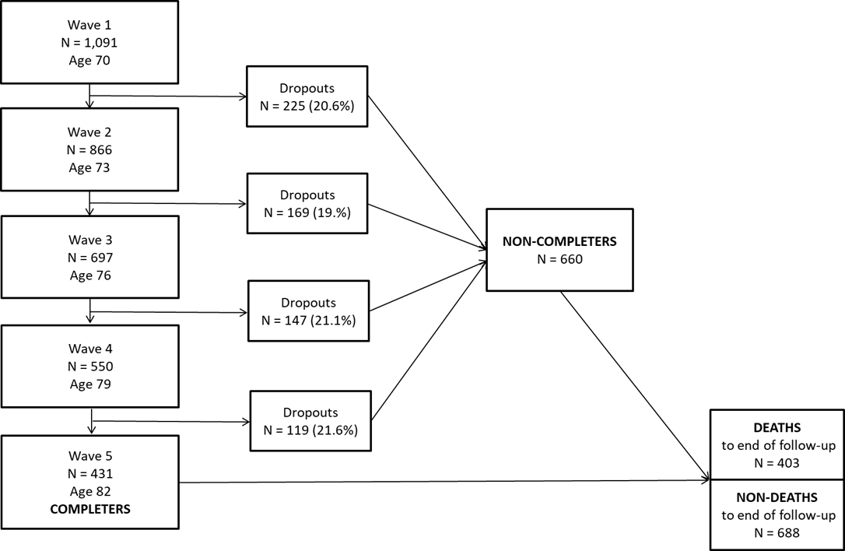

S1 Figure. LBC1936 recruitment and attrition flowchart. Flowchart showing waves of testing and attrition between waves in the LBC1936 study. Deaths were ascertained using linkage data obtained via the National Health Service Central Register up to April 2021, provided by the National Records of Scotland. Number of deaths (N = 403) is correct at the time of analysis, i.e. after wave 5 assessment, and therefore include deaths among the completers and non-completers.

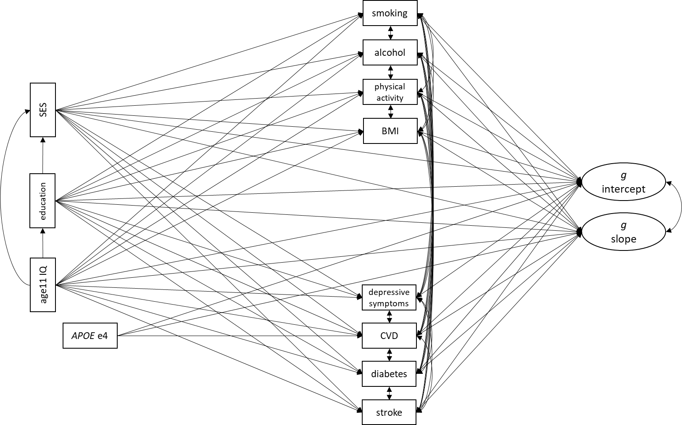
S2 Figure. Path (SEM) diagram. Path (SEM) diagram including variables from early-life (age 11 IQ, education, APOE e4), mid-life (adult SES) and older age (smoking, alcohol, physical activity, BMI, depressive symptoms, CVD, diabetes, stroke). Age and sex were included in the path model but not shown to reduce visual clutter. All model predictors were regressed on a latent variable of general cognitive function (g) intercept and slope, estimated within the model. Single-headed arrows represent regression pathways. Double-headed arrows represent covariances.
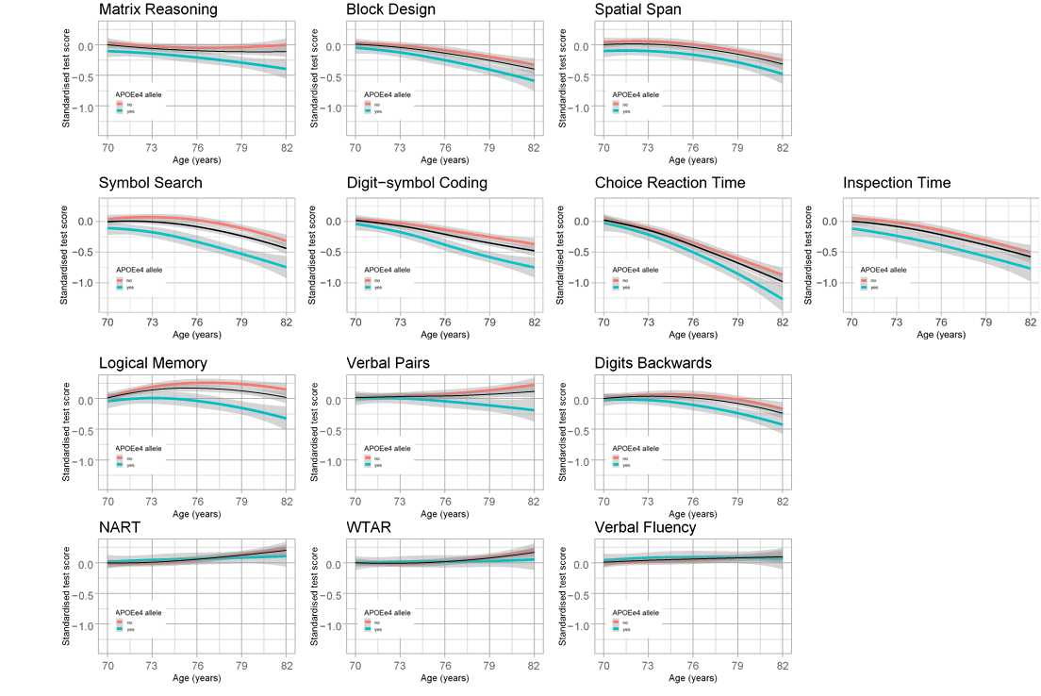

S3 Figure. Raw data regression plots for each cognitive test. Plots of fitted (non-linear) regression lines through the raw data using ‘loess’ smoothing (ggplot2 in R), normalised for baseline score, to illustrate the differences in trajectories of cognitive change with age by APOEe4 carrier status (with shaded 95% confidence intervals). The black line is the regression line for the full sample. Red = non-carrier, blue = carrier.

