eMethod

Description of TriNetX database
The data used in this study was collected on September 14, 2022 from the TriNetX COVID-19 Research Network, which provided access to electronic heath records (diagnoses, procedures, medications, laboratory values, genomic information) from approximately 109 million patients from 77 healthcare organizations. TriNetX, LLC is compliant with the Health Insurance Portability and Accountability Act (HIPAA). Any data displayed on the TriNetX Platform in aggregate form, or any patient level data provided in a data set generated by the TriNetX Platform, only contains de-identified data as per the de-identification standard defined in Section §164.514(a) of the HIPAA Privacy Rule. MetroHealth System, Cleveland, Ohio, IRB has determined research using TriNetX, is not Human Subject Research and therefore exempt from IRB review.
TriNetX is a platform that de-identifies and aggregates electronic health record (EHR) data from contributing healthcare systems, most of which are large academic medical institutions with both inpatient and outpatient facilities at multiple locations, across 50 states in the US. TriNetX Analytics provides web-based and secure access to patient EHR data from hospitals, primary care, and specialty treatment providers, covering diverse geographic locations, age groups, racial and ethnic groups, income levels and insurance types including various commercial insurances, governmental insurance (Medicare and Medicaid), self-pay/uninsured, worker compensation insurance, military/VA insurance among others.

Self-reported race and ethnicity data in TriNetX comes from the underlying clinical EHR systems of the contributing healthcare systems. TriNetX maps race and ethnicity data from the contributing healthcare systems to the following categories: (1) Race: Asian, American Indian or Alaskan Native, Black or African American, Native Hawaiian or Other, White, Unknown race; and (2) Ethnicity: Hispanic or Latino, Not Hispanic or Latino, Unknown Ethnicity.

Incidence rate analysis
Incidence rate of new diagnosis (first-time) of endocarditis from 2011 through August 2022 were examined in three cohorts: patients with a diagnosis of OUD, patients with a diagnosis of CocaineUD, and patients without a diagnosis of OUD or CocaineUD. In this study, incidence is a rate of first-time endocarditis cases in the population under analysis. For a given time window (each year in this study), the incidence proportion denominator includes all and only those patients in the cohort under analysis, whose fact record overlaps the time window by at least one day and who did not have endocarditis any time before the time window. The incidence proportion numerator includes all and only those patients who are in the denominator and who had endocarditis within the time window. For a given time window, the incidence rate denominator is the product of the number of patients in the incidence proportion denominator and the number of days covered by the time interval. The incidence rate numerator is equivalent to the incidence proportion numerator.

Covariates, propensity-score matching
eTable 1: Covariates, exposures, clinical outcomes, their standardized names, codes, data types and time window that are used in the TriNetX database.
Covariates, Clinical outcomes | Name, code | Data type | Time Window
Exposure
COVID-19 diagnosis | - coronavirus 2 and related RNA [Presence] (Logical Observation Identifiers Names and Codes (LOINC) code: 9088)  - COVID-19 (The International Classification of Diseases, Tenth Revision (ICD-10) code: U07.1) | present/absent
Outcome
Endocarditis | - Endocarditis, valve unspecified (ICD-10 code: I38)  - Excluded: Acute and subacute endocarditis (ICD-10 code: I33) |  | Within 180 days starting from the day of COVID-19 diagnosis
Covariates
Age at Index | Age at Index | continuous
Female | F | present/absent
Male | M | present/absent
Asian | Asian (Demographics: 2028-9) | present/absent
Black or African American | Black or African American (Demographics: 2054-5) | present/absent
White | White (Demographics: 2106-3) | present/absent
Hispanic/Latino | Hispanic or Latino (Demographics: 2135-2) | present/absent
Not Hispanic or Latino | Not Hispanic or Latino (Demographics: 2186-5) | present/absent
Adverse socioeconomic and psychosocial circumstances (%) | Persons with potential health hazards related to socioeconomic and psychosocial circumstances  (ICD-10 code: Z55-Z65), including:  - Problems related to education and literacy (Z55)  - Problems related to employment and unemployment (Z56)  - Occupational exposure to risk factors (Z57)  - Problems related to physical environment (Z58)  - Problems related to housing and economic circumstances (Z59)  - Problems related to social environment (Z60)  - Problems related to upbringing (Z62)  - Other problems related to primary support group, including family circumstances (Z63)  - Problems related to certain psychosocial circumstances (Z64)  - Problems related to other psychosocial circumstances (Z65) | present/absent | Anytime up to 1 day before COVID-19 diagnosis
Congenital heart diseases | Congenital malformations of the circulatory system (ICD-10 code: Q20-Q28) | present/absent | Anytime up to 1 day before COVID-19 diagnosis
Gingivitis and periodontal diseases | Gingivitis and periodontal diseases  (ICD-10 code: K05) | present/absent | Anytime up to 1 day before COVID-19 diagnosis
Dental caries | Dental caries  (ICD-10 code: K02) | present/absent | Anytime up to 1 day before COVID-19 diagnosis
Cocaine use disorders | Cocaine related disorders  (ICD-10 code: F14) | present/absent | Anytime up to 1 day before COVID-19 diagnosis
Opioid use disorders | Opioid related disorders  (ICD-10 code: F11) | present/absent | Anytime up to 1 day before COVID-19 diagnosis
Rheumatic heart diseases | Chronic rheumatic heart diseases  (ICD-10 code: I05-I09) | present/absent | Anytime up to 1 day before COVID-19 diagnosis
Rheumatic fever | Acute rheumatic fever  (ICD-10 code: I00-I02) | present/absent | Anytime up to 1 day before COVID-19 diagnosis
Hemodialysis | Hemodialysis Procedures  (CPT code: 1012752) | present/absent | Anytime up to 1 day before COVID-19 diagnosis
Surgical procedures involving heart and artery | Heart and Great Vessels  (ICD-10 code: 02), including:  - Bypass  - Dilation  - Creation  - Destruction  - Division  - Excision  - Insertion  - Extirpation  - Fragmentation  - Removal  - Repair  - Resection  - Translation  - Supplementation  - Reposition | present/absent | Anytime up to 1 day before COVID-19 diagnosis
Cardiac catheterization | Cardiac Catheterization Procedures  (CPT code: 1013071) | present/absent | Anytime up to 1 day before COVID-19 diagnosis
Cardiac and vascular implants and grafts | Presence of cardiac and vascular implants and grafts (ICD-10 code: Z95) | present/absent | Anytime up to 1 day before COVID-19 diagnosis
Obesity and overweight | Overweight and obesity  (ICD-10 code E66) | present/absent | Anytime up to 1 day before COVID-19 diagnosis
Type 2 diabetes | Type 2 diabetes mellitus  (ICD-10 code E11) | present/absent | Anytime up to 1 day before COVID-19 diagnosis
Hypertension | Essential (primary) hypertension  (ICD-10 code I10) | present/absent | Anytime up to 1 day before COVID-19 diagnosis
Cancer | Neoplasms  (ICD-10 code C00-D49) | present/absent | Anytime up to 1 day before COVID-19 diagnosis
Disorders involving the immune mechanisms | Certain disorders involving the immune mechanism  (ICD-10 code D80-D89) | present/absent | Anytime up to 1 day before COVID-19 diagnosis
Atrial fibrillation and flutter | Atrial fibrillation and flutter  (ICD-10 code I48) | present/absent | Anytime up to 1 day before COVID-19 diagnosis
HIV | Human immunodeficiency virus [HIV] disease  (ICD-10 code B20) | present/absent | Anytime up to 1 day before COVID-19 diagnosis
Viral hepatitis | Viral hepatitis  (ICD-10 code B15-B19) | present/absent | Anytime up to 1 day before COVID-19 diagnosis
Liver diseases | Diseases of liver  (ICD-10 code K70-K77) | present/absent | Anytime up to 1 day before COVID-19 diagnosis
Chronic kidney disease | Chronic kidney disease (CKD)  (ICD-10 code N18) | present/absent | Anytime up to 1 day before COVID-19 diagnosis
Tobacco use | Tobacco use  (ICD-10 code Z72.0) | present/absent | Anytime up to 1 day before COVID-19 diagnosis
Chemotherapy | Chemotherapy  (Procedure code: TNX:1002) | present/absent | Anytime up to 1 day before COVID-19 diagnosis
Corticosteroids | Corticosteroids  (RxNorm code R01AD) | present/absent | Anytime up to 1 day before COVID-19 diagnosis
Dexamethasone | Corticosteroids  (RxNorm code 3264) | present/absent | Anytime up to 1 day before COVID-19 diagnosis
Immunosuppressants | IMMUNOSUPPRESSANTS  (RxNorm code L01) | present/absent | Anytime up to 1 day before COVID-19 diagnosis
Antidepressants | ANTIDEPRESSANTS  (RxNorm code CN600) | present/absent | Anytime up to 1 day before COVID-19 diagnosis
Antipsychotics | ANTIPSYCHOTICS  (RxNorm code CN700) | present/absent | Anytime up to 1 day before COVID-19 diagnosis
Anticonvulsants | ANTICONVULSANTS  (RxNorm cod CN400) | present/absent | Anytime up to 1 day before COVID-19 diagnosis
CNS stimulants | CNS STIMULANTS  (RxNorm code CN800) | present/absent | Anytime up to 1 day before COVID-19 diagnosis
Other CNS medications | CNS MEDICATIONS,OTHER  (RxNorm code CN900) | present/absent | Anytime up to 1 day before COVID-19 diagnosis
EHR-documented COVID-19 vaccination | SARS-CoV-2 (COVID-19) Vaccine  (RxNorm code 213) | present/absent | Anytime up to 1 day before COVID-19 diagnosis

Propensity Score Matching
Propensity score matching was performed on all listed characteristics.

Cohort 1 and cohort 2 patient count before and after propensity score matching
 |  | OUD Cohort | Patient count before matching |  | Patient count after matching
 |  | 1 - COVID-19 (+) | 49,331 |  | 46,362
 |  | 2 - COVID-19 (-) | 405,959 |  | 46,362
Propensity score density function - Before and after matching (cohort 1 - purple, cohort 2 - green)
 |  | 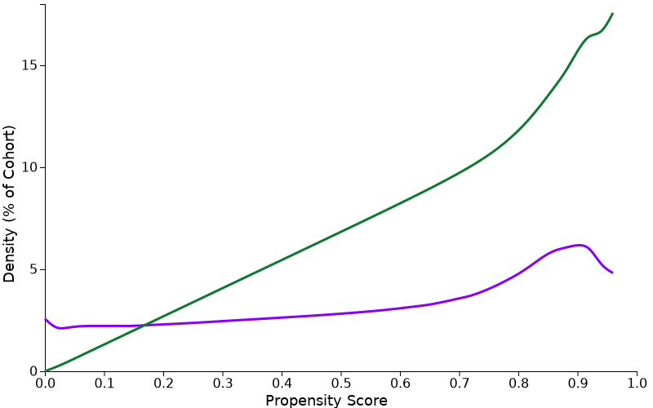 |  | 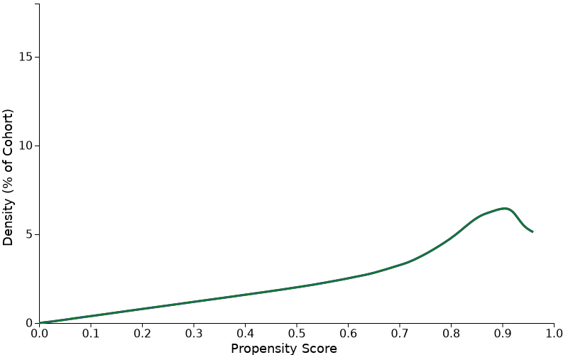

Cohort 1 and cohort 2 patient count before and after propensity score matching
 |  | CocaineUD Cohort | Patient count before matching |  | Patient count after matching
 |  | 1 – COVID-19 (+) | 23,687 |  | 22,420
 |  | 2 - COVID-19 (-) | 192,35 |  | 22,420
Propensity score density function - Before and after matching (cohort 1 - purple, cohort 2 - green)
 |  | 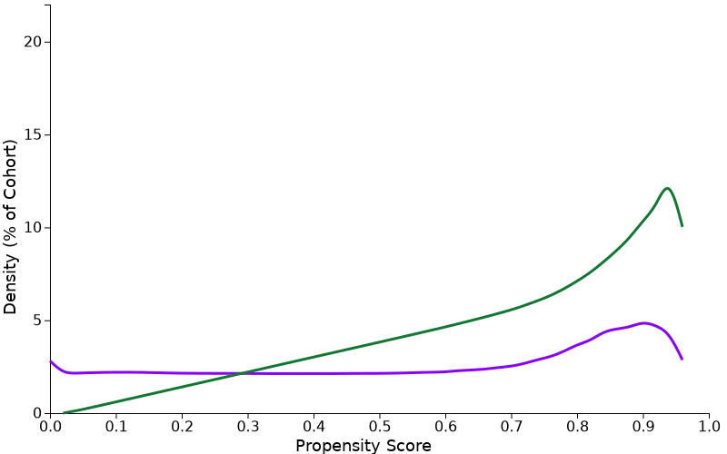 |  | 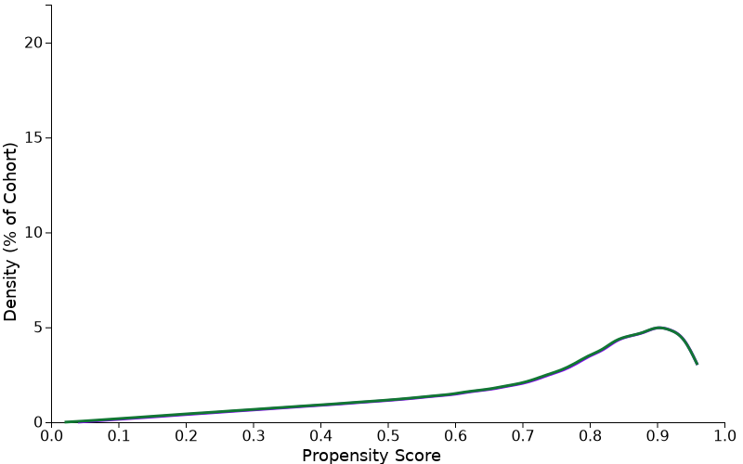

Survival Analysis
The Kaplan-Meier Analysis estimates probability of the outcome at a respective time interval (daily time interval is used in this analysis). In order to account for the patients who exited the cohort during the analysis period, and therefore should not be included in the analysis, censoring is applied. In this analysis, patients are removed from the analysis (censored) after the last fact in their record. The proportional hazard assumption was tested using the generalized Schoenfeld approach. The TriNetX Platform calculates the hazard ratios and associated confidence intervals using R's Survival package v3.2-3. For generating hazard ratios, TriNetX sets robust=FALSE using the R survival package, which is a limitation of the TriNetX platform since it does not consider potential clustering of COVID-19 cases within the healthcare organizations or specific geolocations. All Statistical tests were conducted on 9/14/2022 within the TriNetX Analytics Platform with significance set at p-value < 0.05 (two-sided).

