Proteasome-independent K63 polyubiquitination selectively regulates ATP levels and proteasome activity during fear memory formation in the female amygdala

Supplemental Information

Kayla Farrell, Madeline Musaus, Aubrey Auerbach, Shaghayegh Navabpour, W. Keith Ray, Richard F. Helm & Timothy J. Jarome

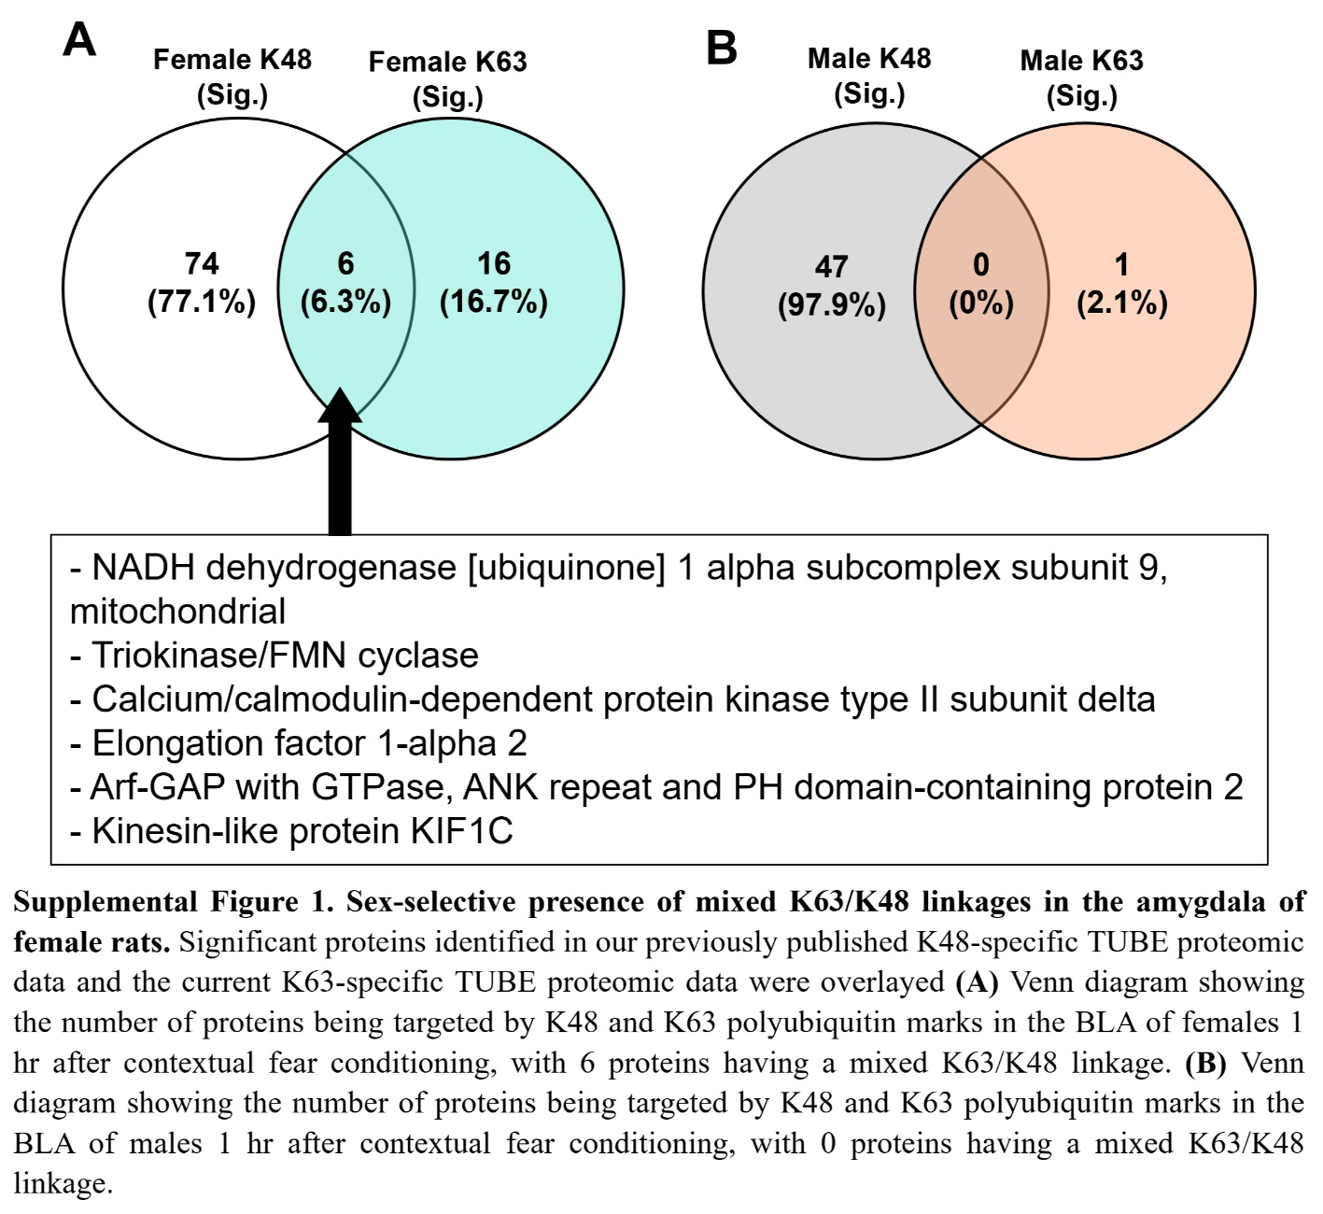

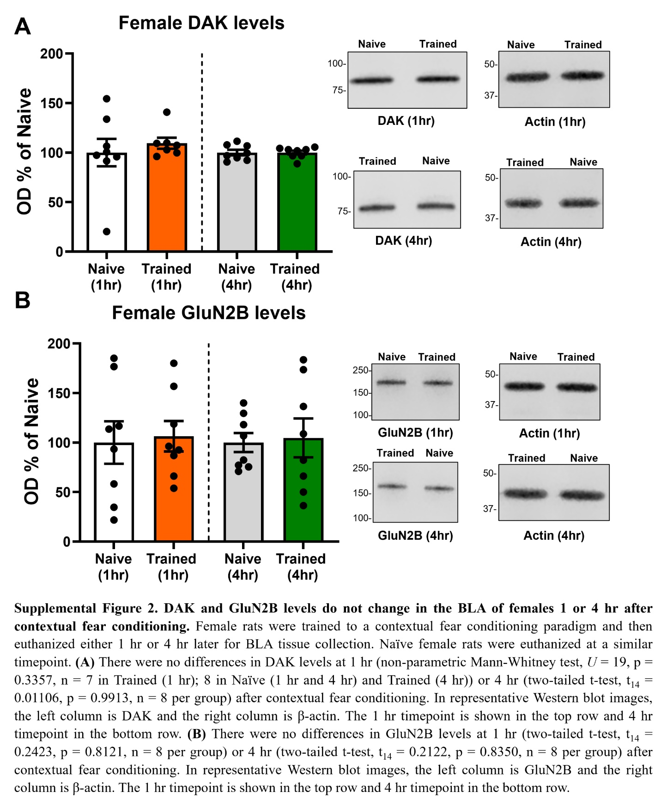

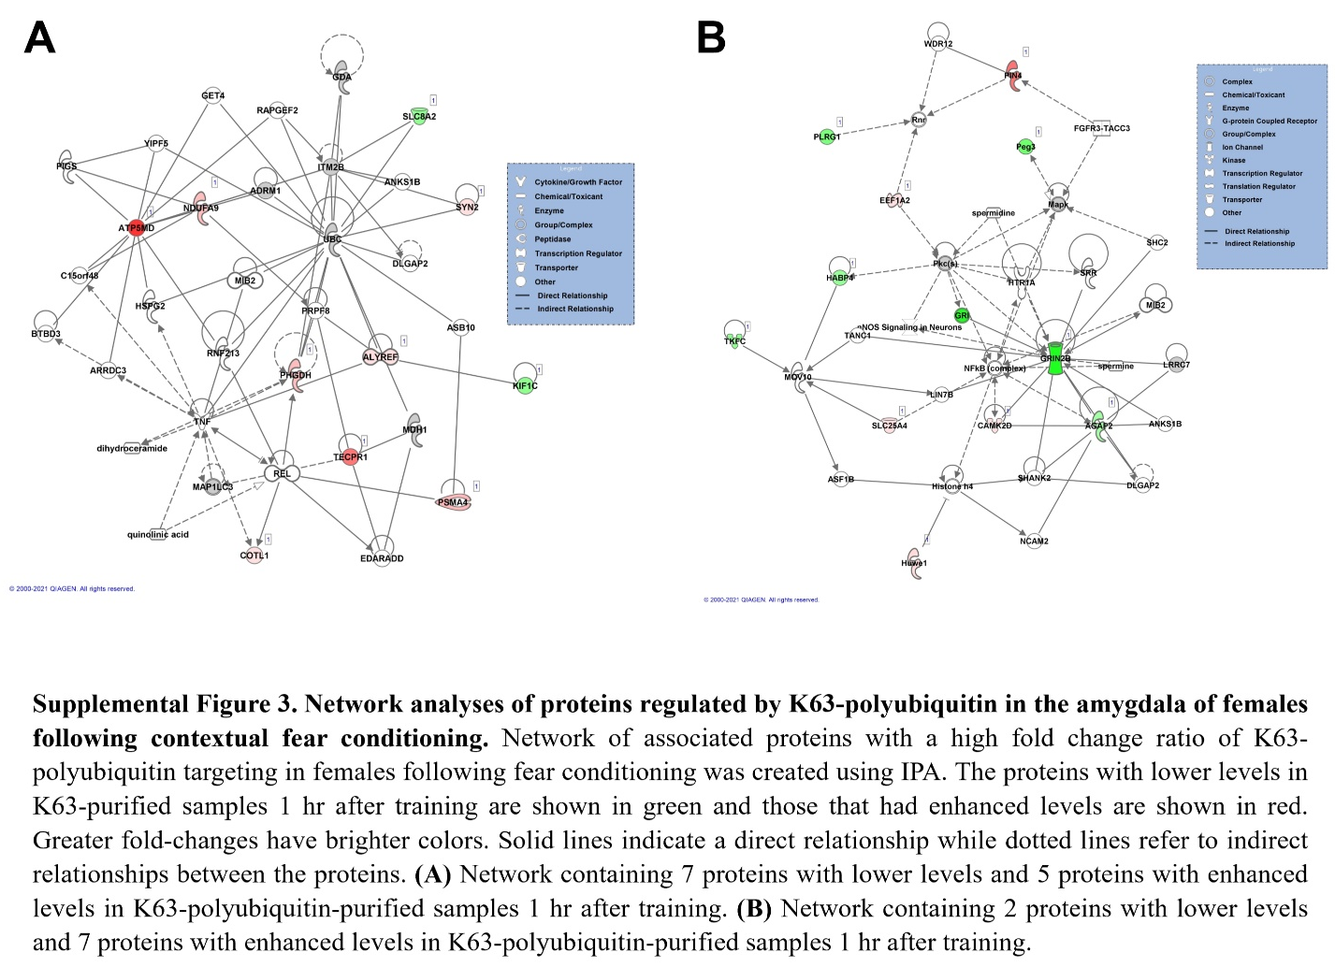
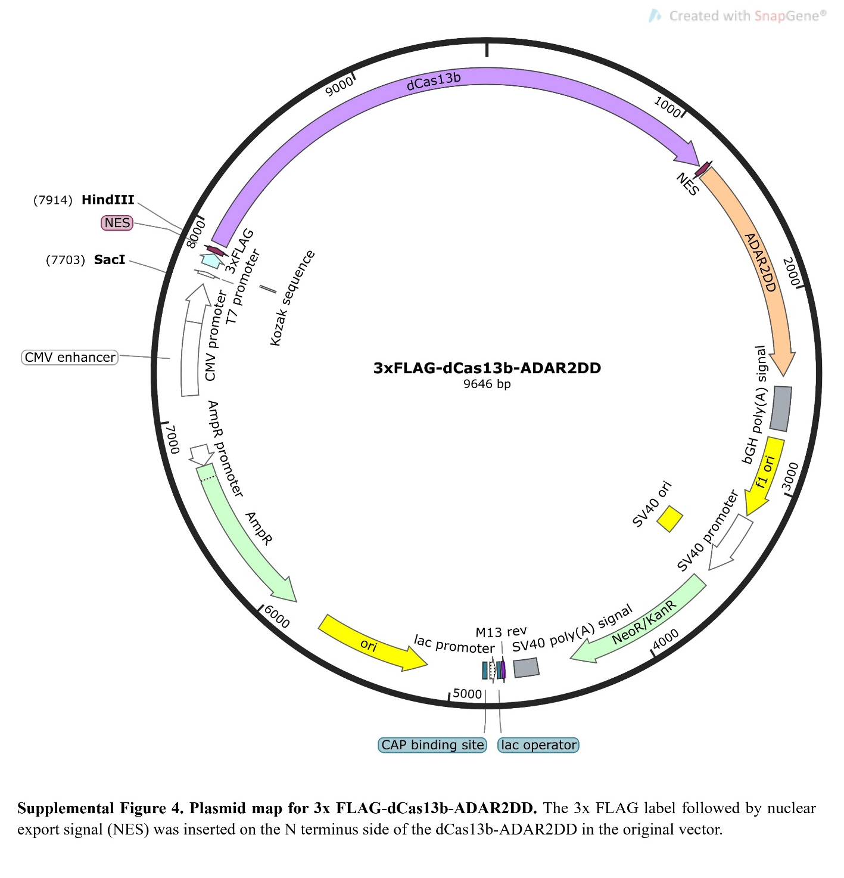

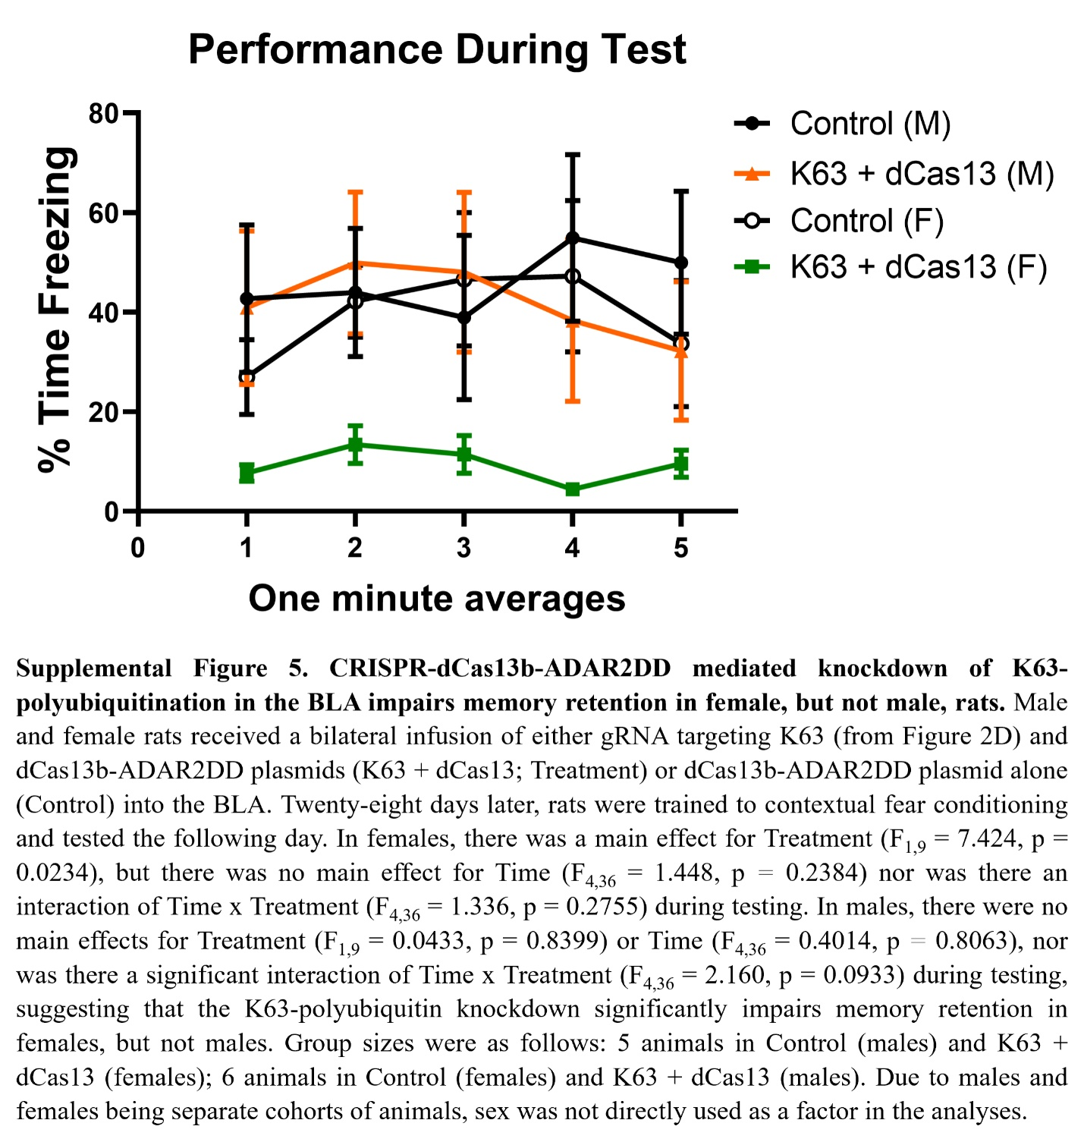

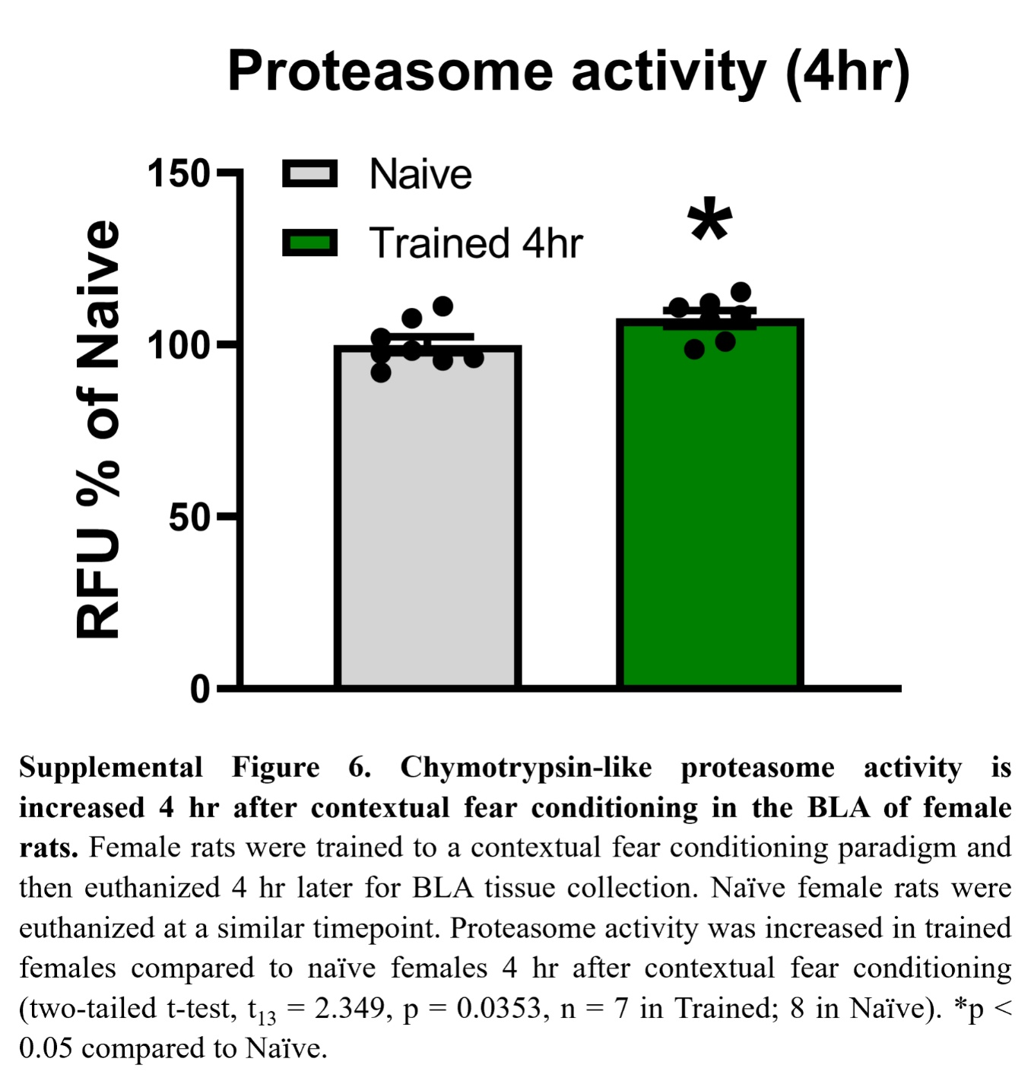

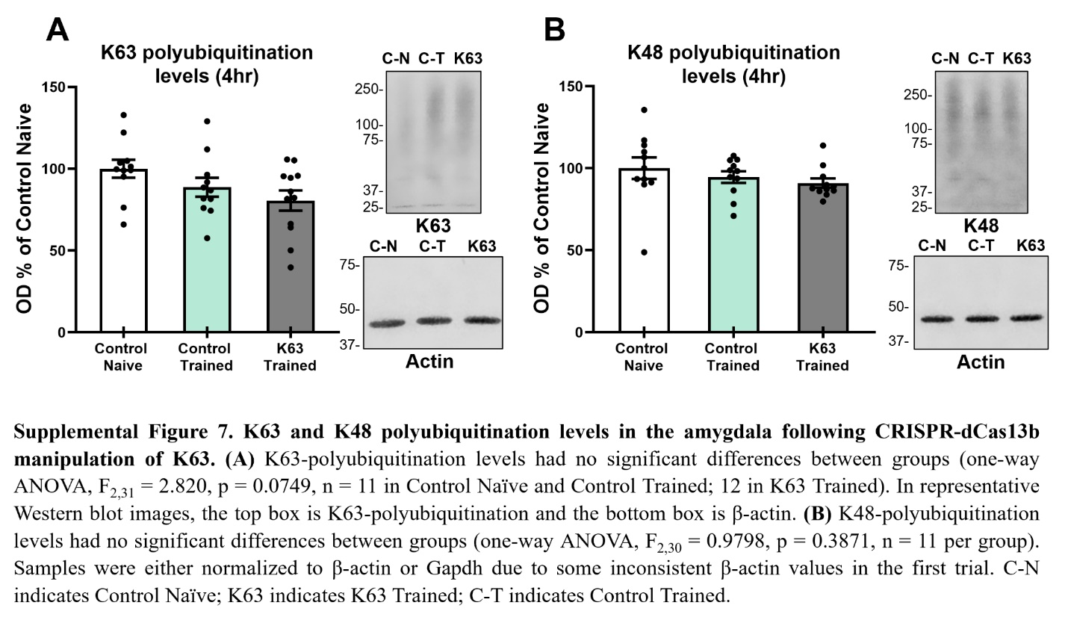

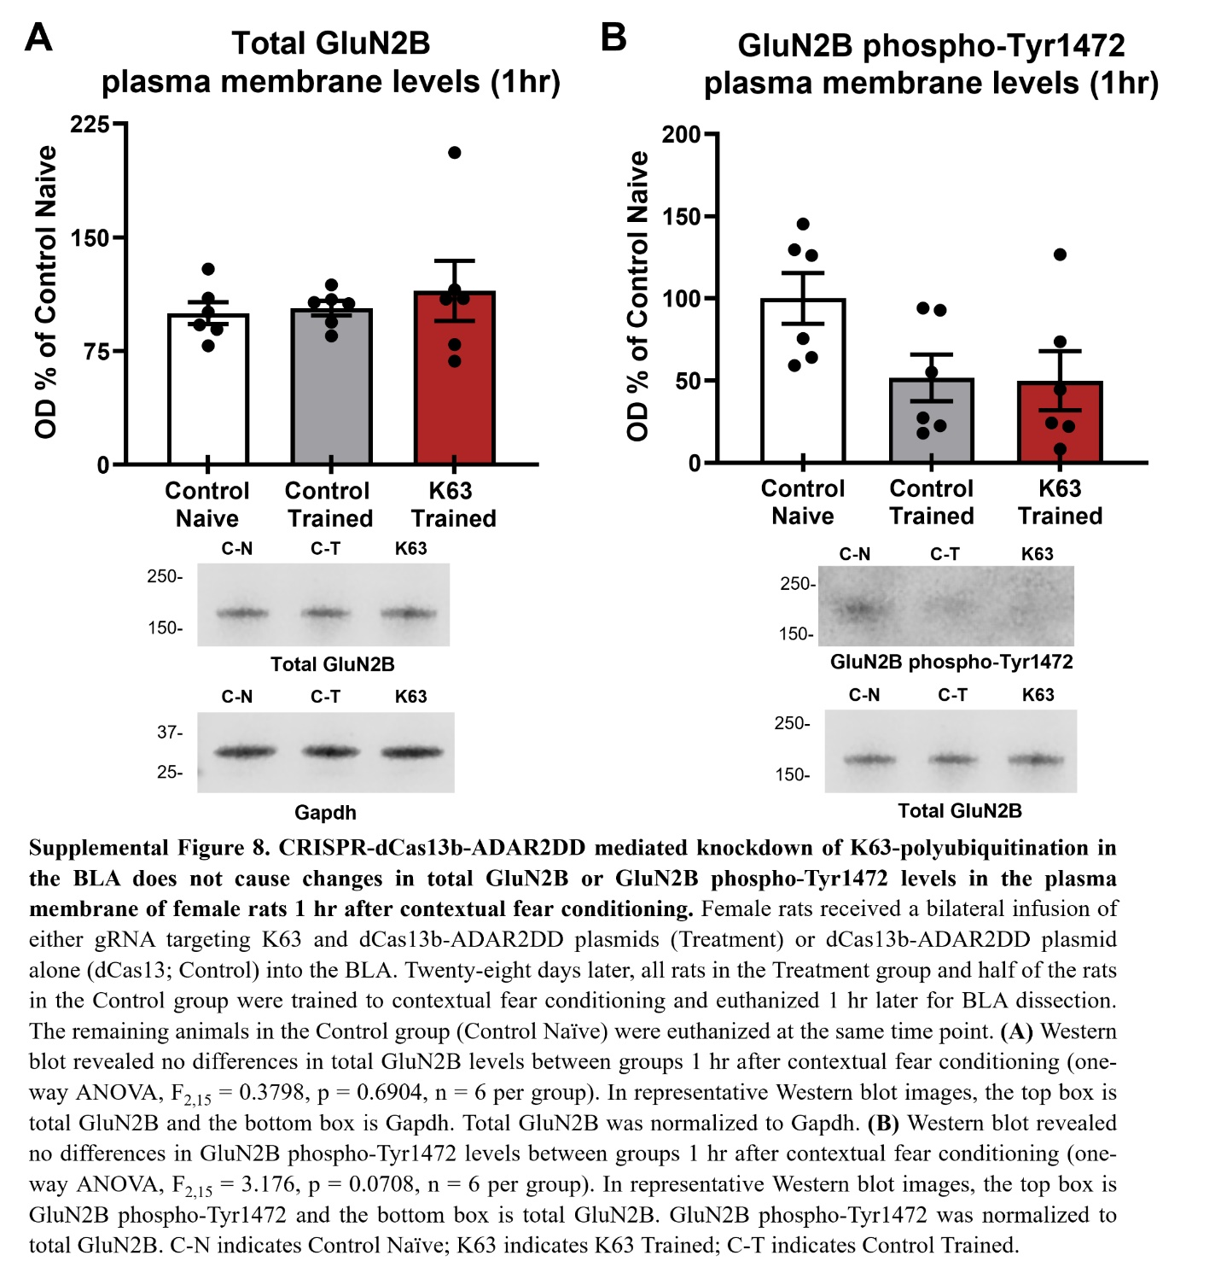

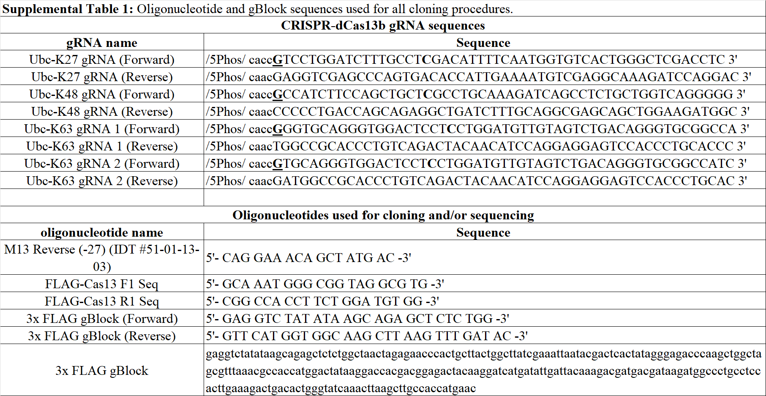

SUPPLEMENTAL METHODS
Subjects
All animals (Envigo, Fedrick, MA) were housed two per cage, had free access to water and rat chow, and were maintained under a 12:12-h light/dark cycle. Experiments and animal handling took place only during the light portion of the cycle. Animals within a cage were randomly assigned to experimental groups with the exception that naïve animals were caged together to prevent any unintended social transmission of fear. Researchers were not blinded to group allocation but were unable to distinguish between control and experimental animals during the behavioral procedures. All procedures were approved by the Virginia Polytechnic Institute and State University Institutional Animal Care and Use Committee (protocols #18-019 and #20-233) and conducted with the ethical guidelines of the National Institutes of Health.
Cranial Infusion of Plasmids
Animals were anesthetized with 1.5-4% isoflurane in 100% O₂ and rats received a bilateral infusion of CRISPR-dCas13b plasmids using In Vivo Jet-PEI (Polyplus, Berkeley, CA) as a transfection reagent into the BLA with the following coordinates relative to bregma: AP -3.0 mm, ML ±5.0 mm, DV -7.7 mm¹. A linear actuator was used to infuse plasmids at a constant rate of 0.1 ul per minute for a total volume of 0.5 µl per side. Animals recovered for at least 14 days after surgery before they underwent handling.
Fear Conditioning Apparatus
The two identical Habitest chambers used for fear conditioning have been previously described². Each chamber consisted of a steel test cage with front and back Plexiglass walls and a grid shock floor above a plastic drop pan. A house light in the top back corner of the right wall of the chamber remained on during behavioral procedures. A USB camera was mounted on a steel panel outside the back Plexiglass wall of the chamber, angled at ∼45 degrees. The entire chamber was housed in an isolation cubicle with an acoustic liner and a house fan, which remained active during all behavioral procedures. Both chambers were equipped with a speaker centered in the middle of the right-side wall. Shock was delivered through the grid floor via a Precision Animal Shocker under the control of FreezeFrame 4 software, which also analyzed animal behavior in real-time. A freezing threshold of 2.0 was used as the scoring parameter for all animals. All video was recorded and stored for later analysis. The chamber walls were wiped with 70% isopropanol (Contextual Fear Conditioning and Context A) before use. For auditory fear testing, the grid floor was covered with black Plexiglass and the walls of the chamber were covered with orange and green tape and wiped with 4.25% of hydrogen peroxide (Context B) before use.
Contextual Fear Conditioning Behavioral Procedures
All animals were handled for a total of 4 days prior to behavioral training to a contextual fear-conditioning paradigm. Animals were handled in the housing room for 2 days and then transported to an adjacent room where behavioral training was to occur and handled for 2 additional days. Animals assigned to an experimental group requiring training were then placed into the fear conditioning apparatus. After a 1 min baseline, animals received 4 unsignaled footshock (1.0 mA, 1 sec) presentations, followed by a 1 min post-shock period, after which animals were returned to their homecage. Naïve animals were not exposed to the conditioning chamber or trained to the fear conditioning task. Rats that underwent testing for memory retention were placed back into the chamber 24 hrs after training for 5 min, receiving no footshock presentations, before being returned to their homecage.
Shock Reactivity Analysis
Scores were obtained for each animal’s reaction to the four shocks given during training, by recording the time from when the shock terminated to the first instance of freezing behavior. The first instance of freezing behavior was identified by FreezeFrame 4 software with 2.0 as the freezing threshold. All animals were scored offline from saved video files.
Elevated Plus Maze
The apparatus and protocol used for the elevated plus maze has been described previously³. The apparatus was wiped down with 70% isopropanol between animals. The test took place in a dimly lit room and animals were placed into the center square facing a closed arm. Animals were left in the maze for 5 min during which time the behavior was recorded and scored based on the center point and tail-base position of the animal using a computerized video tracking system (Noldus Ethovision, Leesburg, VA).
Open Field
A 150×150×50 cm³ black Plexiglass box with the floor marked into 16 equal 37.5 cm² squares was wiped with 70% isopropanol before use. In a dimly lit room, animals were placed in the bottom right corner of the box and their activity was recorded for 5 min. Due to malfunctioning of animal detection in the open field by the computerized video tracking system, behavior was scored offline later from the recorded video. The percentage of time spent in center was determined by the amount of time (sec) at least 75% of the rat’s body (not including the tail) was inside one of the four center squares over the 5 min testing period. The number of line crossings was recorded using the same criteria as above, where 75% of the rat’s body had to be across the line, and was used as an indicator of locomotion activity.
Auditory Fear Conditioning Behavioral Procedures
Four or six days prior to auditory fear conditioning, animals were tested to open field or elevated plus maze, respectively. On the day of auditory fear training, animals were placed into Context A described above. Following a 3 min baseline, animals were exposed to four tone (10 sec)-shock (1.0 mA, 1 sec) pairings separated by 60 sec intervals. After a 1 min post-shock period, animals were returned to their homecage. One day later, rats were placed into Context B (described above) to test memory retention. After a 1 min baseline, animals were exposed to eight unreinforced (no shock) tone (30 sec) presentations separated by 30 sec intervals, and then returned to their homecage.
Tissue Collection
Rats were overdosed on isoflurane in a necrosis chamber, decapitated, and then the brain was rapidly removed and immediately frozen on dry ice. Animals in an experimental training group were euthanized either 1 hr or 4 hr after the training session and naïve animals were euthanized at the same time. Both hemispheres of the BLA were then dissected out blocking the brain in a rat brain matrix (Harvard Apparatus, Holliston, MA) incubated with dry ice. All dissected tissue was frozen at -80°C until needed.
Whole Cell Protein Collection
One hemisphere of BLA tissue was homogenized in whole cell lysis buffer (10 mM HEPES, 1.5 mM MgCl2, 10 mM KCl, 0.5 mM DTT, 0.5% IGEPAL, 0.02% SDS, 70 mM NEM, 1 µl/ml protease inhibitor cocktail (#P8340, MilliporeSigma, Burlington, MA), and 1 µl/ml phosphatase inhibitor cocktail (#524625, MilliporeSigma) and then centrifuged for 10 min at 4,000 x g at 4°C. The supernatant was collected and protein concentration was measured using the Bio-Rad DC protein assay.
Tandem Ubiquitin Binding Entity (TUBE) Assays
BLA tissue previously homogenized in whole cell lysis buffer (10 mM HEPES, 1.5 mM MgCl2, 10 mM KCl, 0.5 mM DTT, 0.5% IGEPAL, 0.02% SDS, 70 mM NEM, 1 µl/ml protease inhibitor cocktail, and 1 µl/ml phosphatase inhibitor cocktail), which contains N-ethylmaleimide (NEM) to preserve endogenous polyubiquitinated chains, was used. The high affinity K63 polyubiquitin-selective tandem ubiquitin binding entity (K63-TUBE, 100 µl, #UM404M, Life Sensors, Malvern, PA) conjugated to beads was washed in wash buffer (100 mM Tris-HCL, 150 mM NaCl, 5 mM EDTA, 0.08% NP-40) and a 500 µl mixture of protein (300 µg), protease inhibitor (1 µg/ml), and Wash Buffer was added. The mixture was incubated for 2 hr on a rotator at 4°C and then samples were washed twice with wash buffer before being incubated at 96°C for 5 min at 800 rpm in 1X sample buffer (Bio-rad). After cooling at room temperature, the supernatant was collected and stored at −80°C for mass spectrometry analysis, which was performed as described previously². All data and related files were submitted to the PRIDE archive with accession number PXD036369.
Plasma Membrane Protein Collection
Plasma membrane protein was isolated using the BioVision Plasma Membrane Protein Extraction Kit (K268-50, BioVision, USA) following the manufacturer’s instructions. Briefly, one hemisphere of BLA tissue was homogenized in 750 µl of homogenization buffer and then centrifuged at 700 x g for 10 min at 4°C. The supernatant was then centrifuged at 10,000 x g for 30 min at 4°C. The resulting pellet was purified for isolation of plasma membrane protein, which was resuspended in 1X PBS containing 0.5% SDS and 0.5% Triton X-100.
Antibodies
Antibodies used for western blotting include K48 polyubiquitin (1:1000, #ab140601 Abcam, Cambridge, MA), K63 polyubiquitin (1:1000, #ab179434 Abcam), K27 polyubiquitin (1:1000, #ab181537 Abcam), USMG5 (1:500, #17716-1-AP Proteintech, Rosemont, IL), PSMA4 (1:1000, #abx001953 abbexa, Houston, TX), DAK (1:1000, #12224-1-AP Proteintech), GluN2B (1:1000, #4212 Cell signaling, Danvers, MA), GluN2B phospho-Tyr1472 (1:500, #4208 Cell Signaling Technology), Gapdh (1:1000, #2118 Cell Signaling Technology, and β-actin (1:1000, #4967 Cell Signaling Technology). Antibodies used for immunohistochemistry include 3x FLAG/DDDDK tag (1:500, #ab205606 Abcam).
Immunohistochemistry
Animals were killed with rapid decapitation, brains removed, and placed in 4% paraformaldehyde for 24 hr at 4°C. One day later, brains were transferred to ice-cold 1X PBS and stored at 4°C until ready for use. Slices (~45-50 µΜ) were taken throughout the CA1 region of the hippocampus and stored in 1X PBS in a 12-well dish at 4°C. Slices were fixed with 4% paraformaldehyde for 10 min and washed with PBS, followed by antigen retrieval in boiling citric acid buffer. Slices were washed in PBS, blocked for 1 hr (4% normal goat serum, 4% normal donkey serum and 3% Triton X in PBS) and incubated in 3x FLAG/DDDDK tag (1:500) overnight at 4°C. The following day, slices were rinsed in PBS, incubated in Alexa Fluor 488 (1:500, #111-545-003 Jackson Immuno Research, West Grove, PA) secondary antibody for 2 hr, and then rinsed in PBS. Tissue was mounted on slides and coverslipped with VectaSheild Mounting Medium with DAPI (#H-1200 Vector Laboratories, Burlingame, CA). Images were taken on a Nikon A1 confocal laser microscope (Melville, NY) and adjusted using Image J Fiji.
Western Blot
Normalized proteins (5-10 µg) were separated on a 7% or 20% polyacrylamide gel with a 4% stacking gel before being transferred onto an Immobilon-FL membrane using the turbo transfer system (Biorad, Hercules, CA). Membranes were washed in TBS + 0.1% Tween-20 (TBSt) and then blocked in a 50:50 LI-COR blocking buffer (50% LI-COR TBS blocking buffer and 50% TBSt) for 1 hr at room temperature. After blocking, membranes were incubated overnight in primary antibody at 4°C. The following day, membranes were washed three times with TBSt for 10 min, incubated in a Goat anti-Rabbit secondary antibody (1:40000; LI-COR, Lincoln, NE, USA) or Goat anti-Mouse antibody (1:2000; LI-COR) for 45 min, and then washed twice in TBSt for 10 min. Membranes were rinsed with TBS before imaging with the Odyssey Fc near infrared system (LiCOR). After each development, membranes were stripped for 10 min with 0.2 N NaOH, washed with TBSt for 15 min twice, and then re-blocked for 1 hr before overnight incubation in primary antibody at 4°C. Image Studio Ver 5.2. was used to quantify proteins. Mean pixel density was calculated for each sample, normalized to β-actin, Gapdh, or Coomassie stain, which were used as loading controls, and expressed as a percentage of the control group.
Proteasome Activity Assay
Samples (30 µg) were diluted in ddH2O, mixed with reaction buffer (250mM HEPES, pH 7.5, 5mM EDTA, 0.5% NP-40, 0.01% SDS, 5mM ATP), and then fluorogenic peptide Suc-LLVY-AMC (BML-P802-0005 Enzo Life Sciences, Farmingdale, NY) was added to the samples to assess proteasome chymotrypsin-like activity (10µM). Reactions were incubated at 37°C for 2 hr (Suc-LLVY-AMC) and fluorescence was monitored with a 360/460 (excitation/emission) filter (Synergy HT; Biotek). Protein-free blanks were used, and an AMC standard curve was produced.
Luminescent ATP Assay
Rapid bioluminescence was used to measure total ATP levels with the EnzyLight ATP Assay Kit (#EATP-100 BioAssay Systems) following manufacturer’s instruction. Briefly, samples (10-15 µg) were diluted in ddH2O and ATP standards were diluted to generate a standard curve. Assay Buffer, substrate, and ATP enzyme were rapidly added to the samples and mixed by tapping. Luminescence was immediately measured with the Synergy HT plate reader (Biotek).
Cell Culture and Transfection
Rat B35 neuroblastoma cells were cultured as previously described⁴. Our rat B35 neuroblastoma cells (#CRL-2754 ATCC, Manassas, VA) have been confirmed to be free of mycoplasma contamination. Cells at 70-90% confluency were treated with 0.05% Trypsin-EDTA (1X) (#25300054; Gibco) 24 hr prior to transfection and transferred to a 6-well dish containing 2 ml of Dulbecco’s Modified Eagle’s Medium (DMEM) based media at a 1:6 ratio. Lipofectamine 3000 reagent (L3000001 Invitrogen, Waltham, MA) was used for transfection following manufacturer’s instructions. Briefly, DMEM-based media was removed and cells were washed with DPBS. DNA plasmids were mixed with Lipofectamine 3000 reagent and Opti-MEM media following manufacturer’s instructions and then the mixture was added to the cells. Cells were cultured in a NAPCO series 8000 Water Jacket CO2 incubator (model 3586) for 48 hr (K27 and K63 gRNA) or 72 hr (K48 gRNA) post transfection. Protein was isolated from the cells following the Whole Cell Protein Collection protocol outlined above.

Supplemental References
1. Devulapalli R, Jones N, Farrell K, Musaus M, Kugler H, McFadden T et al. Males and females differ in the regulation and engagement of, but not requirement for, protein degradation in the amygdala during fear memory formation. Neurobiol Learn Mem 2021; 180: 107404.

2. Farrell K, Musaus M, Navabpour S, Martin K, Ray WK, Helm RF et al. Proteomic Analysis Reveals Sex-Specific Protein Degradation Targets in the Amygdala During Fear Memory Formation. Front Mol Neurosci 2021; 14: 716284.

3. Unroe KA, Glover ME, Shupe EA, Feng N, Clinton SM. Perinatal SSRI Exposure Disrupts G Protein-coupled Receptor BAI3 in Developing Dentate Gyrus and Adult Emotional Behavior: Relevance to Psychiatric Disorders. Neuroscience 2021; 471: 32-50.

4. Jarome TJ, Perez GA, Webb WM, Hatch KM, Navabpour S, Musaus M et al. Ubiquitination of Histone H2B by Proteasome Subunit RPT6 Controls Histone Methylation Chromatin Dynamics During Memory Formation. Biol Psychiatry 2021; 89(12): 1176-1187.

