SUPPLEMENTARY INFORMATION

Proteomic analysis of the developing mammalian brain links PCDH19 to the Wnt/β-catenin signalling pathway.
Rebekah de Nys^{1,2}, Alison Gardner^{1,2}, Clare van Eyk^{1,2}, Stefka Mincheva-Tasheva^{1,2,3,4}, Paul Thomas^{1,2,3,4}, Rudrarup Bhattacharjee^{1,2}, Lachlan Jolly^{1,2}, Isabel Martinez-Garay⁵, Ian W. J. Fox⁵, Karthik Shantharam Kamath⁶, Raman Kumar^{1,2, Ϯ} and Jozef Gecz^{1,2,4,7, Ϯ,*}

¹ Adelaide Medical School, The University of Adelaide, Adelaide, SA, Australia.
² Robinson Research Institute, The University of Adelaide, Adelaide, SA, Australia.
³ Genome Editing Program, Adelaide, SA, Australia
⁴ South Australian Health and Medical Research Institute, Adelaide, SA, Australia
⁵ Division of Neuroscience, School of Biosciences, Cardiff University, Cardiff, Wales, United Kingdom
⁶ Australian Proteome Analysis Facility, Macquarie University, Macquarie Park, NSW, Australia
⁷ School of Biological Sciences, The University of Adelaide, Adelaide, SA, Australia
^{Ϯ} Co-last authors

*Corresponding author: Email: jozef.gecz@adelaide.edu.au, Phone: 61 8 8313 2453, Address: Adelaide Health and Medical Sciences Building, Level 8, 4 North Terrace, Adelaide, SA, Australia.

SUPPLEMENTARY FIGURES
Supplementary Fig. 1 Schematic diagram of the mRNA and protein domains of PCDH19+Ex2. PCDH19 contains a signal peptide (SP), extracellular cadherin repeats (EC1-6), transmembrane (TM) and conserved CM1 and CM2 domains. Nuclear localisation signal (NLS) 760-782aa was experimentally validated while NLSs 1031-1038aa and 1138-1145aa are predicted ^{6, 7}. The binding regions (where known) of experimentally validated PCDH19 interacting proteins are also shown. PCDH19 interactions with N-cadherin, PCDH19, NONO, DOCK7, NEDD1, PCDH17 and PCDH10 were identified in human cell lines (purple) ^{7, 10-12}. PCDH19 interactions with LSD1 and GABA_{A}R alpha 1 were identified in both rat brain and human cell lines (green-purple) ^{6, 9}. PCDH19 interactions with NAP1 and CYFIP2 were identified in chicken brain (yellow) ¹³. PCDH19 interactions with β-catenin, CAPZA1 and αN-catenin were identified in mouse brain and human cell lines (blue-purple) (this study).
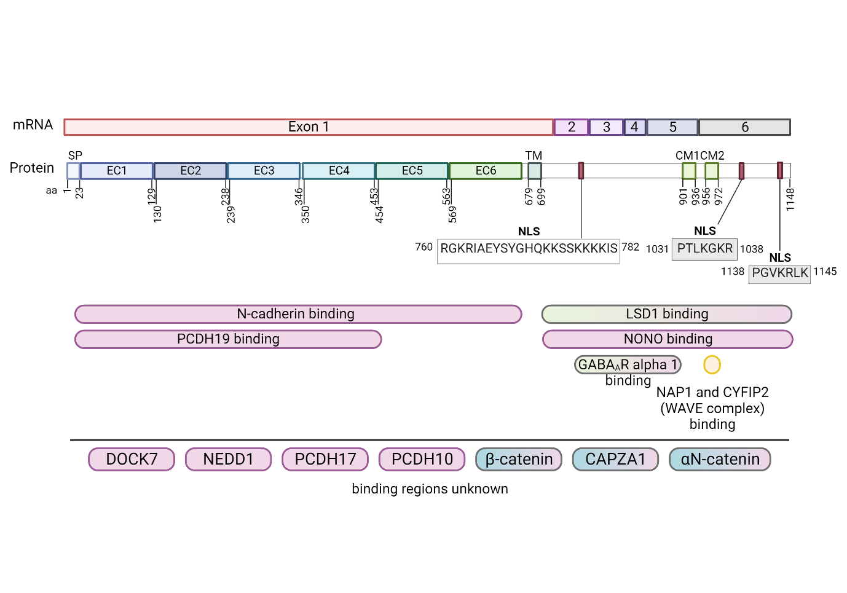

Supplementary Fig. 2 PCDH19 interaction with N-cadherin. Lysate from the hippocampi/cortices of (A) embryonic (E17.5-18.5) or (B) postnatal (P6-7) PCDH19-HA-FLAG mice was incubated with mouse IgG or anti-FLAG agarose beads. Input (2%) and IP (20%) samples were western blotted to detect PCDH19 and N-cadherin. Mouse IgG beads showed a low level of non-specific N-cadherin signal.

Supplementary Fig. 3 Enrichment analysis of the known PCDH19 interactome. A Bar graph of the models used for PCDH19 proteome analysis. B Molecular pathway, C Cellular Component, D Biological Process, E Subcellular Component ¹⁷, and F Signalling pathway enrichment analysis ¹⁹ of all currently identified interacting proteins. The graphs show the top 10 enriched pathways sorted by FDR and Fold enrichment (B-E) or Combined Score (F). n= number of genes, FE= fold enrichment, CS= combined score.

Supplementary Fig. 4 CAPZA1, αN-catenin and β-catenin interaction with δ2-PCDHs. CAPZA1-HA was immunoprecipitated with anti-HA agarose beads. Inputs (2%) and IP (25%) samples were western blotted to detect A-C CAPZA1-HA and A PCDH10-Myc, B PCDH12-Myc and C PCDH17-Myc. D PCDH10-Myc, E PCDH12-Myc and F PCDH17-Myc were immunoprecipitated with anti-Myc magnetic beads. Inputs and IP samples were western blotted to detect D-F Myc-tagged proteins and αN-catenin-HA. G PCDH10-HA, H PCDH12-HA were immunoprecipitated with anti-HA agarose beads and I PCDH17-Myc was immunoprecipitated with anti-Myc magnetic beads. Inputs and IP samples were western blotted to detect G-I Myc-tagged, HA-tagged and β-catenin-V5 proteins.

Supplementary Fig. 5 Myc-PCDH19+Ex2-FLAG, Myc-PDH19 CD-FLAG, Myc-PCDH19 EC-FLAG and Myc-PCDH19 EC-TM-FLAG domains were immunoprecipitated with anti-FLAG beads. Inputs (2%) and IP (25%) samples were western blotted to detect exogenous Myc-PCDH19-FLAG and β-catenin-V5 proteins.

Supplementary Fig. 6 Myc-PCDH19 Full Length (FL)-FLAG and Myc-PCDH19 EC (Extracellular Domain)-FLAG were immunoprecipitated with anti-FLAG conjugated agarose beads from HEK293T cells expression one or more tagged protein as shown. Inputs and IP samples were western blotted to detect Myc-PCDH19 FL-FLAG, Myc-PCDH19 EC-FLAG, N-cadherin (CDH2)-HA and β-catenin-V5.

Supplementary Fig. 7 Western blot of HEK293T cells transfected with (A) empty vector (EV), PCDH19+Ex2 WT, CD, EC or EC-TM proteins, or (B) empty vector (EV), PCDH19+Ex2, PCDH19-Ex2 or CE missense variant proteins were probed with anti-Myc and anti-β-Tubulin (loading control) antibodies.

Supplementary Fig. 8 A Schematic diagram of the mouse full length PCDH19+Ex2 WT, cytoplasmic domain (CD), cytoplasmic domain deleted CMI (ΔCM1), CM2 (ΔCM2) or mutated nuclear localisation signal (MT-NLS) used in TOP-Flash reporter assay. B HEK293T cells were transfected with empty vector (EV) or mouse full-length PCDH19 (WT+Ex2), CD, ΔCM1, ΔCM2 or MT-NLS expression constructs and treated with 200 ng/mL Wnt3a or vehicle (V) for 24 hours. Firefly Luciferase values for TOP were normalised to Renilla Luciferase transfection control. Statistical analysis was performed using Two-way ANOVA with Sidak’s correction (****=p ≤0.0001). Data presented as mean values ± SD Each experiment was performed in two technical replicates and seven biological replicates. C Western blot of HEK293T cells transfected with empty vector (EV), mouse PCDH19+Ex2 (WT+Ex2), CD, ΔCM1, ΔCM2 or MT-NLS expression constructs were probed with anti-HA and anti-GAPDH (loading control) antibodies.

SUPPLEMENTARY TABLES (Provided as separate files)
Supplementary Table 1 Interactome data from embryonic PCDH19-HA-FLAG and untagged mouse cortices.

Supplementary Table 2 Interactome data from embryonic and postnatal PCDH19-HA-FLAG mouse hippocampi and cortices.

Supplementary Table 3 Disease-associated potential PCDH19 interacting proteins. List of PCDH19 interacting proteins identified in the mouse brain associated with OMIM diseases.

Supplementary Table 4 Meta-analysis of reported PCDH19 interacting proteins.

SUPPLEMENTARY METHODS
Supplementary Methods Table: List of primers used for cloning CTNNA2, CAPZA1 and CDH2 into pCMV-HA vector.
Primer Name | Sequence (5’-3’)
hCTNNA2-InFus_F | GCGATCGCGATATCAAGCTTATGACTTCGGCAACTTCACCTATC
hCTNNA2-InFus_R | ATGTCTGGATCCCCGCGGCCGCCTAGAAGGAATCCATTGCTTTGAATTC
hCAPZA1-InFus_F | GCGATCGCGATATCAAGCTTATGGCCGACTTCGATGATCGTGTG
hCAPZA1-InFus_R | ATGTCTGGATCCCCGCGGCCGCTTAAGCATTCTGCATTTCTTTGC
hCDH2_InFus_F | AGGCCCGAATTCGCGATCGCGATATCATGTGCCGGATAGCGGGAGCGCTGCGGA
hCDH2_InFus_R | CCGCGGCCGCGGTACCTCGAGAGTCAGTCATCACCTCCACCATACATGTCA

