Supplementary Information for

The ion channel TRPA1 is a modulator of the cocaine reward circuit in the nucleus accumbens

Young-Jung Kim^{1,}*, Su Jeong Choi^{2,}*, Sa-Ik Hong^{1,}*, Jung-Cheol Park^{2,}*, Youyoung Lee¹, Shi-Xun Ma¹, Kwang-Hyun Hur¹, Young Lee², Kyeong-Man Kim³, Hyung Kyu Kim⁴, Hee Young Kim⁴, Seok-Yong Lee¹, Se-Young Choi^{2,#}, Choon-Gon Jang^{1,#}

¹Department of Pharmacology, School of Pharmacy, Sungkyunkwan University, Suwon, 16419, Republic of Korea
²Department of Physiology, Dental Research Institute, Seoul National University School of Dentistry, Seoul, 03080, Republic of Korea
³Pharmacology Laboratory, College of Pharmacy, Chonnam National University, Gwangju, 61186, Republic of Korea
⁴Department of Physiology, Yonsei University College of Medicine, Seoul, 03722, Republic of Korea

This PDF file includes:

Figure S1
Figure S2
Figure S3
Figure S4
Supplementary Figures and Legends

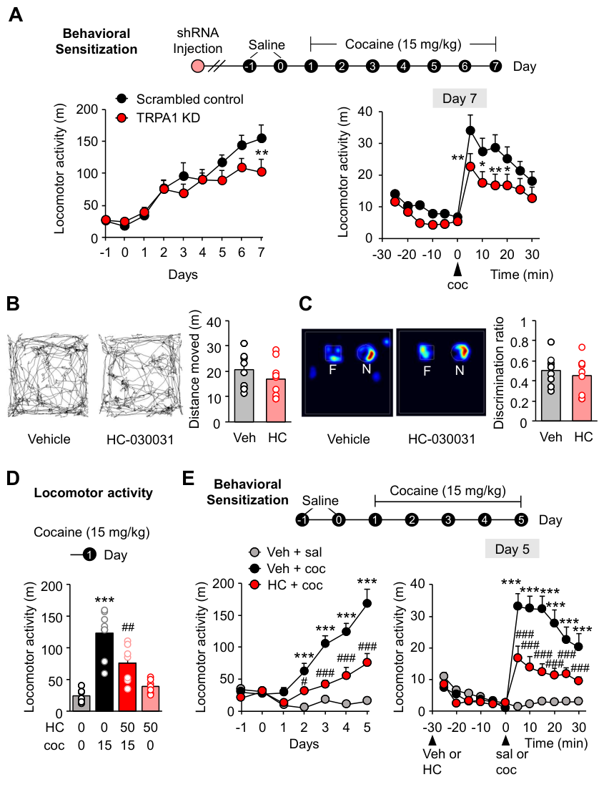

Figure S1. Effects of TRPA1 KD and blockade on cocaine-mediated locomotor sensitization.

Figure S1. Effects of TRPA1 KD and blockade on cocaine-mediated locomotor sensitization.
(A) Timeline of TRPA1 KD cocaine behavioral sensitization tests. Locomotor activity of scrambled control and TRPA1 KD groups in the cocaine behavioral sensitization tests; 30 min of total locomotor activity during 9 daily sessions [n = 8 (scrambled) and 9 (KD)].
(B) Representative trace images of locomotor activity during TRPA1 antagonist (HC-030031) open field tests. Locomotor activity on open field tests in the vehicle- or HC-030031 (10 mg/kg)-injected mice [n = 10 (vehicle) and 9 (HC-030031)].
(C) Representative heat map images of mouse movements during TRPA1 antagonist novel object recognition tests. Discrimination ratio between familiar (F) and novel (N) objects in the vehicle- or HC-030031 (10 mg/kg)-treated mice [n = 10 (vehicle) and 9 (HC-030031)].
(D) Timeline of TRPA1 antagonist acute cocaine locomotor test. 30 min of total locomotor activity of acute cocaine responses following injection of HC-030031 or vehicle [n = 8 (control), 8 (cocaine), 7 (HC-030031, cocaine), and 7 (HC-030031)].
(E) Timeline of TRPA1 antagonist cocaine behavioral sensitization tests. Locomotor activity of each group in the HC-030031 cocaine behavioral sensitization tests; 30 min of total locomotor activity during 7 daily sessions [n = 8 (control), 9 (cocaine), and 9 (HC-030031, cocaine)]. Five-min intervals of locomotor activity on day 5 [n = 8 (control), 9 (cocaine), and 9 (HC-030031, cocaine)].
Data are presented as mean ± standard error of the mean. * P < 0.05, ** P < 0.01, and *** P < 0.001 versus control; # P < 0.05, ## P < 0.01, and ### P < 0.001 versus cocaine; sal, saline; coc, cocaine; TRPA1 KD, TRPA1 knockdown; Veh, vehicle; HC, HC-030031.

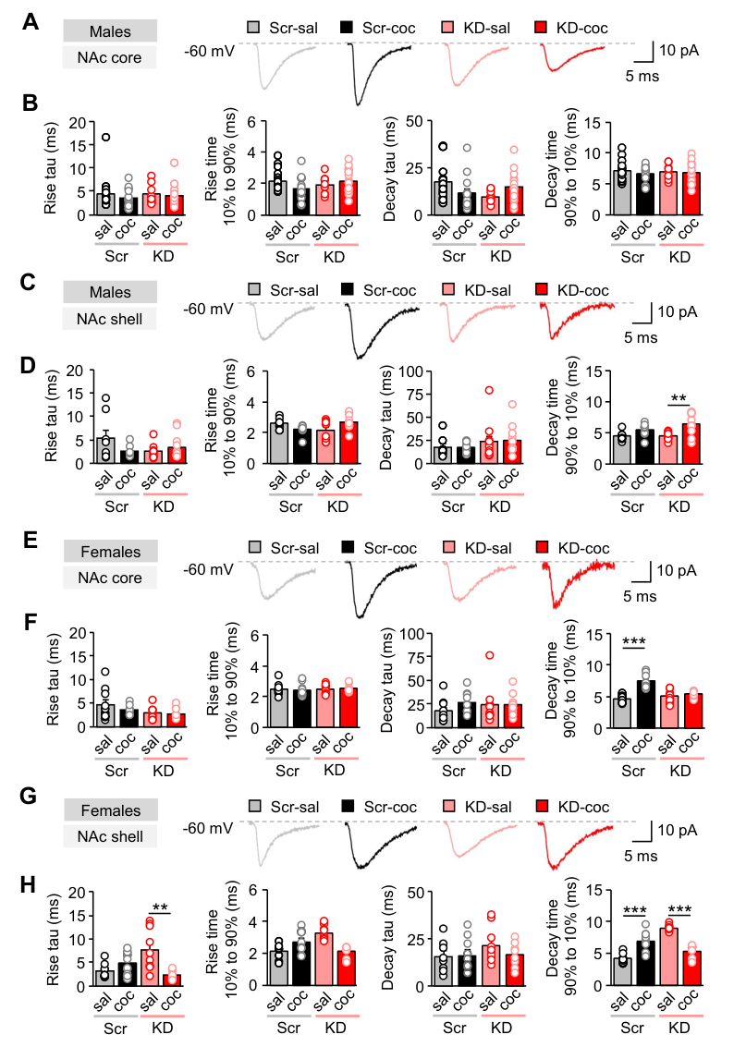

Figure S2. Spontaneous EPSC kinetics
Figure S2. Spontaneous EPSC kinetics
(A) Representative raw traces of spontaneous excitatory post-synaptic current (sEPSC) recordings from the NAc core of male mice.
(B) Rise tau (ms), rise time 10%-90% (ms), Decay tau (ms), and Decay time 90%-10% of sEPSCs in the NAc core MSNs of saline- and cocaine-injected male scrambled control and male TRPA1 KD groups [n = 16 (scrambled, saline), 13 (scrambled, cocaine), 9 (KD, saline), and 15 (KD, cocaine)].
(C) Representative raw traces of spontaneous excitatory post-synaptic current (sEPSC) recordings from the NAc shell of male mice.
(D) Rise tau (ms), rise time 10%-90% (ms), Decay tau (ms), and Decay time 90%-10% of sEPSCs in the NAc shell MSNs of saline- and cocaine-injected male scrambled control and male TRPA1 KD groups [n = 8 (scrambled, saline), 10 (scrambled, cocaine), 11 (KD, saline), and 11 (KD, cocaine)].
(E) Representative raw traces of spontaneous excitatory post-synaptic current (sEPSC) recordings from the NAc core of female mice.
(F) Rise tau (ms), rise time 10%-90% (ms), Decay tau (ms), and Decay time 90%-10% of sEPSCs in the NAc core MSNs of saline- and cocaine-injected female scrambled control and female TRPA1 KD groups [n = 10 (scrambled, saline), 9 (scrambled, cocaine), 9 (KD, saline), and 9 (KD, cocaine)].
(G) Representative raw traces of spontaneous excitatory post-synaptic current (sEPSC) recordings from the NAc shell of female mice.
(H) Rise tau (ms), rise time 10%-90% (ms), Decay tau (ms), and Decay time 90%-10% of sEPSCs in the NAc shell MSNs of saline- and cocaine-injected female scrambled control and female TRPA1 KD groups [n = 8 (scrambled, saline), 10 (scrambled, cocaine), 10 (KD, saline), and 8 (KD, cocaine)].
Data are presented as mean ± standard error of the mean. ** P < 0.01 and *** P < 0.001; sal, Saline; coc, cocaine; Scr, Scrambled control; KD, TRPA1 knockdown.

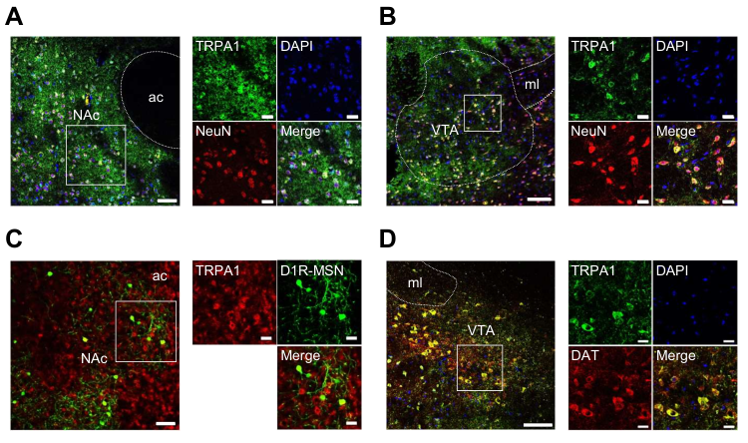

Figure S3. Localization of TRPA1 expression in the NAc and VTA neurons.
(A) Left: NAc neurons co-immunolabeled for TRPA1 (green), NeuN (red), and DAPI (blue). Scale bar: 50 μm. ac, anterior commissure. Right: high magnification of the NAc section. Scale bars: 20 μm.
(B) Left: VTA neurons co-immunolabeled for TRPA1 (green), NeuN (red), and DAPI (blue). Scale bar: 100 μm. ml, medial lemniscus. Right: high magnification of the VTA section. Scale bars: 20 μm.
(C) Left: EYFP-expressing D1R-MSNs (green) immunolabeled for TRPA1 (red) in the NAc of D1-Cre mice. Scale bar: 50 μm. Right: high magnification of the NAc section. Scale bars: 20 μm.
(D) Left: VTA dopaminergic neurons co-immunolabeled for TRPA1 (green), DAT (red), and DAPI (blue). Scale bar: 100 μm. ml, medial lemniscus. Right: high magnification of the VTA section. Scale bars: 20 μm.

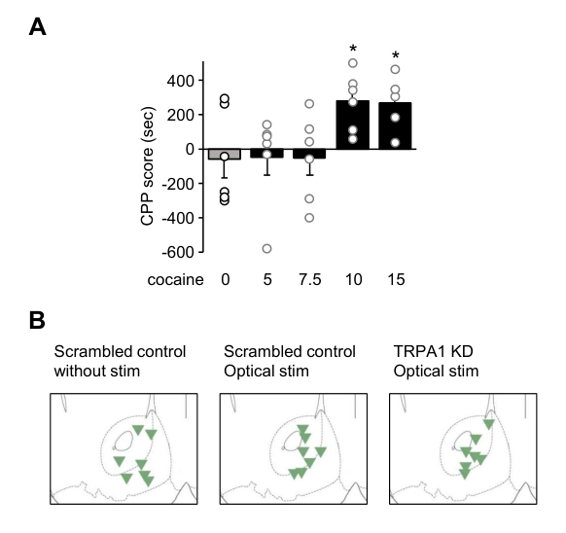

Figure S4. Dose-response analysis of cocaine CPP histological representation for optogenetic test.
(A) CPP score of each group in the varying doses of cocaine (5, 7.5, 10, 15 mg/kg) CPP tests [n = 6 (saline), 6 (5 mg/kg), 6 (7.5 mg/kg), 6 (10 mg/kg), and 5 (15 mg/kg)].
(B) Histology panels of AAV viral infusion regions in the NAc of each group in the TRPA1 KD optogenetic cocaine CPP tests (n = 7).
Data are presented as mean ± standard error of the mean. * P < 0.05 versus control; stim, stimulation; TRPA1 KD, TRPA1 knockdown.

