Supplements: Child maltreatment as a transdiagnostic risk factor for the externalizing dimension: A Mendelian Randomization study

Julian Konzok, PhD¹*, Mathias Gorski, PhD², Thomas W. Winkler, PhD², Sebastian E. Baumeister, PhD³, Varun Warrier, PhD⁴, Michael F. Leitzmann, PhD, MD¹, Hansjörg Baurecht, PhD¹

¹ Department of Epidemiology and Preventive Medicine, University of Regensburg, Germany
² Department of Genetic Epidemiology, University of Regensburg, Regensburg, Germany
³ Institute of Health Services Research in Dentistry, University of Münster, Münster, Germany
⁴ Department of Psychiatry, University of Cambridge, Cambridge, UK
*Corresponding author: julian.konzok@ukr.de (Julian Konzok)

Supplementary Material 1

Power analysis following Brion et al.: This method aligns with asymptotic theory and derives power estimates using the non-centrality parameter from the corresponding asymptotic χ2-distribution. Additional parameters considered in the power calculations encompass the proportion of explained variance in the exposure attributable to the selected instrumental variables (IVs), the sample size of the outcome GWAS and its proportion of cases.

Table S1 Overview of the used datasets
Note. ADHD = Attention deficit hyperactivity disorder, CD = Conduct disorder, ASPD = antisocial personality disorder, AUD = Alcohol use disorder, OUD = Opioid use disorder, CUD = Cannabinoid use disorder.

Study | Phenotype | N cases | N controls | Data available
Exposure
Meta-analysis of childhood maltreatment using data from the UK Biobank (1) | Childhood maltreatment | 143,473 |  | data available
Replication dataset
GWAS meta-analysis from Avon Longitudinal Study of Parents and Children (ALSPAC), Adolescent Brain Cognitive Development Study (ABCS), and Generation R (1) | Childhood maltreatment | 15 651 |  | data available
Outcome
PGC, iPSYCH project (2) | ADHD | 20,183 | 35,191 | data available
FinnGen Consortium (3) | CD | 451 | 256,859 | data available
FinnGen Consortium (3) | ASPD | 381 | 252,877 | data available
FinnGen Consortium (3) | AUD | 13,422 | 244,533 | data available
FinnGen Consortium (3) | OUD | 775 | 255,921 | data available
PGC Substance Use Disorders working group, iPSYCH, and deCODE (4) | CUD | 14,080 | 343,726 | data available

Table S2 Summary of single and common factor GWAS results

Model | SNP-h² | lambda | number of hits  (5x10⁻⁰⁸) | Q_{SNP} hits | mean chi² | LDSC intercept
Externalizing factor  (EXT) | 0.06 | 1.91 | 344 | 4 | 2.37 | 0.98 (0.02)
Externalizing GWAS  from Externalizing Consortium (EXT-CON) | 0.10 | 1.41 | 579 | 160 | 1.45 | 1.26 (0.01)
ADHD | 0.23 | 1.25 | 317 |  | 1.29 | 1.03 (0.01)
CD | 0.01 | 1.03 | 0 |  | 1.02 | 1.00 (0.01)
ASPD | 0.01 | 1.02 | 0 |  | 1.02 | 0.99 (0.01)
AUD | 0.02 | 1.15 | 83 |  | 1.17 | 1.07 (0.01)
OUD | 0.01 | 1.01 | 1 |  | 1.01 | 0.99 (0.01)
CUD | 0.20 | 1.11 | 29 |  | 1.11 | 0.99 (0.01)
Notes. , ADHD = Attention deficit hyperactivity disorder, CD = Conduct disorder, ASPD = antisocial personality disorder, AUD = Alcohol use disorder, OUD = Opioid use disorder, CUD = Cannabinoid use disorder, AIC = Akaike information criterion, CFI = comparative fit index, SRMR = standardized root mean square residual.

Table S3 Results of the MAGMA gene-based association analysis after after Bonferroni correction (defined at 2.61x10⁻⁶)

GENE | CHR | START | STOP | NSNPS | NPARAM | N | ZSTAT | P | SYMBOL
ENSG00000128573 | 7 | 113676382 | 114383827 | 833 | 47 | 80522 | 6.5044 | 3.90E-11 | FOXP2
ENSG00000175161 | 3 | 84958132 | 86173579 | 2829 | 55 | 80522 | 6.2789 | 1.70E-10 | CADM2
ENSG00000152208 | 4 | 93175550 | 94745707 | 2983 | 102 | 80522 | 5.8372 | 2.66E-09 | GRID2
ENSG00000164061 | 3 | 49541922 | 49758978 | 258 | 13 | 80522 | 5.6586 | 7.63E-09 | BSN
ENSG00000137872 | 15 | 47426298 | 48116420 | 1627 | 63 | 80522 | 5.5916 | 1.12E-08 | SEMA6D
ENSG00000174442 | 15 | 66747297 | 66892115 | 415 | 32 | 80522 | 5.4741 | 2.20E-08 | ZWILCH
ENSG00000114316 | 3 | 49265264 | 49428145 | 177 | 16 | 80522 | 5.4683 | 2.27E-08 | USP4
ENSG00000185909 | 3 | 49159044 | 49263917 | 103 | 10 | 80522 | 5.4353 | 2.74E-08 | KLHDC8B
ENSG00000236980 | 3 | 49165065 | 49279291 | 125 | 11 | 80522 | 5.4229 | 2.93E-08 | C3orf84
ENSG00000177352 | 3 | 49149968 | 49253754 | 101 | 10 | 80522 | 5.3945 | 3.44E-08 | CCDC71
ENSG00000188315 | 3 | 49256035 | 49365342 | 108 | 12 | 80522 | 5.382 | 3.68E-08 | C3orf62
ENSG00000173421 | 3 | 49185861 | 49345537 | 168 | 14 | 80522 | 5.3655 | 4.04E-08 | CCDC36
ENSG00000188501 | 15 | 66789517 | 66908317 | 354 | 33 | 80522 | 5.3116 | 5.43E-08 | LCTL
ENSG00000233276 | 3 | 49344609 | 49446033 | 122 | 11 | 80522 | 5.2435 | 7.88E-08 | GPX1
ENSG00000169744 | 4 | 16453164 | 16950432 | 990 | 93 | 80522 | 5.2112 | 9.38E-08 | LDB2
ENSG00000172037 | 3 | 49108547 | 49220551 | 101 | 11 | 80522 | 5.2083 | 9.53E-08 | LAMB2
ENSG00000225399 | 3 | 49247518 | 49348744 | 106 | 12 | 80522 | 5.1819 | 1.10E-07 | RP11-3B7.1
ENSG00000138640 | 4 | 89597106 | 90082549 | 1095 | 49 | 80522 | 5.127 | 1.47E-07 | FAM13A
ENSG00000120885 | 8 | 27404434 | 27522548 | 318 | 33 | 80522 | 5.1139 | 1.58E-07 | CLU
ENSG00000187323 | 18 | 49816542 | 51107784 | 4131 | 99 | 80522 | 5.0924 | 1.77E-07 | DCC
ENSG00000164062 | 3 | 49661435 | 49771396 | 133 | 12 | 80522 | 5.0841 | 1.85E-07 | APEH
ENSG00000139318 | 12 | 89691009 | 89797048 | 194 | 25 | 80522 | 5.0836 | 1.85E-07 | DUSP6
ENSG00000172046 | 3 | 49095479 | 49208371 | 88 | 10 | 80522 | 5.0546 | 2.16E-07 | USP19
ENSG00000067560 | 3 | 49346578 | 49500431 | 181 | 13 | 80522 | 5.024 | 2.53E-07 | RHOA
ENSG00000175497 | 2 | 115149876 | 116653328 | 3032 | 110 | 80522 | 4.9889 | 3.04E-07 | DPP10
ENSG00000259471 | 15 | 66824528 | 67028132 | 577 | 53 | 80522 | 4.9816 | 3.15E-07 | RP11-321F6.1
ENSG00000156564 | 6 | 40309325 | 40605204 | 941 | 55 | 80522 | 4.9762 | 3.24E-07 | LRFN2
ENSG00000174444 | 15 | 66740355 | 66866870 | 325 | 22 | 80522 | 4.957 | 3.58E-07 | RPL4
ENSG00000172053 | 3 | 49083365 | 49192553 | 79 | 9 | 80522 | 4.929 | 4.13E-07 | QARS
ENSG00000173531 | 3 | 49671380 | 49776934 | 129 | 12 | 80522 | 4.9165 | 4.41E-07 | MST1
ENSG00000196782 | 4 | 140587907 | 141125338 | 940 | 80 | 80522 | 4.9078 | 4.61E-07 | MAML3
ENSG00000173402 | 3 | 49456146 | 49623048 | 193 | 13 | 80522 | 4.8747 | 5.45E-07 | DAG1
ENSG00000198218 | 3 | 49017140 | 49181796 | 103 | 12 | 80522 | 4.8267 | 6.94E-07 | QRICH1
ENSG00000143641 | 1 | 230143536 | 230467870 | 917 | 79 | 80522 | 4.8091 | 7.58E-07 | GALNT2
ENSG00000166938 | 15 | 66535555 | 66676236 | 304 | 23 | 80522 | 4.7976 | 8.03E-07 | DIS3L
ENSG00000116329 | 1 | 29088654 | 29240208 | 352 | 33 | 80522 | 4.7947 | 8.15E-07 | OPRD1
ENSG00000174446 | 15 | 66732473 | 66840151 | 257 | 17 | 80522 | 4.7457 | 1.04E-06 | SNAPC5
ENSG00000079102 | 8 | 92917203 | 93165514 | 228 | 10 | 80522 | 4.7292 | 1.13E-06 | RUNX1T1
ENSG00000143032 | 1 | 91127096 | 91232794 | 249 | 31 | 80522 | 4.7068 | 1.26E-06 | BARHL2
ENSG00000145022 | 3 | 49399639 | 49503908 | 129 | 10 | 80522 | 4.7034 | 1.28E-06 | TCTA
ENSG00000169032 | 15 | 66629155 | 66834650 | 483 | 22 | 80522 | 4.6237 | 1.88E-06 | MAP2K1
ENSG00000145029 | 3 | 49410379 | 49516759 | 128 | 10 | 80522 | 4.6033 | 2.08E-06 | NICN1
ENSG00000178035 | 3 | 49011758 | 49116841 | 65 | 8 | 80522 | 4.5793 | 2.33E-06 | IMPDH2
ENSG00000178467 | 3 | 48977319 | 49094587 | 75 | 9 | 80522 | 4.5685 | 2.46E-06 | P4HTM
ENSG00000178057 | 3 | 49007892 | 49110928 | 60 | 7 | 80522 | 4.5664 | 2.48E-06 | NDUFAF3
ENSG00000075131 | 15 | 66578544 | 66729084 | 339 | 21 | 80522 | 4.5649 | 2.50E-06 | TIPIN
ENSG00000145020 | 3 | 49404211 | 49510186 | 129 | 10 | 80522 | 4.5641 | 2.51E-06 | AMT
ENSG00000178149 | 3 | 49002921 | 49109726 | 60 | 7 | 80522 | 4.5628 | 2.52E-06 | DALRD3
ENSG00000164796 | 8 | 113185157 | 114499328 | 2705 | 65 | 80522 | 4.5598 | 2.56E-06 | CSMD3

Table S4 Power analyses for Mendelian Randomization analysis with GWAS for childhood maltreatment from UK Biobank

 | ADHD | CD | ASPD | AUD | OUD | CUD
OR=1.10 | 0.07 | 0.05 | 0.05 | 0.07 | 0.051 | 0.074
OR=1.20 | 0.13 | 0.05 | 0.05 | 0.14 | 0.056 | 0.149
OR=1.30 | 0.23 | 0.06 | 0.06 | 0.26 | 0.062 | 0.275
OR=1.40 | 0.35 | 0.06 | 0.06 | 0.42 | 0.072 | 0.441
OR=1.50 | 0.49 | 0.07 | 0.07 | 0.59 | 0.085 | 0.617
OR=1.60 | 0.62 | 0.08 | 0.08 | 0.74 | 0.101 | 0.772
OR=1.70 | 0.73 | 0.09 | 0.08 | 0.86 | 0.119 | 0.883
OR=1.80 | 0.83 | 0.10 | 0.09 | 0.93 | 0.141 | 0.949
OR=1.90 | 0.89 | 0.12 | 0.11 | 0.97 | 0.166 | 0.981
OR=2.00 | 0.94 | 0.13 | 0.12 | 0.99 | 0.194 | 0.994
OR=4.00 | 1.00 | 0.71 | 0.64 | 1.00 | 0.91 | 1.00
OR=4.50 | 1.00 | 0.84 | 0.77 | 1.00 | 0.972 | 1.00
OR=5.00 | 1.00 | 0.92 | 0.87 | 1.00 | 0.993 | 1.00
N total | 55,374 | 257,310 | 253,258 | 257,955 | 256,696 | 357,806
Cases % | 0.36 | < 0.01 | < 0.01 | 0.05 | < 0.01 | 0.04

Note. ADHD = Attention deficit hyperactivity disorder, CD = Conduct disorder, ASPD = antisocial personality disorder, AUD = Alcohol use disorder, OUD = Opioid use disorder, CUD = Cannabinoid use disorder.

Table S5 Associations of single nucleotide polymorphisms with childhood maltreatment and ADHD, CD, ASPD, AUD, OUD, CUD, and the externalizing factor

Exposure/outcome | SNP | beta | SE | P-value | R² | F-value
Childhood | rs13090329 | 0.0156387 | 0.0028581 | 4.60E-08 | 0.00021 | 29.94
maltreatment | rs611531 | -0.0175435 | 0.00321086 | 4.60E-08 | 0.00021 | 29.85
 | rs1015511 | -0.0173112 | 0.00271547 | 1.90E-10 | 0.00028 | 40.64
 | rs3843947 | -0.0168222 | 0.00270854 | 5.00E-10 | 0.00027 | 38.57
 | rs1350269 | -0.0148856 | 0.00270749 | 4.40E-08 | 0.00021 | 30.23
 | rs4702 | 0.0195476 | 0.0026698 | 2.30E-13 | 0.00037 | 53.61
ADHD | rs13090329 | 0.013 | 0.017 | 0.4399
 | rs611531 | -0.026 | 0.017 | 0.1187
 | rs1015511 | -0.065 | 0.014 | 2.591E-06
 | rs3843947 | -0.039 | 0.014 | 0.004805
 | rs1350269 | -0.036 | 0.014 | 0.008932
 | rs4702 | 0.043 | 0.014 | 0.002325
CD | rs13090329 | -0.086 | 0.075 | 0.2500862
 | rs611531 | -0.049 | 0.073 | 0.5045751
 | rs1015511 | -0.091 | 0.069 | 0.1848967
 | rs3843947 | -0.042 | 0.068 | 0.5387234
 | rs1350269 | -0.022 | 0.068 | 0.7440748
 | rs4702 | 0.129 | 0.068 | 0.0596423
ASPD | rs13090329 | -0.058 | 0.082 | 0.4813425
 | rs611531 | 0.086 | 0.079 | 0.2787539
 | rs1015511 | -0.072 | 0.075 | 0.338645
 | rs3843947 | -0.015 | 0.075 | 0.8450253
 | rs1350269 | -0.07 | 0.075 | 0.3475784
 | rs4702 | 0.135 | 0.075 | 0.0705735
AUD | rs13090329 | 0.004 | 0.015 | 0.8097842
 | rs611531 | -0.017 | 0.015 | 0.2527795
 | rs1015511 | -0.042 | 0.014 | 0.0028882
 | rs3843947 | -0.011 | 0.014 | 0.4419196
 | rs1350269 | -0.011 | 0.014 | 0.4242871
 | rs4702 | 0.041 | 0.014 | 0.0033757
OUD | rs13090329 | 0.046 | 0.058 | 0.4196178
 | rs611531 | 0.015 | 0.056 | 0.7834608
 | rs1015511 | -0.162 | 0.053 | 0.0022165
 | rs3843947 | 0.051 | 0.053 | 0.3284726
 | rs1350269 | -0.018 | 0.053 | 0.735346
 | rs4702 | 0.073 | 0.052 | 0.1617423
CUD | rs13090329 | 0.043 | 0.02 | 0.03237
 | rs611531 | -0.021 | 0.02 | 0.3042
 | rs1015511 | -0.096 | 0.017 | 1.3E-08
 | rs3843947 | 0.021 | 0.017 | 0.2171
 | rs1350269 | -0.005 | 0.017 | 0.7836
 | rs4702 | 0.041 | 0.017 | 0.0154
Externalizing factor | rs13090329 | 0.01 | 0.006 | 0.1308834
(EXT) | rs611531 | -0.011 | 0.007 | 0.0949376
 | rs1015511 | -0.042 | 0.006 | 7.714E-13
 | rs3843947 | -0.007 | 0.006 | 0.2384789
 | rs1350269 | -0.016 | 0.006 | 0.0047852
 | rs4702 | 0.027 | 0.006 | 3.307E-06
Note. ADHD = Attention deficit hyperactivity disorder, CD = Conduct disorder, ASPD = antisocial personality disorder, AUD = Alcohol use disorder, OUD = Opioid use disorder, CUD = Cannabinoid use disorder.

Table S6 Mendelian Randomization estimates for association between childhood maltreatment and ADHD, CD, ASPD, AUD, OUD, CUD as well as the externalizing factor

 |  |  | Instrumental variables (IVs) (P < 5 x 10^{–08})
Outcome | method | N | OR | CI | P-Value | q-value
ADHD | IVW | 6 | 10.09 | (4.76-21.40) | 1.63x10⁻⁰⁹ | 2.96x10⁻⁰⁸
 | IVW radial | 6 | 10.01 | (4.71-21.27) | 2.11x10⁻⁰⁹ | 2.96x10⁻⁰⁸
 | Weighted median | 6 | 9.57 | (3.50-26.17) | 1.08x10⁻⁰⁵ | 1.01x10⁻⁰⁴
 | MR PRESSO | 6 | 10.09 | (4.76-21.40) | 0.002 | 0.006
CD | IVW | 6 | 17.52 | (0.65-471.38) | 0.088 | 0.137
 | IVW radial | 6 | 17.51 | (0.73-419.87) | 0.077 | 0.127
 | Weighted median | 6 | 15.49 | (0.23-1025.34) | 0.200 | 0.237
 | MR PRESSO | 6 | 17.52 | (0.73-419.44) | 0.137 | 0.203
ASPD | IVW | 6 | 6.39 | (0.14-303.57) | 0.346 | 0.359
 | IVW radial | 6 | 6.40 | (0.14-303.80) | 0.346 | 0.359
 | Weighted median | 6 | 24.16 | (0.19-3162.44) | 0.200 | 0.237
 | MR PRESSO | 6 | 6.39 | (0.14-303.57) | 0.390 | 0.390
AUD | IVW | 6 | 3.72 | (1.85-7.52) | 2.42x10⁻⁰⁴ | 0.001
 | IVW radial | 6 | 3.73 | (1.85-7.53) | 2.45x10⁻⁰⁴ | 0.001
 | Weighted median | 6 | 2.50 | (0.97-6.44) | 0.058 | 0.105
 | MR PRESSO | 6 | 3.72 | (1.85-7.52) | 0.014 | 0.040
OUD | IVW | 6 | 10.97 | (0.33-368.22) | 0.182 | 0.237
 | IVW radial | 6 | 10.99 | (0.33-369.07) | 0.181 | 0.237
 | Weighted median | 6 | 10.10 | (0.29-356.32) | 0.203 | 0.237
 | MR PRESSO | 6 | 10.97 | (0.33-368.22) | 0.239 | 0.268
CUD | IVW | 6 | 6.29 | (0.93-42.75) | 0.060 | 0.105
 | IVW radial | 6 | 6.30 | (0.93-42.71) | 0.059 | 0.105
 | Weighted median | 6 | 4.30 | (1.20-15.43) | 0.025 | 0.059
 | MR PRESSO | 4 | 4.97 | (1.89-13.08) | 0.048 | 0.102
Externalizing factor (EXT) | IVW | 6 | 2.64 | (1.52-4.60) | 5.80x10⁻⁰⁴ | 0.002
 | IVW radial | 6 | 2.67 | (1.52-4.66) | 5.71x10⁻⁰⁴ | 0.002
 | Weighted median | 6 | 1.71 | (1.13-2.59) | 0.010 | 0.033
 | MR PRESSO | 5 | 2.13 | (1.44-3.14) | 0.020 | 0.049

Notes. OR = odds ratio, CI = confidence interval, IVW = Inverse variance weighted, MR PRESSO = Mendelian Randomization Pleiotropy RESidual Sum and Outlier, ADHD = Attention deficit hyperactivity disorder, CD = Conduct disorder, ASPD = antisocial personality disorder, AUD = Alcohol use disorder, OUD = Opioid use disorder, CUD = Cannabinoid use disorder.

Table S7 Heterogeneity of Wald ratios and MR-Egger test for directional pleiotropy

outcome | Heterogeneity
outcome | Instrumental variables (P<5x10⁻⁸)
 | Q | df | I² | p value
ADHD | 5.96 | 5 | 0.16 | 0.310
CD | 4.65 | 5 | 0.07 | 0.460
ASPD | 5.75 | 5 | 0.13 | 0.331
AUD | 5.43 | 5 | 0.08 | 0.366
OUD | 9.67 | 5 | 0.48 | 0.085
CUD | 26.65 | 5 | 0.81 | 6.70x10⁻⁰⁵
Externalizing factor  (EXT) | 23.68 | 5 | 0.79 | 2.50x10⁻⁰⁴
 |  | Intercept | se | p value | OR | CI
ADHD |  | -0.0210 | 0.0809 | 0.795 | 34.44 | (0.00-379815.84)
CD |  | -0.5173 | 0.3247 | 0.111 | 2.34x10⁺¹⁴ | (0.01-3.81x10⁺³⁰)
ASPD |  | -0.2889 | 0.4009 | 0.471 | 136606360 | (0-1.40x10⁺²⁸)
AUD |  | -0.1072 | 0.0666 | 0.107 | 1945.584 | (0.93-4080339.28)
OUD |  | -0.1600 | 0.3790 | 0.673 | 125674.2 | (0-1.04x10⁺²⁴)
CUD |  | -0.0988 | 0.2018 | 0.625 | 2019.38 | (0-2.42x10⁺¹³)
Externalizing factor  (EXT) |  | -0.0483 | 0.0545 | 0.375 | 44.69 | (0.08-23658.02)
Notes. SNP = Single nucleotide polymorphism, Q = heterogeneity statistic Q, df = degree of freedom, se = standard error, ADHD = Attention deficit hyperactivity disorder, CD = Conduct disorder, ASPD = antisocial personality disorder, AUD = Alcohol use disorder, OUD = Opioid use disorder, CUD = Cannabinoid use disorder.

Table S8 Leave-one-out analysis

outcome | SNP | OR | CI | P-Value
ADHD | rs1015511 | 7.12 | 3.31-15.33 | 5.09E-07
 | rs13090329 | 12.02 | 5.81-24.87 | 2.081E-11
 | rs1350269 | 9.96 | 4.01-24.71 | 7.26E-07
 | rs3843947 | 10.05 | 3.98-25.42 | 1.088E-06
 | rs4702 | 10.47 | 4.01-27.3 | 1.581E-06
 | rs611531 | 11.49 | 4.98-26.49 | 1.014E-08
 | All | 10.09 | 4.76-21.4 | 1.631E-09
Conduct disorder | rs1015511 | 10.38 | 0.25-430.27 | 0.2180689
 | rs13090329 | 56.65 | 1.69-1904.88 | 0.0244012
 | rs1350269 | 21.62 | 0.5-940.22 | 0.1102754
 | rs3843947 | 18.86 | 0.38-925.83 | 0.1392325
 | rs4702 | 5.74 | 0.13-244.8 | 0.3616231
 | rs611531 | 17.86 | 0.37-867.76 | 0.1456897
 | All | 17.52 | 0.65-471.38 | 0.0882508
ASPD | rs1015511 | 3.87 | 0.04-393.39 | 0.5658003
 | rs13090329 | 13.82 | 0.24-805.48 | 0.2054525
 | rs1350269 | 4.11 | 0.05-363.89 | 0.5366135
 | rs3843947 | 7.81 | 0.07-868.99 | 0.3925519
 | rs4702 | 1.40 | 0.02-84.93 | 0.8711555
 | rs611531 | 24.36 | 0.47-1252.27 | 0.1121756
 | All | 6.39 | 0.14-303.57 | 0.3463142
AUD | rs1015511 | 2.93 | 1.39-6.16 | 0.0046399
 | rs13090329 | 4.33 | 2.1-8.94 | 7.189E-05
 | rs1350269 | 4.06 | 1.8-9.12 | 0.0007138
 | rs3843947 | 4.28 | 1.93-9.49 | 0.0003444
 | rs4702 | 2.95 | 1.37-6.35 | 0.0058661
 | rs611531 | 3.98 | 1.72-9.25 | 0.0013083
 | All | 3.72 | 1.85-7.52 | 0.0002421
OD | rs1015511 | 2.43 | 0.15-39.46 | 0.5327704
 | rs13090329 | 10.12 | 0.15-666.6 | 0.2788166
 | rs1350269 | 13.19 | 0.2-870.99 | 0.2276848
 | rs3843947 | 33.47 | 1.12-1002.29 | 0.0429398
 | rs4702 | 7.29 | 0.09-596.69 | 0.3767028
 | rs611531 | 20.85 | 0.38-1145.87 | 0.137355
 | All | 10.97 | 0.33-368.22 | 0.1816249
CUD | rs1015511 | 2.65 | 0.67-10.44 | 0.1647871
 | rs13090329 | 5.63 | 0.59-53.43 | 0.1321581
 | rs1350269 | 8.14 | 0.89-74.82 | 0.0639109
 | rs3843947 | 12.34 | 2.08-73.19 | 0.0056492
 | rs4702 | 5.81 | 0.5-67.44 | 0.1596794
 | rs611531 | 6.95 | 0.71-68.41 | 0.0964251
 | All | 6.29 | 0.93-42.75 | 0.0599525
Externalizing factor | rs1015511 | 2.38 | 1.63-3.46 | 6.258E-06
(EXT) | rs13090329 | 3.37 | 1.69-6.7 | 0.0005509
 | rs1350269 | 3.18 | 1.54-6.56 | 0.0017998
 | rs3843947 | 3.69 | 1.94-7 | 6.493E-05
 | rs4702 | 2.93 | 1.37-6.23 | 0.0053619
 | rs611531 | 3.43 | 1.72-6.84 | 0.0004824
 | All | 3.14 | 1.72-5.73 | 0.0001968
Notes. SNP = Single nucleotide polymorphism, OR = odds ratio, CI = confidence interval, ADHD = Attention deficit hyperactivity disorder, CD = Conduct disorder, ASPD = antisocial personality disorder, AUD = Alcohol use disorder, OUD = Opioid use disorder, CUD = Cannabinoid use disorder.

Table S9 Causal Analysis Using Summary Effect estimates (CAUSE) for association between prospective childhood maltreatment on ADHD, CD, ASPD, AUD, OUD, CUD as well as the externalizing factor
 |  | Causal estimation
Exposure | Cancer site | OR | CredIn | P-Value
prospective childhood maltreatment | ADHD | 1.22 | (0.66-2.23) | 0.514
 | CD | 1.00 | (0.00-1.19x10⁶) | 1.000
 | ASPD | 0.01 | (0.00-1.25) | 0.494
 | AUD | 1.77 | (0.65-4.35) | 0.214
 | OUD | 1.00 | (0.00-953.37) | 1.000
 | CUD | 1.39 | (0.66-2.92) | 0.382
 | Externalizing factor (EXT) | 1.31 | (1.04-1.64) | 0.021

Notes. OR = odds ratio, CredIn = credible interval, ADHD = Attention deficit hyperactivity disorder, CD = Conduct disorder, ASPD = antisocial personality disorder, AUD = Alcohol use disorder, OUD = Opioid use disorder, CUD = Cannabinoid use disorder.

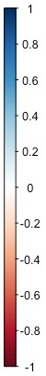
 | ADHD | CD | ASPD | AUD | OUD | CUD
1 | 1.00 | 0.50  (0.11) | 0.51  (0.09) | 0.50  (0.06) | 0.57  (0.12) | 0.52  (0.06)
2 |  | 1.00 | 0.68  (0.26) | 0.60  (0.16) | 0.86  (0.33) | 0.52  (0.13)
3 |  |  | 1.00 | 0.87  (0.14) | 0.21  (0.29) | 0.58  (0.12)
4 |  |  |  | 1.00 | 0.86  (0.17) | 0.71  (0.07)
5 |  |  |  |  | 1.00 | 0.71  (0.14)
6 |  |  |  |  |  | 1.00

Supplementary Figure S1. Genetic correlation matrix of attention deficit hyperactivity disorder (ADHD), conduct disorder (CD), antisocial personality disorder (ASPD), alcohol use disorder (AUD), opioid use disorder (OUD) and cannabinoid use disorder (CUD).

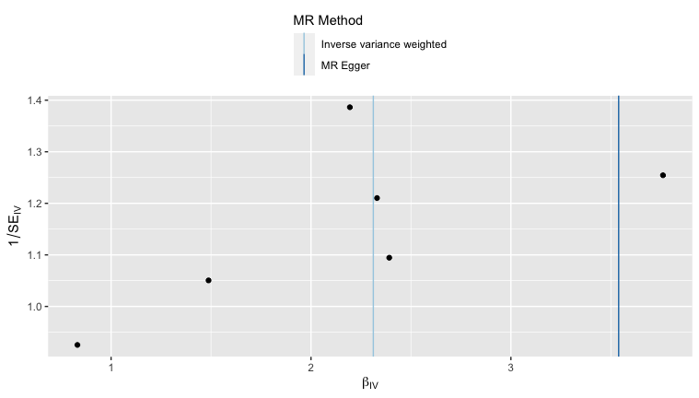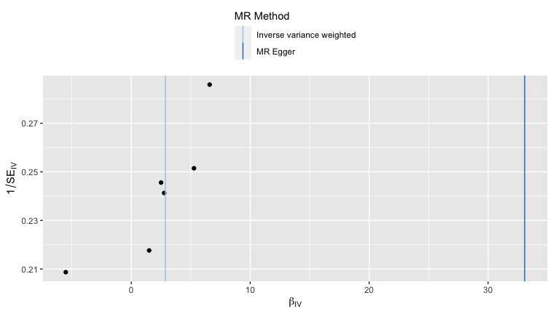
B
A
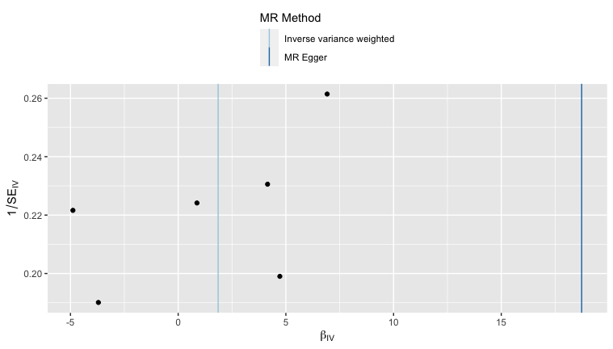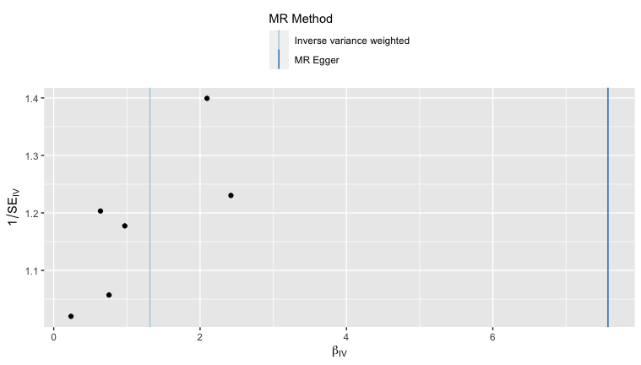
C
D
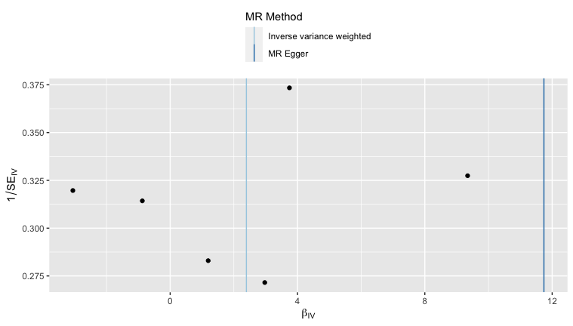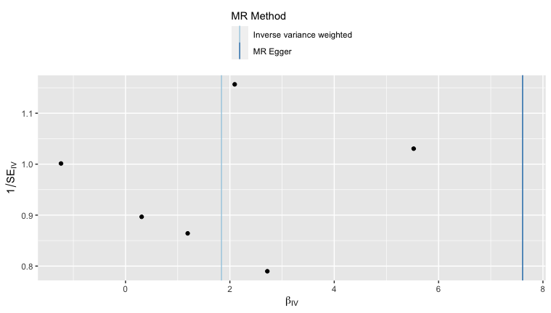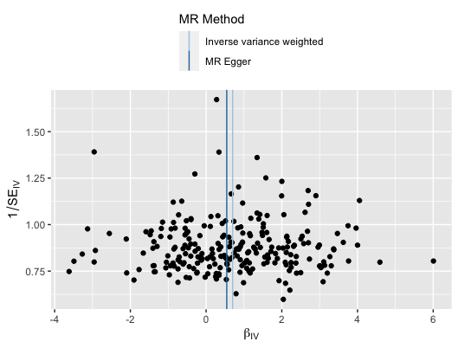
E
F
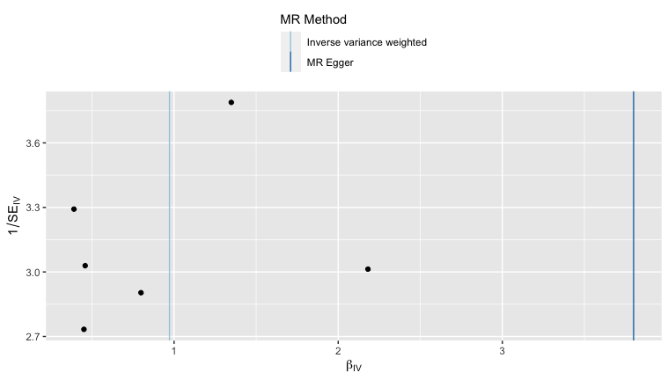
G

Supplementary Figure S2. Funnel plots showing relationship between the SNP associations with childhood maltreatment and the SNP associations with (A) attention deficit hyperactivity disorder, (B) associations with conduct disorder, (C) associations with antisocial personality disorder, (D) associations with alcohol use disorder, (E) associations with opioid use disorder, (F) associations with cannabinoid use disorder and SNP associations with the (G) externalizing factor.
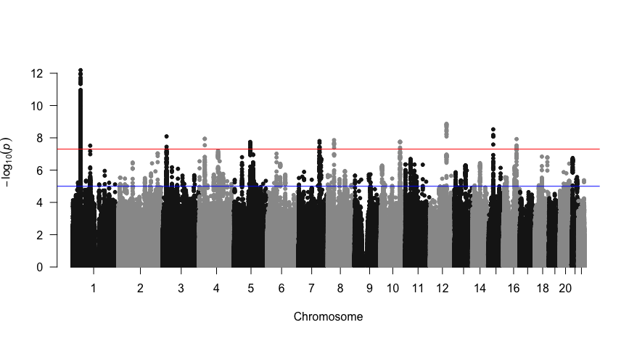
ADHD
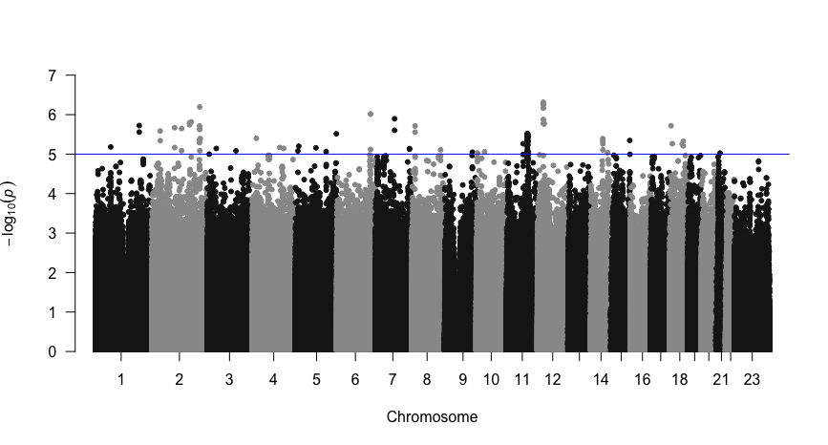
CD
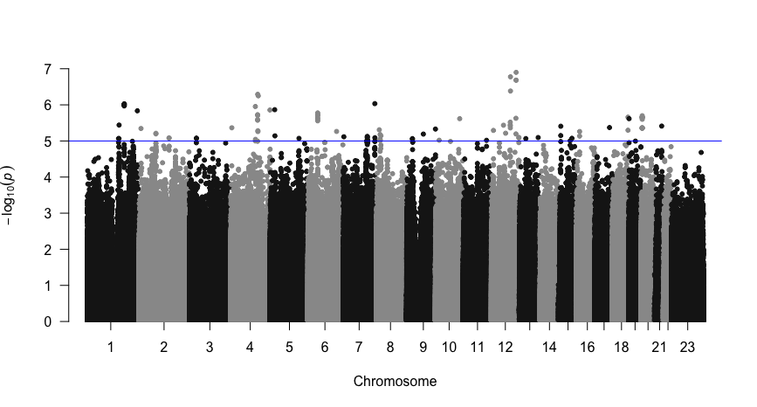
ASPD

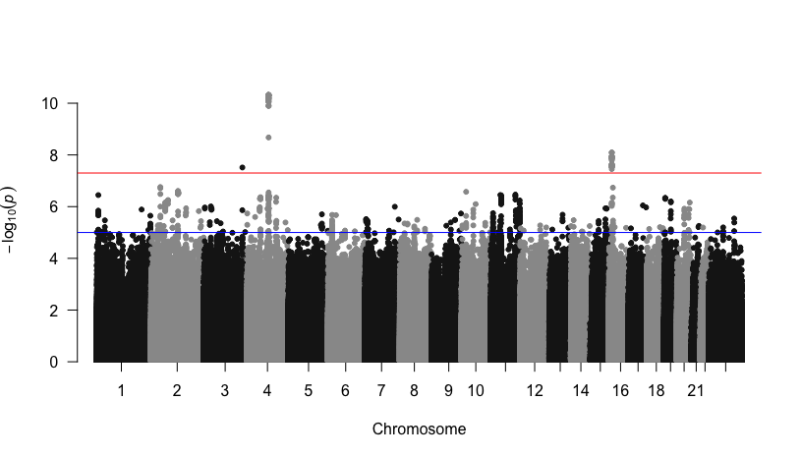
AUD
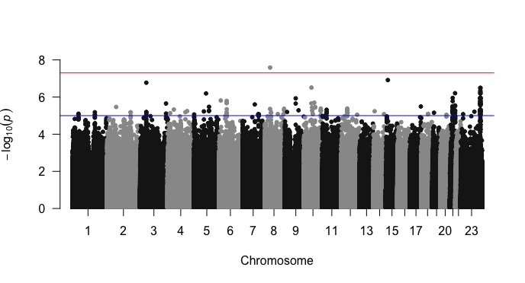
OUD
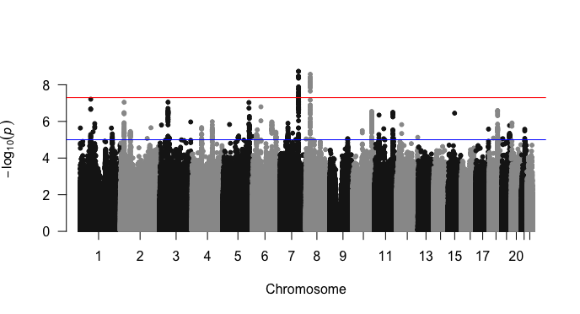
CUD

Supplementary Figure S3. Manhattan plots of GWAS for attention deficit hyperactivity disorder (ADHD), conduct disorder (CD), antisocial personality disorder (ASPD), alcohol use disorder (AUD), opioid use disorder (OUD), and cannabinoid use disorder (CUD).
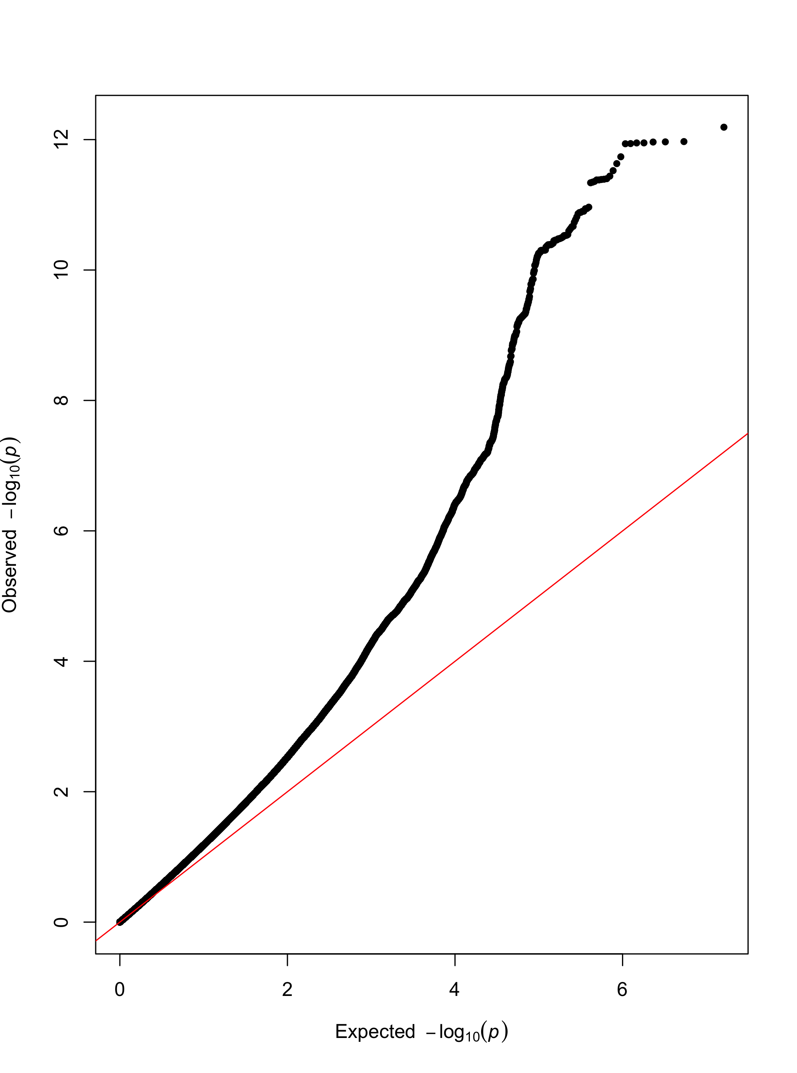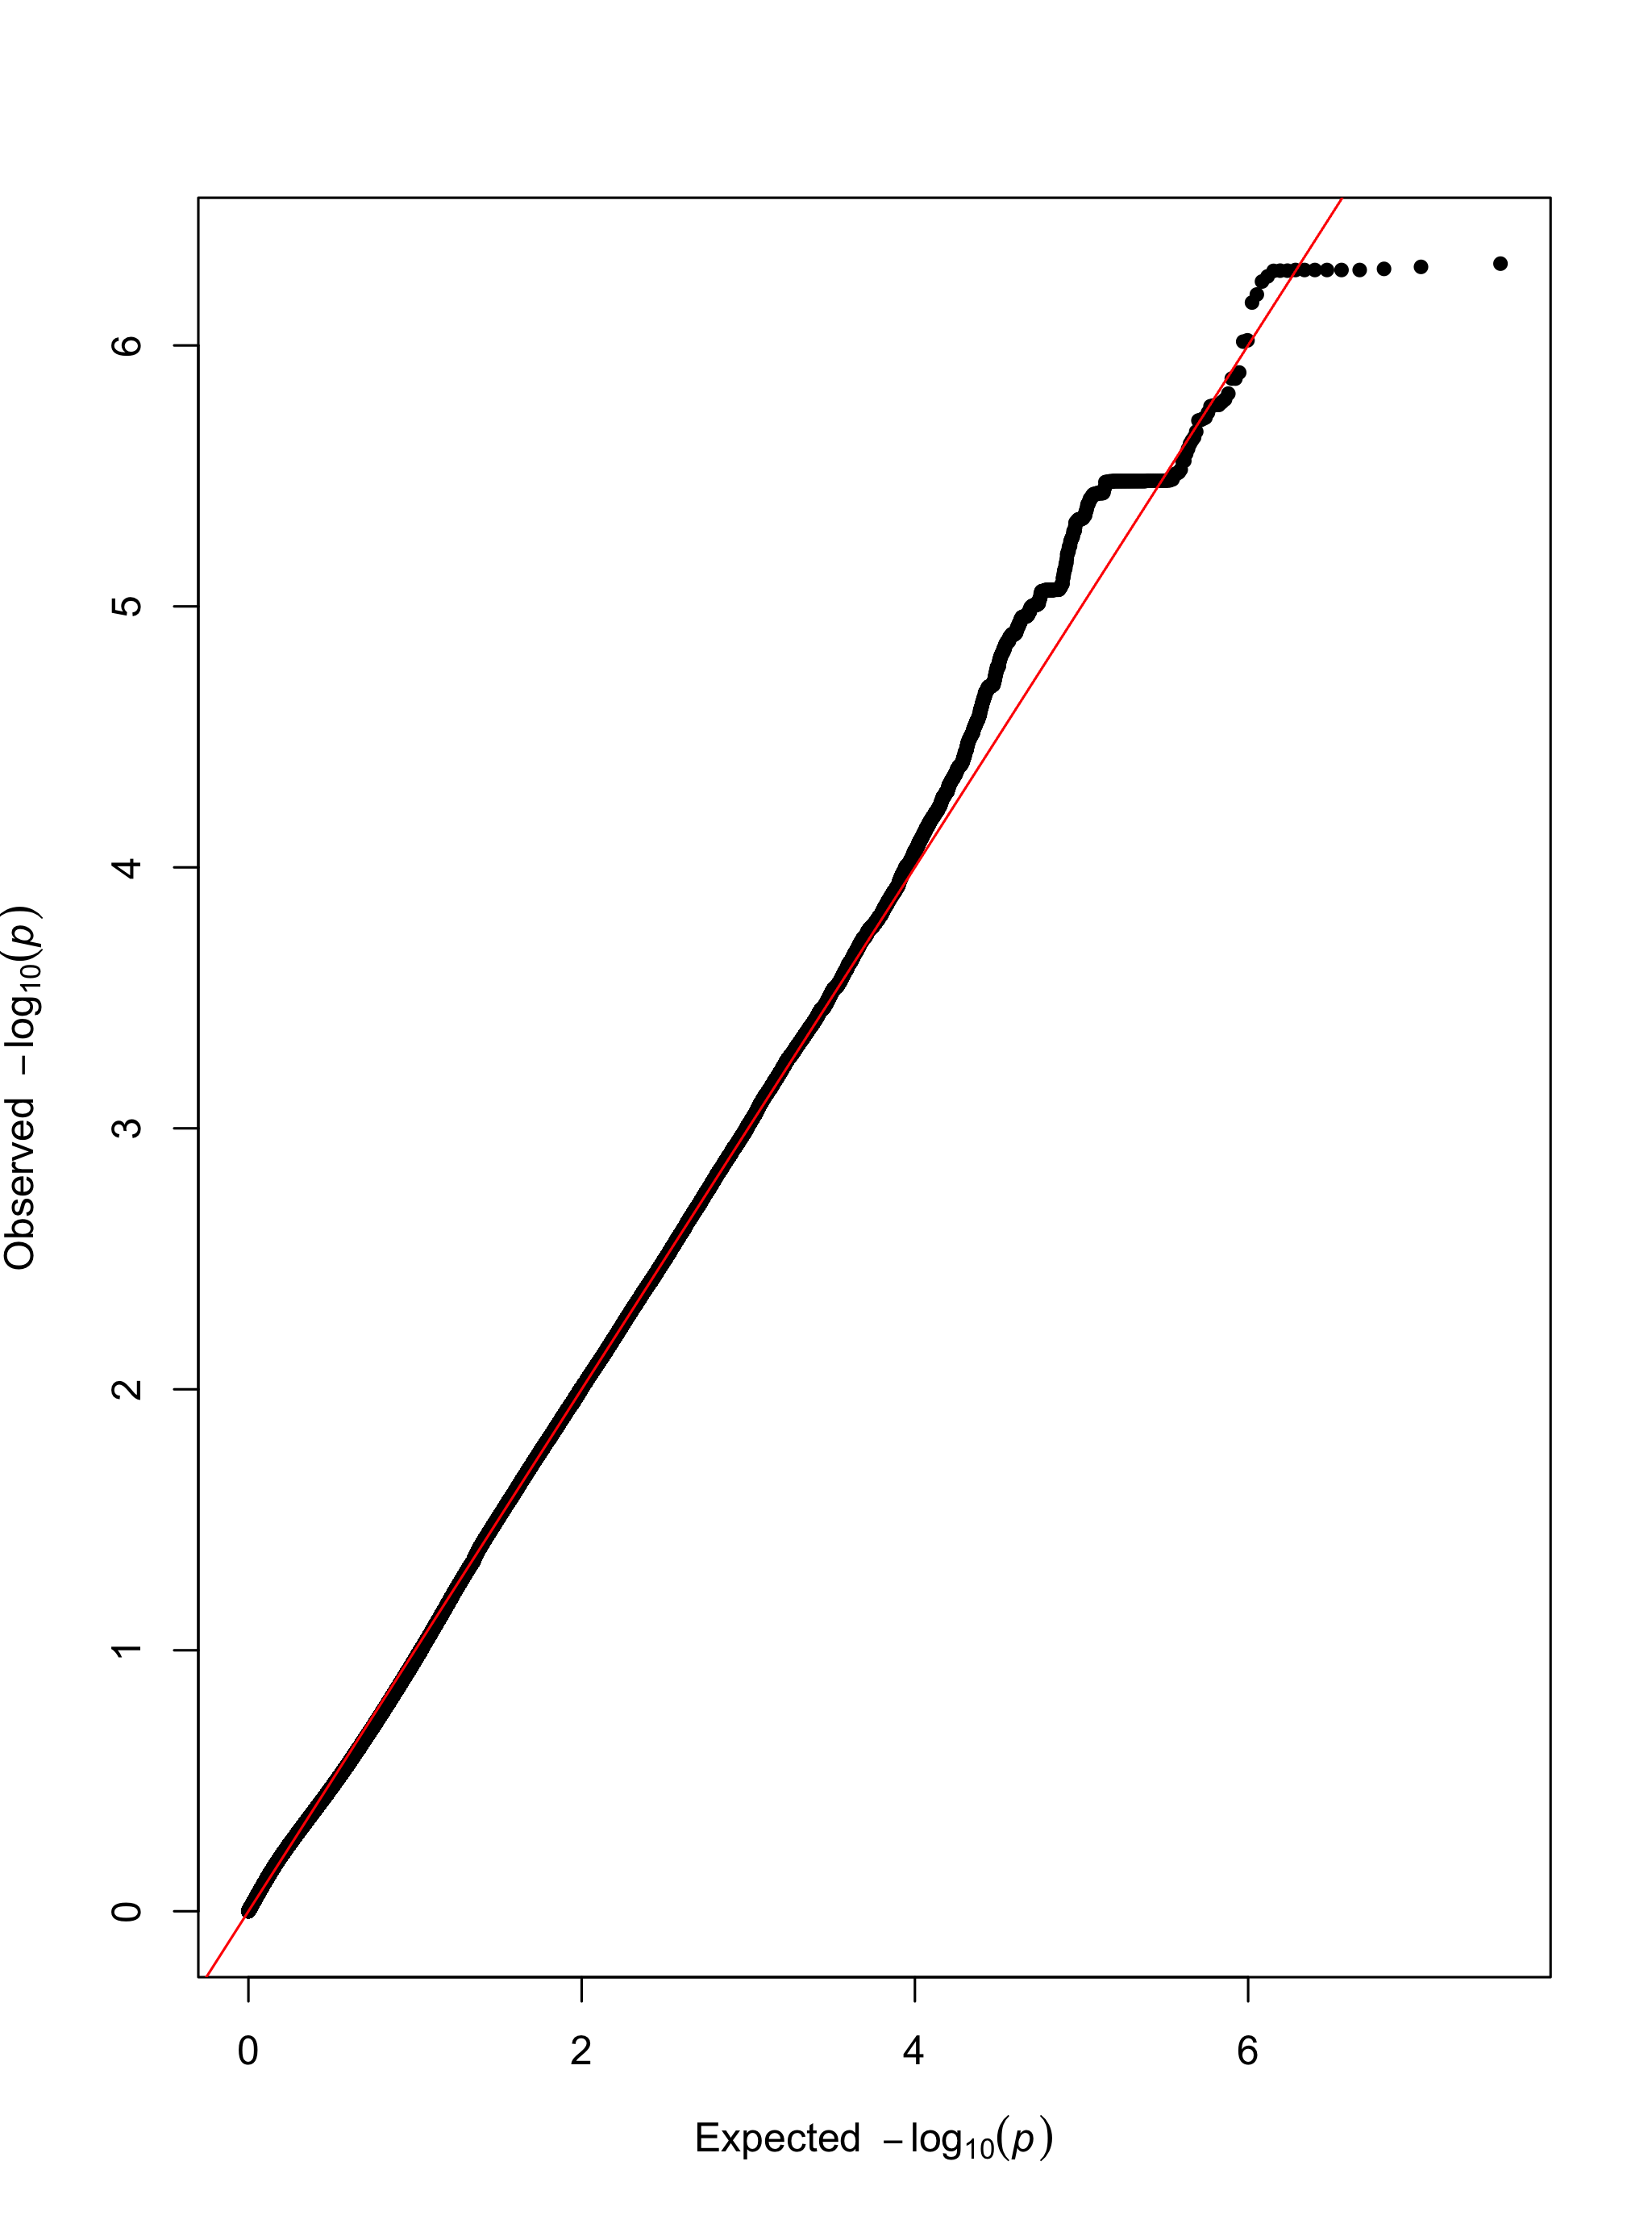
ADHD
CD
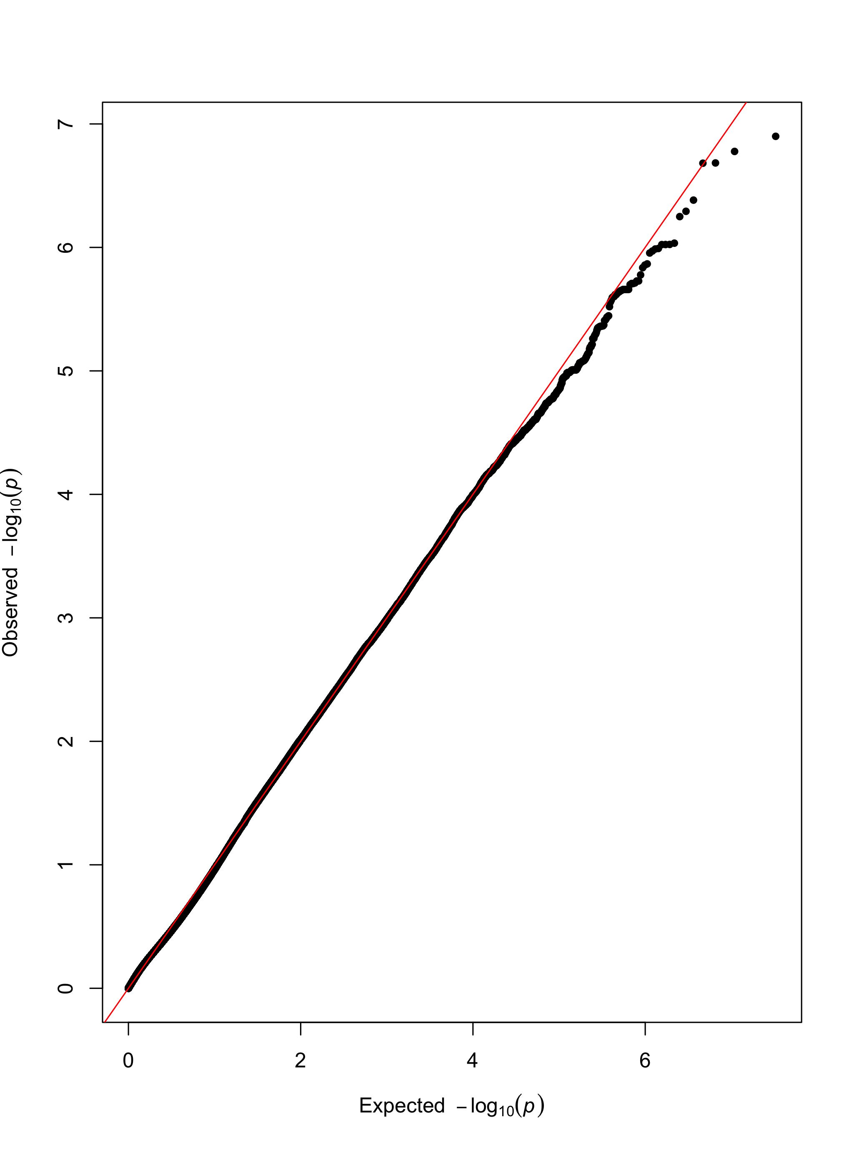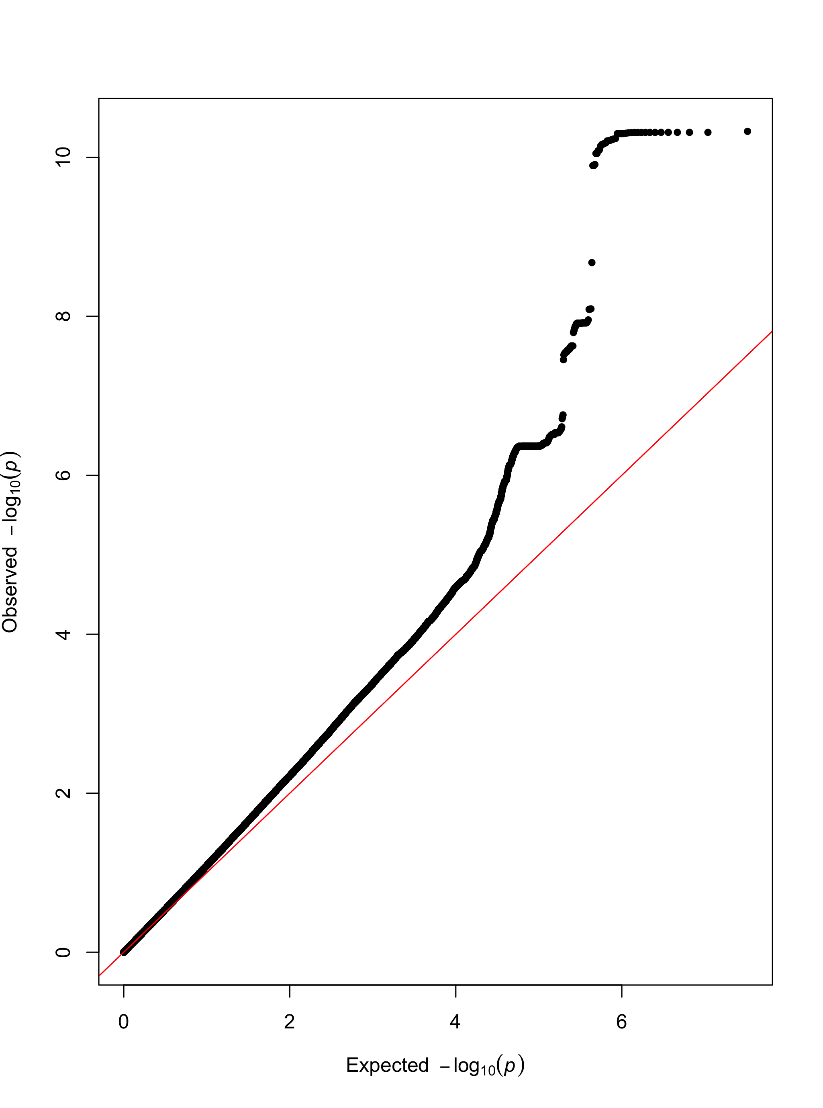
ASPD
AUD
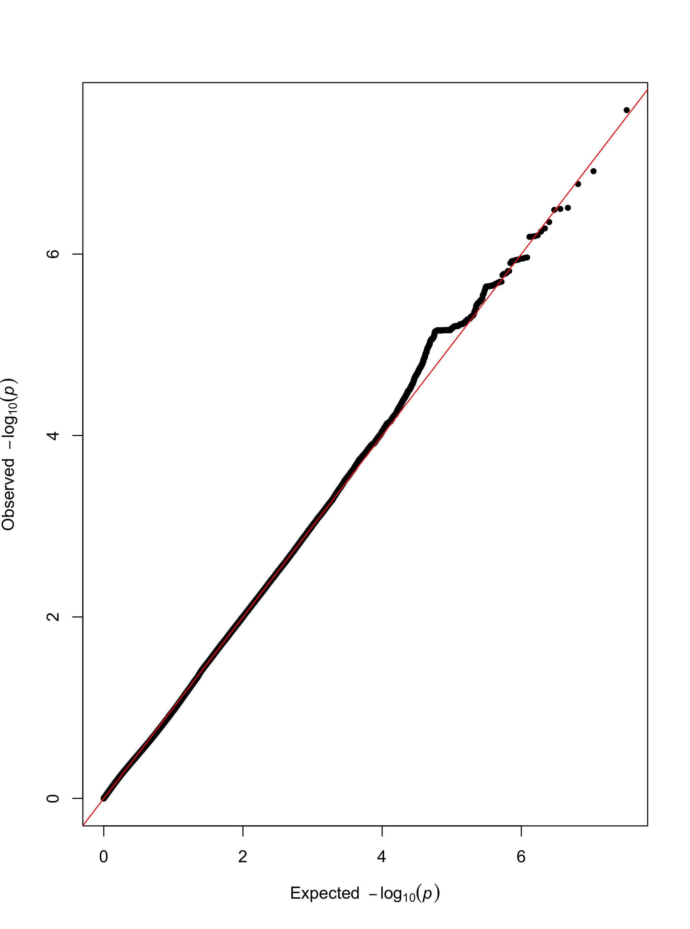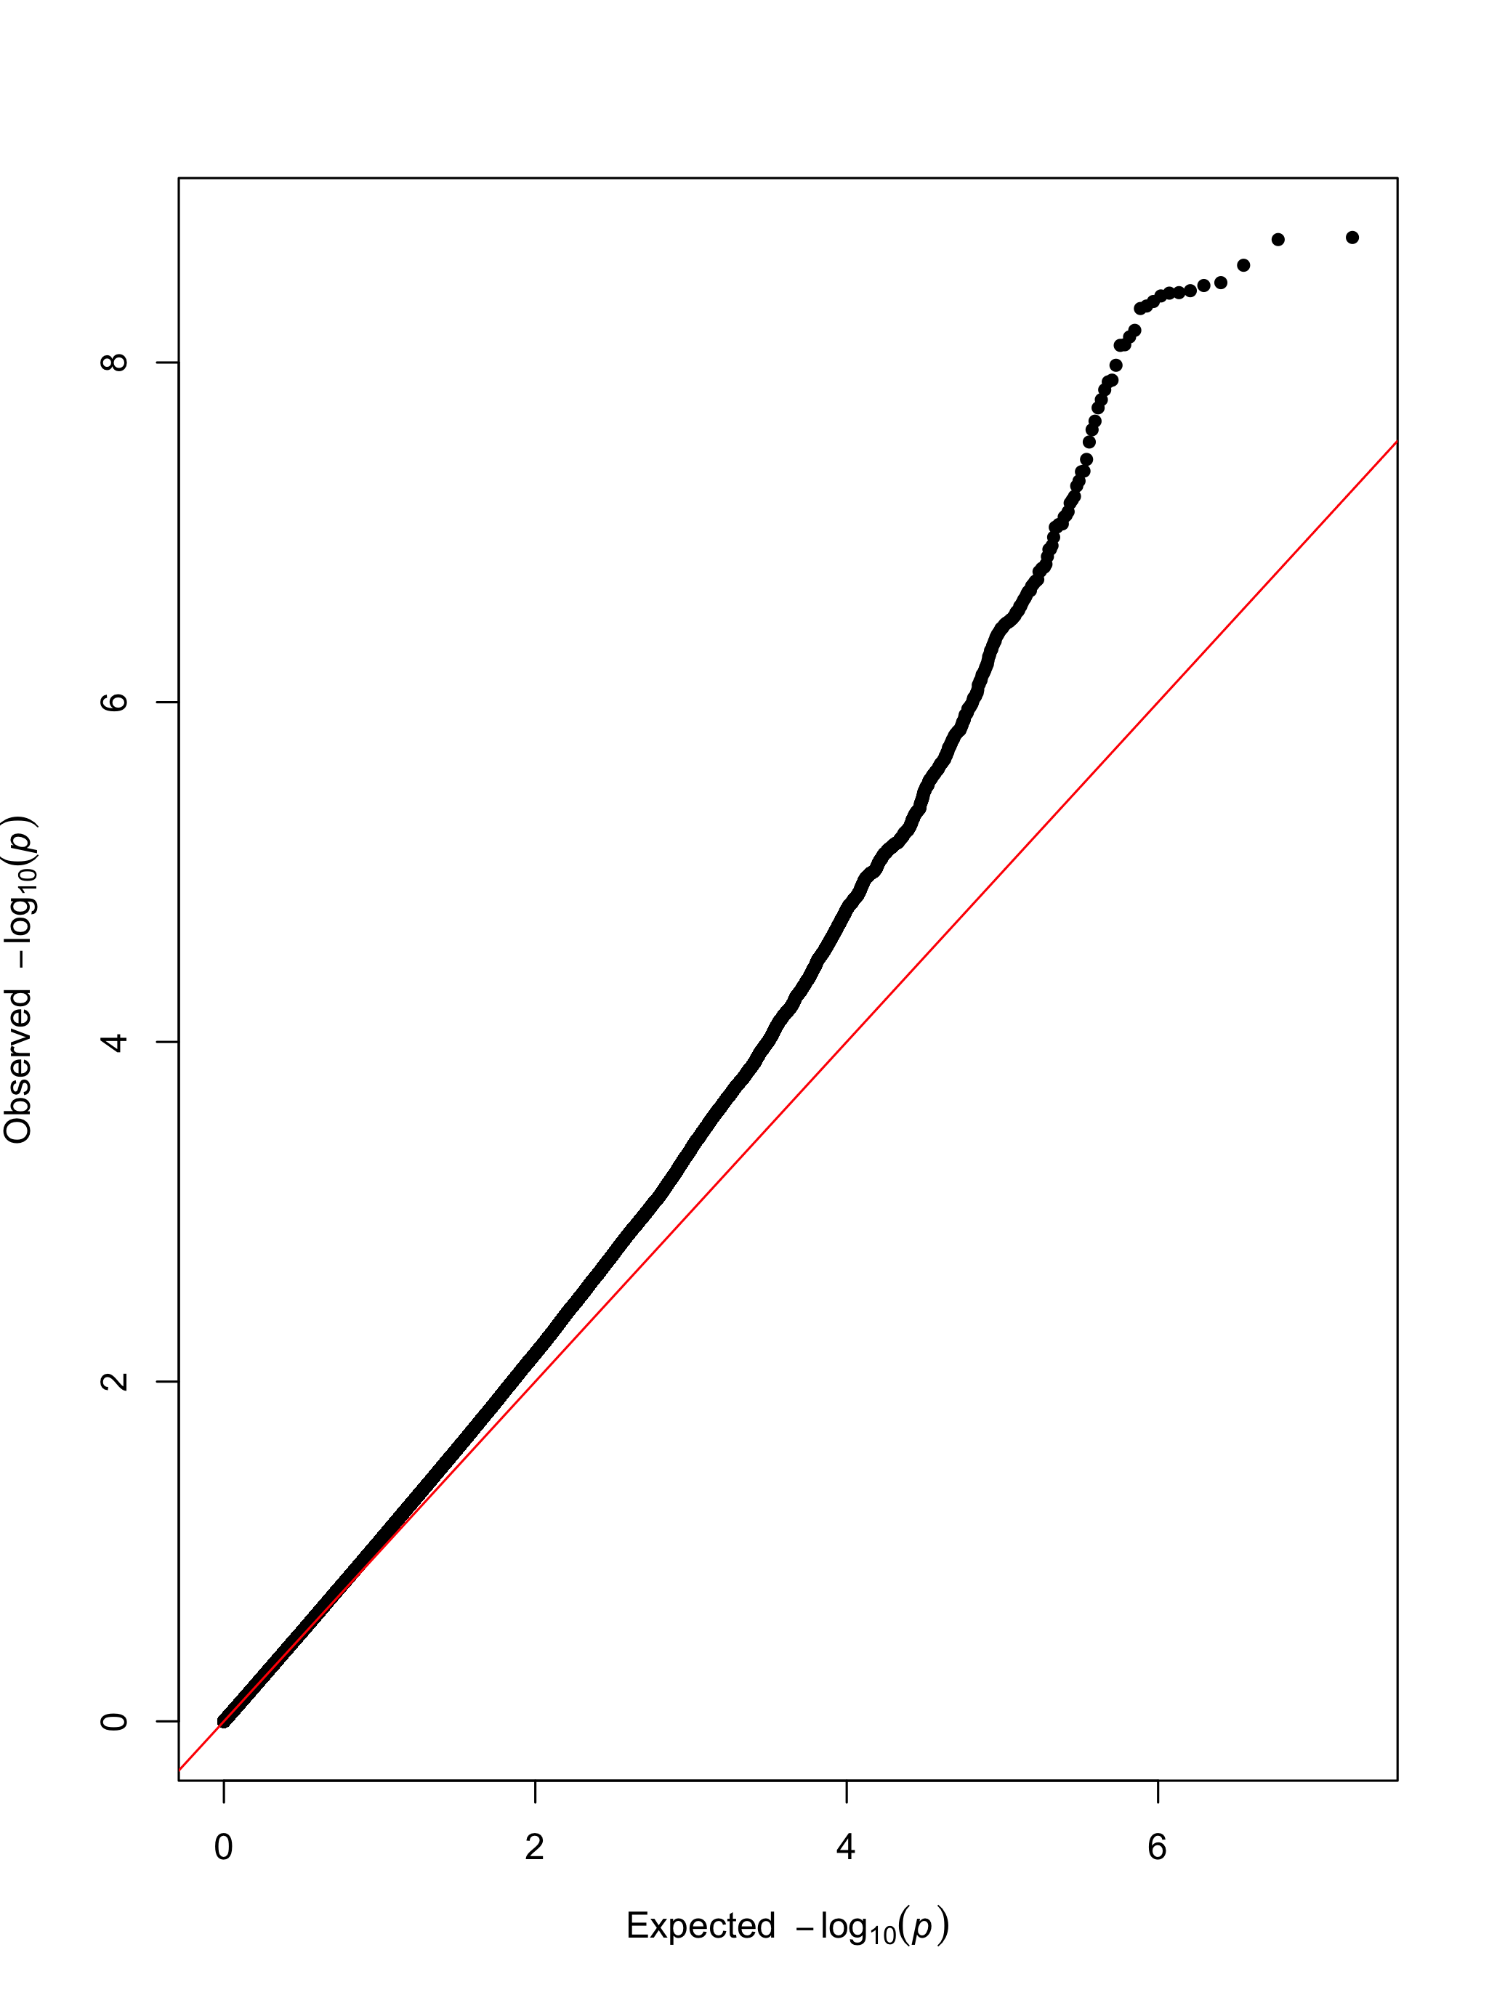
CUD
OUD
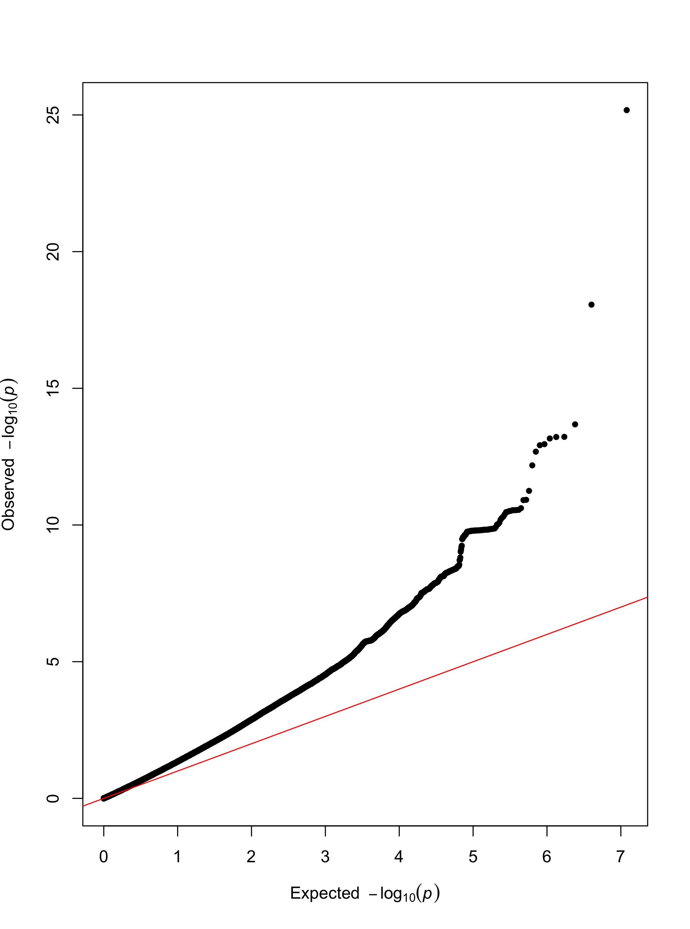
EXT

Supplementary Figure S4. Q-Q plots of GWAS for attention deficit hyperactivity disorder (ADHD), conduct disorder (CD), antisocial personality disorder (ASPD), alcohol use disorder (AUD), opioid use disorder (OUD), cannabinoid use disorder (CUD) and the externalizing factor (EXT).

References
1. Warrier V, Kwong AS, Luo M, Dalvie S, Croft J, Sallis HM, et al. Gene-environment correlations and causal effects of childhood maltreatment on physical and mental health: a genetically informed approach. Lancet Psychiatry. 2021;8:373-86.
2. Demontis D, Walters RK, Martin J, Mattheisen M, Als TD, Agerbo E, et al. Discovery of the first genome-wide significant risk loci for attention deficit/hyperactivity disorder. Nat Genet. 2019;51:63-75.
3. Kurki MI, Karjalainen J, Palta P, Sipilä TP, Kristiansson K, Donner K, et al. FinnGen: Unique genetic insights from combining isolated population and national health register data. medRxiv. 2022.
4. Johnson EC, Demontis D, Thorgeirsson TE, Walters RK, Polimanti R, Hatoum AS, et al. A large-scale genome-wide association study meta-analysis of cannabis use disorder. Lancet Psychiatry. 2020;7:1032-45.

