Peripheral innate immunophenotype in neurodegenerative disease: blood-based profiles and links to survival

Alexandra Strauss¹, Peter Swann², Stacey L Kigar^{2,3}, Rafailia Christou¹, Natalia Savinykh Yarkoni³, Lorinda Turner^{2,3}, Alexander G Murley¹, Leonidas Chouliaras², Noah Shapiro¹, Nicholas J Ashton^{4,5,6}, George Savulich², W Richard Bevan-Jones², Ajenthan Surendranthan², Kaj Blennow ^{4,7}, Henrik Zetterberg ^{4,7,8,9,10,11}, John T O’Brien², James B Rowe^{1,12},
Maura Malpetti^{1,13}

1 University of Cambridge Department of Clinical Neurosciences and Cambridge University Hospitals NHS Trust, Cambridge, United Kingdom
2 Department of Psychiatry, University of Cambridge, Cambridge, United Kingdom
3 Department of Medicine, University Cambridge, Cambridge, United Kingdom
4 Department of Psychiatry and Neurochemistry, University of Gothenburg, Gothenburg, Sweden
5 Banner Alzheimer's Institute and University of Arizona, Phoenix, AZ, USA
6 Banner Sun Health Research Institute, Sun City, AZ 85351, USA5
7 Clinical Neurochemistry Laboratory, Sahlgrenska University Hospital, Mölndal, Sweden
8 Department of Neurodegenerative Disease, UCL Institute of Neurology, Queen Square, London, UK
9 UK Dementia Research Institute at UCL, London, UK
10 Hong Kong Center for Neurodegenerative Diseases, Clear Water Bay, Hong Kong, China
11 Wisconsin Alzheimer’s Disease Research Center, University of Wisconsin School of Medicine and Public Health, University of Wisconsin-Madison, Madison, WI, USA
12 Medical Research Council Cognition and Brain Sciences Unit, Cambridge, United Kingdom
13 UK Dementia Research Institute at University of Cambridge, Cambridge CB2 0XY, UK

Corresponding Author:
Dr. Maura Malpetti
Department of Clinical Neurosciences
University of Cambridge
Herchel Smith Building, Forvie Site Robinson Way,
Cambridge Biomedical Campus Cambridge
CB2 0SZ
Email: mm2243@medschl.cam.ac.uk

Supplementary Figures

Figure S1. Graphic showing cell types in the study. Red arrows indicate the parent population that each raw cell below was divided by to yield the ratio value used for analysis. Grey populations were not considered in this analysis.

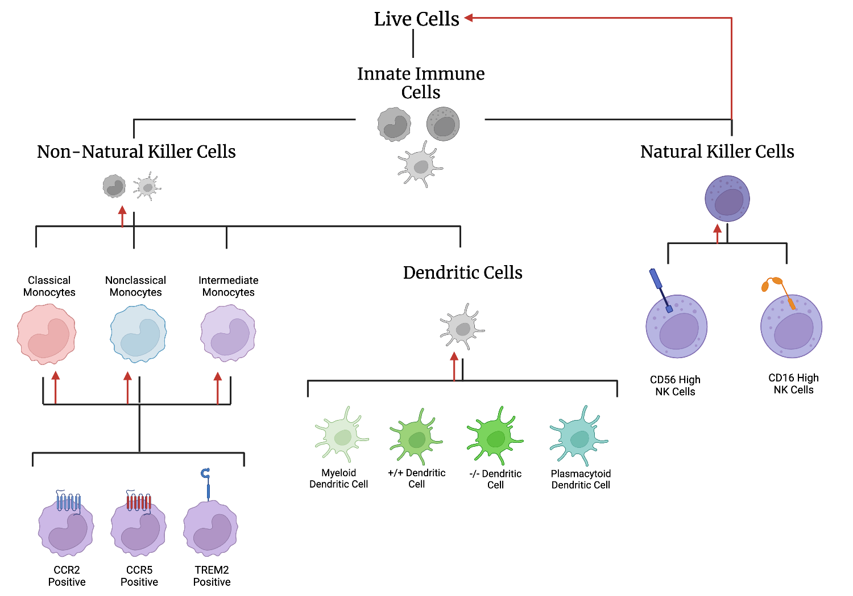

Figure S2. Gating Strategy for Flow Cytometry analysis. Samples were first evaluated for compliance by gating a continuous column flow over time. Next, all live cells were sectioned. B and T cells were eliminated by selecting cells negative for CD3, CD19, and CD20.

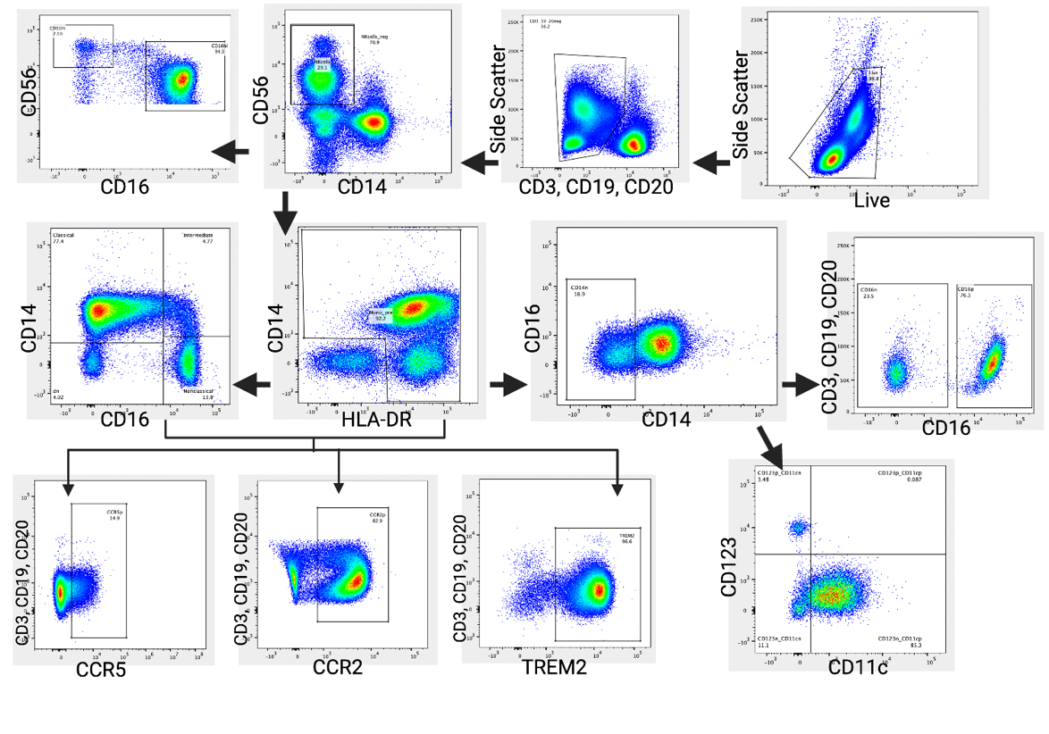

Figure S3. Visual Verification of Gating Strategy. Ten patients were selected and gated by three distinct raters. In addition to ICC analysis, gates that were visually inconsistent were revisited and the strategy was agreed upon between the three raters before continuing with analysis. (e.g. Gater 3 had consistently different values past figure S3.23 which were addressed).

Figure S4. Scree plot from PCA computed following the removal of outliers. 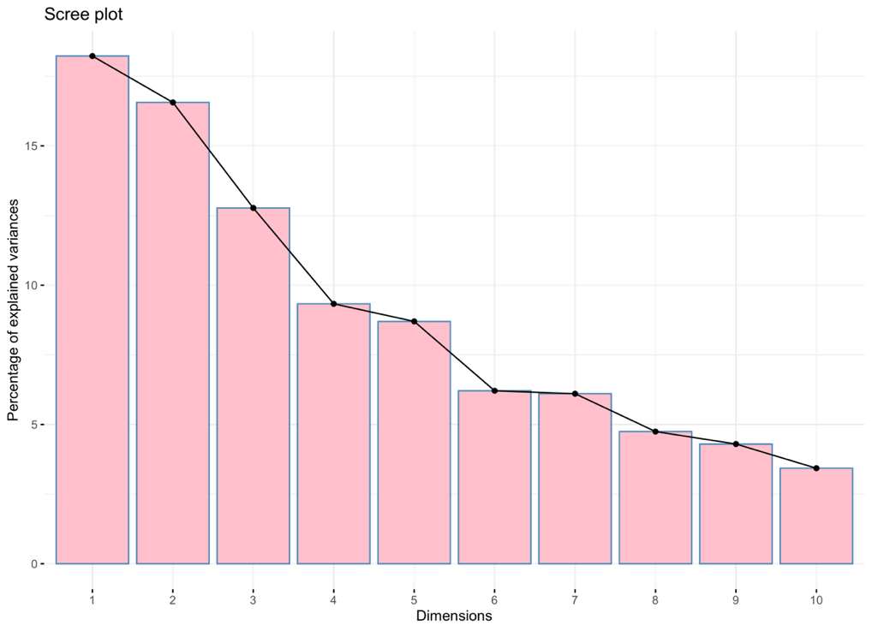

Figure S5. Median prevalence of innate immune cells (as a ratio of parent population) between dementia patients and controls. * indicates statistical significance following FDR correction, + indicated statistical significance prior to FDR correction.

Figure S6. Median prevalence of innate immune cells (as a ratio of parent population) between AD, FTD, PSP, LBD, CBS, and controls. * indicates statistical significance following FDR correction, + indicated statistical significance prior to FDR correction.
Figure S7. Comparing component outputs following removal of participants with hsCRP >10mg/L. Innate immune cell-derived principal components (PC) and correlation on individual scores obtained from the full cohort (n=185) and the reduced cohort (n=182) after excluding participants with confirmed hsCRP > 10 mg/L.

Supplementary Tables

Table S1. Antibodies, blocking reagent, and viability marker used in this study

Antibody | Vendor | Catalogue
CD56-FITC | eBioscience | 11-0566-42
CD123-PerCP/Cy5.5 | eBioscience | 45-1239-42
TREM2-PE  or  Rat IgG2B-PE (iso) | R&D Systems | FAB17291P  or  IC013P
CD11c-PE/Vio770 | Miltenyi Biotec | 130-113-581
CCR5-AlexaFluor647 | eBioscience | 313712
CD20-APC/Cy7 | eBioscience | 47-0209-42
CD19-APC/Cy7 | eBioscience | 47-0199-42
CD3-APC/Cy7 | BioLegend | 317342
CCR2-BV421 | BioLegend | 357210
CD14-BV605 | BioLegend | 301834
CD16-BV650 | BioLegend | 302042
HLADR-BV785 | BioLegend | 307642
Live/Dead Aqua | Thermo Fisher | L34957

Table S2. ICC Results across major gates. The gating strategy was validated between three distinct raters using the same gating strategy individually for 10 shared samples. Inter-rater correlation was assessed graphically as well as mathematically using intraclass correlation coefficient (ICC) analysis: ICC 2,1 (Shrout and Fleiss, 1979). Classical Monocyte and Nonclassical Monocyte inconsistencies were evaluated and normalized prior to continuing with the analysis. The ICC value upon adjustment is also reported.

Gate | ICC Value
Live | 0.96
Innate Cells | 0.96
Natural Killer Cells | 0.95
Non-Natural Killer Cells | 0.97
Dendritic Cells | 0.95
Classical Monocytes | 0.54 -> 0.91
Intermediate Monocytes | 0.9
Nonclassical Monocytes | 0.12 -> 0.9

Table S3. Individual cell type percent contribution to principal component (PC) 1, 2, and 3.

Cell Type | PC1 | PC2 | PC3
TREM2+ Classical Monocytes | 17.55 | 1.27 | 4.95
TREM2+ Nonclassical Monocytes | 17.07 | 2.79 | 7.03
TREM2+ Intermediate Monocytes | 14.99 | 3.51 | 8.52
Classical Monocytes | 11.39 | 1.31 | 3.18
Nonclassical Monocytes | 9.16 | 0.25 | 3.63
CCR2+ Nonclassical Monocytes | 7.68 | 1.49 | 0.94
CCR2+ Classical Monocytes | 4.88 | 10.93 | 0.09
CD16+ NK Cells | 4.77 | 0.28 | 20.19
DC +/+ | 3.58 | 0.28 | 0.69
DC -/- | 3.46 | 13.03 | 1.14
CCR5+ Classical Monocytes | 1.83 | 3.90 | 2.80
Intermediate Monocytes | 0.97 | 0.24 | 11.22
CCR2+ Intermediate Monocytes | 0.86 | 15.10 | 0.74
CD16- NK Cells | 0.78 | 0.00 | 16.30
CCR5p Intermediate Monocytes | 0.43 | 17.27 | 0.27
NK Cells | 0.32 | 0.05 | 15.20
Plasmacytoid DC | 0.12 | 0.37 | 2.39
Myeloid DC | 0.10 | 12.34 | 0.02
CCR5+ Nonclassical Monocytes | 0.06 | 15.62 | 0.69
NK = Natural Killer, TREM = Triggering Receptor Expressed on Myeloid Cells, DC = Dendritic Cells

Table S4. Results for principal component relationships to Age, Sex, and ACE-R score

 | PC1 | PC2 | PC3
Age Interaction Statistics  Statistic, p-value | f= 0.099,  p = 0.753 | f= 0.1381,  p= 0.711 | f= 0.5979,  p= 0.440
Sex Interaction Statistics  Statistic, p-value | U=3739,  p = 0.281 | U= 4243,  p = 0.742 | U= 3598,  p = 0.141
ACE-R Correlation Statistics  statistic, p-value | f= 0.6024,  p =0.439 | f =0.1903,  p = 0.663 | f= 0.853,  p= 0.357

Table S5. PCA analysis with and without participants with high hsCRP. In a subset of participants (Controls = 10, AD = 1, CBS = 6, FTD = 6, LBD = 15, and PSP = 16), serum was analyzed at the Core Biochemistry Assay Laboratory of Cambridge University Hospitals NHS Foundation Trust. The assay for the high sensitivity c-reactive protein (hsCRP) was carried out using Siemens Dimension EXL autoanalyzer. We identified 3 patients (2 FTD and 1 CBS) with hsCRP >10 mg/L. We recomputed the PCA excluding these 3 participants, the PCA results did not change.

Cell Order | PC1-  Original | PC2-  Original | PC3-  Original | Cell Order | PC1- excluding hsCRP > 10 | PC2- excluding hsCRP > 10 | PC3- excluding hsCRP > 10
Classical TREM2+ | 0.78 | 0.17 | 0.35 | Classical TREM2+ | 0.78 | 0.16 | 0.34
Nonclassical TREM2+ | 0.77 | 0.27 | 0.42 | Nonclassical TREM2+ | 0.78 | 0.26 | 0.41
Intermediate TREM2+ | 0.72 | 0.30 | 0.46 | Intermediate TREM2+ | 0.73 | 0.30 | 0.44
Nonclassical Monocytes | 0.56 | -0.11 | -0.29 | Nonclassical Monocytes | 0.56 | -0.17 | -0.25
Nonclassical CCR2+ | 0.52 | 0.20 | -0.15 | Nonclassical CCR2+ | 0.55 | 0.13 | -0.11
Classical CCR5 + | 0.31 | -0.65 | 0.17 | Classical CCR5 + | 0.32 | 0.29 | -0.25
DC -/- | 0.26 | 0.34 | -0.26 | DC -/- | 0.25 | -0.65 | 0.23
Intermediate Monocytes | 0.19 | 0.09 | -0.52 | Intermediate Monocytes | 0.23 | 0.03 | -0.52
CD16- NK Cell | 0.17 | 0.00 | -0.63 | CD16- NK Cell | 0.18 | -0.06 | -0.64
CCR5+ Nonclassical Monocytes | 0.07 | 0.69 | -0.13 | CCR5+ Nonclassical Monocytes | 0.12 | 0.67 | -0.18
Myeloid DC | -0.03 | 0.62 | 0.02 | Myeloid DC | 0.00 | 0.61 | -0.03
Plasmacytoid DC | -0.06 | -0.09 | -0.24 | CCR5+ Intermediate Monocytes | -0.05 | 0.72 | -0.14
CCR5+ Intermediate Monocytes | -0.10 | 0.73 | -0.08 | Plasmacytoid DC | -0.06 | -0.11 | -0.25
CCR2+ Intermediate Monocytes | -0.11 | -0.04 | 0.61 | CCR2+ Intermediate Monocytes | -0.09 | 0.70 | 0.12
NK Cells | -0.15 | 0.68 | 0.14 | NK Cells | -0.13 | 0.02 | 0.61
DC +/+ | -0.34 | 0.11 | -0.13 | DC +/+ | -0.32 | 0.13 | -0.14
CCR2+ Classical Monocytes | -0.39 | 0.59 | -0.05 | CCR2+ Classical Monocytes | -0.34 | 0.61 | -0.08
CD16 + NK Cell | -0.41 | -0.08 | 0.70 | CD16 + NK Cell | -0.43 | 0.00 | 0.70
Classical Monocytes | -0.62 | 0.22 | 0.28 | Classical Monocytes | -0.62 | 0.29 | 0.21
NK = Natural Killer, TREM = Triggering Receptor Expressed on Myeloid Cells, DC = Dendritic Cells

Table S6. Results for Dunn’s Post hoc analysis in individual PC3 loading. Results for comparisons between each group individual loading in PC3in the three components selected. * Indicates significance at p< 0.05.

 |  | Statistic | P Value | P Value- FDR Corrected
Control | AD | 2.10 | 0.04* | 0.426
Control | CBS | 0.77 | 0.44 | 1
Control | LBD | 2.38 | 0.212 | 0.01*
Control | FTD | 2.41 | 0.0163 | 0.212
Control | PSP | 1.03 | 0.31 | 1
AD | CBS | -1.18 | 0.245 | 1
AD | LBD | 1.05 | 0.286 | 1
AD | FTD | 0.459 | 0.634 | 1
AD | PSP | -1.35 | 0.185 | 1
CBS | LBD | 2.27 | 0.0228 | 0.273
CBS | FTD | 1.55 | 0.121 | 1
CBS | PSP | 0.051 | 0.957 | 1
LBD | FTD | 0.487 | 0.63 | 1
LBD | PSP | -2.69 | 0.00668 | 0.094
FTD | PSP | -1.74 | 0.0816 | 0.816
AD = Alzheimer’s disease, LBD= Lewy Body disease, PSP= Progressive Supranuclear Palsy, FTD = Frontotemporal Dementia

Table S7. Results for pairwise comparisons of each cell type between dementia patients and controls. * Indicate significance at p< 0.05. See Figure S6 for graphical representation of values.

Cell Type | Statistic | P Value | P Value- FDR Corrected
CCR2+ Classical Monocytes | 2265 | 0.09 | 1
CCR5+ Classical Monocytes | 2541 | 0.46 | 1
TREM2+ Classical Monocytes | 2847 | 0.75 | 1
CCR2+ Intermediate Monocytes | 2778 | 0.94 | 1
CCR5+ Intermediate Monocytes | 2745 | 0.97 | 1
TREM2+ Intermediate Monocytes | 2958 | 0.49 | 1
CCR2+ Nonclassical Monocytes | 3857.5 | 1.74E-04** | 0.003306*
CCR5+ Nonclassical Monocytes | 2741.5 | 0.96 | 1
TREM2+ Nonclassical Monocytes | 3016 | 0.37 | 1
DC-/- | 2853 | 0.74 | 1
Myeloid DC | 2711 | 0.87 | 1
Plasmacytoid DC | 3120 | 0.21 | 1
DC+/+ | 2695 | 0.83 | 1
CD16+ NK Cells | 2184 | 0.05 | 0.969
CD16- NK Cells | 3437 | 0.020* | 0.3857
Classical Monocytes | 1805 | 0.0012** | 0.02242*
Intermediate Monocytes | 3075 | 0.27 | 1
Nonclassical Monocytes | 3697 | 0.0013** | 0.02546*
NK Cells | 1988 | 0.0088** | 0.16701
NK = Natural Killer, TREM = Triggering Receptor Expressed on Myeloid Cells, DC = Dendritic Cells

Table S8. Results for Kruskal Wallace comparisons of each cell type between FTD, LBD, PSP, CBS, AD, and Controls. * Indicate significance at p< 0.05. See Figure S7 for graphical representation of values.

Cell Type | Statistic | P value | P FDR corrected | Post-hoc group difference
CCR2+ Classical Monocytes | 10.41 | 0.06 | 1
CCR5+ Classical Monocytes | 7.75 | 0.17 | 1
TREM2+ Classical Monocytes | 10.59 | 0.06 | 1
CCR2+ Intermediate Monocytes | 3.14 | 0.67 | 1
CCR5+ Intermediate Monocytes | 3.70 | 0.59 | 1
TREM2+ Intermediate Monocytes | 8.40 | 0.13 | 1
CCR2+ Nonclassical Monocytes | 23.28 | 2.99E-04 | 0.005 ** | Control > AD (p = 0.01), CBS (p =0.03),  FTD (p = 0.005), PSP (p = 0.01)
CCR5+ Nonclassical Monocytes | 4.54 | 0.47 | 1
TREM2+ Nonclassical Monocytes | 10.35 | 0.06 | 1
DC -/- | 13.75 | 0.017 | 0.32 | FTD >LBD (p =0.031)
Myeloid DC | 12.55 | 0.027 | 0.53 | CBS > LBD (p = 0.03)
Plasmacytoid DC | 9.57 | 0.088 | 1
DC +/+ | 1.31 | 0.93 | 1
CD16+ NK Cells | 9.67 | 0.08 | 1
CD16- NK Cells | 17.60 | 0.003 | 0.06 | Control > LBD (p =0.002), CBS > LBD ( p= 0.03), PSP > LBD (p =0.039)
Classical Monocytes | 20.19 | 0.00115 | 0.02185 * | AD > Control (p < 0.001)
Intermediate Monocytes | 15.21 | 0.0094 | 0.18031 | n.s.
Nonclassical Monocytes | 19.69 | 0.0014 | 0.02717 * | Control > AD (p < 0.0.001)
NK Cells | 12.43 | 0.029 | 0.5586 | LBD > Control (p = 0. 02)
AD = Alzheimer’s disease, LBD= Lewy Body disease, PSP= Progressive Supranuclear Palsy, FTD = Frontotemporal Dementia, NK = Natural Killer

