Supplementary information

Supplementary Table 1. Co-occurrence risk between prior, mutually adjusted ADHD and ASD and later ED
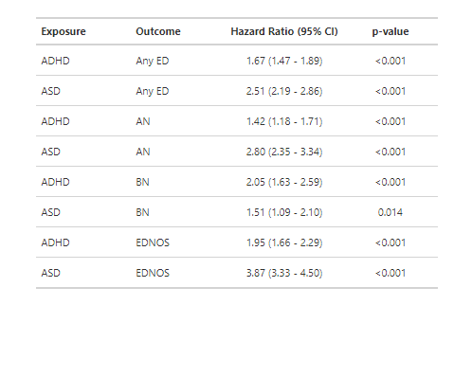

Supplementary Table 2. Time between first and second diagnoses in individuals diagnosed with both an ED and ADHD or ASD, depending on order of diagnoses. Median and interquartile range (IQR), rounded to nearest tens to comply with Danish data protection rules.
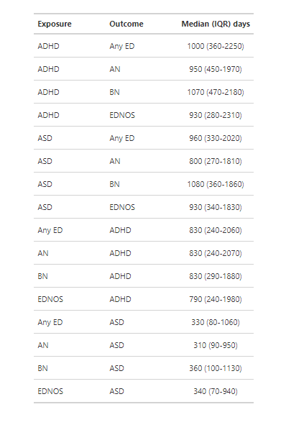

Supplementary Table 3. Associations between EDs and ADHD (narrow definition - diagnoses of F90.0 only)
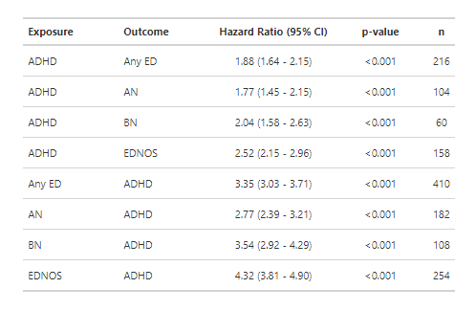

Supplementary Figure 1. Cumulative incidence of included disorders by age and sex.
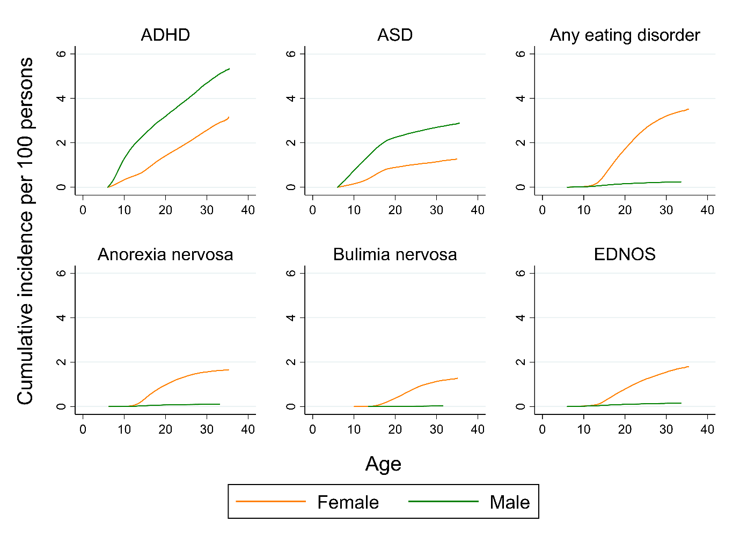

Supplementary Figure 2. A) Hazard ratios for within-individual associations between quintiles of ADHD-PGS or ASD-PGS and diagnosis of AN, with first quintile (i.e., AN cases who are in the bottom 20% for ADHD or ASD PGS) as referent. B) Hazard ratios for within-individual associations between quintiles of AN-PGS and diagnosis of ADHD or ASD, with first quintile (i.e., ADHD or ASD cases who are in the bottom 20% for AN PGS) as referent.

