Supplemental Table and Figure Legends:

Supplemental Table 1: Remission Rates at Treatment Week 5 (based on post treatment HDRS₁₇ of ≤7) eITT Analysis Set
eITT = enriched intent-to-treat; HDRS₁₇ = Hamilton Depression Rating Scale 17. *Total number of patients in the eITT analysis set with evaluable assessments.
Supplemental Table 2: RRS Total Score at Baseline; eITT Analysis Set
Supplemental Table 3: RRS Mean Changes from Baseline; eITT Analysis Set
Supplemental Table 4: Polysomnography: Mean Changes from Lead-in Baseline and Comparison versus Placebo at Treatment Week 3-4 by Treatment; eITT Analysis Set

Supplemental Figure 1: Proportion of Participants Manifesting a Clinical Response as Assessed by 50% Improvement in HDRS₁₇ Total Score; eITT Analysis Set

eITT, enriched intent-to-treat; HDRS17, Hamilton Depression Rating Scale 17; JNJ42847922, seltorexant

Supplemental Table 1: Remission Rates at Treatment Week 5 (based on post treatment HDRS₁₇ of ≤7) eITT Analysis Set
 | Placebo  (N = 30) | Seltorexant, 20mg  (N = 28) | Seltorexant, 40 mg  (N = 28)
N* | 29 | 26 | 24
No remission (%) | 25 (86.2) | 19 (73.1) | 17 (70.8)
Remission (%) | 4 (13.8) | 7 (26.9) | 7 (29.2)

eITT = enriched intent-to-treat; HDRS₁₇ = Hamilton Depression Rating Scale 17. *Total number of patients in the eITT analysis set with evaluable assessments.

Supplemental Table 2: RRS Total Score at Baseline; eITT Analysis Set
 | Placebo  (N=30) | Seltorexant 20 mg  (N=28) | Seltorexant 40 mg  (N=28) | Total  (N=86)
RRS Total Score
N | 30 | 27 | 28 | 85
Mean (SD) | 52.5 (12.05) | 54.7 (14.51) | 53.9 (11.37) | 53.7 (12.56)
Median | 51.0 | 52.0 | 54.0 | 52.0
Range | (23; 87) | (30; 81) | (34; 79) | (23; 87)
Categorized RRS Total Score
N | 30 | 27 | 28 | 85
RRS Total Score >=50 | 18 (60.0%) | 15 (55.6%) | 17 (60.7%) | 50 (58.8%)
RRS Total Score <50 | 12 (40.0%) | 12 (44.4%) | 11 (39.3%) | 35 (41.2%)

Supplemental Table 3: RRS Mean Changes from Baseline; eITT Analysis Set
 |  |  |  |  |  |  |  | Change from Baseline
Parameter  Treatment  Analysis Visit | N | Mean | SE | SD | Median | Min | Max | N | Base  Mean | Mean | SE | SD | Median | Min | Max
RRS Total Score
Placebo (N=30)
Treatment
Baseline | 30 | 52.5 | 2.20 | 12.05 | 51.0 | 23 | 87
Week 1 | 30 | 51.4 | 2.26 | 12.36 | 51.0 | 23 | 88 | 30 | 52.5 | -1.1 | 0.81 | 4.42 | -0.5 | -12 | 6
Week 4 | 28 | 49.6 | 2.58 | 13.67 | 47.0 | 23 | 88 | 28 | 52.7 | -3.1 | 1.05 | 5.55 | -5.0 | -13 | 9
Week 5 | 28 | 48.5 | 2.54 | 13.43 | 46.0 | 22 | 86 | 28 | 52.3 | -3.8 | 1.39 | 7.35 | -4.0 | -21 | 16
End Point | 30 | 48.9 | 2.49 | 13.61 | 46.0 | 22 | 86 | 30 | 52.5 | -3.7 | 1.39 | 7.64 | -4.0 | -21 | 16
Seltorexant 20 mg (N=28)
Treatment
Baseline | 28 | 54.6 | 2.69 | 14.25 | 52.0 | 30 | 81
Week 1 | 27 | 51.9 | 2.42 | 12.58 | 49.0 | 33 | 74 | 27 | 55.4 | -3.5 | 1.81 | 9.41 | -1.0 | -36 | 10
Week 4 | 21 | 47.7 | 3.06 | 14.01 | 48.0 | 26 | 71 | 21 | 50.4 | -2.7 | 1.89 | 8.67 | 0.0 | -24 | 11
Week 5 | 26 | 47.5 | 2.80 | 14.28 | 46.0 | 23 | 81 | 26 | 54.2 | -6.7 | 2.42 | 12.31 | -2.5 | -35 | 11
End Point | 28 | 47.9 | 2.69 | 14.23 | 46.0 | 23 | 81 | 28 | 54.6 | -6.7 | 2.25 | 11.90 | -3.0 | -35 | 11
Seltorexant 40 mg (N=28)
Treatment
Baseline | 28 | 53.9 | 2.15 | 11.37 | 54.0 | 34 | 79
Week 1 | 27 | 49.9 | 2.31 | 11.99 | 47.0 | 32 | 76 | 27 | 53.7 | -3.8 | 1.21 | 6.30 | -3.0 | -19 | 10
Week 4 | 22 | 51.7 | 3.01 | 14.13 | 52.5 | 22 | 76 | 22 | 56.2 | -4.5 | 1.78 | 8.36 | -4.5 | -34 | 5
Week 5 | 24 | 47.2 | 2.85 | 13.97 | 44.5 | 22 | 71 | 24 | 53.9 | -6.7 | 1.93 | 9.45 | -5.5 | -34 | 7
End Point | 28 | 48.4 | 2.68 | 14.20 | 47.5 | 22 | 76 | 28 | 53.9 | -5.5 | 1.77 | 9.36 | -4.5 | -34 | 7

Supplemental Table 4: Polysomnography: Mean Changes from Lead-in Baseline and Comparison versus Placebo at Treatment Week 3-4 by Treatment; eITT Analysis Set
Analysis Visit  PSG Parameter  Treatment | N | Mean Change  from Baseline (SD) | Mean Change  to Placebo  (SD pooled) | 90% CI for Mean  Change to Placebo | Effect  Size
Treatment Week 3/4
Total Sleep Time (TST) (min)
Placebo | 30 | -10.43 (86.533)
Seltorexant 20 mg | 27 | 24.37 (37.583) | 34.80 (67.941) | [-64.05,-5.55] | 0.51
Seltorexant 40 mg | 25 | 30.84 (59.089) | 41.27 (75.354) | [-74.32,-8.22] | 0.55
Sleep Efficiency (EFF) (%)
Placebo | 30 | -2.20 (18.021)
Seltorexant 20 mg | 27 | 5.09 (7.825) | 7.29 (14.149) | [-13.38,-1.20] | 0.52
Seltorexant 40 mg | 25 | 6.47 (12.271) | 8.67 (15.681) | [-15.55,-1.80] | 0.55
Wake After Sleep Onset (WASO) (min)
Placebo | 30 | 1.05 (55.821)
Seltorexant 20 mg | 27 | -13.30 (32.890) | -14.35 (46.415) | [-5.78,34.47] | -0.31
Seltorexant 40 mg | 25 | -17.84 (52.482) | -18.89 (54.334) | [-5.61,43.39] | -0.35
Latency to Persistent Sleep (LPS) (min)
Placebo | 30 | 19.65 (81.047)
Seltorexant 20 mg | 27 | -12.59 (36.918) | -32.24 (64.092) | [4.63,59.86] | -0.50
Seltorexant 40 mg | 25 | -17.36 (26.816) | -37.01 (62.608) | [10.44,63.58] | -0.59
Number of Awakenings
Placebo | 30 | -1.23 (9.637)
Seltorexant 20 mg | 27 | 1.59 (4.932) | 2.83 (7.776) | [-6.18,0.53] | 0.36
Seltorexant 40 mg | 25 | 2.40 (7.483) | 3.63 (8.728) | [-7.50,0.23] | 0.42
Number of REM Blocks
Placebo | 30 | -0.53 (1.332)
Seltorexant 20 mg | 27 | -0.04 (0.980) | 0.50 (1.179) | [-1.01,0.02] | 0.42
Seltorexant 40 mg | 25 | 0.48 (0.918) | 1.01 (1.163) | [-1.52,-0.50] | 0.87
Sleep Onset to R (REM Latency) (min)
Placebo | 29 | -0.57 (64.718)
Seltorexant 20 mg | 27 | -7.17 (34.268) | -6.60 (52.318) | [-16.45,29.64] | -0.13
Seltorexant 40 mg | 25 | -26.00 (44.010) | -25.43 (56.118) | [0.46,50.40] | -0.45
Stage N1 (min)
Placebo | 30 | -4.87 (26.556)
Seltorexant 20 mg | 27 | 0.98 (18.271) | 5.85 (23.014) | [-15.88,4.18] | 0.25
Seltorexant 40 mg | 25 | 8.52 (19.142) | 13.39 (23.490) | [-23.73,-3.04] | 0.57
Stage N2 (min)
Placebo | 30 | 0.50 (55.184)
Seltorexant 20 mg | 27 | 19.20 (33.054) | 18.70 (46.067) | [-38.69,1.28] | 0.41
Seltorexant 40 mg | 25 | 10.72 (34.018) | 10.22 (46.801) | [-30.60,10.16] | 0.22
Stage N3 (Deep Sleep) (min)
Placebo | 30 | -4.22 (35.871)
Seltorexant 20 mg | 27 | -2.24 (26.314) | 1.98 (31.714) | [-15.84,11.88] | 0.06
Seltorexant 40 mg | 25 | 1.12 (31.277) | 5.34 (33.868) | [-20.50,9.83] | 0.16
Stage REM (min)
Placebo | 30 | -1.85 (33.190)
Seltorexant 20 mg | 27 | 6.43 (23.637) | 8.28 (29.068) | [-20.96,4.41] | 0.28
Seltorexant 40 mg | 25 | 10.48 (23.932) | 12.33 (29.362) | [-25.26,0.60] | 0.42
Time First Awakening After Sleep Onset (min)
Placebo | 28 | 25.41 (87.260)
Seltorexant 20 mg | 23 | 19.83 (162.198) | -5.58 (126.520) | [-58.14,69.31] | -0.04
Seltorexant 40 mg | 25 | 46.30 (125.287) | 20.89 (106.854) | [-71.34,29.56] | 0.20
Note: Treatment baseline is defined as Lead-in baseline value.

Supplemental Figure 1: Proportion of Participants Manifesting a Clinical Response as Assessed by 50% Improvement in HDRS₁₇ Total Score; eITT Analysis Set
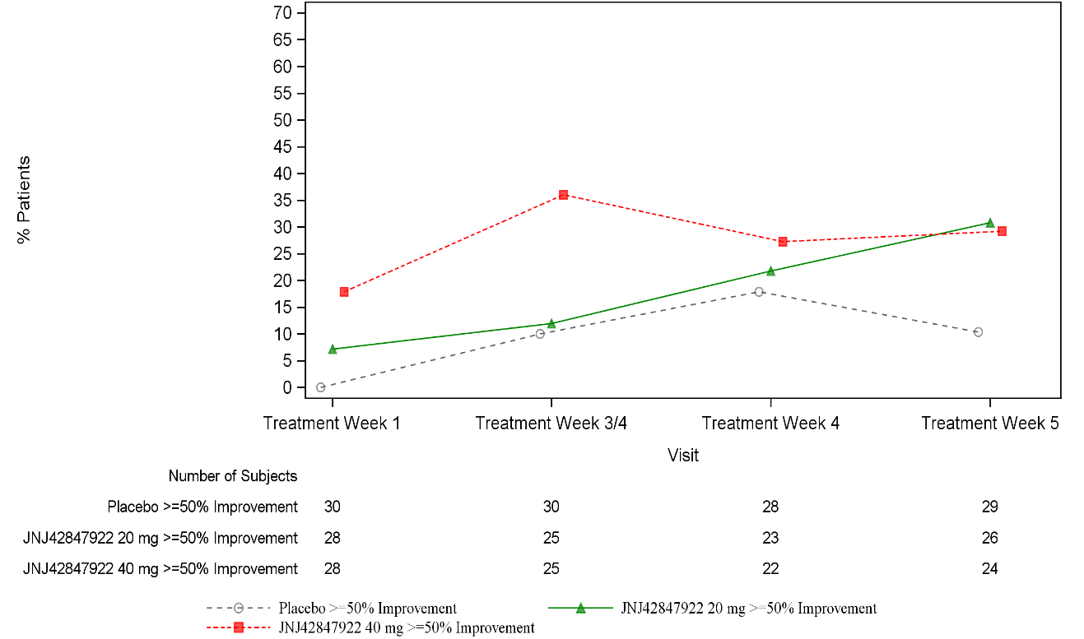

eITT, enriched intent-to-treat; HDRS₁₇, Hamilton Depression Rating Scale 17; JNJ42847922, seltorexant

