Supplemental Information

Gut microbiota regulate insomnia-like behaviors via gut-brain metabolic axis

Supplementary Figures and Figure Legends
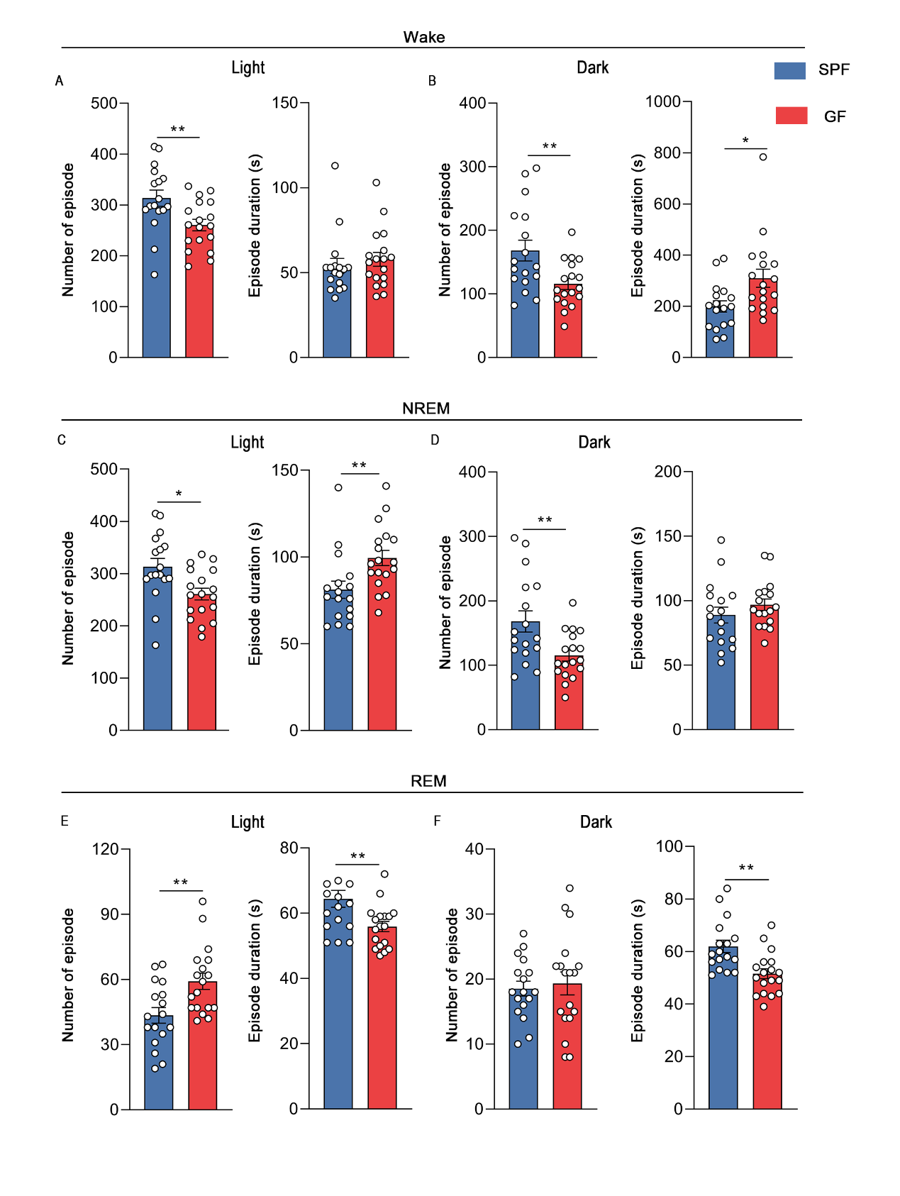 Supplementary Figure 1. Average duration and bout numbers in SPF and GF mice.
(A-B) Episode numbers and average duration of wakefulness during 12-h light phase and 12-h dark phase in SPF and GF mice.
(C-D) Episode numbers and average duration of NREM sleep during 12-h light phase and 12-h dark phase in SPF and GF mice.
(E-F) Episode numbers and average duration of REM sleep during 12-h light phase and 12-h dark phase in SPF and GF mice.
The data are expressed as the mean ± SEM. *p < 0.05, **p < 0.01. n = 17-18. (independent-sample t-test, except for A [Mann-Whitney U test]).
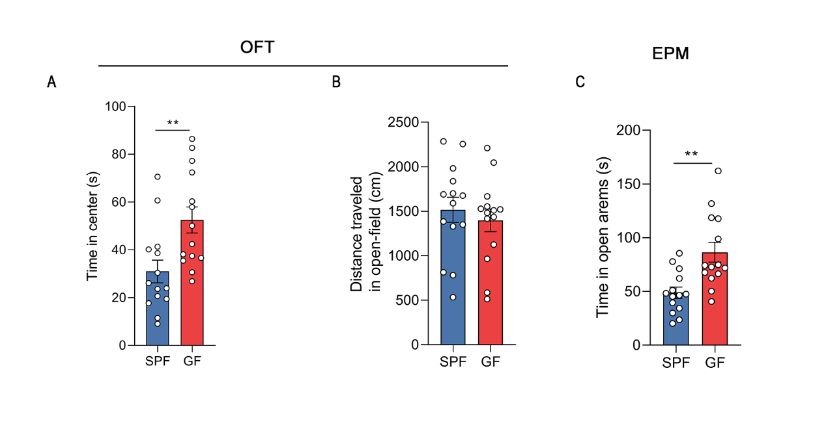
Supplementary Figure 2. Anxiety-like behavior in GF and SPF mice.
(A) Locomotor activity in the open-field test in GF and SPF mice.
(B) Center zone duration in the open-field test in GF and SPF mice.
(C) Open arm duration in the elevated plus maze in GF and SPF mice.
The data are expressed as the mean ± SEM. **p < 0.01. n = 14. (independent-sample t-test, except for C [Mann-Whitney U test]).

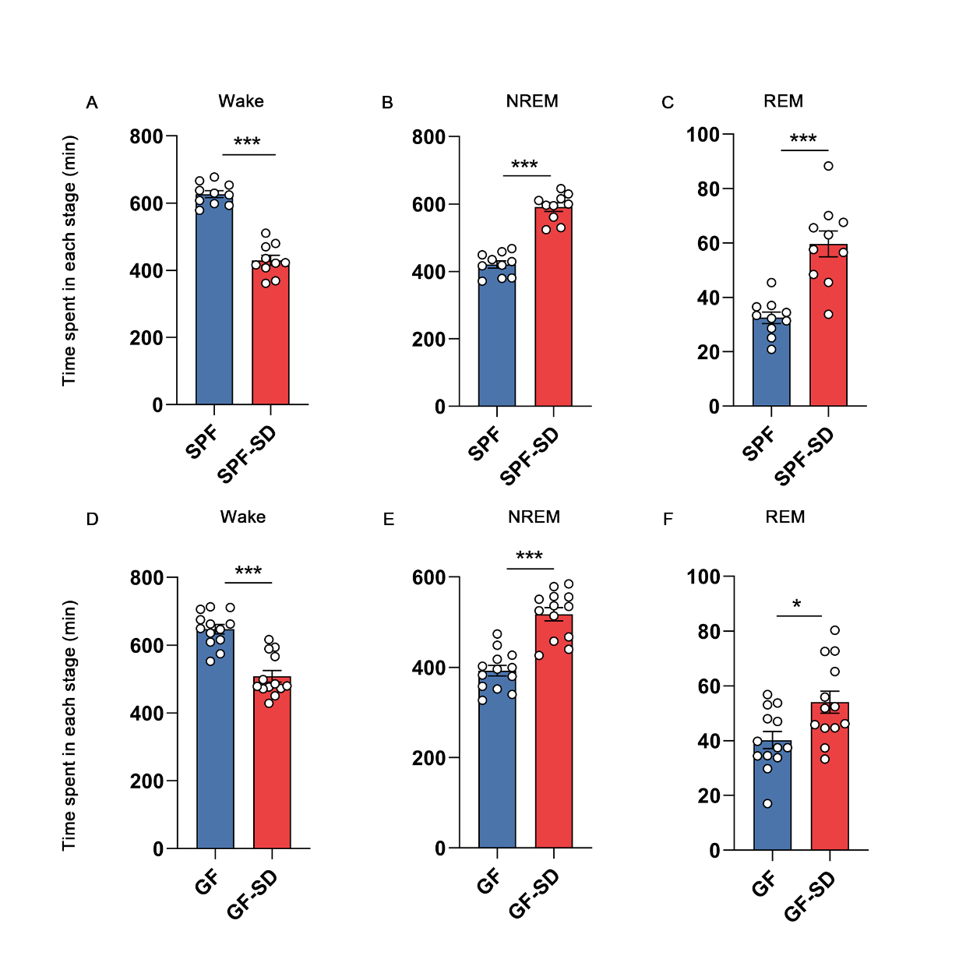
Supplementary Figure 3. Sleep recovery in SPF and GF mice.
(A-C) Time spent in wakefulness (A), NREM sleep (B), and REM sleep (C) under control and SD conditions during ZT6-24 period in SPF mice.
(D-F) Time spent in wakefulness (D), NREM sleep (E), and REM sleep (F) under control and SD conditions during ZT6-24 period in GF mice.
The data are expressed as the mean ± SEM. *p < 0.05, ***p < 0.001. n = 10-13. (independent-sample t-test, except for D [Mann-Whitney U test]).

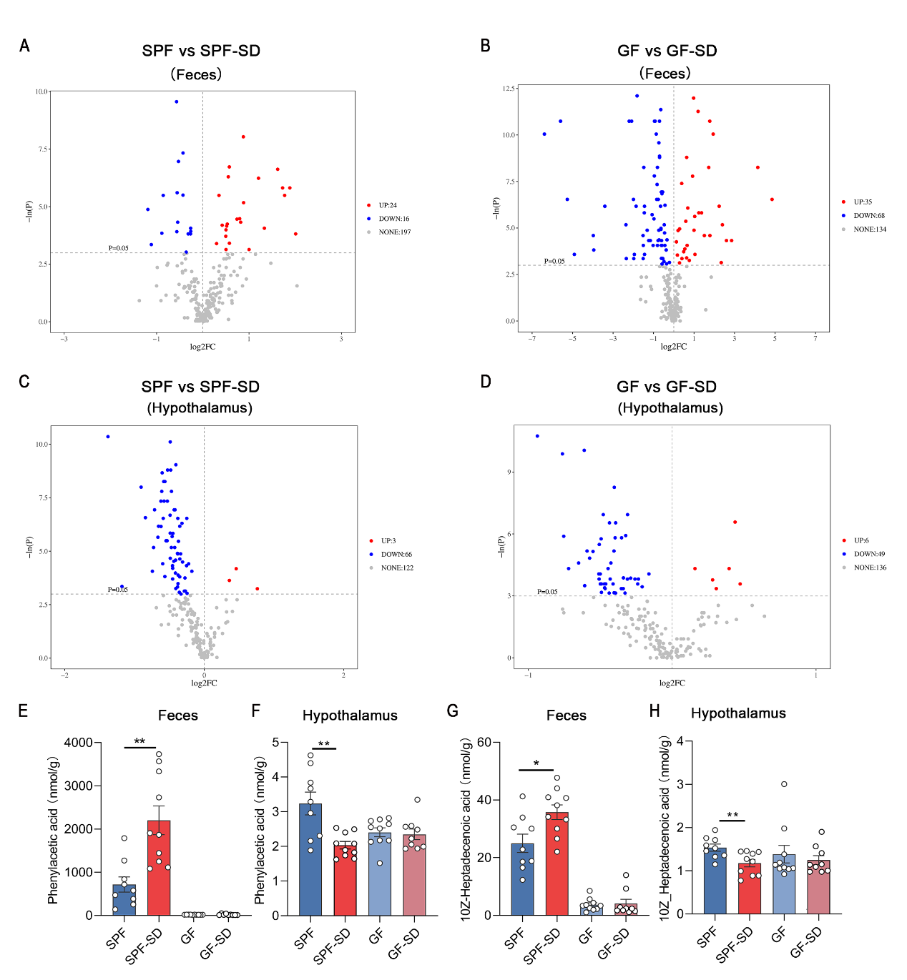
Supplementary Figure 4. Feces and hypothalamus metabolome evaluation of SPF and GF mice after sleep deprivation.
(A-D) Volcano plots of differentially abundant metabolites identified by targeted metabolomics of (A, B) colon contents and (C, D) the hypothalamus by GC-MS.
(E-H) Quantification of phenylacetic acid and 10Z-heptadecenoic acid by LC–MS in colon contents and the hypothalamus in SPF and GF mice.
The data are expressed as the mean ± SEM. *p < 0.05, **p < 0.01. n = 9-10. (independent-sample t-test).

Supplementary Figure 5. Quantification of butyrate by GC-MS in serum from SPF/GF and SD mice.
The data are expressed as the mean ± SEM. *p < 0.05. n = 6. (independent-sample t-test).

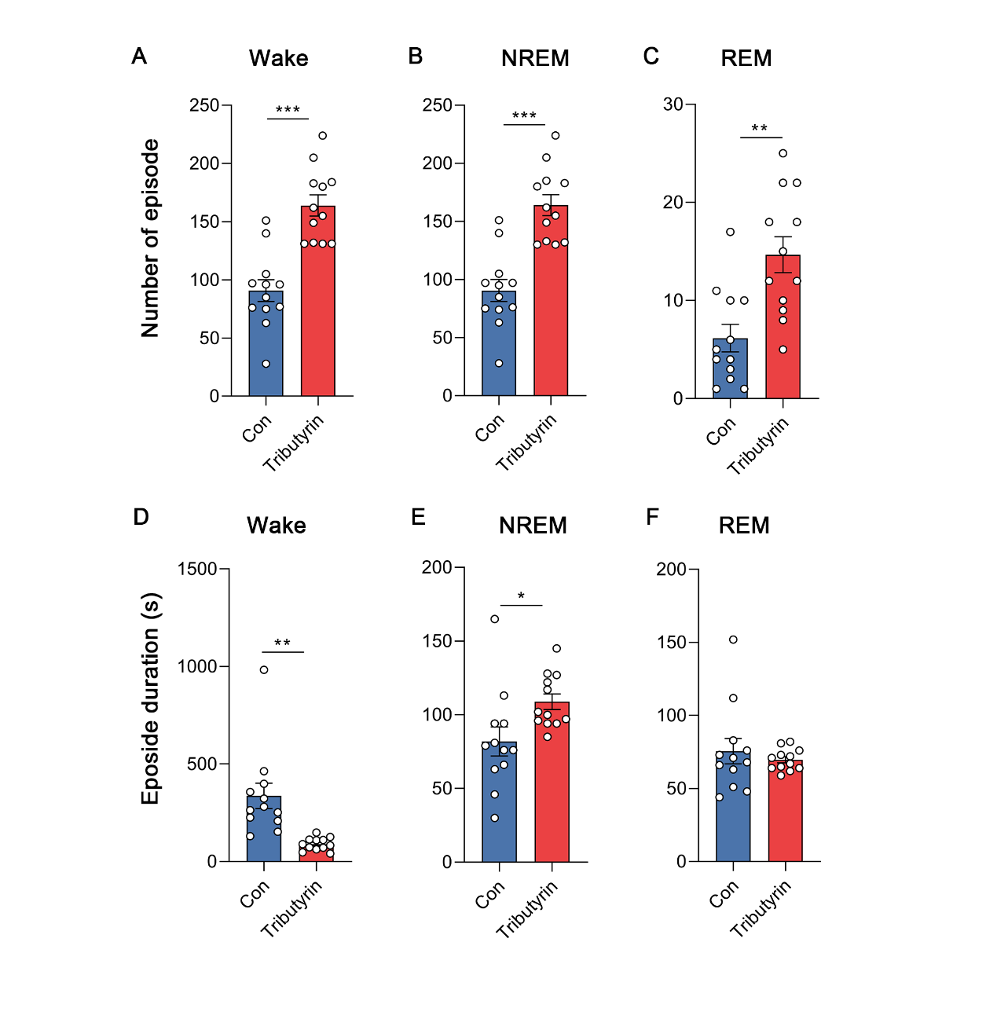
Supplementary Figure 6. Average duration and bout numbers after oral saline and tributyrin administration in mice.
(A-C) Average amount of wakefulness (A), NREM sleep (B), and REM sleep (C) after oral saline and tributyrin administration in mice.
(D-F) Average length of wakefulness (D), NREM sleep (E), and REM sleep (F) after oral saline and tributyrin administration in mice.
The data are expressed as the mean ± SEM. *p < 0.05, **p < 0.01, ***p < 0.001. n = 12. (independent-sample t-test, except for F [Mann-Whitney U test]).

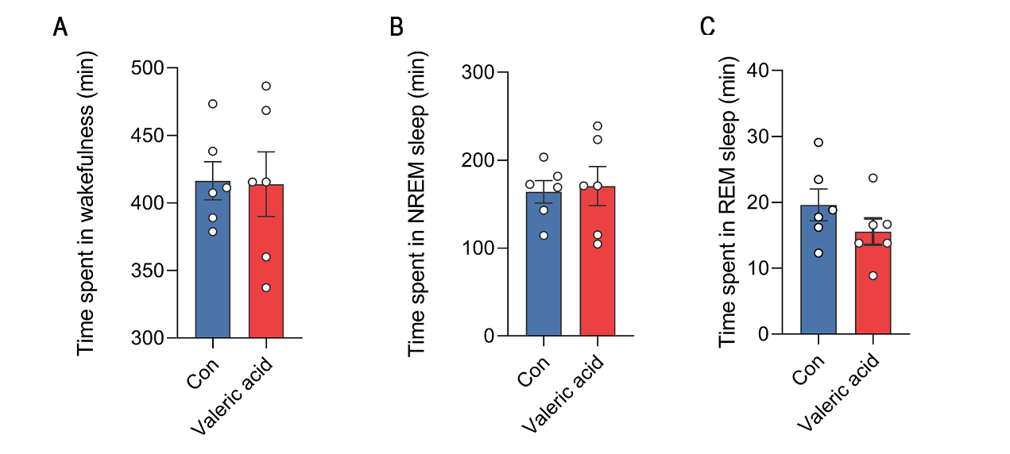
Supplementary Figure 7. Time spent in wakefulness (A), NREM sleep (B), and REM sleep (C) following oral administration saline or valeric acid of in mice (n = 6).
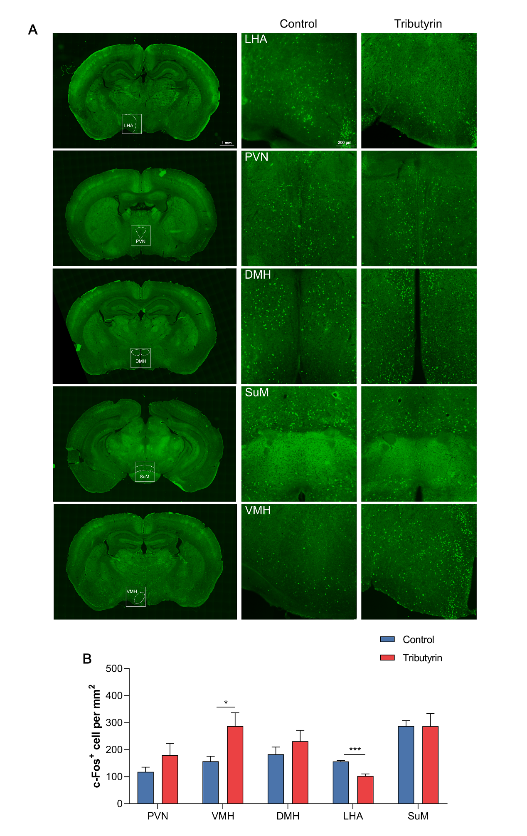
Supplementary Figure 8. Fos expression in the hypothalamus after tributyrin administration.
(A) Representative images of Fos expression in the PVN, VMH, DMH, SuM, and LH area (LHA) in the control and tributyrin groups. Scale bar = 200 μm.
(B) Quantification of Fos⁺ cells in the control or tributyrin groups.
The data are expressed as the mean ± SEM. *p < 0.05, ***p < 0.001. n = 5. (independent-sample t-test).

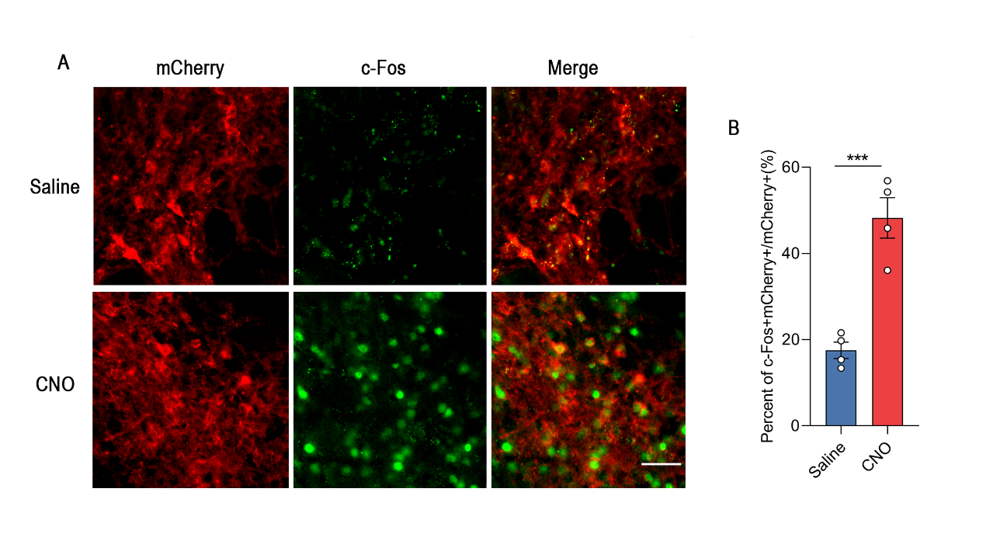
Supplementary Figure 9. Fos expression in orexin neurons in tributyrin-treated mice transduced with hM3Di-mCherry in the LH.
(A) Representative images of Fos expression in orexin neurons 90 min after saline or CNO administration in tributyrin-treated mice transduced with hM3Di-mCherry in the LH. Scale bar = 50 μm.
(B) Quantification of Fos+ cells in orexin neurons after saline or CNO administration in tributyrin-treated mice.
The data are expressed as the mean ± SEM. ***p < 0.001. n = 4. (independent-sample t-test).

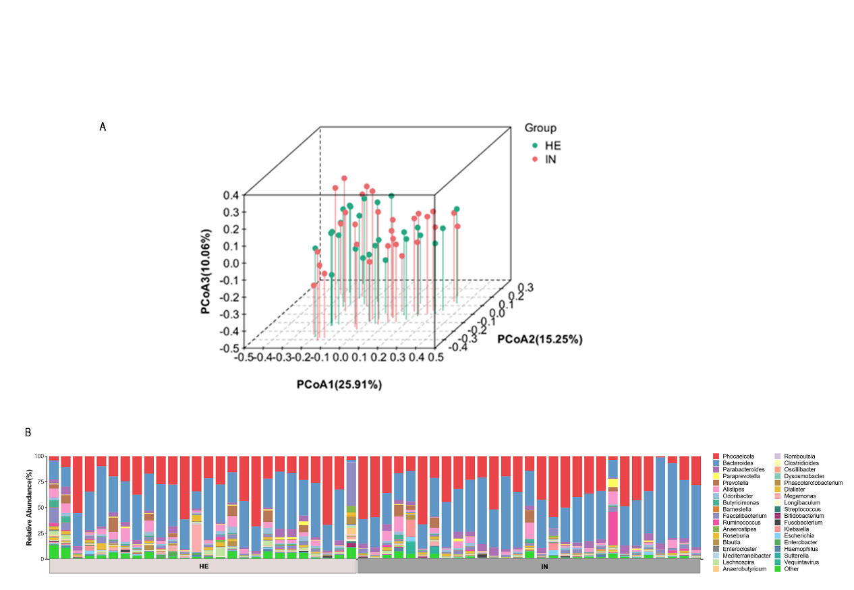
Supplementary Figure 10. Distribution of gut microbiota in insomnia patients and healthy controls.
(A) Three-dimensional principal coordinate analysis (PCoA) of unweighted and weighted UniFrac distances in gut microbiota community composition between insomnia patients and healthy controls.
(B) Genus-level distribution of bacteria of in insomnia patients and healthy controls.

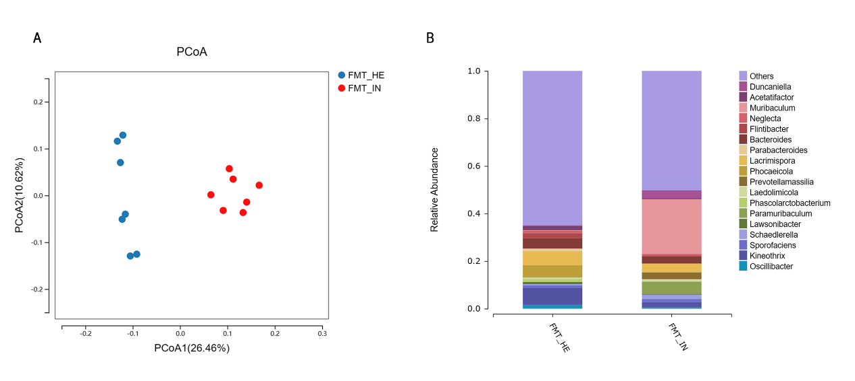
Supplementary Figure 11. Alterations of the gut microbiome in mice that were colonized with fecal microbiota from insomnia patients.
(A) Principal coordinate analysis at the species level for the microbiome of feces from FMT_IN mice (red circle) and FMT_HE mice (blue circle).
(B) Relative abundances of bacterial genus in stool samples in recipient mice.

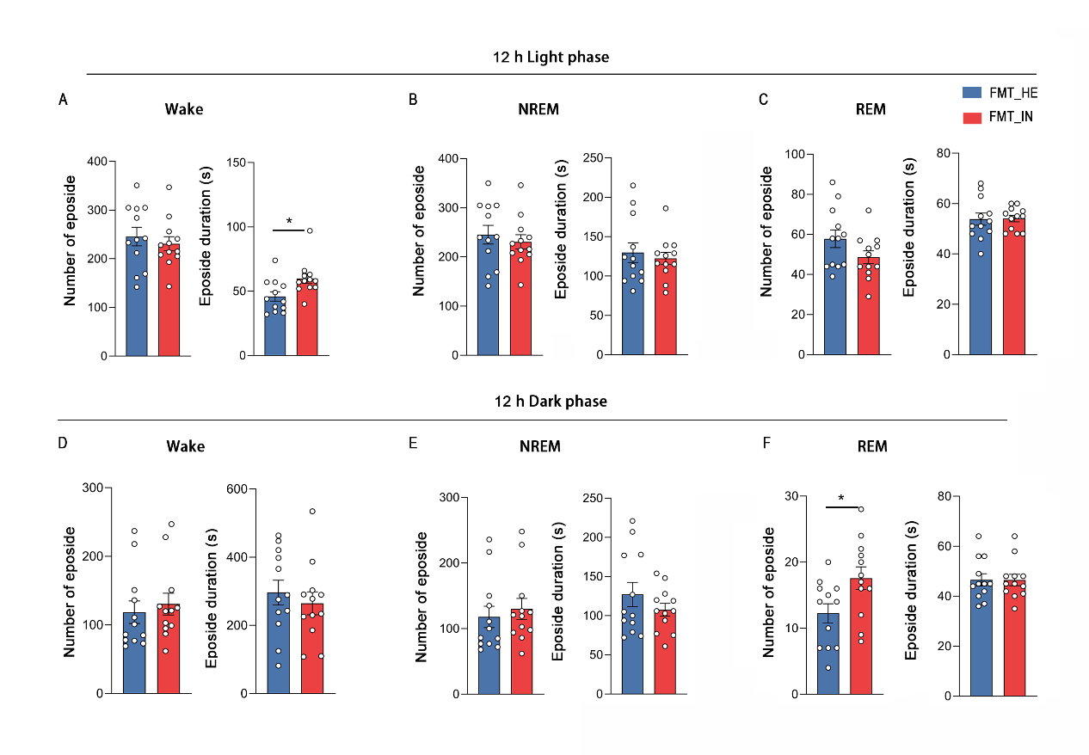
Supplementary Figure 12. Average duration and bout numbers in FMT_IN and FMT_HE mice.
(A-C) Average duration and bout numbers in wakefulness (A), NREM sleep (B), and REM sleep (C) during 12-h light phase in FMT_IN and FMT_HE mice.
(D-F) Average duration and bout numbers in wakefulness (D), NREM sleep (E), and REM sleep (F) during 12-h dark phase in FMT_IN and FMT_HE mice.
The data are expressed as the mean ± SEM. *p < 0.05. n = 12. (independent-sample t-test).

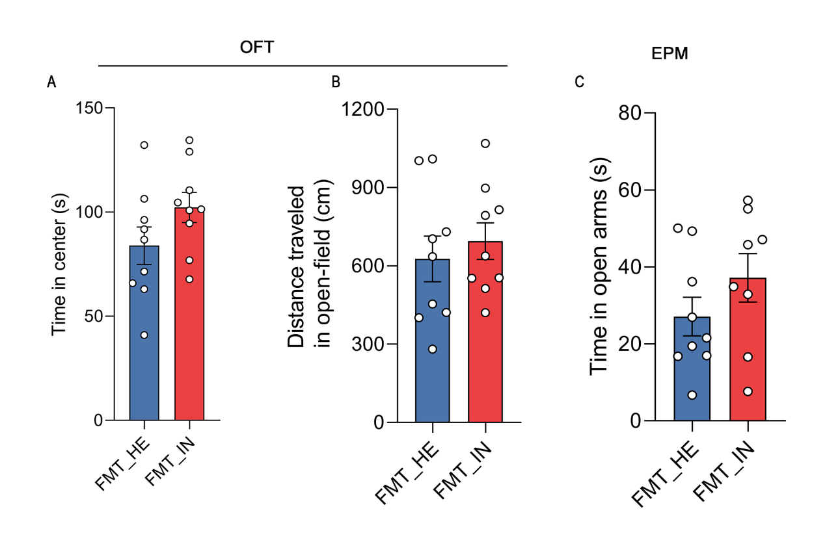
Supplementary Figure 13. Anxiety-like behavior in FMT_IN and FMT_HE mice.
(A) Locomotor activity in the open-field test in FMT_IN and FMT_HE mice.
(B) Center zone duration in the open-field test in FMT_IN and FMT_HE mice.
(C) Open arm duration in the elevated plus maze in FMT_IN and FMT_HE mice.
The data are expressed as the mean ± SEM. n = 8-9. (independent-sample t-test).

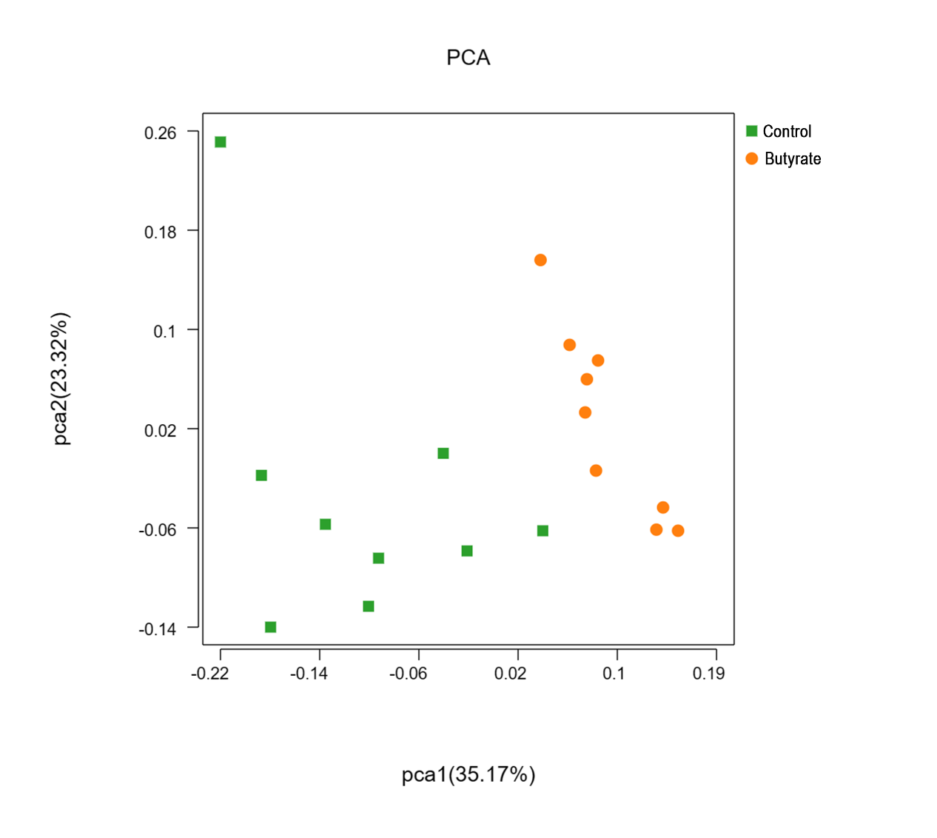
Supplementary Figure 14. Principal coordinate analysis at the species level for the microbiome of feces from control and butyrate-treated recipient mice.

Supplementary Table 1. Comparisons of sociodemographic characteristics, polysomnographic data, and neuropsychological scores among insomnia patients and healthy controls.
 | Insomnia patients (n = 29) | Healthy controls (n = 27) | χ² /z/t | p
Sociodemographics
Female, n (%) | 20 (68.97%) | 17 (62.96%) | 0.23 | p = 0.635
Age (years) | 47.48 ± 2.13 | 43.52 ± 2.34 | 1.26 | p = 0.215
Body Mass Index (kg/m²) | 23.39 ± 0.54 | 23.94 ± 0.49 | -0.75 | p = 0.455
Education (years) | 12.79 ± 0.72 | 13.15 ± 0.77 | 4.73 | p = 0.960
Course of insomnia (months) | 61.84 ± 14.85 | __ | __ | __
PSQI | 14.69 ± 0.65 | 2.74 ± 0.32 | 16.60 | p < 0.001
ISI | 17.00 ± 1.05 | 1.41 ± 0.30 | -6.45 | p < 0.001
HAMD | 8.41 ± 0.79 | 1.18 ± 0.35 | -5.99 | p < 0.001
HAMA | 8.65 ± 0.83 | 0.85 ± 0.22 | 6.26 | p < 0.001
MEQ | 59.27 ± 1.21 | 63.07 ± 1.35 | 2.85 | p < 0.001
MoCA | 24.07 ± 0.55 | 27.81 ± 0.40 | 4.73 | p < 0.001
Sleep continuity
TST (min) | 349.55 ± 14.71 | 421.83 ± 8.50 | -4.25 | p < 0.001
SE (%) | 71.47 ± 2.17 | 87.99 ± 1.64 | 3.99 | p < 0.001
SL (min) | 36.72 ± 6.06 | 9.30 ± 1.71 | -4.62 | p < 0.001
WASO (min) | 104.17 ± 9.98 | 49.43 ± 7.83 | -4.31 | p < 0.001
Sleep architecture
N1 (min) | 39.09 ± 3.64 | 40.30 ± 3.42 | -0.24 | p = 0.810
%TIB | 7.97 ± 0.73 | 8.34 ± 0.66 | -0.37 | p = 0.709
N2 (min) | 202.88 ± 10.23 | 213.98 ± 7.29 | -0.88 | p = 0.381
%TIB | 41.35 ± 1.65 | 44.70 ± 1.55 | -1.48 | p = 0.145
N3 (min) | 56.40 ± 6.47 | 102.22 ± 8.05 | -4.46 | p < 0.001
%TIB | 11.83 ±1.42 | 21.21 ± 1.59 | -4.41 | p < 0.001
REM (min) | 50.78 ± 5.88 | 65.36 ± 4.30 | -1.98 | p = 0.053
%TIB | 10.19 ± 1.11 | 13.74 ± 0.95 | -2.42 | p = 0.019
TIB (min) | 488.12 ± 11.72 | 481 ± 8.74 | -1.06 | p = 0.290
The data are expressed as the mean ± SEM; Values of p reflect independent-sample t-tests between the two nights. PSQI, Pittsburgh Sleep Quality Index; ISI, insomnia Severity Index; HAMD, Hamilton Depression Scale; HAMA, Hamilton Anxiety Scale; MEQ, Morningness-Eveningness Questionnaire; MoCA, Montreal Cognitive Assessment; PSG, polysomnographic; TST, total sleep time; SE, sleep efficiency; SL, sleep latency; WASO, wake after sleep onset; REM, rapid eye movement; TIB, time in bed.

