Supplementary Information for: Brain-age prediction and its associations with glial and synaptic CSF markers

Supplementary Table 1. List of TREM2 variants present in ALFA+.

TREM2 rare variants | N Participants
L211P/rs2234256 | 4
H157Y/rs2234255 | 2
T96K/rs2234253 | 3 (repeated)
D87N/rs142232675 | 1
R62H / rs143332484 | 8
R47H / rs75932628 | 1

Supplementary Table 2 Effect of CSF Synaptic and glial biomarkers in brain-age delta after including AB40 as covariate

 |  | Brain-age delta
Model 1 | CSF biomarkers | β | [0.025 | 0.075] | P
Model 1 | GAP43 | -0,1657 | -0,384 | 0,052 | 0,136
Model 1 | GFAP | 0,0023 | -0,117 | 0,121 | 0,97
Model 1 | IL6 | -0,0194 | 0,052 | -0,122 | 0,083
Model 1 | Neurogranin | 0,1334 | -0,074 | 0,341 | 0,207
Model 1 | S100b | -0,1139 | -0,221 | -0,007 | 0,037
Model 1 | YKL40 | -0,037 | -0,177 | 0,102 | 0,602
Model 1 | α-synuclein | 0,0106 | -0,126 | 0,147 | 0,879
Model 1 | SNAP25 | -0,0524 | -0,205 | 0,101 | 0,502
Model 1 | SYT1 | -0,1801 | -0,38 | 0,02 | 0,077
Model 1 | sTREM2 | -0,2105 | -0,336 | -0,085 | 0,001
Model 2 | GAP43 | -0,2131 | -0,478 | 0,052 | 0,115
Model 2 | GFAP | 0,0057 | -0,116 | 0,127 | 0,927
Model 2 | IL6 | -0,0194 | -0,122 | 0,084 | 0,712
Model 2 | Neurogranin | 0,2292 | -0,022 | 0,481 | 0,074
Model 2 | S100b | -0,1161 | -0,224 | -0,008 | 0,035
Model 2 | YKL40 | -0,0312 | -0,177 | 0,114 | 0,673
Model 2 | α-synuclein | 0,0196 | -0,121 | 0,16 | 0,784
Model 2 | SNAP25 | -0,0496 | -0,219 | 0,12 | 0,566
Model 2 | SYT1 | -0,2316 | -0,478 | 0,015 | 0,065
Model 2 | sTREM2 | -0,2091 | -0,336 | -0,082 | 0,001
Linear regression results for Model 1 (brain-age delta or AD signature ~ CSF biomarker + age + sex + APOE status) and for Model 2 (brain-age delta or AD signature – CSF biomarker + age + sex + APOE status + Aβ + p-tau).
Abbreviations: CSF, cerebrospinal fluid; GAP-43, growth-associated protein-43; GFAP, glial fibrillary acidic protein; IL-6, cytokine interleukin-6; S100b, S100 calcium binding protein B; SNAP-25, synaptosomal-associated protein-25; sTREM2, soluble triggering receptor expressed on myeloid cells 2 (TREM2).

Supplementary Table 3. Interaction effects of CSF Synaptic and glial biomarkers with AB status in brain-age delta and AD signature in ALFA+

 | Brain-age delta |  |  |  | AD signature
CSF biomakers | Mean square | F | P | P_{FDR} | Mean squares | F | P | P_{FDR}
GAP43 | 3.834 | 0.275 | 0.600 | 0.858 | 0.038 | 9.030 | 0.0028 | 0.026
GFAP | 53.873 | 3.887 | 0.049 | 0.174 | 0.049 | 11.693 | 0.00069 | 0.015
IL6 | 0.788 | 0.056 | 0.813 | 0.992 | 0.000 | 0.010 | 0.920 | 0.992
Neurogranin | 0.207 | 0.015 | 0.903 | 0.992 | 0.020 | 4.705 | 0.031 | 0.132
S100b | 9.042 | 0.657 | 0.418 | 0.760 | 0.007 | 1.679 | 0.196 | 0.519
YKL40 | 33.315 | 2.405 | 0.122 | 0.348 | 0.043 | 10.189 | 0.0016 | 0.018
α-synuclein | 11.174 | 0.809 | 0.369 | 0.738 | 0.014 | 3.286 | 0.0707 | 0.235
SNAP25 | 10.401 | 0.746 | 0.388 | 0.752 | 0.024 | 5.611 | 0.018 | 0.092
SYT1 | 0.285 | 0.020 | 0.886 | 0.992 | 0.026 | 6.129 | 0.014 | 0.082
sTREM2 | 0.409 | 0.030 | 0.863 | 0.992 | 0.026 | 6.127 | 0.014 | 0.082
Linear regression results for: brain-age delta or AD signature ~ CSF biomarker *Aβ status + age + sex + APOE status).
Abbreviations: AD, Alzheimer’s disease; CSF, cerebrospinal fluid; GAP-43, growth-associated protein-43; GFAP, glial fibrillary acidic protein; IL-6, cytokine interleukin-6; S100b, S100 calcium binding protein B; SNAP-25, synaptosomal-associated protein-25; sTREM2, soluble triggering receptor expressed on myeloid cells 2 (TREM2).

Supplementary Table 4. List of TREM2 variants present in ADNI.
TREM2 rare variants | N Participants CU | N Participants MCI
L211P/rs2234256 | 1 | 4
H157Y/rs2234255 | 0 | 0
T96K/rs2234253 | 0 | 3
D87N/rs142232675 | 1 | 1 (repeated)
R62H / rs143332484 | 3 | 5
R47H / rs75932628 | 1 | 2

Supplementary Table 5. Interaction effects of CSF sTREM2 with Aβ status in brain-age delta in ADNI
 | Brain-age delta
Diagnosis | Mean square | F | P
CU | 3.110 | 3.200 | 0.076
MCI | 0.567 | 0.591 | 0.442
Linear regression results for: brain-age delta or AD signature ~ CSF biomarker *Aβ status + age + sex + APOE status).
Abbreviations: CU, cognitively unimpaired; MCI, mild cognitive impaired.

Supplemental Fig. 1. Cross-correlation between CSF biomarkers in ALFA+.

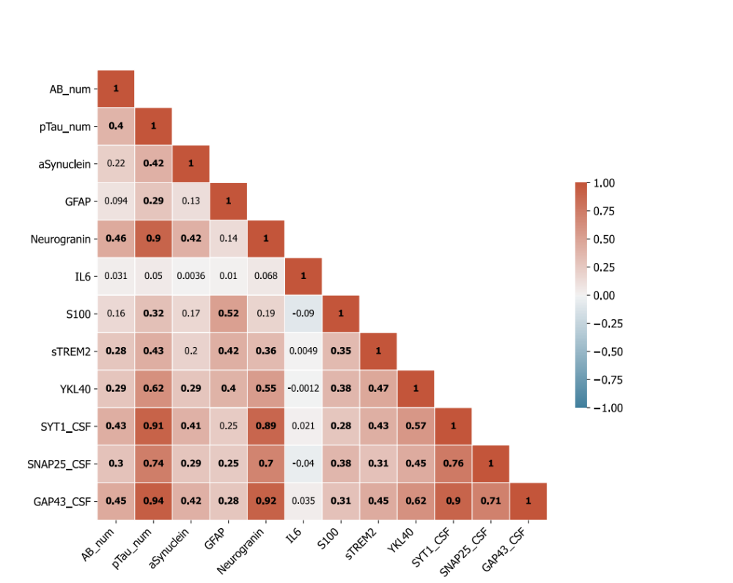

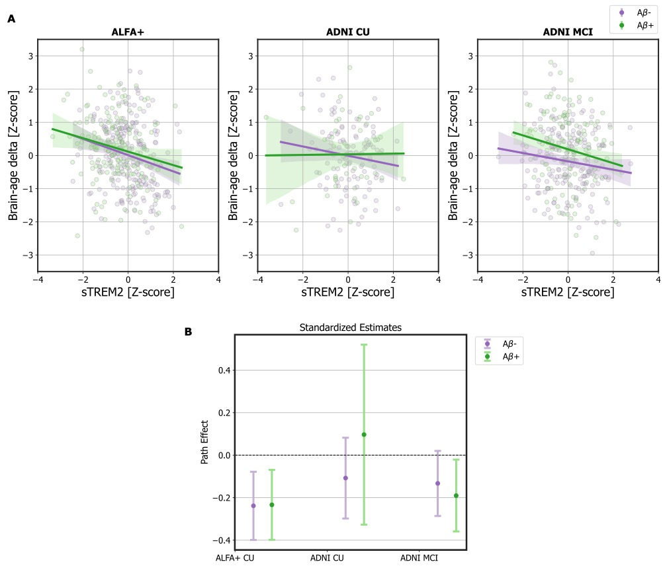
Supplementary Fig. 2. In A, scatter plots representing the associations of sTREM2 and brain-age delta in ALFA+ CU, ADNI CU and ADNI MCI, stratified by Ab status. In purple, Aβ- individuals and, in green, Aβ+ individuals. Also plotting the linear regression results for the model: brain-age delta ~ CSF biomarker + age + sex + APOE status. In B, Standardized estimates of the linear regressions.

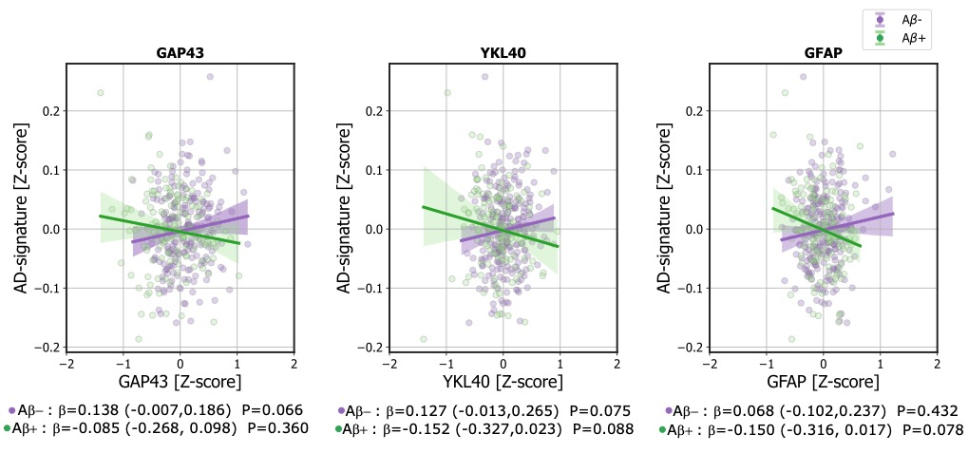
Supplementary Fig. 3. scatter plots representing the associations of CSF GAP43, YKL, and GFAP with AD-signature in ALFA+, stratified by Ab status. In purple, Aβ- individuals and, in green, Aβ+ individuals.

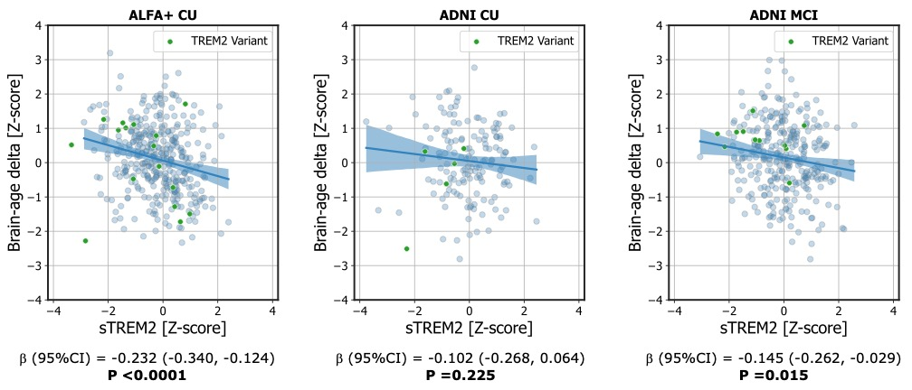
Supplementary Fig. 4. scatter plots representing the associations of sTREM2 and brain-age delta in ALFA+ CU, ADNI CU and ADNI MCI for individuals without any computed TREM2 variant. Points in green represent individuals with any TREM2 variant. Linear regression results for Model 1 (brain-age delta ~ CSF biomarker + age + sex + APOE status).

