SUPPLEMENTARY MATERIAL
SUPPLEMENTARY METHODS

Chromatin interaction analysis
We employed the 3D-genome Interaction Viewer and Database (3DIV) (http://3div.kr/) to examine chromatin interactions at rs3101339 in human dorsolateral prefrontal cortex and hippocampus tissues [1]. The input bait was set to chr1:72282986 (hg38), with an interaction range of 2 Mb, respectively.

AAVs purification
The target AAVs were harvested and resuspended in cell lysis buffer (0.15 M NaCl; 20 mM Tris-HCl), followed by four freeze-thaw cycles between liquid nitrogen and 37 ℃ water bath to release the target AAVs. Subsequently, sodium deoxycholate (0.5%) and benzonase (50 U/mL, #E1014, Sigma) were added to the cell lysis buffer and incubated at 37 ℃ for 30 minutes, following this, the mixture was centrifuged at 5,588 ×g for 90 minutes at 4 ℃. The supernatant containing AAVs was carefully transferred to a 40 PA Seal Tube (#345321A, himac) pre-filled with a step gradient of iodixanol (15%, 25%, 40%, 54%, #D1556, Sigma), and centrifuged at 255,300 ×g for 3 hours at 18 ℃. The fraction containing the target AAVs in the 40% iodixanol layer was collected for further purification using an Amicon ultrafiltration tube (#UFC910096, Millipore). Finally, the purified target AAVs were stored at -80 ℃, and the viral titer was determined by qPCR as described at website: https://www.addgene.org/protocols/aav-titration-qpcr-using-sybr-green-technology/.

Western-blot
To confirm NEGR1 protein was overexpressed in the NEGR1-OE group mice, tissues from the mPFC or vHIP labeled with red fluorescent protein (mCherry) were isolated and homogenized using RIPA lysis buffer (#89901, Thermo Fisher) supplemented with protease inhibitors (#78430, Thermo Fisher) and phosphatase inhibitors (#04-906-837-001, Roche). Protein concentrations were measured using the BCA protein assay kit (#23225, Thermo Fisher). The protein samples were mixed with 5× protein loading buffer (#P0015, Biotechnology), denatured at 95 °C for 10 minutes, and separated using 10% SDS-PAGE gels, and transferred onto polyvinylidene difluoride membranes (#03010040001, Millipore). After blocking with 5% BSA, the membranes were incubated overnight at 4 °C with primary antibodies diluted in 1× TBST buffer containing 5% BSA. The following day, the membranes were incubated for 1 hour at room temperature with the corresponding secondary antibodies. Blot images were captured using the Tanon ECL chemiluminescence reagent (#180-5001W, Tanon) and Tanon 5200 imaging system Rabbit anti-NEGR1 (1:800, #13674-1-AP, proteintech), Mouse anti-GADPH (1:80000, #60004-1-Ig, proteintech), HRP-conjugated Goat anti-Mouse (1:3000, #SA00001-1, proteintech), and HRP-conjugated Goat anti-Rabbit (1:3000, #SA00001-2, proteintech).

Behavior paradigm evaluation
Four behavioral tests were conducted between 9:00 AM and 5:00 PM, and the detailed processes were presented as follows,
Y maze. The Y-maze consists of three arms set at a 120° angle. Each test mouse was placed in the same arm and permitted to freely explore three arms for 8 minutes. The activity tracks of test mice were recorded by a video camera and analyzed by SuperMaze software. The apparatus was cleaned with a 70% ethanol solution and water after each trial. The percentage of spontaneous alternation was calculated as the ratio of the number of spontaneous alternations to total number of arm entries minus 2.
Open field test. The bottom surface of the open field apparatus (length: 40 cm; width: 40 cm; height: 40 cm) was evenly divided into 16 squares, with the central 4 squares designated as the central region and the 4 corner squares defined as corner regions. Each test mouse was placed in a designated corner of the open field arena, facing the wall, and given 5 minutes to freely explore the space. The activity tracks of test mice were recorded by using a video camera and SuperMaze software. The apparatus was cleaned with a 70% ethanol solution and water after each trial. The total distance traveled, average speed, number of entries into the central region, average speed within the central region, percentage of distance traveled in the central region, and percentage of distance traveled in the corner regions were used to evaluate the anxiety-like behaviors of the test mice.
Elevated plus maze (EPM). The EPM apparatus consists of a pair of open arms (33 cm × 8 cm) and a pair of closed arms (30 cm × 6 cm), arranged in a cross shape approximately 75 cm above the ground. The test mice were gently placed at the center of the EPM, facing the open arms, and allowed to freely explore the apparatus for a duration of 5 minutes. The following parameters were recorded to evaluate the anxiety levels of the test mice: total distance traveled, the percentage of distance traveled in the open arms, the time spent in the open arms, and the number of entries into the open arms. The percentage of distance traveled in the open arms was calculated as (distance traveled in open arms / total distance) × 100%.
Forced swimming test. The test apparatus is that a transparent cylindrical barrel (Height: 30 cm, Diameter: 11.2) which is filled with a certain volume of water (Height: 20 cm) maintained under 21-23℃. During test, each mouse was put into water for 6 minutes, and the last 4 minutes is utilized for analysis. The struggling or immobility state of the test mice were recorded by video and analyzed using FST software. The percentages of immobility and struggling were used to evaluate the depression level of the test mice.

SUPPLEMENTARY FIGURES

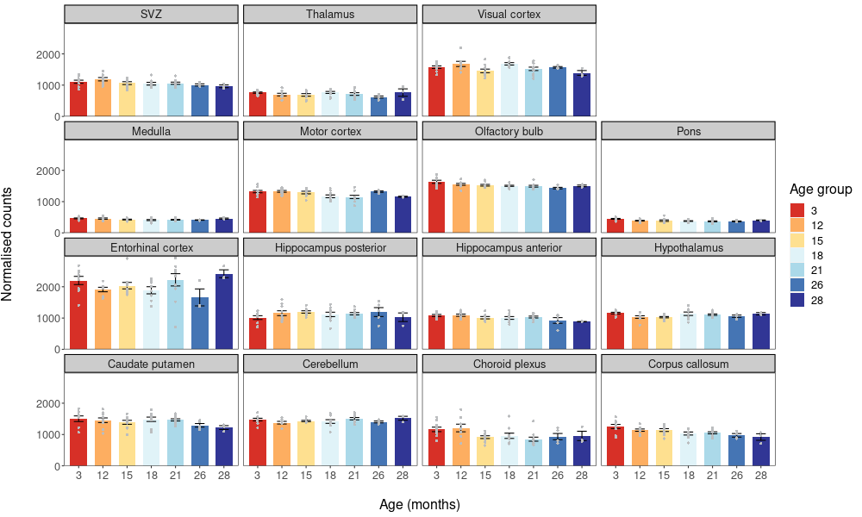Fig. S1 The Negr1 mRNA expression in different brain region of mouse from 3 to 68 months.
(Expression data downloading from website: https://twc-stanford.shinyapps.io/spatiotemporal_brain_map/) [2]

Fig. S2 The Negr1 mRNA expression in different cell types from human and mouse brain.
(Expression data downloaded from Spatio-Temporal Cell Atlas of Brain website: https://mai.fudan.edu.cn/stab2/explore-type-exp) [3]

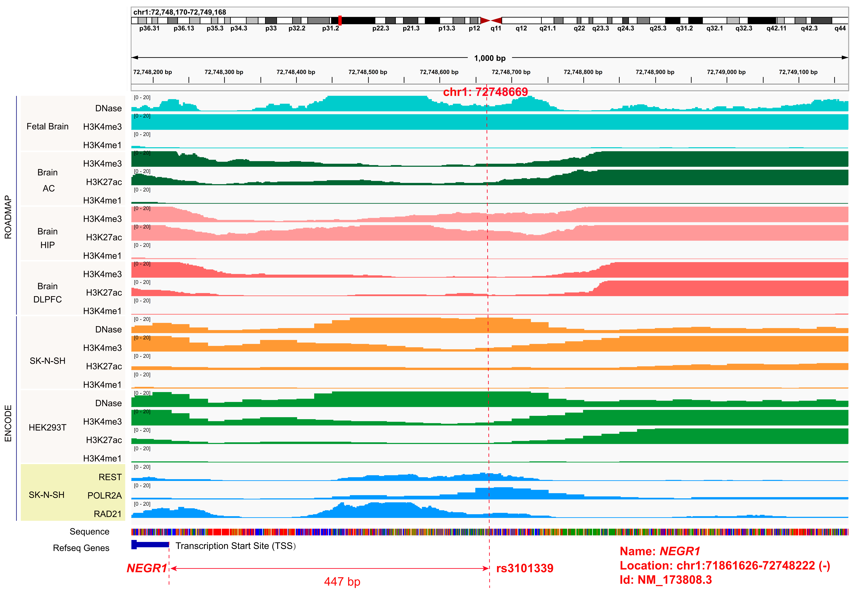Fig. S3 The functional SNP rs3101339 is located in the active promoter of NEGR1 gene across multiple tissues marked with DNase, H3K4me3, and H3K27ac and transcription factors (REST, POLR2A and RAD21).

Fig. S4 rs3101339 is located in chromatin accessibility region of human fetal cerebrum cells.
(Data downloaded from descartes: https://descartes.brotmanbaty.org/bbi/human-chromatin-during-development/dataset/cerebrum) [4]

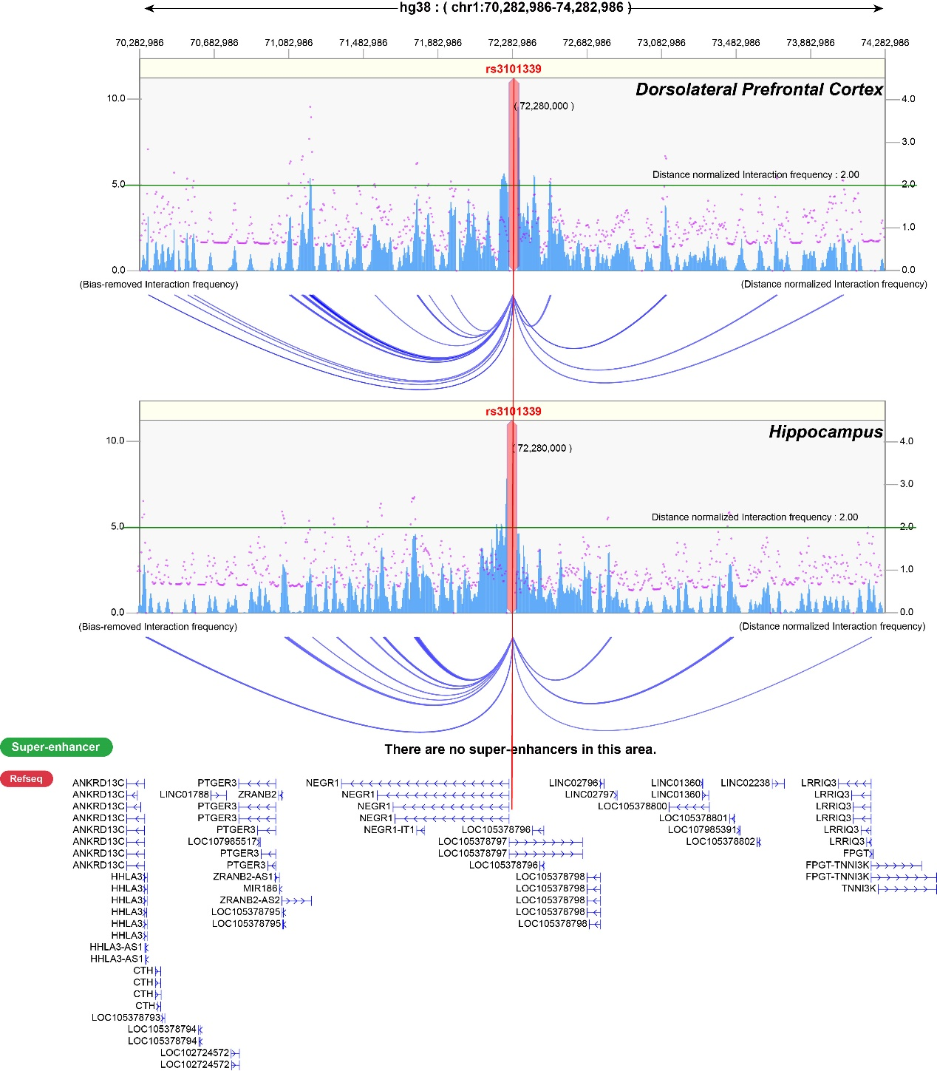Fig. S5 The chromatin interactions at rs3101339 in human dorsolateral prefrontal cortex and hippocampus tissues.
(Data downloaded from 3D-genome Interaction Viewer and Database (3DIV) website: http://3div.kr/) [1]

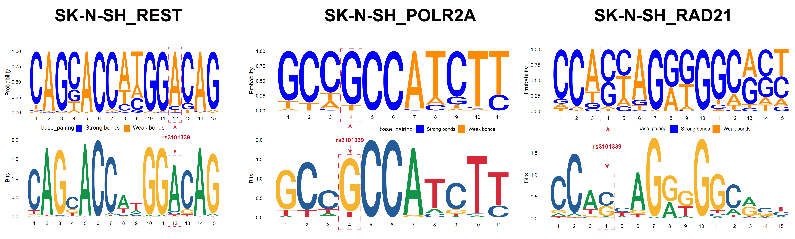Fig. S6 The DNA binding motifs of REST, RAD21 and POLR2A in SK-N-SH are altered by rs3101339

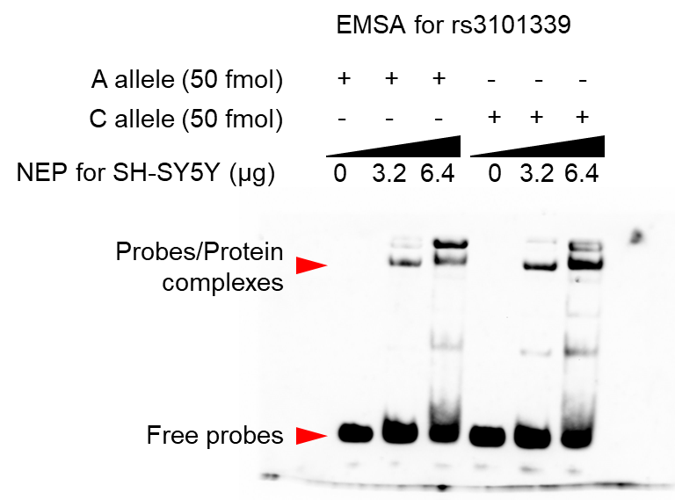
Fig. S7 The full-length EMSA of rs3101339 A and C alleles

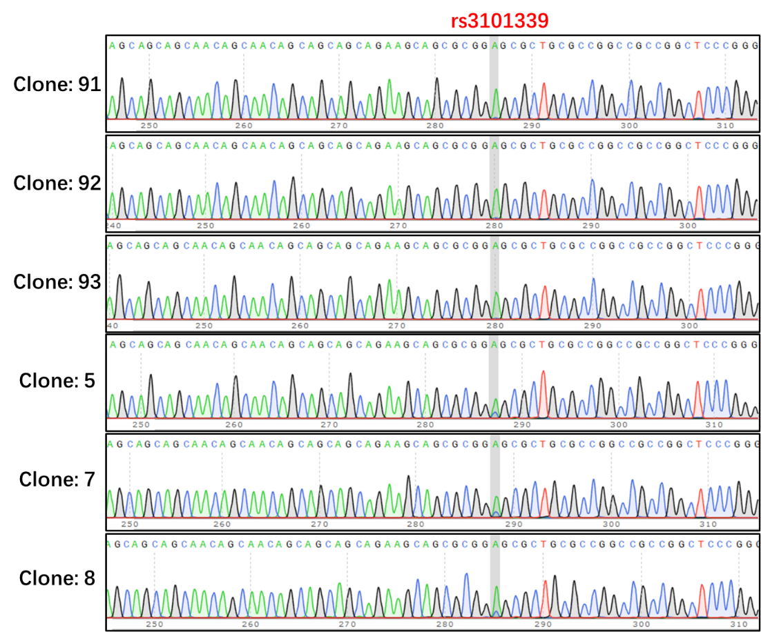
Fig. S8 The genotypes of rs3101339 in 6 colonies of HEK293T were validated by sanger sequencing.

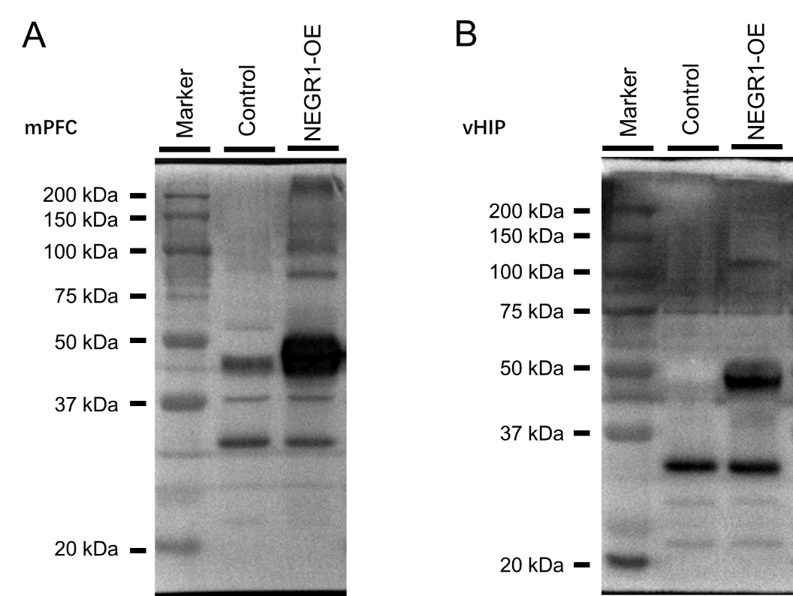
Fig. S9 The full-length western blot detection of NEGR1 overexpression in the brain (mPFC and vHIP) of mice.

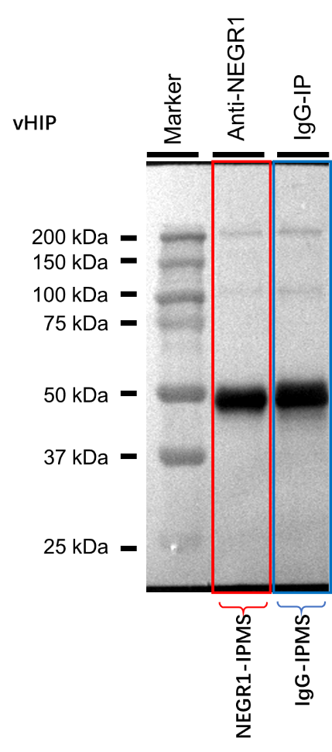
Fig. S10 The full-length western blot detection image before IP-MS for NEGR1.

SUPPLEMENTARY REFERENCES

1. Kim K, Jang I, Kim M, Choi J, Kim MS, Lee B, et al. 3DIV update for 2021: a comprehensive resource of 3D genome and 3D cancer genome. Nucleic Acids Res. 2021;49(D1):D38-d46.
2. Hahn O, Foltz AG, Atkins M, Kedir B, Moran-Losada P, Guldner IH, et al. Atlas of the aging mouse brain reveals white matter as vulnerable foci. Cell. 2023;186(19):4117-33.e22.
3. Yang YT, Gan Z, Zhang J, Zhao X, Yang Y, Han S, et al. STAB2: an updated spatio-temporal cell atlas of the human and mouse brain. Nucleic Acids Research. 2024;52(D1):D1033-D41.
4. Domcke S, Hill AJ, Daza RM, Cao J, O’Day DR, Pliner HA, et al. A human cell atlas of fetal chromatin accessibility. Science. 2020;370(6518):eaba7612.

