Supplementary Materials and methods
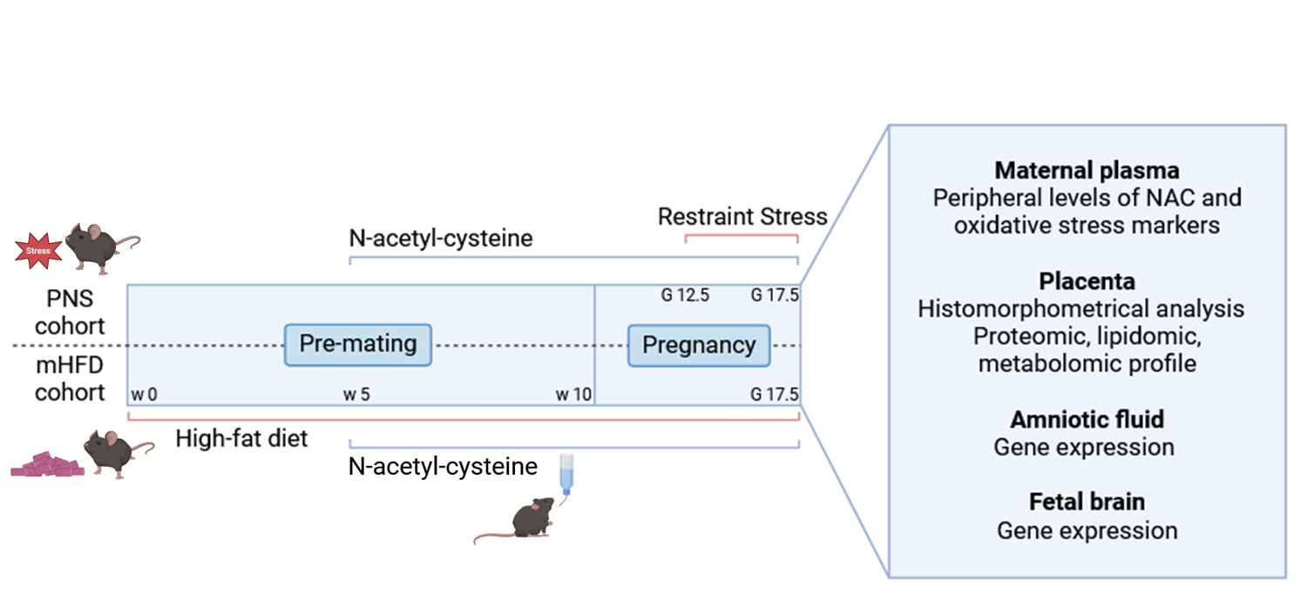
Figure S1 Experimental timeline. PNS= prenatal stress; mHFD= maternal high-fat diet; w= week; G= gestational day; NAC= N-acetyl-cysteine.

Placenta samples and protein, lipid and metabolite extraction
Considering the different kind of stress (CD, CTRL, HFD, PNS); treatments (Vehicle; NAC) and sex (F/M) we divided the samples in 16 groups: CD_NAC_F/M; CD_Veh_F/M; CTR_NAC_F/M; CTR_Veh_F/M; HFD_NAC_F/M; HFD_Veh_F/M; PNS_NAC_F/M; PNS_Veh_F/M. For each group, we analysed 3 biological replicates, resulting in 48 independent samples of murine placentas. Frozen samples were washed three times in cold PBS on ice and lyophilized over night. Samples were then weighted, homogenized (Tissue Lyser for 2 minutes at 20Hz) and subjected to methyl-tert-butyl ether/methanol extraction of lipids, metabolites and proteins.

Proteomic analysis
Protein pellets were resuspended in 3% Sodium Deoxycholate (SDC) in 20 mM triethylammonium bicarbonate (TEAB), and yield concentration was assessed by BCA Protein Assay (Pierce™ Rapid Gold BCA Kit). Equal amounts (100 μg) from individual samples were reduced (10mM Tris(2-carboxyethyl)phosphine, 30 minutes at 56°C) and alkylated (40 minutes iodoacetamide, at room temperature in the dark) in solution. Protein mixtures were then diluted to 450 μl in Urea 8M in 20 mM TEAB and transferred to Microcon-30kDa Centrifugal Filter Unit (MERK) previously washed with 0.5% SDC in Urea 8M, 20 mM TEAB. After buffer exchange, double enzymatic digestion with LysC/Trypsin mixture (Promega) was performed in 1:50 enzime/substrate ratio, in the presence of 0.5% SDC in 20 mM TEAB, over night at 37°C. Then 50 μl of TEAB 20 mM where added to the filter unite and the tryptic digested collected by centrifuging 5 minutes at 14000 x g. The elution was repeated twice. To stop digestion and allow SDC to precipitate Trifluoroacetic acid was added to a final concentration of 0.5%. A final extraction with Ethyl-acetate 1:1 was performed twice to eliminate any salt trace and then the peptide solutions were lyophilized in speed-vac, resuspended in buffer A (5% acetonitrile, 0,1% formic acid) and quantified by Quantitative Colorimetric Peptide Assay (Pierce). For generating a spectral library 3ug of each sample were run firstly in data-dependent mode (DDA) and then in technical triplicate in data-independent mode (DIA) using an Orbitrap Fusion Tribrid Mass Spectrometer (Thermo Fisher Scientific) coupled to an UltiMate 3000 UHPLC system (Thermo Fisher Scientific). DDA and DIA raw files were run on FragPipe version 21.0. Further details on mass spectrometry methods and analysis are reported at ftp://massive.ucsd.edu/v06/MSV000092388.

Lipidomic and metabolomic profiles of placental samples by Nuclear Magnetic Resonance (NMR) spectroscopy analysis
The polar phase of containing water-soluble cellular metabolites was evaporated using a rotary evaporator and lyophilized while the organic fraction (lipid phase) was evaporated under nitrogen gas flow. High-resolution 1H-NMR analyses (acquisition and quantification) were performed as previously described (Rossi et al., 2023; Santilli et al., 2023) by using a 14.1 T Bruker AVANCE Neo spectrometer (Karlsruhe, Germany, Europe). Reagents: deuterated reagents (methanol (CD3OD), chloroform (CDCl3) and deuterium oxide (D2O) were purchased from Cambridge Isotope Laboratories, Inc.; 3-(trimethylsilyl)propionic-2,2,3,3-d4 acid sodium salt (TSP) was obtained from Merck & Co, Montreal, Canada).

Sex determination by PCR reactions
Genomic DNA was extracted from embryo mice tails (about 1 cm) using DNeasy Blood & Tissue kit (Qiagen), according to the manufacturer instructions, and the genetic sex of mice was determined by Sly/Xlr PCR with the SX_F, 5ʹ-GATGATTTGAGTGGAAATGTGAGGTA-3ʹ and SX_R, 5ʹ-CTTATGTTTATAGGCATGCACCATGTA-3ʹ primer pairs, according to (McFarlane et al., 2013). 15 µL of PCR products were electrophoresed together with a DNA ladder (GelPilot MidRange ladder, Qiagen) and GelRed nucleic acid stain (Biotium) on 2% agarose gels, and visualized with the Bio-Rad ChemiDoc XRS system.
Gene expression on fetal brains and amniotic fluid
Fetal brains from one male and one female from each pregnant dam were selected, for a total of 6 males and 6 females per experimental group. Each brain was removed from the skull on ice, homogenized using TissueLyser LT (Qiagen) for 5 min at 50 Hz in lysis buffer from RNeasy mini kit (Qiagen), and total RNA extracted according to the same kit.
Total RNA from amniotic fluid was isolated using the RNA Purification Mini Kit (Norgen, Biotek Corp). Quality and concentration of RNA was measured at Nanodrop. cDNA was reverse transcribed from 1 µg of RNA using the High-Capacity cDNA Reverse Transcription Kit and the Gene Amp PCR System 9700 (Applied Biosystems, Thermo Fisher Scientific). Real-time PCR was performed on the reverse transcription products using the AB 7500 Real-Time PCR System, with TaqMan master mix and the following TaqMan™Gene Expression Assays (Applied Biosystems, Thermo Fisher Scientific): Hprt, Il-1β, Il-6, Tnf-α, Tgf-β1, Igf-1, iNos, Arg-1, Ucp 2, Cd 68, Trem 2, Tmem 119, Sod-2 (Table S1). Annealing temperature was 60 °C for all the primer pairs listed. All samples were run in duplicate, and each PCR well contained 20 μl as a final volume of reaction, including 2 μl of complementary DNA corresponding to approximately 60 ng total RNA, 750 nM of each primer, and 10 μl PCR master mix. Thermal cycling conditions were as follows: 1 cycle at 95 °C for 10 min, 40 cycles at 95 °C for 15 s and 60 °C for 1 min. The relative expression level of each mRNA (normalized to HPRT used as the housekeeping gene, and relative to the appropriate male mice vehicle group) was calculated using the 2^{-ΔΔCt} method.

Table S1 ID assays for gene expression analysis
Gene | ID assay
Hprt | Mm00446968_m1
Il-1β | Mm00434228_m1
Il-6 | Mm00446190_m1
Tnf-α | Mm00443258_m1
Tgf-β1 | Mm01178820_m1
Igf-1 | Mm00439560_m1
iNOS | Mm00440502_m1
Arg-1 | Mm00475988_m1
Ucp2 | Mm00627599_m1
Cd68 | Mm03047343_m1
Trem 2 | Mm04209424_g1
Tmem 119 | Mm00525305_m1
Sod-2 | Mm01313000_m1
Acronyms: Arg-1= arginase 1; Cd 68= cluster of differentiation 68; Hprt= hypoxanthine guanine phosphoribosyl transferase; Igf-1= insulin-like growth factor 1; Il-1β = interleukin-1β; Il-6= interleukin-6; iNos= inducible nitric oxide synthase; Sod-2= superoxide dismutase; Tgf-β1= transforming growth factor β 1; Tmem 119= transmembrane protein 119; Tnf-α= tumor necrosis factor-alpha ; Trem 2= triggering receptor expressed on myeloid cells 2; Ucp 2= uncoupling protein 2

Supplementary Results

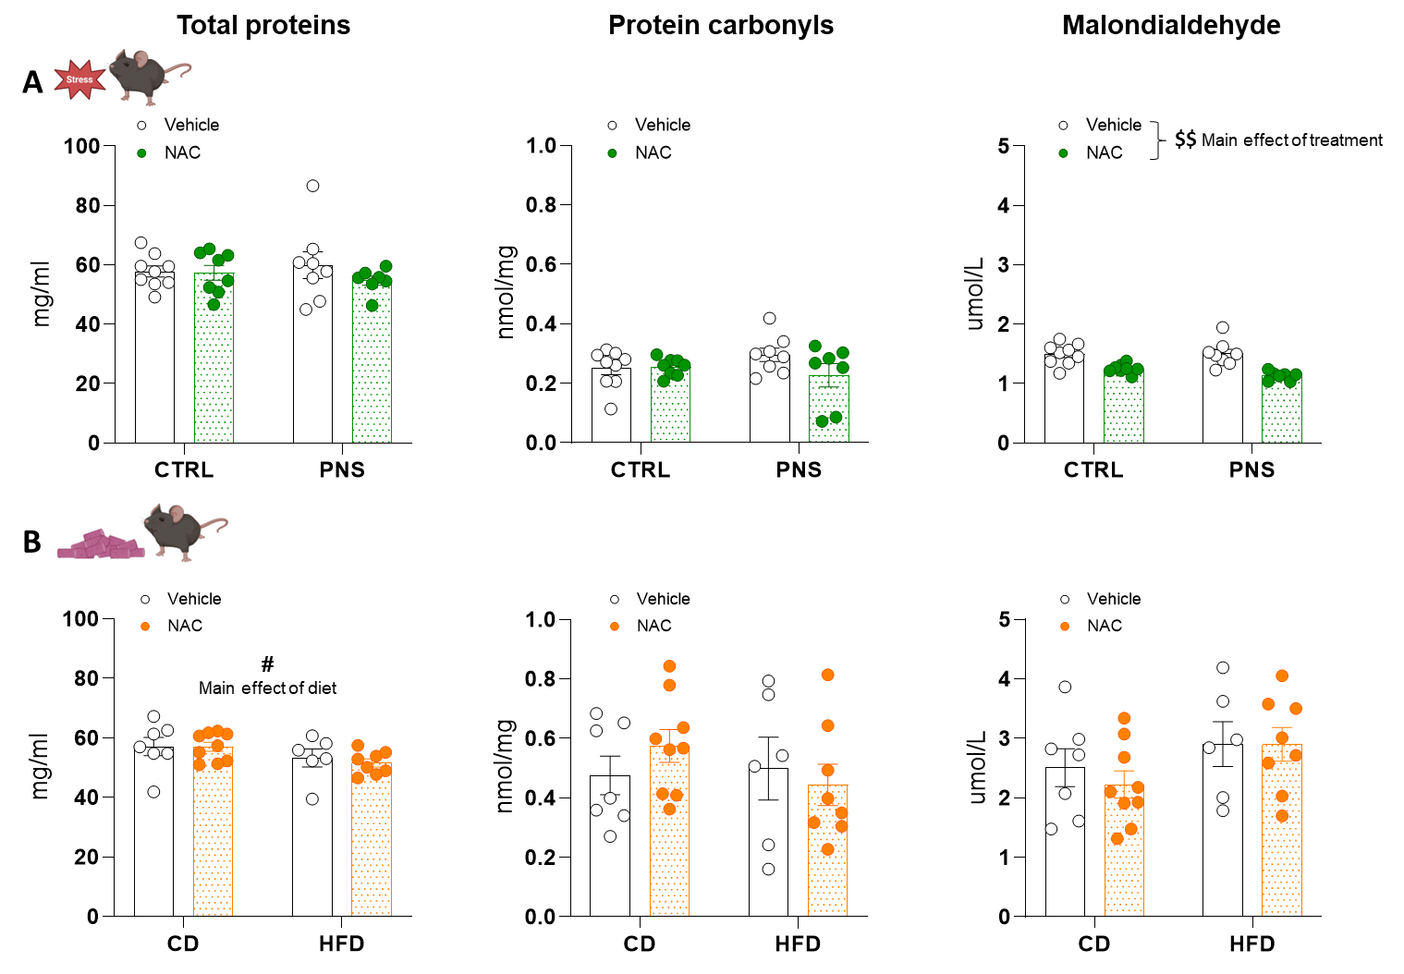
Figure S2 Total proteins and markers of oxidative stress in dams’ peripheral circulation. A) Protein levels and carbonyls were not affected by either PNS nor by NAC treatment (interaction _{stress x treatment} protein levels: F_{1,28}=2.241, p=0.1456; protein carbonyls: F_{1,28}=0.7007, p=0.4096). Overall NAC treatment decreased malondialdehyde levels (main effect of treatment: F_{1,28}=32.35, $$ p<0.0001). B) Exposure to HFD decreased total circulating protein levels (main effect of diet: F_{1,26}=4.15, # p=0.0478). Malondialdehyde and protein carbonyls were not altered between groups (interaction _{diet x treatment} malondialdehyde: F_{1,26}=0.2211, p=0.6422; protein carbonyls: F_{1,26}=1.133, p=0.2970). Two-way ANOVA. Number of subjects: 6-9 within each experimental group. Data are mean ± SEM.

Table S2 Circulating levels of NAC (nM) in pregnant females administered with the compound
Experimental group | NAC (nM)
CTRL-NAC | 1.853 ± 0.672
PNS-NAC | 4.768 ± 2.213
CD-NAC | 2.761 ± 0.774
HFD-NAC | 3.087 ± 0.693
PNS. No main effect of stress was found in maternal circulating levels of NAC (F_{1,8}=2.255, p=1.1716).
mHFD. No main effect of diet was found in maternal circulating levels of NAC (F_{1,8}=0.086, p=0.7767).
Two-way ANOVA. Number of subjects: 4-6 within each experimental group. Data are mean ± SEM.
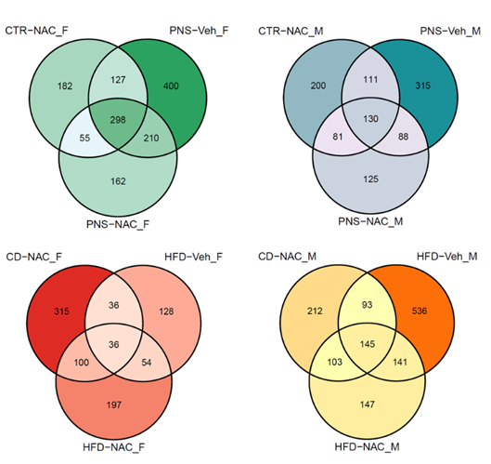
Figure S3 Venn Diagrams of DEPs for each group. The intensity of colors is proportional to the number of DEPs. Generally, stressful conditions had the highest number of unique DEPs, except HFD-Veh of female placentas; among the same stress group, female PNS/NAC showed the highest DEP overlap.

Figure S4 Enriched KEGG pathways in PNS condition. Enriched KEGGs are shown in decreasing order of significance. Featured down- and up-regulated DEPs are indicated by blue and red stacked histograms, respectively.

Figure S5 Enriched KEGG pathways in HFD condition. Enriched KEGGs are shown in decreasing order of significance. Featured down- and up-regulated DEPs are indicated by blue and red stacked histograms, respectively.

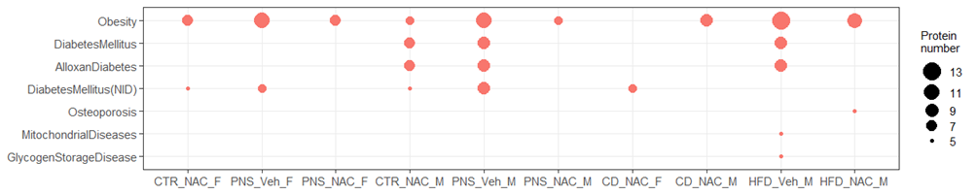
Figure S6 Metabolic/Nutritional diseases associated with DEPs. Dot plots show diseases associated with at least five DEPs in each experimental condition. Dot size is proportional to the number of featured DEPs.

Figure S7 Neurological/behavioral diseases associated with DEPs. Dot plots show diseases associated with at least five DEPs in each experimental condition. Dot size is proportional to the number of featured DEPs.
Table S3 Summary results of the generalized linear models analysis on lipidomic and metabolomic data χ2 and p-values are indicated only for significant factors/interactions.

PNS
Metabolite | SEX (M/F) | TREAT (VEH/NAC) | STRESS (CTR/PNS) | SEX X TREAT | STRESS X SEX | STRESS X TREAT | STRESS X SEX X TREAT
PC |  |  |  | NAC-M > Veh-M  χ2=4.19; p-value=0.0407
MUFA |  |  |  |  |  | NAC > Veh  χ2=4.32; p-value=0.0377
Formate |  |  |  |  |  | CTR-NAC < CTR-Veh and PNS-NAC > PNS-Veh  χ2=3.96; p-value=0.0465 | CTR-NAC-M < CTR-Veh-M and NAC-PNS-M > Veh-PNS-M  χ2=4.85; p-value=0.0276
Phenylalanine |  | NAC < Veh  χ²=6.00; p-value=0.0143 |  |  | CTR-M < CTR-F and PNS-M > PNS-F χ2=5.15; p-value=0.0232
Tyrosine |  | NAC < Veh  χ2=6.52; p-value=0.0107 |  |  | CTR-M < CTR-F and PNS-M > PNS-F  χ2=6.16; p-value=0.0130
Fumarate |  |  |  |  | CTR-M < CTR-F and PNS-M > PNS-F χ2=7.46; p-value=0.0063
UDP-gluc-nac |  |  |  |  | CTR-M < CTR-F and PNS-M > PNS-F χ2=10.33; p-value=0.0013
UDP-Glc |  |  |  | NAC-M < Veh-M  χ²=4.58; p-value=0.0323 | CTR-M < CTR-F and PNS-M > PNS-F χ²=12.24; p-value=0.0005
Glucose |  |  |  |  | CTR-M < CTR-F and PNS-M > PNS-F χ²=8.36; p-value=0.0038
Myo-inositol |  | NAC < Veh  χ²=5.57; p-value=0.0182 |  | NAC-M < Veh-M  χ²=4.32; p-value=0.0377 | CTR-M < CTR-F and PNS-M > PNS-F χ²=6.22; p-value=0.0126
Taurine |  |  |  |  | CTR-M < CTR-F and PNS-M > PNS-F χ²=5.57; p-value=0.0183
GPC+PCho |  |  |  |  | CTR-M < CTR-F and PNS-M > PNS-F χ²=5.36; p-value=0.0207
Choline |  | NAC < Veh  χ²=5.58; p-value=0.0182 |  |  | CTR-M < CTR-F and PNS-M > PNS-F χ²=5.25; p-value=0.0220
Tot creatine |  |  |  |  | CTR-M < CTR-F and PNS-M > PNS-F χ²=6.87; p-value=0.0087
Aspartate |  | NAC < Veh  χ²=7.06; p-value=0.0079 | PNS > CTR  χ²=4.93; p-value=0.0264 | NAC-M < Veh-M  χ²=7.84; p-value=0.0051 | CTR-M < CTR-F and PNS-M > PNS-F χ2=16.65; p-value=<0.0001
Glutathione | M > F  χ²=4.83; p-value=0.0279 |  | PNS > CTR  χ²=7.40; p-value=0.0065 | NAC-M < Veh-M  χ²=4.14; p-value=0.0419 | PNS-M > PNS-F  χ²=5.42; p-value=0.0200
Glutamine |  |  |  |  | CTR-M < CTR-F and PNS-M > PNS-F χ²=6.61; p-value=0.0101
Succinate |  | NAC < Veh  χ²=4.91; p-value=0.0267 |  | NAC-M < Veh-M  χ²=4.67; p-value=0.0307 | PNS-M > PNS-F  χ²=3.96; p-value=0.0465
Pyruvate |  |  |  | NAC-M < Veh-M  χ²=6.10; p-value=0.0135 | CTR-M < CTR-F and PNS-M > PNS-F χ²=4.84; p-value=0.0278
Glutamate |  | NAC < Veh  χ²=4.61; p-value=0.0318 |  | NAC-M < Veh-M  χ²=5.46; p-value=0.0194 | CTR-M < CTR-F and PNS-M > PNS-F χ²=10.09; p-value=0.0015
Acetate | M > F  χ²=6.75; p-value=0.0094 | NAC < Veh  χ²=8.24; p-value=0.0041 |  | NAC-M < Veh-M  χ²=6.48; p-value=0.0109 | PNS-M > PNS-F  χ²=6.08; p-value=0.0137
Spermidine | M > F  χ²=4.14; p-value=0.0419
Alanine | M > F  χ²=4.64; p-value=0.0313 |  |  |  | CTR-M < CTR-F and PNS-M > PNS-F χ²=8.87; p-value=0.0029
Lysine | M > F  χ²=4.84; p-value=0.0278
Lactate |  | NAC < Veh  χ²=4.28; p-value=0.0385 |  |  | CTR-M < CTR-F and PNS-M > PNS-F χ²=7.72; p-value=0.0055
Valine |  | NAC < Veh  χ²=8.35; p-value=0.0039 |  | NAC-M < Veh-M  χ²=4.63; p-value=0.0313 | CTR-M < CTR-F and PNS-M > PNS-F χ²=7.78; p-value=0.0053
Isoleucine |  | NAC < Veh  χ²=5.67; p-value=0.0172 |  |  | PNS-M > PNS-F  χ²=4.44; p-value=0.0351
Leucine |  | NAC < Veh  χ²=9.90; p-value=0.0017 |  | NAC-M < Veh-M  χ²=6.11; p-value=0.0135 | CTR-M < CTR-F and PNS-M > PNS-F χ²=9.45; p-value=0.0021
Histidine |  | NAC < Veh  χ²=22.21; p-value=<0.0001 |  | NAC-M < Veh-M and NAC-F < Veh-F  χ²=11.69; p-value=0.0006 | CTR-M < CTR-F and PNS-M > PNS-F χ²=5.77; p-value=0.0163
HFD
Metabolite | SEX (M/F) | TREAT (VEH/NAC) | STRESS (CD/HFD) | SEX X TREAT | STRESS X SEX | STRESS X TREAT | STRESS X SEX X TREAT
UFA | M > F  χ²=3.94; p-value=0.0471
PC |  |  | HFD > CD  χ²=5.21; p-value=0.0223
LPC | M > F  χ²=4.32; p-value=0.0377 |  |  |  |  | CD-NAC < CD-Veh and HFD-NAC > HFD-Veh  χ²=5.01; p-value=0.0253 | CD-NAC-M < CD-Veh-M and HFD-NAC-M > HFD-Veh-M χ²=4.27; p-value=0.0389
Linoleic acid |  |  | HFD > CD  χ²=4.52; p-value=0.0335
Phenylalanine |  |  |  |  | CD-M <  CD-F  and HFD-M > HFD-F χ²=6.83; p-value=0.0090
Tyrosine |  |  |  |  | CD-M <  CD-F  and HFD-M > HFD-F χ²=4.01; p-value=0.0451
UDP-gluc-nac | M > F  χ²=4.06; p-value=0.0440
UDP-Glc | M > F  χ²=5.10; p-value=0.0240
Myo-inositol | M > F  χ²=4.06; p-value=0.0440
Alanine | M > F  χ²=5.67; p-value=0.0173

Acronyms: GPC+ PCho= sn-glycerophosphocholine plus O-phosphocholine; LPC= Lysophosphatidylcholine; MUFA= monounsaturated fat; TOT CREATINE= total creatine (creatine plus phosphocreatine); PC= phosphatidylcholine; UDP-GLC= UDP-glucose; UDP-GLC_NAC= UDP-N-acetylglucosamine; UFA= unsaturated fat.

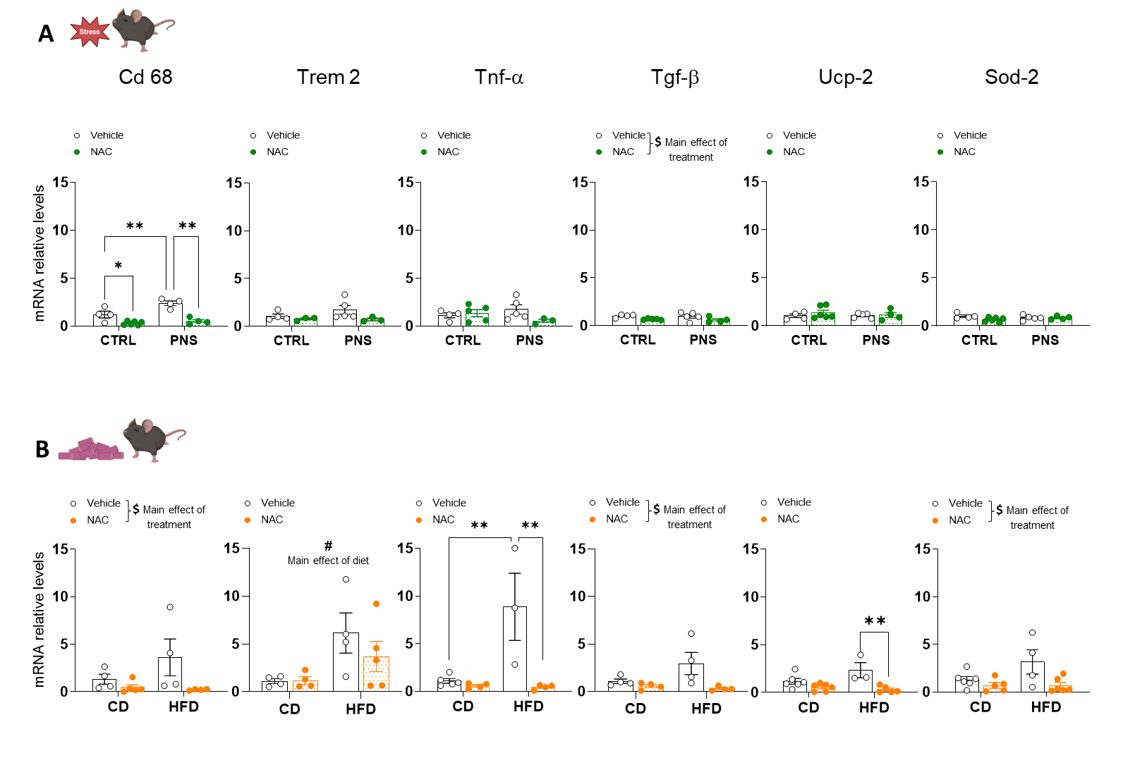
Figure S8 Immuno-inflammatory and oxidative stress markers in amniotic fluid. A) Cd 68 levels were increased by PNS, while NAC decreased this marker (interaction _{stress x treatment}: F_{1,14}=5.33, p=0.0368, Šídák’s post-hoc comparisons ** p<0.01 PNS-Veh vs CTRL-Veh, PNS-NAC vs PNS-Veh, * p<0.05 CTRL-NAC vs CTRL-Veh). Overall NAC decreased Tgf-β levels (main effect of treatment: F_{1,14}=7.09, $ p=0.0185). No effect of PNS or NAC were found in modulating Trem 2 (interaction _{stress x treatment}: F_{1,11}=0.9552, p=0.3494), Tnf-α (interaction _{stress x treatment}: F_{1,13}=3.272, p=0.0937), Ucp-2 (interaction _{stress x treatment}: F_{1,15}=0.362, p=0.5564) and Sod-2 (interaction _{stress x treatment}: F_{1,15}=2.783, p=0.116) transcript levels. B) mHFD overall increased the expression of Trem 2 (main effect of diet: F_{1,13}=7.325, # p=0.018). mHFD also increased levels of Tnf-α, while NAC was able to prevent this alteration (interaction _{diet x treatment}: F_{1,12}=9.56, p=0.0093, Šídák’s post hoc comparisons: ** p<0.01 HFD-Veh vs CD-Veh, HFD-NAC vs HFD-Veh). Prenatal NAC overall reduced the expression of Cd 68 (F_{1,13}=4.95, $ p=0.0445), Tgf-β (F_{1,12}= 6.83, $ p=0.0226) and Sod-2 (F_{1,17}=7.33, $ p=0.0150). Ucp-2 mRNA was lowered by NAC in mHFD group (interaction _{diet x treatment}: F_{1,16}=4.637, p=0.0469, Šídák’s post hoc comparisons: ** p<0.01 HFD-NAC vs HFD-Veh). Two-way ANOVA. Number of subjects: 3-6 within each experimental group. Data are mean ± SEM.

