Distinct and Shared Intrinsic Resting-State Functional Networks in Children with Idiopathic Autism Spectrum Disorder and Fragile X Syndrome

Methods

Clinical Assessments
Relevant medical records were reviewed. Physical and neurological examinations were performed by senior pediatricians. Evaluations for comorbidities were reviewed during the clinical visit.
ASD diagnosis was based on the DSM-5 (1) and ADOS-2 (2) and administrated by certified clinicians. The ADOS-2 included the Social Affect (SA) domain score, Restricted and Repetitive Behaviors (RRB) domain score, total ADOS score, and severity score (CSS). Domain severity (CSS-SA & CSS-RRB) scores were also calculated (Table 1) (3).
The developmental and cognitive level was evaluated by Griffiths Development Scales-Chinese (GDS-C) in children which consists of five developmental domains including gross motor, fine motor, social, language, and performance (4). All clinical assessments were administrated to children with FXS and ASD (Table 1).

FXS genetic testing
The FMR1 CGG repeats testing utilized the PCR-CE FMR1 Kit (Biofast Biotechnology Co., Ltd.), and capillary electrophoresis (CE) conducted on the ABI 3500 Dx Genetic Analyzer (Thermo Fisher Scientific, Waltham, MA) using 1200 LIZ™ Size Standard, following the manufacturer's instructions.
Gene-specific primers annealing to the upstream region in FMR1 5'UTR determined CGG repeats, and the triplet-repeated primer targeting the CGG region revealed AGG interruption status. The larger amplicon in FMR1 5'UTR covered the full expansion lengths and was converted into CGG repeat numbers using a regression curve derived from a standard mixture, and the CGG stutter amplicon indicated the status of AGG interruptions.

FMR1 gene methylation level
Methylation status was assessed using the PCR-CE mFMR1 assay (Biofast), a PCR-based approach that offers accurate, sensitive, and standardized determination of FMR1 methylation and CGG repeat length in both males and females with fragile X syndrome (including all premutation and full mutation alleles), and it can also harmonize results across different laboratories. According to manufacturer guidelines, gDNA, methylation-sensitive plasmid, and a reference control were pooled, then separated into control and methylation-digested groups. The latter was treated with HpaII then amplified with FAM-labeled primer, while the control group's allele was amplified with NED-labeled primers. Both amplicons were pooled for capillary electrophoresis. The methylation percentage for each allele was calculated by normalizing against the reference control according to the equation adopted in previous studies (5,6):
$$Methylation \left(\%\right)=100*\frac{FAM labeled\left(\frac{FMR1 height}{RefControl height}\right)}{NED labeled \left(\frac{FMR1 height}{RefControl height}\right)}$$

Image preprocessing
The imaging data from 7 subjects (5 FXS, 1 ASD, 1 TD) were excluded after quality control. BOLD images were processed using Data Processing & Analysis for Brain Imaging (DPABI) (7). The first 10 volumes were discarded to allow for the steady BOLD activity signal. The remaining 190 images were corrected for slice timing effects and motion artifacts. The anatomical T1 images from each subject were then registered to the mean EPI image and segmented into different tissues (gray matter, white matter, and cerebrospinal fluid). Linear trends, Friston 24 head motion parameters (8), the white matter signal, and the cerebrospinal fluid signal were regressed out from the functional signal as nuisance covariates. Then, the Diffeomorphic Anatomical Registration Through Exponentiated Lie algebra (DARTEL) tool was used to normalize functional images to Montreal Neurological Institute (MNI) space (resampled voxel size = 3 mm × 3 mm × 3 mm). Finally, the data were bandpass filtered between 0.01 and 0.1 Hz.

Resting-state Functional Network Analysis
Time series from a total of 160 regions of interest (ROIs) defined by the Dosenbach's 160 atlas were extracted by averaging the denoised BOLD time series across all voxels within each ROI (9). Pearson correlation coefficients between all ROI pairings were calculated and Fisher z-transformed to construct an ROI-based resting-state functional connectivity (rsFC) matrix for each participant.
We further defined eight intrinsic function networks based on a well-defined functional parcellation derived from a sample of 1000 healthy participants (10). These networks included the sensorimotor network (SMN), ventral attention network (VAN), visual network (VN), dorsal attention network (DAN), default mode network (DMN), and frontoparietal network (FPN). Since subcortical regions and cerebellum were often affected in FXS and ASD (11), we defined subcortical ROIs as the "subcortical network" (SCN) and cerebellum ROIs as the "cerebellum network" (CN). Information of the ROIs in each network was summarized in the supplementary material (Table S2).

Table S1. The blood CGG level and type and methylation level in FXS group. FM = Full mutation; PM = Premutation.
Subjects | CGG repeat number | CGG type | Methylation level (%)
F02 | 224, 293, 334, 367 | FM | 72
F03 | NA | NA | NA
F04 | 314, 365 | FM | 100
F05 | 144, 375 | PM/FM | 61
F06 | 268, 377 | FM | 97
F07 | 276, 295, 377 | FM | 94
F08 | 378 | FM | 88
F10 | 105, 236, 332, 377 | PM/FM | 73
F12 | 380 | FM | 91
F13 | 140, 183, 381 | PM/FM | 79
F14 | 195, 311, 331, 352, 362 | PM/FM | 94
F15 | 315, 365 | FM | 91
F17 | 357 | FM | 79
F18 | 271, 364 | FM | 58
F19 | 259, 309, 370 | FM | 99
F20 | 264, 363 | FM | 95
F21 | 273, 377 | FM | 72
F22 | 201, 296, 339, 377 | FM | 79
F25 | 112, 139, 289, 322, 364 | PM/FM | 69
F29 | 245, 335, 367 | FM | 78
F30 | 297, 321, 368 | FM | 96
F32 | 29, 70, 94, 351, 368 | PM/FM | 65
F33 | 277, 363 | FM | 73
F34 | 63, 112, 298, 367 | PM/FM | 84
F35 | 123, 334, 366 | PM/FM | 39
F36 | 83, 215, 228, 335, 367 | PM/FM | 44
F37 | 103, 120, 333, 364 | PM/FM | 50
F38 | 193, 306, 377 | PM/FM | 88
F39 | 362, 402 | PM/FM | 80
F41 | 376 | FM | 90
F42 | 365 | FM | 100
F43 | 86, 167, 266, 302, 377 | PM/FM | NA
F44 | 222, 364 | FM | 100
F45 | 364 | FM | 95
FF01 | >200 | NA | NA
FF02 | 30, 78, 144, 260, 362 | PM/FM | 50
FF04 | 29, 194, 214, 247, 370 | FM | 62

Table S2. Information of the ROIs in each network, including ROI label, corresponding Brodmann area and anatomical region, along with MNI coordinates.
Network | Label | Brodmann area | Anatomical region | x | y | z
Visual  Network  (VN) | occipital | 17 | Calcarine Cortex (R) | 9 | -76 | 14
Visual  Network  (VN) | post occipital | 17 | Calcarine Cortex (L) | -5 | -80 | 9
Visual  Network  (VN) | post occipital | 17 | Calcarine Cortex (R) | 13 | -91 | 2
Visual  Network  (VN) | post occipital | 18 | Calcarine Cortex (L) | -4 | -94 | 12
Visual  Network  (VN) | occipital | 18 | Cuneus (L)) | -16 | -76 | 33
Visual  Network  (VN) | occipital | 18 | Cuneus (R) | 15 | -77 | 32
Visual  Network  (VN) | occipital | 18 | Cuneus (R) | 17 | -68 | 20
Visual  Network  (VN) | occipital | 18 | Lingual gyrus (R) | 20 | -78 | -2
Visual  Network  (VN) | occipital | 19 | Lingual gyrus (R) | 19 | -66 | -1
Visual  Network  (VN) | post occipital | 18 | Middle Occipital gyrus (L) | -29 | -88 | 8
Visual  Network  (VN) | post occipital | 18 | Middle Occipital gyrus (R) | 27 | -91 | 2
Visual  Network  (VN) | occipital | 19 | Precuneus (L) | -18 | -50 | 1
Visual  Network  (VN) | occipital | 19 | Lateral Occipital Cortex, superior division (R) | 29 | -73 | 29
Visual  Network  (VN) | post occipital | 19 | Lateral Occipital Cortex, superior division (R) | 29 | -81 | 14
Visual  Network  (VN) | post occipital | 19 | Lateral Occipital Cortex, inferior division (R) | 33 | -81 | -2
Visual  Network  (VN) | post occipital | 19 | Lateral Occipital Cortex, inferior division (L) | -37 | -83 | -2
Visual  Network  (VN) | fusiform | 37 | Fusiform (R) | 28 | -37 | -15
Visual  Network  (VN) | occipital | 37 | Fusiform (L) | -28 | -42 | -11
Visual  Network  (VN) | occipital | 37 | Posterior Inferior Temporal Cortex (L) | -34 | -60 | -5
Visual  Network  (VN) | occipital | 37 | Posterior Inferior Temporal Cortex (R) | 36 | -60 | -8
Visual  Network  (VN) | occipital | 37 | Middle Occipital gyrus (R) | 39 | -71 | 13
Visual  Network  (VN) | temporal | 37 | Middle Temporal gyrus (R) | 46 | -62 | 5
Sensorimotor network (SMN) | SMA | 0 | Supplementary Motor Area | 0 | -1 | 52
Sensorimotor network (SMN) | parietal | 0 | Precentral Gyrus (R) | 18 | -27 | 62
Sensorimotor network (SMN) | sup parietal | 2 | Postcentral Gyrus (R) | 34 | -39 | 65
Sensorimotor network (SMN) | precentral gyrus | 3 | Precentral Gyrus (R) | 44 | -11 | 38
Sensorimotor network (SMN) | parietal | 3 | Precentral Gyrus (L) | -47 | -12 | 36
Sensorimotor network (SMN) | frontal | 4 | Precentral Gyrus (R) | 53 | -3 | 32
Sensorimotor network (SMN) | parietal | 4 | Precentral Gyrus (R) | 41 | -23 | 55
Sensorimotor network (SMN) | parietal | 4 | Precentral Gyrus (L) | -38 | -15 | 59
Sensorimotor network (SMN) | parietal | 4 | Postcentral Gyrus (R) | 46 | -20 | 45
Sensorimotor network (SMN) | parietal | 4 | Postcentral Gyrus (L) | -47 | -18 | 50
Sensorimotor network (SMN) | parietal | 4 | Postcentral Gyrus (L) | -38 | -27 | 60
Sensorimotor network (SMN) | parietal | 4 | Postcentral Gyrus (L) | -24 | -30 | 64
Sensorimotor network (SMN) | dFC | 6 | Dorsal Frontal Cortex (R) | 60 | 8 | 34
Sensorimotor network (SMN) | temporal | 22 | Superior Temporal gyrus (R) | 51 | -30 | 5
Sensorimotor network (SMN) | temporal | 22 | Superior Temporal gyrus (R) | 59 | -13 | 8
Sensorimotor network (SMN) | temporal | 22 | Supramarginal Gyrus, posterior division (L) | -59 | -47 | 11
Sensorimotor network (SMN) | temporal | 41 | Superior Temporal gyrus (L) | -41 | -37 | 16
Sensorimotor network (SMN) | temporal | 42 | Planum Temporale (L) | -53 | -37 | 13
Sensorimotor network (SMN) | precentral gyrus | 43 | Precentral Gyrus (L) | -54 | -9 | 23
Sensorimotor network (SMN) | temporal | 48 | Superior Temporal gyrus (L) | -54 | -22 | 9
Sensorimotor network (SMN) | precentral gyrus | 48 | SupraMarginal gyrus (L) | -54 | -22 | 22
Sensorimotor network (SMN) | precentral gyrus | 48 | Precentral Gyrus (R) | 58 | -3 | 17
Sensorimotor network (SMN) | precentral gyrus | 48 | Precentral Gyrus (R) | 46 | -8 | 24
Sensorimotor network (SMN) | mid insula | 48 | Middle Insular Cortex (R) | 33 | -12 | 16
Sensorimotor network (SMN) | mid insula | 48 | Middle Insular Cortex (L) | -36 | -12 | 15
Sensorimotor network (SMN) | mid insula | 48 | Middle Insular Cortex (R) | 32 | -12 | 2
Sensorimotor network (SMN) | mid insula | 48 | Middle Insular Cortex (L) | -30 | -14 | 1
Sensorimotor network (SMN) | post insula | 48 | Posterior Insular Cortex (R) | 42 | -24 | 17
Sensorimotor network (SMN) | post insula | 48 | Posterior Insular Cortex (L) | -30 | -28 | 9
Dorsal Attention Network  (DAN) | precuneus | 0 | Precuneous Cortex (R) | 8 | -40 | 50
Dorsal Attention Network  (DAN) | parietal | 3 | Postcentral Gyrus (L) | -55 | -22 | 38
Dorsal Attention Network  (DAN) | post parietal | 3 | Postcentral Gyrus (L) | -41 | -31 | 48
Dorsal Attention Network  (DAN) | vFC | 6 | Precentral Gyrus (L) | -55 | 7 | 23
Dorsal Attention Network  (DAN) | precentral gyrus | 6 | Precentral Gyrus (L) | -44 | -6 | 49
Dorsal Attention Network  (DAN) | parietal | 6 | Precentral Gyrus (L) | -26 | -8 | 54
Dorsal Attention Network  (DAN) | IPS | 7 | Intraparietal sulcus (R) | 32 | -59 | 41
Dorsal Attention Network  (DAN) | occipital | 19 | Lateral Occipital Cortex, superior division (L) | -29 | -75 | 28
Dorsal Attention Network  (DAN) | TPJ | 37 | Temporoparietal Junction (L) | -52 | -63 | 15
Dorsal Attention Network  (DAN) | occipital | 37 | Inferior Temporal Gyrus, temporooccipital part (L) | -44 | -63 | -7
Dorsal Attention Network  (DAN) | occipital | 39 | Lateral Occipital Cortex, superior division (L) | -42 | -76 | 26
Dorsal Attention Network  (DAN) | IPL | 40 | Inferior Parietal Lobule (L) | -41 | -40 | 42
Dorsal Attention Network  (DAN) | post parietal | 40 | Superior Parietal Lobule (L) | -35 | -46 | 48
Dorsal Attention Network  (DAN) | dFC | 44 | Precentral Gyrus (R) | 44 | 8 | 34
Ventral Attention Network  (VAN) | mFC | 0 | medial Frontal Cortex | 0 | 15 | 45
Ventral Attention Network  (VAN) | pre-SMA | 6 | Supplementary Motor Area (R) | 10 | 5 | 51
Ventral Attention Network  (VAN) | temporal | 21 | Lateral Temporal Cortex (R) | 43 | -43 | 8
Ventral Attention Network  (VAN) | basal ganglia | 32 | Dorsal anterior cingulate cortex (L) | -6 | 17 | 34
Ventral Attention Network  (VAN) | dACC | 32 | Dorsal anterior cingulate cortex (R) | 9 | 20 | 34
Ventral Attention Network  (VAN) | parietal | 42 | Supramarginal Gyrus, posterior division (R) | 58 | -41 | 20
Ventral Attention Network  (VAN) | frontal | 44 | Inferior frontal gyrus, opercular part (R) | 58 | 11 | 14
Ventral Attention Network  (VAN) | aPFC | 46 | Frontal Pole (R) | 27 | 49 | 26
Ventral Attention Network  (VAN) | ant insula | 47 | Anterior Insular Cortex (R) | 38 | 21 | -1
Ventral Attention Network  (VAN) | ant insula | 48 | Anterior Insular Cortex (L) | -36 | 18 | 2
Ventral Attention Network  (VAN) | mid insula | 48 | Opercular Cortex (R) | 37 | -2 | -3
Ventral Attention Network  (VAN) | mid insula | 48 | Opercular Cortex (L) | -42 | -3 | 11
Ventral Attention Network  (VAN) | vPFC | 48 | Ventral Prefrontal Cortex (R) | 34 | 32 | 7
Ventral Attention Network  (VAN) | vFC | 48 | Ventral Frontal Cortex (L) | -48 | 6 | 1
Ventral Attention Network  (VAN) | vFC | 48 | Ventral Frontal Cortex (R) | 43 | 1 | 12
Ventral Attention Network  (VAN) | parietal | 48 | Supramarginal Gyrus, posterior division (L) | -55 | -44 | 30
SCN | basal ganglia | 0 | Putamen (L) | -20 | 6 | 7
SCN | basal ganglia | 0 | Caudate (R) | 14 | 6 | 7
SCN | thalamus | 0 | Caudate (L) | -12 | -3 | 13
SCN | thalamus | 0 | Thalamus (L) | -12 | -12 | 6
SCN | thalamus | 0 | Thalamus (R) | 11 | -12 | 6
SCN | basal ganglia | 0 | Thalamus (R) | 11 | -24 | 2
SCN | post cingulate | 0 | Brain-stem | -4 | -31 | -4
Frontoparietal Network  (FPN) | occipital | 0 | Precuneous Cortex (L) | -2 | -75 | 32
Frontoparietal Network  (FPN) | ACC | 0 | Paracingulate Gyrus (L) | -1 | 28 | 40
Frontoparietal Network  (FPN) | occipital | 7 | Precuneous Cortex (L) | -9 | -72 | 41
Frontoparietal Network  (FPN) | IPS | 7 | Superior Parietal Lobule (L) | -32 | -58 | 46
Frontoparietal Network  (FPN) | aPFC | 10 | Frontal Pole (L) | -29 | 57 | 10
Frontoparietal Network  (FPN) | fusiform | 20 | Inferior temporal gyrus (R) | 54 | -31 | -18
Frontoparietal Network  (FPN) | ACC | 32 | Cingulate Gyrus, anterior division (L) | -2 | 30 | 27
Frontoparietal Network  (FPN) | IPL | 40 | Supramarginal Gyrus, posterior division (R) | 54 | -44 | 43
Frontoparietal Network  (FPN) | IPL | 40 | Supramarginal Gyrus, posterior division (L) | -48 | -47 | 49
Frontoparietal Network  (FPN) | IPL | 40 | Angular Gyrus (R) | 44 | -52 | 47
Frontoparietal Network  (FPN) | dFC | 44 | Middle Frontal Gyrus (R) | 40 | 17 | 40
Frontoparietal Network  (FPN) | dFC | 44 | Middle Frontal Gyrus (L) | -42 | 7 | 36
Frontoparietal Network  (FPN) | vFC | 44 | Inferior frontal gyrus, opercular part (L) | -46 | 10 | 14
Frontoparietal Network  (FPN) | dlPFC | 45 | Middle Frontal Gyrus (R) | 46 | 28 | 31
Frontoparietal Network  (FPN) | dlPFC | 45 | Middle Frontal Gyrus (L) | -44 | 27 | 33
Frontoparietal Network  (FPN) | vPFC | 45 | Inferior frontal gyrus, triangular part (L) | -52 | 28 | 17
Frontoparietal Network  (FPN) | vlPFC | 45 | Frontal Pole (R) | 39 | 42 | 16
Frontoparietal Network  (FPN) | vent aPFC | 45 | Frontal Pole (L) | -43 | 47 | 2
Frontoparietal Network  (FPN) | dlPFC | 46 | Frontal Pole (R) | 40 | 36 | 29
Frontoparietal Network  (FPN) | aPFC | 46 | Frontal Pole (R) | 29 | 57 | 18
Frontoparietal Network  (FPN) | vent aPFC | 47 | Frontal Pole (R) | 42 | 48 | -3
Default Mode Network  (DMN) | mPFC | 0 | Superior Frontal gyrus, medial | 0 | 51 | 32
Default Mode Network  (DMN) | vlPFC | 0 | Frontal Pole (R) | 46 | 39 | -15
Default Mode Network  (DMN) | post cingulate | 0 | Middle Cingulate (L) | 1 | -26 | 31
Default Mode Network  (DMN) | precuneus | 0 | Cingulate Gyrus, posterior division (L) | -3 | -38 | 45
Default Mode Network  (DMN) | post cingulate | 0 | Precuneous Cortex (L) | -8 | -41 | 3
Default Mode Network  (DMN) | precuneus | 7 | Precuneous Cortex (R) | 11 | -68 | 42
Default Mode Network  (DMN) | IPS | 7 | Lateral Occipital Cortex, superior division (L) | -36 | -69 | 40
Default Mode Network  (DMN) | sup frontal | 8 | Superior Frontal Gyrus (L) | -16 | 29 | 54
Default Mode Network  (DMN) | sup frontal | 9 | Superior Frontal Gyrus (R) | 23 | 33 | 47
Default Mode Network  (DMN) | vmPFC | 10 | Paracingulate Gyrus (R) | 9 | 51 | 16
Default Mode Network  (DMN) | vmPFC | 10 | Paracingulate Gyrus (L) | -6 | 50 | -1
Default Mode Network  (DMN) | vmPFC | 10 | Paracingulate Gyrus (R) | 8 | 42 | -5
Default Mode Network  (DMN) | vmPFC | 10 | Frontal Pole (R) | 6 | 64 | 3
Default Mode Network  (DMN) | inf temporal | 20 | Middle Temporal Gyrus, posterior division (R) | 52 | -15 | -13
Default Mode Network  (DMN) | inf temporal | 20 | Middle Temporal Gyrus, posterior division (L) | -59 | -25 | -15
Default Mode Network  (DMN) | inf temporal | 21 | Middle Temporal Gyrus, posterior division (L) | -61 | -41 | -2
Default Mode Network  (DMN) | precuneus | 23 | Precuneous Cortex (L) | -6 | -56 | 29
Default Mode Network  (DMN) | precuneus | 23 | Cingulate Gyrus, posterior division (R) | 5 | -50 | 33
Default Mode Network  (DMN) | post cingulate | 26 | Cingulate Gyrus, posterior division (L) | -5 | -43 | 25
Default Mode Network  (DMN) | precuneus | 26 | Cingulate Gyrus, posterior division (R) | 9 | -43 | 25
Default Mode Network  (DMN) | post cingulate | 30 | Cingulate Gyrus, posterior division (L) | -5 | -52 | 17
Default Mode Network  (DMN) | post cingulate | 30 | Precuneous Cortex (R) | 10 | -55 | 17
Default Mode Network  (DMN) | post cingulate | 30 | Precuneous Cortex (L) | -11 | -58 | 17
Default Mode Network  (DMN) | vmPFC | 32 | Paracingulate Gyrus (L) | -11 | 45 | 17
Default Mode Network  (DMN) | ACC | 32 | Anterior cingulate cortex, pregenual (R) | 9 | 39 | 20
Default Mode Network  (DMN) | angular gyrus | 39 | Angular Gyrus (R) | 51 | -59 | 34
Default Mode Network  (DMN) | angular gyrus | 39 | Angular Gyrus (L) | -48 | -63 | 35
Default Mode Network  (DMN) | angular gyrus | 39 | Angular Gyrus (L) | -41 | -47 | 29
Default Mode Network  (DMN) | occipital | 39 | Lateral Occipital Cortex, superior division (R) | 45 | -72 | 29
Default Mode Network  (DMN) | IPL | 40 | Inferior Parietal Lobule (L) | -53 | -50 | 39
Default Mode Network  (DMN) | sup temporal | 41 | Superior Temporal gyrus (R) | 42 | -46 | 21
Default Mode Network  (DMN) | vFC | 45 | Inferior Frontal gyrus, triangular part (R) | 51 | 23 | 8
Default Mode Network  (DMN) | aPFC | 46 | Frontal Pole (L) | -25 | 51 | 27
Cerebellum Network  (CN) | inf cerebellum | 0 | Inferior Cerebellum (R) | 32 | -61 | -31
Cerebellum Network  (CN) | inf cerebellum | 0 | Inferior Cerebellum (R) | 33 | -73 | -30
Cerebellum Network  (CN) | inf cerebellum | 0 | Inferior Cerebellum (R) | 18 | -81 | -33
Cerebellum Network  (CN) | inf cerebellum | 0 | Inferior Cerebellum (L) | -37 | -54 | -37
Cerebellum Network  (CN) | inf cerebellum | 0 | Inferior Cerebellum (L) | -25 | -60 | -34
Cerebellum Network  (CN) | inf cerebellum | 0 | Inferior Cerebellum (L) | -34 | -67 | -29
Cerebellum Network  (CN) | inf cerebellum | 0 | Inferior Cerebellum (L) | -21 | -79 | -33
Cerebellum Network  (CN) | inf cerebellum | 0 | Inferior Cerebellum (L) | -6 | -79 | -33
Cerebellum Network  (CN) | med cerebellum | 0 | Medial Cerebellum (R) | 1 | -66 | -24
Cerebellum Network  (CN) | med cerebellum | 0 | Medial Cerebellum (R) | 5 | -75 | -11
Cerebellum Network  (CN) | med cerebellum | 18 | Medial Cerebellum (R) | 14 | -75 | -21
Cerebellum Network  (CN) | med cerebellum | 18 | Medial Cerebellum (L) | -16 | -64 | -21
Cerebellum Network  (CN) | med cerebellum | 18 | Medial Cerebellum (L) | -11 | -72 | -14
Cerebellum Network  (CN) | med cerebellum | 18 | Medial Cerebellum (L) | -6 | -60 | -15
Cerebellum Network  (CN) | lat cerebellum | 19 | Lateral Cerebellum (R) | 21 | -64 | -22
Cerebellum Network  (CN) | lat cerebellum | 37 | Lateral Cerebellum (L) | -34 | -57 | -24
Cerebellum Network  (CN) | lat cerebellum | 37 | Lateral Cerebellum (L) | -28 | -44 | -25
Cerebellum Network  (CN) | lat cerebellum | 37 | Lateral Cerebellum (L) | -24 | -54 | -21

Figure S1. Comparisons of within-network mean FC with no significant differences.
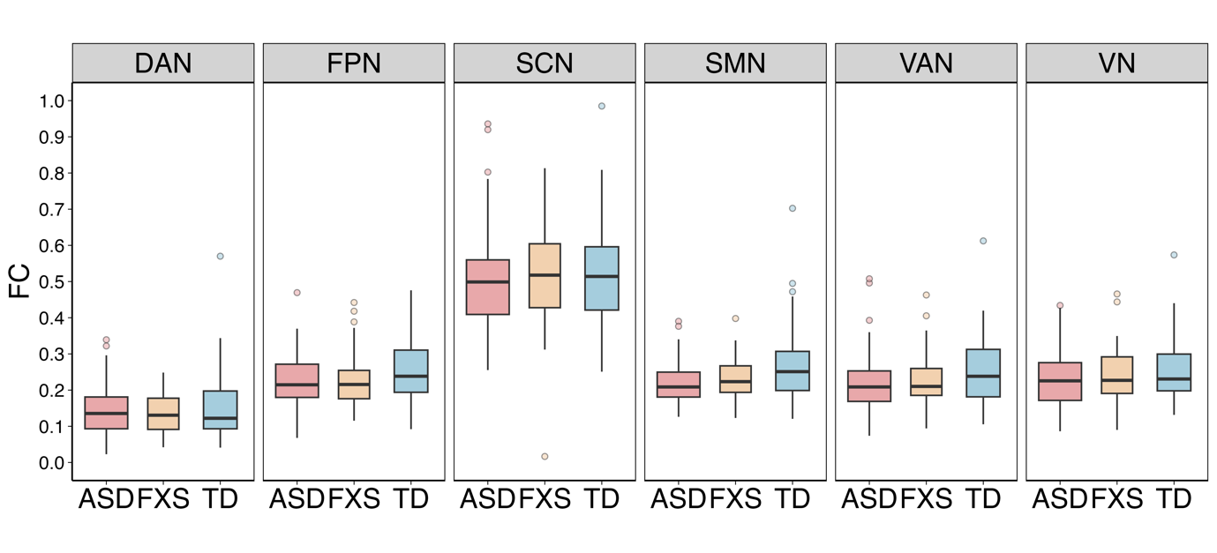

Figure S2. Comparisons of between-network mean FC with no significant differences.
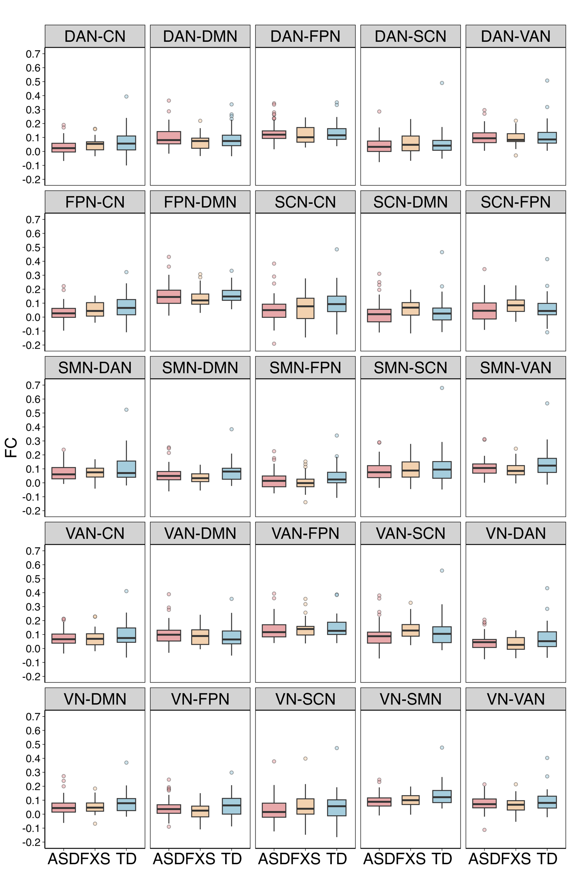

References
1. Diagnostic and statistical manual of mental disorders: DSM-5TM, 5th ed. Arlington, VA, US: American Psychiatric Publishing, Inc.; 2013. xliv, 947 p. (Diagnostic and statistical manual of mental disorders: DSM-5TM, 5th ed).
2. Lord C, Rutter M, Goode S, Heemsbergen J, Jordan H, Mawhood L, et al. Autism diagnostic observation schedule. J Autism Dev Disord. 2012;
3. Hus V, Lord C. The Autism Diagnostic Observation Schedule, Module 4: Revised Algorithm and Standardized Severity Scores. J Autism Dev Disord. 2014 Aug;44(8):1996–2012.
4. Tso WWY, Wong VCN, Xia X, Faragher B, Li M, Xu X, et al. The Griffiths Development Scales-Chinese (GDS-C): A cross-cultural comparison of developmental trajectories between Chinese and British children. Child Care Health Dev. 2018;44(3):378–83.
5. Grasso M, Boon EMJ, Filipovic-Sadic S, van Bunderen PA, Gennaro E, Cao R, et al. A Novel Methylation PCR that Offers Standardized Determination of FMR1 Methylation and CGG Repeat Length without Southern Blot Analysis. J Mol Diagn. 2014 Jan 1;16(1):23–31.
6. Chen L, Hadd AG, Sah S, Houghton JF, Filipovic-Sadic S, Zhang W, et al. High-resolution methylation polymerase chain reaction for fragile X analysis: Evidence for novel FMR1 methylation patterns undetected in Southern blot analyses. Genet Med. 2011 Jun 1;13(6):528–38.
7. Yan CG, Wang XD, Zuo XN, Zang YF. DPABI: Data Processing & Analysis for (Resting-State) Brain Imaging. Neuroinformatics. 2016 Jul 1;14(3):339–51.
8. Friston KJ, Williams S, Howard R, Frackowiak RSJ, Turner R. Movement-Related effects in fMRI time-series. Magn Reson Med. 1996;35(3):346–55.
9. Dosenbach NUF, Nardos B, Cohen AL, Fair DA, Power JD, Church JA, et al. Prediction of Individual Brain Maturity Using fMRI. Science. 2010 Sep 10;329(5997):1358–61.
10. Thomas Yeo BT, Krienen FM, Sepulcre J, Sabuncu MR, Lashkari D, Hollinshead M, et al. The organization of the human cerebral cortex estimated by intrinsic functional connectivity. J Neurophysiol. 2011 Sep;106(3):1125–65.
11. Lightbody AA, Reiss AL. Gene, Brain, and Behavior Relationships in Fragile X Syndrome: Evidence from Neuroimaging Studies. Dev Disabil Res Rev. 2009;15(4):343–52.

