SUPPLEMENTARY INFORMATION

RO4938581, a GABA_{A}-α5 negative allosteric modulator rescued behavioral and EEG phenotypes of a mouse model of Dup15q syndrome

Ryoko Nakagawa, Francesca Nani, Joerg F. Hipp, Michael Honer, Frederic Knoflach, Rodolfo Gasser, Laurence Ozmen, Kota Tamada, Fatiha Fjeldskaar, Livia Takacs, Audrey Vautheny, Stephen R. Morairty, Michael Saxe, Toru Takumi, Maria-Clemencia Hernandez

Table of Contents
Supplementary Figure 1. Increased mRNA and protein levels of GABA_{A}R α5 in the 15q dup mouse 2
Supplementary Method: Real-Time Quantitative Polymerase Chain Reaction 3
Supplementary Method: Primary Neuronal Culture 4
Supplementary Method: Immunocytochemistry 4
Supplementary Method: Immunohistochemistry 5
Supplementary Figure 2. Spontaneous excitatory neurotransmission in CA1 pyramidal neurons in hippocampal slices prepared from 15q dup and wild type mice 6
Supplementary Figure 3. Spontaneous inhibitory neurotransmission in CA1 pyramidal neurons in hippocampal slices prepared from 15q dup and wild type mice 7
Supplementary Method: Synaptic Physiology 8
Supplementary Figure 4. Long-term potentiation in CA1 hippocampal slices from 15q dup and wild type mice 9
Supplementary Method: Local Field Potential Recordings and LTP Induction 10
Supplementary Figure 5. Behavioral characterization of 15q dup mice 11
Supplementary Figure 6. No significant effects of RO4938581 treatment on open field, ultrasonic vocalization, olfactory habituation/dishabituation test in 15q dup mice 12
Supplementary Figure 7. RO4938581 partially normalizes increased beta-band activity in 15q dup mice 14
Supplementary Table S1. Plasma concentration raw data from WT and 15q dup mice 15
Supplementary Method: Sampling and Bioanalytics 15

Supplementary Figure 1. Increased mRNA and protein levels of GABA_{A}R α5 in the 15q dup mouse
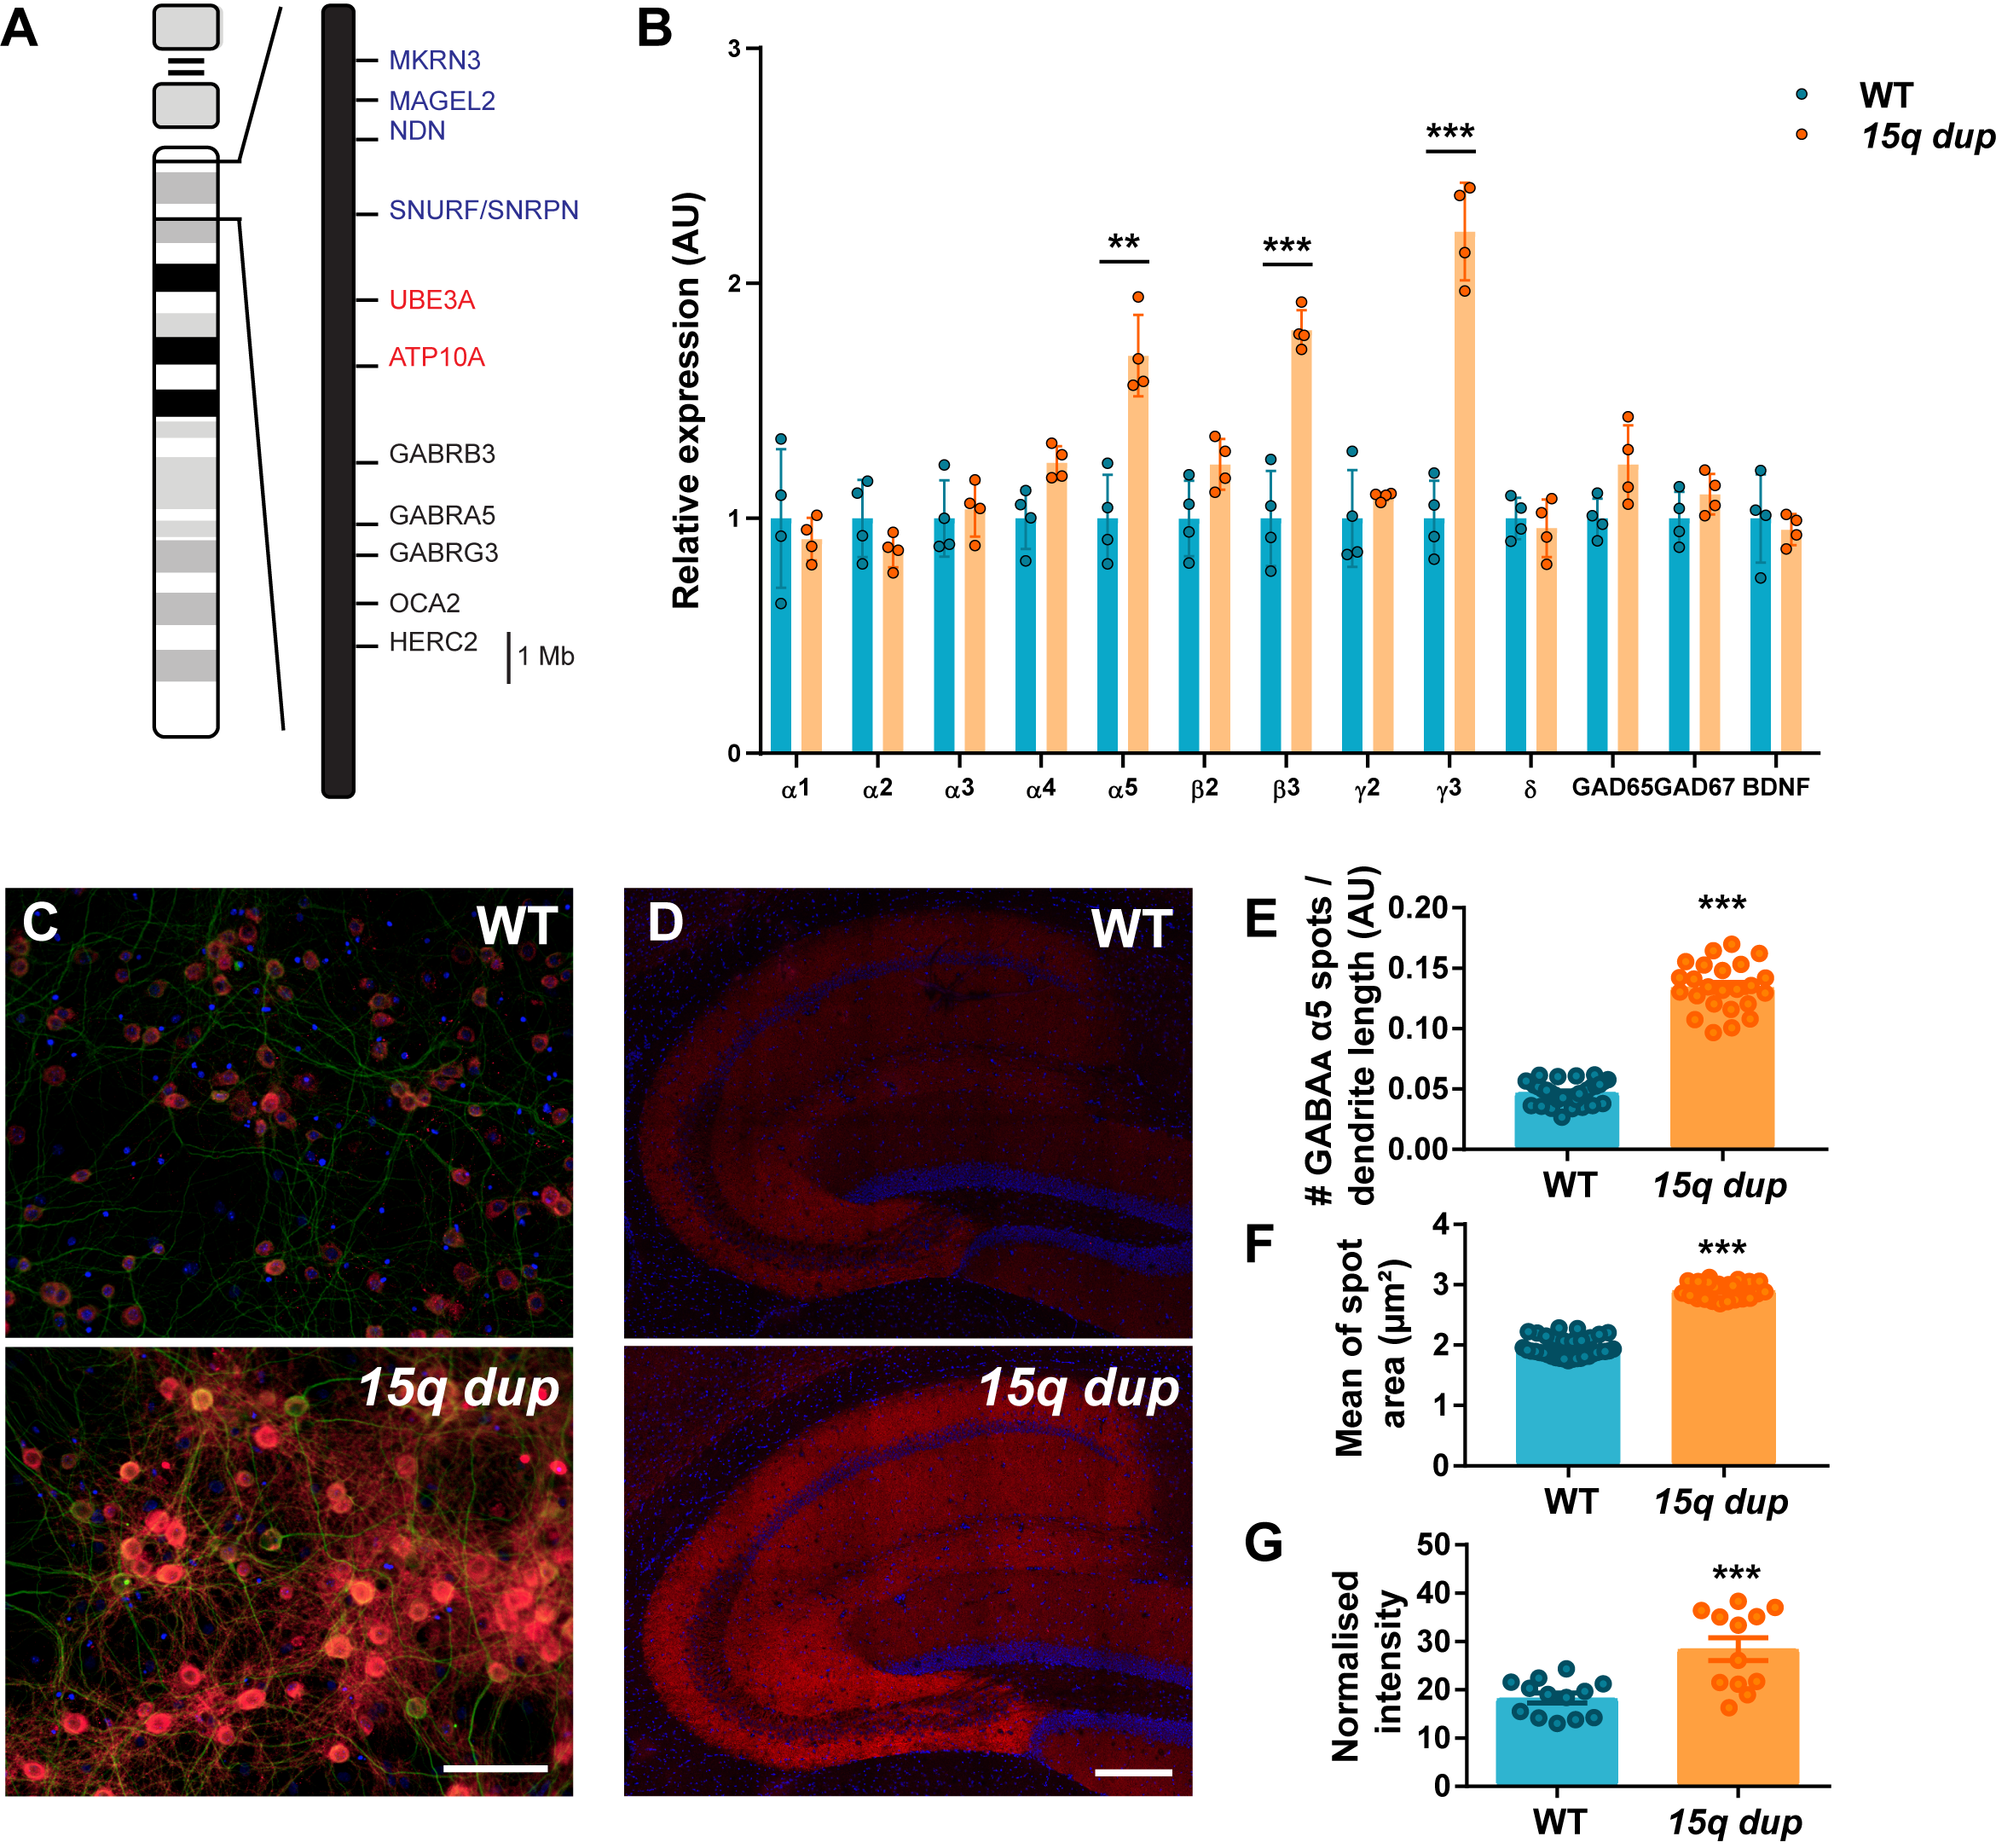
(A) Schematic representation of the human genes located between breakpoint 1 and breakpoint 3 in the 15q11-13 region. Paternally expressed genes are in blue, maternally expressed genes are in red, and non-imprinted genes are in black. (B) Hippocampal mRNA expression of GABR genes encoding GABA_{A} receptor subunits, glutamic acid decarboxylase (GAD) genes encoding GAD enzyme isoforms involved in GABAergic transmission, as well as brain-derived neurotrophic factor (BDNF) was measured in 15q dup mice by RT-qPCR. Each value was normalized by the expression of glyceraldehyde 3-phosphate dehydrogenase (GAPDH) and β-actin, which were used as internal controls, and described as a relative value to wild type (WT) expression (n = 4 mice per genotype). Immunofluorescent staining for GABA_{A}R α5 in primary neurons (C) and hippocampal sections (D) from WT (n=4) and 15q dup (n=4) mice. In red = GABA_{A}R α5, in green = microtubule-associated protein 2 (MAP2), in blue = 4′,6′-diamidino-2-phenylindole (DAPI). Scale bar = 100 μm in C; 200 μm in D. (E) Number of GABA_{A}R α5 spots normalized by dendrite length in C. (F) Mean spot area in C. Each dot represents a technical replicate on a 96-well plate. (G) Normalized intensity of the immunofluorescence in D. Data (D–F) are presented as mean ± standard error of the mean.

Supplementary Method: Real-Time Quantitative Polymerase Chain Reaction
Total RNA was extracted from hippocampal tissues collected from four WT and four 15q dup mice by using the NucleoSpin RNAII Kit, according to the manufacturer’s instructions (740955.50, Macherey-Nagel GmbH & Co. KG). cDNA synthesis was performed by using 500 ng of total RNA and the Transcriptor First Strand cDNA Synthesis Kit (04379012001, Roche Diagnostics). The resulting cDNAs were stored at −20°C until use. The primers used for amplification of the different GABR subunit transcripts and reference genes (glyceraldehyde 3-phosphate dehydrogenase and b-actin) were purchased from Microsynth (Balgach, Switzerland) (Table 1). Real-time qRCR (RT-qPCR) was performed using the Light Cycler 480 II PCR System (Roche Diagnostics GmbH) and LightCycler® 480 SYBR Green I Master (04707516001, Roche Life Science) by using 2.5 ng of cDNA. All reactions were performed in duplicate. PCR cycling conditions were as follows: 95°C for 10 minutes, followed by 40 cycles of 95°C for 10 seconds, 57°C for 10 seconds, and 72°C for 10 seconds. The results were calculated by the comparative 2^{−ΔΔCt} method [Livak KJ, Schmittgen TD, Methods. 2001;25:402–8]. The calibrator for this calculation was the group of WT littermates.
Table 1. Primer sequences for real-time quantitative polymerase chain reaction
Transcript | Forward primer 5`-3` | Reverse primer 5`-3` | Amplicon (bp)
α1 (GABRA1) | CAA GCC TGA GAC AAA ACC AC | GAT TCC AAA TAG CAG CGG AAA G | 99
α2 (GABRA2) | CAC TGC CAT GGA CTG GTT TA | TAC ACT CTT CCC GTC CCA AG | 118
α3 (GABRA3) | GCT CCC AGT GCT TCT TCA AC | ATG CGG GAA ATT TTG TCA AC | 122
α4 (GABRA4) | TGT TGC GAA GAT GGT TTC TG | CTG TCC TGG GGA TTC GTT TA | 118
α5 (GABRA5) | GAC CCA TCC TCC AAA CAT CC | ACT CTC CGC AGT CTT CTC TTC | 100
α6 (GABRA6) | ATC AGT GCT CGG CAC TCT CT | GTT GAC AGC TGC GAA TTC AA | 114
β2 (GABRB2) | ACC ACA ATC AAC ACC CAC CT | CGT ATT CCA GAA GGG CCA TA | 115
β3 (GABRB3) | AGT GAA AAA CCG CAT GAT CC | GCA GTT TTG CTC ATC CAG TG | 121
γ2 (GABRG2) | TTG AAG ATT GCC GAA CAG GAG | CAA AAG GCG GTA GGG AAG AAG | 100
γ3 (GABRG3) | CCT TCG ATT CAA CAG CAC AA | GCT GGC ACT CTG CAT TGA TA | 200
δ (GABRD) | TAT GCA TTT GCC CAC TTC AA | TGA GAG GGA GAA AAG GAC GA | 117
GAD1 | GCC AGA CAA GCA GTA TGA TGT | CCA GTT CCA GGC ATT TGT TGA T | 150
GAD2 | GGAAGACAATGAAGAGAGAAT GAG | AGG AAG TCA ATG TCT TGG TGA G | 150
β-actin | TGT TAC CAA CTG GGA CGA CA | GGG GTG TTG AAG GTC TCA AA | 165
GAPDH | ACA GCA ACT CCC ACT CTT CC | ATG TAG GCC ATG AGG TCC AC | 180

Supplementary Method: Primary Neuronal Culture
On embryonic day 18, the hippocampus was dissected from the brains of 15q dup and wild type (WT) embryos. After removing the meninges, tissues were collected into individual tubes containing HBSS Ca²⁺/Mg²⁺ free (14175-053, Gibco) and 5 mM D(+)-glucose (G8769, Sigma) and digested with 0.25% trypsin at 37°C for 20 minutes. The tissue was washed 3 times with plating medium (high glucose DMEM [21969, Gibco] supplemented with 5% fetal bovine serum [16000, Gibco], 2% B27, 50 U/mL penicillin, 50 μg/mL streptomycin [15140, Gibco], and 0.5 mM GlutaMAX [35050061, Gibco]) to inactivate trypsin. After the last washing step, 2 ml plating media was left in the 15 ml Falcon tube. Tissue was gently homogenized with Pasteur pipettes. 3−4 different size openings of the Pasteur pipettes (descending sizes) were used to obtain a cell suspension. Cells were centrifuged at 600 rpm for 5 minutes at 4°C. Supernatant was discarded and cells were resuspended in a plating medium. Cells were seeded onto poly-D-lysine-coated 96-well culture plates (655946, Greiner bio-one) at a density of 1.5×10⁴ cells/well. After 24 hours, the medium was changed to Neurobasal (21103-049, Gibco) supplemented with 4% B27, 5 mM D(+)-glucose, 0.5 mM GlutaMAX (35050061, Gibco), 50 U/mL penicillin, and 50 μg/mL streptomycin (15140, Gibco). The cells were cultured in a humidified incubator maintained at 37°C and 5% CO₂ atmosphere. Half of the medium was replaced every 3−4 days with a fresh one. A piece of each embryo was used for genotyping.

Supplementary Method: Immunocytochemistry
After 21 days in culture, primary neurons were fixed with 4% paraformaldehyde (PFA; 15710-S, Electron Microscopy Sciences) and 3% Sucrose (107651, Merck) for 15 minutes and blocked with 10% normal donkey serum (NDS; D9663, Sigma-Aldrich) containing 0.2% Triton X-100 for 1 hour to reduce non-specific staining. Primary and secondary antibodies were diluted in the blocking buffer. Cells were incubated overnight at 4°C with the following antibodies: anti-GABA_{A}R α5 (224 503, Synaptic Systems; 1:500 dilution) and anti-microtubule-associated protein 2 (CH22103, Neuromics; 1:5000 dilution). Cells were rinsed three times with phosphate-buffered saline (PBS) and incubated for 1.5 hours at room temperature (RT) with appropriate secondary antibodies raised in donkey and conjugated to Alexa-488 (711-545-152, Jackson ImmunoResearch; 1:200 dilution) and DyLight-647 (703-605-155, Jackson ImmunoResearch; 1:200 dilution). Cells were counterstained with 4′,6′-diamidino-2-phenylindole (DAPI). Images were obtained by a high-content scanner (Perkin Elmer-Operetta) and acquired by a 20× wide−working distance objective. The expression of GABA_{A}R a5 (spots per dendrite length, spot area) was then analyzed by Harmony® high-content analysis software (Perkin Elmer).

Supplementary Method: Immunohistochemistry
Immunohistochemistry was performed on sagittal sections of fresh-frozen brains from four WT and four 15q dup mice. Tissue sections, 10-μm thick, were prepared from fresh-frozen mouse brains by using a cryostat (Leica CM3050). Sections were collected on microscope glass slides (HistoBond, Paul Marienfeld GmbH), post-fixed with 4% PFA for 15 minutes, permeabilized with 0.2% Triton X-100 for 5 minutes, and then quenched with 0.3 M glycine for 20 minutes. Sections were then washed three times with PBS, blocked with 10% NDS containing 0.2% Triton X-100 for 1 hour to reduce non-specific staining, and incubated overnight at 4°C with anti-GABA_{A}R α5 (224 503, Synaptic Systems; 1:250 dilution). The next day, the sections were rinsed three times with PBS, incubated for 1.5 hours at RT with the appropriate secondary antibody raised in donkey and conjugated to Cy3 (711-165-152, Jackson ImmunoResearch; 1:500 dilution), and counterstained with DAPI (1:5000 dilution). Images were acquired by using a Leica SP5 confocal microscope and a 20× objective. Serial z-stacks were acquired every 0.5 μm. The expression of GABA_{A}R a5 was analyzed using Definiens Tissue Studio® Software (Definiens Inc.) by measuring the intensity of the fluorescent signal in the hippocampus in 13 slices from four WT and 12 slices from four 15q dup mice.

Supplementary Figure 2. Spontaneous excitatory neurotransmission in CA1 pyramidal neurons in hippocampal slices prepared from 15q dup and wild type mice
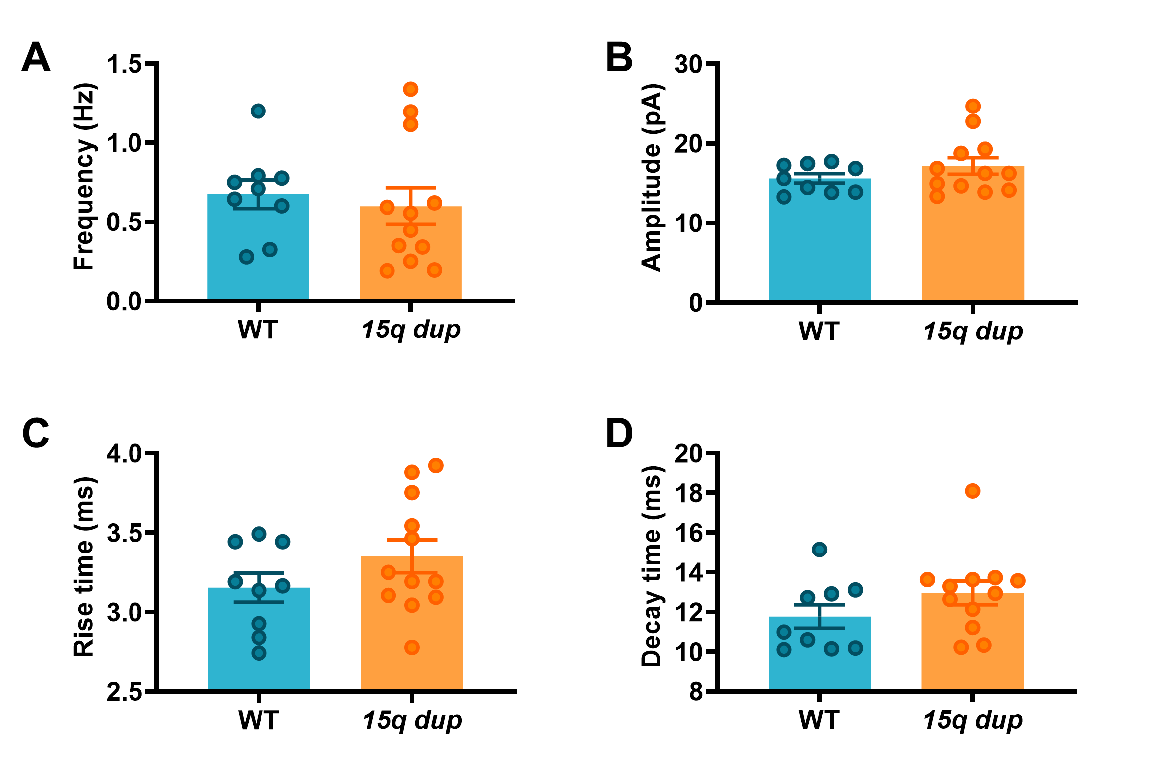
There were no differences between 15q dup and WT on spontaneous excitatory synaptic current (sEPSC) frequency, p=0.28 (A), amplitude, p=0.21 (B), rise time, p=0.19 (C), and decay time, p=0.18 (D) measured in CA1 pyramidal neurons in hippocampal slices obtained from WT (n=9 neurons from 4 mice) and 15q dup (n=12 neurons from 7 mice).
Data are presented as individual points (circles) and mean ± standard error of the mean.

Supplementary Figure 3. Spontaneous inhibitory neurotransmission in CA1 pyramidal neurons in hippocampal slices prepared from 15q dup and wild type mice
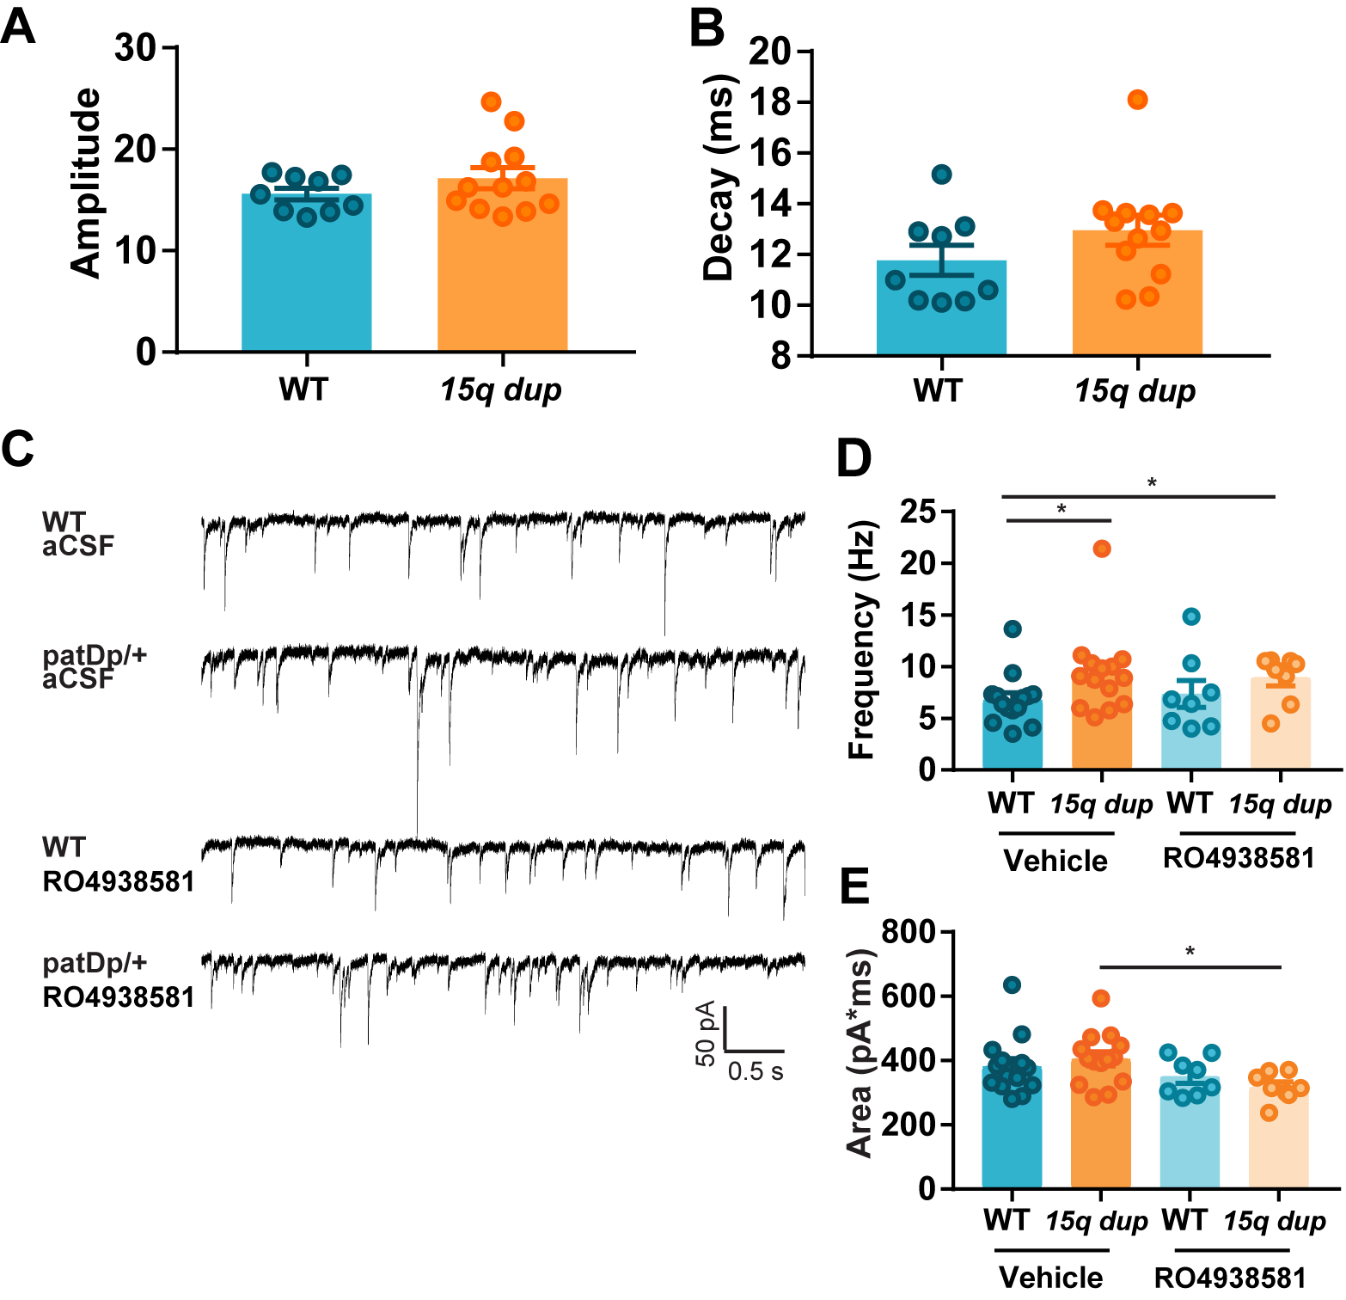
Spontaneous inhibitory synaptic current (sIPSC) amplitude, p=0.23 (A) and decay time, p=0.80 (B) in CA1 pyramidal neurons in hippocampal slices obtained from wild type (WT; n=14 neurons from 5 mice) and 15q dup (n=14 neurons from 5 mice) mice during vehicle (aCSF) perfusion and 15 minutes after treatment with 1 μM RO4938581. (C) Recordings of sIPSCs obtained from WT (n=14) and 15q dup (n=14) CA1 pyramidal neurons held at −60 mV in the presence of 2 mM kynurenic acid at room temperature during bath perfusion with artificial cerebrospinal fluid (aCSF) or 1 μM RO4938581 for 15 min. Bar graphs of sIPSC (D) frequency, p=0.73 WT vs. 15q dup; * p= 0.032 15q dup groups vs. WT control group, and (E) mean area, p=0.23 WT vs. 15q dup; * p= 0.039 15q dup RO4938581 group vs. 15q dup control group; in WT and 15q dup hippocampal neurons during aCSF perfusion and 15 minutes after treatment with 1 μM RO4938581 (n=14).
Data are presented as individual points (circles) and mean ± standard error of the mean.

Supplementary Method: Synaptic Physiology
Synaptic physiology experiments were performed by using 1-month-old mice. Animals were deeply anesthetized in a 2.5% isoflurane/96.5% oxygen mixture and sacrificed. All the slicing and recording solutions were saturated with 95% O₂ and 5% CO₂. The brain was quickly removed and sagittal hippocampal slices (250 µm) were cut using a Leica VT1200S vibratome (Leica Biosystems) in chilled slicing solution containing (in mM): sucrose 75, NaCl 87, NaHCO₃ 25, D-glucose 25, KCl 2.5, NaH₂PO₄ 1.25, CaCl₂ 0.5, and MgCl₂ 7, pH 7.3. The slices were transferred to a storage chamber with fresh artificial cerebrospinal fluid containing (in mM): NaCl 126, KCl 2.5, MgCl₂ 2, CaCl₂ 2, NaH₂PO₄ 1.25, NaHCO₃ 26, and D-glucose 10, pH 7.3, and incubated at 37°C for 30 minutes. The slices were then maintained at RT in this solution, until required. Whole cell voltage-clamp recordings were performed on CA1 pyramidal neurons within hippocampal slices visualized using an Olympus BX50WI microscope (Olympus Corporation) equipped with a 40x immersion objective and a video camera. Patch electrodes were pulled from thin-walled glass capillaries (Harvard Apparatus) in two stages on a DMZ-Universal-Puller (Zeitz, NBT New Bio Technology Ltd.). For the recordings of spontaneous inhibitory postsynaptic currents (sIPSCs), the patch electrodes were filled with intracellular solution containing (in mM): CsCl 135, HEPES 20, EGTA 2, Mg-ATP 2, Na-GTP 0.5, QX-314 2, pH 7.25. Kynurenic acid (1 mM) was included in the perfusion solutions to block the excitatory synaptic transmission during the sIPSC recordings. For the recordings of spontaneous excitatory postsynaptic currents (sEPSCs), CsCl was replaced by Cs-methanesulfonate. When filled with intracellular solution, patch electrode resistance ranged from 3 to 5 MΩ. Recordings were obtained through a Multiclamp 700-A amplifier (Molecular Devices) by using a data-acquisition software (pCLAMP 10.0, Molecular Devices). Access resistance was continuously monitored for each cell; recordings were terminated/discarded when a significant (>10%) increase in resistance occurred. sIPSCs and sEPSCs were analyzed using Mini Analysis software (Synaptosoft).

Supplementary Figure 4. Long-term potentiation in CA1 hippocampal slices from 15q dup and wild type mice
Time courses of the excitatory postsynaptic potential (EPSP) slope. Theta-burst stimulation (TBS) was applied at the time indicated by the arrow. The field excitatory postsynaptic potential (fEPSP) slope was not significantly different in hippocampal slices from 15q dup mice (148.6 ± 5.3 %, n=8 slices from 4 mice) compared with those from WT littermates (138.2 ± 4.5%, n=8 slices from 4 mice) at 90 minutes post-induction. Data are presented as mean ± standard error of the mean.

Supplementary Method: Local Field Potential Recordings and LTP Induction
Long-term potentiation (LTP) experiments were performed by using 6-month-old mice. Animals were deeply anesthetized in a 2.5% isoflurane/96.5% oxygen mixture and sacrificed. All the slicing and recording solutions were saturated with 95% O₂ and 5% CO₂. Field excitatory postsynaptic potentials (fEPSP) were recorded from hippocampal slices of WT and 15q dup mice by using glass micropipettes (Clark GC 120F; 1-4 MΩ) filled with 2 M NaCl and placed in the stratum radiatum of the CA1. Slices were constantly superfused at 30°C with an artificial cerebrospinal fluid (ACSF) containing (in mM): NaCl 120, KCl 3.5, MgSO₄ 1.3, CaCl₂ 2.5, NaH₂PO₄ 1.25, NaHCO₃ 26, and glucose 10 equilibrated with 95% O₂/5% CO₂. fEPSPs were evoked by stimulating the stratum radiatum (0.033 Hz, 100 µs) by insulated bipolar platinium/iridium electrodes (RDM). The stimulus strength was adjusted to evoke fEPSPs equal to 30% of the relative maximum amplitude without superimposed PS. This was determined from separate input-output experiments recorded for each slice. After obtaining stable baseline recordings, LTP was induced using a theta-burst stimulation paradigm (TBS) consisting of a pattern of 5 stimuli at 100 Hz repeated 10 times at 200-ms intervals. The duration of the stimulation pulses was doubled during TBS without modifying the stimulation strength.
fEPSPs were amplified by a Cyberamp 380 amplifier (Molecular Devices), filtered at 2.4 kHz and digitized at 20 kHz by a Digidata 1322 acquisition board (Molecular Devices). The pClamp data acquisition software (Molecular Devices) was used to record and analyze the signals.

Supplementary Figure 5. Behavioral characterization of 15q dup mice
Comparison of wild type (WT) and 15q dup mice in the following behavioral tests. (A) Total locomotion exploration in the open field test. (B) Total time touching or investigating their partner in the social interaction test. (C) Number of ultrasonic vocalizations to a spot of female urine. (D) Olfactory habituation/dishabituation test: mean time spent investigating non-social and social odors. Morris water maze: (E) mean escape latency (s) each day during the visible and hidden platform acquisition phases and reversal phase. Time spent in each quadrant during probe tests undertaken 24 h after acquisition phase (F) and 24 h after reversal phase (G). TR = Target; OP = Opposite; AR = Adjacent Right; AL = Adjacent Left. Data are presented as individual points (circles) and mean ± standard error of the mean (n=10 per genotype). Statistics: *p < 0.05, **p < 0.01, ***p < 0.001 vs. WT mice.

Supplementary Figure 6. No significant effects of RO4938581 treatment on open field, ultrasonic vocalization, olfactory habituation/dishabituation test in 15q dup mice
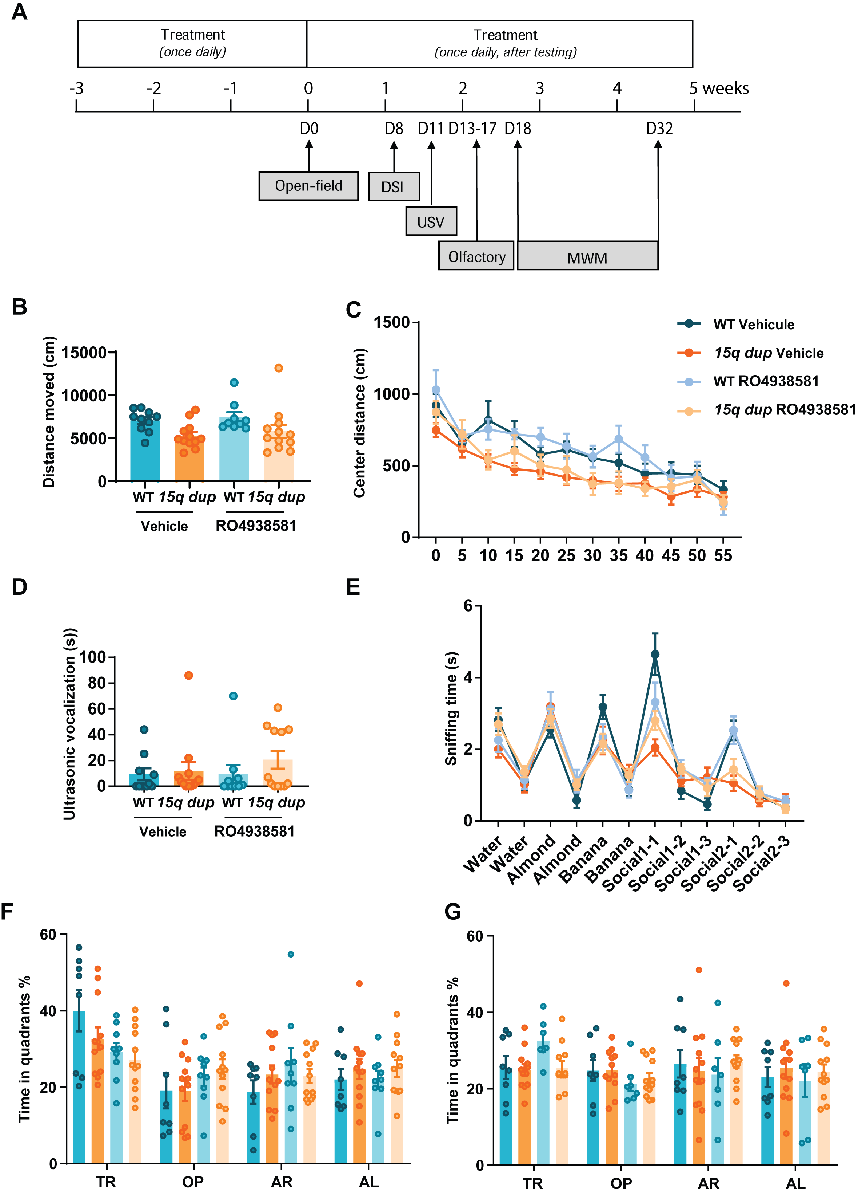
Chronic treatment with vehicle or RO4938581 (10 mg/kg) administered per os (p.o.) once daily to wild type (WT) and 15q dup mice. (A) Experimental protocol. (B) Total activity in the open field test. (C) Distance travelled in the center of the open field in 5 min time bins over 1 h. (D) Number of ultrasonic vocalizations to a spot of female urine. (E) Olfactory habituation/dishabituation test: mean time spent investigating non-social and social odors. Morris water maze: Time spent in each quadrant during probe tests undertaken 24 h after acquisition phase (F) and 24 h after reversal phase (G). TR = Target; OP = Opposite; AR = Adjacent Right; AL = Adjacent Left. Data are presented as individual points (circles) and mean ± standard error of the mean (n=8 vehicle-treated WT; n=9 α5- RO4938581-treated WT; n=12 vehicle-treated 15q dup; n=12 α5- RO4938581-treated 15q dup).

Supplementary Figure 7. RO4938581 partially normalizes increased beta-band activity in 15q dup mice

(A) Changes in EEG power spectrum in response to the low dose of RO4938581 (3 mg/kg) in 15q dup mice in the frequency range of 20−30 Hz, i.e., focused on the frequency range of the 15q dup phenotype shown in (Figure 4A, main manuscript). A significant decrease in power was observed in 15q dup mice after RO4938581 administration (~20–28 Hz; p = 0.030, cluster randomization test).
(B) Changes in EEG power spectrum in response to the high dose of RO4938581 (10 mg/kg) in 15q dup mice in the frequency range of 20–30 Hz, i.e., focused on the frequency range of the 15q dup phenotype shown in (Figure 4A, main manuscript). Cluster permutation did not reveal a significant decrease in power in 15q dup mice after RO4938581 administration.
CI = confidence interval.

Supplementary Table S1. Plasma concentration raw data from WT and 15q dup mice
Sample ID | Genotype | Concentration (ng/mL)
3 | WT | 117
7 | WT | 202
11 | WT | 213
15 | 15q dup | 183
17 | 15q dup | 211
4 | 15q dup | 895
8 | 15q dup | 185
12 | 15q dup | 218
19 | 15q dup | 100
21 | 15q dup | 205
RO4938581 administered at 10 mg/kg p.o. 60 min prior to sacrifice and sample collection.
Mean = 253 ng/mL; SD = 229.3; CV = 90.6%.

Supplementary Method: Sampling and Bioanalytics
After the last behavioral experiment, mice from each group were administered with vehicle or RO4938581 and 60 min later were briefly anaesthetized with 5% isoflurane and then decapitated with a guillotine. The blood was collected in 1.5 ml Eppendorf tubes containing NaF + EDTA Na₂/2H₂O and centrifuged at 4000 rpm at 4°C for 5 min. The plasma was collected in storage tubes and immediately frozen in dry ice. All samples were stored under -80°C until analysis.
A qualified method was used in the bioanalytical laboratory at F. Hoffmann-La Roche, Basel, Switzerland. Rat blood plasma samples (5 μL) were extracted by protein precipitation with 200 μL of methanol containing RO4938581 (100 ng/mL) as an internal standard (IS). Extracts (2 μL) were injected onto the analytical column (YMC Triart C18, 3 μm; 2.1x50 mm) and analyzed using liquid chromatography coupled to tandem mass spectrometry (LC-MS/MS). Separation was performed using gradient elution from 30%-95% mobile phase B in 2.5 minutes at a flow of 0.8 mL/min, where mobile phase A was 20 mM ammonium-acetate and mobile phase B was acetonitrile. Multiple reaction monitoring (MRM) was carried out on a Sciex QTrap 6500+ mass spectrometer using MRM transitions (m/z) 432.2/123.0 for RO4938581 and 436.2/124.0 for IS. The calibration range (lower limit of quantification−upper limit of quantification) was 20.0−20,000 ng/mL.

