Captopril Restores Microglial Homeostasis and Reverses ASD-like Phenotype in a model of ASD induced by exposure in utero to anti-Caspr2 IgG.
Benjamin Spielman, B.A^{1,2}, Ciara Bagnall-Moreau, PhD¹, Frank Chen, B.A¹, Crystal Balvuena. M.A^{1,2}, Christian Cruz, B.A¹, Joseph Carrion, PhD¹, An Vo, PhD¹, Arnon Arazi, PhD¹ and Lior Brimberg, PhD ^{1, 2,3*}
¹ Institute of Molecular Medicine, The Feinstein Institutes for Medical Research, Manhasset, NY
² The Donald and Barbara Zucker School of Medicine at Hofstra/Northwell, Hempstead, NY
^{3.} Elmezzi Graduate School of Molecular Medicine at Northwell Health, Manhasset, NY, USA.

*Corresponding Author: Lior Brimberg, PhD: lbrimberg@northwell.edu

Supplementary Figures

Supplementary Figure 1

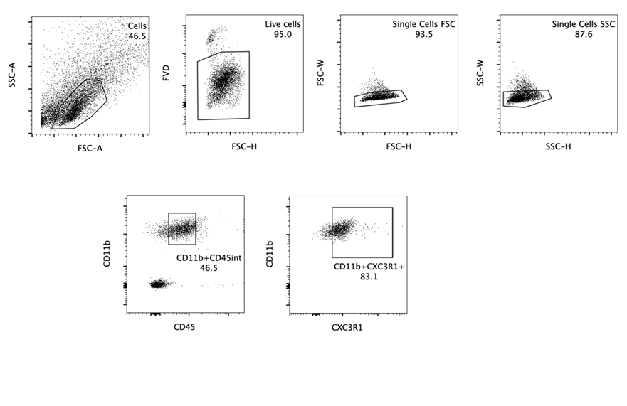
FACS gating strategy for microglia enrichment before single-cell sequencing. Representative FACS plot is displayed. Plots are shown in order (left to right) to show the gating strategy used to distinguish cells from debris, to isolate single cells, and then to identify microglia by CD45+CD11b++ and Cx3cr1+CD11++ (out of CD45+CD11b++). Numbers represent percentage.

Supplementary Figure 2
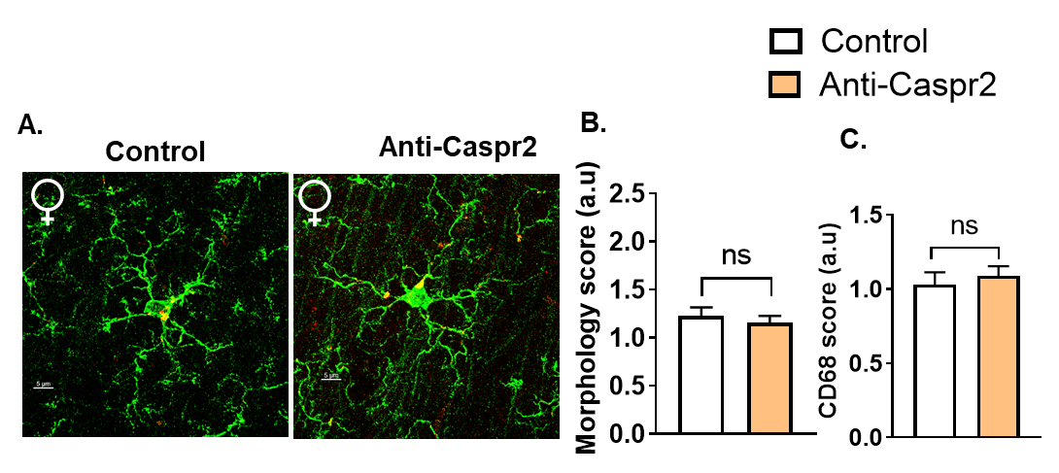

A. Representative confocal images of microglia from stratum radiatum of the CA1 hippocampal sections of adult (16 weeks) Control and Anti-Caspr2 female mice. Green - Iba1, Red - CD68. B-C. Quantification of Adult microglia morphology (B) and CD68 (C) scores in Control (Control, microglia=35, n=5 mice representing 3 litters) and Anti-Caspr2 (microglia=35, n=5 mice representing 3 litters). Mann Whitney, ns=non-significant. a.u., arbitrary units.

Supplementary Figure 3
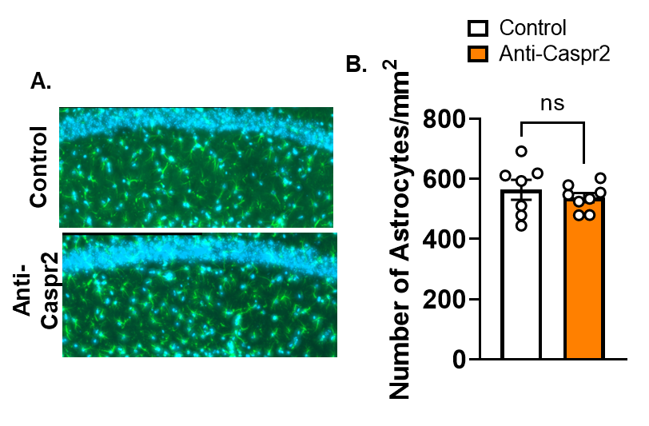

A. 20x tiled widefield fluorescent microscopy images of astrocytes from stratum radiatum (hippocampus) from adult (6-7 weeks old) Control and Anti-Caspr2 male mice. Green - GFAP, Blue - DAPI. B. Quantification of the average number of GFAP + astrocytes per mouse in Control and Anti-Caspr2 male mice. Control, 23 hippocampal regions were counted from 7 mice, representing 6 litters. Anti-Caspr2, 30 hippocampal regions were counted from 8 mice, representing 7 litters. Unpaired t-test, t(13)=0.787, P=0.467, ns=non-significant.

Supplementary Figure 4

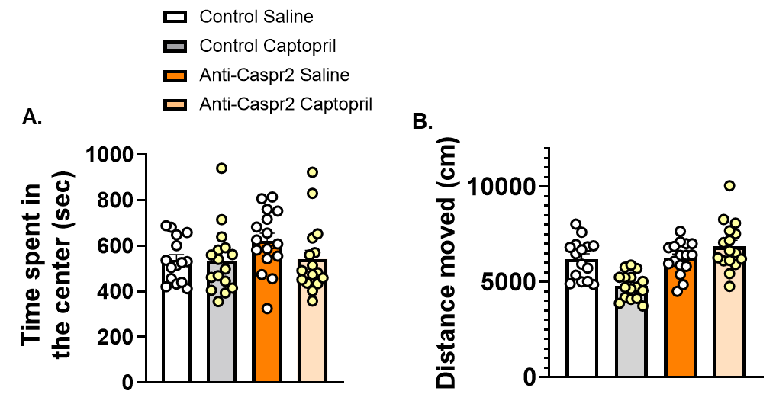

A. Time spent in the center of the behavioral arena during open field testing. One way ANOVA, F(3,59)=1.519, P=0.219. B. Distance moved during the first familiarization session. One way ANOVA, followed by Dunn’s post hoc test with false discover rate (FDR)-adjusted p values, Control saline compared to Anti-Caspr2 saline P=0.887, Anti- Caspr2 saline compared to Anti-Caspr2 Captopril P=0.0857. A-B. Control Saline, n=15 mice representing 12 litters. Control Captopril, n=16 mice representing 13 litters. Anti-Caspr2 Saline, n=16 mice representing 12 litters. Anti-Caspr2 Captopril, n=16 mice representing 15 litters.

Supplementary Figure 5
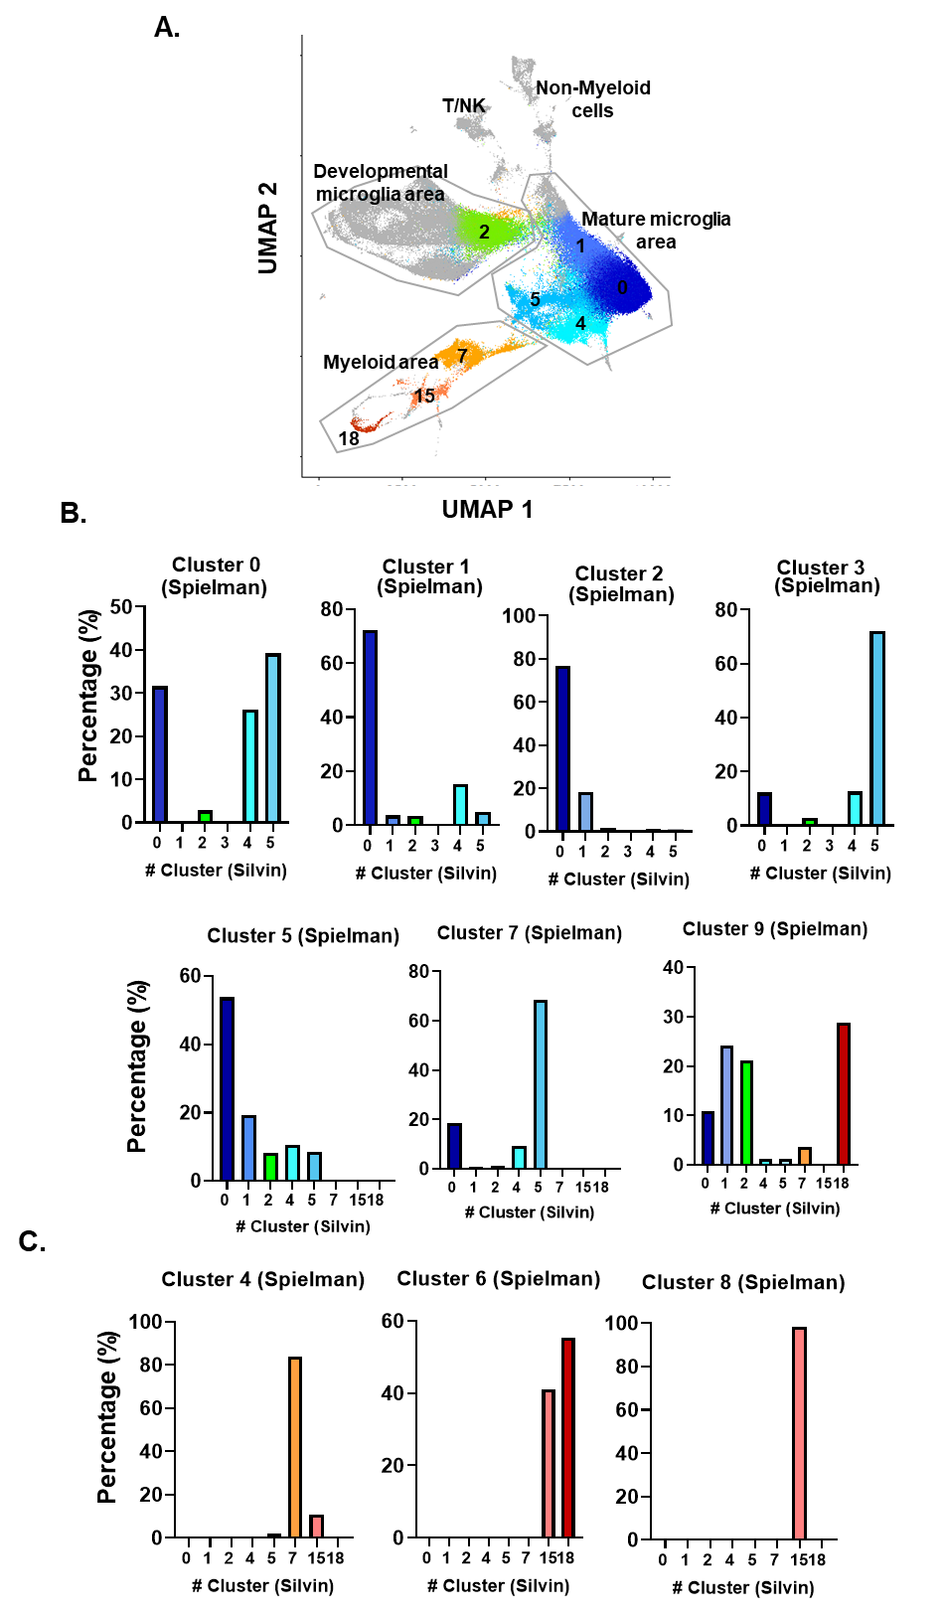

A. Individual Silvin clusters projected on the M verse ⁵⁶ . B-C. Similarity score calculated between Spielman and Silvin ⁵⁶ clusters. Spearman correlation p<0.05.

Supplementary Figure 6
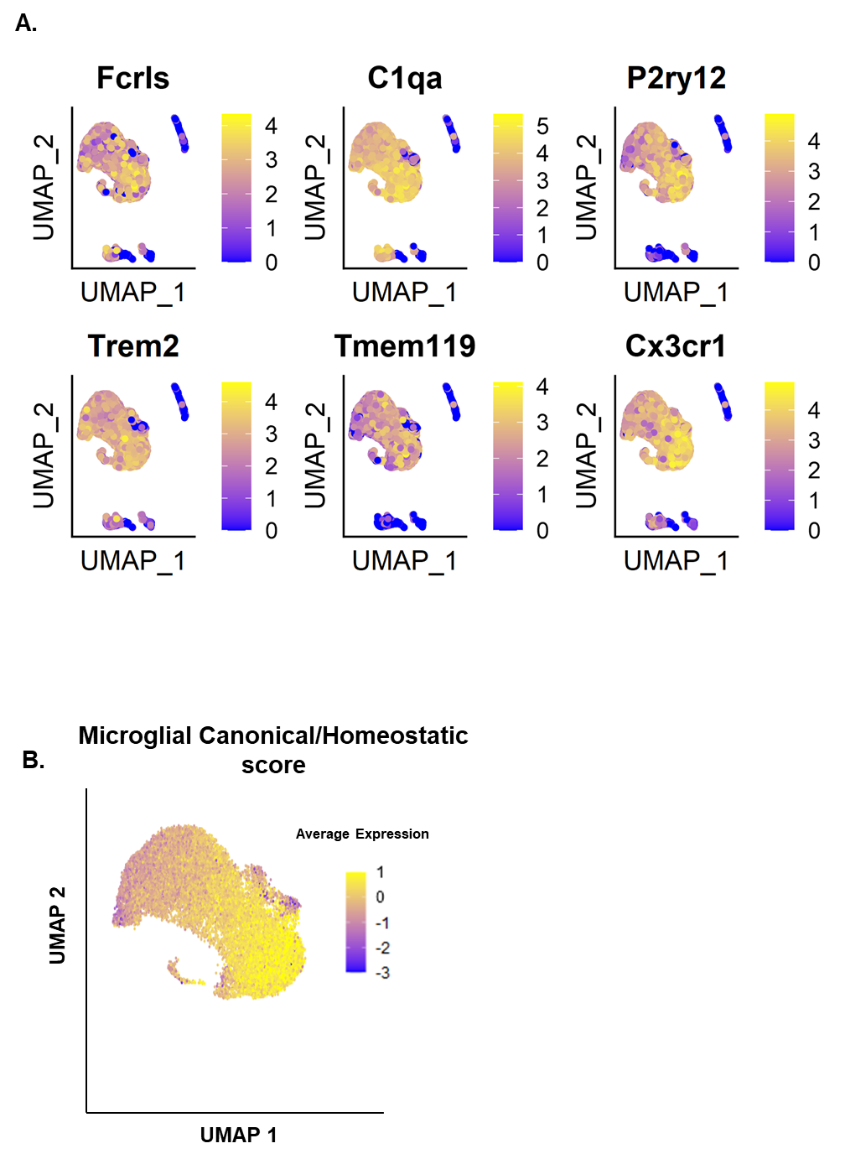

- Microglia feature plot. UMAP plots colored for expression of canonical microglial genes. B. Visualization of microglial canonical/homeostatic gene module scoring results plotted on UMAP coordinates.

Supplementary Figure 7
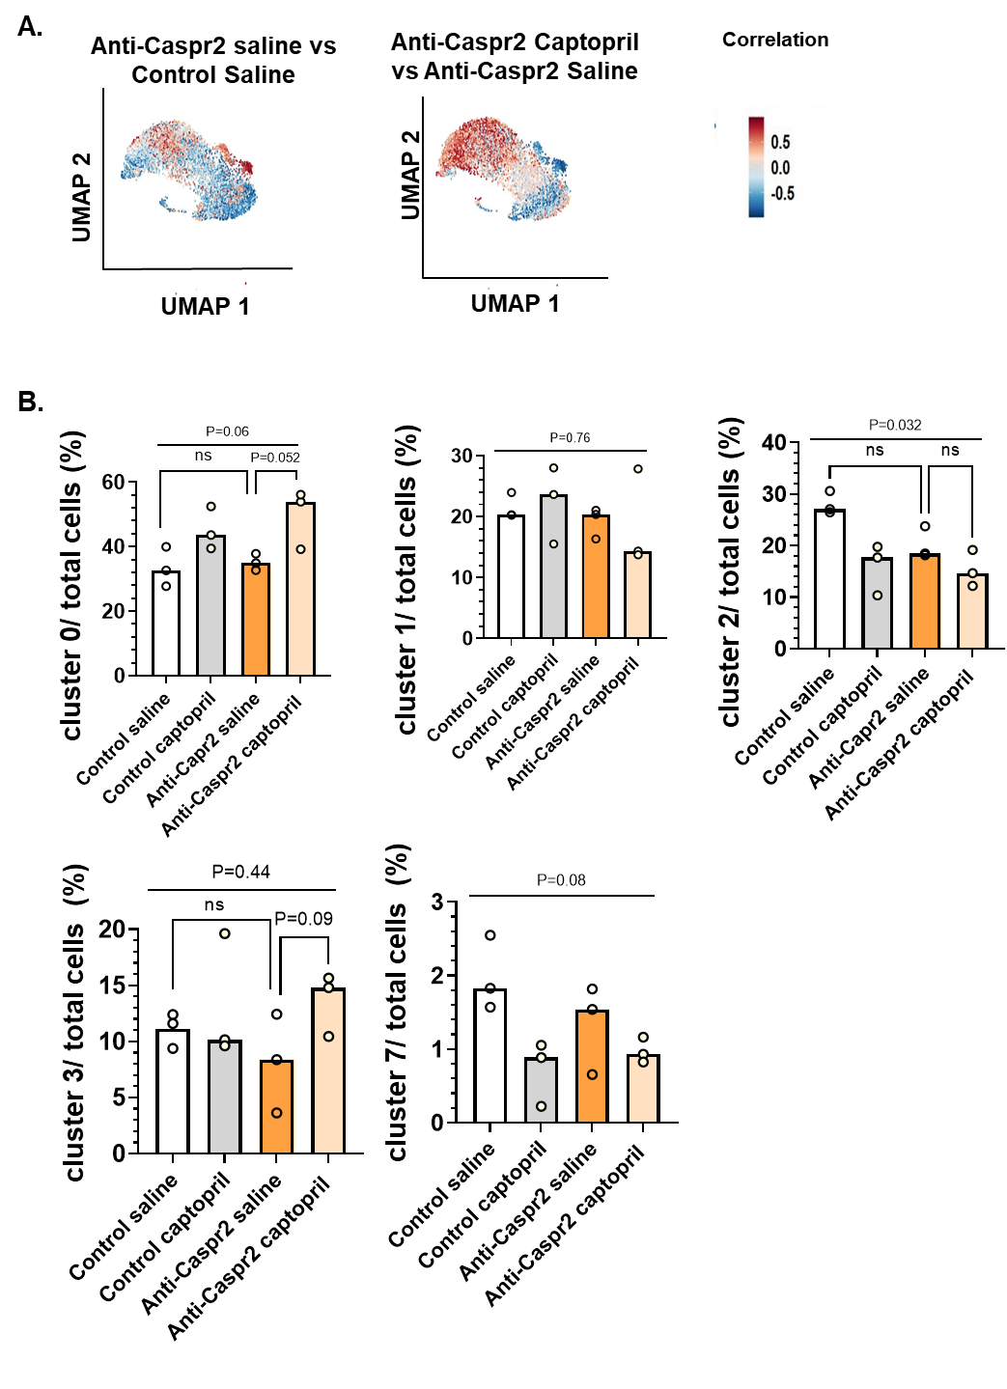
A. Results of association test for microglial cells across the whole cohort using CNA. Cell neighborhoods with a positive association are colored in red; those with a negative association are colored in blue. Left, comparison of Anti-Caspr2 Saline with Control Saline (red indicates higher frequency of a neighborhood in Anti-Caspr2 Saline). Right, comparison of Anti-Caspr2 Captopril with Anti-Caspr2 Saline (red indicates higher frequency in Anti-Caspr2 Captopril). Note that the correlations depicted are not statistically significant after correction for multiple comparisons). B. The percentage of total cells is represented in clusters 0,1,2,3 and 7. Kruskal-Wallis test, followed by Dunn’s post hoc test with false discover rate (FDR)-adjusted P values. ns=non-significant.
Supplementary Figure 8

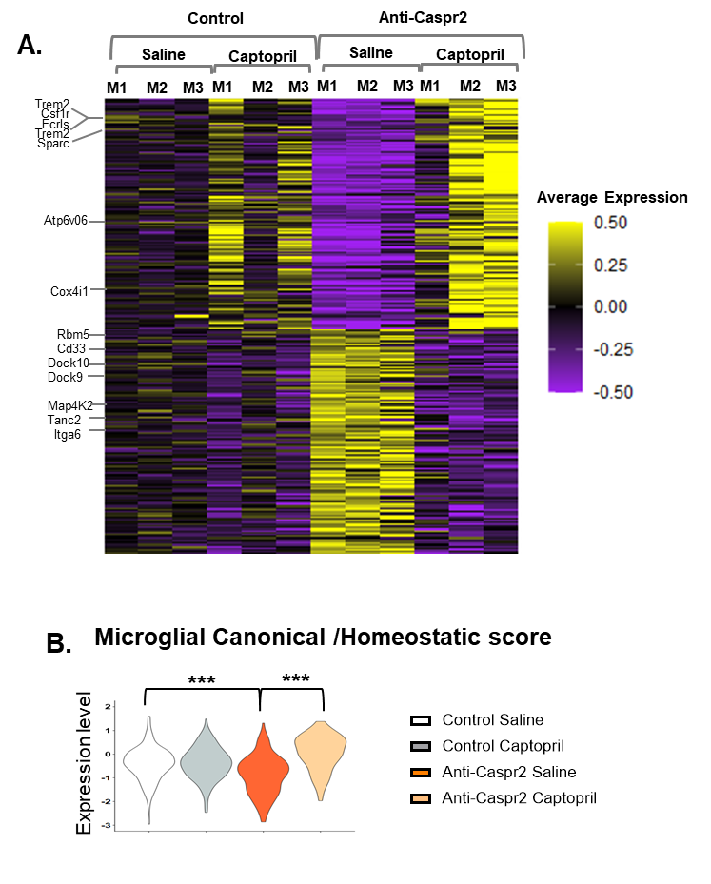

A. Heatmap, averaging the gene expression per library (i.e., mouse) in cluster 5 showing differentially expressed genes between Anti-Caspr2 Saline and Control Saline that were reversed in Anti-Caspr2 mice treated with captopril. M1=Mouse 1, M2=Mouse 2, M3=Mouse 3. Selected genes are shown. B. Microglial canonical/homeostatic gene module scoring results plotted on violin plot comparing Anti-Caspr2 Saline to Control Saline and Anti Caspr2 Captopril to Control Saline. Mann Whitney analysis, *** P<0.001

Supplementary Figure 9
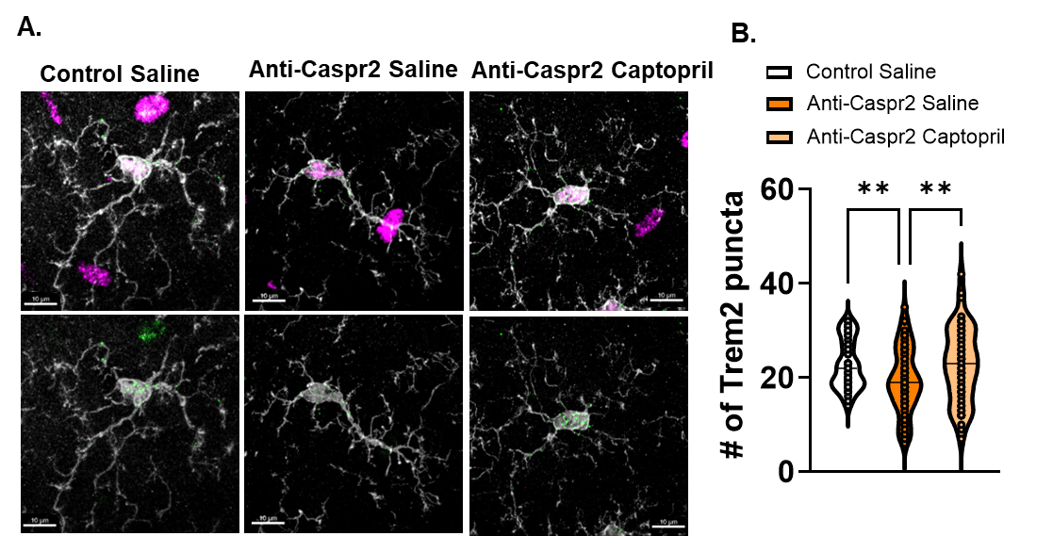

A. Representative confocal images of Malat1+ (magenta), Trem2 (green) microglia (white) from stratum radiatum of the CA1 hippocampal sections of P42-P45 Control treated with saline, Anti-Caspr2 treated with saline and Anti-Caspr2 treated with captopril male mice. Scale bar 10 µm. B. Quantification of number of Trem2 puncta (corresponding to mRNA) of P42-P45 Malat1+ microglia from Control treated with saline (microglia= 55), Anti-Caspr2 treated with saline (microglia=72) and Anti-Caspr2 treated with captopril (microglia=56). One way ANOVA, followed by post hoc test with false discover rate (FDR)-adjusted P values. Control Saline versus Anti-Caspr2 Saline P=0.006. Anti-Caspr2 Captopril versus Anti-Caspr2 Saline, P=0.006.

Supplementary Figure 10
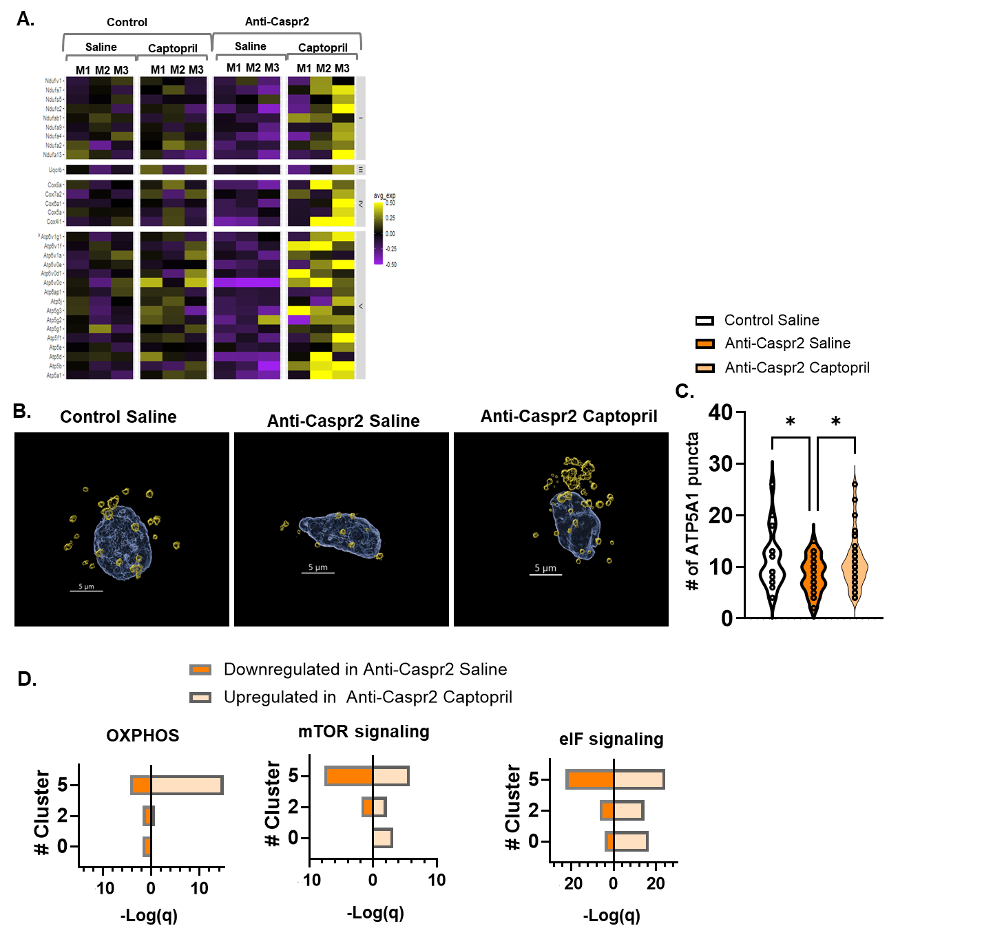
A. Heatmap showing the average gene expression per library (i.e., mouse) in cluster 5, of differentially expressed genes between Anti-Caspr2 Saline and Control Saline that were reversed in Anti-Caspr2 mice treated with captopril in the OXPHOS pathway. M1=Mouse 1, M2=Mouse 2, M3=Mouse 3. Selected genes from this pathway are shown. B. 3D Imaris surface reconstruction of the soma of microglia from stratum radiatum from P42-P45 male Control mice treated with saline, and Anti-Caspr2 mice treated with saline or captopril (Blue- Iba1+Dapi soma, Yellow- Atp5a1). C. Quantification of number of Atp5a1 puncta of P42-P45 around the soma from Control treated with saline (microglia= 23), Anti-Caspr2 treated with saline (microglia= 30) and Anti-Caspr2 treated with captopril. (microglia=30). One way ANOVA, followed by post hoc test with false discover rate (FDR)-adjusted P values. Control Saline versus Anti-Caspr2 Saline P=0.0404. Anti-Caspr2 Captopril versus Anti-Caspr2 Saline, P=0.0405. D. Bar plot showing the statistical significance of GSEA checking the enrichment of the OXPHOS, mTOR and eIF signaling pathways for clusters 0, 2 and 5. Dark orange, genes downregulated in Anti-Caspr2 Saline versus Control Saline. Light orange, genes upregulated in Anti-Caspr2 Captopril compared to Anti-Caspr2 Saline.

