Fig S1. Behavioral outcomes of drug intervention in BD transplanted mice.
A. Line graph of body weight changes in mice (Two way ANOVA multiple comparison, control group, n=17 mice; BD group, n=19 mice). B. Schematic diagram of antidepressant intervention experiment. C. Total movement distance in the OFT of control mice, BD-transplanted mice, BD+ fluoxetine treated mice, and BD+ lithium treated mice(one way ANOVA multiple comparison, CON group:N=8, BD group:N=8, BD+ fluoxetine group:N=8, BD+ lithium group:N=8). D. Movement distance in central area in the OFT of control mice, BD-transplanted mice, BD+ fluoxetine treated mice, and BD+ lithium treated mice(one way ANOVA multiple comparison, CON group:N=8, BD group:N=8, BD+ fluoxetine group:N=8, BD+ lithium group:N=8). E.Total crossing number in the OFT of control mice, BD-transplanted mice, BD+ fluoxetine treated mice, and BD+ lithium treated mice(Kruskal-Wallis test, CON group:N=8, BD group:N=8, BD+ fluoxetine group:N=8, BD+ lithium group:N=8). F. Number of crossing in central area in the OFT of control mice, BD-transplanted mice, BD+ fluoxetine treated mice, and BD+ lithium treated mice(one way ANOVA multiple comparison, CON group:N=8, BD group:N=8, BD+ fluoxetine group:N=8, BD+ lithium group:N=8). G. Time of movement in central area in the OFT of control mice, BD-transplanted mice, BD+ fluoxetine treated mice, and BD+ lithium treated mice(one way ANOVA multiple comparison, CON group:N=8, BD group:N=8, BD+ fluoxetine group:N=8, BD+ lithium group:N=8). H. The immobile time of control mice, BD-transplanted mice, BD+ fluoxetine treated mice, and BD+ lithium treated mice in FST(one way ANOVA multiple comparison, CON group:N=8, BD group:N=8, BD+ fluoxetine group:N=8, BD+ lithium group:N=8). I. The immobile time of control mice, BD-transplanted mice, BD+ fluoxetine treated mice, and BD+ lithium treated mice in TST(Kruskal-Wallis test, CON group:N=8, BD group:N=8, BD+ fluoxetine group:N=8, BD+ lithium group:N=8). All data are listed as the Mean ± SEM.

Fig S2. 16s rRNA analysis of donor and mice and the RT-PCR results of mPFC
A-D. Gut microbiota richness by the Chao1 index, Shannon index, Simpson index, Observed species in mice feces before and after antibiotic treatment (Wilcoxon rank-sum test, Pre-ABX group, n=55 mice; After-ABX group, n=55 mice). E-F. Gut microbiota richness by the Shannon index, Observed species in BD and control mice(Mann-Whitney test, control group, n=28 mice; BD group, n=27 mice;Shannon: P=0.0941; Observed species: P=0.0534). G. Heatmap of TOP30 gut microbiota in genus in BD and control mice(control group, n=28 mice; BD group, n=27 mice). H. Analysis of gut microbiota in BD mice and BD donor on Principal coordinate analysis (PCoA) (BD-Human, n=6; BD-Mice, n=27). I. Analysis of gut microbiota in control mice and health donor on Principal coordinate analysis (PCoA) (CON-Human, n=6; CON-Mice, n=28). J. The gut microbiota of health donors and control mice were analyzed and compared at the genus level(CON-Human, n=6; CON-Mice, n=28). K-L. RT-PCR results of genes at translation at postsynapse in the mPFC(multiple t test, control group, n=12 mice; BD group, n=12 mice). All data are listed as the Mean ± SEM.
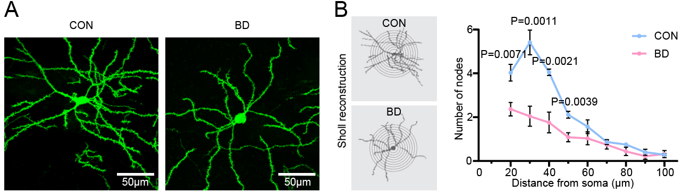
Fig S3. Sholl analysis of mPFC neurons range 10-100 μm.
A. cell morphology of mPFC neuron from CON and BD mice after FMT. B. Sholl analysis of node numbers in CON and BD neurons (multiple t test, CON n=5 vs. BD n= 6, 50-60μm, 60-70μm, 70-80μm, 80-90μm, 90-100μm, P > 0.05).
Fig S4. Reduced dopamine space connections to mPFC neurons
A. All start cell locations and quantitative analyses, mostly from the prelimbic-infralimbic complex of the mPFC Layer 2/3 and Layer 5. (left represent control group, right represent BD group.) B. Analysis of the number of start cells in the control and BD groups. Quantitative analysis revealed equivalent starter cell densities between Control (79±18 cells, n=9) and BD (136±21 cells, n=10) groups (two-tailed unpaired t test, P=0.0533). C. Schematic of extended cholinergic space. D. Proportion of labeled input cells of mPFC neurons from extended cholinergic space. E. Coronal sections show cells monosynaptically traced from the ACh, DA, 5-HT and NE space. F. Outline of the subregions of the Thalamus, according to the ARA. G. Proportion of labeled input cells of the subregions of the Thalamus. H. Outline of the subregions of the Hippocampal. I. Proportion of labeled input cells of the subregions of the Hippocampal. J. Outline of the subregions of the Amygalar. K. Proportion of labeled input cells of the subregions of the Amygalar.

Fig S5. Reduced dopamine space connections to mPFC neurons
A. All start cell locations and quantitative analyses, mostly from the prelimbic-infralimbic complex of the mPFC Layer 2/3. (left represent control group, right represent BD group.) B. Analysis of the number of start cells in the control and BD groups. Quantitative analysis revealed equivalent starter cell densities between Control (11±3 cells, n=8) and BD (8±2 cells, n=9) groups (two-tailed unpaired t test, p=0.4281). C. Schematic of extended cholinergic space. D. Coronal sections show cells monosynaptically traced from the DA space. E. Proportion of labeled input cells of BLA-projection mPFC neurons from extended cholinergic space. F. Outline of the subregions of the Thalamus, according to the ARA. G. Proportion of labeled input cells of the subregions of the Thalamus. H. Outline of the subregions of the Hippocampal. I. Proportion of labeled input cells of the subregions of the Hippocampal. J. Outline of the subregions of the Amygalar. K. Proportion of labeled input cells of the subregions of the Amygalar.

Fig S6. The CONSORT diagram for different outcomes.

