Supplement

Normative reference structural connectome construction

To estimate inter-regional axonal connectivity, we computed a representative weighted connectivity matrix from tractography applied to diffusion-weighted imaging (DWI) data from an independent healthy unrelated cohort of 150 (71 males, aged 21-35 years) individuals from the S900 release of the Human Connectome Project¹, which served as a reference connectome for computational modelling. This subset of 150 individuals was selected to reduce computational burden, and represented individuals with the lowest head motion, as estimated using framewise displacement². Data were acquired on a customized Siemens 3T Connectome Skyra scanner at Washington University in St. Louis, MO, USA, using a multishell protocol for the diffusion weighted imaging with the following parameters: 1.25-mm³ voxel size; repetition time = 5520 ms; echo time = 89.5 ms; field of view of 210 mm by 180 mm; 270 directions with b = 1000, 2000, 3000 s/mm² (90 per b value); and 18 b = 0 volumes. Structural T1-weighted data were acquired with 0.7 mm voxels, repetition time = 2400 ms, echo time = 2.14 ms, and a field of view of 224 mm².

The DWI data first underwent the HCP minimal pre-processing pipeline³, that included normalization of mean b = 0 images across diffusion acquisitions and correction for echo-planar imaging susceptibility and signal outliers, eddy current–induced distortions, slice dropouts, gradient nonlinearities, and participant motion. T1-weighted data were corrected for gradient and readout distortions before being processed with FreeSurfer⁴. Further details regarding this pipeline are provided elsewhere⁵. Using the corrected DWI data, fiber orientation distributions were estimated using multishell Constrained Spherical Deconvolution⁶. Probabilistic tracking was performed with the Fiber Orientation Distributions (iFOD2) algorithm, implemented using MRtrix3^{7,8} and used Anatomically Constrained Tractography which takes advantage of previously computed tissue maps to ensure that streamline can begin, traverse, and terminate in anatomically plausible locations⁹. A total of 10 million streamlines were generated using dynamic seeding along with default MRtrix3 parameters^{7,10}.

The same 332 regions atlas (the homotopic version was not available at time of connectome construction^{11,12}) was then transformed from template surface space to the individual surface of each subject using the spherical registration¹³. The same atlas was used to parcellate the synaptic density alteration map for the network diffusion model. Next, the parcellation was projected to a volumetric image and resampled to the same resolution as the DWI using nearest-neighbor interpolation¹⁴. To create a connectivity matrix, streamlines were assigned to each of the closest regions in the parcellation within a 5mm radius of the streamline endpoints⁷.

Importantly, most tractography algorithms are prone to false positives and do not directly index the quantitative strength of connections between pairs of regions^{15,16}. We therefore implemented a state-of-the-art optimization procedure, Convex Optimization Modelling for Microstructure Informed Tractography (COMMIT2), which has shown to be superior to other methods on key benchmarks derived from fiber-tracking phantoms¹⁷. COMMIT2 uses a forward model to recover the connectivity matrix with the minimum number of bundles that best explains the local axon density estimated from the DWI signal¹⁷. In doing so, the algorithm filters and re-weights inter-regional connectivity strengths and provides more biologically accurate quantitative estimates of connectivity. After optimized connectivity matrices were generated for each subject, we computed a single group-consensus matrix by retaining connections if they appeared in at least $τ$ subjects, where $τ$ is the consensus threshold that results in a binary density comparable to that of a typical subject¹⁸, and which was set to 37.7% for this sample. This threshold is computed separately for inter-/intra-hemispheric connections. Retained connections are assigned the corresponding group-average connectivity weight, resulting in a weighted consensus connectivity matrix. Finally, the connectivity weights from the group- consensus matrix were z-scored. This procedure resulted in a single 332 × 332 weighted connectivity matrix.

Network diffusion model

We used a network diffusion model to test whether the pattern of lower synaptic density is consistent with a diffusion process that spreads through the brain and the extent to which certain brain regions may act as sources, or initiation sites, of pathological spread (Fig4)¹⁹. The network diffusion model simulates the dynamic spread of pathology between the nodes of a weighted network via a process of diffusion (Fig4A), defined as

$f\left(t\right)= e^{-αHt}f_{0}$ ,

where $t$ is the model diffusion time, which has arbitrary units (a.u.), and $f\left(t\right)$ is a vector characterizing the amount of diffusion in each region at time $t$. The model was constrained by a weighted structural connectivity matrix, as the base of diffusion modelling. Here, the structural connectivity matrix was derived using tractography applied to high-resolution diffusion-weighted imaging data the Human Connectome Project¹ (details of the procedure provided in the Supplement). The strength of the diffusion process is controlled by a constant ($α)$ and $H$ is the Laplacian of the weighted base matrix. $f_{0}$ represents the initial distribution of pathology. We repeatedly initialized the model using each of the 332 regions as the starting seed, such that the initial state was set to 1 for the seed region, and 0 for all other regions. At each initialization, using a constant of $α=1$, the network diffusion model was used to estimate the diffusion at all other regions at time $t = 0$ to 50. In this way, we were able to determine whether a diffusion process seeded from each region resulted in a spatial distribution of synaptic density loss that matched the empirically observed patterns.

Consistent with prior work¹⁹⁻²¹, model performance was evaluated as the product-moment correlation between the predicted diffusion and observed volume abnormalities at each time step and for each seed, with the maximum correlation across all time steps. The seed region was excluded when correlating predicted and observed volume abnormalities to ensure that our analysis was not influenced by large synaptic abnormalities in the seeds. The performance of the model in capturing the empirical maps of synaptic density abnormalities was compared to its performance in capturing surrogate maps generated using the two benchmark models derived using either the spin-test applied to the empirical synaptic density alteration map, or a network rewiring algorithm applied to the empirical structural connectivity matrix. Seed regions were considered significant if they were assigned a p_{FWE} <.05 for both benchmark null models described below.

The network diffusion model tests the spreading hypotheses by simulating a passive diffusion process to model the spread of synaptic density alterations from specific seed, or ‘epicentre’, regions from which the spread may initiate. We seeded the network diffusion model using each of the 332 individual brain regions as a seed region for each seed region from the parcellated synaptic density alteration map (Fig1A). For each simulation, the measure of accuracy used to evaluate the network diffusion model was the maximum correlation obtained across different time steps of the diffusion process ($r_{max};$ Fig3B) between the simulated and observed synaptic density alteration. Note that, in principle, the network diffusion model could be initialized using any combination of seed regions^{19,20}, but this can quickly result in a combinatorial problem of alternative initial conditions for the model, therefore we focused on testing specific hypotheses about individual brain regions as putative sources of synaptic density alteration.

To evaluate the statistical significance of each region’s $r_{max}$, we generated a null distribution of $r_{max}$ values using two benchmark models: the Null_{spin} and the Null_{rewire} null. The Null_{spin} model evaluated whether the observed findings were specific to the empirically observed pattern of synaptic density abnormality or were a generic property of the intrinsic spatial structure of the abnormality map. The model uses a spin-test to rotate region-level cortical test-statistics 1000 times²², with subcortical regions randomly permuted without replacement. The rotation was applied to one hemisphere and then mirrored for the other hemisphere. This is the same benchmark used for all other analyses in the paper. The second null model (Null_{rewire}) involved rewiring the structural connectome while preserving the degree sequence and length-weight relationship, and approximately preserving the edge-length distribution²³. As per previous work²⁴, we used 10 distance bins and 50,000 edge swaps to generate 1000 rewired networks. These surrogate networks were used to test the hypothesis that any apparent network-based prediction of local synaptic denisity is specific to the actual topology of the connectome itself, and cannot be explained by basic network properties, such as regional variations in node degree or the spatial dependence of inter-regional connectivity.

To generate null $r_{max}$ values for each contrast using the Null_{spin}, we initiated the network diffusion model from each brain region 1000 times and evaluated the correlation between the simulated synaptic density loss and the spatially constrained null synaptic density loss generated by the Null_{spin}. The $r_{max}$ from each iteration was retained, resulting in 1000 null $r_{max}$ values at each brain region. For each contrast and each brain region, the p-value was considered as the percentage of nulls $r_{max}$ null values greater than the observed $r_{max}$. To implement FWE correction, the maximum brain-wide null $r_{max}$ from each of the 1000 iterations was used to construct a FWE-corrected null distribution²⁵. The FWE-corrected p-value was considered as the percentage of FWE-corrected null $r_{max}$ values greater than the observed $r_{max}$. To evaluate significance using the Null_{rewire} null model, we followed the same procedure described above, but instead of varying the synaptic density loss, we varied the structural connectome at each of the 1000 iterations, using null connectomes generated using the rewiring method. Regions were considered significant seeds if they passed the p<.05 FWE threshold for both Null_{spin} and Null_{rewire}.

Normative reference receptor/transporter similarity matrix construction

For regional normative neurochemical densities, we used 18 different group-consensus PET binding maps from healthy population collated by the neuromaps toolbox²⁶. Following previous work, for tracers that had multiple samples, a sample-size weighted average map was computed²⁷. For cases where two different tracers targeted the same receptor/transporter, the one with the larger sample size was retained. Further details regarding each PET map are provided elsewhere²⁶. Each PET map was masked and parcellated into the same 332 region atlas as the synaptic density alteration maps used for the network diffusion modelling. Inter-regional receptor/transporter similarity were estimated using the same parcellated 18 PET binding maps. Regional binding values were first z-scored within each map and pair-wise product moment correlations were computed between each region’s receptor/transporter profile, followed by a Fishers z-transformation. Finally, the matrix was min-max transformed to scale the similarity values between [0,1] as the network diffusion model cannot account for negative weights.

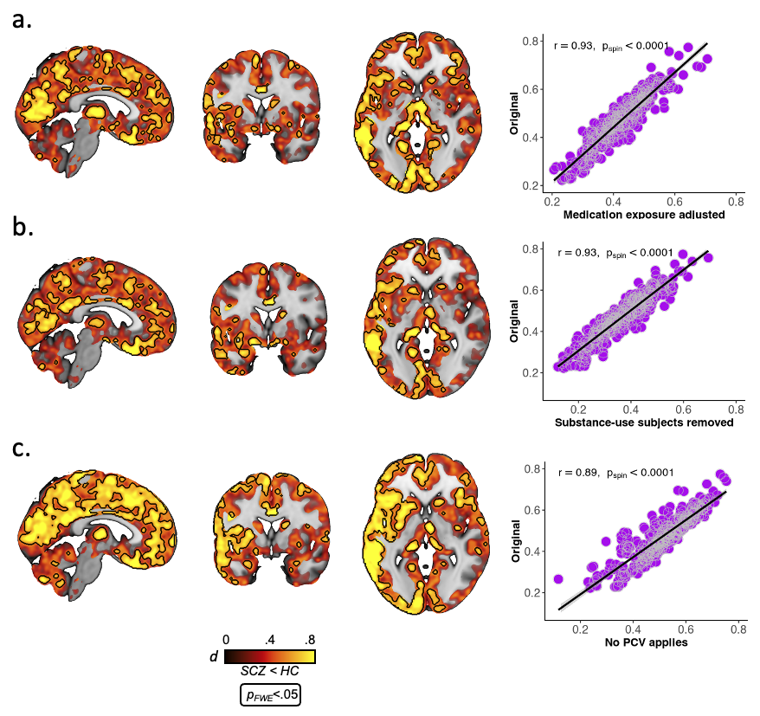
SFig. 1 – Effect size maps for group difference in synaptic density after adjusting for medication exposure (a), removal of subjects with substance abuse (b), removing partial volume correction (c; PVC). Black outline shows voxel-level FWE-corrected significant areas. Scatter plots show association between each parcellated effect size map and the group difference maps used in the primary analysis (Fig. 1A).

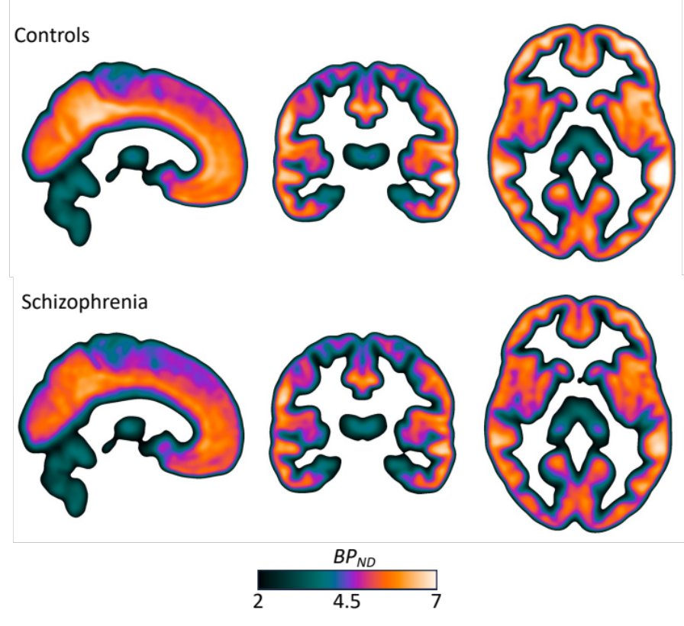
SFig. 2 – Mean of parametric BP_{ND} images for controls (top) and patients (bottom). Linear interpolation has been applied to the images for visualization.

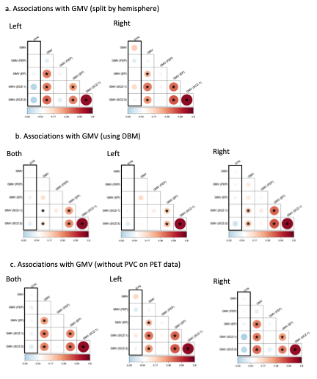
SFig. 3 – Spatial correlation (Pearsons r) between parcellated synaptic density alterations (SYN) and gray matter volume (GMV) within the current sample (top left box in each panel), as well as four independent samples including antipsychotic-naive first-episode psychosis (FEP), early psychosis (EP) and two established schizophrenia (SCZ) cohorts. All other boxes represent correlations between GMV maps between the current and independent samples. (a) Correlations when hemispheres are examined separately, when (b) synaptic density data is not partial volume corrected (PVC) and, (c) when DBM is used to measure grey matter alterations, instead of VBM.

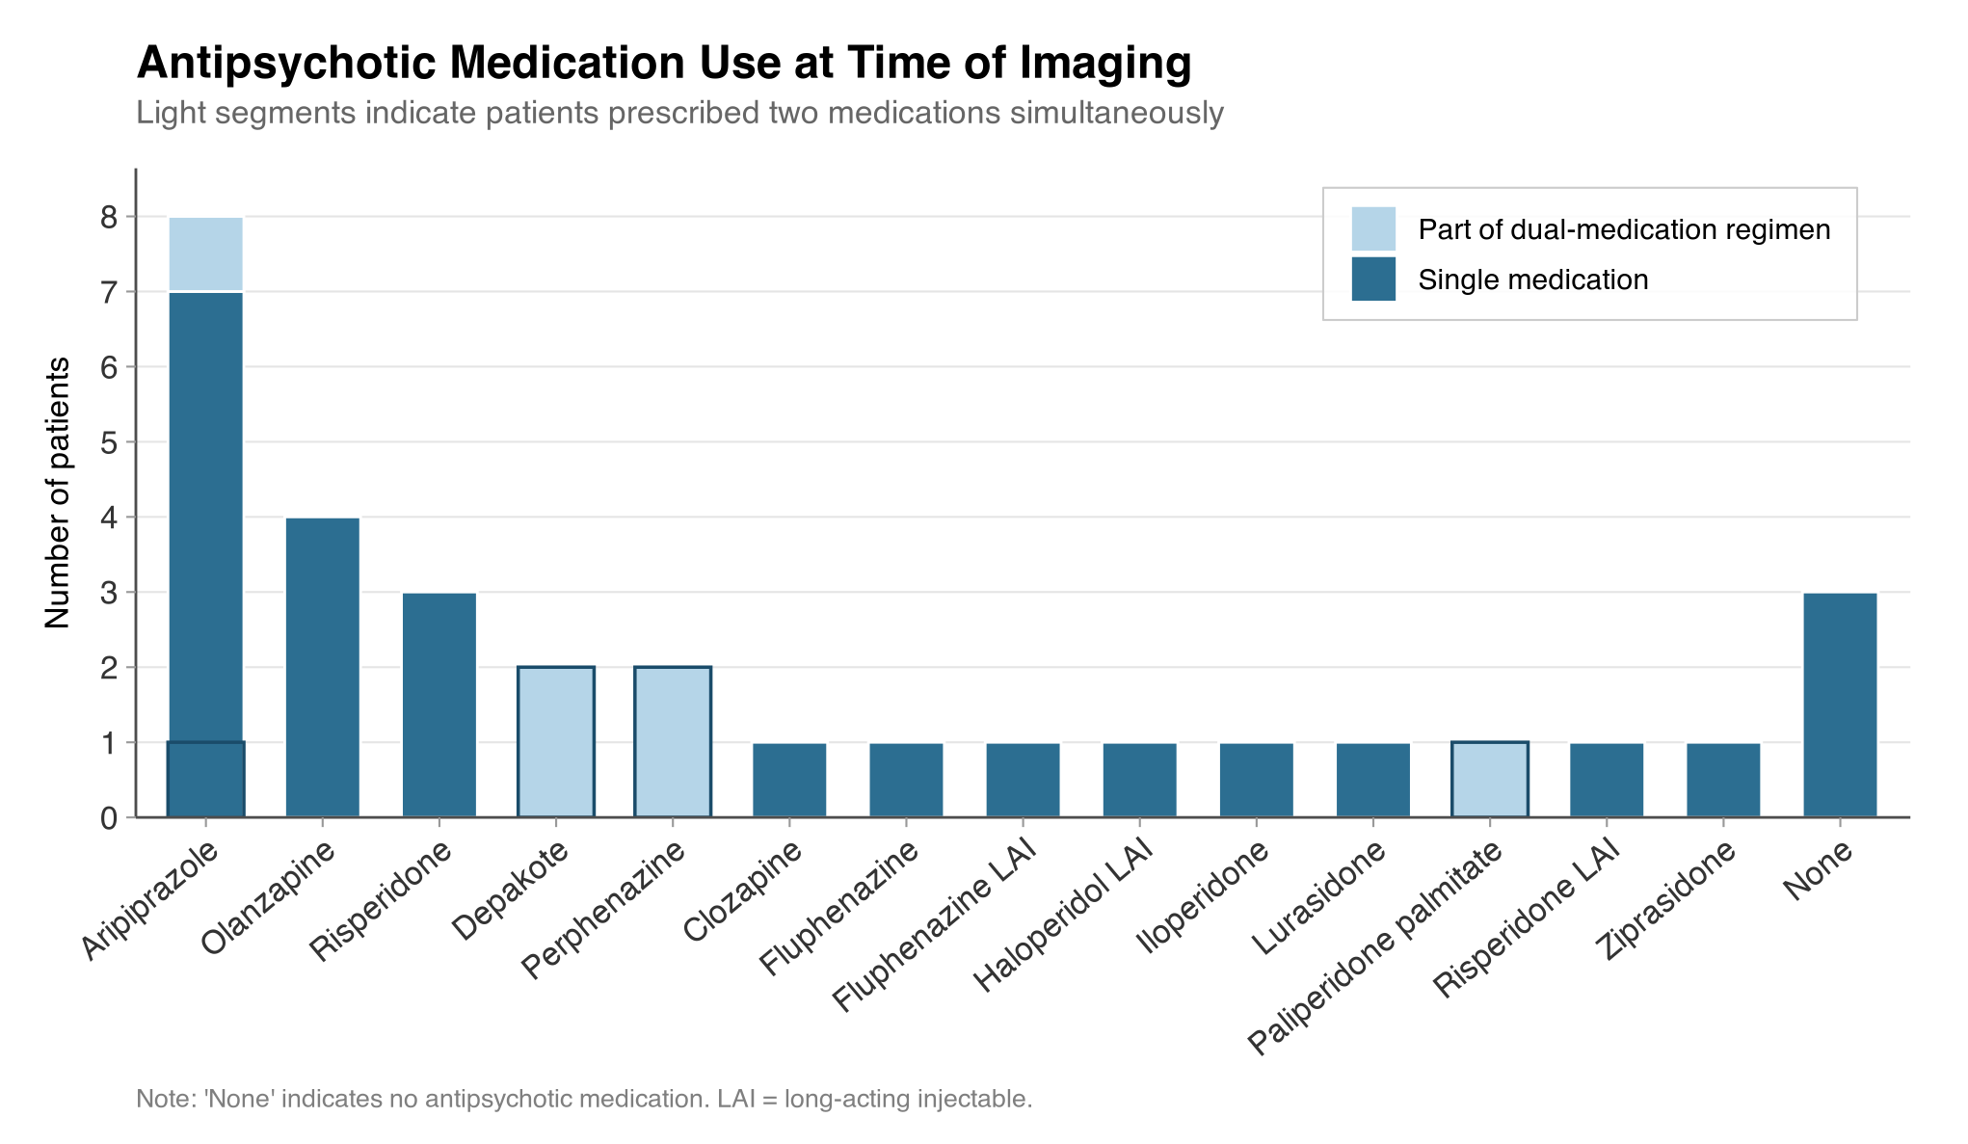
SFig. 4 – Histogram of Antipsychotic type at time of imaging. LAI=Long-acting injectable.

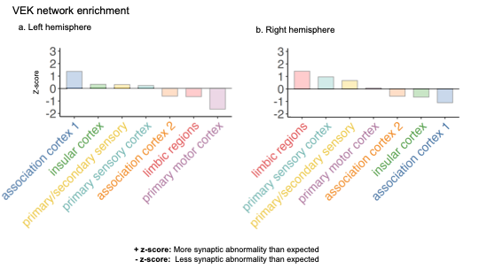

SFig. 5 - Von Economo (VEK) network enrichment of synaptic pathology in schizophrenia. a-b) Enrichment of synaptic pathology within left (a) and right (b) hemisphere VEK networks. Bars plot each network’s corresponding z-scores relative to the null distribution generated by the spatial permuting procedure. A positive z-score indicates greater synaptic loss than expected, whereas a negative z-score indicates less synaptic loss than expected. No significant effects ($p<0.05$) were detected.

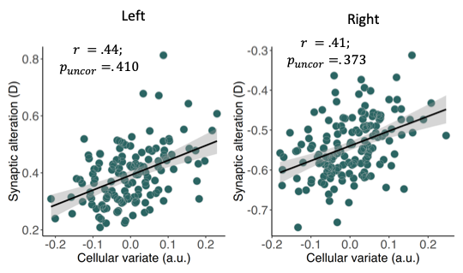

SFig. 6 –Scatter plot of canonical correlation between regional synaptic deficits and normative transcriptomic cell-type density in the left and right hemisphere. The synaptic variate (y-axis) in this case is the regional synaptic deficit/effect size, whereas the cell-type variate is a normalised weighted combination of 24 regional cell-type densities. The non-parametric p-value was computed using the spatial permuting procedure.

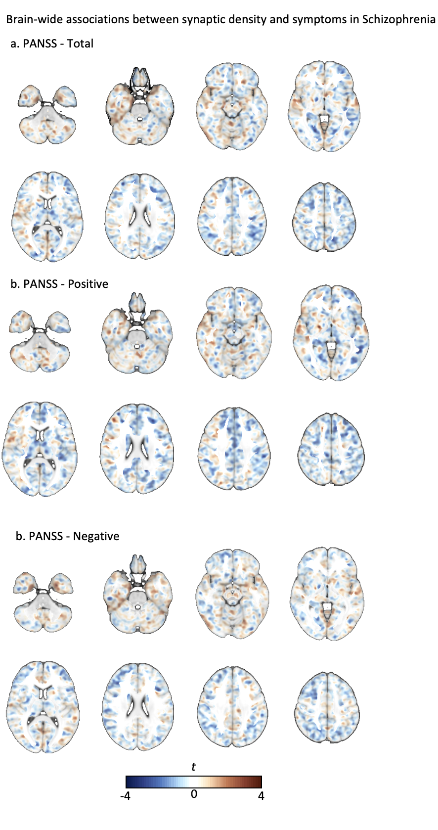
SFig. 7 – Unthresholded voxel-level t-statistic maps of the association between symptom severity (PANSS) and synaptic density, adjusting for age and sex. No voxels survived FWE-correction.

References

1 Van Essen, D. C. et al. The WU-Minn human connectome project: an overview. Neuroimage 80, 62-79 (2013).
2 Jenkinson, M., Bannister, P., Brady, M. & Smith, S. Improved optimization for the robust and accurate linear registration and motion correction of brain images. Neuroimage 17, 825-841 (2002).
3 Glasser, M. F. et al. The minimal preprocessing pipelines for the Human Connectome Project. Neuroimage 80, 105-124 (2013).
4 Fischl, B. et al. Whole brain segmentation: automated labeling of neuroanatomical structures in the human brain. Neuron 33, 341-355 (2002).
5 Arnatkeviciute, A. et al. Genetic influences on hub connectivity of the human connectome. Nature Communications 12, 4237 (2021). https://doi.org/10.1038/s41467-021-24306-2
6 Jeurissen, B., Tournier, J.-D., Dhollander, T., Connelly, A. & Sijbers, J. Multi-tissue constrained spherical deconvolution for improved analysis of multi-shell diffusion MRI data. NeuroImage 103, 411-426 (2014).
7 Tournier, J. D. et al. MRtrix3: A fast, flexible and open software framework for medical image processing and visualisation. NeuroImage 202, 116137 (2019). https://doi.org/https://doi.org/10.1016/j.neuroimage.2019.116137
8 Tournier, J. D., Calamante, F. & Connelly, A. Robust determination of the fibre orientation distribution in diffusion MRI: Non-negativity constrained super-resolved spherical deconvolution. NeuroImage 35, 1459-1472 (2007). https://doi.org/https://doi.org/10.1016/j.neuroimage.2007.02.016
9 Smith, R. E., Tournier, J. D., Calamante, F. & Connelly, A. Anatomically-constrained tractography: improved diffusion MRI streamlines tractography through effective use of anatomical information. Neuroimage 62, 1924-1938 (2012). https://doi.org/10.1016/j.neuroimage.2012.06.005
10 Smith, R. E., Tournier, J.-D., Calamante, F. & Connelly, A. SIFT2: Enabling dense quantitative assessment of brain white matter connectivity using streamlines tractography. Neuroimage 119, 338-351 (2015).
11 Schaefer, A. et al. Local-Global Parcellation of the Human Cerebral Cortex from Intrinsic Functional Connectivity MRI. Cerebral Cortex (New York, N.Y.: 1991) 28, 3095-3114 (2018). https://doi.org/10.1093/cercor/bhx179
12 Tian, Y., Margulies, D. S., Breakspear, M. & Zalesky, A. Topographic organization of the human subcortex unveiled with functional connectivity gradients. Nature Neuroscience 23, 1421-1432 (2020). https://doi.org/10.1038/s41593-020-00711-6
13 Fischl, B. FreeSurfer. Neuroimage 62, 774-781 (2012).
14 Jenkinson, M., Beckmann, C. F., Behrens, T. E., Woolrich, M. W. & Smith, S. M. FSL. Neuroimage 62, 782-790 (2012). https://doi.org/10.1016/j.neuroimage.2011.09.015
15 Maier-Hein, K. H. et al. The challenge of mapping the human connectome based on diffusion tractography. Nature Communications 8, 1349 (2017). https://doi.org/10.1038/s41467-017-01285-x
16 Schilling, K. G. et al. Limits to anatomical accuracy of diffusion tractography using modern approaches. Neuroimage 185, 1-11 (2019). https://doi.org/10.1016/j.neuroimage.2018.10.029
17 Schiavi, S. et al. A new method for accurate in vivo mapping of human brain connections using microstructural and anatomical information. Science advances 6, eaba8245-eaba8245 (2020). https://doi.org/10.1126/sciadv.aba8245
18 Betzel, R. F., Griffa, A., Hagmann, P. & Mišić, B. Distance-dependent consensus thresholds for generating group-representative structural brain networks. Netw Neurosci 3, 475-496 (2019). https://doi.org/10.1162/netn_a_00075
19 Raj, A., Kuceyeski, A. & Weiner, M. A network diffusion model of disease progression in dementia. Neuron 73, 1204-1215 (2012). https://doi.org/10.1016/j.neuron.2011.12.040
20 Raj, A. et al. Network diffusion model of progression predicts longitudinal patterns of atrophy and metabolism in Alzheimer’s disease. Cell reports 10, 359-369 (2015).
21 Chopra, S. et al. Network-Based Spreading of Gray Matter Changes Across Different Stages of Psychosis. JAMA Psychiatry (2023). https://doi.org/10.1001/jamapsychiatry.2023.3293
22 Váša, F. et al. Adolescent tuning of association cortex in human structural brain networks. Cerebral Cortex 28, 281-294 (2018).
23 Betzel, R. F. & Bassett, D. S. Specificity and robustness of long-distance connections in weighted, interareal connectomes. Proceedings of the National Academy of Sciences, 201720186 (2018). https://doi.org/10.1073/PNAS.1720186115
24 Chopra, S. et al. Network-based spreading of grey matter changes across different stages of psychosis. medRxiv, 2022.2001.2011.22268989 (2023). https://doi.org/10.1101/2022.01.11.22268989
25 Nichols, T. & Hayasaka, S. Controlling the familywise error rate in functional neuroimaging: a comparative review. Statistical methods in medical research 12, 419-446 (2003).
26 Markello, R. D. et al. Neuromaps: structural and functional interpretation of brain maps. Nature Methods 19, 1472-1479 (2022).
27 Hansen, J. Y. et al. Mapping neurotransmitter systems to the structural and functional organization of the human neocortex. bioRxiv, 2021.2010.2028.466336 (2022). https://doi.org/10.1101/2021.10.28.466336

