Supplementary material for:
Regional Gray Matter Alterations in Anorexia Nervosa: Implications for Subtype Heterogeneity and Clinical Severity
Haidar Alzaid^{1*}, Martin Bendszus¹, Hans-Christoph Friederich², Joe J. Simon².

*Corresponding Author:
¹Department of Neuroradiology, Heidelberg University Hospital, Heidelberg, Germany.
²Department of General Internal Medicine and Psychosomatics, University Hospital Heidelberg, Heidelberg, Germany.

Haidar Alzaid
Department of Neuroradiology
Im Neuenheimer Feld 400
69120 Heidelberg
Germany

Supplementary Table S1. Antidepressant intake in the AN group:
 | Antidepressant class | Agent (n) | Mean daily dose (mg ± SD) | Dose range (mg)
  n (%) taking
  antidepressants
10 (12.8%) | SSRI | Citalopram (1) | 30 ± 0 | 30
10 (12.8%) | SSRI | Escitalopram (2) | 10 ± 0 | 10
10 (12.8%) | SSRI | Fluxetine (1) | 20 ± 0 | 20
10 (12.8%) | SSRI | Sertraline (2) | 100 ± 70.7 | 50 - 150
10 (12.8%) | SNRI | Ventlafaxine (1) | 75 ± 0 | 75
10 (12.8%) | NaSSA | Mirtazapine (4) | 18.8 ± 7.5 | 15 – 30

SSRI = selective serotonin reuptake inhibitor; SNRI = serotonin–norepinephrine reuptake inhibitor; NaSSA = noradrenergic and specific serotonergic antidepressant.
Values reflect medication status at the time of MRI scanning. One patient was receiving a combination of venlafaxine and mirtazapine.

Supplementary Table S2. Psychiatric comorbidities in the entire AN group and by subtype (restricting vs. binge–purging):
Parameter | AN (n = 78) | AN-R (n = 57) | AN-BP (n = 21) | AN-R vs. AN-BP (p value)
Comorbidities (total) | 19 (24.4%) | 12 (21.1%) | 7 (33.3%) | ns
Depression | 19 (24.4%) | 12 (21.1%) | 7 (33.3%) | ns
Panic disorder | 2 (2.6%) | 2 (3.5%) | 0 (0%) | ns
Obsessive–compulsive disorder | 1 (1.3%) | 1 (1.8%) | 0 (0%) | ns

Values are given as n (%). Group differences between AN-R and AN-BP were assessed using chi-square tests. Abbreviations: AN, anorexia nervosa; AN-R, anorexia nervosa – restrictive subtype; AN-BP, anorexia nervosa - binge/purge subtype; ns, not significant. Two subjects have more than one comorbidity.

Supplementary Table S3. Distribution of acquisition protocols across groups:
Group | n | Protocol 1 (TR = 1570 ms, TE = 2.63 ms) | Protocol 2 (TR = 1900 ms, TE = 2.52 ms)
HC | 94 | 69 (73.4 %) | 25 (26.6 %)
AN (total) | 78 | 54 (69.2 %) | 24 (30.8 %)
AN-R | 57 | 34 (59.6 %) | 23 (40.4 %)
AN-BP | 21 | 20 (95.2 %) | 1 (4.8 %)

The distribution of acquisition protocols did not differ between AN and HC (χ² test, p > .05).
A significant difference was observed between AN-R and AN-BP (χ² test, p < .01).

Supplementary Figure S1 and Table S4. Negative correlation between regional GMV and BMI in AN-BP:

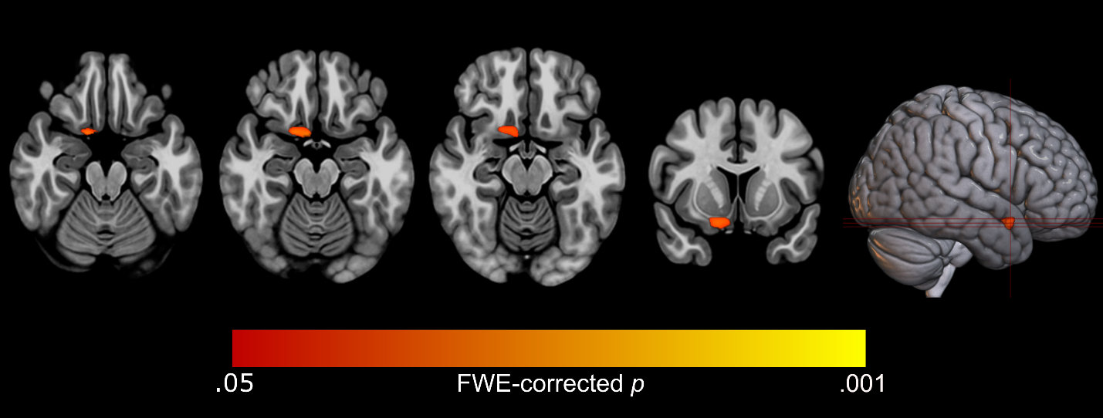

Peak region | MNI coordinates | p value (FWE-corrected) | Cluster size  (voxels) | Cluster regions
Olfactory cortex (R) | 6 x 6 x -18 | .021 | 202 | Olfactory cortex (R); nucleus accumbens (R); gyrus rectus (R); medial orbital gyrus (R); posterior orbital gyrus (R).

Each significant cluster is defined by the region with the peak p value, and all regions within the clusters are listed according to the AAL3 atlas and verified through visual inspection. Abbreviations: AN-BP, anorexia nervosa - binge/purge subtype; BMI, body mass index; R, right hemisphere; L, left hemisphere.

