Supplementary files
S. Table S1: Food frequency questionnaire used in ASPREE longitudinal study of older persons (ALSOP)
Food Item | Never/ rarely | Once or twice a  month | Once or twice a  week | Often or 3-6 times  per week | Every day or several  times a day
Cheese
Yoghurt
Cream, cream cheese or similar
Ice cream, frozen yoghurt or
other dairy desserts
White bread
Brown/multigrain bread
Breakfast cereal/ oats
Rice
Pasta / noodles
Crackers / savoury biscuits
Fresh fruit
Cooked, tinned or dried fruit
Raw/salad vegetables
Cooked green vegetables
Cooked orange / yellow / red vegetables e.g. carrots, beets
Potatoes
Beans and Legumes
e.g. peas, lentils
Red meat (not corned, pickled or processed)
Chicken, turkey, other poultry
Sausages
Processed meats e.g. bacon,
ham, corned beef or salami
Eggs
Deep fried/battered fish
Salmon, mackerel or other oily fish
not including deep fried fish
White fish,
not including deep fried fish
Tinned fish e.g. canned salmon,
tuna, sardines
Other seafood e.g. prawns or
Shellfish
Nuts
Potato chips or similar
Sweet biscuits/ cakes
Dark Chocolate
Milk Chocolate
Lollies or other sweets
Hamburgers, pizza or 'fast' food
Meat pies, sausage rolls etc
Drinks | Never/ rarely | Once per week or  less | Several times a week | 1-2 times a day | 3 or more times/day
Full-cream milk
Low-fat or skim milk
Soy or other non-dairy milk
Water
Coffee
Tea
Malt drinks e.g. Milo or Horlicks
Hot chocolate
Fruit juice
Cordial
Soft Drink e.g. reguar Coke
Diet Soft drink e.g. diet Coke
Supplement drink
e.g. Ensure or Sustagen
Herbal tea
What was the most common cooking oil used in your household?
Olive oil
Butter
Other vegetable oil
Don’t know
Did you regularly add salt to your cooking? |  |  |  | Yes | No
Did you regularly add salt to your food at the table? |  |  |  | Yes | No
Do you currently take any of the following? |  |  | No | Yes, occasionally | Yes, every day
Fish oil
Glucosamine
Coenzyme Q10
Zinc supplements
Calcium supplements
Multivitamin
Vitamin B (including Thiamine)
Vit C
Vit D
Vit E
Gingko Biloba
Chinese or herbal medicines
Other supplements, herbal or complementary medicines

S. Table 2: The effect modification role of genetic predisposition and hs-CRP in the association between diet quality and depressive symptoms
 |  |  | Depressive symptoms (CES-D 10≥8)
 |  |  | RR (95%CI) | P-value
*Diet-genetic interaction | UPF
*Diet-genetic interaction | UPF consumption | High | 1.13 (1.05-1.23) | 0.002
*Diet-genetic interaction | UPF consumption | Low | 1.00 | 0.002
*Diet-genetic interaction | PGS |  | 1.23 (1.18-1.28) | <0.001
*Diet-genetic interaction | UPF x PGS |  | 0.95 (0.87-1.03) | 0.204
*Diet-genetic interaction | DIS
*Diet-genetic interaction | DIS | Anti-inflammatory | 0.92 (0.85-0.99) | 0.029
*Diet-genetic interaction | DIS | Pro-inflammatory | 1.00 | 0.029
*Diet-genetic interaction | PGS |  | 1.16 (1.10-1.22) | <0.001
*Diet-genetic interaction | DIS x PGS |  | 1.07 (1.00-1.16) | 0.056
**Interaction between diet and low-grade inflammation | UPF
**Interaction between diet and low-grade inflammation | UPF consumption | High | 1.10 (1.00-1.21) | 0.054
**Interaction between diet and low-grade inflammation | UPF consumption | Low | 1.00 | 0.054
**Interaction between diet and low-grade inflammation | Hs-CRP |  | 1.08 (1.04-1.13) | <0.001
**Interaction between diet and low-grade inflammation | UPF x hs-CRP |  | 1.02 (0.94-1.10) | 0.691
**Interaction between diet and low-grade inflammation | DIS
**Interaction between diet and low-grade inflammation | DIS | Anti-inflammatory | 0.97 (0.89-1.06) | 0.470
**Interaction between diet and low-grade inflammation | DIS | Pro-inflammatory | 1.00 | 0.470
**Interaction between diet and low-grade inflammation | CRP |  | 1.12 (1.06-1.18) | <0.001
**Interaction between diet and low-grade inflammation | DIS x hs-CRP |  | 0.95 (0.89-1.02) | 0.171
- x: Interaction
- PGS: standardised polygenic score
- *Interaction between diet quality (UPF consumption and dietary inflammation score (DIS) and standardised polygenic score (PGS) for risk of depressive symptoms
- **Interaction between diet quality (UPF consumption and dietary inflammation score (DIS) and log hs-CRP (high sensitivity C-reactive protein) for risk of depressive symptoms
- Covariates in the main analysis were accounted for, except for variables used in the interaction.

S. Table 3: Interaction analysis using categorical PGS and hs-CRP as effect modifiers
 |  |  |  | Depressive symptoms (CES-D 10≥8)
 |  |  |  | RR (95%CI) | P-value
*Diet-genetic interaction | UPF
*Diet-genetic interaction | UPF consumption (high vs low) |  |  | 1.25 (1.03-1.53) | 0.025
*Diet-genetic interaction | PGS |  | High | 1.74 (1.51-2.00) | <0.001
*Diet-genetic interaction |  |  | Medium | 1.36(1.20-1.54) | <0.001
*Diet-genetic interaction | UPF x PGS |  | High x high | 0.91 (0.70-1.17) | 0.454
*Diet-genetic interaction |  |  | High x medium | 0.87 (0.69-1.08) | 0.212
*Diet-genetic interaction | DIS
*Diet-genetic interaction | DIS | Anti-inflammatory vs pro-inflammatory |  | 0.96 (0.79-1.15) | 0.630
*Diet-genetic interaction | PGS |  | High | 1.54 (1.29-1.84) | <0.001
*Diet-genetic interaction |  |  | Medium | 1.35 (1.16-1.57) | <0.001
*Diet-genetic interaction | DIS x PGS |  | High x anti-inflammatory | 1.13 (0.89-1.44) | 0.305
*Diet-genetic interaction |  |  | Medium x anti-inflammatory | 0.91(0.74-1.12) | 0.376
**Interaction between diet and low-grade inflammation | UPF
**Interaction between diet and low-grade inflammation | UPF consumption (high vs low) |  |  | 1.07 (0.97-1.18) | 0.168
**Interaction between diet and low-grade inflammation | Hs-CRP (high vs low) |  |  | 1.17 (1.07-1.29) | 0.001
**Interaction between diet and low-grade inflammation | UPF x hs-CRP |  | High x high | 1.10 (0.92-1.31) | 0.287
**Interaction between diet and low-grade inflammation | DIS
**Interaction between diet and low-grade inflammation | DIS |  | Anti-inflammatory vs pro-inflammatory | 0.97 (0.89-1.06) | 0.496
**Interaction between diet and low-grade inflammation | Hs-CRP (high vs low) |  |  | 1.11 (1.05-1.17) | <0.001
**Interaction between diet and low-grade inflammation | DIS x hs-CRP |  | High x anti-inflammatory | 0.96 (0.90-1.03) | 0.242
- x: Interaction
- PGS: high (Q5), medium (Q2-Q4) and low (Q1- reference group)
- Hs-CRP: high(>3mg/L) and low (≤3mg/L- reference group)
- X: interaction
- Covariates in the main analysis were accounted for, except for variables used in the interaction.

S. Table 4: Sex-disaggregated analysis showing the association between diet quality and depressive symptoms, adjusting for PGS and hs-CRP
Male
Diet quality |  | Depressive symptoms (CES-D 10≥8)
 |  | RR (95%CI) | P-value
UPF consumption | High | 1.08 (0.96-1.23) | 0.209
UPF consumption | Low | 1.00 | 0.209
DIS | Anti-inflammatory | 0.98 (0.87-1.10) | 0.713
DIS | Pro-inflammatory | 1.00 | 0.713
Female
UPF consumption | High | 1.20 (1.08-1.33) | 0.001
UPF consumption | Low | 1.00 | 0.001
DIS | Anti-inflammatory | 0.90 (0.82-0.99) | 0.030
DIS | Pro-inflammatory | 1.00 | 0.030

S. Table 5: Sex-disaggregated analyses exploring the effect modification of genetic predisposition and low-grade inflammation in the association between diet quality and depressive symptoms
Male |  |  |  | Depressive symptoms (CES-D 10≥8)
Male |  |  |  | RR (95%CI) | P-value
Male | Diet-genetic interaction | UPF | High | 1.14 (1.02-1.29) | 0.027
Male | Diet-genetic interaction | PGS |  | 1.33 (1.24-1.43) | <0.001
Male | Diet-genetic interaction | High x PGS |  | 0.87 (0.77-0.98) | 0.027
Male | Diet-genetic interaction | DIS | Anti-inflammatory | 0.95 (0.84-1.07) | 0.383
Male | Diet-genetic interaction | PGS |  | 1.18 (1.09-1.28) | <0.001
Male | Diet-genetic interaction | Anti-inflammatory x PGS |  | 1.17 (1.04-1.31) | 0.009
Male | Diet x hs-CRP | UPF | High | 1.09 (0.96-1.25) | 0.184
Male | Diet x hs-CRP | Hs-CRP |  | 1.07 (1.00-1.14) | 0.049
Male | Diet x hs-CRP | High x hs-CRP |  | 1.04 (0.93-1.15) | 0.522
Male | Diet x hs-CRP | DIS | Anti-inflammatory | 1.00 (0.88-1.15) | 0.948
Male | Diet x hs-CRP | Hs-CRP |  | 1.10 (1.02-1.19) | 0.015
Male | Diet x hs-CRP | Anti-inflammatory x hs-CRP |  | 0.95 (0.86-1.06) | 0.398
Female | Diet-genetic interaction | UPF | High | 1.16 (1.05-1.29) | 0.004
Female | Diet-genetic interaction | PGS |  | 1.17 (1.11-1.23) | <0.001
Female | Diet-genetic interaction | High x PGS |  | 1.00(0.91-1.10) | 0.984
Female | Diet-genetic interaction | DIS | Anti-inflammatory | 0.93 (0.85-1.01) | 0.096
Female | Diet-genetic interaction | PGS |  | 1.18(1.11-1.26) | <0.001
Female | Diet-genetic interaction | DIS x PGS |  | 0.98 (0.90-1.07) | 0.696
Female | Diet x hs-CRP | UPF | High | 1.14 (1.00-1.29) | 0.046
Female | Diet x hs-CRP | Hs-CRP |  | 1.08 (1.03-1.13) | 0.002
Female | Diet x hs-CRP | High x CRP |  | 1.01 (0.91-1.11) | 0.888
Female | Diet x hs-CRP | DIS | Anti-inflammatory | 0.94(0.85-1.05) | 0.297
Female | Diet x hs-CRP | Hs-CRP |  | 1.08 (1.01-1.15) | 0.016
Female | Diet x hs-CRP | Anti-inflammatory x hs-CRP |  | 0.99 (0.91-1.08) | 0.814

S. Table 6: Stratified analysis by aspirin treatment (aspirin vs placebo)
Exposure categories | Depressive symptoms (CES-D 10 ≥8)
Exposure categories | Aspirin |  | Placebo
Exposure categories | RR (95% CI) | p-value | RR (95% CI) | p-value
UPF consumption
High | 1.17 (1.03-1.32) | 0.016 | 1.10 (0.97-1.25) | 0.145
Low | 1.00 | 0.016 | 1.00 | 0.145
DIS
Anti-inflammatory | 0.89 (0.80-1.00) | 0.052 | 0.98 (0.88-1.10) | 0.786
Pro-inflammatory | 1.00 | 0.052 | 1.00 | 0.786
Interaction
UPF x aspirin | 0.94 (0.79-1.12) |  |  | 0.510
DIS x aspirin | 1.10 (0.94-1.29) |  |  | 0.234

S. Table 7: Association between diet quality and depressive symptoms, adjusting for PGS and hs-CRP after excluding participants with depressive symptoms (CES-D 10 cut-off ≥8) and taking antidepressants/antipsychotics at time zero.
Diet quality |  | Depressive symptoms (CES-D 10≥8)
 |  | RR (95%CI) | P-value
Excluding participants with depressive symptoms at time 0
UPF consumption | High | 1.10 (1.00-1.23) | 0.054
UPF consumption | Low | 1.00 | 0.054
DIS | Anti-inflammatory | 0.93 (0.85-1.01) | 0.099
DIS | Pro-inflammatory | 1.00 | 0.099
Excluding participants taking antidepressants/antipsychotics at time 0
UPF consumption | High | 1.12 (1.02-1.24) | 0.014
UPF consumption | Low | 1.00 | 0.014
DIS | Anti-inflammatory | 0.91 (0.84-0.99) | 0.029
DIS | Pro-inflammatory | 1.00 | 0.029

S. Table 8: Association between diet quality and depressive symptoms, adjusting for PGS and hs-CRP and effect-modification analysis using CES-D 10 cut-off ≥10
Diet quality |  | Depressive symptoms (CES-D 10≥10)
 |  | RR (95%CI) | P-value
Main effect
UPF consumption | High | 1.11 (1.00-1.24) | 0.046
UPF consumption | Low | 1.00 | 0.046
DIS | Anti-inflammatory | 0.93 (0.84-1.02) | 0.143
DIS | Pro-inflammatory | 1.00 | 0.143
Interaction effect
UPF x PGS |  | 0.95 (0.85-1.06) | 0.343
UPF x hs-CRP |  | 0.99 (0.90-1.09) | 0.864
DIS x PGS |  | 1.08(0.98-1.19) | 0.117
DIS x hs-CRP |  | 0.94 (0.86-1.03) | 0.175
PGS: standardised polygenic score, hs-CRP: log high-sensitivity C-reactive protein
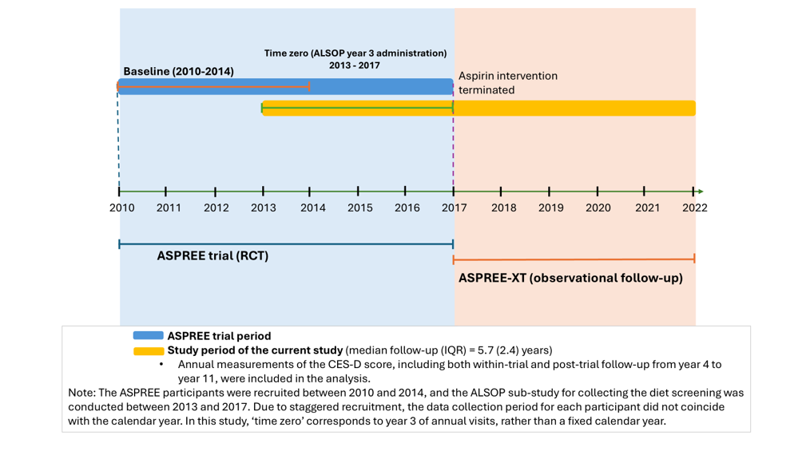S. Figure 1: ASPREE and ASPREE-XT study timeline showing CES-D follow-up data collection periods included in the current analysis
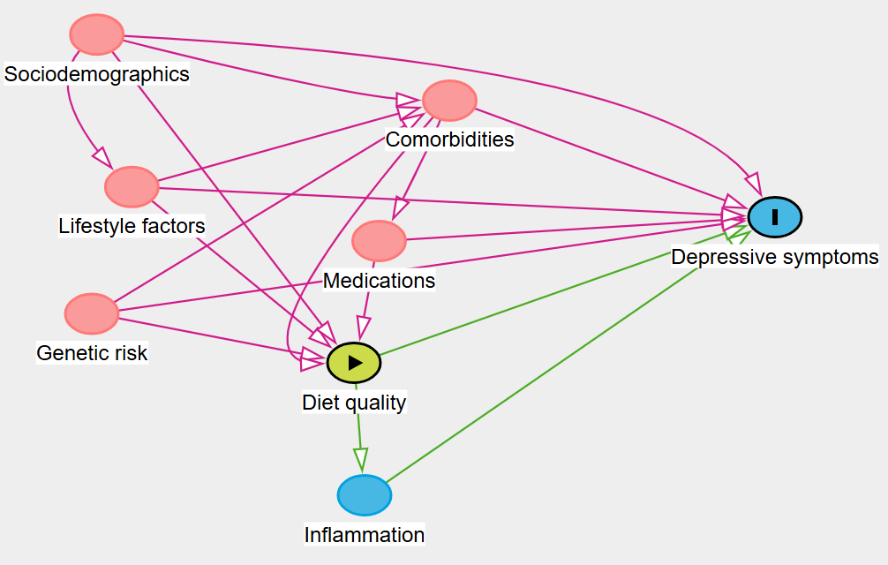
S. Figure 2: Directed acyclic graphs (DAGs) showing potential confounders.
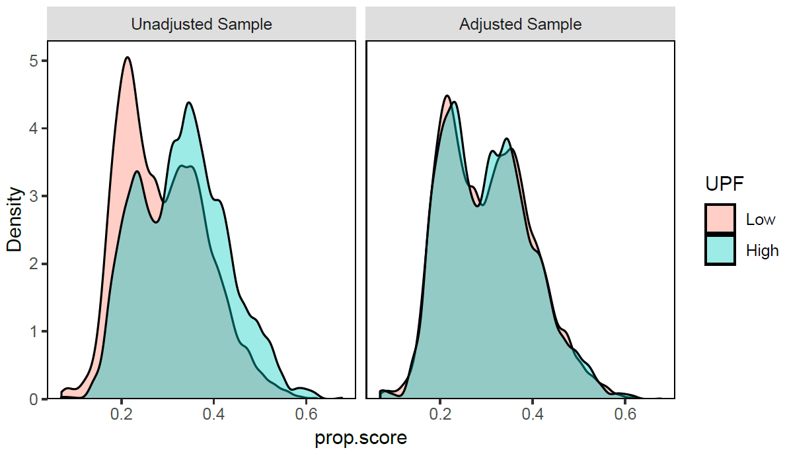
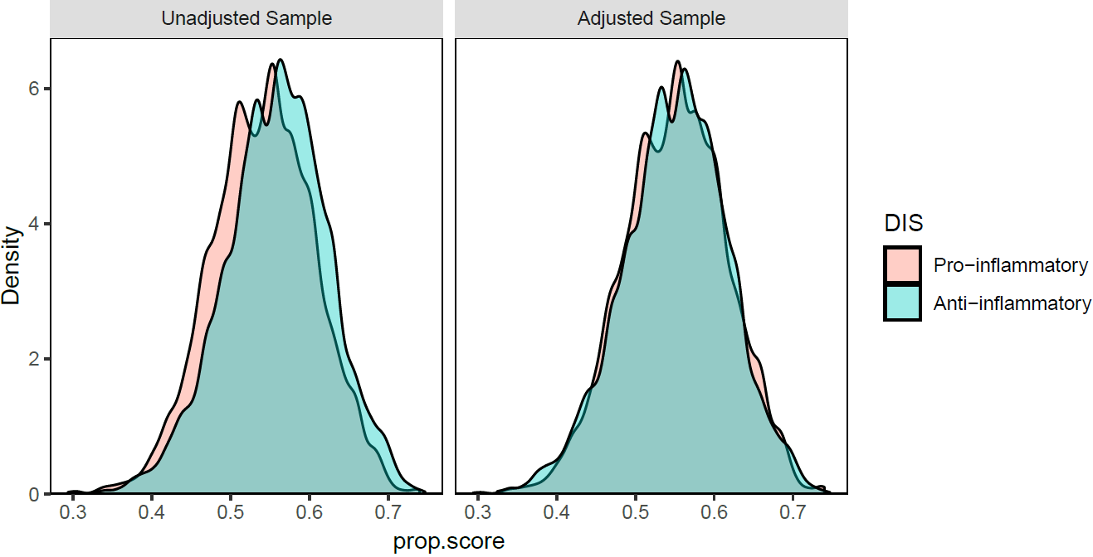
S. Figure 3: Balance plots of diet quality indicators (UPF and DIS) showing before and after IPTW.

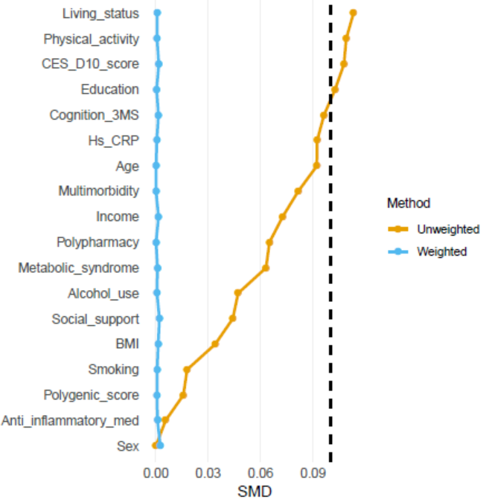
S. Figure 4: Plot showing standardised mean difference (SMD) for covariates at time zero

a)
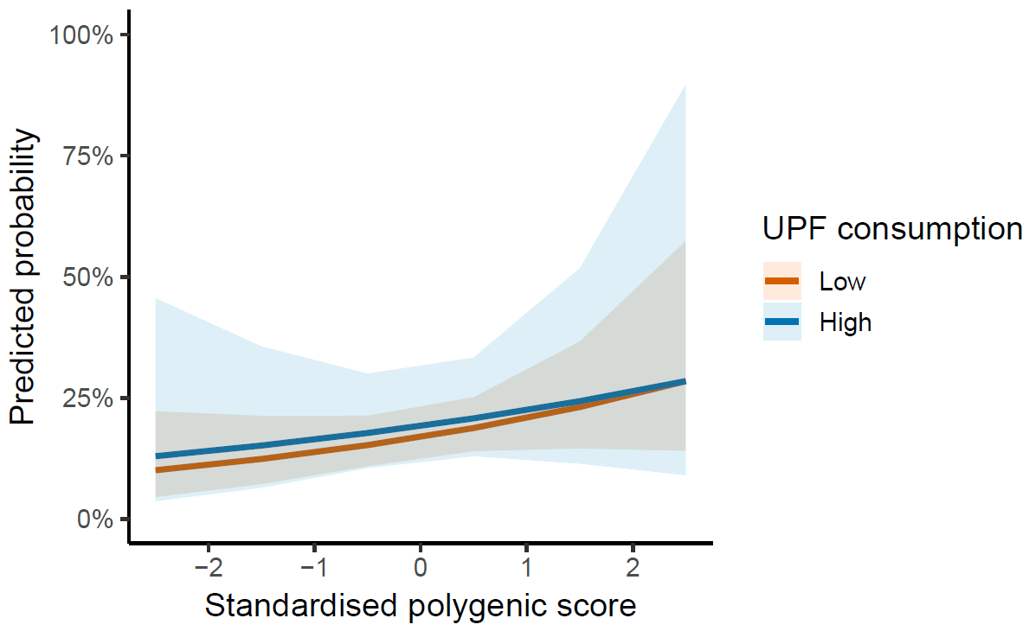

b) 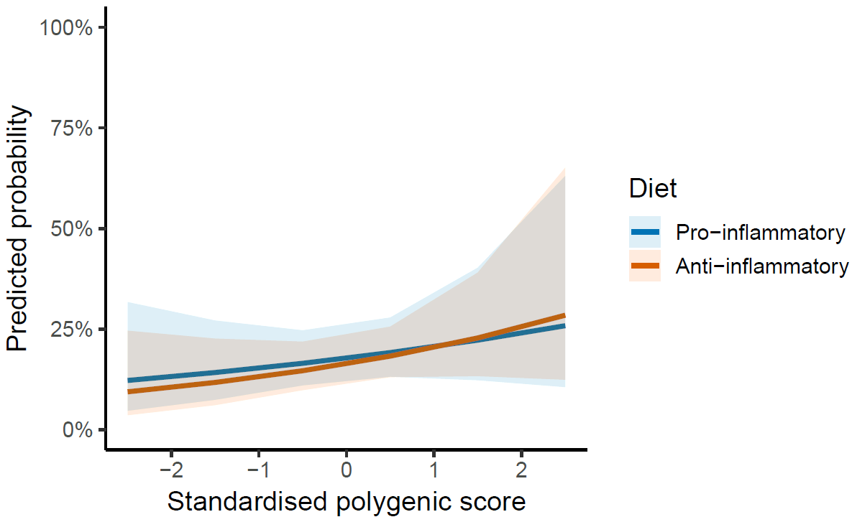

c)
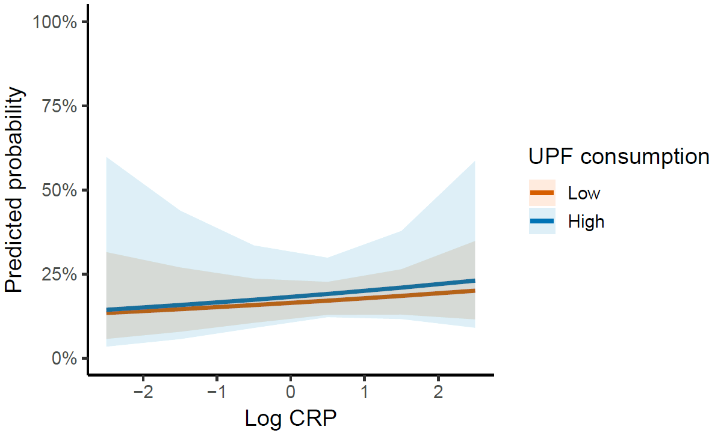

d)
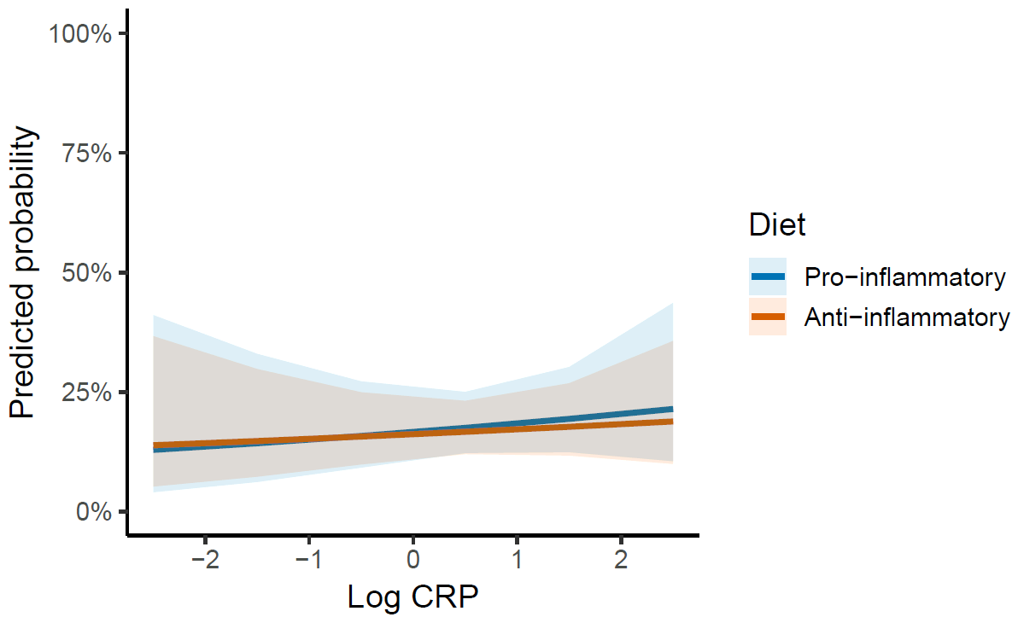
S. Figure 5: Effect modification of polygenic score to depression (a and b) and low-grade inflammation (c and d) in the association between diet quality and depressive symptoms.

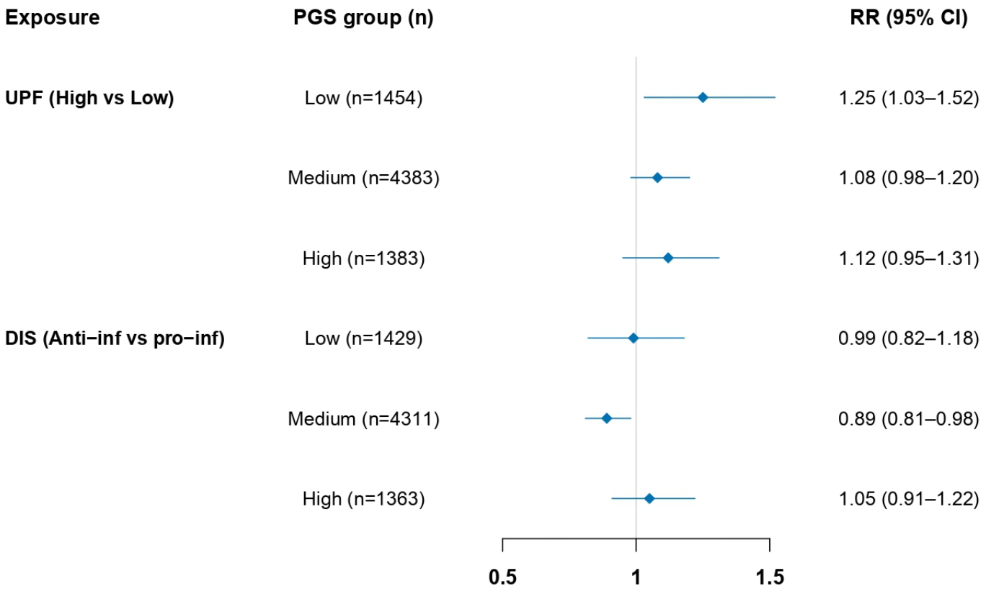
S. Figure 6: Stratified analysis showing the association between diet quality and depressive symptoms by PGS category
DIS: Dietary inflammation score, anti-inf: anti-inflammatory, pro-inf: pro-inflammatory, UPF: ultra-processed food. All covariates in the main analysis were included in the IPTW, except for the stratification variable (PGS).

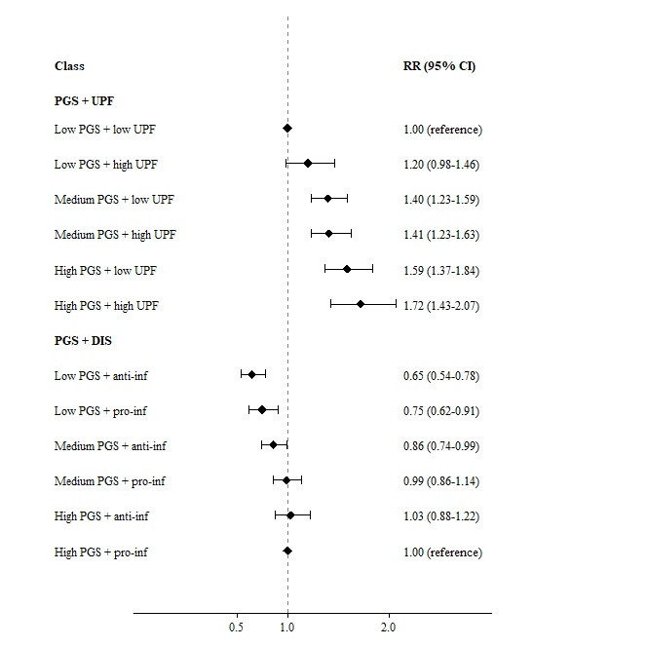
S. Figure 7: Association between the combination of genetic risk and diet quality and risk of depressive symptoms
UPF: Ultra-processed food, DIS: Dietary inflammation score, anti-inf: anti-inflammatory diet, pro-inf: pro-inflammatory diet. All covariates accounted for in the main model, except PGS, were included in IPTW.
As shown in S. Figure 7, using participants with low genetic risk and low UPF consumption as the reference group, those with high genetic risk and high UPF consumption had the highest risk of depressive symptoms (RR: 1.72, 95% CI: 1.43-2.07). Conversely, participants with low genetic risk and an anti-inflammatory diet showed the greatest reduction in depressive symptoms compared to those with high genetic risk and a pro-inflammatory diet (RR: 0.65, 95% CI: 0.54-0.78).

a)
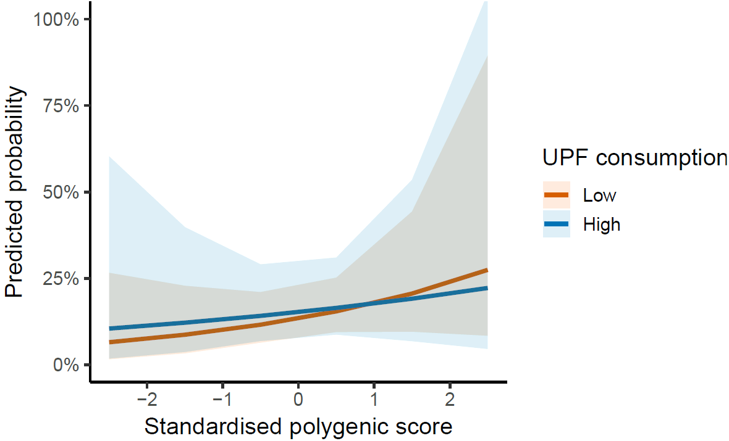
b)
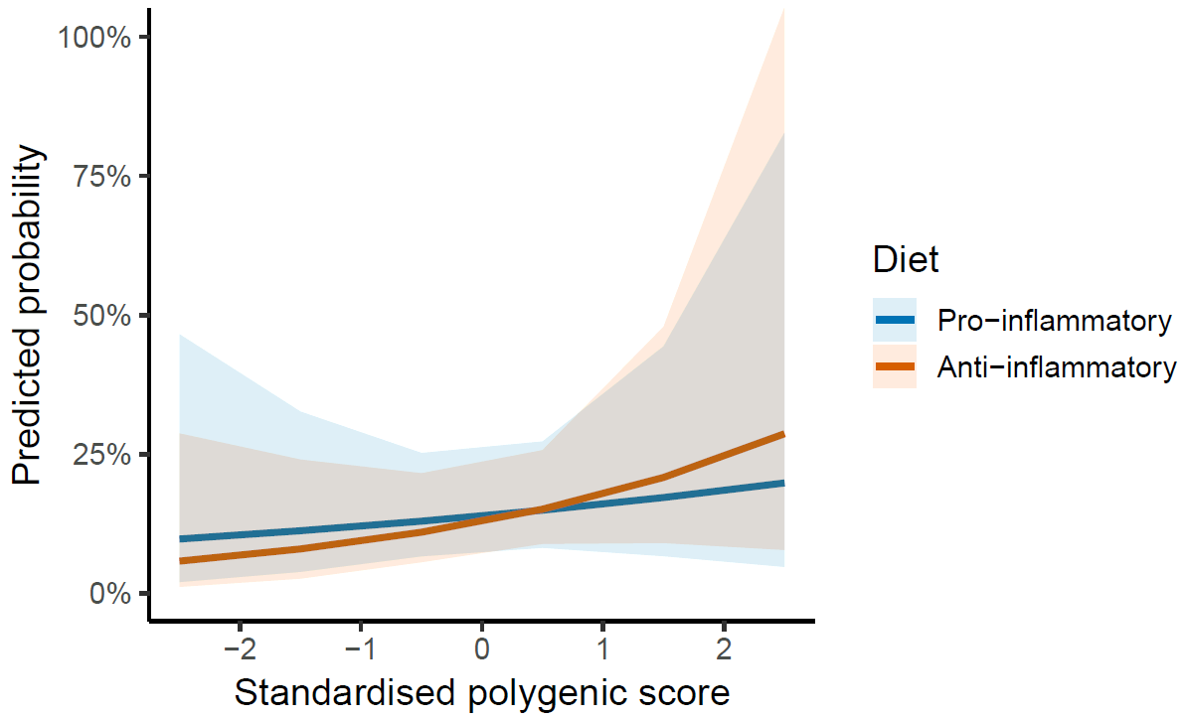
c)
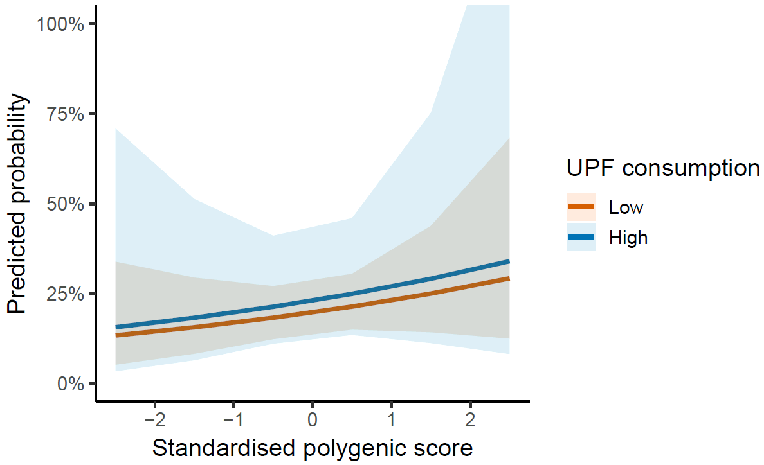

d)
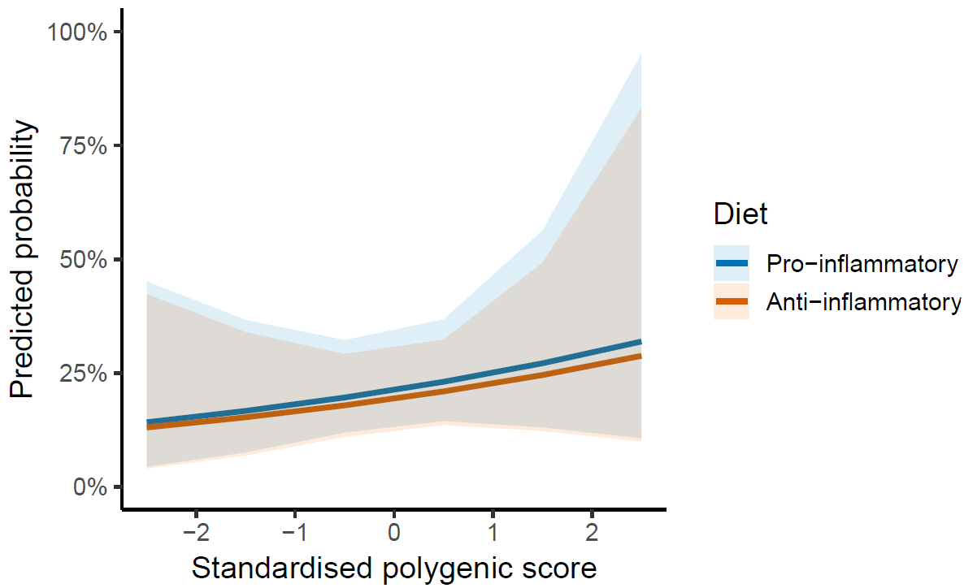
S. Figure 8: Effect modification of polygenic score to depression in the association between diet quality and depressive symptoms by sex: male (a and b) and female (c and d).

