Supplementary information for manuscript
The HDAC Inhibitor Sodium Butyrate Moderately Enhances Long-Term Fear Extinction Memory Retrieval in Humans
Camille Ribbens, MSc.¹, Lisa Peeters, MSc.¹, Lukas Van Oudenhove, MD, PhD.^{2,3}, Bram Vervliet, PhD^{1,3}, & Boushra Dalile, PhD.^{1,3*}

METHODS
Participants
Sample size calculation
Data to estimate expected effect sizes for the effect of NaBu or any HDACi on SCRs during long-term memory retrieval are scarce. A previous study comparing placebo vs. the HDACi valproic acid found a small effect on SCRs during 24 h retrieval test (ηp² = 0.058) and a medium effect during fear reinstatement (ηp² = 0.094) using an average of 15 participants per arm[1]. Using the smallest available effect size (ηp² = 0.058), transformed to Cohen’s f = 0.248 in G*Power’s F-test family for ANOVA: Repeated measures, between factors with α=0.05, we calculated a priori required total sample size of n = 174 (29 participants per arm) to achieve 90% power to detect an effect of this magnitude for the omnibus test of the between-subject effect comparing the 6 arms [3 (‘treatment’) x 2 (‘extinction duration)], taking into account four retrieval/reinstatement trials (within-subject) as number of measurements and the default correlation among repeated measures of 0.5. To achieve full randomisation of participants and counterbalancing of the stimulus presentation (i.e., which of the two stimuli is the CS+ and which is the CS-) we needed to recruit an additional participant per group, leading to a total sample size of 180 participants. When pooling extinction learning durations to render three treatment arms and test our primary hypotheses H1 and H2 (main effect of treatment), we computed an achieved power of 97% with 180 participants, using the same effect size and number of measurements.

Randomisation, blinding, unblinding
Participants were randomly assigned into treatment groups and the CSs were counterbalanced. Participants were further stratified by sex to insure equal distribution of the ratio of women to men across the treatment groups. Participants that dropped-out or were excluded from the study due to compliance or potential data quality issues were replaced in the randomisation table. Treatment arms were blinded to the study participant, the investigator who distributes the intervention, and during outcome assessment. The interventional product was manufactured, packaged and labelled in such a way that the packaging was identical for the treatment and the placebo. The smell of the NaBu vs. Placebo differed due to the nature of NaBu. Hence, because participants in 4 out of 6 groups would in principle be able to distinguish Placebo from NaBu capsules, all participants were told that they will consume both capsules and the timing will be manipulated across the different arms. In reality, 2 groups out of 6 consumed Placebo capsules only (FIG 1A). Participants were debriefed about this deception at the end of study visit 3. After all participants have completed the study, the database was locked and analysed. The collected data was only unblinded by outcome assessors and data analysts after the statistical analysis was completed to maintain the triple blind.
RESULTS
Adherence to dietary instructions
At study visit 1, participants reported their pre-visit meal, categorized as fasted, white bread with jam, another low-fiber option, or a non–low-fiber option. Meal type distribution did not differ significantly between groups, χ²(15, N = 180) = 10.02, p = 0.82. Overall, 30.56% were fasted, 42.22% consumed white bread with jam, and 14.44% chose another low-fiber option totaling 87.22% adherence to minimal fiber intake. At study visit 2, pre-session meal types were again comparable across groups, χ²(15, N = 180) = 4.49, p = 1.00. A total of 88.89% of participants adhered to minimal fiber intake, including 29.44% who were fasted, 43.89% who consumed white bread with jam, and 15.56% who opted for another low-fiber meal. Similarly, at visit 3, no significant group differences were observed in pre-visit meal type, χ²(15, N = 180) = 8.37, p = 0.91). Overall, 87.22% of participants adhered to minimal fiber intake, including 29.44% who were fasted, 41.11% who consumed white bread with jam, and 16.67% who opted for another low-fiber meal.
Compliance with acute capsule intake and potential unblinding
Participants took the capsules in the experimental cubicle while being monitored via a camera by the researcher. All but one participant successfully swallowed all capsules. One participant experienced a gag reflex, resulting in the loss of a capsule.
Treatment guess accuracy varied by experimental group χ²(5, N = 180) = 27.35, p < 0.001, V = 0.39), with participants who received NaBu performing better overall, likely due to NaBu’s distinctive odor. The Post-short-extinction-NaBu group showed the highest guess accuracy (86.67%), followed by the Pre-short-extinction-NaBu (66.67%), Pre-long-extinction-NaBu (63.33%), and Post-long-extinction-NaBu (60.00%) groups. In contrast, Placebo-short-extinction (40.00%) and Placebo-long-extinction (26.67%) groups were below chance level. Using a logistic regression with "treatment" and "extinction duration" as predictors, a main effect of extinction duration (χ²(1) = 4.78, p = 0.029) was significant indicating lower treatment guess accuracy in the long extinction groups relative to the short extinction groups (ß = -0.74, SE = 0.34, z = -2.19, p = 0.029, OR = 0.48, 95% CI [0.25, 0.93]). Additionally, the main effect of treatment (χ²(2) = 21.11, p < 0.001) was also significant indicating lower treatment guess accuracy in Placebo groups relative to the Pre-extinction-NaBu groups (ß = -1.33, SE = 0.39, z = -3.42, p < 0.001, OR = 0.27, 95% CI [0.12, 0.57]) and relative to the Post-extinction-NaBu groups (ß = -1.85, SE = 0.43, z = 4.30, p < 0.001, OR = 0.16, 95% CI [0.07, 0.37])) with no differences between the NaBu groups (ß = -0.52, SE = 0.42, z = 1.22, p = 0.22). However, no treatment × extinction duration interaction effect was found (χ²(2) = 2.43, p = 0.30).
Assessment of side effects
Capsule side effects were assessed using GASE and GSRS questionnaires (Table 1). Running a LMM on GASE (F(5,88) = 0.54, p = 0.75) and GSRS (F(5,174) = 0.69, p = 0.63) questionnaire scores revealed no significant group differences. Running a Kruskal-Wallis test on the diarrhea (H(5) = 6.38, p = 0.27), indigestion (H(5) = 1.45, p = 0.92), constipation (H(5) = 6.22, p = 0.29), reflux (H(5) = 0.97, p = 0.96) and abdominal pain (H(5) = 9.33, p = 0.10) subscales of the GSRS questionnaire revealed no significant group differences.

Study visit 1: Acquisition
US expectancy ratings and SCRs in response to CS
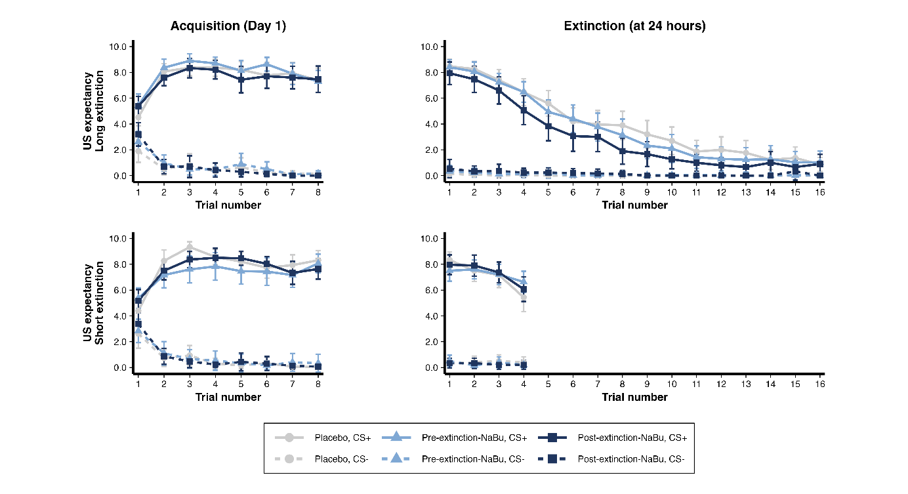
FIG S1. US expectancy ratings during fear acquisition and extinction learning. Mean (±95% CI) US expectancy to CS+ and CS– over trials during acquisition (left panels) and extinction learning (right panels) tests are shown separately for the long extinction (top row) and short extinction (bottom row) groups.
During fear acquisition, all groups showed the expected CS+ > CS− differential responding for both US expectancy and SCRs (US expectancy: FIG S1; SCR: FIG S2), reflected in main effects of CS (US expectancy: F(1,2599) = 9697.71, p < 0.001, ηp² = 0.771; SCR: F(1,2610) = 291.77, p < 0.001, ηp² = 0.092). US expectancy increased for the CS+ and decreased for the CS− across trials (CS × trial: F(7,2599) = 52.03, p < 0.001, ηp² = 0.113), while SCRs decreased over time (F(7,2610) = 49.10, p < 0.001, ηp² = 0.107) but remained higher for CS+ than CS−, as indicated by a significant CS × trial interaction (F(7,2610) = 6.09, p < 0.001, ηp² = 0.015).
Differential responding (CS+ vs. CS−) varied between groups for US expectancy (group × CS: F(5,2599) = 2.41, p = 0.034, ηp² = 0.004), but not over time (group × CS × trial: F(35,2599) = 0.65, p = 0.94), whereas differential SCRs did not differ between groups (group × CS: F(5,2610) = 1.12, p = 0.34; group × CS × trial: F(35,2610) = 0.85, p = 0.72), though there was a main effect of group for SCRs (F(5,2610) = 3.91, p = 0.002, ηp² = 0.007).
Follow-up comparisons indicated that Placebo-short-extinction differed from Pre-short-extinction-NaBu in US expectancy (t(2599) = 3.01, p_{adj} = 0.040, d = 0.78), and that Placebo-short-extinction had lower SCRs across trials and CSs than Placebo-long-extinction (t(2610) = −3.70, p_{adj} = 0.003, d = −0.96) and Pre-long-extinction-NaBu (t(2610) = −3.39, p_{adj} = 0.009, d = −0.88). Including NA as a covariate in the models did not change these results (US expectancy: group × CS: F(5,2599) = 2.41, p = 0.034, ηp² = 0.004; SCR: group: F(5,2609) = 3.80, p = 0.002, ηp² = 0.007).
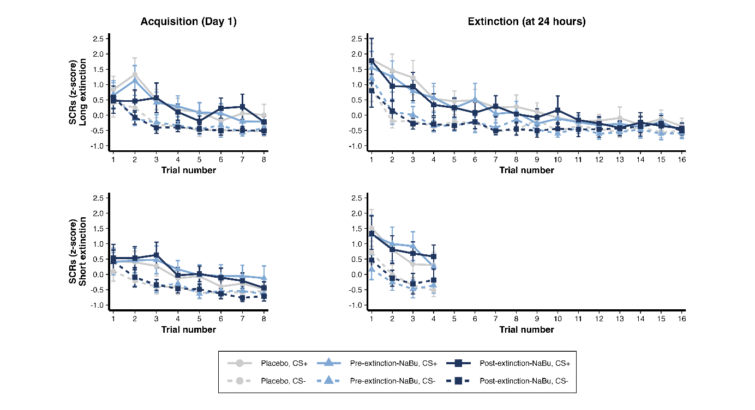
FIG S2. SCRs during fear acquisition and extinction learning. Mean (±95% CI) z-scored SCRs to CS+ and CS– over trials during acquisition (left panels) and extinction learning (right panels) tests are shown separately for the long extinction (top row) and short extinction (bottom row) groups.

Retrospective ratings
During study visit 1, the individually titrated intensity of the electrical stimulation was comparable across the experimental groups, F(5, 174) = 0.60, p = 0.70, as were subjective ratings of the electric stimulation’s unpleasantness, F(5, 172) = 1.39, p = 0.23 (Table 1). These ratings were collected retrospectively following the acquisition phase, during which all participants underwent identical procedures. This suggests that neither the objective intensity nor the subjective experience of the electrical stimulation differed between groups and is unlikely to have influenced learning outcomes.
Study visit 2: Extinction
US expectancy ratings and SCRs in response to CS
Long extinction
During long extinction, all treatment groups showed the expected CS+ > CS− pattern for both US expectancy and SCRs (US expectancy: FIG S1; SCR: FIG S2), reflected in main effects of CS (US expectancy: F(1,2693) = 3217.84, p < 0.001, ηp² = 0.528; SCR: F(1,2697) = 294.26, p < 0.001, ηp² = 0.093). Both measures decreased over trials (US expectancy: F(15,2693) = 128.35, p < 0.001, ηp² = 0.402; SCR: F(15,2697) = 35.94, p < 0.001, ηp² = 0.158), with significant CS × trial interactions (US expectancy: F(15,2693) = 112.50, p < 0.001, ηp² = 0.371; SCR: F(15,2697) = 7.71, p < 0.001, ηp² = 0.039) indicating that CS+ vs. CS− differences changed over time.
CS+ vs. CS− differences were larger at trial 1 (US expectancy: t(2693) = 30.69, p_{adj} < 0.001, dz = 3.25; SCR: t(2697) = 3.51, p_{adj} = 0.004, dz = 0.37) and reduced by trial 16 (US expectancy: t(2693) = 5.15, p_{adj} < 0.001, dz = 0.55; SCR: t(2697) = 1.22, p_{adj} = 0.45), with significant reductions from trial 1 to trial 16 (US expectancy: t(2693) = 22.17, p_{adj} < 0.001, dz = 2.35; SCR: t(2697) = 2.85, p_{adj} = 0.004, dz = 0.30).
Differential responding varied by treatment group (US expectancy: F(2,2693) = 31.07, p < 0.001, ηp² = 0.021; SCR: F(2,2697) = 3.89, p = 0.021, ηp² = 0.003), but not across trials. Placebo showed larger CS+ vs. CS− differences than Pre-extinction-NaBu (US expectancy: t(2693) = 2.75, p_{adj} = 0.006, d = 0.71; SCR: t(2697) = 2.55, p_{adj} = 0.032, d = 0.66) and Post-extinction-NaBu (US expectancy: t(2693) = 7.83, p_{adj} < 0.001, d = 2.02; SCR: t(2697) = 2.24, p_{adj} = 0.051), while Pre-extinction-NaBu exceeded Post-extinction-NaBu for US expectancy (t(2693) = 5.13, p_{adj} < 0.001, d = 1.32) but not SCRs (t(2697) = 0.29, p_{adj} = 0.77).
Short extinction
During short extinction, all treatment groups also showed CS+ > CS− responding for both US expectancy and SCRs (US: FIG S1; SCR: FIG S2), reflected in main effects of CS (US expectancy: F(1,609) = 3402.41, p < 0.001, ηp² = 0.826; SCR: F(1,609) = 153.24, p < 0.001, ηp² = 0.176). Both measures decreased over trials (US expectancy: F(3,609) = 12.54, p < 0.001, ηp² = 0.050; SCR: F(3,609) = 23.62, p < 0.001, ηp² = 0.090), with a significant CS × trial interaction for US expectancy (F(3,609) = 10.32, p < 0.001, ηp² = 0.041) but not for SCRs (F(3,609) = 1.00, p = 0.39).
CS+ vs. CS− differences remained significant at trial 1 (US expectancy: t(609) = 34.64, p_{adj} < 0.001, dz = 3.65; SCR: t(609) = 5.06, p_{adj} < 0.001, dz = 0.53) and trial 4 (US expectancy: t(609) = 22.00, p_{adj} < 0.001, dz = 2.32; SCR: t(609) = 5.66, p_{adj} < 0.001, dz = 0.60), with a decline across trials for US expectancy (t(609) = 5.18, p_{adj} < 0.001, dz = 0.55) but not SCRs (t(609) = 0.87, p_{adj} = 0.39), indicating limited extinction. Differential responding did not differ between treatment groups for either measure, nor across trials. Including the differential of the last two trials of acquisition as covariates in all extinction models to control for between-group differences in acquisition did not alter results (data not shown).
SCR to the omission of US*
Long extinction
During long fear extinction (15 trials per CS), all treatment groups exhibited the expected omission response pattern to the CS+ and the CS- (FIG S3), as evidenced by a main effect of CS (F(1,2523) = 183.08, p < 0.001, η_{p}² = 0.064). SCRs were attenuating throughout the extinction phase as indicated by a main effect of trial (F(14,2523) = 30.55, p < 0.001, η_{p}² = 0.137). Importantly, the significant CS × trial interaction (F(14,2523) = 2.60, p = 0.001, η_{p}² = 0.013) indicates that the differential omission responses between CS+ and CS- changed over time. Follow-up pairwise comparisons indicated that offset-related SCRs to CS+ (with US omitted) were initially similar to offset-related SCRs on CS- trials in the beginning of extinction (trial 1; t(2523) = 1.69, p_{adj} = 0.12), but differences emerged on the remaining trials, with the exception of trial 11 and 12 (p_{adj} > 0.05). Overall estimates indicated reductions in differential omission responses as can be seen in FIG S3. Differential (CS+ vs. CS-) omission responses during the extinction phase were not significantly different between the treatment groups (treatment × CS (F(2,2523) = 0.09, p = 0.92; treatment × CS × trial (F(28,2523) = 0.89, p = 0.63)).
Short extinction
During short fear extinction (3 trials per CS), all treatment groups exhibited the expected offset-related SCRs pattern to the CS+ (with US omitted) and the CS- (FIG S3), as evidenced by a main effect of CS (F(1,435) = 37.05, p < 0.001, η_{p}² = 0.064). SCRs were attenuating throughout the extinction phase as indicated by a main effect of trial (F(2,435) = 4.51, p = 0.012, η_{p}² = 0.016), but the responses to both stimuli change over time at a similar rate as indicated by a non-significant CS × trial interaction (F(2,435) = 3.00, p = 0.05). Differential (CS+ vs. CS-) omission responses during the extinction phase were not significantly different between the treatment groups (treatment × CS (F(2,435) = 0.34, p = 0.71; treatment × CS × trial (F(4,435) = 0.90, p = 0.46)).
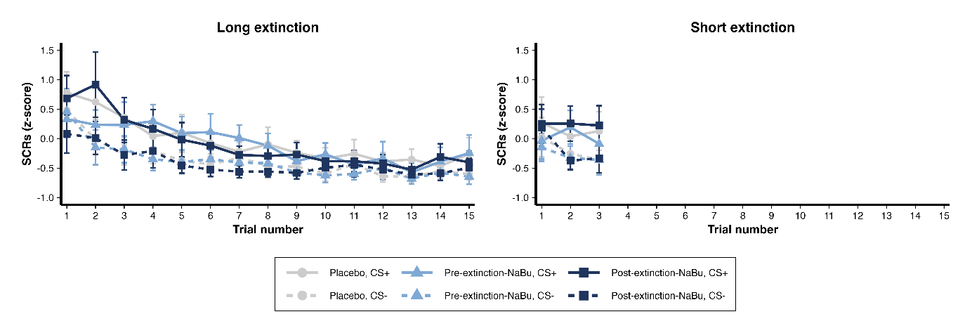
FIG S3. SCRs to the omitted US during fear extinction. Mean (±95% CI) z-scored SCRs to CS+ and CS– over trials during long (left panel) and short (right panel) extinction learning.

Effects of Pre-extinction-NaBu administration on within-session SCRs to omission of US during extinction learning
Running an LMM with a random intercept and random slope to test linear and quadratic effects of the treatment in subjects that have undergone long extinction duration (n = 30 per group) revealed no treatment × CS × trial (F(1,1676) = 0.90, p = 0.34) for the linear effect and no treatment × CS × trial (1,1672) = 3.25, p = 0.07) for the quadratic effect. The analysis also showed no intercept differences at the start of extinction (treatment × CS (F(1,1616) = 0.89, p = 0.35)).
Running an LMM with a random intercept and random slope to test linear and quadratic effects of the treatment with “trial” 1-3 only (n = 60 for Pre-extinction-NaBu vs. n = 60 for Placebo) revealed no treatment × CS × trial (F(1,476) = 0.07, p = 0.80) for the linear effect and no treatment × CS × trial (1,472) = 1.14, p = 0.29) for the quadratic effect. The analysis also showed no intercept differences at the start of extinction (treatment × CS (F(1,476) = 1.52, p = 0.22)).
*Trial 16 and trial 4 of the long and short extinction, respectively, were removed from the analysis as the post-US omission duration (in sec) was short and overlapped with the announcement of the end of the session, which produced a pronounced SCR.

Retrospective ratings
During study visit 2, retrospective ratings were collected after the extinction phase. These data showed that prior to commencing extinction learning phase, 99.4% (179/180) of the participants were expecting to receive an electric stimulation to the CS+ presentation, with no significant differences between groups, χ²(5, N = 180) = 5.03, p = 0.41 (Table 1). Similarly, all groups reported comparable levels of relief after not receiving an electrical stimulation, F(2, 168) = 0.02, p = 0.98 (Table 1). These findings confirm that participants retained the CS–US association 24 hours later and commenced extinction learning with comparable expectations.
Study visit 3: Basic response pattern analysis during Retrieval and Reinstatement
Retrieval
US expectancy ratings and SCRs in response to CS
During the extinction retrieval test, all treatment groups exhibited the expected CS+ > CS− differential responding for both US expectancy and SCRs (US expectancy: FIG 2; SCR: FIG 2), reflected in main effects of CS (US expectancy: F(1,1218) = 1886.41, p < 0.001, ηp² = 0.567; SCR: F(1,1211) = 156.85, p < 0.001, ηp² = 0.099). Both measures decreased across trials (US expectancy: F(3,1218) = 96.34, p < 0.001, ηp² = 0.167; SCR: F(3,1211) = 65.10, p < 0.001, ηp² = 0.120), with significant CS × trial interactions (US expectancy: F(3,1218) = 62.50, p < 0.001, ηp² = 0.115; SCR: F(3,1211) = 2.85, p = 0.036, ηp² = 0.006), indicating that differential responding reduced over time.
For US expectancy, CS+ responses decreased over trials (trial 1 vs. trial 2, t(1218) = 6.37, p_{adj} < 0.001, dz = 0.47; trial 1 vs. trial 3, t(1218) = 13.67, p_{adj} < 0.001, dz = 1.02; trial 1 vs. trial 4, t(1218) = 20.50, p_{adj} < 0.001, dz = 1.53), whereas CS− responses did not change significantly. Differential US expectancy was higher in the short vs. long extinction groups (extinction duration × CS: F(1,1218) = 23.58, p < 0.001, ηp² = 0.016), driven by the CS+ vs. CS− difference (t(1218) = 4.86, p_{adj} < 0.001, d = 0.89), but not by CS+ or CS− alone. The extinction duration × CS × trial interaction was non-significant (F(3,1218) = 1.67, p = 0.17).
For SCRs, both CS+ and CS− responses decreased over trials (CS+: trial 1 vs. trial 2, t(1211) = 4.95, p_{adj} < 0.001, dz = 0.37; trial 1 vs. trial 3, t(1211) = 8.16, p_{adj} < 0.001, dz = 0.61; trial 1 vs. trial 4, t(1211) = 9.69, p_{adj} < 0.001, dz = 0.72; CS−: trial 1 vs. trial 2, t(1211) = 5.80, p_{adj} < 0.001, dz = 0.43; trial 1 vs. trial 3, t(1211) = 9.01, p_{adj} < 0.001, dz = 0.67; trial 1 vs. trial 4, t(1211) = 8.83, p_{adj} < 0.001, dz = 0.66). Differential SCRs were significant on every trial, but only declined significantly from trial 1 to trial 4 (t(1211) = 2.39, p_{adj} = 0.050, dz = 0.18). Neither extinction duration nor its interactions with CS or trial were significant for SCRs (main effect: F(1,1211) = 0.01, p = 0.92; extinction duration × CS: F(1,1211) = 2.74, p = 0.10; extinction duration × CS × trial: F(3,1211) = 2.51, p = 0.06).
Overall, these results indicate robust CS+ > CS− responding during retrieval, with worse extinction retrieval after short extinction training evident in US expectancy, whereas SCRs showed similar patterns across extinction durations.
SCR to the omission of US
Examining the SCRs to the omission of the US’s during retrieval revealed the expected differential responding to the CS+ and the CS-, as evidenced by a main effect of CS (F(1,865) = 69.89, p < 0.001, η_{p}² = 0.061). Omission responses were attenuating throughout the retrieval phase as indicated by a main effect of trial (F(2,865) = 27.64, p < 0.001, η_{p}² = 0.049). However, there was no significant CS × trial interaction (F(2, 865) = 1.08, p = 0.34).
There was an extinction duration × CS interaction (F(1, 865) = 6.04, p = 0.014, η_{p}² = 0.006), indicating that differential omission responses were higher in the short extinction vs. the long extinction. There was no extinction duration × CS × trial interaction (F(2, 865) = 0.24, p = 0.79).
Reinstatement
US expectancy ratings and SCRs in response to CS
During the fear reinstatement test, all treatment groups exhibited the expected CS+ > CS− differential responding for both US expectancy and SCRs (US expectancy: FIG 2; SCR: FIG 2), reflected in main effects of CS (US expectancy: F(1,1217) = 1139.89, p < 0.001, ηp² = 0.442; SCR: F(1,1211) = 58.26, p < 0.001, ηp² = 0.039). Both measures decreased over trials (US expectancy: F(3,1217) = 54.38, p < 0.001, ηp² = 0.102; SCR: F(3,1211) = 60.36, p < 0.001, ηp² = 0.112), with significant CS × trial interactions (US expectancy: F(3,1217) = 39.24, p < 0.001, ηp² = 0.076; SCR: F(3,1211) = 3.61, p = 0.013, ηp² = 0.008), indicating that differential responding reduced over time.
For US expectancy, CS+ responses decreased over trials (trial 1 vs. trial 2, t(1217) = 6.69, p_{adj} < 0.001, dz = 0.50; trial 1 vs. trial 3, t(1217) = 12.82, p_{adj} < 0.001, dz = 0.96; trial 1 vs. trial 4, t(1217) = 15.41, p_{adj} < 0.001, dz = 1.15), whereas CS− responses did not change significantly. Differential US expectancy was higher in the short vs. long extinction groups (extinction duration × CS: F(1,1217) = 7.96, p = 0.005, ηp² = 0.006), driven by the CS+ vs. CS− difference (t(1217) = 2.82, p_{adj} = 0.005, d = 0.52), but not by CS+ or CS− alone. The extinction duration × CS × trial interaction was non-significant (F(3,1217) = 0.27, p = 0.85).
For SCRs, both CS+ and CS− responses decreased over trials (CS+: trial 1 vs. trial 2, t(1211) = 7.74, p_{adj} < 0.001, dz = 0.58; trial 1 vs. trial 3, t(1211) = 8.28, p_{adj} < 0.001, dz = 0.62; trial 1 vs. trial 4, t(1211) = 10.25, p_{adj} < 0.001, dz = 0.77; CS−: trial 1 vs. trial 2, t(1211) = 6.67, p_{adj} < 0.001, dz = 0.50; trial 1 vs. trial 3, t(1211) = 8.59, p_{adj} < 0.001, dz = 0.64; trial 1 vs. trial 4, t(1211) = 8.43, p_{adj} < 0.001, dz = 0.63). Differential SCRs were significant on every trial but only declined significantly from trial 1 to trial 4 (t(1211) = 2.74, p_{adj} = 0.020, dz = 0.20). Neither extinction duration nor its interactions with CS or trial were significant for SCRs (main effect: F(1,1211) = 0.19, p = 0.66; extinction duration × CS: F(1,1211) = 0.90, p = 0.34; extinction duration × CS × trial: F(3,1211) = 1.75, p = 0.16).
Overall, these results indicate robust reinstatement of CS+ > CS− responding, with greater reinstatement indexed by US expectancy ratings after short extinction, whereas SCRs were similar across extinction durations.
SCR to the omission of US
Examining the SCRs to the omission of the US’s during reinstatement revealed the expected differential responding to the CS+ and the CS-, as evidenced by a main effect of CS (F(1,865) = 62.37, p < 0.001, η_{p}² = 0.055). Omission responses were attenuating throughout the retrieval phase as indicated by a main effect of trial (F(2,865) = 37.90, p < 0.001, η_{p}² = 0.066). However, there was no significant CS × trial interaction (F(2, 865) = 2.41, p = 0.09).
There was no extinction duration × CS interaction (F(1, 865) = 0.10, p = 0.75), indicating that differential omission responses were similar in the short extinction vs. the long extinction. There was no extinction duration × CS × trial interaction (F(2, 865) = 2.15, p = 0.12).
Assessment of spontaneous recovery of conditioned responses
To assess whether spontaneous recovery occurred seven days post extinction learning, we compared extinction phase (last trial) to retrieval phase (first trial) on US expectancy ratings and SCRs, separately for the long vs. short extinction arms.
Long extinction
US expectancy showed a main effect of phase (F(1, 261) = 203.44, p < 0.001, ηp² = 0.362) and a significant CS × phase interaction effect (F(1, 261) = 136.05, p < 0.001, ηp² = 0.275; FIG S4). Follow-up comparisons indicated that US expectancy following CS+ increased from extinction to retrieval (t(261) = -18.33, p_{adj} < 0.001, d = -1.93; FIG S4), while CS- expectancy showed a smaller increase (t(261) = -1.84, p_{adj} = 0.07; FIG S4). SCRs showed a main effect of phase (F(1, 259) = 160.94, p < 0.001, ηp² = 0.311) and a significant CS × phase interaction effect (F(1, 259) = 14.91, p < 0.001, ηp² = 0.040; FIG S4). Follow-up comparisons indicated that the SCRs following CS+ increased from extinction to retrieval (t(259) = -11.70, p_{adj} < 0.001, d = -1.23; FIG S4), while CS- expectancy showed a smaller increase (t(261) = -6.24, p_{adj} < 0.001, d = -0.66); FIG S4.
Short extinction
US expectancy showed no main effect of phase (F(1, 261) = 0.01, p = 0.93) nor a significant CS × phase interaction effect (F(1, 261) = 1.88, p = 0.17). SCRs showed a main effect of phase (F(1, 261) = 23.88, p <.001, ηp² = 0.062; FIG S4) where SCRs to the CS+ (t(-2.44, p_{adj} = 0.031, d = -0.26; FIG S4) and the CS- (t(-4.87, p_{adj} < 0.001, d = -0.51; FIG S4) increased in a similar magnitude from extinction to retrieval (CS × phase interaction effect (F(1,216) = 1.01, p = 0.32).

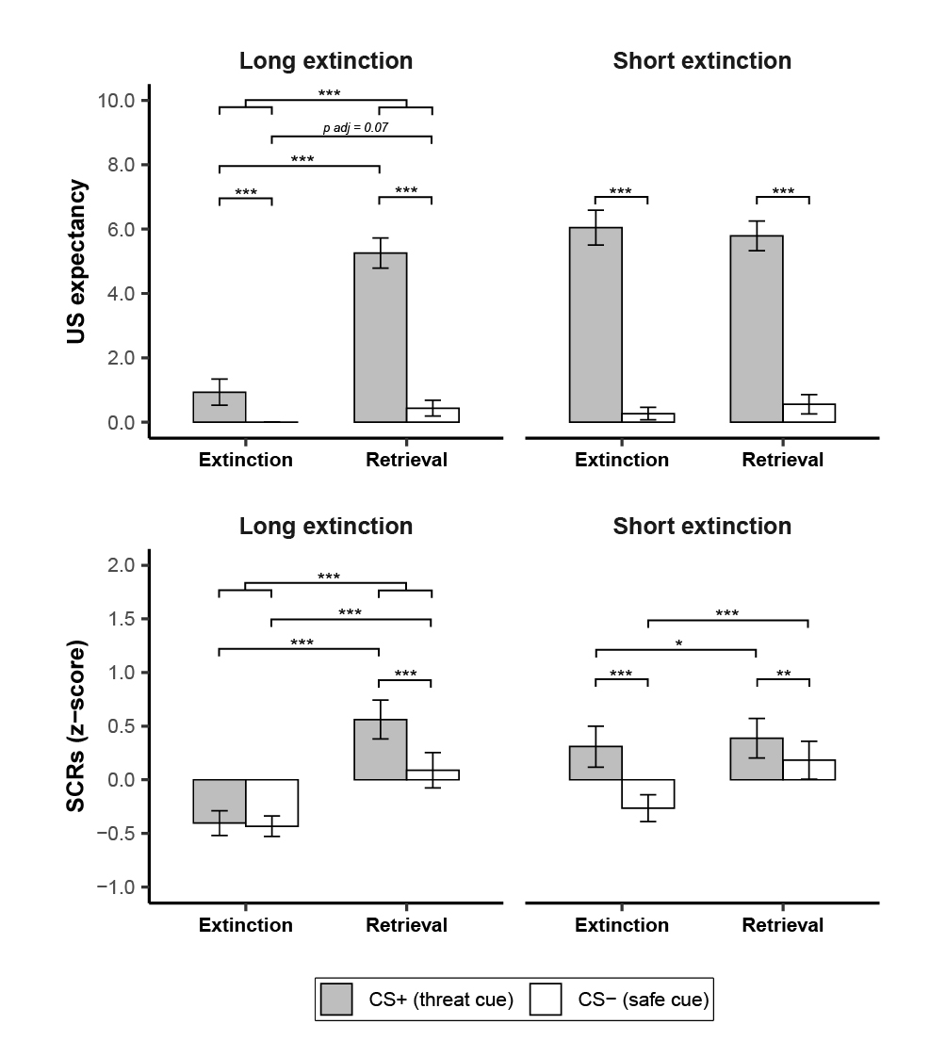
FIG S4. US expectancy and SCRs assessing spontaneous recovery of conditioned responses following extinction learning. Mean (±95% CI) US expectancy (top panel) and z-scored SCRs (bottom panel) for CS+ and CS– during the final retrieval trial (trial 4) and first reinstatement trial (trial 1). *p < 0.05, **p < 0.01, ***p < 0.001.
Assessment of reinstatement of conditioned responses
To assess whether reinstatement occurred following the presentation of three unsignalled USs, we compared retrieval phase (last trial) to reinstatement phase (first trial) on US expectancy ratings and SCRs (FIG S5). US expectancy (trial 4 of retrieval vs. trial 1 of reinstatement) showed a main effect of phase (F(1,521) = 63.65, p < 0.001, ηp² = 0.081) and a significant CS × phase interaction effect (F(1,521) = 41.72, p < 0.001, ηp² = 0.055; FIG S5). Follow-up comparisons indicated that conditioned fear responses were differentially reinstated, as US expectancy to the CS+ increased from retrieval to reinstatement (t(521) = -7.54, p_{adj} < 0.001, d = -0.56; FIG S5), while US expectancy to the CS- showed a smaller increase (t(521) = -2.62, p_{adj} = 0.009, d = -0.20; FIG S5). SCRs (trial 4 of retrieval vs. trial 1 of reinstatement) exhibited a main effect of phase (F(1,519) = 104.95, p < 0.001, ηp² = 0.128; FIG S5), where SCRs to the CS+ (t(-7.49, p_{adj} < 0.001, d = -0.56) and the CS- (t(-7.01, p_{adj} < 0.001, d = -0.52) increased in a similar magnitude from retrieval to reinstatement (CS × phase interaction effect (F(1,519) = 1.33, p = 0.25). The presence of non-differential reinstatement in SCRs has been previously observed in multiple studies [2].
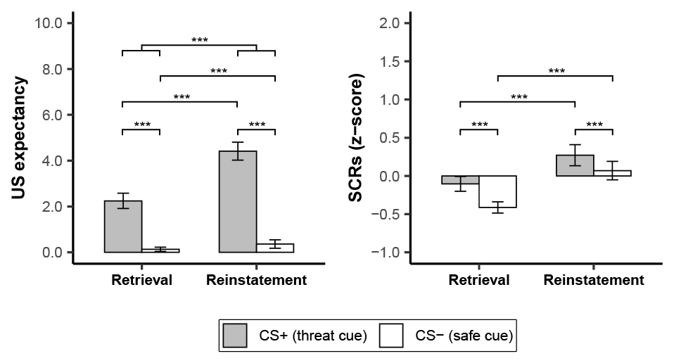
FIG S5. US expectancy and SCRs assessing reinstatement of conditioned responses following retrieval. Mean (±95% CI) US expectancy (left panel) and z-scored SCRs (right panel) for CS+ and CS– during the final retrieval trial (trial 4) and first reinstatement trial (trial 1). *p < 0.05, **p < 0.01, ***p < 0.001.

DEVIATIONS FROM PRE-REGISTRATION
The study was preregistered on OSF (https://osf.io/btx2f). However, several deviations from the preregistered plan occurred, as described below. First, SCRs were extracted using Ledalab rather than the preregistered analysis pipeline, as the latter was mistakenly ambiguously described. Second, SCRs were standardized within each participant to have a mean of 0 and a standard deviation of 1, rather than being further transformed into T-scores (mean = 50, SD = 10), to simplify interpretation and comparison across studies. Third, participants with a raw SCR difference (CS+ vs. CS-) below zero averaged across the last four acquisition trials were not excluded, contrary to the preregistered plan. Excluding these participants would have resulted in a high number of removals (29 participants, 17% of the total sample), which was not feasible to re-recruit given practical constraints. Fourth, all analyses were conducted on CS+ and CS– as levels of the within-subject factor CS, rather than beginning with the differential response (CS+ – CS–) and subsequently including CS as a factor in the models, as initially preregistered. This approach was adopted because all models with four factors converged without issues and to avoid running multiple separate models, and because the observed treatment effects were primarily driven by changes in responses to the CS+, not the CS–. Fifth, return-of-fear analyses (retrieval and reinstatement) controlled for between-group differences in extinction, and within-session extinction analyses controlled for acquisition differences; results were unchanged when not controlling for these factors (data not shown). Finally, certain hypotheses were renumbered for more logical reporting.

References
1. Kuriyama, K., M. Honma, T. Soshi, T. Fujii and Y. Kim, Effect of d-cycloserine and valproic acid on the extinction of reinstated fear-conditioned responses and habituation of fear conditioning in healthy humans: a randomized controlled trial. Psychopharmacology, 2011. 218(3): p. 589-597.
2. Haaker, J., A. Golkar, D. Hermans and T.B. Lonsdorf, A review on human reinstatement studies: an overview and methodological challenges. Learn Mem, 2014. 21(9): p. 424-40.

