Supplementary Section to Accompany Prisciandaro et al., Molecular Psychiatry
The purpose of this supplementary section is to elucidate the relationship between TMS stimulator output at the scalp-level and electric field (E-field) intensity at the brain-level. E-field modeling is an approach utilizing T1-weighted structural MRI scans, segmentation, creation of a 3-dimensional mesh for each person, tissue conductivity values, and stimulation intensity (dI/dt) specific to the TMS machine and stimulator output[1]. The goal of E-field modeling is to estimate the intensity of stimulation reaching the cortex at the target, and this computational approach has been validated against intracranial recordings[2].
Here, we utilized T1 structural MRI scans and created head meshes using the CHARM pipeline[3] in combination with Freesurfer 7.4.1[4] segmentations in all N = 70 participants with AUD enrolled in this study. We used SimNIBS 4.5[5] and the Magventure Cool B65 coil model with a maximum stimulator output of dI/dt = 150A/μs to match what was used in this study. We positioned the center of the TMS coil at the EEG locations F3 for dlPFC and Fp1 for mPFC and simulated TMS at 110% rMT as was utilized in this study. Main body Supplementary Figure 1 shows a visualization of each of the N = 70 models for each target averaged into the fsavg brain space. In total, we computed 2 models per person (1 over each location) for 140 total models.
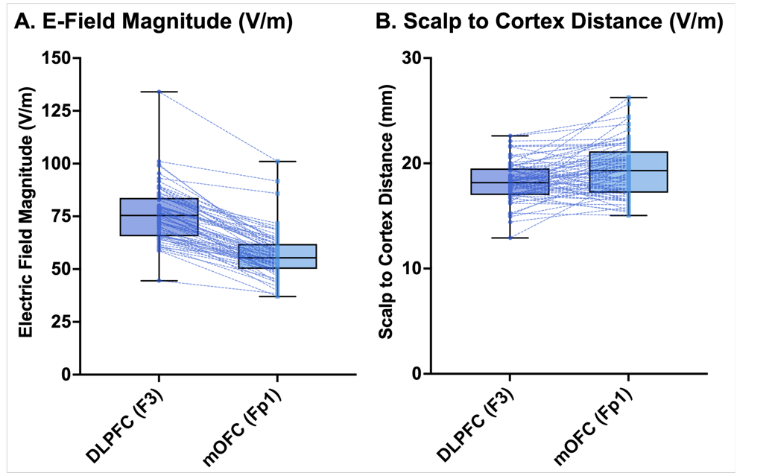
Supplementary Figure 1: E-field magnitudes and scalp to cortex distances.
Visually, similar peak E-field intensities were achieved at the same TMS stimulation intensity (110% rMT) between the dlPFC and mPFC targets. Regarding the quantitative E-field magnitudes, shown in Supplementary Figure 1A, we extracted the 99.9th percentile E-field as is commonly done across TMS studies to extract the peak intensity values underlying the coil, or the on-target intensity. We found that at the same 110% rMT stimulation intensity, dlPFC (F3) E-fields were higher than over mPFC (Fp1); for the dlPFC, the mean E-field was 75.94 ± 13.31V/m (range = 44.5-134) and for the mPFC, the mean E-field was 56.74 ± 10.90V/m (range = 37.0-101.0). This relationship between stimulation target and E-field was substantiated by scalp to cortex distance measurements between the center of the TMS coil (scalp-level) and the first gray matter node in the underlying cortex (brain-level). For the dlPFC, there were lower scalp to cortex values than mPFC (Supplementary Figure 1B; for the dlPFC, the mean scalp to cortex distance was 18.27 ± 1.93mm (range = 12.91-22.61), compared to mPFC, which had a mean scalp to cortex distance of 19.35 ± 2.57mm (range = 15.04-26.24). Tying these values directly together, we graphed correlations between E-field magnitude and scalp to cortex distance in Supplementary Figure 2.
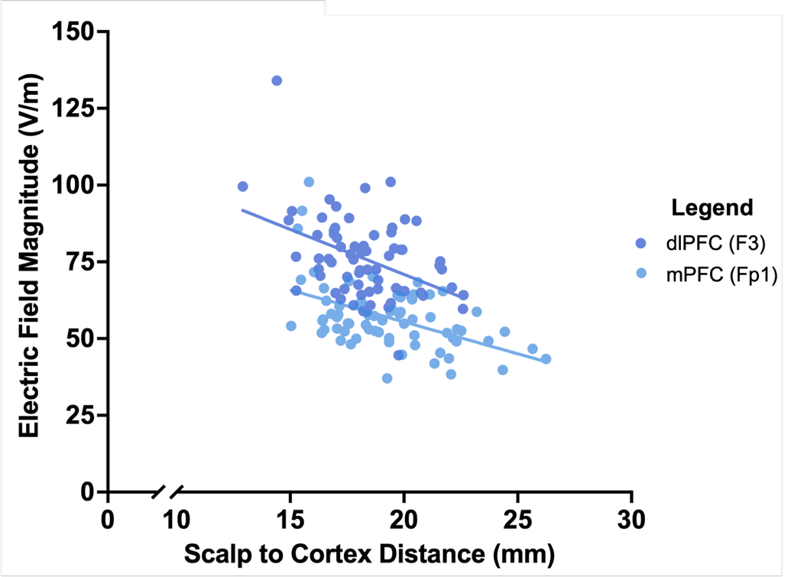
Supplementary Figure 2: Linear correlations between E-field magnitude and scalp to cortex distance for both dlPFC and mPFC targets.
For both the dlPFC and mPFC, E-field magnitudes dropped off with increased scalp-to-cortex distance, in line with published TMS literature over the past 20 years and relationships between scalp to cortex distance and motor physiology[6] and E-field modeling[7].

Interpretation of E-field Modeling Data
These E-field modeling data point to the importance of considering stimulation intensity and what might impact behavioral and imaging response. Our group has previously published on the importance of overlap between structural E-fields and functional imaging from alcohol cue reactivity maps, showing that individuals with overlap were more likely to remain enrolled at follow-up visits[8]. Notably, in this prior study we utilized a cutoff E-field magnitude of 35V/m based on prior literature[9]. In this study, for every E-field model for stimulation over both the dlPFC and mPFC locations (N = 70 models each; 140 total models), the peak E-field was over 35V/m. Thus, our selection of 110% rMT intensity for both locations is validated by E-field modeling. While there was a difference between mean E-fields for each location, there is not yet a consensus regarding whether there is an optimal therapeutic E-field magnitude[1]. In the future, researchers might consider utilizing prospective E-field dosing[10] to ensure that each stimulation target receives a consistent and appropriate amount of stimulation.
Supplementary Section References:
1. Van Hoornweder, S., et al., Outcome measures for electric field modeling in tES and TMS: A systematic review and large-scale modeling study. Neuroimage, 2023. 281: p. 120379.
2. Huang, Y., et al., Measurements and models of electric fields in the in vivo human brain during transcranial electric stimulation. elife, 2017. 6: p. e18834.
3. Puonti, O., et al., Accurate and robust whole-head segmentation from magnetic resonance images for individualized head modeling. NeuroImage, 2020. 219: p. 117044.
4. Fischl, B., FreeSurfer. Neuroimage, 2012. 62(2): p. 774-81.
5. Saturnino, G.B., et al., SimNIBS 2.1: A Comprehensive Pipeline for Individualized Electric Field Modelling for Transcranial Brain Stimulation, in Brain and Hum Bod Model 2018, S. Makarov, M. Horner, and G. Noetscher, Editors. 2019, Springer Copyright 2019, The Author(s). Cham (CH). p. 3-25.
6. Stokes, M.G., et al., Simple metric for scaling motor threshold based on scalp-cortex distance: application to studies using transcranial magnetic stimulation. J Neurophysiol, 2005. 94(6): p. 4520-7.
7. Caulfield, K.A., et al., Mitigating the risk of overdosing TMS due to coil-to-scalp distance: An electric field modeling study. Brain Stimul, 2024. 17(4): p. 970-974.
8. McCalley, D.M. and C.A. Hanlon, The importance of overlap: A retrospective analysis of electrical field maps, alcohol cue-reactivity patterns, and treatment outcomes for alcohol use disorder. Brain Stimulation: Basic, Translational, and Clinical Research in Neuromodulation, 2023. 16(3): p. 724-726.
9. Zmeykina, E., et al., Weak rTMS-induced electric fields produce neural entrainment in humans. Scientific Reports, 2020. 10(1): p. 11994.
10. Caulfield, K.A., X. Li, and M.S. George, Four electric field modeling methods of Dosing Prefrontal Transcranial Magnetic Stimulation (TMS): Introducing APEX MT dosimetry. Brain Stimul, 2021. 14(4): p. 1032-1034.

