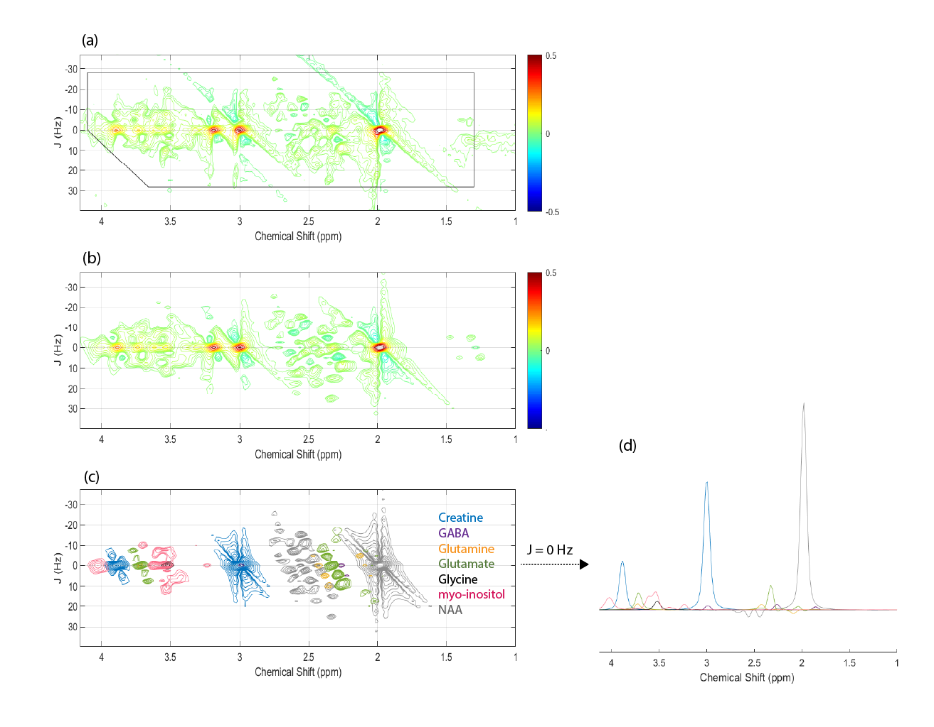
Supplementary Figure 2. (a) Representative 2D J-resolved 1 H MRS data recorded in vivo from the mPFC of a single healthy control participant. The expanded spectral region (chemical shift: 1.0 – 4.1 ppm, J: ±32.5 Hz) is shown for visualization purposes. (b) The 2D spectral fit as generated using the ProFit software. The colorbars presented in (a) and (b) display the colormap used and indicate the mapping of contour data values into the colormap. (c) The individual 2D spectral fits for GABA, glutamine, glutamate, and glycine, along with myo-inositol, creatine and NAA (included as they represent the dominant overlapping signals pertinent to the target metabolites) directly extracted from ProFit spectral fitting. The color key is provided to aid identification of each of the metabolites presented. Identical 2D contouring was used to present all data shown for the 2D plots in (a) - (c). The single row extracted from J = 0 Hz of plot (c) is presented in plot (d) and is presented using the same color coding shown in plot (c).

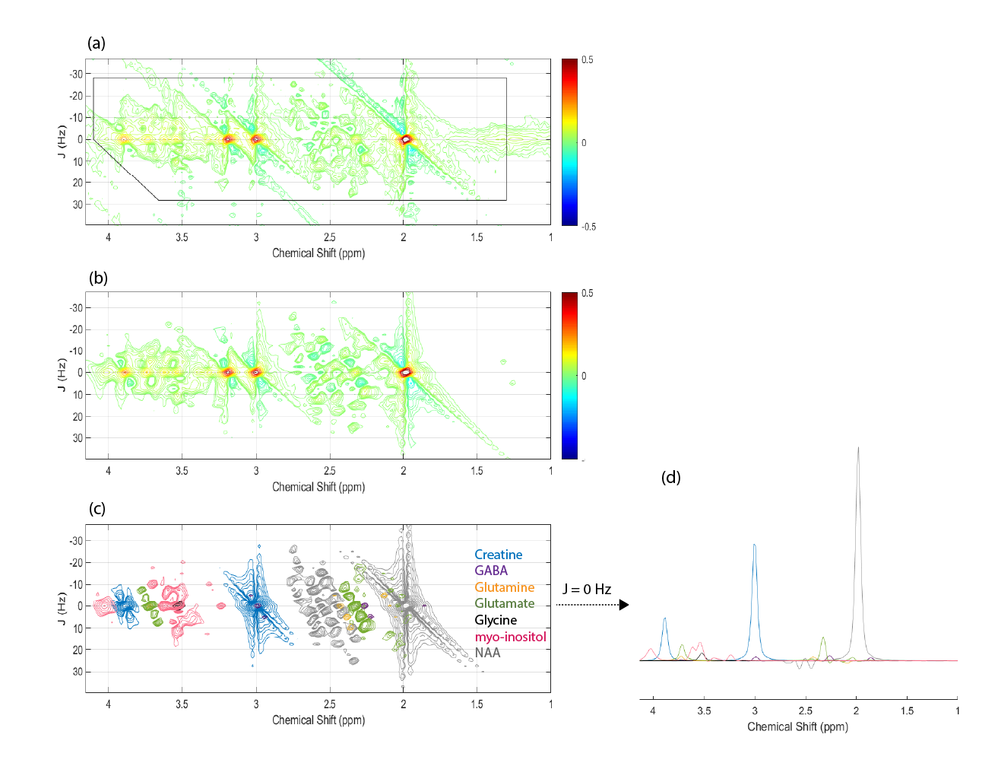
Supplementary Figure 3. (a) Representative 2D J-resolved 1 H MRS data recorded in vivo from the DLPFC of a single healthy control participant. The expanded spectral region (chemical shift: 1.0 – 4.1 ppm, J: ±32.5 Hz) is shown for visualization purposes. (b) The 2D spectral fit as generated using the ProFit software. The colorbars presented in (a) and (b) display the colormap used and indicate the mapping of contour data values into the colormap. (c) The individual 2D spectral fits for GABA, glutamine, glutamate, and glycine, along with myo-inositol, creatine and NAA (included as they represent the dominant overlapping signals pertinent to the target metabolites) directly extracted from ProFit spectral fitting. The color key is provided to aid identification of each of the metabolites presented. Identical 2D contouring was used to present all data shown for the 2D plots in (a) - (c). The single row extracted from J = 0 Hz of plot (c) is presented in plot (d) and is presented using the same color coding shown in plot (c).

