Cross-species brain-wide mapping reveals convergent mesocorticolimbic engagement by nucleus accumbens deep brain stimulation

Supplementary Material

Supplemental Methods
Animal model and DBS surgery
We utilized 8-week-old TRAP2:Ai14 mice (N = 18) with double homozygous genotype confirmed at 2 weeks age with tail biopsies (TRAP2: Jackson Laboratory, stock #030323; Ai14: Jackson Laboratory, stock #007908; all lines kept on a C57Bl/6J background). This mouse line allows for capture-and-control of neural circuits defined by their activity within a temporal window of 4-6 hours, triggered by administration of 4-OHT. While TRAP2 mice have been used by multiple groups to interrogate the role of functionally defined circuits, TRAP2 reporter expression (via Ai14) does not uniformly represent Fos expression across the brain.[1,2] By examining Fos in mice that also express tdT, we are able to establish which identified circuits (by Fos mapping) may be amenable to manipulation using the TRAP2 mouse line, facilitating future work by our and other groups. Sample size was chosen based on prior work generating brain-wide c-fos maps. [3]
Equal numbers of male (n = 9) and female (n = 9) mice were utilized. All mice were individually housed in plastic cages with disposable bedding on a standard light cycle with ad libitum access to standard chow and water. All procedures followed the National Institutes of Health Guide for the Care and Use of Laboratory Animals and received approval from the Stanford University Administrative Panel on Laboratory Animal Care (#32691).
All mice were implanted with bipolar electrodes (FHC, Inc., Bowdoin, ME, USA) in the NAc shell bilaterally. They were anesthetized with isoflurane (5% induction, 1% maintenance) and mounted to a stereotaxic frame (David Kopf Instruments, Tujunga, CA, USA). The NAc shell region is targeted with the following coordinates relative to bregma: +1.35 mm anterior-posterior, -4.25 mm dorsal-ventral, and +/- 0.6 mm lateral-medial (Fig 1A). Electrodes are inserted at a 10-degree angle relative to the orthogonal direction to facilitate bilateral placement. Pain was managed with meloxicam (0.5 mg/mL) and all animals were monitored until recovery from anesthesia. Experiments started 1-week post-electrode implantation to allow for healing.
Animal DBS
Mice are randomly divided into 2 stimulation cohorts by cage: active and sham. Both active (N = 10 / 10) and sham (N = 8 / 8) cohorts had equal numbers of male and female mice (Fig 1B). Following recovery from electrode implantation, mice are first transferred in their home cages into the experimental chambers where wires are attached without any electrical stimulation to facilitate habituation. After 1 hour, stimulation delivered as continuous monophasic pulses (160 Hz, 0.15 mA, 60 us) was started for the active DBS cohort. One hour after DBS initiation, mice in both cohorts received intraperitoneal injections of 4-hydroxytamoxifen (4-OHT) at the lower right quadrant of the abdomen. DBS was terminated for the active DBS cohort 3 hours after the 4-OHT injection. All mice remained in their experimental chambers with attached wires for an additional 3 hours to minimize extraneous neural stimulation and possible Fos expression. Mice were then detached and removed from the experimental chambers. Overall, mice in the active DBS cohort received a total of 4 hours of stimulation. No electrical stimulation was delivered to the sham cohort at any point.
At the second stimulation experiment 1 week later, mice were again given 1 hour to habituate to the experimental chambers and attached wires. Afterwards, stimulation identical to that mentioned above was initialized for the active DBS cohort. No stimulation was started in the sham cohort. Termination of DBS occurred after 1 hour, at which point all mice were immediately detached.
iDISCO brain-clearing 3D histology
Immediately following the second stimulation, mice were killed by transcardial perfusion. Following anesthetization with 5% isoflurane, mice were transcardially perfused with 20 mL 1x phosphate-buffered saline (PBS). Next, 20 mL of ice-cold 1x PBS / 4% paraformaldehyde (PFA) were perfused. Electrodes were first carefully removed. Whole brains were extracted from the crania and post-fixed for 24 hours in 1x PBS / 4 % PFA at 4°C. All solutions were freshly prepared from stock.
Pretreatment
Fixed brains are removed from 4°C and allowed to warm to room temperature. They are moved to new tubes (5 mL Eppendorf) and rinsed with 1x PBS with nutation for 30 minutes, repeated 3 times. Samples are returned to 4°C in 1x PBS overnight. On day 2, samples are moved into new tubes and progressively dehydrated with solutions of increasing concentrations of methanol in PBS (20%, 40%, 60%, 80%, and 100%) for 1 hour each with shaking. An additional wash with 100% methanol for 1 hour is performed. All samples are chilled to 4°C for 20 minutes before an overnight incubation in a solution of 66% dichloromethane (DCM) / 33% methanol with nutation at room temperature. On day 3, samples are washed twice with 100% methanol for 1 hour at room temperature before being transferred to new tubes. Freshly prepared and chilled 5% hydrogen peroxide in methanol is used to bleach the samples overnight at 4°C without shaking. On day 4, samples are moved into new tubes and rehydrated with solutions of decreasing concentrations of methanol in PBS (80%, 60%, 40%, 20%, and 0%) for 1 hour each with shaking. Samples are again moved into new tubes and washed for 1 hour in PTx.2 (100 mL PBS 10x + 2 mL TritonX-100). After transferring into new tubes, samples are incubated in a freshly prepared permeabilization solution (400 mL PTx.2, 11.5 g glycine, 100 mL dimethyl sulfoxide (DMSO)) at 37°C for 48 hours with nutation. At 24 hours, samples are transferred into new tubes with fresh permeabilization solution before returning to the incubator.
Immunolabeling
After moving into new tubes, samples are incubated in freshly prepared blocking solutions (75.6 mL PTx.2 + 5.4 mL donkey serum (DS) + 3 mL DMSO) at 37°C for 48 hours with rotation (Fig 1C). Samples are then moved into new tubes and incubated with the primary antibodies – rabbit anti-Fos (1:500; Synaptic systems, Goettingen, Germany, 226-008) and chicken anti-RFP (1:500; Novus Biologicals, Littleton, CO, USA, NBP1-97371) – diluted in freshly prepared solution of PTwH [100 mL PBS 10X, 2 mL Tween-20, 1 mL of 10 mg/mL Heparin stock solution] / 5% DMSO / 3% DS at 37°C for 10 days with nutation. At completion of primary incubation, samples are moved to new tubes, washed with PTwH for several hours, and left overnight nutating. Next, samples are incubated with the secondary antibodies – goat anti-chicken Alexa 568 (1:250; Thermo Fisher Scientific Inc., Waltham, MA, USA, A11041) and donkey anti-rabbit Alexa 647 (1:250; Thermo Fisher Scientific Inc., Waltham, MA, USA, A31573) – diluted in PTwH / 3% DS at 37°C for 10 days with nutation and limited light exposure. At completion of secondary incubation, samples are washed with PTwH with nutating for 48 hours.
Clearing
Dried samples are embedded in 1% low melting point agarose and dehydrated with solutions of increasing concentrations of methanol in PBS (20%, 40%, 60%, 80%, and 100%) for 1 hour each with nutation. An additional wash with 100% methanol for 1 hour is performed after moving to new tubes. Samples are covered and left to incubate overnight in 66% DCM / 33% methanol at room temperature. On the following day, samples are first washed with 100% DCM for 15 minutes twice with nutation at room temperature. Next, samples are moved to a new tube and incubated with dibenzyl ether with no agitation. Contact with air and light should be minimized for the samples.
Light sheet imaging and preprocessing
We used custom Python scripts, Fiji macros, and open-source tools for image preprocessing and registration, including UNRAVEL (UN-biased high-Resolution Analysis and Validation of Ensembles using Light sheet images; http://github.com/b-heifets/UNRAVEL)[3] and MIRACL (Multi-modal Image Registration and Connectivity anaLysis (MIRACL).[4] Following CZI-to-TIFF conversion, images with odd dimensions were cropped to ensure compatibility with MIRACL’s TIFF-to-NIfTI conversion step. Background-subtracted images are generated through rolling ball subtraction. The rolling ball algorithm calculates and subtracts local background values for every pixel by averaging a large ball around the pixel, thereby hypothetically removing any spatial variations in background intensities; a rolling ball radius of 4 was used (Fig 1D).[5] Next, images are down-sampled by a factor of 2 and converted to a NIFTI format. Co-registration was performed using the MIRACL pipeline, as previously described, to register samples to a standard atlas, substituting an averaged template brain generated with iDISCO+ and light sheet fluorescence microscopy (LSFM) in place of one obtained via serial two-photon microscopy, to better match our samples’ autofluorescence profile (Fig. 1E). This resulted in the transformation matrix that allows conversion of the LSFM atlas in template space into native space (Fig 1E).
Cell detection
Ilastik is an unbiased, interactive segmentation program that was used to classify active cells.[6] For “pixel classification”, a Random Forest classifier uses user annotations and selected pixel features to generate a binary probabilistic map. Raw data (TIFFs) were imported as stacks of 20 axial slices of 3.5 µm thickness. Representation of both ON (N = 3) and OFF (N = 3) cohorts was balanced for training the classifier. The following parameters were chosen for pixel features: Gaussian Smoothing (0.3 & 3.5), Laplacian of Gaussian (3.5 & 5.0), Gaussian Gradient Magnitude (3.5), and Hessian of Gaussian Eigenvalues (0.7 & 1.6). Individual Z-stacks are then annotated as ‘cell’ or ‘non-cell’ regions. The “object classification” workflow builds on pixel classification with additional training, ultimately designating sets of pixels as belonging to single entities. Hysteresis thresholding was utilized.
Fiji is an open-source multifunctional image processing software.[7] Its 3D object counter is a plugin that quantifies 3D objects within a stack. Edge objects and background were excluded. This cell detection method inputs the Ilastik pixel classification outputs, which is a binarized map of background and classified cells.
Given the heavy computational burden of performing cell detection on full samples, both methods were instead run on volumes of the cluster. To generate these volumes, the length, width, and height of full-resolution clusters were obtained through the statistics tool of the FMRIB Software Library (FSL). After cropping out this specific volume from the entire brain, a binary cluster mask was applied to this new volume. This process was performed blind to experimental condition on raw data or the Ilastik pixel classification output for the Ilastik object classification and Fiji 3D object counter, respectively. Ilastik object classification was the primary cell detection method, given the more comprehensive classification methodology and its non-inferiority to the Fiji 3D cell counter.
Statistical Analyses
Identification of significant clusters is accomplished through nonparametric permutation thresholding with the randomise function of FSL. The data, as a 4D (time-series of 3D images) NIFTI file, are modeled in a generalized linear model (GLM) with design (to designate independent variables) and contrast (to compare variable outputs) matrices (Fig 1F). Threshold-free cluster enhancement, a methodology that enhances cluster-like structures without a preset threshold, was used for the output. The null distribution was generated with 5,000 permutations. Given the resolution of the input images and consideration of physiological feasibility, a minimal volume of 2,500 voxels was set a priori. The output was further refined with a smoothing sigma of 50 μm and a threshold of p < 0.01, yielding the final clusters.
Cluster cell densities are defined as the number of active cells in the cluster divided by the cluster volume. Total cluster cell densities are the summation of both left and right cluster cell densities. Statistical analyses were performed using R Studio version 3.6.3. Wilcoxon tests were performed to compare mean total cell densities (active cell count / cluster volume) between ON and OFF cohort samples. Grubbs’ test was performed to detect outliers (normality assumption was evaluated with the Shapiro-Wilk test). Spearman’s rank-order correlations were used to calculate the association between different neuronal clusters. Statistical significance was determined using alpha = 0.05.
Human Stimulation-Evoked Potentials
Informed consent for participation in research is approved by the institutional ethical committee and obtained according to the Declaration of Helsinki. It is covered by the Stanford University Institutional Review Board (IRB-11354).
Stereo-EEG surgery and electrode localization
The participant was a patient with refractory epilepsy whose pattern of epileptiform activity warranted invasive brain mapping as part of additional standard-of-care work-up. After a meeting between her treatment team, a consensus decision was made to implant the patient's brain with intracranial electrodes in the suspected cortical regions such as the frontal lobe, the hypothalamus (through the nucleus accumbens), and the limbic lobe including medial temporal lobe, insula, anterior and anterior cingulate.[8] The entire insula was evaluated with an anterior to posterior trajectory.
Stereo-EEG procedure with depth electrodes (0.86 mm in diameter; 2.29 mm height; 3–5 mm inter-electrode center-to-center distance made by AdTech). Pre-surgical MRI scan was co-registered to post-surgical CT scan for electrode visualization and localization. Locations of depth electrodes utilized in single-pulse stimulation experiments were then examined by one rater with expertise in neuroanatomy and neuroimaging (D.A.N.B). All electrodes utilized in those experiments as well as a recording electrode in the NAc were selected for further evaluation and were labeled numerically. This localization was performed prior to signal processing.
Single pulse evoked potentials acquisition and pre-processing
As previously described, we performed single-pulse stimulations at rest using an intracranial electrical waveform generator and switchbox (MS-120BK-EEG and PE-210AK, Nihon Kohden, Tokyo, Japan).[9] Electrical stimulation was delivered through adjacent pairs of electrodes in biphasic pulses (6mA; 200 μs/phase, 49 trials) at a frequency of 0.5 Hz for a total of 120 seconds. We measured electrical potentials in the NAc in response to stimulation with a video EEG monitoring system using a sampling rate of 2000 Hz (version WEE-1200, Nihon Kohden). We analyzed the single-pulse stimulation data using custom Matlab scripts. We first applied a high-pass butterworth filter (1 Hz) to exclude slow varying effects and segmented evoked responses time series from recording channels into 2500 ms epochs time-locked to stimulus onset (500 ms pre-stimulus and 2000 ms post-stimulus). Then, we re-referenced the data to the common average signal, excluding stimulated channels, channels with artifacts, and channels with large, evoked responses, as previously described.[10] Finally, to exclude potential effects of pre-stimulus signal fluctuations, we applied a baseline correction by subtracting the average signal between 500 ms and 10 ms prior to stimulus onset. Single pulse evoked potentials (SPEP) were obtained from the time series of the NAc recordings as single pulse stimulations were performed. An exponential decay weighting function with time constant, t, equal to 500 ms was applied to all trials to focus on earlier signal changes following stimulation as previously described.[11]
Basis profile curve identification
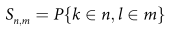
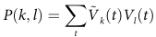
Given the limitations and ambiguity in interpreting SPEP measurements, a previously described algorithm involving a convergent paradigm for generating basis profile curves (BPC) was utilized.[10] BPCs are canonical summaries of similar evoked potential traces, which facilitates a higher-level quantification of regions under investigation. For the present study, the NAc (electrode location) was the single recording site with the following stimulation electrode contacts (Figs. 3B, S4). Stimulation is delivered as biphasic pulses to all electrode pairs, with each trial unit-normalized and stored in a matrix ( ). Self and cross-projections of single trials are performed ( ) and sorted into different subgroup interaction sets ( ). Next, a scaled significance matrix (t-values from Sn,m) is constructed. Of note, negative t-values need to be set to zero in order to fulfill a non-negativity constraint. As the convergent approach eliminates the problem of source-localization, an individual cluster’s contribution cannot be both positive and negative because the underlying architecture of the single recording site is stable. Hence, if there are flips in voltage at a stimulation site, the constraint facilitates segregation into different clusters. To identify and categorize different CCEP clusters, non-negative matrix factorization (NNMF) is used to generate the decomposition: . Ξ has dimensions of N x M. Dimensions for W and H are N x Q and Q x M, respectively. W and H are updated through a repetitive multiplication process. First, elements in H are scaled as:
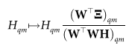
Second, rows of H are unit normalized and the columns of W are multiplied by the normalization factor:
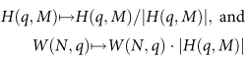
Third, elements of W are scaled:
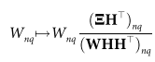
Lastly, error ( ) is calculated. The process is repeated until the error reaches a set threshold: Given the highly degenerate output (off-diagonal elements of matrix HH^{T}) of NNMF, dimensionality reduction is accomplished by iteratively reducing Q (inner component number) by 1 until z (maximum of the upper-half off-diagonal elements of HH^{T}) < 0.5. This process limits the quantity of shared structures between different response motifs. A “winner-takes-all” approach is adopted for each column in H (non-maximal elements are set to zero) such that each subgroup element only belongs to a single component. For each q row in H, subgroup n is assigned to a cluster with thresholding if . Lastly, a linear kernel principal component decomposition (PCA) is used to invert the decomposition and identify a representative basis curve. Individual trials can be generated with the BPC with a scalar and residual error. Specific details regarding methodology can be found in Miller et al. 2021.

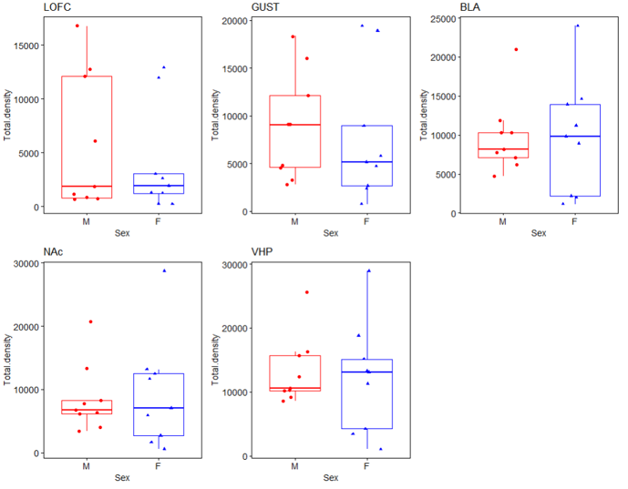

Supplementary Figure 1. No differences between male and female mice stimulation cell counts. LOFC – M / F: 5811.2 ± 6345.2 vs 3929 ± 4913.5; p = 0.7962. GUST – M / F: 8911.9 ± 5644.5 vs 7640.7 ± 6938.5; p = 0.5457. BLA – M / F: 9696.7 ± 4772.9 vs 9752.4 ± 7408.4; p = 0.9314. NAc – M / F: 8546 ± 5391.5 vs 9315.2 ± 8670; p = 0.7962. VHP – M / F: 13190 ± 5390.7 vs 12144 ± 8652.1; p = 1. LOFC, lateral orbitofrontal cortex; GUST, gustatory cortex; BLA, basolateral amygdala; NAc, nucleus accumbens; VHP, ventral hippocampus
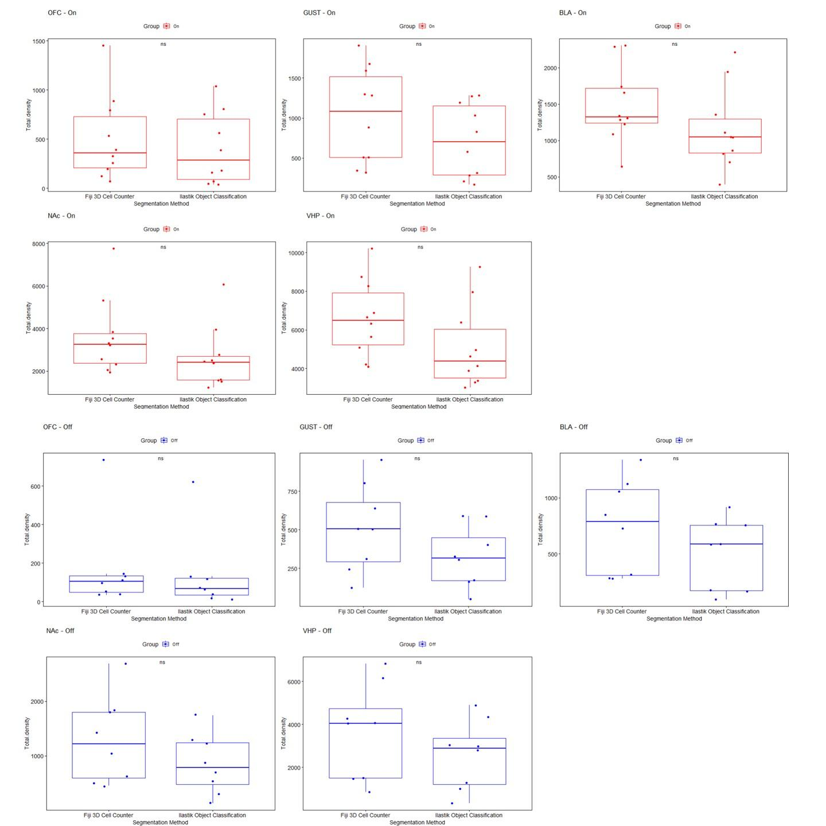

Supplementary Figure 2. Insignificant changes between segmentation methods. OFC – On | Fiji / Ilastik: 502.2 ± 430.82 vs 403.5 ± 365.3; p = 0.481. GUST – On | Fiji / Ilastik: 1032.2 ± 593.6 vs 717.9 ± 459.3; p = 0.123. BLA – On | Fiji / Ilastik: 1487.4 ± 520.65 vs 1149 ± 556.1; p = 0.123. NAc – On | Fiji / Ilastik: 3583.4 ± 1778.2 vs 2600 ± 1459.3; p = 0.1431. VHP – On | Fiji / Ilastik: 3642.9 ± 2210.5 vs 2575.6 ± 1610.1; p = 0.3823. OFC – Off | Fiji / Ilastik: 168.12 ± 232.9 vs 134 ± 201.8; p = 0.494. GUST – Off | Fiji / Ilastik: 510.3 ± 282.5 vs 324.6 ± 196.5; p = 0.235. BLA – Off | Fiji / Ilastik: 746.8 ± 417.9 vs 504.9 ± 317.7; p = 0. 195. NAc – Off | Fiji / Ilastik: 1290.9 ± 788.1 vs 848.9 ± 543.5; p = 0.279. VHP – Off | Fiji / Ilastik: 3642.9 ± 2210.5 vs 2575.6 ± 1610.1; p = 0.382. Fiji, Fiji 3D Cell Counter; Ilastik, Ilastik Object Classification; OFC, lateral orbitofrontal cortex; GUST, gustatory cortex; BLA, basolateral amygdala; NAc, nucleus accumbens; VHP, ventral hippocampus

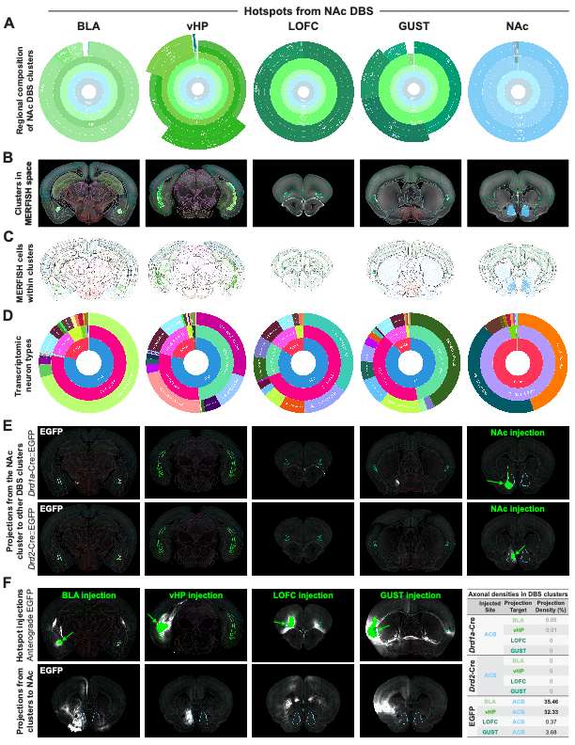Supplemental Figure 3. Cell types and connectivity of NAc DBS clusters. A. Regional composition of NAc DBS clusters shown as sunburst plots. Wider slices indicate larger volumes, with finer anatomical subdivisions in outer rings. B. To estimate cell-type proportions using spatial transcriptomic data from the Allen Brain Cell Atlas (ABCA [12]), DBS clusters were warped to MERFISH space. Clusters were first warped to the common coordinate framework v3 (CCFv3) and then to MERFISH CCFv3 space using deformation fields derived from (1) registration of iDISCO/LSFM and CCFv3 atlases, and (2) registration of CCFv3 and MERFISH templates. C. MERFISH cells falling within each warped DBS cluster were extracted for downstream analysis. D. Proportions of transcriptomic neuron types were calculated across hierarchical levels of the ABCA taxonomy, including neurotransmitter, class, and subclass levels. E–F. AAV-based experiments from the Allen Mouse Brain Connectivity Atlas were selected based on maximal overlap between injection sites and DBS clusters. E. Anterograde projections from D1 and D2 medium spiny neurons within the NAc DBS cluster were visualized using Cre-dependent EGFP reporters in Drd1a-Cre and Drd2-Cre mice. Transduced somata are shown in solid green; DBS clusters are displayed as opaque atlas wireframes; axonal projections are shown in greyscale. F. AAV-EGFP injections into other DBS clusters were used to assess projections to the NAc DBS cluster. Projection densities (sum of projection density values / the # of voxels in the cluster × 100) are summarized in the table. Connectivity experiment IDs: 170785775, 175732001, 113144533, 127222723, 112306316, 180436360 (viewable at: https://connectivity.brain-map.org/projection/experiment/<experiment ID>). UNRAVEL (https://github.com/b-heifets/UNRAVEL/) was used for all analyses in this figure.

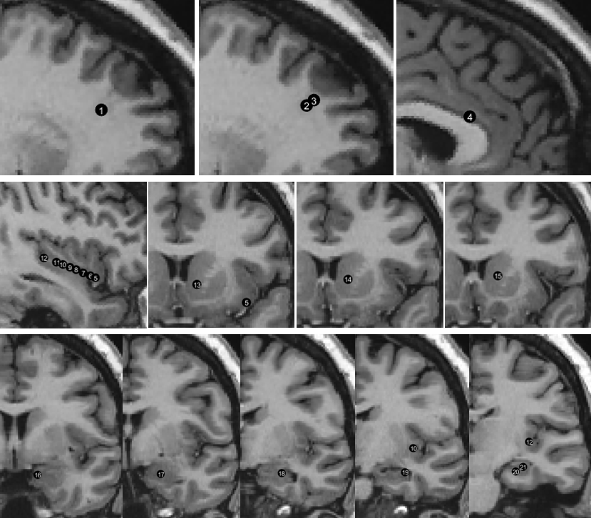

Supplementary Figure 4. Stimulation sites plotted in corresponding anatomical MRI slices.

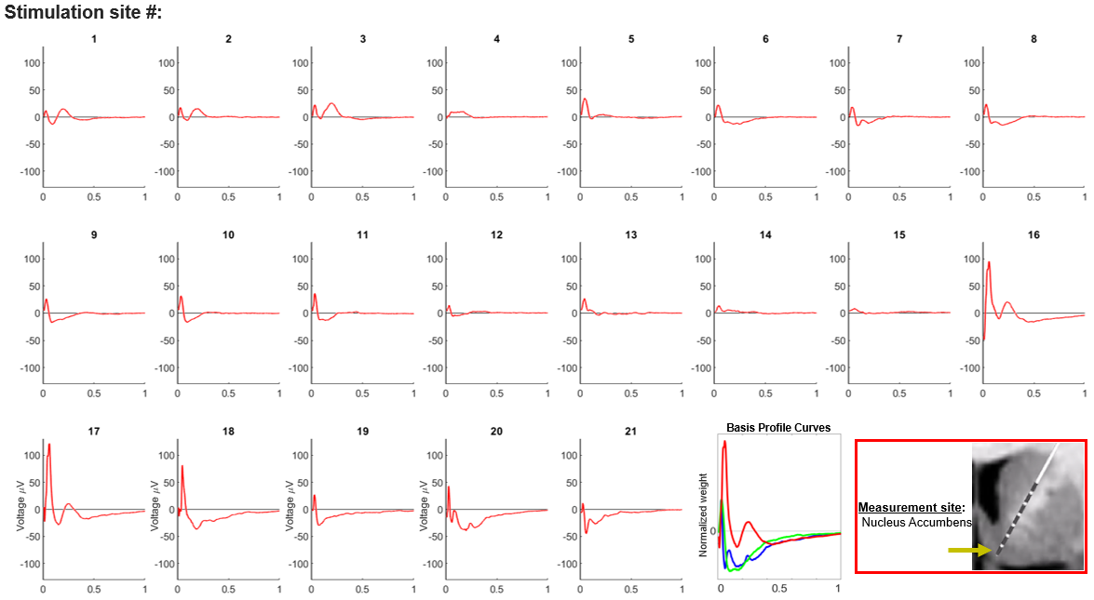

Supplementary Figure 5. Nucleus Accumbens evoked potentials for each stimulation site.
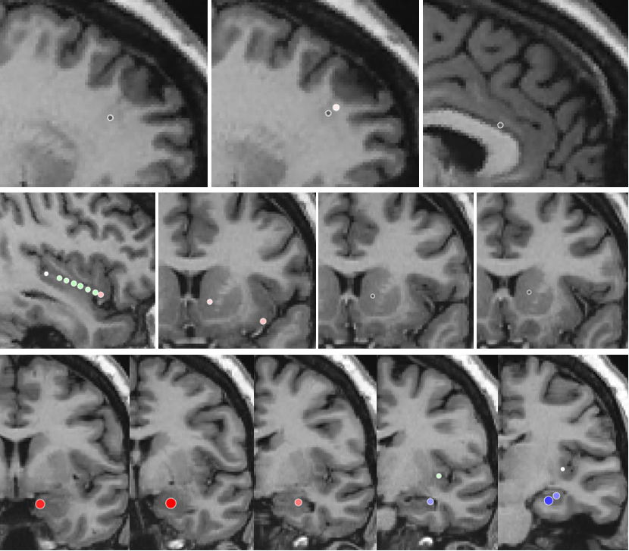

Supplementary Figure 6. Projection profile and weight plotted in anatomical MRI slices corresponding to stimulation sites.

References:
1. Allen WE, DeNardo LA, Chen MZ, Liu CD, Loh KM, Fenno LE, et al. Thirst-associated preoptic neurons encode an aversive motivational drive. Science (1979). 2017;357:1149–55.
2. DeNardo LA, Liu CD, Allen WE, Adams EL, Friedmann D, Fu L, et al. Temporal evolution of cortical ensembles promoting remote memory retrieval. Nat Neurosci. 2019;22:460–9.
3. Rijsketic DR, Casey AB, Barbosa DAN, Zhang X, Hietamies TM, Ramirez-Ovalle G, et al. UNRAVELing the synergistic effects of psilocybin and environment on brain-wide immediate early gene expression in mice. Neuropsychopharmacology. 2023;48:1798–807.
4. Goubran M, Leuze C, Hsueh B, Aswendt M, Ye L, Tian Q, et al. Multimodal image registration and connectivity analysis for integration of connectomic data from microscopy to MRI. Nat Commun. 2019;10:1–17.
5. Sternberg SR. Biomedical image processing. Computer. 1983;16(1):22–34. doi:10.1109/MC.1983.1654163
6. Berg S, Kutra D, Kroeger T, Straehle CN, Kausler BX, Haubold C, et al. Ilastik: interactive machine learning for (Bio)image analysis. Nat Methods. 2019;16:1226–32.
7. Schindelin J, Arganda-Carreras I, Frise E, Kaynig V, Longair M, Pietzsch T, et al. Fiji: An open-source platform for biological-image analysis. Nat Methods. 2012;9:676–82.
8. Parvizi J, Veit MJ, Barbosa DAN, Kucyi A, Perry C, Parker JJ, et al. Complex negative emotions induced by electrical stimulation of the human hypothalamus. Brain Stimul. 2022;15:615–23.
9. Keller CJ, Honey CJ, Mégevand P, Entz L, Ulbert I, Mehta AD. Mapping human brain networks with cortico-ortical evoked potentials. Philos Trans R Soc Lond B Biol Sci. 2014;369:20130528.
10. Miller KJ, Müller KR, Hermes D. Basis profile curve identification to understand electrical stimulation effects in human brain networks. PLoS Comput Biol. 2021;17:e1008710.
11. Huang H, Gregg NM, Ojeda Valencia G, Brinkmann BH, Lundstrom BN, Worrell GA, et al. Electrical stimulation of temporal and limbic circuitry produces distinct responses in human ventral temporal cortex. J Neurosci. 2023;43:4434–47.
12. Yao Z, van Velthoven CTJ, Kunst M, Zhang M, McMillen D, Lee C, et al. A high-resolution transcriptomic and spatial atlas of cell types in the whole mouse brain. Nature. 2023;624:317–32.

