Supplementary text: Detailed proband characteristics
Proband 1 (NM_014991.6: c.7016del, p. Tyr2339Serfs*2, de novo)
This female proband was last examined at the age of 20 in a clinical genetics center in the United Kingdom. The diagnosis was confirmed using trio WES. She shows a normal occipital-frontal circumference (OFC) (54.4 cm, 11th percentile), but is severely underweight and of short stature (height: 150.8 cm, weight: 44 kg, both <1st percentile, all measurements were last taken at the age of 16 years). She has a moderate to severe intellectual disability with motor and speech delay and goes to a special needs school. She started to walk at the age of 15 months and was reported to be behind on all developmental milestones. She also started having complex partial and myoclonic seizures at 15 months, showing an EEG with generalized spike/poly-spike wave discharges and photosensitivity. She also developed generalized tonic–clonic seizures and absences. A vagal nerve stimulator was inserted at the age of 7 and the proband is on several medications for her epilepsy. A brain MRI showed no abnormalities. The proband was furthermore diagnosed with ASD and anxiety disorder at the age of 11. She showed slow growth during pregnancy and was born in the 37.5th gestational week with a body weight of 2.2 kg and in a hypoglycemic state. Apart from broad thumbs no other dysmorphic features were described.
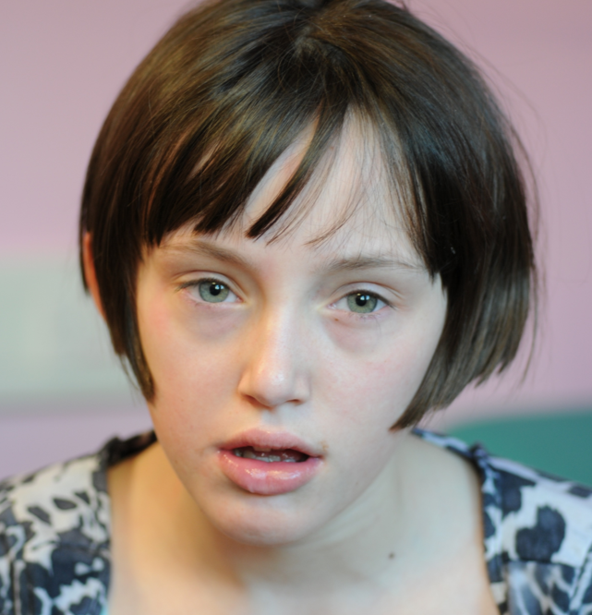
Probands 2 and 3 (twins) (NM_014991.6: c.8098-1G>C, p.?, de novo)
These monozygous male twins were last examined at the age of 9 and 4 ½ years in a clinical genetics center in Northern Macedonia. Their diagnosis was confirmed using Trio Exome Sequencing. The children were first seen in the clinic at 1 1/2 years old due to frequent respiratory infections. Body measurements were not provided at that time. At the age of 4 1/2 years old body measurements were first recorded. Proband 3 shows macrocephaly (OFC: 54 cm, 98th percentile), is underweight (10th percentile) and of normal stature (50th percentile). Proband 4 also shows macrocephaly (OFC: 53 cm, 89th percentile) and is of normal weight (25th percentile) and stature (also 50th percentile). These proportions remained the same for proband 3. He was last seen at the clinic at age 9 years due to the epileptic attack that occurred. His twin brother 4 was not seen but according to the parents he has the same proportion as his brother 3.
Both show signs of intellectual disability, and delay in all their developmental milestones. At the age of 1 year, proband 4.1 started smiling and using first syllables and now he is only able to answer questions with yes and no. He was diagnosed with ASD. Both are diagnosed with ADHD, which is more pronounced in proband 3. Proband 3’s seizures are treated with Oxcarbazepine. No seizures were reported in proband 4. Both are characterized as “clumsy” and dysmorphic features include dolichocephaly, protruded forehead, synophris, prominent eyes, laterally extended eyebrows, prominent eyelashes, and a saddle nose.
The mother’s first pregnancy was uneventful. The mother’s second pregnancy, a twin pregnancy in which these two children shared the placenta and had two amniotic sacs, was accompanied by pain and vaginal bleeding. The mother thus received therapy with progesterone. The children were delivered spontaneously in the 38th gestational week. The proband and his twin had low glucose levels after birth which corrected afterwards. An additional metabolic screening was reported as normal.
Proband 4 (NM_014991.6: c. 153_154del, p. Met53Aspfs*6, de novo)
This male proband was last examined in a clinical genetics center in the United Kingdom, at the age of 13. Karyotype, microarray, and Fragile X testing were normal. He has a moderate intellectual delay accompanied by a mild motor and speech delay. He only speaks short sentences or single words. He shows a macrocephaly, (59 cm, 98th percentile) is of normal weight (92nd percentile) and of normal height. (83rd percentile) He was diagnosed with ASD at the age of 3. His anxiety is currently being treated with sertraline. On physical examination a mild unilateral ptosis was noted. During infancy he had a prolonged reflux disease, requiring multiple medications.
Proband 5 (NM_014991.6: c.2390_2391del, p. Leu797Profs*28, de novo)
This male proband was last examined at the age of 8 years in a clinical genetics center in the United States of America. Diagnosis was performed using the “Autism/ID Xpanded” panel from GeneDx. Microarray analysis and Fragile X Syndrome testing were without findings. No precise measurements of head circumference are available, but he is reported to have had macrocephaly at the age of 2 months that followed the growth chart. His height and body weight were reported as normal. He is reported to have no intellectual disability. However, his speech development is delayed. He spoke his first words at 4 years of age and is currently minimally verbal. He is diagnosed with ADHD, ASD and OCD and has anxiety and depressive symptoms. The proband receives occupational therapy, physical therapy, speech therapy, and applied behavioral analysis therapy. On physical examination a low anterior hairline with bitemporal narrowing was noted. He has a history of hypotonia.
Probands 6 and 7 (NM_014991.6: c.8806del, p. Tyr2936Metfs*14, paternally inherited)
This father-son duo was last examined at ages 35 and 4 years respectively in a clinical genetics center in the United States of America. The inheritance was confirmed by Trio-Exome sequencing. The father shows normal cognitive development and no neuropsychiatric disorder. He however presents with macrocephaly (61.4 cm, P>99th) and is quite short (162 cm, P~1st).
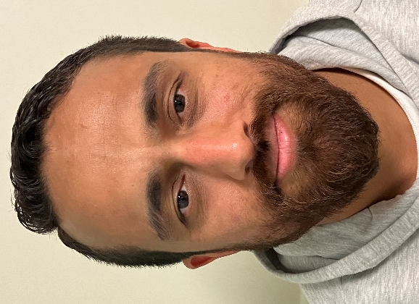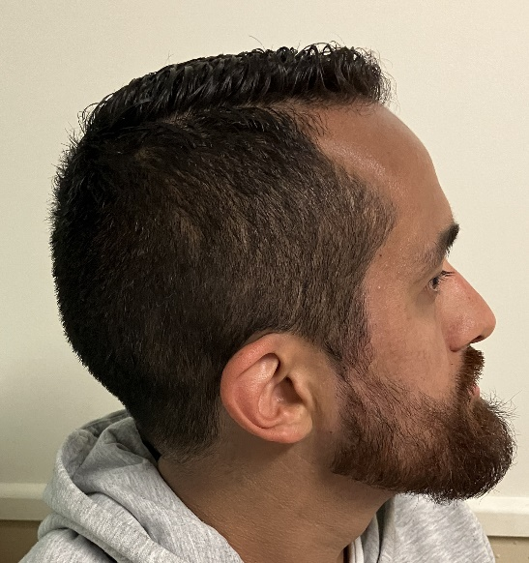
The son also presents with macrocephaly (P95th) and his short and rather small (88.9 cm, P<1st; 13.9 kg, P22nd). He shows mild intellectual disability, and his language and motor development are delayed. He is described as essentially non-verbal. He is diagnosed with Autism. A brain MRI was conducted and showed age-appropriate results. He has a clubfoot on the right side that was treated with tendon release. He was treated for multiple issues and receives occupational, speech and physiotherapy.
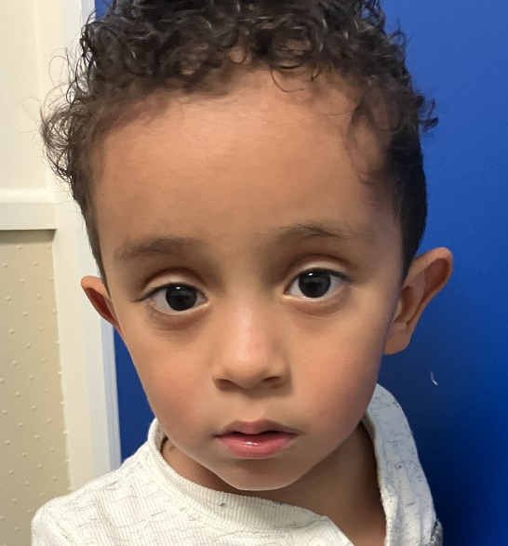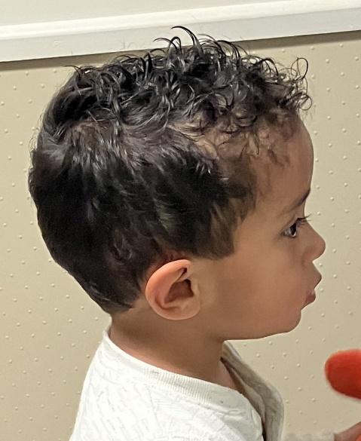
Proband 8 (arr[GRCh37]4q21.23(84733315_85303803) x1, de novo)
This male proband was last examined at age 4 in a clinical genetics center in Italy. His de novo variant was confirmed by segregation analysis on chromosome microarray. He presents with moderate developmental delay. He has macrocephaly (55 cm, +4.3 SD) and normal height and weight (102 cm, P50th; 20 kg, P90th). He was diagnosed with autism spectrum disorder, and both speech and motor development are reported to be delayed. A brain MRI was conducted and showed age-appropriate results. He showed no clinical seizures, but an abnormal EEG when falling asleep was reported. On physical evaluation dolichocephaly, mild bitemporal narrowing, telecanthus, bilateral epicanthus inversus and a smooth philtrum were noted.
Proband 9 (NM_014991.6: c 2322dupA, p. Val775Serfs*7, unknown)
This male proband was last examined at age 19 a clinical genetics center in the United States of America. His variant was identified by Singleton-exome sequencing. He presents with moderate intellectual disability. He presents with macrocephaly (59 cm, +2.7 SD) and is rather small and skinny (162.6 cm, -1.98 SD; 58 kg, -1.2 SD). He is diagnosed with autism and ADHD and shows oppositional-defiant behavior. Both speech and motor development are reported to be delayed. No seizures are reported nor was an MRI conducted. On physical evaluation down slanting palpebral fissures, widely spaced eyes, a high and narrow palate, and dental overcrowding were noted. He furthermore has a hemihyperplasia of the right leg and broad toes and is diagnosed with Crohn’s disease.
Probands 10 and 11 (NM_014991.6: c. 3257_3258del, p. Gly1086Aspfs*5, maternally inherited)
Proband 10 was last examined at age 8 in a clinical genetics center in France. Her variant was identified through trio-exome sequencing and found to be inherited from her mother (Proband 11), who is also mildly affected, showing signs of a mood disorder. Unfortunately, nothing more specific is known.
She does not present with intellectual disability and presents with learning difficulties with heterogeneous profiles at IQ scale. She presents with macrocephaly (53.5 cm at 5 years, +2 SD) and is of normal height and stature (110 cm at 5 y, -0.1 SD; 17.1 kg at 5 y, -0.6 SD). Her language and motor development are delayed. She is diagnosed with ADHD, shows stereotypical movements, and is described to sometimes throw tantrums. On physical evaluation a prominent forehead and a bulbous nose were noted. No seizures are reported nor was an MRI conducted.
Probands 12 and 13 (NM_014991.4: c. 1906C>T, p. Arg636*, maternally inherited)
This male proband was last examined at age 8 in a clinical genetics center in Spain. His diagnosis was confirmed using Trio Exome Sequencing. Array-CGH and fragile X testing were normal. He is the first child of healthy non-consanguineous parents. His pregnancy and delivery were unremarkable, and no feeding issues were reported. He has a mild intellectual disability (IQ 63), and his language development is reported to be delayed. He presents with macrocephaly (53.9 cm, + 0.88 SD) and is of normal weight and height (128.5 cm -0.34 SD; 26.7 kg, - 0.45 SD). On physical examination Coarse facial features, a tall forehead, and arched, wide and sparse eyebrows were noted. Furthermore, he shows hypertelorism with wide palpebral fissures, as short nose with bulbous tip and anteverted nares, wide columella and low set, anteverted ears. He has a long neck with downsloping shoulders, wide hands with redundant skin, brachydactyly and persistent fetal pads. This all prompted the clinical suspicion of Kabuki-like syndrome. Abdominal and cardiac ultrasonography were normal. No seizures are reported nor was an MRI conducted.
His mother, from which the variant was inherited, shows normal development. No IQ testing was conducted, and she has a normal head circumference (+0.37 SD) On physical examination a high forehead and high anterior hairline were noted.
Proband 14 (NM_014991.6: c.10153 C>T, p. Arg3385*, de novo)
This male proband was last examined at the age of 4 in a clinical genetics center in the United States of America. His diagnosis was confirmed using trio-exome sequencing. He has a low-normal intelligence quotient and is reported to be behind on motor and language development (sat at 9 months, walked at 17 months, only shows limited speech). He shows symptoms of ASD but has not been formally assessed. He shows macrocephaly (variable measurements from 52.2 to 54.5 cm, P95th to P98th) and is tall and overweight (107.1 cm, P85th; 24.9 kg, P99th). A brain MRI at age 2 revealed possible heterotopic gray matter in the subependymal tissue adjacent to the right lateral ventricle and a suspected prior microhemorrhage in the medial aspect of the left thalamus. He further has a history of persistent vomiting, snores and reduced stamina.
Probands 15 and 16 (NM_014991.6: c.8017C>T, p. Arg2673*, paternally inherited)
This female proband was last examined at the age of 5 in Israel. Her diagnosis was confirmed using Trio-Exome sequencing. Sequencing also yielded a VUS in ACAN (NM_001369268.1, c.630-13G>A) that was maternally inherited, which might explain the short stature in both (mother is 138cm, - 3.9 SD and the proband was 95.5 cm at age 4.10 yrs, -2.3 SD, P<1st). The proband has a moderate intellectual disability and is reported to be mildly delayed in her language development, as she can speak in full sentences. Her motor development is reported as also mildly delayed (walked at 16 months). Furthermore, she has been diagnosed with ASD. She shows macrocephaly (53 cm, P97th). A brain MRI showed a low position of her cerebellar tonsils, which was described as a Budd-Chiari malformation type 1.5, for which she had later gone through surgery, and abnormal nonspecific white matter signals. At the age of 2 she had a singular seizure during fever and another singular seizure later that was not associated with fever. Two EEGs were reported as normal. On physical examination a tall forehead was noted.
Her father, from which her variant was inherited, was last seen at the age of 49. He shows severe macrocephaly (+4.8 SD) and is rather short (P18th). He has been diagnosed with ASD. His speech began at age 3 years, and he started some higher education learning but dropped out of university. Furthermore, he has trouble keeping a job, is described as having no sense of humor and difficulties with social interactions. Lastly, he possibly shows obsessive behavior and requires help with bureaucratic issues.
Proband 17 (NM_014991.6: c.235 C>T, p. Gln79*, de novo)
This female proband was last examined at the age of 4 years and 10 months in a clinical genetics center in the United States of America. Her diagnosis was confirmed using Trio-Exome sequencing. She has been diagnosed with ASD and shows macrocephaly (55 cm, P>99th, +2.69 SD). She is of normal height (113 cm, P71st) and overweight (26.6 kg, P99th). The proband is delayed in both receptive and expressive language development. At age 3 years 11 months, she was evaluated to have receptive language at the 7–9-month age-level and expressive language at the 16–18-month age-level. At the same age, the proband was evaluated to have fine motor skills at the 23-month age-level, below age-level visual motor skills, and impaired gross motor skills. Some adaptive skills, such as drinking from a bottle, are also delayed. There was a regression in eye contact, response to name, gestures, and verbalizations around 14 months of age. Lastly, she has feeding difficulties and selective eating habits.
Proband 18 (NM_014991.6: c.5278C>T, p. Gln1760*, de novo)
This proband is from the Autism Clinical and Genetic Resources in China (ACGC) database. The age of this male proband was not reported. The diagnosis was confirmed using trio whole exome sequencing. He has a mild intellectual disability with an IQ of 50-60 and motor and speech delay. He presents with Macrocephaly. An abnormal EEG and brain MRI were reported, though no details are known to us. No seizures were reported. Furthermore, the proband was reported to have had severe gastrointestinal disturbances until the age of 4. He shows symptoms of attention deficit hyperactivity disorder (ADHD) and has obsessive behavior, anxiety, and sleep problems.
Proband 19 (NM_014991.6: c.8501C>G, p. Ser2834*, de novo)
This male proband is from the Simons Foundation Powering Autism Research (SPARK) database. He was examined at the age of 17. The diagnosis was confirmed using trio whole exome sequencing. No body measurements or results of an IQ test were reported. He can make longer sentences, describe events and is able to walk. He was diagnosed with several neuropsychiatric disorders, notably Asperger’s disorder and ADHD, and is described to have issues with social interaction and communication. Furthermore, sleeping problems were noted.
Proband 20 (NM_014991.6: c.8313T>G, p. Tyr2789*, de novo)
This male proband is from the Simons Foundation Powering Autism Research (SPARK) database. He was examined at the age of 17. The diagnosis was confirmed using trio whole exome sequencing. Only a little information was submitted about him: No body measurements or results of an IQ test were reported. He is reported to be able to make longer sentences, describe events and to walk. He is further diagnosed with ASD.
Proband 21 (NM_014991.6: c.3382C>T, p. Arg1128*, de novo)
This female proband is from the Simons Foundation Powering Autism Research (SPARK) database. She was last examined at the age of 15. The diagnosis was confirmed using trio whole exome sequencing. No body measurements or results of an IQ test were reported. Her language development is reported to be delayed, and she seems to have issues with social interactions. She shows no signs of motor developmental delay. She is diagnosed with ASD and has an anxiety and sleeping disorder.
Proband 22 (NM_014991.6: 85634394T>C, p.?, de novo)
This male proband is from the Simons Foundation Powering Autism Research (SPARK) database. He was last examined at the age of 17. The diagnosis was confirmed using trio whole exome sequencing. No body measurements or results of an IQ test were reported. His language development seems to be somewhat delayed, though he can use longer sentences of his own and is able to tell you something that happened. She shows no signs of motor developmental delay. He is diagnosed with Asperger's Disorder.
Proband 23 (NM_014991.6: 85634394T>C, p.?, de novo)
This male proband is from the Simons Foundation Powering Autism Research (SPARK) database. The diagnosis was confirmed using trio whole exome sequencing. He was last examined at the age of 15. The diagnosis was confirmed using trio whole exome sequencing. No body measurements or results of an IQ test were reported. His language development is delayed as he can only use single words meaningfully. He is unable to walk or use his hands. He is diagnosed with ASD.

