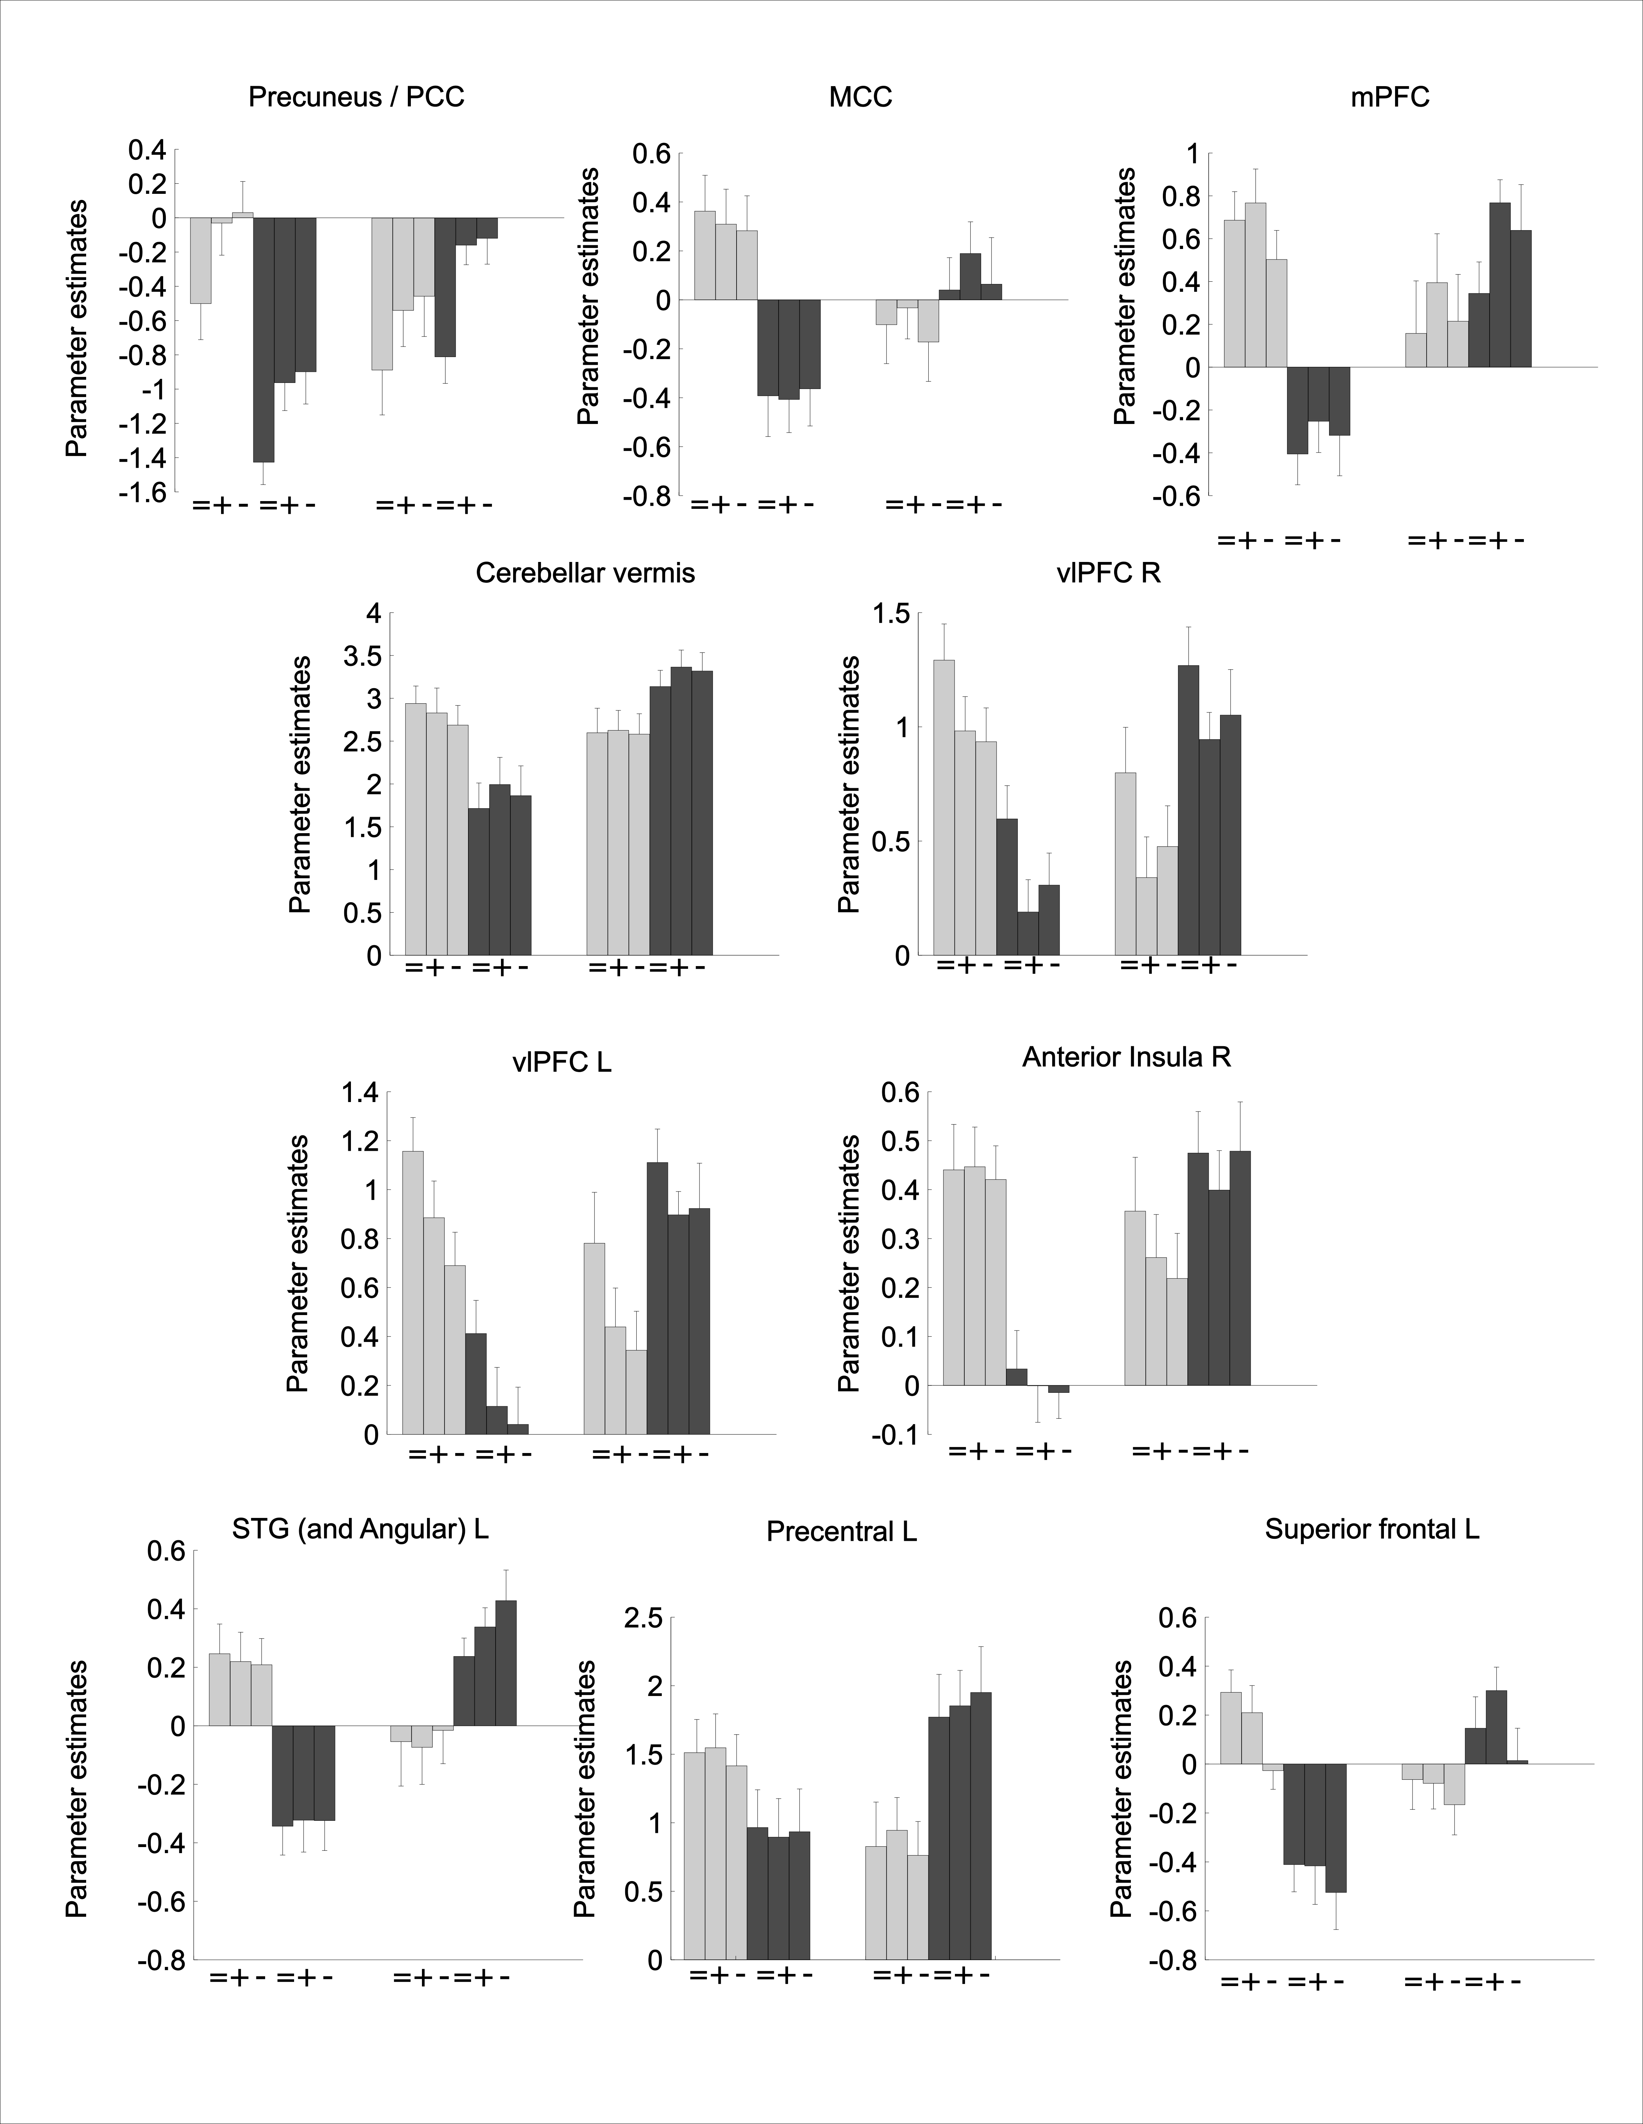
Figure S1 | Clusters showing a group (control/sibling) * stress (stress/no-stress) interaction, each valence presented separately. Con: Control; Sib: Schizophrenia sibling; PCC: posterior cingulate cortex; mPFC: medial prefrontal cortex; STG: superior temporal gyrus; vlPFC: ventrolateral prefrontal cortex; =: neutral; +: positive; -: negative. Error bars represent standard error of the mean (SEM).

