SUPPLEMENTARY ONLINE MATERIAL

Summary. This supplement contains:

(a) Procedural information and additional results for the self-administration, contextual conditioning, extinction and reinstatement in the alcohol, cocaine, and sweet solution test groups (S1).

(b) Information on inactive lever responses and closed arm entries in the elevate plus maze (EPM) test in further support of the absence of general nonspecific effects of CBD on behavior (S2; Figures S2, S3, S4).

S1: Self-administration, contextual conditioning, extinction and reinstatement - procedures and results

Alcohol. Voluntary alcohol self-administration was initiated by a sweet solution fading procedure [(SSC) 3% glucose, 0.125% saccharin; see (Walker and Koob, 2008)] conducted in daily 30 min sessions on a continuous reinforcement (FR1) schedule. After two weeks of training, animals were divided into two groups. Rats designated for stress-induced reinstatement continued to self-administer alcohol for ten days. Rats designated for contextual reinstatement continued to self-administered alcohol in two different stimulus contexts signaling either alcohol availability or non-availability. The stimulus context signaling alcohol availability consisted of a compound olfactory (banana extract) plus auditory (70 dB white noise) stimulus. The stimulus context signaling alcohol non-availability consisted of anise extract plus a continuous tone (7 kHz, 70 dB). The stimulus context was introduced 30 s before onset of self-administration sessions by depositing five drops of olfactory extract into the bedding of the operant chamber, paired with onset the respective auditory stimulus. The sequence of the availability and non-availability session conducted each day was determined randomly and sessions continued for ten days (i.e., 10 availability and 10 non-availability) sessions. The mean±SEM number of responses during the final three alcohol availability sessions was 43.38±3.63 in rats designated for contextual reinstatement and 29.39± 3.47 in rats designated for stress-induced reinstatement. Daily 30-min sessions then continued under extinction conditions until a criterion of 5 responses or less over three consecutive days was reached. During this time, levers were presented without the contextual stimuli, and operant responses resulted in no scheduled consequences. The mean±SEM number of days to reach the extinction criterion was 10.00±1.01 in rats designated for contextual reinstatement and 14.17±0.65 in rats designated for stress-induced reinstatement. Reinstatement tests (30 min) tests were conducted under extinction conditions, except that either the respective stimulus context signaling alcohol availability/non-availability was reintroduced, or rats were subjected to stress manipulations. Rats prepared for contextual reinstatement were tested first in the alcohol non-availability context. Rats did not show reinstatement in this context with 7.24±1.62 responses (vs. extinction criterion ≦5) confirming that reinstatement occurred selectively in the alcohol availability but not the non-availability context. Thereafter, all reinstatement tests were conducted in the alcohol availability context.

Cocaine. Rats were trained to self-administer cocaine on an FR 1 schedule in daily 2h sessions. Reinforced responses were accompanied by illumination of the cue light above the active lever (20 s), signaling a timeout (TO) period during which the lever remained inactive. After acquisition of stable cocaine-reinforced responding (2 weeks), animals were divided into two groups. Rats designated for stress-induced reinstatement continued to self-administer cocaine for ten days. Rats designated for contextual reinstatement continued to self-administered cocaine in two different stimulus contexts signaling either alcohol availability or non-availability. The subsequent contextual conditioning and reinstatement procedures were identical to those described for alcohol above. The stimulus context signaling cocaine availability consisted of a compound olfactory (banana extract) plus auditory (70 dB white noise) stimulus. The stimulus context signaling cocaine non-availability consisted of anise extract plus a continuous tone (7 kHz, 70 dB). The stimulus context was introduced 30 s before onset of self-administration sessions by depositing five drops of olfactory extract into the bedding of the operant chamber, paired with onset the respective stimulus. The sequence of the availability and non-availability session conducted randomly each day in two drug sessions and one non-reward session, separated by 30 min. Between sessions, rats were placed in their home cages for 30 min. Drug and saline sessions lasted 1 h each. Sessions continued for ten days (i.e., 20 availability and 10 non-availability) sessions. The mean±SEM number of responses during the final three cocaine availability sessions was 22.59±2.06 in rats designated for contextual reinstatement and 18.42±4.01 in rats designated for stress-induced reinstatement. Daily sessions then continued under extinction conditions, each lasting 60 min, until a criterion of 5 responses or less over three consecutive days was reached. During this time, levers were presented without the contextual stimuli, and operant responses resulted in no scheduled consequences. The mean±SEM number of days to reach the extinction criterion was 9.32±1.96 in rats designated for contextual reinstatement and 13.33±2.26 in rats designated for stress-induced reinstatement. Reinstatement tests (60 min) were conducted under extinction conditions, except that either the respective stimulus context signaling cocaine availability/non-availability was reintroduced, or rats were subjected to yohimbine stress. Rats prepared for contextual reinstatement were tested first in the cocaine non-availability context. Rats did not show reinstatement in this context with 6.34±3.09 responses (vs. extinction criterion ≦5) confirming that reinstatement occurred selectively in the cocaine availability but not non-availability context. Thereafter, all reinstatement tests were conducted in the cocaine availability context.

Sweet solution. Rats were trained to orally self-administer the same 3% glucose/0.125% saccharin sweet solution (SSC) used for the initiation of alcohol self-administration in daily 30 min sessions on a FR 1 schedule. Once stable self-administration was obtained (10 days) rats continued to self-administered SSC in two different stimulus contexts signaling either SSC availability or non-availability as described above for alcohol. The stimulus context signaling SSC availability consisted of a compound olfactory (banana extract) plus auditory (70 dB white noise) stimulus. The stimulus context signaling SSC non-availability consisted of anise extract plus a continuous tone (7 kHz, 70 dB). The stimulus context was introduced 30 s before onset of SSC self-administration sessions by depositing five drops of olfactory extract into the bedding of the operant chamber, paired with onset the respective auditory stimulus. The sequence of the availability and non-availability session conducted each day was determined randomly and sessions continued for ten days (i.e., 10 availability and 10 non-availability) sessions. The mean±SEM number of responses during the final three SSC availability sessions in rats later randomly assigned to the VEH control vs CBD treatment conditions was nearly identical (VEH: 261.11 ± 13.09; CBD: 258.18 ± 17.69). Daily 30-min sessions then continued under extinction conditions until a criterion of 5 responses or less over three consecutive days was reached. During this time, levers were presented without the contextual stimuli, and operant responses resulted in no scheduled consequences. Like the self-administration performance, the mean±SEM number of days to reach the extinction criterion in the groups assigned to the VEH vs CBD conditions was nearly identical (VEH: 10.41 ± 2.75; CBD: 10.21 ± 2.45). Reinstatement tests (30 min) then were conducted under extinction conditions, except that either the respective stimulus context signaling SSC availability/non-availability was reintroduced, or rats were subjected to yohimbine stress. Rats were tested for reinstatement of SSC seeking induced by the SSC stimulus context on treatment day 1, and for stress-induced (yohimbine) reinstatement on PostTx days 3 and 18.

S2. EPM closed arm entries and inactive lever responses

General nonspecific effects on behavior could compromise the interpretation of attenuating effect of CBD on reinstatement. Converging evidence in our data, however, rules out this alternative interpretation. The data show that CBD does not alter locomotor activity as measured in activity chambers or in terms of EPM arm crossings for all groups of rats (Fig. S2), and did not alter inactive lever-responses in all reinstatement tests (see Figures S3 and S4 for yohimbine-induced reinstatement tests). Yohimbine-induced reinstatement increased with repeated treatment across experimental phases, presumably reflecting sensitization to the stressor. However, the fact that inactive-lever responses across test days were not modified (Figures S2 and S3) argues against simple locomotor sensitization by yohimbine. Although more studies are needed, the brain stress response (including elevated noradrenergic signaling) has been hypothesized to be sensitized by drug withdrawal and contribute to stress-induced (Koob and Le Moal, 2008).

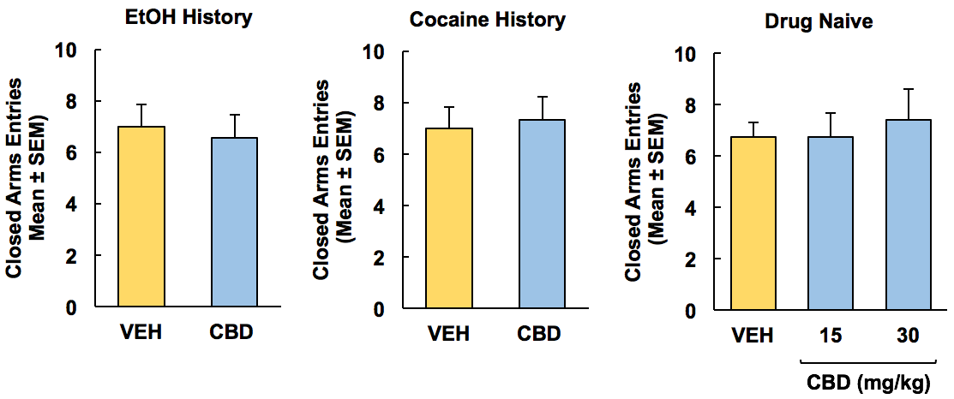
Figure S2. Experimental anxiety (EPM closed arm entries). In rats with an alcohol or cocaine history, and drug-naïve rats. CBD did not alter closed arm entries.

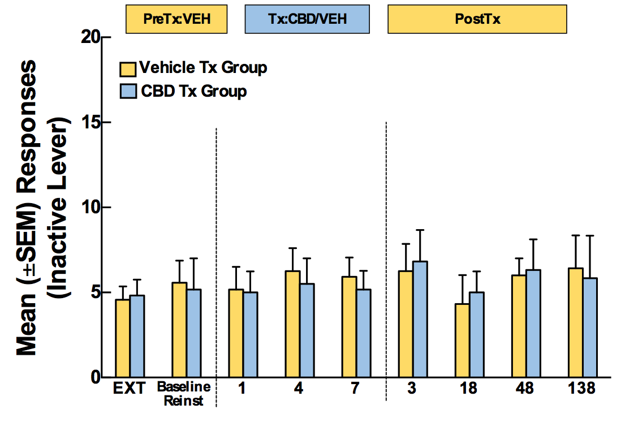
Figure S3. Inactive lever responses during yohimbine-induced reinstatement of alcohol seeking. The same profile of effects was observed for CBD and VEH rats across all three experimental phases.

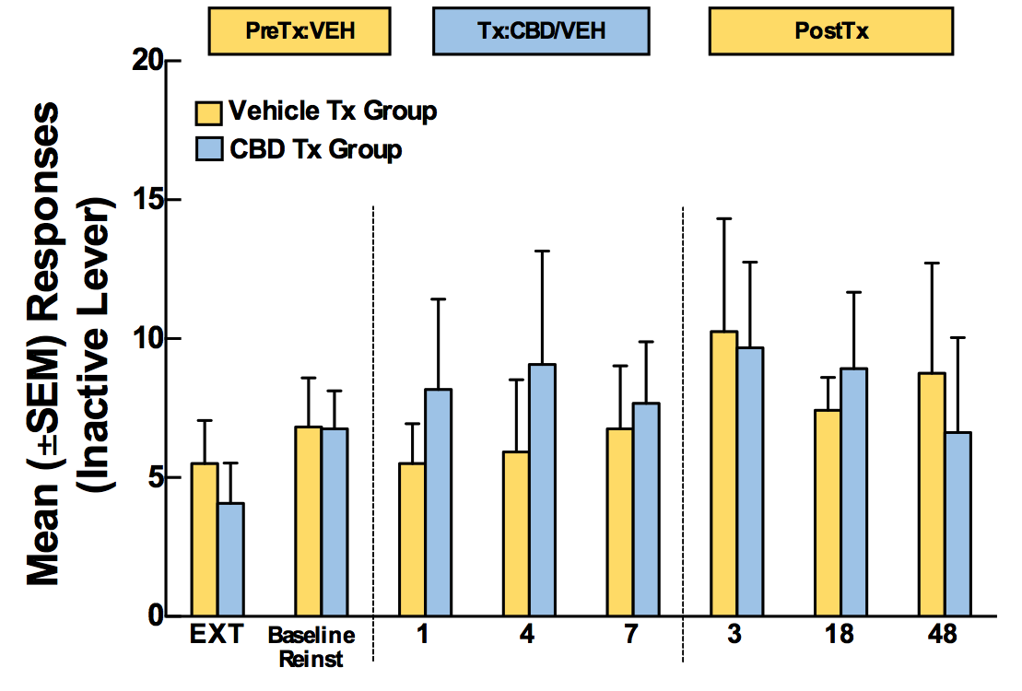
Figure S4. Inactive lever responses during yohimbine-induced reinstatement of cocaine seeking. The same profile of effects was observed for CBD and VEH rats across all three experimental phases.

REFERENCES

Koob GF, Le Moal M (2008). Review. Neurobiological mechanisms for opponent motivational processes in addiction. Philos Trans R Soc Lond B Biol Sci 363(1507): 3113-3123.

Walker BM, Koob GF (2008). Pharmacological evidence for a motivational role of kappa-opioid systems in ethanol dependence. Neuropsychopharmacology 33(3): 643-652.

